FUFA Data Science Unit
UPL Season Report

Generated on: January 19, 2026

1. Introduction
This report presents a comprehensive analysis of the UPL competitions for the season. The data collected via Catapult wearable technology provides insights into the physical demands and performance characteristics of the league.
The report is divided into two main sections: Usage Analysis, which details data coverage and participation, and Performance Analysis, which delves into the physical metrics.

2. Usage Analysis
This section outlines the extent of data collection, highlighting club participation and consistency across matchdays.

2.1 Player Participation per Club
Mbarara City Fc had the highest number of unique players analyzed (30), indicating significant squad rotation or broad data capture.
club_for | unique_players
Mbarara City Fc | 30
Wakiso Giants Fc | 28
Kitara Fc | 27
Bul Fc | 27
Vipers Sc | 27
Police Fc | 26
Lugazi Fc | 26
Kcca Fc | 26
Ura Fc | 25
Nec Fc | 24
Maroons Fc | 24
Updf Fc | 23
Soltilo Bright Stars Fc | 21
Mbale Heroes Fc | 20
Express Fc | 17
Sc Villa | 17

2.2 Matchday Participation Trends
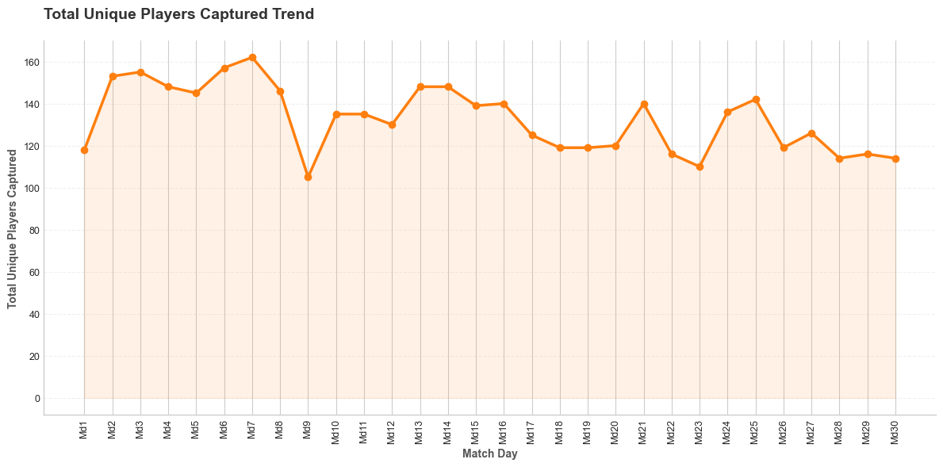
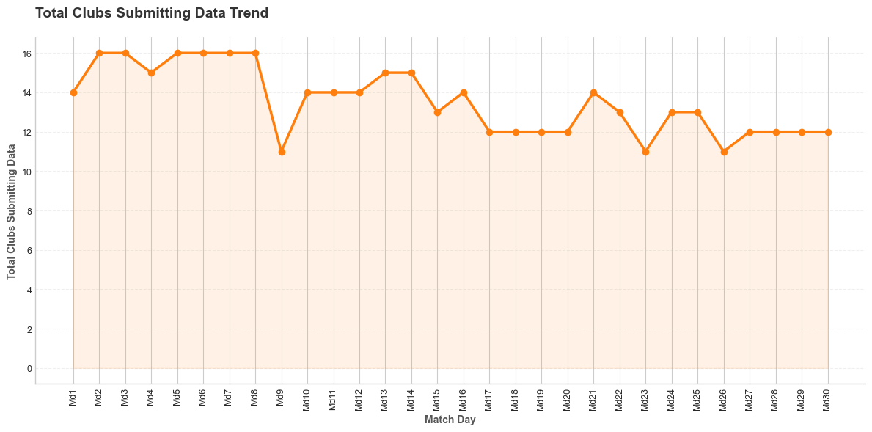
The charts above illustrate the volume of data captured over time. Peaks typically correspond to full matchday rounds where most clubs uploaded data.

2.3 Data Coverage Grid
The grid below visualizes which clubs uploaded data for each matchday (Green = Uploaded).
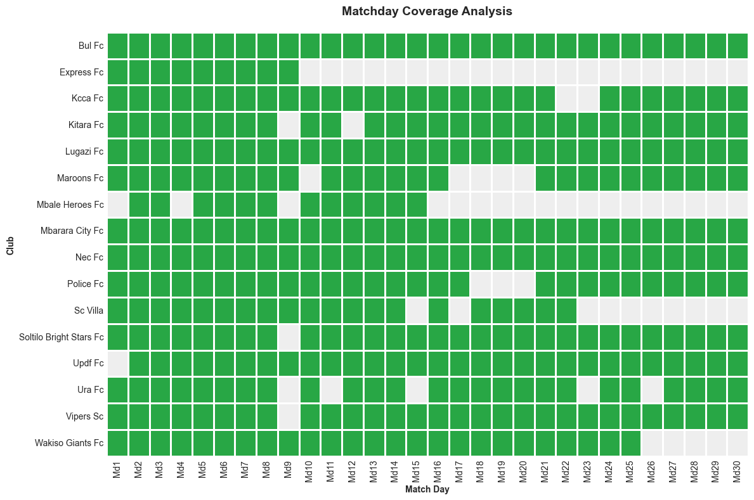

3. Performance Analysis
This section analyzes the physical output of players, categorized by volume (total work done) and intensity (rate of work).

3.1 Metric Distributions
Distribution of key volume (Distance) and intensity (Player Load) metrics.
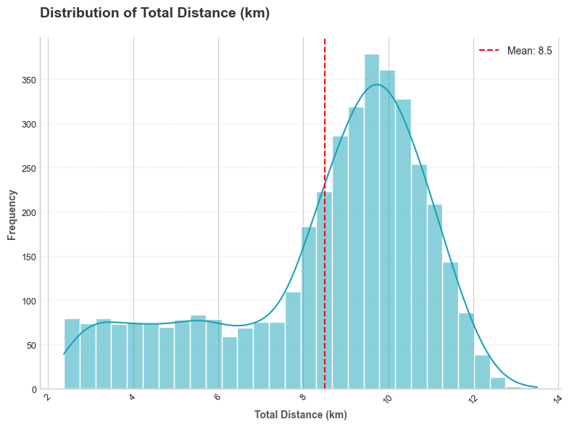
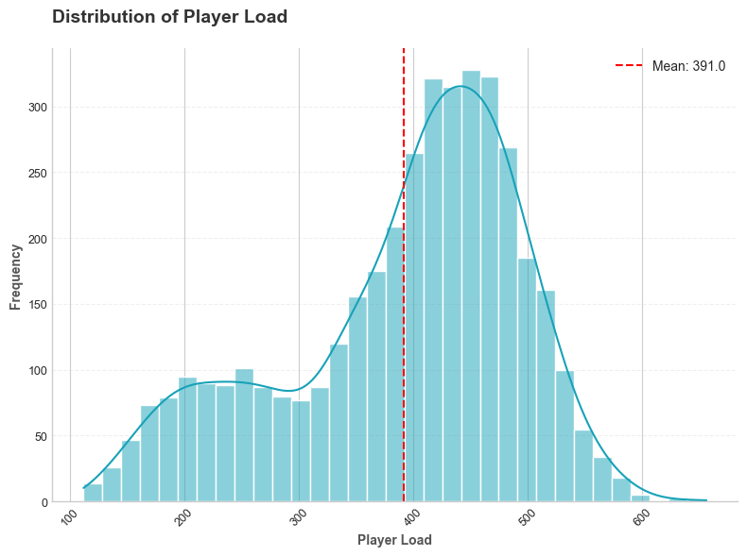

3.2 League Averages

Volume Metrics
sum | mean | std
33921.71 | 8.51 | 2.45
3364024.13 | 843.54 | 379.16
240174.00 | 60.22 | 23.06
4150620.97 | 1040.78 | 304.81
25101.00 | 6.29 | 4.86
1583565.00 | 397.08 | 121.36
1519838.00 | 381.10 | 117.14

Intensity Metrics
max | mean | std
655.96 | 391.02 | 103.50
36.42 | 29.59 | 2.30
136.52 | 86.75 | 24.92
21.99 | 13.96 | 4.06
122.17 | 72.41 | 23.00
10.00 | 5.85 | 0.63
10.00 | 7.16 | 0.97
7.11 | 4.05 | 1.23
6.71 | 3.89 | 1.19

3.3 Contextual Analysis

Home vs Away
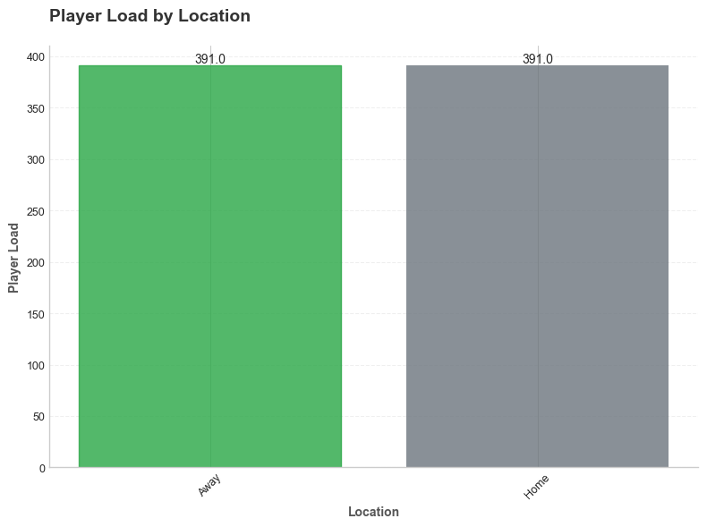

3.4 Seasonal Metric Trends
Rolling averages (3-matchday window) for key performance indicators.
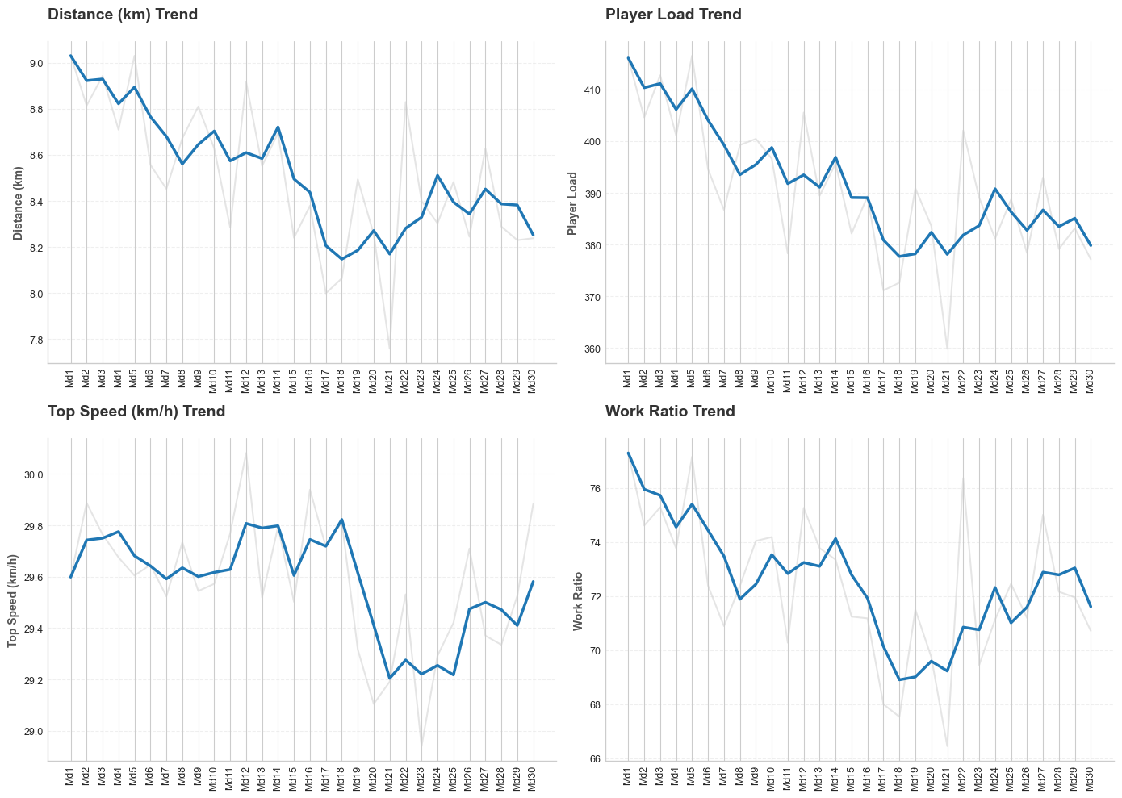

3.5 Speed Zone Analysis

Distance in Speed Zones
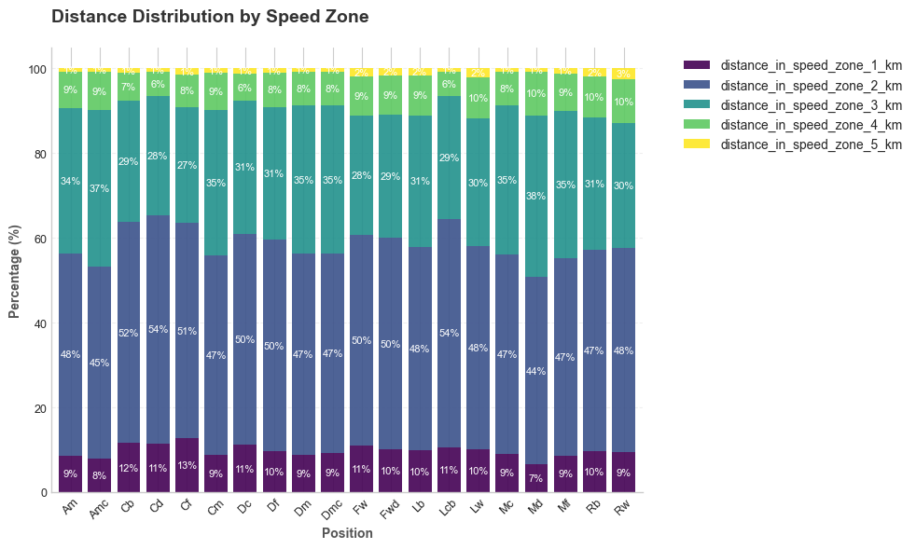

3.6 Record Breakers
The following tables highlight the highest single-match values recorded for key metrics.
Highest distance_km: Ronald Ssekiganda (Sc Villa) - 13.50
p_name | player_club_ | match_day | distance_km
Ronald Ssekiganda | Sc Villa | Md7 | 13.50
Ronald Ssekiganda | Sc Villa | Md1 | 13.49
Tonny Atukunda | Sc Villa | Md7 | 12.97
Jude Semugabi | Kitara Fc | Md7 | 12.79
Ian Amanya | Lugazi Fc | Md2 | 12.76
James Penz Begisa | Ura Fc | Md13 | 12.75
Abdul Kalanzi | Lugazi Fc | Md11 | 12.67
Richard Okello | Bul Fc | Md16 | 12.67
Innocent Wafula Esimu | Mbarara City Fc | Md1 | 12.60
Joseph Janjali | Updf Fc | Md26 | 12.60
Highest top_speed_kmh: Yafeesi Mubiru (Bul Fc) - 36.42
p_name | player_club_ | match_day | top_speed_kmh
Yafeesi Mubiru | Bul Fc | Md11 | 36.42
Joseph Ssemujju | Ura Fc | Md18 | 36.22
Freedom Mungudit | Lugazi Fc | Md18 | 36.21
Hakim Kiwanuka | Sc Villa | Md4 | 36.02
Paul Mucureezi | Nec Fc | Md14 | 36.02
Enock Luyima | Vipers Sc | Md20 | 35.84
Joseph Akandwanaho | Mbarara City Fc | Md2 | 35.73
Freedom Mungudit | Lugazi Fc | Md14 | 35.63
Sadat Anaku | Kcca Fc | Md11 | 35.57
Milton Karisa | Vipers Sc | Md8 | 35.56
Highest player_load: Felix Okot (Maroons Fc) - 655.96
p_name | player_club_ | match_day | player_load
Felix Okot | Maroons Fc | Md29 | 655.96
Richard Okello | Bul Fc | Md16 | 647.93
Innocent Kitamwe Kitimbo | Soltilo Bright Stars Fc | Md18 | 626.97
Richard Okello | Bul Fc | Md17 | 623.39
Innocent Kitamwe Kitimbo | Soltilo Bright Stars Fc | Md27 | 608.26
Patrick Jonah Kakande | Sc Villa | Md7 | 598.29
Hassan Kato | Mbale Heroes Fc | Md10 | 597.36
Frank Tumwesigye | Kitara Fc | Md27 | 594.27
Hassan Kato | Mbale Heroes Fc | Md5 | 593.12
Ronald Ssekiganda | Sc Villa | Md1 | 592.99
Highest sprint_distance_m: Innocent Wafula Esimu (Mbarara City Fc) - 2894.44
p_name | player_club_ | match_day | sprint_distance_m
Innocent Wafula Esimu | Mbarara City Fc | Md1 | 2894.44
James Penz Begisa | Ura Fc | Md13 | 2200.87
Elagu Gabriel | Police Fc | Md12 | 2159.44
Musa Ssegujja | Wakiso Giants Fc | Md7 | 2125.15
Jude Semugabi | Kitara Fc | Md7 | 2096.37
Brian Ljara | Kcca Fc | Md16 | 2078.27
Mujahid Ogama | Maroons Fc | Md8 | 2066.75
Elagu Gabriel | Police Fc | Md27 | 2060.02
Umar Kyebatala | Mbale Heroes Fc | Md2 | 2048.54
Kawawa Rashid | Express Fc | Md3 | 2036.44

4. Conclusion
This report summarizes the physical performance data for the season. Continued data collection will allow for deeper longitudinal analysis and benchmarking.

