Convention Registration Simulator Paper

Analysis of Line Length from a Registration Simulator

Course: CSCI 2210-201, Fall 2015

Authors: Matthew Humphrey, Jarred Wininger

With the parameters as given to us by the convention organizers we found that six lines should be sufficent to keep the longest line lengths at five people or less. However, with only six lines a line may occasionally be more than five people long, but this is rare. If the lines absolutly must be shorter than five people then a total of seven lines may be needed.

Secondly, we tested a number of other circumstances. If an average of five minutes is expected at checkout then seven lines are needed like six was under normal circumstances. If fifteen-hundred people are expected then a total of eight lines are needed.

A result that was longer than five with six lines:

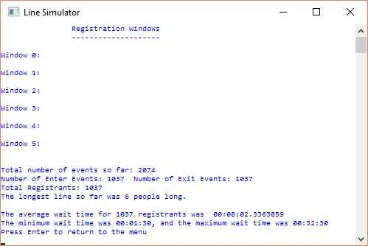

A result that was correct with six lines:

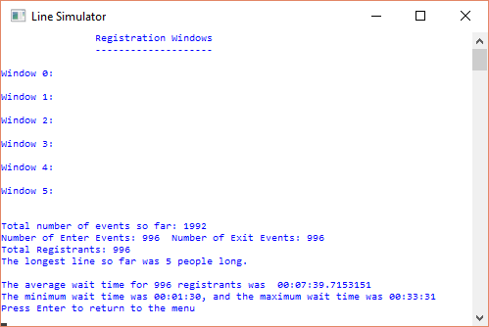

A result that was correct with seven lines:

