TEAM TESLA

REPORT 6






VNIT
Nagpur, MAHARASHTRA
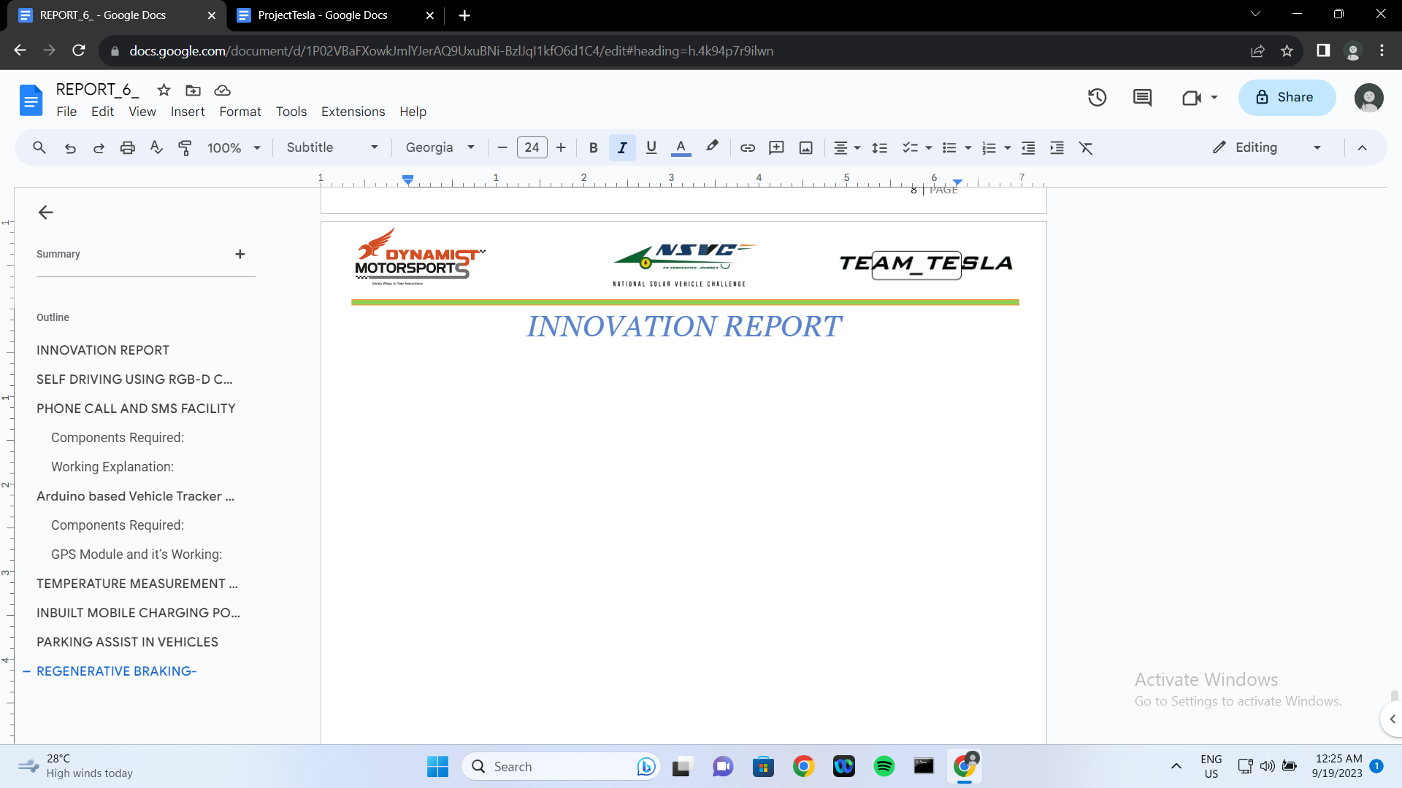

TABLE OF CONTENTS

- Using Ultrasonic Sensors for
- Automatic Braking System
- Parking Assistant Page no. 3-4

- LDR Circuit for Ambient Light Sensing Page no. 5

- Temperature Measurement of Battery & Motor Page no. 10

- Topple/Accident Detection Page. 11-12

- Battery State of Charge Indicator Page no. 13

- Speedometer Page no.14

- Smoke Detection Page no. 15

- Conclusion Page no.18

- (a) Automatic Braking System
Safety is paramount, and our Automatic Braking System plays a pivotal role in enhancing it. This Arduino code is designed to control a vehicle's safety features using ultrasonic sensors, a servo motor, and a buzzer. The code continuously monitors distances from both the front and rear ultrasonic sensors. If an obstacle is detected within 28 cm of the vehicle, the automatic braking system is activated, applying the brakes through a servo motor to prevent a collision. To avoid rapid activation and provide the rider with time to maneuver the vehicle away from the obstacle, a delay of 5 seconds is implemented before reactivation. Additionally, a Manual Push Button is provided for the rider, which waits for 45 seconds before reactivating the Automatic Braking System. The distance is continuously monitored and displayed on the screen. For ease of use, the screen also shows status messages such as 'ACTIVE,' 'RELEASED,' 'MANUALLY RELEASED,' and 'INACTIVE' when the Automatic Braking System activates the servo motor to apply the brakes, when the brakes are temporarily released for 5 seconds to allow the vehicle to move away from the obstacle, when the brakes are manually released for 45 seconds by pressing the manual push button (along with the total time remaining before reactivation), and when the brakes are not actively applied or necessary to be applied automatically simultaneously.
Components Required:
- Arduino Uno or any other microcontroller board
- Ultrasonic Sensor [HC-SR04] x2
- Micro Servo [SM-S2309S]
- Push Button
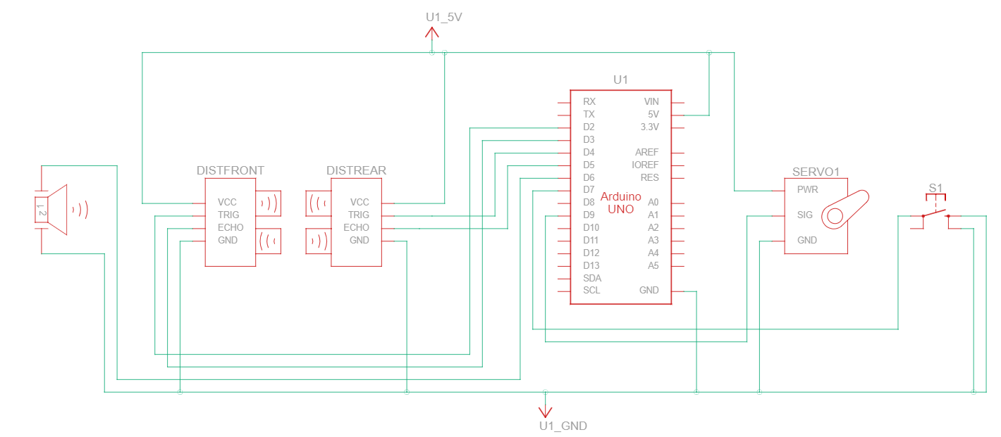
Schematic Diagram:

This innovation operates seamlessly, providing an additional layer of safety by significantly reducing stopping distances and mitigating accident severity.
- (b) Parking Assistant
The code we’ve developed for the Automatic Braking System using ultrasonic sensors, a servo motor, and a buzzer can also be a component of a parking assistant system. It has the capability to detect obstacles and automatically apply the brakes or provide warnings to prevent collisions, which is a key function of a parking assistant.
Our Parking Assistant system integrates an ultrasonic sensor (HC-SR04) to simplify parking in tight spaces. The sensor emits ultrasonic waves, measuring distances to nearby objects, aiding precise parking. When activated, the system actively scans the surroundings. As the vehicle nears obstacles, real-time data is relayed to the Arduino Mega microcontroller, which triggers the buzzer.
Integrating this with a camera (on rear) to display the real time visual feedback of the rear of the car, the rider/driver will have more information and will be able to park seamlessly.
Components Required:
- Automatic Braking System(1(a))
- Buzzer
- Camera
- Display
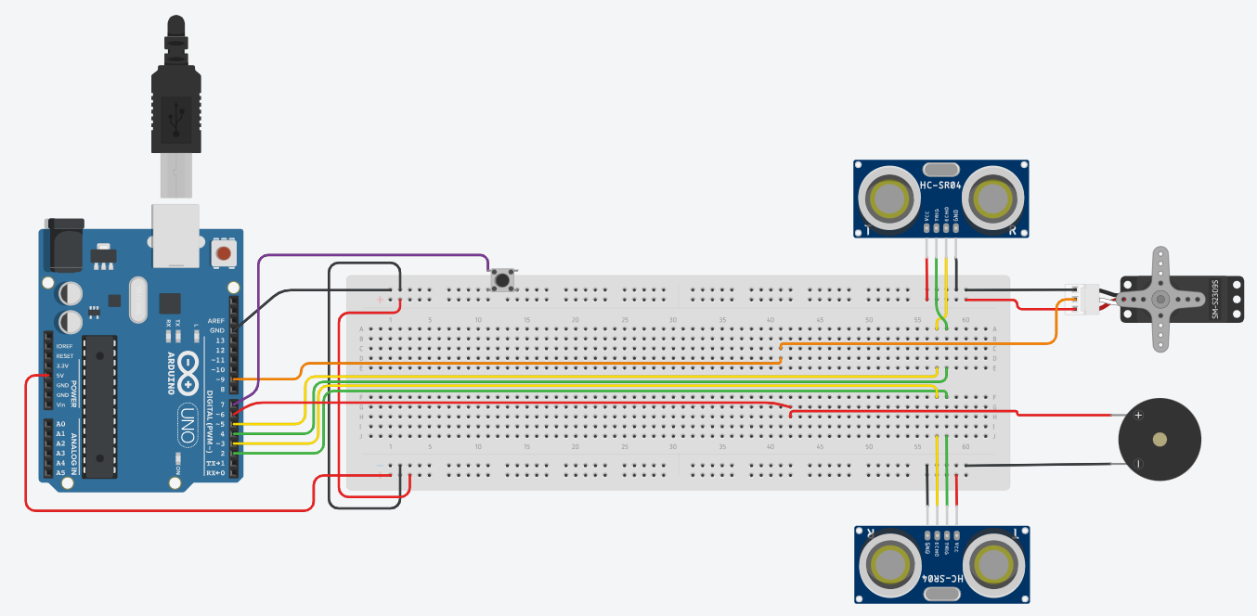
This innovation enhances safety, reducing parking-related accidents and showcasing user-friendly technology, prioritizing safety and ease of use.

- LDR Circuit
In Theory, an LDR circuit in an electric vehicle can be used for ambient light sensing and automatic lighting control, which helps conserve energy, improve safety, and enhance the driving experience by adapting lighting to the surrounding environment. It's a simple yet effective way to incorporate smart and energy-efficient features into our vehicle's design.
The Ambient Light Sensing system uses a Light Dependent Resistor (LDR) / photoresistor circuit to autonomously adjust the vehicle's lighting(such as headlights, dashboard lights, interior lights, fog lights if any etc.) based on ambient light conditions. An LDR, sensitive to light intensity, is integrated with LED lighting. In well-lit environments, the LDR circuit dims LED lights during daytime to conserve energy. Conversely, in low-light conditions or at night, it increases LED brightness to ensure optimal visibility.
Components Required:
- Arduino Uno or any other microcontroller board
- PhotoResistors x2
- 10kΩ Resistor x2
- 230 Ω Resistor x2
- LED and other Lights
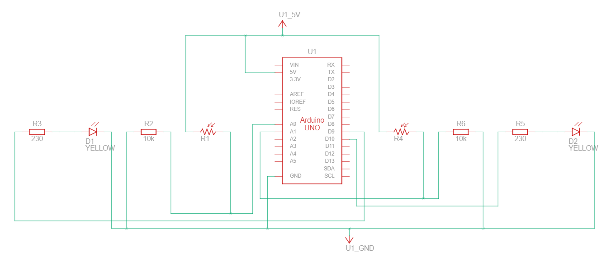
Schematic Diagram:

This innovation enhances energy efficiency and safety, as it conserves energy and ensures adequate lighting as needed.

3) Temperature Measurement of Battery And Motor
Monitoring the temperature of the vehicle's battery is a crucial aspect of ensuring its longevity, performance, and safety. Our Temperature Measurement of Battery system accomplishes this task by employing specialized temperature sensors that continuously and accurately monitor the battery's temperature throughout the vehicle's operation.
We are using two temperature sensors and displaying how hot or cold the battery temperature is, not only that but also if one of the sensors senses a relatively higher temperature than the other, the display will show “Possible Danger” indicating one end of the battery is overheating due to any possible reasons.
The same implementation for more safety is done for motors too.
Components required:
- Temperature Sensor[TMP36] x2
- Arduino Uno or any other microcontroller board
- LCD 16x2 Display
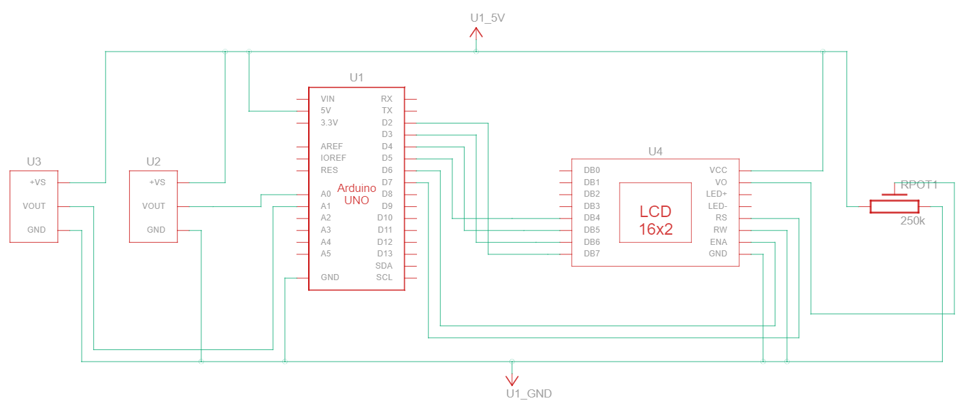
- 250kΩ Potentiometer

By integrating this innovation, we prioritize the health and safety of our solar vehicle's power source, enhancing its overall reliability and efficiency. This ensures that the vehicle can operate optimally and safely, even under varying environmental conditions and during demanding usage scenarios.
6) Topple/Accident Detection
The Topple/Accident Detection system is a critical safety feature designed to proactively detect and respond to potential accidents or rollovers. It relies on a combination of advanced sensors, including accelerometers and gyroscopic sensors, to continuously monitor the vehicle's dynamics and orientation.
When sudden and irregular motions, such as sharp tilting or rapid rolling, are detected, the system rapidly interprets these signals as indicators of a potential accident or rollover event. In response, it initiates a series of safety measures. These may include sending immediate alerts to emergency services, and notifying predefined emergency contacts with the vehicle's precise GPS coordinates; also further possibility is activating airbags.
Components Required:
- MPU6050
- Microcontroller
- Power Supply
- GPS/GSM Module
- Connecting Wires
MPU6050 Pinout Configuration
Pin Number | Pin Name | Description
1 | Vcc | Provides power for the module, can be +3V to +5V. Typically +5V is used
2 | Ground | Connected to Ground of system
3 | Serial Clock (SCL) | Used for providing clock pulse for I2C Communication
4 | Serial Data (SDA) | Used for transferring Data through I2C communication
5 | Auxiliary Serial Data (XDA) | Can be used to interface other I2C modules with MPU6050. It is optional
6 | Auxiliary Serial Clock (XCL) | Can be used to interface other I2C modules with MPU6050. It is optional
7 | AD0 | If more than one MPU6050 is used a single MCU, then this pin can be used to vary the address
8 | Interrupt (INT) | Interrupt pin to indicate that data is available for MCU to read.

MPU6050 Features:
- MEMS 3-axis accelerometer and 3-axis gyroscope
- I2C Protocol
- Built-in 16-bit ADC and DMP for high accuracy and computational Power
- Can be used to interface with IIC devices like magnetometer
- Built-in Temperature Sensor
- Power Supply: 3-5V
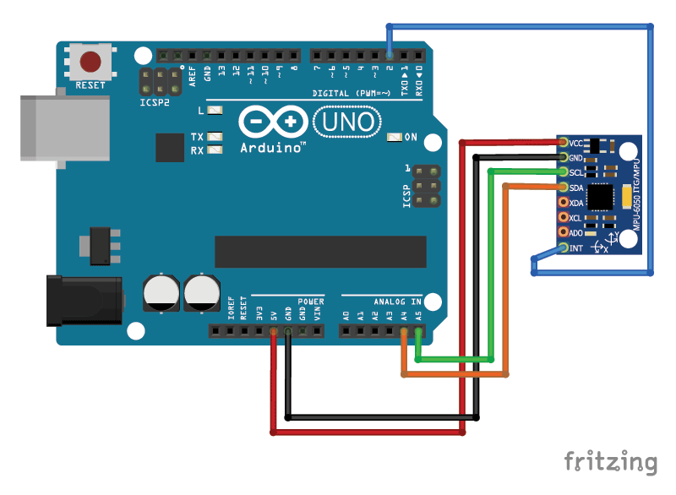
Circuit Diagram:

This innovative safety system not only significantly reduces the severity of accidents but also showcases our unwavering commitment to prioritizing the safety of both the vehicle and its occupants. It is a testament to our dedication to leveraging cutting-edge technology to enhance road safety.
8) Speedometer
Our Speedometer innovation introduces an accurate and reliable method of measuring the vehicle's speed. This system employs a Hall sensor strategically attached to the motor controller. The Hall sensor is designed to detect the rotational speed of the motor's rotor with precision.
As the motor operates, the Hall sensor continuously monitors the rotor's rotations and calculates the vehicle's speed in real-time. This data is then seamlessly displayed on the vehicle's dashboard, offering the driver a clear and accurate reading of their current speed.
By implementing this innovation, we prioritize driving safety and provide drivers with a vital tool for maintaining appropriate speeds on various terrains. This precise speedometer enhances the overall driving experience, ensuring that the vehicle operates safely and efficiently, particularly when adhering to speed limits is crucial for road safety.
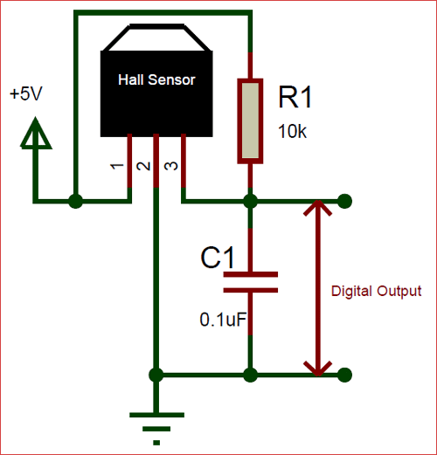
Pin Diagram:

By implementing this innovation, we prioritize driving safety and provide drivers with a vital tool for maintaining appropriate speeds on various terrains. This precise speedometer enhances the overall driving experience, ensuring that the vehicle operates safely and efficiently, particularly when adhering to speed limits is crucial for road safety.
9) Smoke Detection
Our Smoke Detection system represents a critical safety feature within the solar vehicle, prioritizing the well-being of passengers and the integrity of the vehicle itself. This innovative safety system utilizes specialized smoke sensors strategically placed within the vehicle's cabin.
The green LED glows indicating that the smoke detection system is turned on. Whenever a smoke is detected, red LED glows and in any case if the led is ignored by the rider the buzzer also buzzes. The 2 different gas detectors at 2 different positions, one inside the car and other near the battery continuously monitors and notifies.
Components Required:
- Arduino
- LED [Red and Green]
- Buzzer x2
- Gas Sensor x2
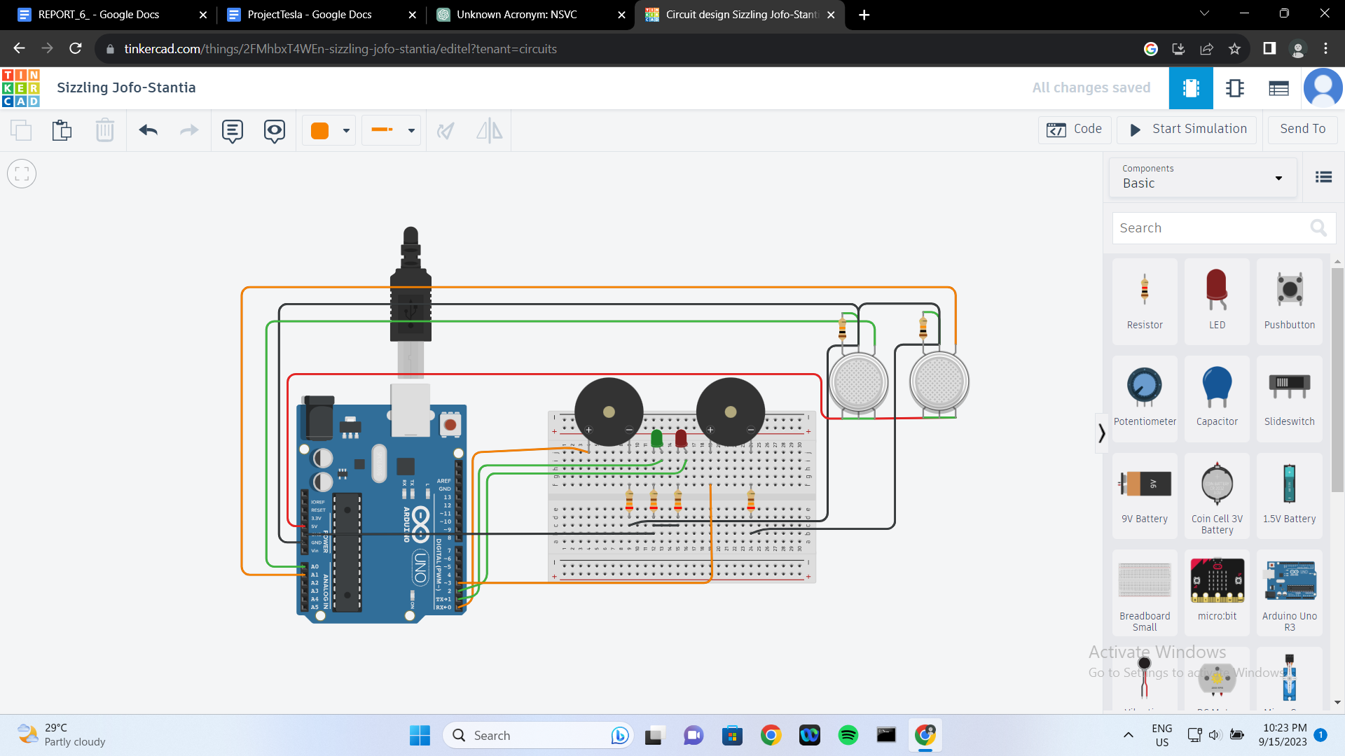
- Resistors [230Ω x4 and 10kΩ x2]

Made on Tinkercad
By integrating this innovation, we underscore our unwavering commitment to passenger safety and vehicle protection. It ensures that potential fire hazards or smoke-related incidents are detected and addressed promptly, reducing the risks associated with such emergencies. This feature exemplifies our dedication to leveraging advanced technology for the safety and well-being of all vehicle occupants.

CONCLUSION

In today's rapidly evolving automotive landscape, the integration of advanced technologies plays a pivotal role in enhancing road safety. The Accident Detection and Response System presented in this report represents a significant step forward in leveraging these technologies to proactively respond to potential accidents and prioritize the safety of vehicle occupants.]

Our vehicle embodies a harmonious blend of cutting-edge innovations designed to redefine the driving experience. From guiding drivers with precision through parking assistance and optimizing visibility using Light-Dependent Resistor (LDR) technology to ensuring safety through Automatic Braking, hands-free Phone Call and SMS functionality, and real-time GPS-based vehicle tracking, we've left no stone unturned.
In emergencies, our system springs into action, alerting authorities and contacts through the Emergency Accident Service. Battery health is a paramount concern, monitored through Battery Temperature Measurement and real-time Battery State of Charge Indication. The accurate Speedometer and Cruise Control enhance long journeys, while our Smoke Detection system adds a crucial layer of safety.
These innovations seamlessly converge on the vehicle's dashboard, providing drivers with critical information. Our mobile app extends this accessibility remotely, ensuring convenience and peace of mind. This holistic approach sets the stage for a safer, smarter, and more connected future of driving.

