In this paper, an initial velocity prediction strategy in electromagnetic launch technology is proposed applying RBF neural network, a kind of machine learning technology. Firstly, an RBF neural network model is built including an input layer, a hidden layer, and an output layer. Then it is trained with the preprocessed data set ~~obtained in a simulation system, the accuracy of which has been verified experimentally [7]. The data set~~ includes four features armature mass, acceleration distance, current time integration and initial velocity of armature. By setting the target variables as initial velocity we trained a model predicting this variable. ~~Testing the models with 3 different test data sets the maximum error predicting velocity is 1.12%~~ When the number of training samples reaches 400, the average prediction error on the test set reaches a minimum of 18.3 m/s and the prediction costs time less than 1 seconds, which shows this prediction method has high accuracy and efficiency. As it is based on a machine learning framework, which is easy to apply, flexible to expand and has a fast prediction speed, it has an undoubtable great advantage over the traditional numerical calculation with long calculation time and complicated structure.

本文提出了一种基于径向基函数算法的初始速度预测策略用于电磁发射技术中，将RBF神经网络，一种机器学习技术，应用于电磁发射中。首先建立基于径向基函数神经网络，包括输入层，隐藏层和输出层。然后使用经过预处理的~~通过仿真得到的数据集对其进行训练，仿真系统的准确性经过实验验证。~~数据集包含4个特征电枢质量，加速距离，当前时间积分和电枢的初始速度。通过将目标变量设置为初始速度，我们训练了得到了预测初速度的最优模型。~~使用3种不同的测试数据集对模型进行测试，最大误差预测速度和电流为1.12％且预测耗时小于1秒，~~这表明这种预测方法具有较高的准确性。由于它是基于机器学习框架，易于应用，扩展灵活，预测速度快，与传统的数值计算的计算时间长、结构复杂相比毫无疑问具有巨大优势。

**电磁发射技术中基于径向基函数的初速度预测**

Initial Velocity Prediction based on Radial Basis Function (RBF) in Electromagnetic Launch Technology

## Introduction

电磁发射~~是一个毫秒的过程。磁场扩散，热传导，结构变形和材料磨损耦合在这个高速发射过程和这些参数都是非线性变化。因此，电枢的初始速度无法实现实时反馈和控制。脉冲电源网络由多个并联的脉冲电源模块组成，被广泛用作电磁发射的主要能量源[4]。功率模块电气参数是在同一实验环境下确定的，而~~可以通过调节每个模块的放电时间改变直接影响初始速度的电流波形。通过电流精确控制初速度，是电磁发射相对于传统发射方法的优势。因此，找到 通过发射条件预测初速度，是绝对有意义的，因为这是精确控制速度的基础。

Electromagnetic emission is a millisecond process. ~~Magnetic field diffusion, thermal conduction, structural deformation, and material wear coupled during this high-speed launch process and these parameters are all nonlinear changes.~~ The real-time feedback and control cannot be realized for the initial velocity of the armature. While the pulse power supply network consists of a plurality of pulse power supply modules in parallel, ~~which is widely used as the main energy source of electromagnetic launch~~ [4]. ~~The power modules’ electrical parameters are determined under the same experimental environment~~ the discharge timing of each module can be adjusted to change the current waveform which directly affects the initial velocity. Therefore, precise speed control through current is the advantage of electromagnetic launch over the traditional emission method. It is absolutely meaningful to find a method to predict the initial velocity, as it is the basics of precise speed control.

初始速度可以通过~~数值程序求解耦合变量和非线性微分方程来~~模拟发射过程来计算。[5]中，建立了轨道炮系统的瞬态电路模型并使用Micro-Cap VI（一种电路分析软件包）仿真了轨道炮的瞬态表现。在[1]和[6]中，研究人员提高了轨道电感和轨道上力的分布的计算精度。然而，在所有上述方法中，工作条件和计算有不同程度的简化。在这些模拟中，它往往是单向耦合而不是双向耦合~~，忽略了一些问题，如轨道上的相位变化。尽管这些仿真平台可以准确地解决发射过程，但也存在很多限制。例如，所有电源模块需要预先建立，所有系统参数需要手动设置，必须事先估计上限，~~并且如果考虑更多因素或计算双向耦合，仿真时间可能是不可接受的几小时。

The initial velocity can be calculated by simulation of the launch process ~~with numerical procedure solving the coupled variables and the nonlinear differential equations~~. In [5], a transient electric circuit model for a railgun system was developed and the railgun transient performance was simulated using Micro-Cap VI, an electrical circuit analysis software package. In [1] and [6] researchers improved the calculation accuracy of the rails’ inductance and the force distribution upon the rails. However, there are different degrees of simplification of working conditions and calculations in all above methods. It is often one-way coupling rather than two-way coupling that is used in these simulations. ~~ignoring some problems like the phase changing upon the rails. Although these simulation platforms can accurately solve the launch process, there are also many limitations. For example, all power supply modules need to be pre-built, all system parameters need to be manually set, the upper limit must be estimated in advance,~~ And the simulation duration could be hours if more factors are considered or a two-way coupling is calculated.

本文将机器学习技术应用于EML的初始速度预测中，提出了一种基于径向基函数（RBF）神经网络算法的新的预测策略。建立了基于径向基函数神经网络，并用经过预处理的仿真得到的数据进行训练，仿真系统的准确性经过实验验证[7]。~~增加参数和训练样本的数量可以提高模型的准确性，因此在进一步的研究中可以提高该方法的准确性。~~该方法基于机器学习框架易于应用和扩展。一旦模型完成了训练，每个初始速度预测就可以在常数时间内完成，考虑到数值模拟的复杂性，该方法无疑具有优势。

In this paper, applying the machine learning technique to the initial velocity prediction of EML, a new prediction strategy based on ~~Radial Basis Function (~~RBF neural network is presented. A neural network based on RBF is built, and then it is trained with the preprocessed data obtained in a simulation system, the accuracy of which has been verified experimentally [7]. ~~Increasing the number of parameters and training samples can improve the accuracy of the model, therefore the accuracy of the method could be improved much in further research.~~ The method is easy to apply and expand based on the machine learning framework. Once the model has completed training, each initial velocity prediction can be completed in constant time, which has undoubted advantages considering about the complexity of numerical simulation.

## RBF Neural Network Building and Training

1. **~~Algorithm Introduction~~**

径向基函数是一种传统的多维空间插值技术，由Powell于1985年提出.RBF神经网络属于BP神经网络的类型。网络结构类似于多层前向网络，是一个三层前向网络[8]。一般的BP神经网络在函数逼近中花费更多的训练时间，容易陷入局部最小值，并且获得的网络表现不佳。而RBF神经网络具有良好的函数逼近能力，结构简单，学习速度更快。

The Radial Basis Function is a traditional technique for multidimensional spatial interpolation, proposed by Powell in 1985. The RBF neural network belongs to the type of BP neural network. The network structure is similar to the multilayer forward network and is a three-layer forward network [8]. General BP neural network costs more training time in the function approximation, easily falls into a local minimum and the obtained network performed poorly. While the RBF neural network has a good function approximation capability, simple structure and more fast learning speed.

1. **The structure and parameters of the RBF Neural Network**

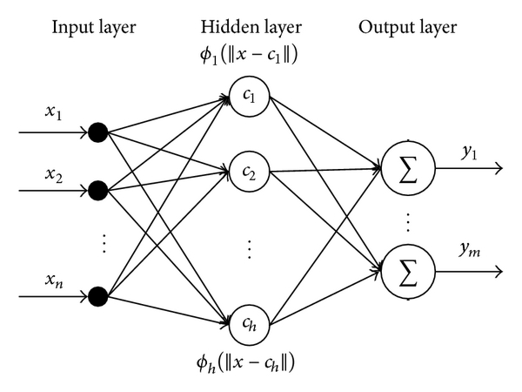

Fig. 3. The structure of the RBF neural network

RBF 神经网络模型结构如图3。第一层是输入层。输入矢量x用作所有径向基函数的输入。第二层是具有非线性RBF激活函数的隐藏层，且径向基函数通常使用高斯函数。每个RBF单元的输出如下[9-10]：

The structure of the RBF neural network is shown in Fig.3. The first layer is the input layer. An input vector x is used as input to all radial basis functions. The second layer is the hidden layer with a non-linear RBF activation function, and the function is commonly taken to be Gaussian. The output of each RBF unit is as follows [9-10]:



是输入向量是第i个高斯函数中心，可以使用k均值聚类算法来确定[11]，为欧式范数， 为隐藏层的个数，是RBF单元的宽度

 is the input vector, is the center of the ith Gaussian function and can be determined by k means clustering algorithm[11].  indicates the Euclidean norm on the input space,  is the spread of ith RBF unit,  is the number of the neurons in the hidden layer.

网络的输出是输入向量的标量函数,

The output of the network is then a scalar function of the input vector



p表示第p个样本，j表示输出层中的第j个神经元，ypj是第p个样本第j个输出神经元的输出，wij是第i个隐藏层神经元到第j个输出的权重或强度，w0j是第j个输出的偏置。为了减少网络的复杂性，在以下分析中不考虑偏置。

 indicates the pth sample,  indicates the jth neuron in the output layer,  is the output of the pth sample and the jth output neuron,  is the weight or strength of the ith neuron in hidden layer to the jth output ,  is the bias of the jth output. In order to reduce the network complexity, the bias is not considered in the following analysis.

输出值的目标函数期望Ep：

The expectation target function of the output value :



其中表示相对于第 k 个输入向量的理想输出，表示相对于第 k个输入向量的实际输出；权值修正公式为：

where  and  represent the kth actual output and the target output, respectively. The weight adjusting equation is





其中为学习率，通过对网络权值的不断循环修正计算出最优的权值。

where  is the learning rate ; Through continuously adjusting the optimal weights are finally calculated.

1. **Data preprocessing and Model Training**

我们已经通过一个仿真系统获得了包括质量、加速距离、电流和初速度的数据集。为了使模型有较好的训练效果，在使用这些数据训练模型之前需要进行预处理。对数据集中的每一个特征进行如下转换：

We’ve got the data set including the mass of the armature , the acceleration distance ， the current time integration  and the initial velocity  through a simulation system, the accuracy of which has been verified experimentally [7]. In order to training the network efficiently, data preprocessing is necessary. Normalize each feature in the dataset as follows:



对于特征，是转换后的数据，是原始数据，和分别是该特征数据的均值和标准差。

~~预测模型的参数配置如表1。将表中数据集分割为含有400个样本的训练集和3个含有20个样本的测试集，测试集用于测试训练得到的最优模型。~~将作为作为输入特征向量，预测目标是初速度 ，神经网络输入400*3的矩阵， 400*1的目标矩阵，得到预测初速度的模型；

For the ith feature,  is the converted data,  is the original data;  and  are the average and standard deviation of the feature data, respectively. ~~The parameter configuration of the prediction model is shown in Table 1. Split the data set into a training set with 400 samples and 3 testing sets with 20 samples. And the testing sets are used to test the performance of trained optimal model.~~

We takeas input feature vector  and the initial velocity  as target variable. ~~Then~~ the input of RBF neural network is a 400*3 matrix and the output is a 400*1 matrix and a model predicting initial velocity is obtained.

Table Ⅰ

FEATURES OF INPUT AND OUTPUT OF PREDICTION MODEL

|  |  |  |  |  |
| --- | --- | --- | --- | --- |
| Sample number | Features | | | Target |
| mass of the armature (g) | acceleration distance (m) | current time integration (kA·ms) | initial velocity (m/s) |
| 1 | 9.64 | 2.47 | 209.58 | 2303.60 |
| 2 | 8.11 | 2.17 | 162.43 | 2996.28 |
| 3 | 12.54 | 2.42 | 221.11 | 3220.46 |
| … |  |  |  |  |
| 460 | 11.20 | 2.24 | 232.64 | 1744.46 |

## Results

在测试集上的预测误差随训练样本数量的变化如图4，测试集~~是从表1中分离出来的3个测试集之一，~~包含20个样本，未包含在训练集中。本研究中平均误差为误差绝对值的平均值，因此都是正数。阴影部分为预测误差的标准差。训练样本较少时标准差极大，为便于显示图中使用了真实标准差的0.1倍。~~真实的平均误差绝对值和标准差如表3.~~

The relationship between prediction error on the test set and the number of training samples is shown in Fig. 4. The test set ~~is one of the 3 test sets split from table 1 and~~ contains 20 samples which are not included in the training data. In this study, the average error is the average of the absolute value of the error, so it is a positive number. The shaded part reflects the standard deviation of the prediction error. When the training sample is small, the standard deviation is extremely large, and 0.1 times the actual standard deviation is used for the convenience of displaying the map. ~~The specific actual average absolute error and standard deviation are shown in Table 3.~~

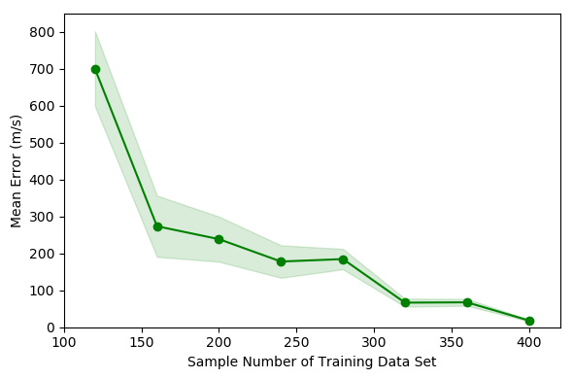

Fig.4 Error changing of model 1 with different number of training data

Table Ⅲ

Error changing of model 1

|  |  |  |
| --- | --- | --- |
| Training Data | Mean Error | Standard Error |
| 40 | 406.06 | 501.13 |
| 80 | 468.69 | 550.99 |
| 120 | 699.26 | 1012.86 |
| 160 | 273.31 | 828.12 |
| 200 | 238.35 | 610.42 |
| 240 | 177.78 | 439.56 |
| 280 | 184.4 | 276.13 |
| 320 | 66.51 | 108.12 |
| 360 | 67.41 | 92.09 |
| 400 | 18.3 | 25.76 |

~~可以看出随着训练样本数量增多，预测误差逐渐减小。~~训练样本数量达到400时在测试集上的平均预测误差达到最小为18.3m/s, 标准差为25.76m/s。因此选择样本数量400训练后的模型为最优模型，该模型有160个隐藏层神经元，Spread of radial basis functions is 0.93。~~图5是该模型在3个不同的测试集上的表现，具体的平均绝对误差、平均绝对误差百分数和标准差见表5. 平均绝对误差百分数的表达式如下，At是目标值Pt是模型输出的预测值~~

Fig.4 shows that ~~as the number of training samples increases, the prediction error gradually decreases.~~ When the number of training samples reaches 400, the average prediction error on the test set reaches a minimum of 18.3 m/s, and the standard deviation is 25.76 m/s. Therefore, the model trained with 400 samples is the optimal prediction model which has 160 hidden layer neurons and the spread of radial basis functions is 0.93. ~~Figure 5 shows the performance on 3 different test sets. The specific average absolute error, average absolute error percentage, and standard deviation are shown in Table 5. The expression of the Mean absolute percentage error~~  is as follows.  is the target value and  is the predicted value.



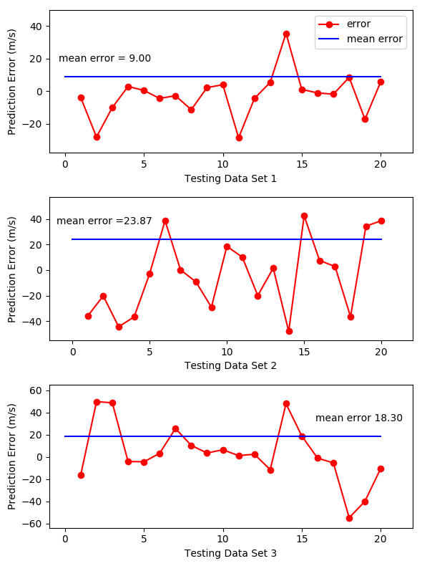

Fig.5 Prediction error on 3 testing data sets

Table Ⅴ

Prediction error of model 1 on 3 testing data sets

|  |  |  |  |  |  |
| --- | --- | --- | --- | --- | --- |
| Target Variable | Hyperparameter | Testing Data Set | MAPE（%） | Mean Error | Standard Error |
| Initial Velocity | Centers = 160  Spread = 0.93 | 1 | 0.35 | 9.00 | 13.27 |
| 2 | 1.12 | 23.87 | 28.33 |
| 3 | 0.75 | 18.30 | 25.76 |

模型的训练耗时为6.3秒。完成测试集20个样本的预测耗时0.3秒，表明使用rbf 神经网络模型用于电磁发射系统初速度与电流的预测是十分准确且高效的。

Training model takes 3.6 seconds and the prediction of the 20 samples of the test set takes 0.3 seconds. The testing result indicats that applying the rbf neural network for the prediction of the initial velocity in the EML system is very accurate and efficient.

## ~~Conclusion and Discussion~~

本研究使用rbf neural network通过电枢质量m，加速距离s，电流时间积分值预测电磁发射中电枢的初速度，测试中最大平均误差为23.87m/s（1.12%），同时该方法仅使用了400组样本数据进行训练，意味着使用真实的实验数据用作训练集是可行的。

虽然电磁发射的速度预测可以通过仿真模拟发射过程来获得，但需要耦合多个物理场。每个影响因素的精确模型和系统结构的精细网格是实现更高精度所必需的。这些都意味着冗长的代码和长达几小时的计算时间，因此一旦训练出可用的模型，该方法预测初速度要比一个复杂的仿真系统准确、高效。

In this study, we trained an RBF neural network to predict the initial velocity of the armature in EML technology through the armature mass, acceleration distance, and the current time integration. The maximum average error in the test is 23.87 m/s (1.12%). At the same time, this method only uses 400 samples for training, which means that it is feasible to obtain a training set from experiments.

Although the EML velocity can be predicted by simulating the launch process, it needs to couple multiple physical fields. Accurate model of each influencing factor and fine meshing of the system structure to achieve higher accuracy, which means lengthy code and hours of computing time. Therefore, once the available RBF neural network models are trained, they are more accurate, efficient, and generally applicable to predicting the initial velocity than a complicated simulation system.

[1]BAYATI M S, KESHTKAR A, KHOSRAVI F等. Analyzing the electromagnetic launcher with combination both FEM-3D and IEM methods in time domain[C]//2012 16th International Symposium on Electromagnetic Launch Technology. 2012: 1–7. [3]

[2] J. S. Bernardes, M. F. Stumborg, and T. E. Jean, “Analysis of a capacitor-based pulsed-power system for driving long-range electromagnetic guns,” IEEE Trans. Magn., vol. 39, no. 1, pp. 486–490, Jan. 2003.

[3] J. D. Wang, “Development and application in military of electromagnetic emission technology,” in Proc. Fire Command Control. 2001, p. 1.

[4] H. D. Fair, “Electric launch science and technology in the United States,” IEEE Trans. Magn., vol. 39, no. 1, pp. 11–17, Jan. 2003. [1]

[5] J. S. Bernardes, M. F. Stumborg, and T. E. Jean, “Analysis of a capacitor-based pulsed-power system for driving long-range electromagnetic guns,” IEEE Trans. Magn., vol. 39, no. 1, pp. 486–490, Jan. 2003. [2]

[6] GHASSEMI M, BARSI Y M, HAMEDI M H. Analysis of Force Distribution Acting Upon the Rails and the Armature and Prediction of Velocity With Time in an Electromagnetic Launcher With New Method[J]. IEEE Transactions on Magnetics, 2007, 43(1): 132–136. [4]

[7] Yuan Ruimin．Study on Trigger Strategy of Pulse High Current Timing Discharge [D]．Institute of Electrical Engineering, Chinese Academy of Sciences．2017．[5]

[8] POWELL M J D. Radial Basis Function Methods for Interpolation to Functions of Many Variables[M]. 2001.

[9] WANG Z, YANG B, KANG Y等. Development of a Prediction Model Based on RBF Neural Network for Sheet Metal Fixture Locating Layout Design and Optimization[J]. Computational Intelligence and Neuroscience, 2016, 2016: 1–6. [6]

[10] ER M J, WU S, LU J等. Face recognition with radial basis function (RBF) neural networks[J]. IEEE Transactions on Neural Networks, 2002, 13(3): 697–710. [7]

[11] LIKAS A, VLASSIS N, J. VERBEEK J. The global k-means clustering algorithm[J]. Biometrics, 2003, 36(2): 451–461. [8]