电磁发射的初速度的预测可以通过仿真模拟一次发射实验来获得。例如通过仿真软件或编写程序进行仿真。使用仿真软件需要耦合多个物理场，电磁场、温度场、力场；编写程序则需要准确的模拟电源模块的放电、电枢的运动过程以及关键部位的温度变化。想提高预测的准确度和精确度就需要对各影响因素建立准确的数学模型进行描述，建立精细的物理模型和剖分网格进行数值计算，这意味着复杂的建模过程和冗长的代码，并且不同的供电设备、不同结构的发射装置、不同结构的电枢都需要不同的模型和代码。

本文提出一种基于径向基函数（Radial Basis Function ，RBF）神经网络算法的电磁发射速度预测策略，将机器学习技术应用于电磁发射的速度预测。具体实现过程如下：首先建立一个基于RBF神经网络算法的机器学习模型，然后用经过预处理的实验测量数据对此模型进行训练[20]，特征参数包括电枢质量m，填充距离s，电流波形的上升时间t，电流最大值I，目标参数为初速度V，样本数据集（分为训练集和测试集）为通过仿真实验得到的430组数据，训练后的学习模型能够找出速度与电流波形（电流上升沿及电流最大值）的关系，最终实现系统输入电流波形，预测发射速度。训练中使用机器学习中的网格搜索法和交叉验证法确定模型的最优参数。最终的测试结果表明，该方法能准确预测发射速度，误差不超过1%。通过增加特征参数该模型的精确度具有极大的提高潜力，且该方法基于机器学习框架易应用、易扩展，相比通过数值计算预测速度的复杂性有很大优势。

[1]BAYATI M S, KESHTKAR A, KHOSRAVI F等. Analyzing the electromagnetic launcher with combination both FEM-3D and IEM methods in time domain[C]//2012 16th International Symposium on Electromagnetic Launch Technology. 2012: 1–7.

[2] J. S. Bernardes, M. F. Stumborg, and T. E. Jean, “Analysis of a capacitor-based pulsed-power system for driving long-range electromagnetic guns,” IEEE Trans. Magn., vol. 39, no. 1, pp. 486–490, Jan. 2003.

[3] J. D. Wang, “Development and application in military of electromagnetic emission technology,” in Proc. Fire Command Control. 2001, p. 1.

[4] H. D. Fair, “Electric launch science and technology in the United States,” IEEE Trans. Magn., vol. 39, no. 1, pp. 11–17, Jan. 2003.

[5] J. S. Bernardes, M. F. Stumborg, and T. E. Jean, “Analysis of a capacitor-based pulsed-power system for driving long-range electromagnetic guns,” IEEE Trans. Magn., vol. 39, no. 1, pp. 486–490, Jan. 2003.

[6] GHASSEMI M, BARSI Y M, HAMEDI M H. Analysis of Force Distribution Acting Upon the Rails and the Armature and Prediction of Velocity With Time in an Electromagnetic Launcher With New Method[J]. IEEE Transactions on Magnetics, 2007, 43(1): 132–136.

[112] POWELL M J D. Radial Basis Function Methods for Interpolation to Functions of Many Variables[M]. 2001.

[14] ER M J, WU S, LU J等. Face recognition with radial basis function (RBF) neural networks[J]. IEEE Transactions on Neural Networks, 2002, 13(3): 697–710.

[15] The global k-means clustering algorithm

[16] Ma J, Zhang D D, Yuan W Q, et al. A method of generating timing for a given target current waveform in electromagnetic launch technology [J].IEEE Transactions on Plasma Science. 10.1109/TPS.2017.2706219.

[17] DIETTERICH T. Overfitting and Undercomputing in Machine Learning[J]. ACM Comput. Surv., 1995, 27(3): 326–327.

Initial Velocity Prediction based on Radial Basis Function (RBF) Neural Network in electromagnetic launch technology

## Introduction

电磁发射技术是一项先进的驱动技术。通过导轨传递电流并通过电枢闭合电流路径会产生磁场，导致施加在电枢上沿轨道方向的力[1]。它在科学实验，武器，导弹防御系统，发射火箭和卫星以及航空弹射器等领域有着广泛的应用前景。

Electromagnetic launch technology is an advanced drive technology. Passing current through the rails and closing the current-path by the armature, generate the magnetic field. This field causes the applied force on armature and moves it in rails line.[1] It has broad application prospects in many fields like science experiments, weapons, missile defense systems, launch rockets and satellites, and aviation catapult. [2][3]

电磁发射是一个毫秒的过程。磁场扩散，热传导，结构变形和材料磨损耦合在这个高速发射过程和这些参数都是非线性变化。因此，电枢的初始速度无法实现实时反馈和控制。脉冲电源网络由多个并联的脉冲电源模块组成，被广泛用作电磁发射的主要能量源[4]。功率模块电气参数是在同一实验环境下确定的，而可以通过调节每个模块的放电时间改变直接影响初始速度的电流波形。通过电流精确控制初速度，是电磁发射相对于传统发射方法的优势。因此，找到通过发射条件预测初速度、以及想达到某初速度所需要的电流的方法[16]，是绝对有意义的，因为这些是精确控制速度的基础。

Electromagnetic emission is a millisecond process. Magnetic field diffusion, thermal conduction, structural deformation, and material wear coupled during this high-speed launch process and these parameters are all nonlinear changes. Therefore the real-time feedback and control cannot be realized for the initial velocity of the armature. The pulse power supply network consists of a plurality of pulse power supply modules in parallel, which is widely used as the main energy source of electromagnetic launch.[4] The power module electrical parameters are determined under the same experimental environment while the discharge timing of each module can be adjusted to change the current waveform which directly affects the initial velocity. Precise speed control through current is the advantage of electromagnetic launch over the traditional emission method. Then it is absolutely meaningful to find a method to predict the initial velocity and the current needed for reaching a certain initial velocity, as these are the basics of Precise speed control.

初始速度可以通过数值程序求解耦合变量和非线性微分方程来模拟发射过程来计算。

[5]中，使用Micro-Cap VI（一种电路分析软件包）模拟轨道导弹系统和轨道导弹瞬态性能的瞬态电路模型，在[1]和[6]中，研究人员提高了轨道电感的计算精度和轨道上的力分布。然而，在所有上述方法中，工作条件和计算有不同程度的简化。在这些模拟中，它往往是单向耦合而不是双向耦合，忽略了一些问题，如轨道上的相位变化。尽管这些仿真平台可以准确地解决发射过程，但也存在很多限制。例如，所有PFU需要预先建立，所有系统参数需要手动设置，必须事先估计上限，并且如果考虑更多因素或计算双向耦合，则不可接受的模拟持续时间可能是几小时。

本文将机器学习技术应用于EML的初始速度预测中，提出了一种基于径向基函数（RBF）神经网络算法的新的预测策略。建立了基于径向基函数的机器学习模型，并对模拟得到的预处理数据进行训练，实验验证了其准确性。增加参数和训练样本的数量可以提高模型的准确性，因此在进一步的研究中可以提高该方法的准确性。该方法基于机器学习框架易于应用和扩展。一旦模型完成了训练，每个初始速度预测就可以瞬间完成，考虑到数值模拟的复杂性，这无疑具有优势。

The initial velocity can be calculated by simulation of the launch process with numerical procedure solving the coupled variables and the nonlinear differential equations. In [5], a transient electric circuit model for a railgun system and railgun transient performance was simulated using Micro-Cap VI, an electrical circuit analysis software package. In [1] and [6] researchers improved the calculation accuracy of the rails’ inductance and the force distribution upon the rails. However, there are different degrees of simplification of working conditions and calculations in all above methods. It is often one-way coupling rather than two-way coupling in these simulations ignoring some problems like the phase changing upon the rails. Although these simulation platforms can accurately solve the launch process, there are also many limitations. For example, all PFUs need to be pre-built, all system parameters need to be manually set, the upper limit must be estimated in advance, and the unacceptable simulation duration which could be hours if more factors are considered or bidirectional coupling is calculated.

In this paper, applying the machine learning technique to the initial velocity prediction of EML, a new prediction strategy based on Radial Basis Function (RBF) neural network algorithm is presented. A machine learning model based on RBF is built, and then it is trained with the preprocessed data obtained in simulation the accuracy of which has been verified experimentally. Increasing the number of parameters and training samples can improve the accuracy of the model, therefore the accuracy of the method could be improved much in further research. The method is easy to apply and expand based on the machine learning framework. Once the model has completed training, each initial velocity prediction can be completed in an instant, which has undoubted advantages considering about the complexity of numerical simulation.

## Obtain Data Set

***i***

***B***

***F***

**Pulse Power**

**Supply Network**

system diagram of electromagnetic launch

为了便于获取训练数据，建立了图1所示的电磁发射系统的电路模型。输入不同的发射条件并计算初始速度。电枢的初始速度实际上是到达身管末端时的速度。基于电磁轨道发射系统的工作原理和组成部分，在电源和发射器两个方面建立了整个系统的电路模型。几个主要假设包括晶闸管和硅堆栈的压降在导通电流时大约为零，并且在发射期间导轨电感梯度不变。使用离散时间步长和电源解耦的思想用MATLAB解决电路问题。针对多模块解耦处理的相互作用，各模块放电的放电过程被认为是独立的，它们包含一阶和二阶放电过程。脉冲电源网络包括许多脉冲形成单元（PFU），其中一个如图2所示。

其中C是储能电容器，TH是普通晶闸管，D是续流硅堆栈，L是PFU的电感值和电缆电感的总和，R是电抗器电阻，电缆和一个PFU中的引线电阻;

In order to easily obtain training data, a circuit model of an electromagnetic launch system showed in Fig.1 was established. Input different launch conditions and the initial velocity was calculated. The initial velocity of the armature is actually the velocity when it reaches the end of the barrel. Based on the working principle and components of the electromagnetic rail launching system, the circuit model of the whole system is established based on the two aspects of power supply and launcher. Several primary assumptions include that the pressure drop of thyristor and silicon stack is approximately zero when they conduct current and the rail inductance gradient is constant during the launch. The idea of discrete time step and power supply decoupling is used to solve the circuit with the MATLAB. [31清华] For the interaction of multiple modules decoupling processing, the discharge process of each module discharges is considered as independent, and they contain first-order and second-order discharge processes. The pulse power supply network includes many pulse forming units (PFU) one of which showed in Fig.2. Where C is the energy storage capacitor, TH is an ordinary thyristor, D is a freewheeling silicon stack, L is the sum of the inductance value of the PFU and the cable inductance, and R is the sum of the reactor resistance，the cable and the lead resistance in one PFU;

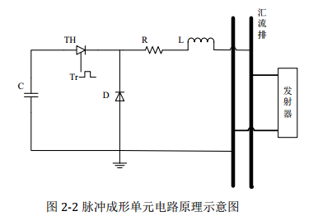

Fig. 2. Circuit schematic of Pulse Forming Unit

The relationship expression is

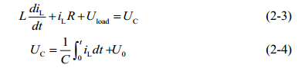

When the capacitor stops discharging, its model expression is



iL 为 PFU 中流过电感形成脉冲的电流， UC 为电容两端电压，U0 为电容器初始充电电压, Uload 为电源侧汇流排两端电压（或称负载电压）。

iL Current flowing through an inductor to form a pulse in one PFU，; UC voltage of the capacitor, U0 Capacitors’ initial charge voltage; Uload voltage of the track



I current into the track from all the PFU；ik （k= 1,2, , n）current value of the kth PFU

In the circuit model, the influence of the velocity skin effect [47][48], the contact resistance[46] and the friction between the armature and rail[44-45] are taken into account.

发射器也就是负载端的负载电压和运动控制方程分别为：

The governing motion equations and load voltage at the launcher side are:











Rsum是回路中轨道电阻、电枢电阻、枢轨间的接触电阻、速度趋肤效应产生的电阻和电缆电阻之和；Lr Lcable分别为轨道和电缆的电感；a v s分别为电枢在t时刻的加速度、速度和位移；

从电路模型中可以看出影响电枢初速度的主要变量包括质量、加速距离和电流。通过该仿真得到的电流数据是发射过程中的电流波形，而训练时要求数据集中每一个特征参数是一维的，因此使用电流对时间的积分值（也就是波形对时间横轴所围的面积）作为电流特征参数。在MATLAB中用此模型模拟发射过程，随机给出不同的质量、加速距离和电流计算得到初速度。以获得训练RBF神经网络所需的数据集。

Rsum is the sum of the rails resistance, the armature resistance, the contact resistance between the rail and armature, the cable the resistance and the resistance caused by the velocity skin effect. Lr and Lcable are the inductances of the rails and cables respectively; a, v and s are the acceleration, velocity and displacement of the armature at time t.

This circuit model of the electromagnetic launch system shows that the main variables affecting the armature’s initial velocity include the mass of the armature, the acceleration distance and the current waveform. The current data obtained through the simulation is the current waveform during the launch process. While each feature parameter in the data set is required to be one dimension.Therefore, we select the integration of current and time as the current feature data. Then simulate the launch process with this model in MATLAB. Give randomly different mass of armature, the acceleration distance and the current waveform to calculate the initial velocity and repeat the simulation for hundreds of times. Then we can obtain the data set needed to train the RBF neural network.

## RBF Neural Network Building and Training

1. **Algorithm Introduction**

径向基函数是一种传统的多维空间插值技术，由Powell于1985年提出.RBF神经网络属于BP神经网络的类型。网络结构类似于多层前向网络，是一个三层前向网络[112]。一般的BP神经网络在函数逼近中花费更多的训练时间，容易陷入局部最小值，并且获得的网络表现不佳。而RBF神经网络具有良好的函数逼近能力，结构简单，学习速度更快。

The Radial Basis Function is a traditional technique for multidimensional spatial interpolation, proposed by Powell in 1985. The RBF neural network belongs to the type of BP neural network. The network structure is similar to the multilayer forward network and is a three-layer forward network [112]. General BP neural network costs more training time in the function approximation, easily falls into a local minimum and the obtained network performed poorly. While the RBF neural network has a good function approximation capability, simple structure and more fast learning speed.

1. **The structure and parameters of the RBF Neural Network**

RBF 神经网络模型结构如图 5-2 RBF

第一层是输入层。输入矢量x用作所有径向基函数的输入。第二层是具有非线性RBF激活函数的隐藏层且径向基函数通常使用高斯函数。每个RBF单元的输出如下：[14]。

The structure of the RBF neural network is shown in Figure 5-2.

The first layer is the input layer. An input vector x is used as input to all radial basis functions. The second layer is the hidden layer with a non-linear RBF activation function, and the function is commonly taken to be Gaussian. The output of each RBF unit is as follows[14]:



x是输入向量ci是第i个高斯函数中心，可以使用k均值聚类算法来确定[15]，为欧式范数， n为隐藏层的个数，σi是RBF单元的宽度

x is the input vector, is the center of the ith Gaussian function and can be determined by k means clustering algorithm.  indicates the Euclidean norm on the input space,  is the width of the th RBF unit, n is the number of the neurons in the hidden layer.



网络的输出是输入向量的标量函数,

p表示第p个样本，j表示输出层中的第j个神经元，ypj是第p个样本和第j个输出神经元的输出，wij是第i个接收字段到第j个输出的权重或强度，w0j是偏差的第j个输出。

为了减少网络的复杂性，在以下分析中不考虑偏差。

The output of the network is then a scalar function of the input vector

p indicates the pth sample, j indicates the jth neuron in the output layer, ypj is the output of the pth sample and the jth output neuron, wij is the weight or strength of the ith receptive field to the jth output and w0j is the bias of the jth output.

In order to reduce the network complexity, the bias is not considered in the following analysis.

输出值的目标函数期望Ep：



其中表示相对于第 k 个输入向量的理想输出，表示相对于第 k个输入向量的实际输出

where  and  represent the kth real output and the target output, respectively.



其中为学习率，权值修正公式为：

where  is the learning rate and the weight adjusting equation is



通过对网络权值的不断循环调整计算出最优的权值。

Through continuously adjusting the weights the optimal weights are calculated.

1. **Data preprocessing and Model Training**

在第二部分中我们已经获得了包括质量、加速距离、电流和初速度的数据集。为了使模型有较好的训练效果，在使用这些数据训练模型之前需要进行预处理：异常值检测和归一化处理，由于该数据集来自仿真计算，理论上不会出现异常值，因此只进行归一化处理。对数据集中的每一个特征进行如下转换：



对于特征i，是转换后的数据，x是原始数据，μ和σ分别是该特征数据的均值和标准差。

为了通过电枢质量、加速位移、电流三个特征预测初速度、以及预测达到某初速度所需要的电流，我们训练了以下两个模型,两个模型的参数配置分别如表1表2

1. 将电枢质量、加速位移、电流对时间的积分值作为输入特征向量x，预测目标是初速度v
2. 将电枢质量、加速位移、初速度作为输入特征向量x，预测目标是电流对时间的积分值

|  |  |  |  |  |
| --- | --- | --- | --- | --- |
| 样本序号 | 特征 | | | 目标 |
| 电枢质量g | 加速位移m | 电流时间积分kA·ms | 初速度V |
| 1 | 9.64 | 2.47 | 209.58 | 2303.60 |
| 2 | 8.11 | 2.17 | 162.43 | 2996.28 |
| 3 | 12.54 | 2.42 | 221.11 | 3220.46 |
| … |  |  |  |  |
| 460 | 11.20 | 2.24 | 232.64 | 1744.46 |

|  |  |  |  |  |
| --- | --- | --- | --- | --- |
| 样本序号 | 特征 | | | 目标 |
| 电枢质量g | 加速位移m | 初速度V | 电流时间积分kA·ms |
| 1 | 9.64 | 2.47 | 2303.60 | 209.58 |
| 2 | 8.11 | 2.17 | 2996.28 | 162.43 |
| 3 | 12.54 | 2.42 | 3220.46 | 221.11 |
| … |  |  |  |  |
| 460 | 11.20 | 2.24 | 1744.46 | 232.64 |

我们将表中数据集分割为含有400个样本的训练集和3个含有20个样本的测试集，测试集用于测试训练得到的最优模型。

将X（m, x, I）作为特征，初速度作为目标时，神经网络输入400*3的特征矩阵， 400*1的目标矩阵，得到模型1；

将X（m, x, V）作为特征，电流时间积分值作为目标时，神经网络输入400*3的特征矩阵，400*1的目标矩阵，得到模型2。

When training model 1, we extract the rise time and the current peak from the waveform, and use the current time integral when training model 2 and 3. The training parameters are configured as Table 1 and Table 2.

## Results

Model1在测试集上的预测误差随训练样本数量的变化如图1：

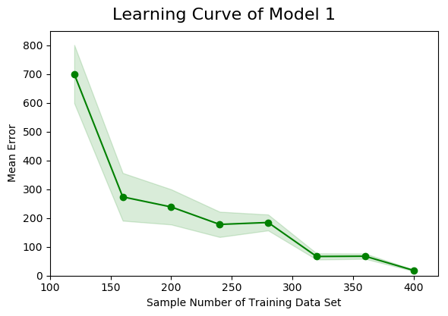

|  |  |  |
| --- | --- | --- |
| sample | test_diffmean | test_std |
| 40 | 406.06 | 501.13 |
| 80 | 468.69 | 550.99 |
| 120 | 699.26 | 1012.86 |
| 160 | 273.31 | 828.12 |
| 200 | 238.35 | 610.42 |
| 240 | 177.78 | 439.56 |
| 280 | 184.4 | 276.13 |
| 320 | 66.51 | 108.12 |
| 360 | 67.41 | 92.09 |
| 400 | 18.3 | 25.76 |

测试集含有20个通过仿真随机得到的样本。可以看出随着训练样本数量增多，预测误差逐渐减小。本研究中平均误差为误差绝对值的平均值，因此都是正数。阴影部分为预测误差的标准差。训练样本较少时标准差极大，为便于显示图中使用了真实标准差的0.1倍。真实的平均误差绝对值和标准差如表1.

训练样本数量达到400时在训练集上的平均预测误差达到最小为18.3m/s, 标准差为25.76m/s。因此选择样本数量400训练后的模型为最优模型，该模型有160个隐藏层神经元，Spread of radial basis functions is 0.93。

图2是该模型在3个不同的测试集上的表现，具体的平均误差和标准差见表2.

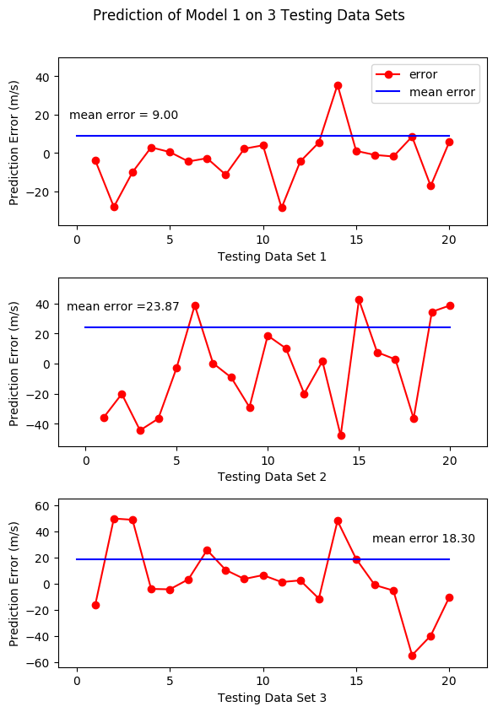

|  |  |  |
| --- | --- | --- |
| 测试集 | Mean error | Standard error |
| 1 | 9.00 | 13.27 |
| 2 | 23.87 | 28.33 |
| 3 | 18.30 | 25.76 |

Model2在测试集上的预测误差随训练样本数量的变化如图3：

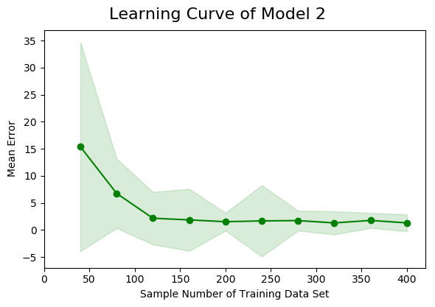

|  |  |  |
| --- | --- | --- |
|  | test_diffmean | test_std |
| 40 | 15.388 | 19.32 |
| 80 | 6.752 | 6.43 |
| 120 | 2.163 | 4.85 |
| 160 | 1.856 | 5.73 |
| 200 | 1.518 | 1.65 |
| 240 | 1.669 | 6.59 |
| 280 | 1.727 | 1.84 |
| 320 | 1.296 | 2.14 |
| 360 | 1.753 | 1.39 |
| 400 | 1.302 | 1.55 |

图3中的标准差为实际值，具体平均误差和标准差见表3。从图3可以看出训练样本数量达到120时，训练集上预测误差绝对值平均接近于0，但标准差较大。

训练样本数量达到320时在测试集上的平均预测误差达到最小为1.3kA·ms, 标准差为2.14 kA·ms。选择该模型为最优模型，该模型有140个隐藏层神经元，Spread of radial basis functions is 1。当训练样本数量增加至360和400时，平均误差反而上升，可能的原因是模型出现了过拟合[17]。

图4是该模型在3个不同测试集上的表现，具体的平均误差和标准差见表4.

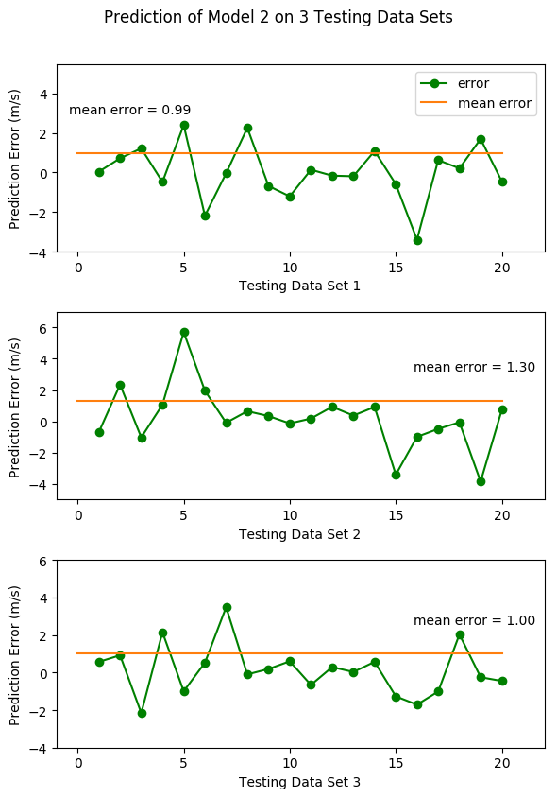

|  |  |  |
| --- | --- | --- |
| 测试集 | Mean error | Standard error |
| 1 | 0.99 | 1.35 |
| 2 | 1.30 | 1.93 |
| 3 | 1.00 | 1.32 |

对比模型1和2，可以看出模型1的误差和标准差较大，但模型1预测的量是初速度，模型2预测的是电流对时间积分，考虑前者比后者实际值要大得多（见Part3-C表1表2），在该范围内的误差也是可以接受的。模型1的训练耗时为xx，模型2的训练耗时为xx

## Conclusion and Discussion

使用rbf neural network通过xx，xx，xx，预测电磁发射中电枢的初速度，精确度能够达到18.3m/s，通过xx，xx，xx，预测发射过程中电流对时间的积分值，精确度能够达到1.3kA·ms，同时该方法仅使用了400组数据训练模型，可以使用真实的实验数据用作训练集。以上说明该方法是可行、准确且高效的。

同时，通过该方法可以得到某一初速度所对应的电流对时间的积分值，那么结合文献[16], 就可以得到能够使电枢达到该初速度的触发时序。因此该方法具有能够精确控制发射速度的潜力。

应该注意到，通过机器学习的方法训练模型，该模型仅能对产生训练集数据的装置进行有效预测。例如本文的模型仅可以有效准确预测产生表1中400组数据的系统。但通过应用机器学习的方法，模型易扩展，可以增加更多特性，如轨道特性参数、电枢特性参数、接触电阻、接触面粗糙度等。训练出适用于更多种装置的模型，训练数据的来源也同时增多。一旦训练出可用的模型，该方法预测初速度或电流要比一个复杂的仿真系统准确且高效得多。因此应用前景极具吸引力。

通常高分辨率图像的规格在4-6英寸、600 dpi

一张图片的打印出来的实际尺寸是由电子图片的像素和分辨率共同决定的，像素(Pixel)是指构成图片的小色点，分辨率(单位DPI)是指每英寸(Inch)上的像素数量，可以看做是这些小色点的分布密度；像素相同时，分辨率越高则像素密度越大，实际打印尺寸越小，图像也越清晰。

实际尺寸(英寸)=像素/分辨率; 1英寸=2.54厘米; 如一张图片宽为600像素，分辨率为300，那么实际打印宽度为：600/300=2英寸，约为5厘米。