In this paper, an initial velocity and current prediction strategy in electromagnetic launch technology based on Radial Basis Function is proposed applying RBF neural network, a kind of machine learning technology, in electromagnetic launch. Firstly, a circuit model of the electromagnetic launch process is established which is applied to simulate the launch process. Run the model in MATLAB language repeatedly with randomly changed armature mass, acceleration distance, current time integration and solve the initial velocity, a data set including these four features is obtained. Then the RBF neural network model is built including an input layer, a hidden layer, and an output layer. After preprocessed, the data set is used to train and test the neural network. By setting the target as initial velocity and current time integration respectively, we trained two models, one predicting the initial velocity and the other predicting the current. Testing the models with 3 different testing data sets the maximum error predicting velocity and current is 1.12% and 0.56% and the prediction costs time less than 1 seconds, which shows this prediction method has high accuracy and efficiency. And according to [5], by using a multipopulation genetic algorithm with the current time integration as target, the trigger timing and current waveform needed for reaching a certain initial velocity can be obtained. Therefore, this method has the potential to accurately control the launch speed. As it is based on a machine learning framework, which is easy to apply, flexible to expand and has a fast prediction speed, it has an undoubtable great advantage over the traditional numerical calculation with long calculation time and complicated structure.

本文提出了一种基于径向基函数算法的初始速度和电流预测策略用于电磁发射技术中，将RBF神经网络，一种机器学习技术，应用于电磁发射中。首先建立电磁发射过程的电路模型，用于模拟发射过程。用随机改变的电枢质量，加速距离，当前时间积分和初始速度重复运行模型，用MATLAB语言，获得一个包括这四种特征的数据集。然后建立RBF神经网络模型，包括输入层，隐藏层和输出层。经预处理后，数据集用于训练和测试神经网络，通过分别将目标变量设置为初始速度和电流时间积分，我们训练了两个预测初始速度和电流的模型。使用3种不同的测试数据集对模型进行测试，最大误差预测速度和电流分别为1.12％和0.56％且预测耗时小于1秒，这表明这种预测方法具有较高的准确性。并且通过一种多种群遗传算法将电流对时间的积分值作为目标，可以得到某一初速度所需的触发时序和电流波形[5]。因此，这种方法有能够精确控制发射速度的潜力。由于它是基于机器学习框架，易于应用，扩展灵活，预测速度快，与传统的数值计算的计算时间长、结构复杂相比毫无疑问具有巨大优势。

**电磁发射技术中基于径向基函数的初速度与电流预测**

Initial Velocity and Current Prediction based on Radial Basis Function (RBF) in Electromagnetic Launch Technology

## Introduction

电磁发射技术是一项先进的电驱动技术。通过导轨传递电流并通过电枢闭合电流路径会产生磁场，导致施加在电枢上沿轨道方向的力[1]。它在科学实验，武器，导弹防御系统，发射火箭和卫星以及航空弹射器等领域有着广泛的应用前景。[2][3]

Electromagnetic launch（EML） technology is an advanced electric drive technology. Passing current through the rails and closing the current-path by the armature, generate the magnetic field. This field causes the applied force on armature and moves it in rails line.[1] It has broad application prospects in many fields like science experiments, weapons, missile defense systems, launch rockets and satellites, and aviation catapult. [2][3]

电磁发射是一个毫秒的过程。磁场扩散，热传导，结构变形和材料磨损耦合在这个高速发射过程和这些参数都是非线性变化。因此，电枢的初始速度无法实现实时反馈和控制。脉冲电源网络由多个并联的脉冲电源模块组成，被广泛用作电磁发射的主要能量源[4]。功率模块电气参数是在同一实验环境下确定的，而可以通过调节每个模块的放电时间改变直接影响初始速度的电流波形。通过电流精确控制初速度，是电磁发射相对于传统发射方法的优势。因此，找到 通过发射条件预测初速度、以及达到某初速度所需要的电流 的方法[5]，是绝对有意义的，因为这些是精确控制速度的基础。

Electromagnetic emission is a millisecond process. Magnetic field diffusion, thermal conduction, structural deformation, and material wear coupled during this high-speed launch process and these parameters are all nonlinear changes. Therefore, the real-time feedback and control cannot be realized for the initial velocity of the armature. The pulse power supply network consists of a plurality of pulse power supply modules in parallel, which is widely used as the main energy source of electromagnetic launch [4]. The power modules’ electrical parameters are determined under the same experimental environment while the discharge timing of each module can be adjusted to change the current waveform which directly affects the initial velocity. Precise speed control through current is the advantage of electromagnetic launch over the traditional emission method. Then it is absolutely meaningful to find a method to predict the initial velocity and the current waveform needed for reaching a certain initial velocity[5], as these are the basics of precise speed control.

初始速度可以通过数值程序求解耦合变量和非线性微分方程来模拟发射过程来计算。[6]中，建立了轨道炮系统的瞬态电路模型并使用Micro-Cap VI（一种电路分析软件包）仿真了轨道炮的瞬态表现。在[1]和[7]中，研究人员提高了轨道电感和轨道上力的分布的计算精度。然而，在所有上述方法中，工作条件和计算有不同程度的简化。在这些模拟中，它往往是单向耦合而不是双向耦合，忽略了一些问题，如轨道上的相位变化。尽管这些仿真平台可以准确地解决发射过程，但也存在很多限制。例如，所有PFU需要预先建立，所有系统参数需要手动设置，必须事先估计上限，并且如果考虑更多因素或计算双向耦合，仿真时间可能是不可接受的几小时。

The initial velocity can be calculated by simulation of the launch process with numerical procedure solving the coupled variables and the nonlinear differential equations. In [6], a transient electric circuit model for a railgun system was developed and the railgun transient performance was simulated using Micro-Cap VI, an electrical circuit analysis software package. In [1] and [7] researchers improved the calculation accuracy of the rails’ inductance and the force distribution upon the rails. However, there are different degrees of simplification of working conditions and calculations in all above methods. It is often one-way coupling rather than two-way coupling in these simulations ignoring some problems like the phase changing upon the rails. Although these simulation platforms can accurately solve the launch process, there are also many limitations. For example, all PFUs need to be pre-built, all system parameters need to be manually set, the upper limit must be estimated in advance, and the unacceptable simulation duration could be hours if more factors are considered or a two-way coupling is calculated.

本文将机器学习技术应用于EML的初始速度预测中，提出了一种基于径向基函数（RBF）神经网络算法的新的预测策略。建立了基于径向基函数神经网络，并用经过预处理的仿真得到的数据进行训练，仿真系统的准确性经过实验验证[8-1]。增加参数和训练样本的数量可以提高模型的准确性，因此在进一步的研究中可以提高该方法的准确性。该方法基于机器学习框架易于应用和扩展。一旦模型完成了训练，每个初始速度预测就可以在常数时间内完成，考虑到数值模拟的复杂性，该方法无疑具有优势。

In this paper, applying the machine learning technique to the initial velocity prediction of EML, a new prediction strategy based on Radial Basis Function (RBF) neural network is presented. A neural network based on RBF is built, and then it is trained with the preprocessed data obtained in simulation, the accuracy of which has been verified experimentally [8-1]. Increasing the number of parameters and training samples can improve the accuracy of the model, therefore the accuracy of the method could be improved much in further research. The method is easy to apply and expand based on the machine learning framework. Once the model has completed training, each initial velocity prediction can be completed in constant time, which has undoubted advantages considering about the complexity of numerical simulation.

## Obtain Data Set

***i***

***B***

***F***

**Pulse Power**

**Supply Network**

Fig.1 System diagram of electromagnetic launch

为了便于获取训练数据，建立了图1所示的电磁发射系统的电路模型。输入不同的发射条件并计算初始速度。电枢的初始速度实际上是到达身管末端时的速度。基于电磁轨道发射系统的工作原理和组成部分，在电源和发射器两个方面建立了整个系统的电路模型。几个主要假设包括晶闸管和硅堆栈的压降在导通电流时大约为零，并且在发射期间导轨电感梯度不变。使用离散时间步长和电源解耦的思想用MATLAB解决电路问题[8]。针对多模块解耦，各模块放电的放电过程被认为是独立的，它们包含一阶和二阶放电过程。  
脉冲电源网络包括许多电源模块，其中一个如图2所示。其中C是储能电容器，TH是普通晶闸管，D是续流硅堆栈，L是电源模块的电感值和电缆电感的总和，R是电抗器电阻，电缆和一个模块中的引线电阻之和;

In order to easily obtain training data, a circuit model of an electromagnetic launch system showed in Fig.1 was established. Input different launch conditions and the initial velocity was calculated. The initial velocity of the armature is actually the velocity when it reaches the end of the barrel. Based on the working principle and components of the electromagnetic rail launching system, the circuit model of the whole system is established from two aspects which are power supply and launcher. Several primary assumptions include that the pressure drop of thyristor and silicon stack is approximately zero when they conduct current and the rail inductance gradient is constant during the launch. The idea of discrete time step and power supply decoupling is used to solve the circuit in MATLAB [8]. For the multiple modules decoupling, the discharge process of each module is considered as independent, and they contain first-order and second-order discharge processes.

The pulse power supply network includes many power supply modules and one of which showed in Fig.2. Where C is the energy storage capacitor, TH is an ordinary thyristor, D is a freewheeling silicon stack, L is the sum of the inductance value of the power supply module and the cable inductance, and R is the sum of the reactor resistance，the cable and the lead resistance in one module.

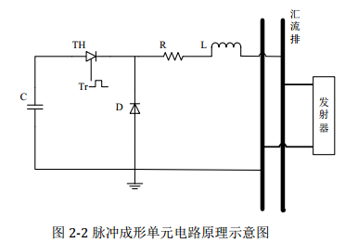

Fig. 2 Circuit schematic of a pulse power supply module

二阶放电时表达式如下：

The relationship expression second-order discharge processe is

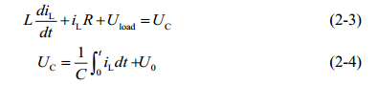

电容停止放电时，表达式如下：

When the capacitor stops discharging, its model expression is



iL 为一个电源模块中流过电感形成脉冲的电流，

UC 为电容两端电压，

U0 为电容器初始充电电压,

Uload 为电源侧汇流排两端电压（或称负载电压）。

iL : Current flowing through an inductor to form a pulse in one power supply module;

UC : voltage of the capacitor,

U0 : Capacitors’ initial charge voltage;

Uload : voltage of the track



I 为从所有脉冲电源模块流入轨道的电流；ik为第k个电源模块的电流值。电路模型中还考虑了速度趋肤效应[9-10]、接触电阻[11]和枢轨间摩擦[12]的影响。

I : current flow into the track from all the power supply modules；

ik :（k= 1,2, , n）current value of the kth power supply module

In the circuit model, the influence of the velocity skin effect [9-10], the contact resistance[11] and the friction between the armature and rail[12] are taken into account.

运动控制方程和发射器端的负载电压分别为：

The governing motion equations and the load voltage at the launcher side are:











Rsum是回路中轨道电阻、电枢电阻、枢轨间的接触电阻、速度趋肤效应产生的电阻和电缆电阻之和；Lr Lcable分别为轨道和电缆的电感；a v s分别为电枢在t时刻的加速度、速度和位移；

从电路模型中可以看出影响电枢初速度的主要变量包括质量、加速距离和电流。通过该仿真得到的电流数据是发射过程中的电流波形，而训练时要求数据集中每一个特征参数是一维的，因此使用电流时间的积分值（也就是波形对时间横轴所围的面积）作为电流特征参数。应用MATLAB语言，并用此模型模拟发射过程。随机给出不同的质量、加速距离和电流计算得到初速度。以获得训练RBF神经网络所需的数据集。

Rsum is the sum of the rails resistance, the armature resistance, the contact resistance between the rail and armature, the cable resistance and the resistance caused by the velocity skin effect. Lr and Lcable are the inductances of the rails and cables respectively; a, v and s are the acceleration, velocity and displacement of the armature at time t.

This circuit model of the electromagnetic launch system shows that the main variables affecting the armature’s initial velocity include the mass of the armature, the acceleration distance and the current waveform. The current data obtained through the simulation is the current waveform during the launch process. While each feature parameter in the data set is required to be one dimension. Therefore, we select the integration of current and time as the current feature data. The language of MATLAB is applied and the launch process is simulated with this model. The simulation results have been verified by experiments. The errors are reasonable and acceptable [8-1]. So we consider the neural network could learn correct pattern from the simulation results. Give randomly different mass of armature, the acceleration distance and the current waveform to calculate the initial velocity and repeat the simulation for hundreds of times. Then we obtain the data set needed to train the RBF neural network.

## RBF Neural Network Building and Training

1. **Algorithm Introduction**

径向基函数是一种传统的多维空间插值技术，由Powell于1985年提出.RBF神经网络属于BP神经网络的类型。网络结构类似于多层前向网络，是一个三层前向网络[13]。一般的BP神经网络在函数逼近中花费更多的训练时间，容易陷入局部最小值，并且获得的网络表现不佳。而RBF神经网络具有良好的函数逼近能力，结构简单，学习速度更快。

The Radial Basis Function is a traditional technique for multidimensional spatial interpolation, proposed by Powell in 1985. The RBF neural network belongs to the type of BP neural network. The network structure is similar to the multilayer forward network and is a three-layer forward network [13]. General BP neural network costs more training time in the function approximation, easily falls into a local minimum and the obtained network performed poorly. While the RBF neural network has a good function approximation capability, simple structure and more fast learning speed.

1. **The structure and parameters of the RBF Neural Network**

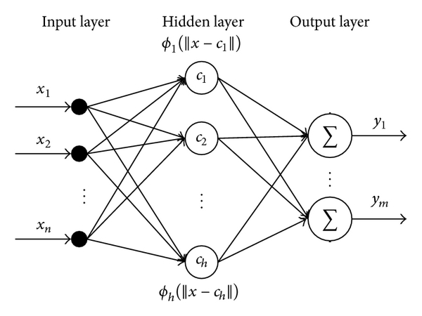

Fig. 3 The structure of the RBF neural network

RBF 神经网络模型结构如图3。第一层是输入层。输入矢量x用作所有径向基函数的输入。第二层是具有非线性RBF激活函数的隐藏层，且径向基函数通常使用高斯函数。每个RBF单元的输出如下[14-15]：

The structure of the RBF neural network is shown in Fig.3. The first layer is the input layer. An input vector x is used as input to all radial basis functions. The second layer is the hidden layer with a non-linear RBF activation function, and the function is commonly taken to be Gaussian. The output of each RBF unit is as follows [14-15]:



x是输入向量ci是第i个高斯函数中心，可以使用k均值聚类算法来确定[16]，为欧式范数， n为隐藏层神经元的个数，σi是RBF单元的宽度

x is the input vector, is the center of the ith Gaussian function and can be determined by k means clustering algorithm.  indicates the Euclidean norm on the input space,  is the width of the th RBF unit, n is the number of the neurons in the hidden layer.

网络的输出是输入向量的标量函数,

The output of the network is then a scalar function of the input vector



p表示第p个样本，j表示输出层中的第j个神经元，ypj是第p个样本第j个输出神经元的输出，wij是第i个隐藏层神经元到第j个输出的权重或强度，w0j是第j个输出的偏置。为了减少网络的复杂性，在以下分析中不考虑偏置。

p indicates the pth sample, j indicates the jth neuron in the output layer, ypj is the output of the pth sample and the jth output neuron, wij is the weight or strength of the ith neuron in hidden layer to the jth output , w0j is the bias of the jth output. In order to reduce the network complexity, the bias is not considered in the following analysis.

输出值的目标函数期望Ep：

The expectation target function of the output value :



其中表示相对于第 k 个输入向量的理想输出，表示相对于第 k个输入向量的实际输出；权值修正公式为：

where  and  represent the kth actual output and the target output, respectively. The weight adjusting equation is





其中为学习率，通过对网络权值的不断循环修正计算出最优的权值。

where  is the learning rate ; Through continuously adjusting the optimal weights are finally calculated.

1. **Data preprocessing and Model Training**

在第二部分中我们已经获得了包括质量、加速距离、电流和初速度的数据集。为了使模型有较好的训练效果，在使用这些数据训练模型之前需要进行预处理。对数据集中的每一个特征进行如下转换：

We’ve got the data set including the mass of the armature, the acceleration distance and the current time integration in Part 2. In order to training the network efficiently, data preprocessing is necessary. Normalize each feature in the dataset as follows:



对于特征i，是转换后的数据，x是原始数据，μ和σ分别是该特征数据的均值和标准差。

在该研究中训练了以下两个模型,两个模型的参数配置分别如表1表2。将表中数据集分割为含有400个样本的训练集和3个含有20个样本的测试集，测试集用于测试训练得到的最优模型。将X（m, x, I）作为作为输入特征向量x，预测目标是初速度，神经网络输入400*3的特征矩阵， 400*1的目标矩阵，得到模型1；将X（m, x, V）作为输入特征向量x，预测目标是电流对时间的积分值时，神经网络输入400*3的特征矩阵，400*1的目标矩阵，得到模型2。

For the ith feature,  is is the converted data, x is the original data; μ and σ are the mean and standard deviation of the feature data, respectively. In this research two prediction model are trained and the parameter configuration of the two models is shown in Table 1 and Table 2. Split the data set into a training set with 400 samples and 3 testing sets with 20 samples. And the testing sets are used to test the performance of trained optimal model.

Model 1 take X(m, x, I) as input feature vector x with the initial velocity as target variable. Then the input of RBF neural network is a 400*3 feature matrix and the output is a 400*1 matrix and a model predicting initial velocity is obtained.

Model 2 take X(m, x, V) as input feature vector x with the current time integration as target variable. Then the input of RBF neural network is a 400*3 feature matrix and the output is a 400*1 matrix and a model predicting current is obtained.

mass of the armature, the acceleration distance and the current waveform.

Table Ⅰ

FEATURES OF INPUT AND OUTPUT OF MODEL 1

|  |  |  |  |  |
| --- | --- | --- | --- | --- |
| Sample number | Features | | | Target |
| mass of the armature (g) | acceleration distance (m) | current time integration (kA·ms) | initial velocity (m/s) |
| 1 | 9.64 | 2.47 | 209.58 | 2303.60 |
| 2 | 8.11 | 2.17 | 162.43 | 2996.28 |
| 3 | 12.54 | 2.42 | 221.11 | 3220.46 |
| … |  |  |  |  |
| 460 | 11.20 | 2.24 | 232.64 | 1744.46 |

Table Ⅱ

FEATURES OF INPUT AND OUTPUT OF MODEL 2

|  |  |  |  |  |
| --- | --- | --- | --- | --- |
| Sample number | Features | | | Target |
| mass of the armature (g) | acceleration distance (m) | initial velocity (m/s) | current time integration (kA·ms) |
| 1 | 9.64 | 2.47 | 2303.60 | 209.58 |
| 2 | 8.11 | 2.17 | 2996.28 | 162.43 |
| 3 | 12.54 | 2.42 | 3220.46 | 221.11 |
| … |  |  |  |  |
| 460 | 11.20 | 2.24 | 1744.46 | 232.64 |

## Results

Model1在测试集上的预测误差随训练样本数量的变化如图4，测试集是从表1中分离出来的3个测试集之一，包含20个样本。本研究中平均误差为误差绝对值的平均值，因此都是正数。阴影部分为预测误差的标准差。训练样本较少时标准差极大，为便于显示图中使用了真实标准差的0.1倍。真实的平均误差绝对值和标准差如表3.

The relationship between prediction error of Model1 on the test set and the number of training samples is shown in Fig. 4. The test set is one of the 3 test sets split from table 1 and contains 20 samples. In this study, the average error is the average of the absolute value of the error, so it is a positive number. The shaded part reflects the standard deviation of the prediction error. When the training sample is small, the standard deviation is extremely large, and 0.1 times the actual standard deviation is used for the convenience of displaying the map. The specific actual average absolute error and standard deviation are shown in Table 3.

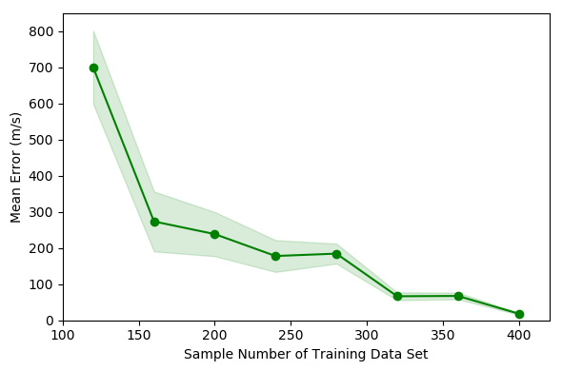

Fig.4 Error changing of model 1 with different number of training data

Table Ⅲ

Error changing of model 1

|  |  |  |
| --- | --- | --- |
| Training Data | Mean Error | Standard Error |
| 40 | 406.06 | 501.13 |
| 80 | 468.69 | 550.99 |
| 120 | 699.26 | 1012.86 |
| 160 | 273.31 | 828.12 |
| 200 | 238.35 | 610.42 |
| 240 | 177.78 | 439.56 |
| 280 | 184.4 | 276.13 |
| 320 | 66.51 | 108.12 |
| 360 | 67.41 | 92.09 |
| 400 | 18.3 | 25.76 |

可以看出随着训练样本数量增多，预测误差逐渐减小。训练样本数量达到400时在测试集上的平均预测误差达到最小为18.3m/s, 标准差为25.76m/s。因此选择样本数量400训练后的模型为最优模型，该模型有160个隐藏层神经元，Spread of radial basis functions is 0.93。图5是该模型在3个不同的测试集上的表现，具体的平均绝对误差、平均绝对误差百分数和标准差见表5. 平均绝对误差百分数的表达式如下，At是目标值Pt是模型输出的预测值

Fig.4 shows that as the number of training samples increases, the prediction error gradually decreases. When the number of training samples reaches 400, the average prediction error on the test set reaches a minimum of 18.3 m/s, and the standard deviation is 25.76 m/s. Therefore, the model trained with 400 samples is selected as the optimal model 1 which has 160 hidden layer neurons and the spread of radial basis functions is 0.93. Figure 5 shows the performance of model 1 on 3 different test sets. The specific average absolute error, average absolute error percentage, and standard deviation are shown in Table 5. The expression of the average absolute error percentage is as follows. At is the target value Pt is the predicted value of model 1.



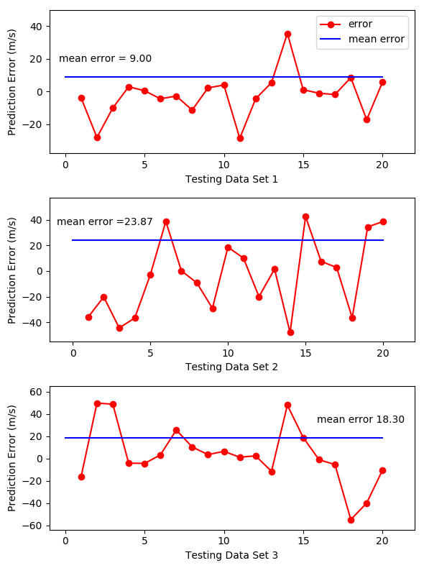

Fig.5 Prediction error of model 1 on 3 testing data sets

Model2在测试集上的预测误差随训练样本数量的变化如图6。图6阴影所示的标准差为实际值，具体平均误差和标准差见表4。从图6可以看出训练样本数量达到120时，训练集上预测误差绝对值平均接近于0，但标准差较大。训练样本数量达到320时在测试集上的平均预测误差达到最小为1.3kA·ms, 标准差为2.14 kA·ms。选择该模型为最优模型，该模型有140个隐藏层神经元，Spread of radial basis functions is 1。当训练样本数量增加至360和400时，平均误差反而上升，可能的原因是模型出现了过拟合[17]。图7是该模型在3个不同测试集上的表现，具体的平均绝对误差、平均绝对误差百分数和标准差见表5.

The relationship between prediction error of Model 2 on the test set and the number of training samples is shown in Fig. 6. The shaded part reflects the actual standard deviation of the prediction error. The specific actual average absolute error and standard deviation are shown in Table 4. Fig. 6 shows that when the number of training samples reaches 320, the average prediction error on the test set reaches a minimum of 1.3kA·ms, and the standard deviation is 2.14 kA·ms. Therefore, the model trained with 320 samples is selected as the optimal model 2 which has 140 hidden layer neurons and the spread of radial basis functions is 1. When the number of training samples increases to 360 and 400, the average error increases instead. This may be due to overfitting of the model[17]. Fig.7 shows the performance of model 2 on 3 different test sets. The specific average absolute error, average absolute error percentage, and standard deviation are shown in Table 5

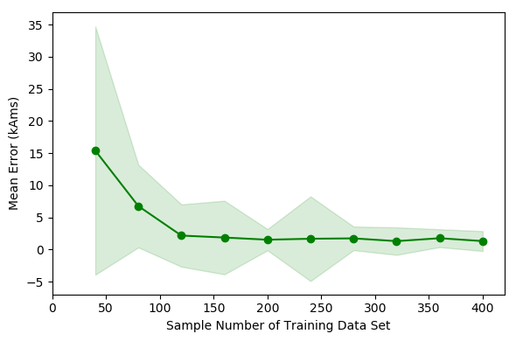

Fig.6 Error changing of model 2 with different number of training data

Table Ⅳ

Prediction error of model 1 on 3 testing data sets

|  |  |  |
| --- | --- | --- |
|  | test_diffmean | test_std |
| 40 | 15.388 | 19.32 |
| 80 | 6.752 | 6.43 |
| 120 | 2.163 | 4.85 |
| 160 | 1.856 | 5.73 |
| 200 | 1.518 | 1.65 |
| 240 | 1.669 | 6.59 |
| 280 | 1.727 | 1.84 |
| 320 | 1.296 | 2.14 |
| 360 | 1.753 | 1.39 |
| 400 | 1.302 | 1.55 |

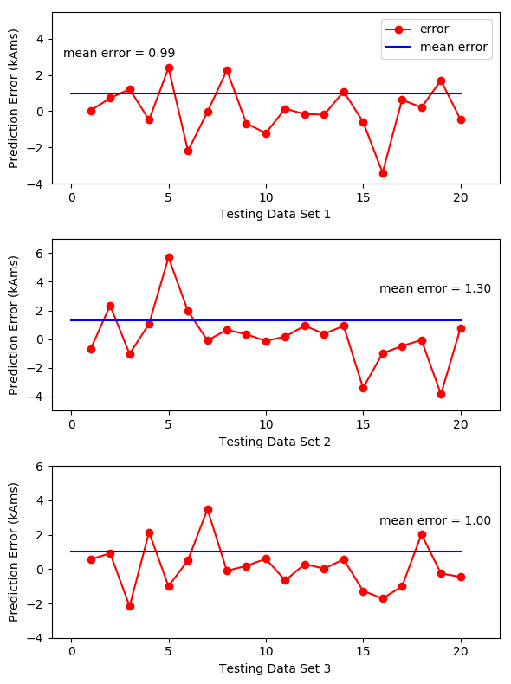

Fig.7 Prediction error of model 2 on 3 testing data sets

Table Ⅴ

Prediction error of model 1 on 3 testing data sets

|  |  |  |  |  |  |  |
| --- | --- | --- | --- | --- | --- | --- |
| Model | Target Variable | Hyperparameter | Testing Data Set | MAPE（%） | Mean Error | Standard Error |
| 1 | Initial Velocity | Centers = 160  Spread = 0.93 | 1 | 0.35 | 9.00 | 13.27 |
| 2 | 1.12 | 23.87 | 28.33 |
| 3 | 0.75 | 18.30 | 25.76 |
| 2 | Current Time Integration | Centers = 140  Spread = 1 | 1 | 0.41 | 0.99 | 1.35 |
| 2 | 0.56 | 1.30 | 1.93 |
| 3 | 0.46 | 1.00 | 1.32 |

对比模型1和2，可以看出模型1的误差和标准差较大，但预测误差与真实值的比值即mean absolute percentage error均在1%左右，因此该范围内的误差是可以接受的。模型1的训练耗时为6.3秒，模型2的训练耗时为2.4秒。完成测试集20个样本的预测耗时0.3秒，表明使用rbf 神经网络模型用于电磁发射系统初速度与电流的预测是十分准确且高效的。

Comparing Models 1 and 2, the error and standard deviation of Model 1 are relatively large, while the mean absolute percentage error between the prediction error and the true value is about 1%, so the error in this range is acceptable. Training model 1 and 2 takes 3.6 and 2.4 seconds, respectively. The prediction of the 20 samples of the test set takes 0.3 seconds, indicating that the use of the rbf neural network model for the prediction of the initial velocity and current in the EML system is very accurate and efficient.

## Conclusion and Discussion

本研究使用rbf neural network通过电枢质量m，加速距离s，电流时间积分值预测电磁发射中电枢的初速度，测试中最大平均误差为23.87m/s（1.12%），通过电枢质量m，加速距离s，和电枢初速度预测发射过程中电流对时间的积分值，测试中最大平均误差为1.3kA·ms（0.56%），同时该方法仅分别使用了400组和320组样本数据进行训练，意味着使用真实的实验数据用作训练集是可行的。

由于通过该方法可以预测某一初速度所对应的电流对时间的积分值，根据文献[5],通过遗传算法将该积分值作为目标，可以得到使电枢达到该初速度的触发时序和电流波形。因此该方法具有能够精确控制发射速度的潜力。

虽然电磁发射的速度预测可以通过仿真模拟发射过程来获得，但需要耦合多个物理场，电磁场、温度场、力场。每个影响因素的精确模型和系统结构的精细网格是实现更高精度所必需的。这些都意味着冗长的代码和长达几小时的计算时间，并且不同的系统需要不同的模型。但通过应用机器学习的方法，模型易扩展，可以增加更多特征，如轨道特性参数、电枢特性参数、接触电阻、接触面粗糙度等。设计出适用于更多种装置的模型，训练数据的来源也同时增多。因此一旦训练出可用的模型，该方法预测初速度或电流要比一个复杂的仿真系统准确、高效且普遍适用得多，应用前景极具吸引力。

In this study, we trained an RBF neural network to predict the initial velocity of the armature in EML technology through the armature mass, acceleration distance, and the current time integration. The maximum average error in the test is 23.87 m/s (1.12%). Also, we trained an RBF neural network to predict the current time integration value through the armature mass, acceleration distance, and the initial velocity. The maximum average error in the test is 1.3 kA·ms (0.56%). At the same time, this method only uses 400 and 320 samples for training, which means that it is feasible to obtain a training set from experiments.

Since this method can predict the current time integration corresponding to a certain initial velocity, according to [5], by using a multipopulation genetic algorithm with the integration as target, the trigger timing and current waveform needed for reaching the initial velocity can be obtained. Therefore, this method has the potential to accurately control the launch speed.

Although the EML velocity can be predicted by simulating the launch process, it needs to couple multiple physical fields like electromagnetic fields, temperature fields, and force fields. Accurate model of each influencing factor and fine meshing of the system structure are necessary to achieve higher accuracy, which means lengthy code and hours of computing time. What’s more, different systems require different models. However, by applying machine learning methods, the model is easy to expand and more features such as the rails’ and armature’s characteristics, contact resistance, contact surface temperature, etc. can be considered. Design the models that are suitable for more systems then the source of training data could also increase. Therefore, once the available models are trained, they are more accurate, efficient, and generally applicable to predicting the initial velocity and current than a complicated simulation system. The application prospect of this method in EML is very attractive.

[1]BAYATI M S, KESHTKAR A, KHOSRAVI F等. Analyzing the electromagnetic launcher with combination both FEM-3D and IEM methods in time domain[C]//2012 16th International Symposium on Electromagnetic Launch Technology. 2012: 1–7.

[2] J. S. Bernardes, M. F. Stumborg, and T. E. Jean, “Analysis of a capacitor-based pulsed-power system for driving long-range electromagnetic guns,” IEEE Trans. Magn., vol. 39, no. 1, pp. 486–490, Jan. 2003.

[3] J. D. Wang, “Development and application in military of electromagnetic emission technology,” in Proc. Fire Command Control. 2001, p. 1.

[4] H. D. Fair, “Electric launch science and technology in the United States,” IEEE Trans. Magn., vol. 39, no. 1, pp. 11–17, Jan. 2003.

[5] Ma J, Zhang D D, Yuan W Q, et al. A method of generating timing for a given target current waveform in electromagnetic launch technology [J].IEEE Transactions on Plasma Science. 10.1109/TPS.2017.2706219.

[6] J. S. Bernardes, M. F. Stumborg, and T. E. Jean, “Analysis of a capacitor-based pulsed-power system for driving long-range electromagnetic guns,” IEEE Trans. Magn., vol. 39, no. 1, pp. 486–490, Jan. 2003.

[7] GHASSEMI M, BARSI Y M, HAMEDI M H. Analysis of Force Distribution Acting Upon the Rails and the Armature and Prediction of Velocity With Time in an Electromagnetic Launcher With New Method[J]. IEEE Transactions on Magnetics, 2007, 43(1): 132–136.

[8-1] Yuan Ruimin．Study on Trigger Strategy of Pulse High Current Timing Discharge [D]．Institute of Electrical Engineering, Chinese Academy of Sciences．2017．

[8]LIU X, YU X, LIU X. An Automatic Calculation Method for the Triggering Strategy of the Capacitive Pulsed-Power Supply[J]. Diangong Jishu Xuebao/Transactions of China Electrotechnical Society, 2016, 31: 186–193.

[9] Yu X ，Fan Z ．Simulation and two-objective optimization of the electromagnetic-railgun model considering VSEC resistance and contact resistance[J]． IEEE Transactions on Plasma Science,2011,39(1):405-410．

[10] Engel T G,Neri J M,Veracka M J. Characterization of the velocity skin effect in the surface layer of a railgun sliding contact[J]. IEEE Transactions on Magnetics, 2008, 44(7)： 1837-1844.

[11] Hsieh K T,Satapathy S, Hsieh M T．Effects of pressure-dependent contact resistivity on contact interfacial conditions[J]． IEEE Transactions onMagnetics,2009,45(1),313-318．

[12] Aigner S, Igenbergs E. Friction and Ablation Measurement in a Round Bore Railgun[J]. IEEE Transactions on Magnetics. 1989，25(1) :33~39.

[13] POWELL M J D. Radial Basis Function Methods for Interpolation to Functions of Many Variables[M]. 2001.

[14] WANG Z, YANG B, KANG Y等. Development of a Prediction Model Based on RBF Neural Network for Sheet Metal Fixture Locating Layout Design and Optimization[J]. Computational Intelligence and Neuroscience, 2016, 2016: 1–6.

[15] ER M J, WU S, LU J等. Face recognition with radial basis function (RBF) neural networks[J]. IEEE Transactions on Neural Networks, 2002, 13(3): 697–710.

[16] LIKAS A, VLASSIS N, J. VERBEEK J. The global k-means clustering algorithm[J]. Biometrics, 2003, 36(2): 451–461.

[17] DIETTERICH T. Overfitting and Undercomputing in Machine Learning[J]. ACM Comput. Surv., 1995, 27(3): 326–327.

通常高分辨率图像的规格在4-6英寸、600 dpi

一张图片的打印出来的实际尺寸是由电子图片的像素和分辨率共同决定的，像素(Pixel)是指构成图片的小色点，分辨率(单位DPI)是指每英寸(Inch)上的像素数量，可以看做是这些小色点的分布密度；像素相同时，分辨率越高则像素密度越大，实际打印尺寸越小，图像也越清晰。

实际尺寸(英寸)=像素/分辨率; 1英寸=2.54厘米; 如一张图片宽为600像素，分辨率为300，那么实际打印宽度为：600/300=2英寸，约为5厘米。