Initial Velocity and Current Prediction based on Radial Basis Function (RBF) in Electromagnetic Launch Technology

In this paper, an initial velocity and current prediction strategy in electromagnetic launch technology applying RBF neural network is proposed. Firstly, a circuit model of the electromagnetic launch process is established which is applied to simulate the launch process. Run the model in MATLAB language repeatedly with randomly changed armature mass, acceleration distance and current time integration and calculate the initial velocity to obtain a data set including these four features. Then the RBF neural network model is built including an input layer, a hidden layer, and an output layer. After preprocessed, the data set is used to train and test the neural network and by setting the target variables as initial velocity and current time integration respectively, we trained two models predicting initial velocity and current. Testing the models with 3 different test data sets the maximum error predicting velocity and current is 1.12% and 0.56% respectively and the prediction costs time less than 1 seconds, which shows this prediction method has high accuracy and efficiency. For a certain initial velocity, the trigger timing and current waveform can be calculated from the current time integration by using a multipopulation genetic algorithm. Therefore, this method has the potential to accurately control the launch speed. As it is based on machine learning framework, which is easy to apply, flexible to expand and has a fast prediction speed, it has an undoubtable great advantage over the traditional numerical calculation with long calculation time and complicated structure.

## Introduction

Electromagnetic launch（EML） technology is an advanced electric drive technology. Passing current through the rails and closing the current-path by the armature, generate the magnetic field. This field causes the force applied on armature and drives it in rails line.[1] It has broad application prospects in many fields like science experiments, weapons, missile defense systems, launch rockets and satellites, and aviation catapult. [2][3]

Electromagnetic emission is a millisecond process. Magnetic field diffusion, thermal conduction, structural deformation, and material wear coupled during this high-speed launch process and these are all nonlinear changes. Therefore, the real-time feedback and control cannot be realized for the initial velocity of the armature. The pulse power supply network consists of a plurality of pulse power supply modules in parallel, which is widely used as the main energy source of electromagnetic launch [4]. The power modules’ electrical parameters are determined under the same experimental environment while the discharge timing of each module can be adjusted to change the current waveform which directly affects the initial velocity. Precise speed control through current is the advantage of electromagnetic launch over the traditional emission method. Then it is absolutely meaningful to find a method to predict the initial velocity and the current waveform needed for reaching a certain initial velocity[5], as these are the basics of precise speed control.

The initial velocity can be calculated by simulation of the launch process with numerical procedure solving the coupled variables and the nonlinear differential equations. In [6], a transient electric circuit model for a railgun system was developed and the railgun transient performance was simulated using Micro-Cap VI, an electrical circuit analysis software package. In [1] and [7] researchers improved the calculation accuracy of the rails’ inductance and the force distribution upon the rails. However, there are different degrees of simplification of working conditions and calculations in all above methods. It is often one-way coupling rather than two-way coupling in these simulations ignoring some problems like the phase changing upon the rails. Although these simulation platforms can accurately solve the launch process, there are also many limitations. For example, all PFUs need to be pre-built, all system parameters need to be manually set, the upper limit must be estimated in advance, and the unacceptable simulation duration could be hours if more factors are considered or a two-way coupling is calculated.

In this paper, applying the machine learning technique to the initial velocity prediction of EML, a new prediction strategy based on Radial Basis Function (RBF) neural network is presented. A neural network based on RBF is built, and then it is trained with the preprocessed data obtained in simulation, the accuracy of which has been verified experimentally [8-1]. Increasing the number of parameters and training samples can improve the accuracy of the model, therefore the accuracy of the method could be improved much in further research. The method is easy to apply and expand based on the machine learning framework. Once the model has completed training, each initial velocity prediction can be completed in constant time, which has undoubted advantages considering about the complexity of numerical simulation.

## Obtain Data Set

***i***

***B***

***F***

**Pulse Power**

**Supply Network**

Fig.1 System diagram of electromagnetic launch

In order to easily obtain training data, a circuit model of an electromagnetic launch system showed in Fig.1 was established. Input different launch conditions and the initial velocity was calculated. The initial velocity of the armature is actually the velocity when it reaches the end of the barrel. Based on the working principle and components of the electromagnetic rail launching system, the circuit model of the whole system is established from two aspects which are power supply and launcher. Several primary assumptions include that the pressure drop of thyristor and silicon stack is approximately zero when they conduct current and the rail inductance gradient is constant during the launch. The idea of discrete time step and power supply decoupling is used to solve the circuit in MATLAB [8]. For the multiple modules decoupling, the discharge process of each module is considered as independent, and they contain first-order and second-order discharge processes.

The pulse power supply network includes many power supply modules and one of which showed in Fig.2. Where C is the energy storage capacitor, TH is an ordinary thyristor, D is a freewheeling silicon stack, L is the sum of the inductance value of the power supply module and the cable inductance, and R is the sum of the reactor resistance，the cable and the lead resistance in one module.

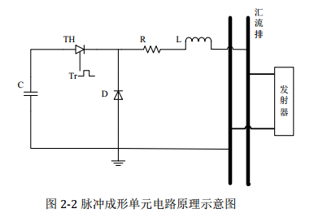

Fig. 2 Circuit schematic of a pulse power supply module

The relationship expression second-order discharge processe is

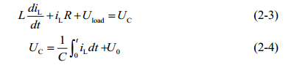

When the capacitor stops discharging, its model expression is



iL : Current flowing through an inductor to form a pulse in one power supply module;

UC : voltage of the capacitor,

U0 : Capacitors’ initial charge voltage;

Uload : voltage of the track



I : current flow into the track from all the power supply modules；

ik :（k= 1,2, , n）current value of the kth power supply module

In the circuit model, the influence of the velocity skin effect [9-10], the contact resistance[11] and the friction between the armature and rail[12] are taken into account.

The governing motion equations and the load voltage at the launcher side are:











Rsum is the sum of the rails resistance, the armature resistance, the contact resistance between the rail and armature, the cable resistance and the resistance caused by the velocity skin effect. Lr and Lcable are the inductances of the rails and cables respectively; a, v and s are the acceleration, velocity and displacement of the armature at time t.

This circuit model of the electromagnetic launch system shows that the main variables affecting the armature’s initial velocity include the mass of the armature, the acceleration distance and the current waveform. The current data obtained through the simulation is the current waveform during the launch process. While each feature parameter in the data set is required to be one dimension. Therefore, we select the integration of current and time as the current feature data. The language of MATLAB is applied and the launch process is simulated with this model. The simulation results have been verified by experiments. The errors are reasonable and acceptable [8-1]. So we consider the neural network could learn correct pattern from the simulation results. Give randomly different mass of armature, the acceleration distance and the current waveform to calculate the initial velocity and repeat the simulation for hundreds of times. Then we obtain the data set needed to train the RBF neural network.

## RBF Neural Network Building and Training

1. **Algorithm Introduction**

The Radial Basis Function is a traditional technique for multidimensional spatial interpolation, proposed by Powell in 1985. The RBF neural network belongs to the type of BP neural network. The network structure is similar to the multilayer forward network and is a three-layer forward network [13]. General BP neural network costs more training time in the function approximation, easily falls into a local minimum and the obtained network performed poorly. While the RBF neural network has a good function approximation capability, simple structure and more fast learning speed.

1. **The structure and parameters of the RBF Neural Network**

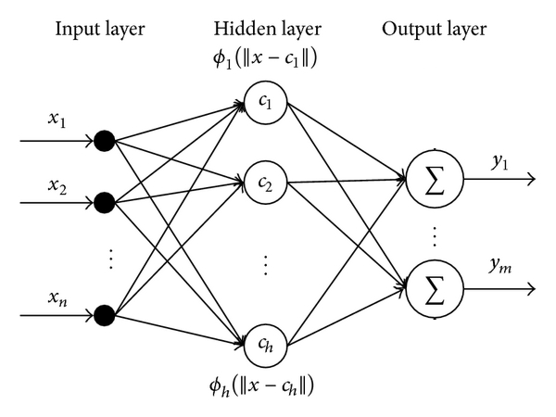

Fig. 3 The structure of the RBF neural network

The structure of the RBF neural network is shown in Fig.3. The first layer is the input layer. An input vector x is used as input to all radial basis functions. The second layer is the hidden layer with a non-linear RBF activation function, and the function is commonly taken to be Gaussian. The output of each RBF unit is as follows [14-15]:



x is the input vector, is the center of the ith Gaussian function and can be determined by k means clustering algorithm.  indicates the Euclidean norm on the input space,  is the width of the th RBF unit, n is the number of the neurons in the hidden layer.

The output of the network is then a scalar function of the input vector



p indicates the pth sample, j indicates the jth neuron in the output layer, ypj is the output of the pth sample and the jth output neuron, wij is the weight or strength of the ith neuron in hidden layer to the jth output , w0j is the bias of the jth output. In order to reduce the network complexity, the bias is not considered in the following analysis.

The expectation target function of the output value :



where  and  represent the kth actual output and the target output, respectively. The weight adjusting equation is





where  is the learning rate ; Through continuously adjusting the optimal weights are finally calculated.

1. **Data preprocessing and Model Training**

We’ve got the data set including the mass of the armature, the acceleration distance and the current time integration in Part 2. In order to training the network efficiently, data preprocessing is necessary. Normalize each feature in the dataset as follows:



For the ith feature,  is is the converted data, x is the original data; μ and σ are the mean and standard deviation of the feature data, respectively. In this research two prediction model are trained and the parameter configuration of the two models is shown in Table 1 and Table 2. Split the data set into a training set with 400 samples and 3 testing sets with 20 samples. And the testing sets are used to test the performance of trained optimal model.

Model 1 take X(m, x, I) as input feature vector x with the initial velocity as target variable. Then the input of RBF neural network is a 400*3 feature matrix and the output is a 400*1 matrix and a model predicting initial velocity is obtained.

Model 2 take X(m, x, V) as input feature vector x with the current time integration as target variable. Then the input of RBF neural network is a 400*3 feature matrix and the output is a 400*1 matrix and a model predicting current is obtained.

mass of the armature, the acceleration distance and the current waveform.

Table Ⅰ

FEATURES OF INPUT AND OUTPUT OF MODEL 1

|  |  |  |  |  |
| --- | --- | --- | --- | --- |
| Sample number | Features | | | Target |
| mass of the armature (g) | acceleration distance (m) | current time integration (kA·ms) | initial velocity (m/s) |
| 1 | 9.64 | 2.47 | 209.58 | 2303.60 |
| 2 | 8.11 | 2.17 | 162.43 | 2996.28 |
| 3 | 12.54 | 2.42 | 221.11 | 3220.46 |
| … |  |  |  |  |
| 460 | 11.20 | 2.24 | 232.64 | 1744.46 |

Table Ⅱ

FEATURES OF INPUT AND OUTPUT OF MODEL 2

|  |  |  |  |  |
| --- | --- | --- | --- | --- |
| Sample number | Features | | | Target |
| mass of the armature (g) | acceleration distance (m) | initial velocity (m/s) | current time integration (kA·ms) |
| 1 | 9.64 | 2.47 | 2303.60 | 209.58 |
| 2 | 8.11 | 2.17 | 2996.28 | 162.43 |
| 3 | 12.54 | 2.42 | 3220.46 | 221.11 |
| … |  |  |  |  |
| 460 | 11.20 | 2.24 | 1744.46 | 232.64 |

## Results

The relationship between prediction error of Model1 on the test set and the number of training samples is shown in Fig. 4. The test set is one of the 3 test sets split from table 1 and contains 20 samples. In this study, the average error is the average of the absolute value of the error, so it is a positive number. The shaded part reflects the standard deviation of the prediction error. When the training sample is small, the standard deviation is extremely large, and 0.1 times the actual standard deviation is used for the convenience of displaying the map. The specific actual average absolute error and standard deviation are shown in Table 3.

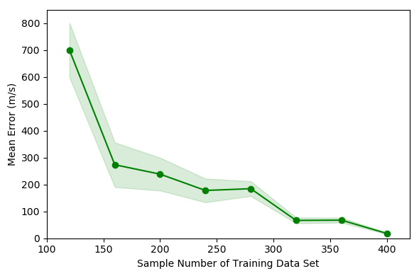

Fig.4 Error changing of model 1 with different number of training data

Table Ⅲ

Error changing of model 1

|  |  |  |
| --- | --- | --- |
| Training Data | Mean Error | Standard Error |
| 40 | 406.06 | 501.13 |
| 80 | 468.69 | 550.99 |
| 120 | 699.26 | 1012.86 |
| 160 | 273.31 | 828.12 |
| 200 | 238.35 | 610.42 |
| 240 | 177.78 | 439.56 |
| 280 | 184.4 | 276.13 |
| 320 | 66.51 | 108.12 |
| 360 | 67.41 | 92.09 |
| 400 | 18.3 | 25.76 |

Fig.4 shows that as the number of training samples increases, the prediction error gradually decreases. When the number of training samples reaches 400, the average prediction error on the test set reaches a minimum of 18.3 m/s, and the standard deviation is 25.76 m/s. Therefore, the model trained with 400 samples is selected as the optimal model 1 which has 160 hidden layer neurons and the spread of radial basis functions is 0.93. Figure 5 shows the performance of model 1 on 3 different test sets. The specific average absolute error, average absolute error percentage, and standard deviation are shown in Table 5. The expression of the average absolute error percentage is as follows. At is the target value Pt is the predicted value of model 1.



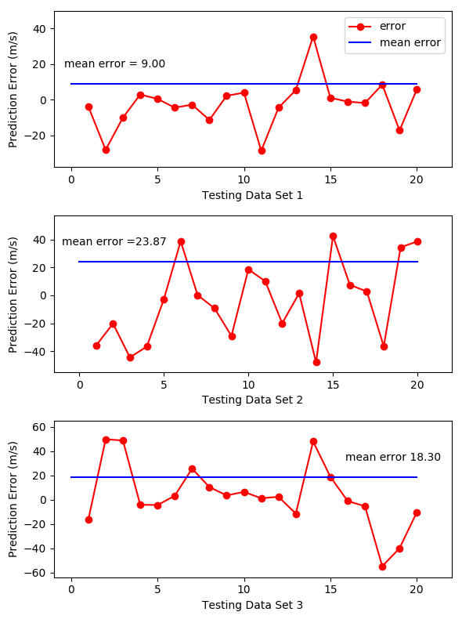

Fig.5 Prediction error of model 1 on 3 testing data sets

The relationship between prediction error of Model 2 on the test set and the number of training samples is shown in Fig. 6. The shaded part reflects the actual standard deviation of the prediction error. The specific actual average absolute error and standard deviation are shown in Table 4. Fig. 6 shows that when the number of training samples reaches 320, the average prediction error on the test set reaches a minimum of 1.3kA·ms, and the standard deviation is 2.14 kA·ms. Therefore, the model trained with 320 samples is selected as the optimal model 2 which has 140 hidden layer neurons and the spread of radial basis functions is 1. When the number of training samples increases to 360 and 400, the average error increases instead. This may be due to overfitting of the model[17]. Fig.7 shows the performance of model 2 on 3 different test sets. The specific average absolute error, average absolute error percentage, and standard deviation are shown in Table 5

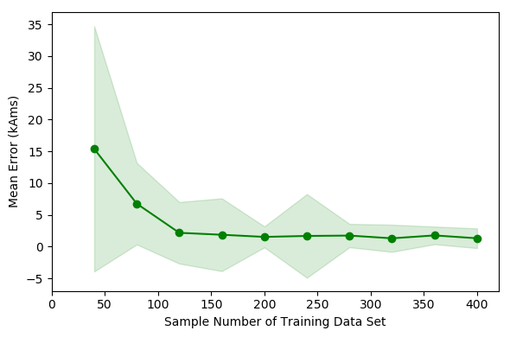

Fig.6 Error changing of model 2 with different number of training data

Table Ⅳ

Prediction error of model 1 on 3 testing data sets

|  |  |  |
| --- | --- | --- |
|  | test_diffmean | test_std |
| 40 | 15.388 | 19.32 |
| 80 | 6.752 | 6.43 |
| 120 | 2.163 | 4.85 |
| 160 | 1.856 | 5.73 |
| 200 | 1.518 | 1.65 |
| 240 | 1.669 | 6.59 |
| 280 | 1.727 | 1.84 |
| 320 | 1.296 | 2.14 |
| 360 | 1.753 | 1.39 |
| 400 | 1.302 | 1.55 |

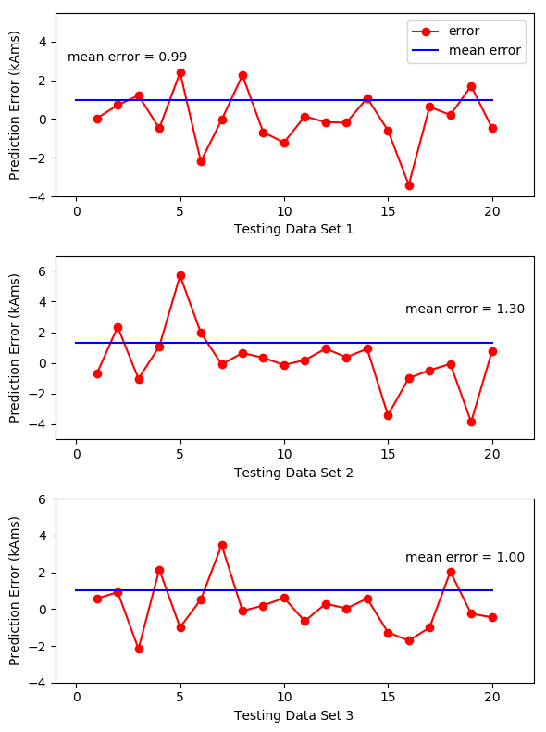

Fig.7 Prediction error of model 2 on 3 testing data sets

Table Ⅴ

Prediction error of model 1 on 3 testing data sets

|  |  |  |  |  |  |  |
| --- | --- | --- | --- | --- | --- | --- |
| Model | Target Variable | Hyperparameter | Testing Data Set | MAPE（%） | Mean Error | Standard Error |
| 1 | Initial Velocity | Centers = 160  Spread = 0.93 | 1 | 0.35 | 9.00 | 13.27 |
| 2 | 1.12 | 23.87 | 28.33 |
| 3 | 0.75 | 18.30 | 25.76 |
| 2 | Current Time Integration | Centers = 140  Spread = 1 | 1 | 0.41 | 0.99 | 1.35 |
| 2 | 0.56 | 1.30 | 1.93 |
| 3 | 0.46 | 1.00 | 1.32 |

Comparing Models 1 and 2, the error and standard deviation of Model 1 are relatively large, while the mean absolute percentage error between the prediction error and the true value is about 1%, so the error in this range is acceptable. Training model 1 and 2 takes 3.6 and 2.4 seconds, respectively. The prediction of the 20 samples of the test set takes 0.3 seconds, indicating that the use of the rbf neural network model for the prediction of the initial velocity and current in the EML system is very accurate and efficient.

## Conclusion and Discussion

In this study, we trained an RBF neural network to predict the initial velocity of the armature in EML technology through the armature mass, acceleration distance, and the current time integration. The maximum average error in the test is 23.87 m/s (1.12%). Also, we trained an RBF neural network to predict the current time integration value through the armature mass, acceleration distance, and the initial velocity. The maximum average error in the test is 1.3 kA·ms (0.56%). At the same time, this method only uses 400 and 320 samples for training, which means that it is feasible to obtain a training set from experiments.

Since this method can predict the current time integration corresponding to a certain initial velocity, according to [5], by using a multipopulation genetic algorithm with the integration as target, the trigger timing and current waveform needed for reaching the initial velocity can be obtained. Therefore, this method has the potential to accurately control the launch speed.

Although the EML velocity can be predicted by simulating the launch process, it needs to couple multiple physical fields like electromagnetic fields, temperature fields, and force fields. Accurate model of each influencing factor and fine meshing of the system structure are necessary to achieve higher accuracy, which means lengthy code and hours of computing time. What’s more, different systems require different models. However, by applying machine learning methods, the model is easy to expand and more features such as the rails’ and armature’s characteristics, contact resistance, contact surface temperature, etc. can be considered. Design the models that are suitable for more systems then the source of training data could also increase. Therefore, once the available models are trained, they are more accurate, efficient, and generally applicable to predicting the initial velocity and current than a complicated simulation system. The application prospect of this method in EML is very attractive.

[1]BAYATI M S, KESHTKAR A, KHOSRAVI F等. Analyzing the electromagnetic launcher with combination both FEM-3D and IEM methods in time domain[C]//2012 16th International Symposium on Electromagnetic Launch Technology. 2012: 1–7.

[2] J. S. Bernardes, M. F. Stumborg, and T. E. Jean, “Analysis of a capacitor-based pulsed-power system for driving long-range electromagnetic guns,” IEEE Trans. Magn., vol. 39, no. 1, pp. 486–490, Jan. 2003.

[3] J. D. Wang, “Development and application in military of electromagnetic emission technology,” in Proc. Fire Command Control. 2001, p. 1.

[4] H. D. Fair, “Electric launch science and technology in the United States,” IEEE Trans. Magn., vol. 39, no. 1, pp. 11–17, Jan. 2003.

[5] Ma J, Zhang D D, Yuan W Q, et al. A method of generating timing for a given target current waveform in electromagnetic launch technology [J].IEEE Transactions on Plasma Science. 10.1109/TPS.2017.2706219.

[6] J. S. Bernardes, M. F. Stumborg, and T. E. Jean, “Analysis of a capacitor-based pulsed-power system for driving long-range electromagnetic guns,” IEEE Trans. Magn., vol. 39, no. 1, pp. 486–490, Jan. 2003.

[7] GHASSEMI M, BARSI Y M, HAMEDI M H. Analysis of Force Distribution Acting Upon the Rails and the Armature and Prediction of Velocity With Time in an Electromagnetic Launcher With New Method[J]. IEEE Transactions on Magnetics, 2007, 43(1): 132–136.

[8-1] Yuan Ruimin．Study on Trigger Strategy of Pulse High Current Timing Discharge [D]．Institute of Electrical Engineering, Chinese Academy of Sciences．2017．

[8]LIU X, YU X, LIU X. An Automatic Calculation Method for the Triggering Strategy of the Capacitive Pulsed-Power Supply[J]. Diangong Jishu Xuebao/Transactions of China Electrotechnical Society, 2016, 31: 186–193.

[9] Yu X ，Fan Z ．Simulation and two-objective optimization of the electromagnetic-railgun model considering VSEC resistance and contact resistance[J]． IEEE Transactions on Plasma Science,2011,39(1):405-410．

[10] Engel T G,Neri J M,Veracka M J. Characterization of the velocity skin effect in the surface layer of a railgun sliding contact[J]. IEEE Transactions on Magnetics, 2008, 44(7)： 1837-1844.

[11] Hsieh K T,Satapathy S, Hsieh M T．Effects of pressure-dependent contact resistivity on contact interfacial conditions[J]． IEEE Transactions onMagnetics,2009,45(1),313-318．

[12] Aigner S, Igenbergs E. Friction and Ablation Measurement in a Round Bore Railgun[J]. IEEE Transactions on Magnetics. 1989，25(1) :33~39.

[13] POWELL M J D. Radial Basis Function Methods for Interpolation to Functions of Many Variables[M]. 2001.

[14] WANG Z, YANG B, KANG Y等. Development of a Prediction Model Based on RBF Neural Network for Sheet Metal Fixture Locating Layout Design and Optimization[J]. Computational Intelligence and Neuroscience, 2016, 2016: 1–6.

[15] ER M J, WU S, LU J等. Face recognition with radial basis function (RBF) neural networks[J]. IEEE Transactions on Neural Networks, 2002, 13(3): 697–710.

[16] LIKAS A, VLASSIS N, J. VERBEEK J. The global k-means clustering algorithm[J]. Biometrics, 2003, 36(2): 451–461.

[17] DIETTERICH T. Overfitting and Undercomputing in Machine Learning[J]. ACM Comput. Surv., 1995, 27(3): 326–327.