Name: Hunar Katyal
UID: 24BDA70085
Batch: 24AIT-KRG-G2
Course: ADBMS
PRACTICAL MST

Q1.

Code:
CREATE TABLE department ( dept_id INT PRIMARY KEY, dept_name VARCHAR(30) );
CREATE TABLE employee ( emp_id INT PRIMARY KEY, emp_name VARCHAR(50), salary NUMERIC(10,2), dept_id INT REFERENCES department(dept_id) );
INSERT INTO department VALUES (1, 'IT'), (2, 'Sales'), (3, 'HR');
INSERT INTO employee VALUES (101, 'Aman', 90000, 1), (102, 'Neha', 70000, 1), (103, 'Raj', 50000, 1), (104, 'Priya', 80000, 2), (105, 'Karan', 60000, 2), (106, 'Riya', 40000, 2), (107, 'Mohit', 75000, 3), (108, 'Simran', 55000, 3);
SELECT d.dept_name, e.emp_name, e.salary FROM employee e JOIN department d ON e.dept_id = d.dept_id WHERE e.salary > ( SELECT AVG(e2.salary) FROM employee e2 WHERE e2.dept_id = e.dept_id ) AND e.dept_id IN ( SELECT dept_id FROM employee GROUP BY dept_id HAVING COUNT(*) >= 3 );

Screenshot:
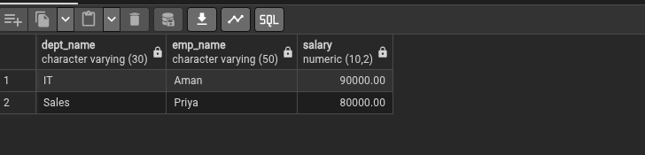
Q2.
DROP TABLE bank_customer;
CREATE TABLE bank_customer ( customer_id INT PRIMARY KEY, customer_name VARCHAR(50), balance NUMERIC(10,2) );
DROP TABLE customer_audit;
CREATE TABLE customer_audit ( audit_id SERIAL PRIMARY KEY, customer_id INT, customer_name VARCHAR(50), action VARCHAR(20), action_time TIMESTAMP );
INSERT INTO bank_customer VALUES (1, 'Rahul', 50000), (2, 'Neha', 75000);
CREATE FUNCTION audit_customer() RETURNS TRIGGER AS $$ BEGIN IF TG_OP = 'INSERT' THEN INSERT INTO customer_audit VALUES (DEFAULT, NEW.customer_id, NEW.customer_name, 'ADDED', CURRENT_TIMESTAMP);
ELSE
INSERT INTO customer_audit
VALUES (DEFAULT, OLD.customer_id, OLD.customer_name,
'REMOVED', CURRENT_TIMESTAMP);
END IF;
RETURN NULL;
END; $$ LANGUAGE plpgsql;
CREATE TRIGGER customer_trigger AFTER INSERT OR DELETE ON bank_customer FOR EACH ROW EXECUTE FUNCTION audit_customer();
INSERT INTO bank_customer VALUES (3, 'Rahul', 50000), (4, 'Neha', 75000);
DELETE FROM bank_customer WHERE customer_id = 3;
SELECT * FROM customer_audit;
Screenshot:
