System Architecture Overview
The Inter-Agency Case Management Platform follows a layered architecture, as outlined in your document. This design ensures modularity, scalability, and security, allowing components to be developed, deployed, or updated independently. Here's a breakdown of the key layers:
- Presentation Layer: Handles user interactions via a web-based interface (primary) and optional mobile app. It supports role-based views (e.g., case officers see editable forms, auditors get read-only dashboards), multi-language (mainly local languages), and accessibility standards.
- Access & Identity Layer: Manages authentication and authorization. Users log in with credentials, SSO, or national ID integration. It uses Role-Based Access Control (RBAC) and delegation for acting authority, with security like token-based sessions and brute-force protection.
- Core Case Management Layer: The functional core for handling cases. Includes sub-components like Case Registry (for registering and classifying cases), Workflow Engine (configurable per organization for state transitions), Assignment & Escalation (auto/manual assignments, SLA tracking, notifications), and Audit & History (immutable logs for compliance).
- Integration & Event Layer: Enables interoperability with external systems (more on this below). Uses RESTful APIs, secure webhooks, and optional message queues for data exchange.
- Data Persistence Layer: Securely stores data like case records, workflows, and audits, with tenant-aware segregation, encryption, and referential integrity.
This layered approach supports multi-tenancy, where each government institution (e.g., police, courts) acts as a "tenant" with isolated data and custom workflows, but controlled sharing is possible.
To visualize, here's an example of a layered architecture diagram similar to your logical view:
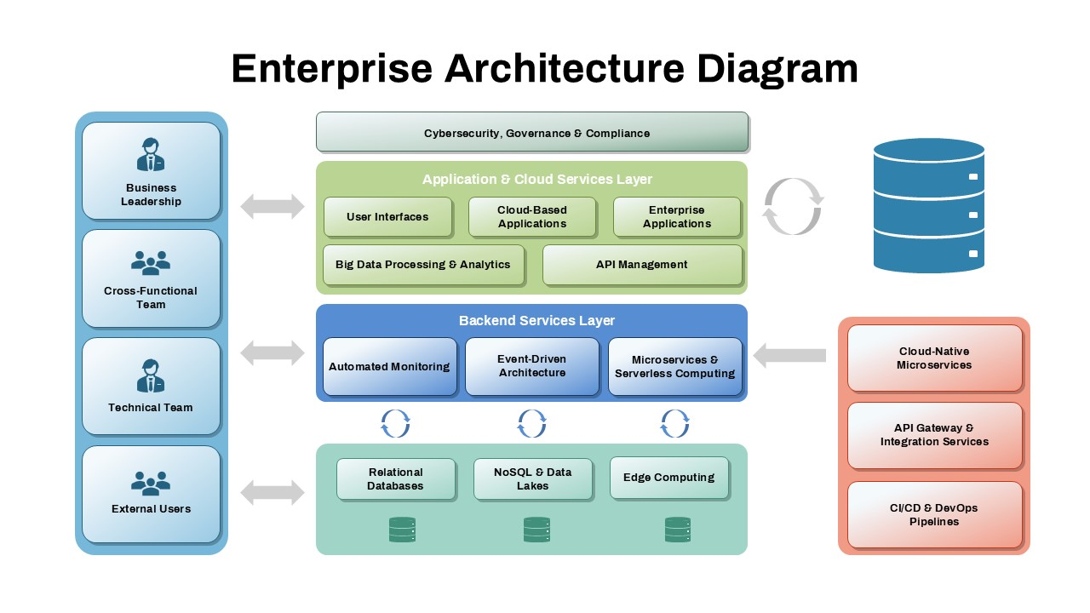
slidekit.com
Enterprise Architecture Diagram Template for PowerPoint and Google Slides

How the System Works: Overall Flow
The system operates as a centralized platform for managing cases across agencies, enforcing standardized processes while allowing customization. It runs on government-controlled infrastructure (on-premise, private cloud, or hybrid) with separate environments for dev, test, and production.
- Data Flow: Requests start at the Presentation Layer, pass through Access & Identity for verification, process in the Core Layer (e.g., updating a case status), trigger events in the Integration Layer if needed (e.g., notifying another agency), and store changes in the Data Layer with audits.
- Security and Compliance: Every action is logged immutably, encrypted at rest/transit, and auditable. Oversight bodies get read-only access, and changes require approvals.
- Scalability: Horizontal scaling for high loads, load balancing, and background processing for tasks like reports.
- Operations: Includes monitoring (health, performance, errors), backups, and disaster recovery.

Possible Workflow: Step-by-Step Example
Let's use a justice sector example (e.g., a criminal case moving from police investigation to prosecution and court referral), as it's the primary focus in your document. Workflows are configurable per tenant, so this can adapt to other sectors like education (student grievances) or health (beneficiary tracking).
- Case Initiation: A police officer (user in Tenant A: Police) logs in via the web interface. They register a new case in the Case Registry, assigning a unique ID, type (e.g., criminal), and priority. The Workflow Engine starts the "Investigation" state.
- Assignment and Processing: The Assignment Module auto-assigns the case to an investigator based on rules (e.g., workload or expertise). The user updates details, attaches evidence, and tracks deadlines/SLAs. If delayed, escalation notifications are sent (email/SMS via Integration Layer).
- Internal Collaboration: Within the same tenant, supervisors review via role-based dashboards. Audits log every view/edit.
- Inter-Agency Referral: When ready for prosecution, the case transitions state. The Integration Layer sends an event (e.g., "Case Updated") to Tenant B (Prosecutor's Office) via API or webhook, sharing limited data (e.g., case summary, not full sensitive details).
- Cross-Agency Updates: The prosecutor's team in Tenant B accesses the referred case (with explicit authorization), updates status (e.g., "Charges Filed"), and syncs back. If needed, reference external systems like court calendars.
- Oversight and Closure: Auditors (cross-tenant read-only access) review the full timeline via Audit Module. Once resolved, the case closes, with exports for compliance. Events like "SLA Breached" trigger alerts.
- Reporting and Analytics: Generate reports on SLAs, case volumes, etc., with future AI enhancements for prioritization.
This workflow ensures traceability: Every step is auditable, with data owned by the originating institution.

Multi-Organization Interoperability: How It Works and Interfaces
Interoperability is a core principle (standards-based APIs for integration with existing systems). Since the platform is multi-tenant, organizations (tenants) have isolated data by default—police can't see court-only cases without permission. Sharing happens via controlled mechanisms in the Integration & Event Layer, preserving data sovereignty.
- How Interoperability Works:
  - Data Exchange: Limited to authorized use cases like external case submission (e.g., police submits to courts), status synchronization (real-time updates), or cross-agency referencing (linking related cases without full data transfer).
  - Event-Driven: Events (e.g., Case Created, Status Transitioned, SLA Breached) trigger notifications or actions. For example, a webhook pushes updates to another agency's system instantly.
  - Isolation with Sharing: Logical isolation uses tenant IDs; explicit authorizations (via RBAC) allow cross-tenant access. Optional physical isolation for sensitive tenants.
  - Mechanisms:
    - RESTful APIs: For pull/push data. E.g., Police system queries "/api/cases/{id}/status" with API credentials.
    - Secure Webhooks: For push notifications. E.g., Courts subscribe to updates from prosecutions.
    - Message Queues (Optional): For asynchronous, reliable delivery in high-volume scenarios.
  - Security: All exchanges use encryption in transit, permission checks, and audits. No proprietary lock-in—uses open standards.
- Interfaces:
  - User Interfaces (Human-to-System): Web-first portal with role-based dashboards. E.g., a police officer sees a form to submit referrals; a court clerk gets a notification popup for incoming cases. Optional mobile for field updates. Here's an example UI screenshot from a similar government justice platform (Clio's case management):
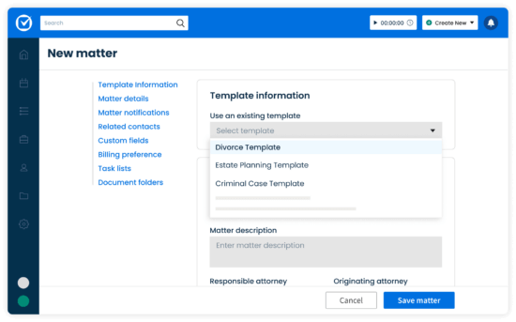
clio.com
Legal Case Management Software for Attorneys & Law firms | Clio
This shows how users might create/view matters (cases), with tabs for details, tasks, and integrations.
- System Interfaces (System-to-System): APIs for automated interoperability. E.g., Police legacy system calls an API to submit a case, receiving a webhook callback on status changes. No direct database access—everything funnels through secured endpoints.
To imagine it better, here's a diagram illustrating multi-organization interoperability with APIs and webhooks:
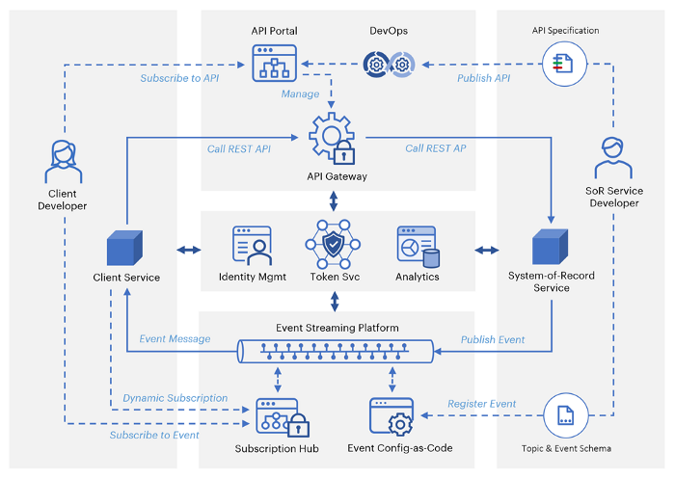
medium.com
API Interoperability Maturity Model | by TRGoodwill | API Central ...
This maturity model shows progression from basic API calls to advanced event-driven integrations, similar to your platform's design.
When building with AI tools (e.g., code generators like GitHub Copilot or low-code platforms like Bubble/Appian), start with the Core Layer (workflow engine using libraries like Camunda or custom Python/Node.js), then add integrations. Test interoperability in a sandbox with mock APIs. If adapting to non-justice sectors, configure workflows via admin panels without code changes. Let me know specifics for more tailored advice!
Handling Information from Multiple Government Organizations in a Generic System
Building a generic Inter-Agency Case Management Platform that can be used by many government organizations is feasible, as your architecture document already positions it as a flexible framework. The key challenge—integrating diverse information from various orgs with different forms, processes, and data formats—can be addressed through standardization, configurability, and robust integration mechanisms. This ensures the system remains generic (one core platform) while accommodating specifics without custom code changes for each org. Below, I'll break it down step by step, drawing from your document and best practices from similar systems like Salesforce Government Case Management, Microsoft Dynamics 365, and federal examples (e.g., U.S. CM/ECF for courts).
1. Understanding the Challenge: Diverse Forms and Data
- Government organizations (e.g., police, courts, health services, education) often use unique forms for case intake (e.g., police reports vs. student grievance forms) with varying fields, formats (PDF, XML, custom databases), and requirements.
- Direct "taking infos" (ingesting data) risks chaos if not normalized—e.g., one org might use "Case ID" while another uses "Incident Number," or forms might include attachments like evidence files.
- Goal: Create a single, generic system where orgs submit/retrieve data seamlessly, with the platform handling mapping, validation, and storage.
2. Core Strategies from Your Architecture
Your document emphasizes modularity, interoperability, and vendor neutrality, which directly support this. Here's how to apply it:
- Multi-Tenancy Model (Section 5): Each organization is a "tenant" with independent users, roles, custom workflows, and isolated data visibility. This allows many orgs to use the same system without seeing each other's full data. For example:
  - Police (Tenant A) has workflows for criminal cases.
  - Health Services (Tenant B) configures for beneficiary tracking.
  - Isolation (logical via tenant IDs or optional physical) ensures data sovereignty, but controlled sharing (e.g., referrals) is possible.
- Configurable Workflows and Forms (Core Case Management Layer, Section 4.3):
  - Use the Workflow Engine to define org-specific processes without altering the architecture.
  - For different forms: Implement dynamic, role-based forms in the Presentation Layer (web-first UI). Admins can configure form templates per tenant (e.g., via JSON schemas or low-code tools), mapping fields to a generic data model in the Data Persistence Layer.
  - Example: A generic "Case Registration" form has core fields (ID, type, priority) plus extensible custom fields. When an org submits a form, the system validates and maps it to standardized case records.
- Sector Adaptation (Section 11): The platform is designed for this—adapt via configuration for justice (strong audits), education (confidentiality), health (high sensitivity), etc. No architectural changes needed; just tweak workflows, roles, and integrations.
3. Integrating and Ingesting Information from Diverse Sources
To "take infos" from many orgs, focus on the Integration & Event Layer (Section 4.4). This enables controlled data exchange without tight coupling.
- Standardization and Mapping:
  - Define a generic data schema (e.g., based on standards like NIEM for justice data or HL7 for health) in the Data Persistence Layer. All incoming data maps to this—e.g., convert org-specific form fields to universal ones (name, date, description, attachments).
  - Handle different forms: Support multiple input methods—web forms, API uploads, or file imports (e.g., PDF parsing). Use AI tools (as you mentioned building with them) for form recognition/extraction (e.g., OCR for scanned docs).
- Integration Mechanisms:
  - RESTful APIs: Orgs submit data via standardized endpoints (e.g., POST /api/cases with JSON payload). The system validates, maps, and registers the case. For example, a court system sends a referral form as JSON; your platform maps it to a case update.
  - Secure Webhooks: For real-time pushes—e.g., when an org updates a form, it triggers a webhook to your system for sync.
  - Optional Message Queues: For high-volume or asynchronous intake from legacy systems.
  - Supported Use Cases: External submission (ingest forms), status sync (update shared cases), cross-referencing (link related forms without full transfer).
- Handling Variety:
  - If forms are in different formats: Use middleware (e.g., API gateways) to normalize—convert CSV/XML/PDF to JSON.
  - Security: All intakes go through Access & Identity Layer (RBAC, encryption), with audits (immutable logs).
  - Example Workflow: An education org submits a student appeal form via API. The system classifies it, assigns it, and notifies oversight if needed—all configurable per tenant.
4. Real-World Examples and Best Practices
Similar systems handle this by prioritizing configurability and APIs:
- Salesforce Government Case Management: Connects disparate teams/data across agencies. Uses dynamic forms and AI to map/automate intake from different sources, improving collaboration without custom builds.
- Microsoft Dynamics 365: Handles casework for any agency; configurable for resource management. Ingests data via integrations, mapping varied forms to a central CRM.
- Appian for Public Sector: Assess needs first, then design workflows. Uses low-code to create generic processes that adapt to different forms via data mapping.
- U.S. CM/ECF (Court System): A federal e-filing system deployed nationwide; standardizes filings from diverse courts via APIs and configurable rules.
- General Tip: Start with a pilot—integrate 2-3 orgs, refine mappings, then scale. Use open standards (e.g., OAuth for auth) to avoid lock-in.
5. Visualizing the Architecture
To help imagine how this fits together in a multi-org setup, here's a conceptual diagram of a generic government case management system (inspired by federal identity management architectures, which handle similar multi-agency data flows):
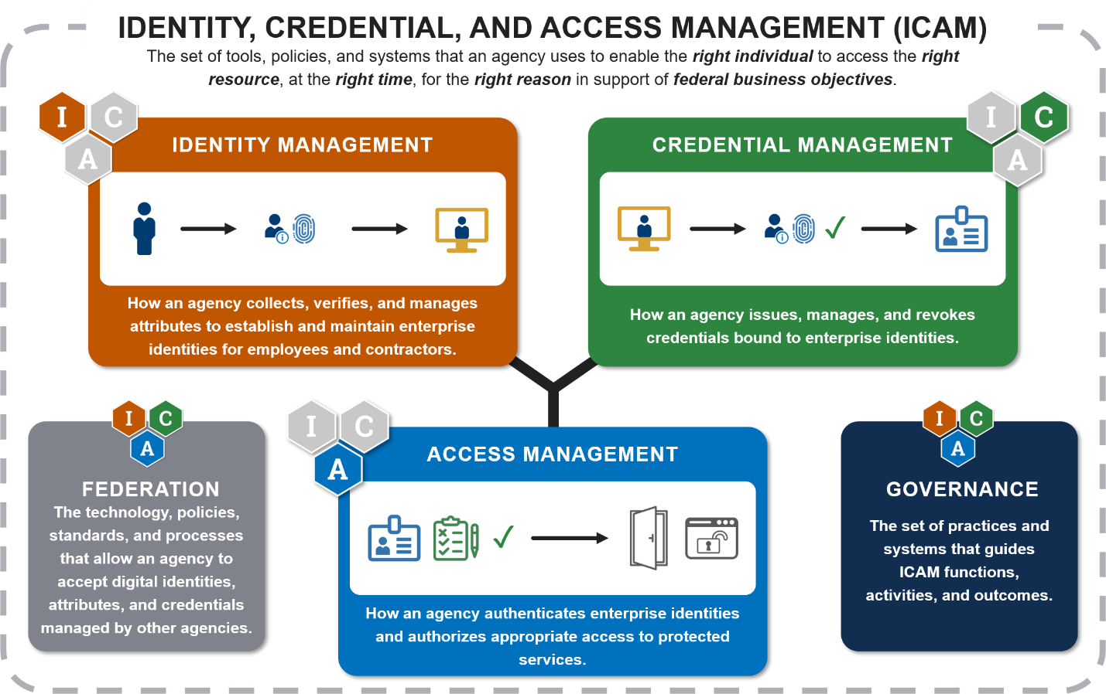
idmanagement.gov
FICAM Architecture - IDManagement
This shows high-level components (e.g., access controls, core services, integrations) that align with your layered design, emphasizing interoperability across organizations.
And here's a more detailed component breakdown for multi-org platforms:
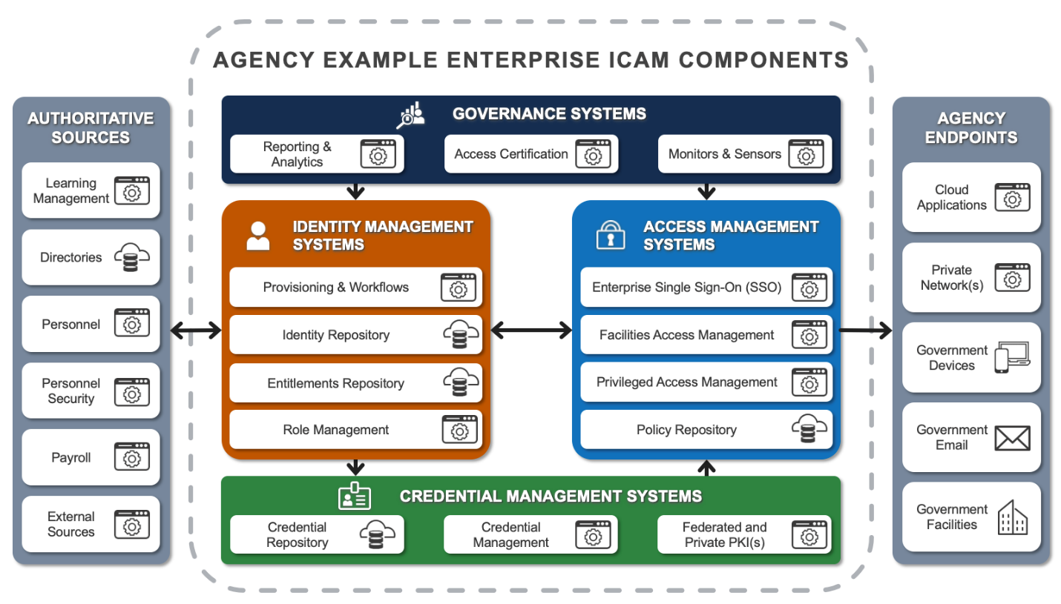
idmanagement.gov
FICAM Architecture - IDManagement
6. Implementation Tips for You and Your Colleague (Using AI Tools)
- Short Timeline Build: Use AI-assisted low-code platforms (e.g., Bubble, Adalo) for the UI/forms, and open-source tools like Camunda for workflows. Generate code snippets with tools like Copilot for API mappings.
- Steps:
  - Define a core data model (e.g., JSON schema for cases).
  - Build the Integration Layer first—test API endpoints for form submissions.
  - Configure tenants and dynamic forms.
  - Add AI for data extraction (e.g., from varied forms) via libraries like Hugging Face models.
- Challenges & Mitigations: Data privacy—enforce encryption and RBAC. Scalability—use cloud for horizontal scaling. Test with mock data from different orgs.
- If needed, extend for AI enhancements (Section 13) like auto-prioritization of incoming forms.
This approach keeps the system generic, scalable, and compliant while handling diversity. If you share more on specific orgs or forms, I can refine further!

Important Questions About the System
- What are the primary sectors or institutions (e.g., police, courts, corrections, education, health) that will initially use the platform, and in what order should we prioritize adaptations?
- What existing government systems (e.g., national ID databases, legacy police/court software) must integrate with the platform, and what APIs or data standards do they use? (very necessary for compatibility)
- How to make the system to take data from different orgs as their data and form inputs vary?

