

Japanese Skill Practice Platform
Software Design Specification

– Hanoi, July 2026 –

Record of changeS
Date | A*  M, D | In charge | Change Description
2026-07-22 | A | AI Agent (per user request) | Initial SDS_Document.docx built from Template3: filled in the Overview (14 packages, DB schema) and 6 Code Designs flows (Auth, Quiz Submission, Flashcard SRS, Kanji Writing, Speaking Grading, Content Review).
2026-07-22 | M | AI Agent (per user request) | Corrected the Speaking Submission Grading flow: added the Student submission step (package speaking - SpeakingController/SpeakingService) and updated SupportTicketService.manualGrade to match the current code (no longer requires status=AI_GRADED, only blocks REJECTED) — reflects the removal of AI auto-grading (commit db0d1648).
2026-07-22 | M | AI Agent (per user request) | Translated the whole document to English and hardened the font handling for the SQL code blocks (explicit ascii/hAnsi/cs/eastAsia font stamp instead of relying on theme fallback).
*A - Added M - Modified D - Deleted

Table of Contents
I. Overview 4
1. Code Packages 4
2. Database Design 4
a. Database Schema 4
b. Table Description 4
II. Code Designs 5
1. <Feature/Function Name1> 5
a. Class Diagram 5
b. Class Specifications 5
c. Sequence Diagram(s) 5
d. Database queries 6
2. <Feature/Function Name2> 6

I. Overview

1. Code Packages

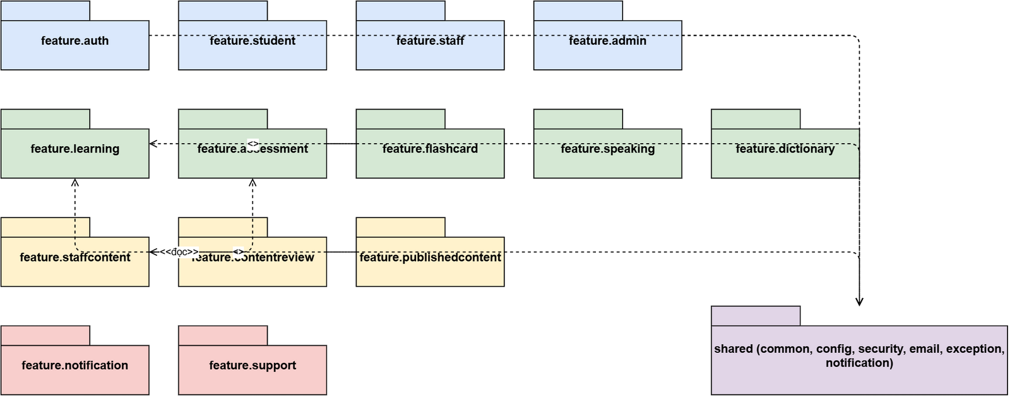
Package descriptions
No | Package | Description
01 | auth | Student login/register, JWT access + refresh token, email verification, forgot password, Google OAuth login.
02 | staff | Staff/StaffManager accounts: separate login, staff member management, staff password reset.
03 | admin | Admin accounts, audit log, statistics dashboard, system configuration (system_settings), maintenance mode.
04 | student | Student profile, dashboard, learning progress (student_content_progress), avatar, enrolled courses.
05 | learning | Learning content: Kana, Kanji, Vocabulary, Grammar, Lesson by JLPT level (N5-N1).
06 | assessment | Question bank, Quiz/Exam (Assessment), attempts (TestAttempt), server-side grading, speaking/writing submissions (StudentSubmission).
07 | speaking | Student records and submits speaking (shadowing) exercises, polls the result (SpeakingController/SpeakingService); grading is done by teachers in the support package — no AI auto-grading step anymore (removed by a recent refactor).
08 | staffcontent | Where Staff draft content before publishing: questions, quizzes, exams, grammar, vocabulary, and a dedicated Staff dashboard.
09 | contentreview | Content review flow for Staff-authored content (approve/reject) before it goes public, with review audit logging.
10 | publishedcontent | Snapshot of published content, served to Students (kept separate from Staff's draft copy).
11 | flashcard | Flashcard + Spaced Repetition (SRS), system decks or user-created decks.
12 | dictionary | Kanji/Vocabulary dictionary lookup by keyword or type.
13 | notification | Notifications sent to individual Students (notification type, delivery channel).
14 | support | Support tickets submitted by Students and staff replies (TicketReply); Staff's speaking-grading queue (SupportTicketService, UC-31).

2. Database Design

a. Database Schema
DBMS: Microsoft SQL Server 2019+, database JLPT_LearningDB. See docs/02-SDD-Architecture/database-design/JLPT_database.md for the full 23-table reference — the ER diagram below summarizes only the table groups relevant to the 6 flows detailed in Section II.
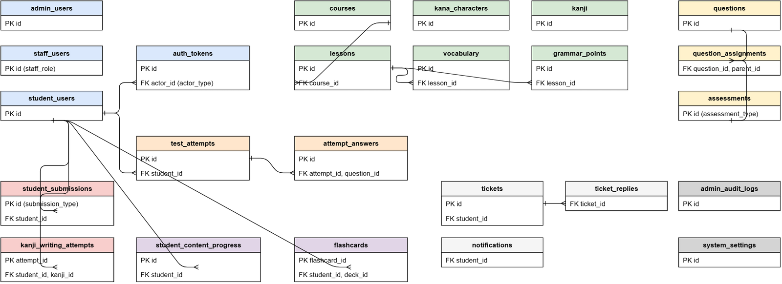

b. Table Description
No | Table | Description
01 | student_users | Student accounts, including OAuth (Google), current/target JLPT level, learning streak.
02 | staff_users | Staff/StaffManager accounts.
03 | admin_users | Admin accounts.
04 | auth_tokens | Shared token store (session, refresh, reset password, verify email) for all 3 actor types via actor_type + actor_id.
05 | assessments | JLPT Quiz and Exam (combined into a single table via assessment_type).
06 | questions | Question bank, with A/B/C/D answers stored inline.
07 | question_assignments | Assigns a question to an assessment or a lesson via parent_type/parent_id.
08 | test_attempts | One quiz/exam/practice attempt by a Student; keeps status to prevent double submission.
09 | attempt_answers | A Student's answer to each question in an attempt, used for grading and review.
10 | flashcards | One flashcard belonging to a Student (vocab/kanji/grammar/custom) plus SRS state (ease_factor, interval_days, next_review_date).
11 | kanji_writing_attempts | One Student attempt at hand-writing a Kanji character on canvas; average DTW score plus stroke_details (JSON).
12 | student_submissions | Submissions requiring Staff grading: submission_type = SPEAKING or HANDWRITING; keeps both the legacy AI score columns (ai_*) and the Staff score (manual_score, manual_feedback, graded_by).
13 | admin_audit_logs | Records every content-review / submission-grading action taken by Staff.

II. Code Designs

1. Authentication & Login

a. Class Diagram
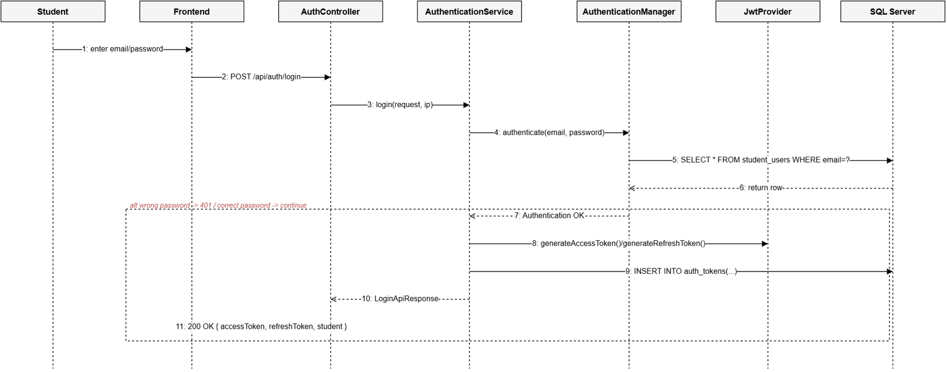

b. Class Specifications

AuthenticationService Class
No | Method | Description
01 | checkAccountType(email, ip) | Input: email, caller IP. Rate-limited to 10 calls/minute/IP. Returns the account type (Student/Staff/Admin) or not-found so the FE can show the right login form.
02 | login(LoginRequest, ip) | Authenticates a Student via AuthenticationManager + passwordEncoder; on success, issues an access token + refresh token (JwtProvider) and stores the refresh token in auth_tokens with actor_type=STUDENT.
03 | loginStaff(LoginRequest, ip) | Same as login but for StaffUser/AdminUser; additionally checks the account status (locked/inactive).
04 | refresh(RefreshTokenRequest) | Input: refresh token. Looks up auth_tokens by hash, checks expires_at and that it has not been revoked, issues a new access token (rotating the refresh token).
05 | logout(LogoutRequest) | Revokes (marks) the current refresh token in auth_tokens — no hard-delete (ADR-004).
06 | loginWithGoogle(GoogleTokenRequest) | Verifies the Google ID token, finds or creates a student_users row by oauth_provider_id, issues a JWT the same way as a normal login.

RegistrationService Class
No | Method | Description
01 | register(RegisterRequest) | Input: email, password, name. Hashes the password with bcrypt cost >= 10 (ADR-003), creates student_users with email_verified_at=null, and publishes a SendVerificationEmailEvent asynchronously.

c. Sequence Diagram(s)
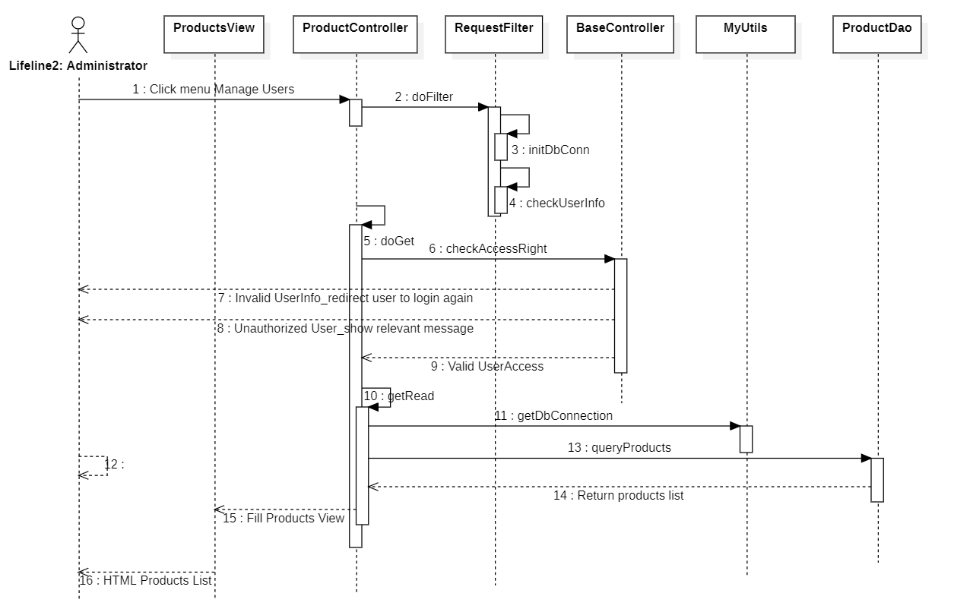

d. Database Queries
-- checkAccountType / login: look up the account by email
SELECT * FROM student_users WHERE email = ? AND is_deleted = 0;
-- store the refresh token on successful login
INSERT INTO auth_tokens (actor_type, actor_id, token_type, token_hash, expires_at, created_at)
VALUES ('STUDENT', ?, 'REFRESH', ?, ?, GETDATE());
-- refresh(): look up a still-valid refresh token
SELECT * FROM auth_tokens
WHERE token_hash = ? AND token_type = 'REFRESH' AND expires_at > GETDATE();
-- logout(): revoke the token (soft, no DELETE)
UPDATE auth_tokens SET revoked_at = GETDATE() WHERE token_hash = ?;

2. Quiz Submission (Assessment)

a. Class Diagram
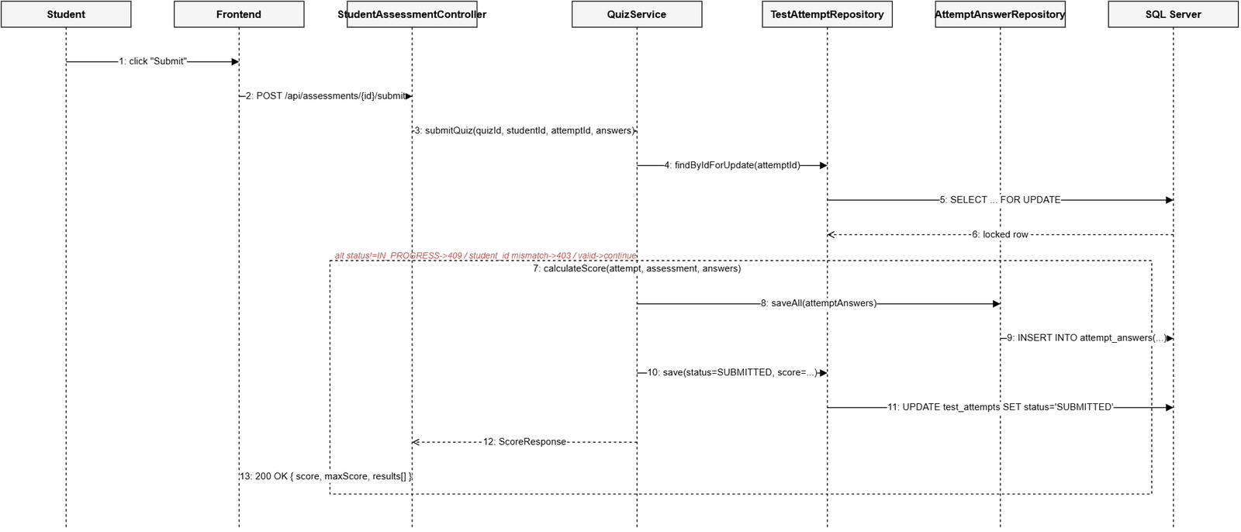

b. Class Specifications

QuizService Class
No | Method | Description
01 | startQuiz(quizId, student) | Input: quiz id, the current Student. Checks the quiz is PUBLISHED, loads the assigned questions (question_assignments), creates a new TestAttempt with status=IN_PROGRESS. Never returns the correct answers to the client.
02 | submitQuiz(quizId, studentId, attemptId, answers) | Locks the test_attempts row with findByIdForUpdate (pessimistic lock) to prevent a race on duplicate submission; checks attempt.student.id==studentId (blocks submitting on someone else's behalf) and status==IN_PROGRESS (blocks double submission, LESSON-005). Calls calculateScore.
03 | calculateScore(attempt, assessment, answers) | The score is computed entirely server-side, never trusting a score from the client: matches answers against each Question's correct_option, saves each AttemptAnswer, updates attempt.status=SUBMITTED.

c. Sequence Diagram(s)


d. Database Queries
-- startQuiz(): check the quiz is published
SELECT * FROM assessments
WHERE id = ? AND assessment_type = 'QUIZ' AND status = 'PUBLISHED';
-- load the assigned questions, in display order
SELECT qa.* FROM question_assignments qa
WHERE qa.parent_type = 'ASSESSMENT' AND qa.parent_id = ?
ORDER BY qa.display_order;
-- create a new attempt when the student starts the quiz
INSERT INTO test_attempts (student_id, attempt_type, parent_type, parent_id, started_at, max_score, status)
VALUES (?, 'QUIZ', 'ASSESSMENT', ?, GETDATE(), ?, 'IN_PROGRESS');
-- submitQuiz(): lock the attempt row to prevent duplicate submission
SELECT * FROM test_attempts WITH (UPDLOCK, ROWLOCK) WHERE id = ?;
-- save each answer after grading
INSERT INTO attempt_answers (attempt_id, question_id, selected_option, is_correct)
VALUES (?, ?, ?, ?);
-- update the attempt after submission
UPDATE test_attempts
SET status = 'SUBMITTED', submitted_at = GETDATE(), score = ?
WHERE id = ?;

3. Flashcard SRS (Spaced Repetition)

a. Class Diagram
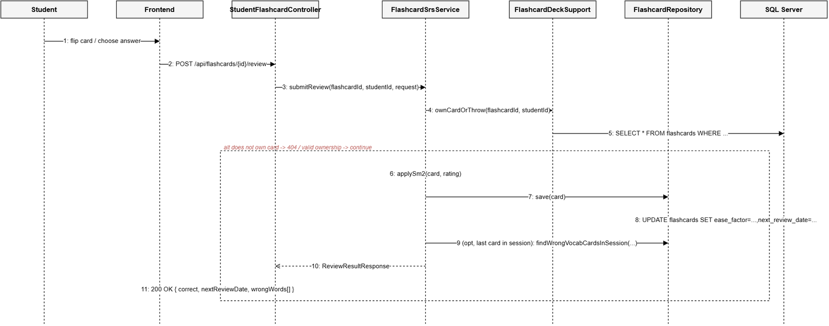

b. Class Specifications

FlashcardSrsService Class
No | Method | Description
01 | submitReview(flashcardId, studentId, ReviewRequest) | Verifies card ownership (ownCardOrThrow). For a multiple-choice vocabulary quiz, the server matches selectedOptionId against the correct contentId itself (never trusts a correct/incorrect flag from the client). Calls applySm2 to update the review schedule.
02 | getSession(studentId, deckId, topicId, newLimit) | Input: exactly one of deckId (personal notebook) or topicId (curriculum topic), plus a limit on new cards (default 10, cap 20). Locks on (studentId, deck/topic) to prevent two tabs creating a session at the same time. Priority order: not-yet-learned -> due for review -> the rest.
03 | applySm2(Flashcard, LastRating) | Implements the SM-2 algorithm: WRONG -> ease decreases (floor 1.30), repetitionCount resets; HARD -> ease unchanged; EASY -> ease+0.1 (cap 2.50). Always updates nextReviewDate = today + intervalDays.

c. Sequence Diagram(s)


d. Database Queries
-- ownCardOrThrow(): verify card ownership before grading
SELECT * FROM flashcards
WHERE flashcard_id = ? AND student_id = ? AND is_deleted = 0;
-- applySm2() -> save(): update the review schedule after grading
UPDATE flashcards
SET ease_factor = ?, interval_days = ?, repetition_count = ?,
next_review_date = ?, last_reviewed_at = GETDATE(), last_rating = ?
WHERE flashcard_id = ?;
-- end of session: collect words answered wrong in THIS session
SELECT * FROM flashcards
WHERE student_id = ? AND last_session_id = ? AND content_type = 'VOCABULARY' AND last_rating = 'WRONG';

4. Kanji Writing Evaluation (OCR/DTW Similarity)

a. Class Diagram
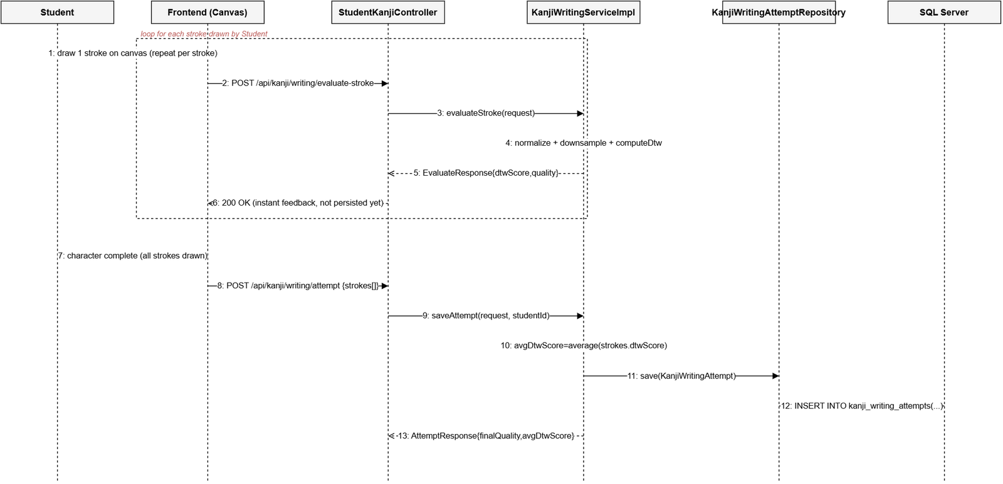

b. Class Specifications

KanjiWritingServiceImpl Class
No | Method | Description
01 | evaluateStroke(EvaluateRequest) | Input: the coordinates of the stroke the Student just drew + the reference stroke for that specific stroke index. Normalizes both paths (normalize+downsample to at most 20 points), computes the distance via DTW, maps it to a quality bucket using 3 fixed thresholds (300/650/1200). Synchronous, does not persist to the DB.
02 | saveAttempt(AttemptRequest, studentId) | Input: every stroke drawn for one Kanji character + the per-stroke DTW score. Computes avgDtwScore as the average of the per-stroke scores, derives finalQuality, saves one KanjiWritingAttempt row (with strokeDetails as JSON).
03 | computeDtw(s1, s2) | Classic Dynamic Time Warping (ADR-007: compares similarity % only, no stroke-order analysis like image-based OCR). Invariant to differences in drawing speed between the two paths.

c. Sequence Diagram(s)


d. Database Queries
-- saveAttempt(): persist one completed writing attempt
INSERT INTO kanji_writing_attempts
(student_id, kanji_id, character_value, total_strokes, avg_dtw_score, final_quality, stroke_details, created_by)
VALUES (?, ?, ?, ?, ?, ?, ?, ?);
-- evaluateStroke() never queries the DB — all DTW computation happens in memory per request.

5. Speaking Submission Grading (Shadowing)

a. Class Diagram
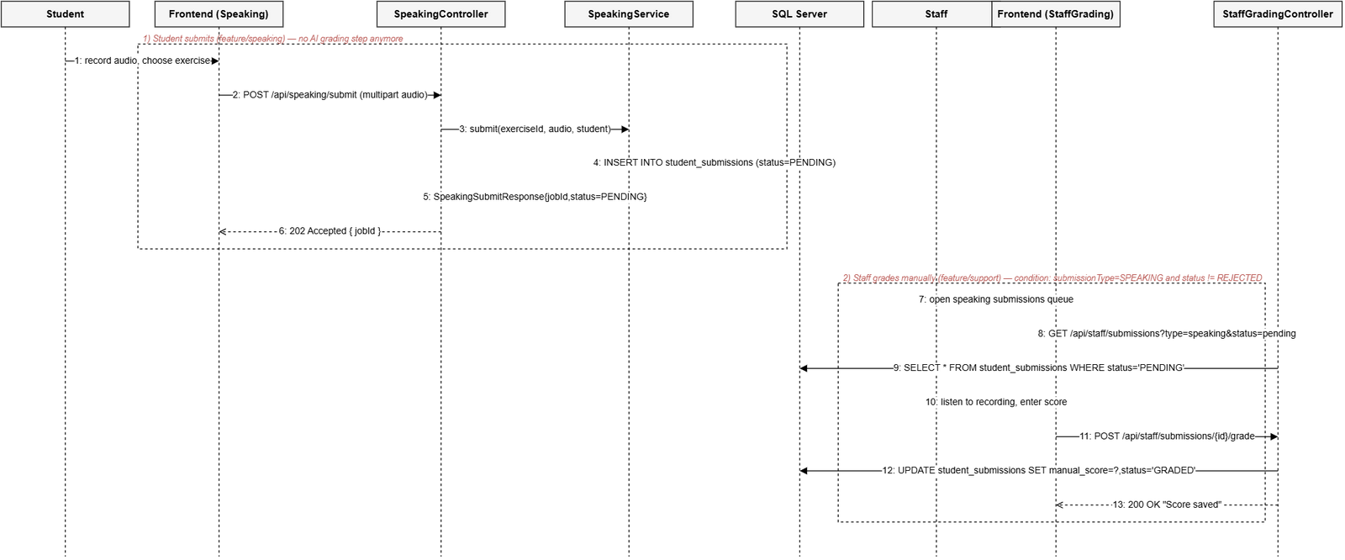

b. Class Specifications

SpeakingService Class
No | Method | Description
01 | getExercises(level, studentId) | Input: JLPT level + student id. Returns the list of published speaking exercises (Lesson of type SPEAKING) for that level, with attemptCount/bestScore (the student's highest teacher-graded score).
02 | submit(exerciseId, audio, student) | Input: exercise id + multipart audio file. Validates the exercise exists & is PUBLISHED, stores the file via SpeakingAudioStorageService (no BLOB in the DB, LESSON-002), creates a StudentSubmission with status=PENDING — there is no AI grading step (removed by a refactor, see the Sequence Diagram). Returns a jobId for the Student to poll.
03 | getResult(jobId, studentId) | Input: submission id + the calling student id (only ever returns that student's own submission). Returns PENDING if not yet graded (manualScore==null), COMPLETED with score/feedback once graded, FAILED if status=REJECTED.

SupportTicketService Class
No | Method | Description
01 | getAllSubmissions(submissionType, status, page, size) | Input: submissionType filter (default speaking), status, pagination. Returns a Page<SubmissionResponse> for the Staff grading queue (UC-31).
02 | getSubmissionDetail(submissionId) | Returns the detail of one submission: recordingUrl, and if already graded, manualScore/manualFeedback/gradedBy. finalScore = manualScore if present, otherwise falls back to aiOverallScore (a legacy column, always null for new data since the AI grading step was removed).
03 | manualGrade(submissionId, actorEmail, ManualGradeRequest) | Current business rule: can only grade a submission whose submissionType=SPEAKING (422 otherwise) and status != REJECTED (422 if already rejected) — no longer requires status=AI_GRADED as it used to, since the AI grading step was removed (commit db0d1648). Sets manualScore/manualFeedback/gradedBy/gradedAt, moves status to GRADED, sends a Notification (ACHIEVEMENT) and writes an AdminAuditLog.

c. Sequence Diagram(s)


d. Database Queries
-- SpeakingService.submit(): create a new submission, awaiting teacher grading (no AI step anymore)
INSERT INTO student_submissions (student_id, submission_type, status, exercise_id, recording_url, created_at)
VALUES (?, 'SPEAKING', 'PENDING', ?, ?, GETDATE());
-- SupportTicketService.getAllSubmissions(): the speaking grading queue
SELECT * FROM student_submissions
WHERE submission_type = 'SPEAKING' AND (status = ? OR ? IS NULL)
ORDER BY submitted_at ASC;
-- manualGrade(): record the teacher's score, change status (no longer checks status=AI_GRADED)
UPDATE student_submissions
SET manual_score = ?, manual_feedback = ?, graded_by = ?, graded_at = GETDATE(), status = 'GRADED'
WHERE submission_id = ? AND status != 'REJECTED';
-- notify the Student once grading is done
INSERT INTO notifications (student_id, title, message, notification_type, reference_key, created_by)
VALUES (?, 'Your speaking submission has been graded', ?, 'ACHIEVEMENT', ?, ?);

6. Content Review (Manager Approve/Reject)

a. Class Diagram
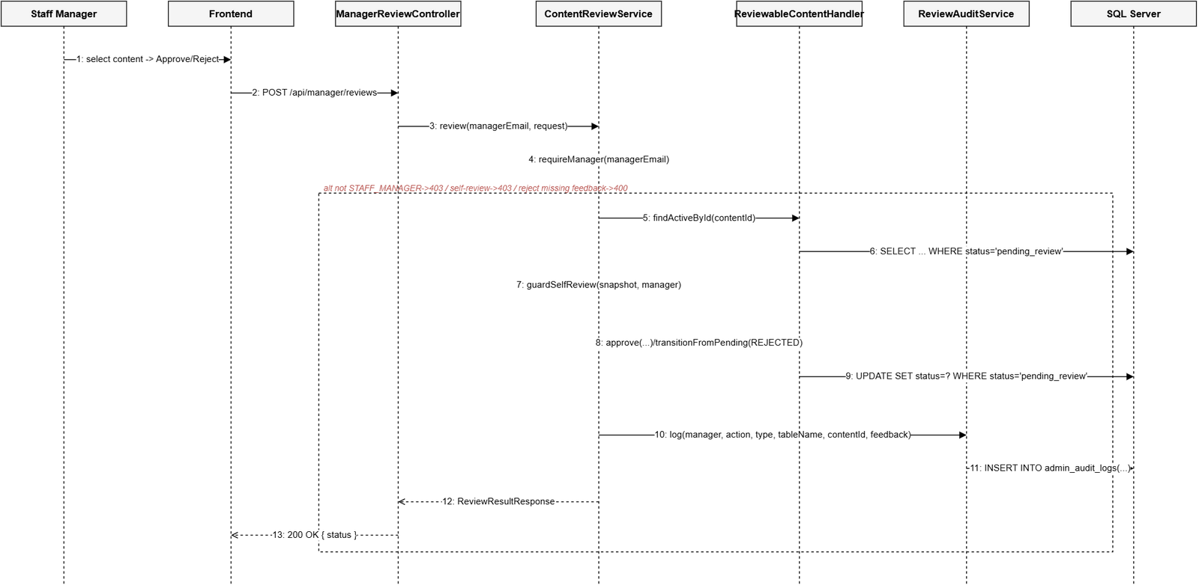

b. Class Specifications

ContentReviewService Class
No | Method | Description
01 | getContentDetail(managerEmail, contentId, typeStr) | Verifies managerEmail is an active STAFF_MANAGER (requireManager), resolves the right handler for the type (course/lesson/grammar/vocabulary/kanji/question/assessment), returns a snapshot (title, JLPT level, author, submission date, content).
02 | review(managerEmail, ReviewActionRequest) | Blocks reviewing one's own content (guardSelfReview). APPROVE -> handler.approve() (status=published); REJECT -> feedback is required, then handler.transitionFromPending(REJECTED). Every action is logged via ReviewAuditService.log(...).
03 | requestChanges(managerEmail, RequestChangesRequest) | Asks Staff to revise content: feedback is required, moves status back to draft (default) or rejected depending on targetStatus. Uses the same guardSelfReview + audit-log mechanism as review().
04 | ensureUpdated(affectedRows) | If the UPDATE affected 0 rows, the content is no longer in pending_review (already handled concurrently by another Manager) -> throws ConcurrentReviewException to prevent one review overwriting another.

c. Sequence Diagram(s)


d. Database Queries
-- findActiveById(): fetch content awaiting review (example: the GRAMMAR handler)
SELECT * FROM grammar_points WHERE grammar_id = ? AND status = 'pending_review';
-- approve(): only updates if still pending_review (prevents double approval)
UPDATE grammar_points
SET status = 'published', approved_by = ?, published_at = GETDATE()
WHERE grammar_id = ? AND status = 'pending_review';
-- reject() / requestChanges(): move back to draft or rejected
UPDATE grammar_points
SET status = ?, updated_at = GETDATE()
WHERE grammar_id = ? AND status = 'pending_review';
-- write an audit row for every review action
INSERT INTO admin_audit_logs (staff_id, action, target_table, target_id, note, created_at)
VALUES (?, ?, ?, ?, ?, GETDATE());

