
SOFTWARE DESIGN SPECIFICATION
Japanese Skill Practice Platform
- Hanoi, July 2026 -
Table of Contents
I. Record of Changes
II. Software Design Document
1. High Level Design
1.1 Software Architecture
1.2 Package Diagram
1.3 Database Design
2. State Transition Diagrams
3. Detailed Design

I. Record of Changes
Date | A/M/D | In charge | Change Description
2026-07-22 | A | AI Agent | Initial SDS_Document.docx built from the old Temp_Document/Template3 template: Overview (14 packages, DB schema) and 6 Code Designs flows (Auth, Quiz Submission, Flashcard SRS, Kanji Writing, Speaking Grading, Content Review).
2026-07-22 | M | AI Agent | Corrected the Speaking Submission Grading flow to match current code (no AI auto-grading step, commit db0d1648); translated to English.
2026-07-24 | M | AI Agent | Rebuilt against the correct template (Guides Templates-20260721/Template2_SDS Document.docx): restructured into I/II + 1.High Level Design (1.1 new Architecture diagram, 1.2 Package Diagram, 1.3 Database Design rewritten as one sub-section per table with real PK/FK/UN/NN fields from V1__init_schema.sql) + 2.State Transition Diagrams (new — 3 real status columns) + 3.Detailed Design (6 features, kept Class Specifications/Database Queries as bonus content). Fixed every diagram where an arrow or line previously crossed through another box's text (class diagrams, package diagram, ER diagram).
2026-07-24 | M | AI Agent | Fixed section 3's heading skeleton to match Template2 exactly (3.N.1 Class Diagram, 3.N.2 <named Sequence Diagram> — e.g. '3.1.2 User Login Sequence' — instead of a generic '3.N.3 Sequence Diagram(s)'/'3.N.4 Database Queries'); Class Specifications and Database Queries are now supporting content under those two headings, not separate numbered sections.
*A - Added, M - Modified, D - Deleted

II. Software Design Document

1. High Level Design

1.1 Software Architecture
The system is a monolithic Spring Boot 3 / Java 21 backend (ADR-002) behind a REST API, serving a React 18 single-page frontend, with MySQL 8 as the primary datastore (ADR-009) and four external systems reached only from the backend: SMTP (email), Google OAuth (social login), file storage for media (ADR-006 — no BLOB in the DB), and an external AI service for OCR/Speech scoring, always called asynchronously (ADR anti-pattern: no Sync AI Calls).
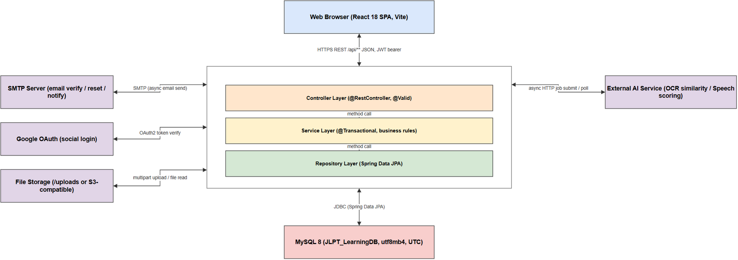

1.2 Package Diagram
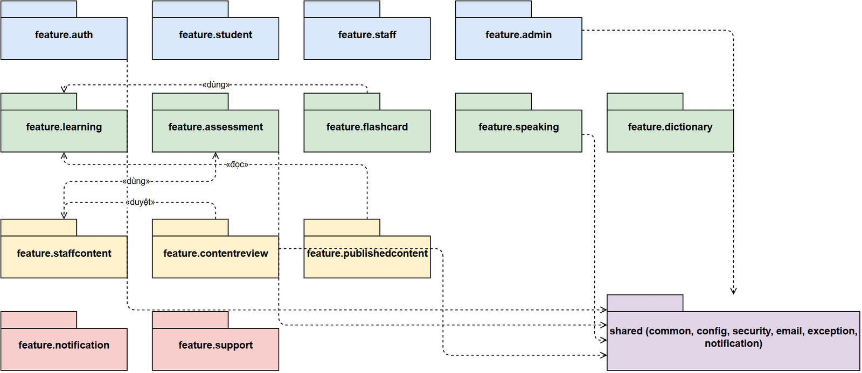
Package descriptions
No | Package | Description
01 | auth | Student login/register, JWT access + refresh token, email verification, forgot password, Google OAuth login.
02 | staff | Staff/StaffManager accounts: separate login, staff member management, staff password reset.
03 | admin | Admin accounts, audit log, statistics dashboard, system configuration (system_settings), maintenance mode.
04 | student | Student profile, dashboard, learning progress (student_content_progress), avatar, enrolled courses.
05 | learning | Learning content: Kana, Kanji, Vocabulary, Grammar, Lesson by JLPT level (N5-N1).
06 | assessment | Question bank, Quiz/Exam (Assessment), attempts (TestAttempt), server-side grading, speaking/writing submissions (StudentSubmission).
07 | speaking | Student records and submits speaking (shadowing) exercises, polls the result (SpeakingController/SpeakingService); grading is done by teachers in the support package — no AI auto-grading step (removed by a recent refactor).
08 | staffcontent | Where Staff draft content before publishing: questions, quizzes, exams, grammar, vocabulary, and a dedicated Staff dashboard.
09 | contentreview | Content review flow for Staff-authored content (approve/reject) before it goes public, with review audit logging.
10 | publishedcontent | Snapshot of published content, served to Students (kept separate from Staff's draft copy).
11 | flashcard | Flashcard + Spaced Repetition (SRS), system decks or user-created decks.
12 | dictionary | Kanji/Vocabulary dictionary lookup by keyword or type.
13 | notification | Notifications sent to individual Students (notification type, delivery channel).
14 | support | Support tickets submitted by Students and staff replies (TicketReply); Staff's speaking-grading queue (SupportTicketService, UC-31).

1.3 Database Design
DBMS: MySQL 8.4 (LTS), database JLPT_LearningDB, utf8mb4/utf8mb4_unicode_ci, container UTC (ADR-009). Schema source of truth: apps/backend/src/main/resources/db/migration/V1__init_schema.sql. The diagram below and the 13 tables detailed in this section are the core tables behind the 6 flows in section 3 — see docs/02-SDD-Architecture/database-design/JLPT_database.md for the full table list (note: that markdown predates the MySQL migration in a few narrative details; this section's field-level tables come directly from the current SQL migration, not from that file).
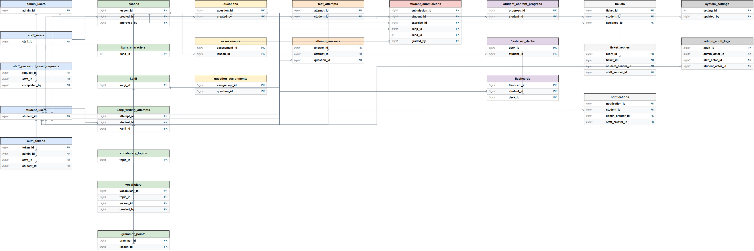

1.3.1 admin_users
System administrator accounts.
No | Field | PK | FK | UN | NN | Description
01 | admin_id | X |  |  | X | PK, auto-increment.
02 | email |  |  | X | X | Login email, unique.
03 | password_hash |  |  |  |  | Bcrypt hash (cost >= 10, ADR-003); nullable until first password set.
04 | full_name |  |  |  | X | Display name.
05 | status |  |  |  | X | active / suspended / pending / deleted.
06 | login_attempts |  |  |  | X | Failed login counter for lockout.
07 | locked_until |  |  |  |  | Lockout expiry timestamp.
08 | last_login_at |  |  |  |  | Last successful login.
09 | created_at / updated_at |  |  |  | X | Audit timestamps.

1.3.2 staff_users
Staff and StaffManager accounts (StaffManager is staff_role='staff_manager', not a separate table).
No | Field | PK | FK | UN | NN | Description
01 | staff_id | X |  |  | X | PK, auto-increment.
02 | email |  |  | X | X | Login email, unique.
03 | password_hash |  |  |  |  | Bcrypt hash; nullable until Admin provisions/first login.
04 | full_name |  |  |  | X | Display name.
05 | staff_role |  |  |  | X | staff / staff_manager.
06 | status |  |  |  | X | active / suspended / pending / deleted.
07 | must_change_password |  |  |  | X | Forces password change after Admin-issued temp password.
08 | login_attempts / locked_until / last_login_at |  |  |  |  | Lockout tracking, same pattern as admin_users.
09 | created_at / updated_at |  |  |  | X | Audit timestamps.

1.3.3 student_users
Student accounts, including Google OAuth identity and JLPT level/streak tracking.
No | Field | PK | FK | UN | NN | Description
01 | student_id | X |  |  | X | PK, auto-increment.
02 | email |  |  | X | X | Login email, unique.
03 | password_hash |  |  |  |  | Bcrypt hash; nullable for OAuth-only accounts.
04 | full_name |  |  |  | X | Display name.
05 | status |  |  |  | X | active / suspended / pending / deleted.
06 | email_verified_at |  |  |  |  | Set after OTP verification (UC-02).
07 | avatar_url / phone |  |  |  |  | Profile fields (UC-04).
08 | oauth_provider / oauth_provider_id / oauth_provider_email / oauth_linked_at |  |  | X* |  | *Unique together (oauth_provider, oauth_provider_id) — Google login (UC-01).
09 | current_jlpt_level / target_jlpt_level |  |  |  |  | N5-N1, used for content access checks (BR-08).
10 | current_streak / longest_streak / last_activity_date |  |  |  |  | Learning streak stats (UC-19).
11 | login_attempts / locked_until / last_login_at |  |  |  |  | Lockout tracking after 5 failed attempts (BR from AuthenticationService).
12 | created_at / updated_at |  |  |  | X | Audit timestamps.

1.3.4 auth_tokens
Shared token store (session, refresh, reset password, email verification) for all 3 actor types.
No | Field | PK | FK | UN | NN | Description
01 | token_id | X |  |  | X | PK, auto-increment.
02 | actor_type |  |  |  | X | admin / staff / student.
03 | admin_id / staff_id / student_id |  | X |  |  | Exactly one is set, per actor_type (CK_auth_token_actor).
04 | token_type |  |  |  | X | session / email_verification / password_reset / refresh / limited_session.
05 | token_value |  |  |  | X | Random UUID, or 6-digit OTP for email_verification.
06 | ip_address |  |  |  |  | Request IP at issuance.
07 | expires_at |  |  |  | X | Expiry timestamp.
08 | revoked_at |  |  |  |  | Soft revoke on logout (ADR-004 — no hard delete).
09 | created_at |  |  |  | X | Issue timestamp.

1.3.5 questions
Question bank with inline A/B/C/D options (no separate question_options table).
No | Field | PK | FK | UN | NN | Description
01 | question_id | X |  |  | X | PK, auto-increment.
02 | question_text |  |  |  | X | Question body.
03 | question_type |  |  |  | X | multiple_choice / fill_blank / true_false.
04 | skill |  |  |  | X | vocabulary / grammar / kanji / reading / listening / mixed.
05 | jlpt_level |  |  |  | X | N5-N1.
06 | option_a .. option_d / correct_option |  |  |  |  | Inline options + correct letter (multiple_choice).
07 | correct_answer_text |  |  |  |  | Correct text (fill_blank).
08 | created_by / approved_by |  | X |  |  | FK -> staff_users.
09 | status |  |  |  | X | draft / pending_review / rejected / published / archived / deleted.
10 | published_at / created_at / updated_at |  |  |  |  | Lifecycle timestamps.

1.3.6 assessments
Quiz and Exam combined via assessment_type (no separate quizzes/exams tables).
No | Field | PK | FK | UN | NN | Description
01 | assessment_id | X |  |  | X | PK, auto-increment.
02 | assessment_type |  |  |  | X | quiz / exam.
03 | title |  |  |  | X | Assessment title.
04 | lesson_id |  | X |  |  | FK -> lessons, optional link to a lesson.
05 | jlpt_level / duration_min / pass_score / total_score |  |  |  |  | Exam parameters.
06 | status |  |  |  | X | draft / pending_review / rejected / published / archived / deleted.
07 | is_deleted |  |  |  | X | Soft delete flag (ADR-004).
08 | created_by / approved_by |  | X |  |  | FK -> staff_users.
09 | published_at / created_at / updated_at |  |  |  |  | Lifecycle timestamps.

1.3.7 test_attempts
One quiz/exam/practice attempt by a Student; status prevents double submission (LESSON-005).
No | Field | PK | FK | UN | NN | Description
01 | attempt_id | X |  |  | X | PK, auto-increment.
02 | student_id |  | X |  | X | FK -> student_users, ON DELETE CASCADE.
03 | attempt_type |  |  |  | X | exam / quiz / practice / reading / listening.
04 | parent_type / parent_id |  |  |  | X* | *parent_type required; identifies the assessment/lesson attempted.
05 | started_at / submitted_at / duration_seconds |  |  |  |  | Timing, validated server-side (BR-02).
06 | total_score / max_score / is_passed |  |  |  |  | Computed only in the Service layer, never trusted from client (BR-02).
07 | language_knowledge_score / reading_score / listening_score |  |  |  |  | Per-section JLPT scores.
08 | status |  |  |  | X | in_progress / submitted / auto_submitted / abandoned (see §2.1 State Diagram).

1.3.8 attempt_answers
A Student's answer to each question in an attempt, used for grading and review.
No | Field | PK | FK | UN | NN | Description
01 | answer_id | X |  |  | X | PK, auto-increment.
02 | attempt_id |  | X |  | X | FK -> test_attempts, ON DELETE CASCADE.
03 | question_id |  | X |  | X | FK -> questions.
04 | selected_option / answer_text |  |  |  |  | Student's answer (multiple_choice / fill_blank).
05 | is_correct / score |  |  |  |  | Computed server-side during grading (BR-02).
06 | answered_at |  |  |  | X | Answer timestamp.

1.3.9 student_submissions
Speaking/handwriting submissions requiring Staff grading (legacy AI columns kept for old data).
No | Field | PK | FK | UN | NN | Description
01 | submission_id | X |  |  | X | PK, auto-increment.
02 | student_id |  | X |  | X | FK -> student_users, ON DELETE CASCADE.
03 | submission_type |  |  |  | X | speaking / handwriting.
04 | status |  |  |  | X | pending / ai_graded / graded / rejected (see §2.2 State Diagram).
05 | exercise_id |  | X |  |  | FK -> lessons (speaking exercise).
06 | recording_url / duration_seconds |  |  |  |  | Speaking submission media (no BLOB, ADR-006).
07 | ai_overall_score .. ai_graded_at |  |  |  |  | Legacy AI-grading columns; not written by current code.
08 | kanji_id / kana_id |  | X |  |  | FK -> kanji / kana_characters (handwriting OCR target).
09 | handwriting_image_url / expected_character / recognized_character / similarity_percent |  |  |  |  | OCR handwriting fields (ADR-007: similarity % only).
10 | manual_score / manual_feedback / graded_by / graded_at |  | X* |  |  | *graded_by -> staff_users. Staff's final grade (AGENTS.md §7.5).
11 | submitted_at / updated_at |  |  |  | X | Lifecycle timestamps.

1.3.10 flashcard_decks
Flashcard deck (system or personal); first-class table separate from flashcards.
No | Field | PK | FK | UN | NN | Description
01 | deck_id | X |  |  | X | PK, auto-increment.
02 | student_id |  | X |  |  | FK -> student_users; NULL for system decks.
03 | name / description / jlpt_level / topic / color / display_order |  |  |  |  | Deck metadata.
04 | is_system / is_review_deck |  |  |  | X | System deck flag; 1 auto-generated review deck per student.
05 | is_deleted |  |  |  | X | Soft delete flag (ADR-004).
06 | active_name_key / review_deck_key |  |  | X |  | Generated columns emulating SQL Server's filtered unique index on MySQL.

1.3.11 flashcards
One flashcard belonging to a Student, plus SRS state (ease_factor, interval_days, next_review_date).
No | Field | PK | FK | UN | NN | Description
01 | flashcard_id | X |  |  | X | PK, auto-increment.
02 | student_id |  | X |  |  | FK -> student_users.
03 | deck_id |  | X |  | X | FK -> flashcard_decks.
04 | content_type / content_id |  |  |  | X* | *content_type required; kanji / vocabulary / grammar / custom.
05 | front_text / back_text |  |  |  |  | Card content (custom cards).
06 | last_rating |  |  |  |  | easy / hard / wrong — last SM-2 review outcome.
07 | interval_days / repetition_count / ease_factor / next_review_date / last_reviewed_at |  |  |  |  | SM-2 spaced-repetition state (default ease_factor 2.50).
08 | last_session_id |  |  |  |  | Groups cards reviewed in the same session.
09 | is_deleted / created_at |  |  |  | X | Soft delete flag + creation timestamp.

1.3.12 kanji_writing_attempts
One Student attempt at hand-writing a Kanji character on canvas; DTW similarity score.
No | Field | PK | FK | UN | NN | Description
01 | attempt_id | X |  |  | X | PK, auto-increment.
02 | student_id |  | X |  | X | FK -> student_users.
03 | kanji_id / character_value |  |  |  | X* | *character_value required; kanji_id references kanji.kanji_id.
04 | total_strokes / avg_dtw_score |  |  |  | X* | *total_strokes required; avg_dtw_score is the DTW similarity metric (ADR-007).
05 | final_quality |  |  |  |  | perfect / good / ok / bad, derived from avg_dtw_score thresholds.
06 | stroke_details |  |  |  |  | Per-stroke coordinates (JSON text).
07 | is_deleted / created_at / updated_at / created_by |  |  |  | X* | *is_deleted required; soft delete flag (ADR-004).

1.3.13 admin_audit_logs
Records every content-review / submission-grading / admin action taken by Staff, StaffManager, or Admin.
No | Field | PK | FK | UN | NN | Description
01 | audit_id | X |  |  | X | PK, auto-increment.
02 | admin_actor_id / staff_actor_id / student_actor_id |  | X |  |  | Exactly one is set (CK_audit_actor).
03 | action |  |  |  | X | Action name, e.g. APPROVE_CONTENT, GRADE_SUBMISSION.
04 | target_table / target_id |  |  |  |  | The row the action was performed on.
05 | description |  |  |  |  | Free-text detail of the action.
06 | ip_address / created_at |  |  |  | X* | *created_at required; actor's IP + audit timestamp.

2. State Transition Diagrams

2.1 Test Attempt Status
Status column: test_attempts.status. Applies to every quiz/exam/practice attempt (UC-10, UC-11). The attempt starts in_progress on the server, and moves to exactly one final state — submitted (student action), auto_submitted (server-side timer), or abandoned (session ends without submitting). All three final states are immutable once reached (BR-04): the score and answers can never be changed afterward.
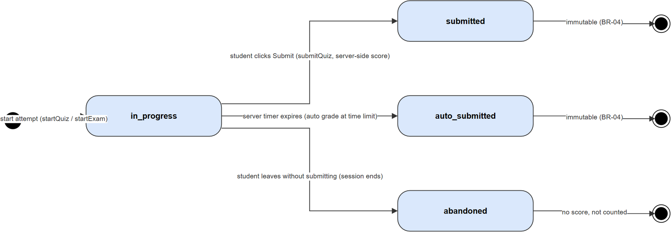

2.2 Student Submission Status
Status column: student_submissions.status. Applies to speaking (UC-13) and handwriting (UC-20) submissions. The current code path is pending -> graded / rejected by Staff (SupportTicketService.manualGrade); the ai_graded state and its transitions (dashed, red) are legacy — the schema still allows them for old data, but no current code path creates them, since AI auto-grading was removed (commit db0d1648).
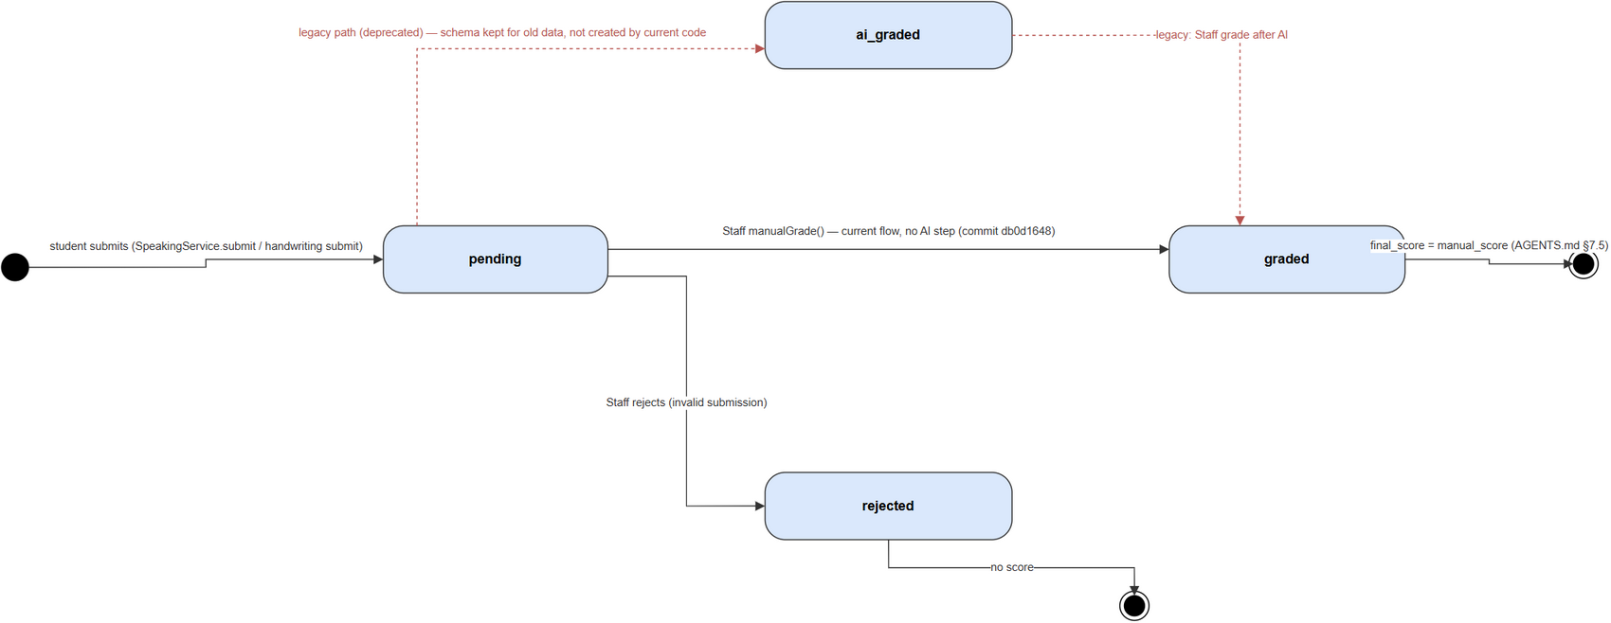

2.3 Learning Content Review Status
Shared status column used by lessons, kanji, vocabulary, grammar_points, questions, and assessments. Staff authors content as draft, submits it for pending_review, and a StaffManager either approves (published), rejects, or requests changes (back to draft) — see ContentReviewService in §3.6. Published content can later be archived/restored, and archived content can be soft-deleted (ADR-004: is_deleted flag or status=deleted, never a hard DELETE).
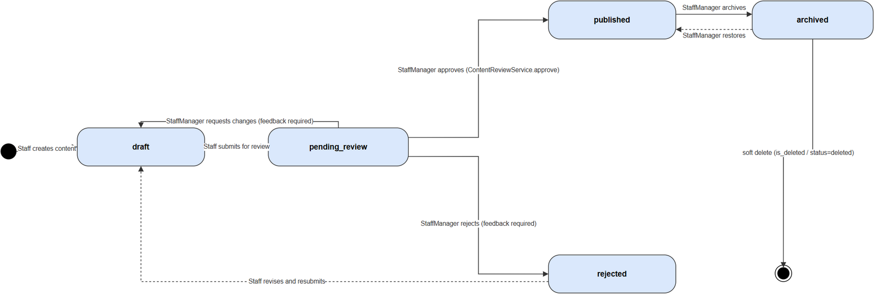

3. Detailed Design
Each feature below provides a Class Diagram and a Sequence Diagram, per Template2's structure. Class Specifications (method-level detail) and Database Queries are included as supporting content directly under the diagram they document, rather than as separate numbered sections.

3.1 Authentication & Login

3.1.1 Class Diagram
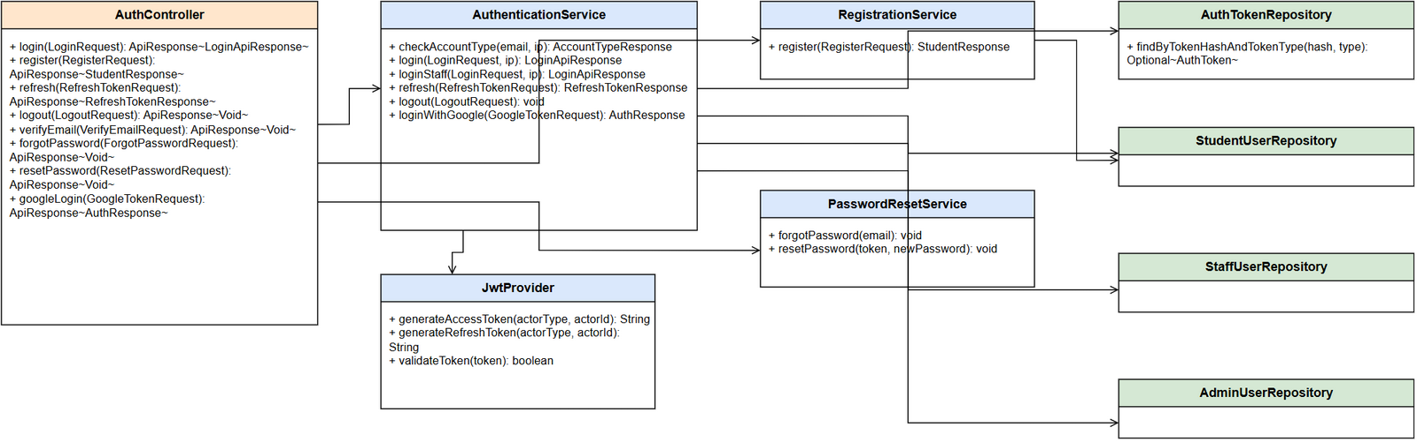
Class Specifications
AuthenticationService Class
No | Method | Description
01 | checkAccountType(email, ip) | Input: email, caller IP. Rate-limited to 10 calls/minute/IP. Returns the account type (Student/Staff/Admin) or not-found so the FE can show the right login form.
02 | login(LoginRequest, ip) | Authenticates a Student via AuthenticationManager + passwordEncoder; on success, issues an access token + refresh token (JwtProvider) and stores the refresh token in auth_tokens with actor_type=STUDENT.
03 | loginStaff(LoginRequest, ip) | Same as login but for StaffUser/AdminUser; additionally checks the account status (locked/inactive).
04 | refresh(RefreshTokenRequest) | Input: refresh token. Looks up auth_tokens by hash, checks expires_at and that it has not been revoked, issues a new access token (rotating the refresh token).
05 | logout(LogoutRequest) | Revokes (marks) the current refresh token in auth_tokens — no hard-delete (ADR-004).
06 | loginWithGoogle(GoogleTokenRequest) | Verifies the Google ID token, finds or creates a student_users row by oauth_provider_id, issues a JWT the same way as a normal login.
RegistrationService Class
No | Method | Description
01 | register(RegisterRequest) | Input: email, password, name. Hashes the password with bcrypt cost >= 10 (ADR-003), creates student_users with email_verified_at=null, and publishes a SendVerificationEmailEvent asynchronously.

3.1.2 User Login Sequence
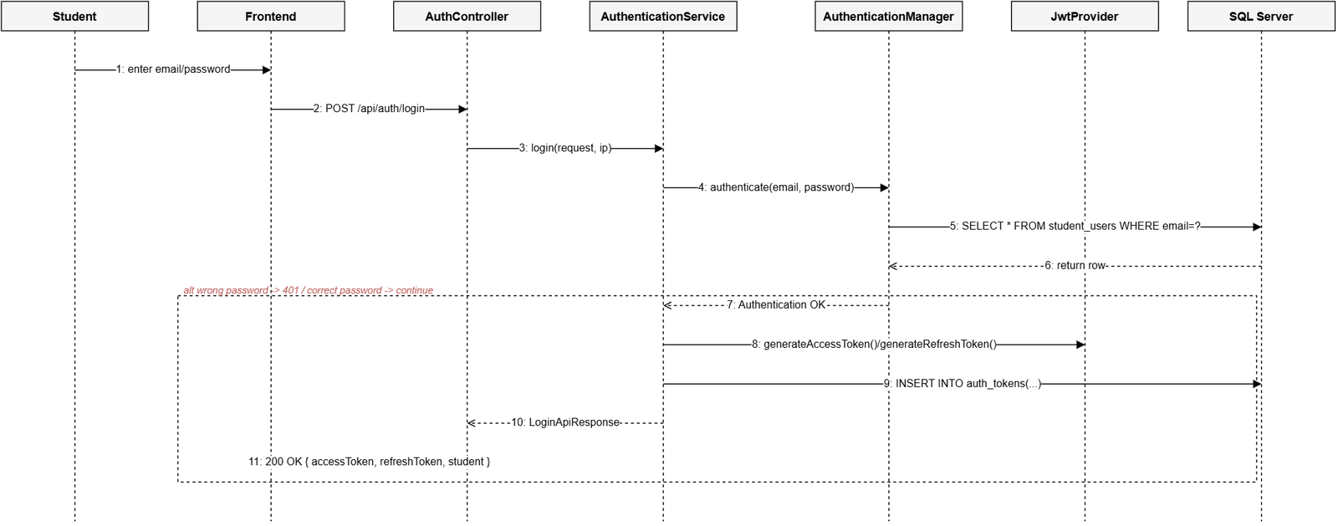
Database Queries
-- checkAccountType / login: look up the account by email
SELECT * FROM student_users WHERE email = ? AND is_deleted = 0;
-- store the refresh token on successful login
INSERT INTO auth_tokens (actor_type, actor_id, token_type, token_hash, expires_at, created_at)
VALUES ('STUDENT', ?, 'REFRESH', ?, ?, GETDATE());
-- refresh(): look up a still-valid refresh token
SELECT * FROM auth_tokens
WHERE token_hash = ? AND token_type = 'REFRESH' AND expires_at > GETDATE();
-- logout(): revoke the token (soft, no DELETE)
UPDATE auth_tokens SET revoked_at = GETDATE() WHERE token_hash = ?;

3.2 Quiz Submission (Assessment)

3.2.1 Class Diagram
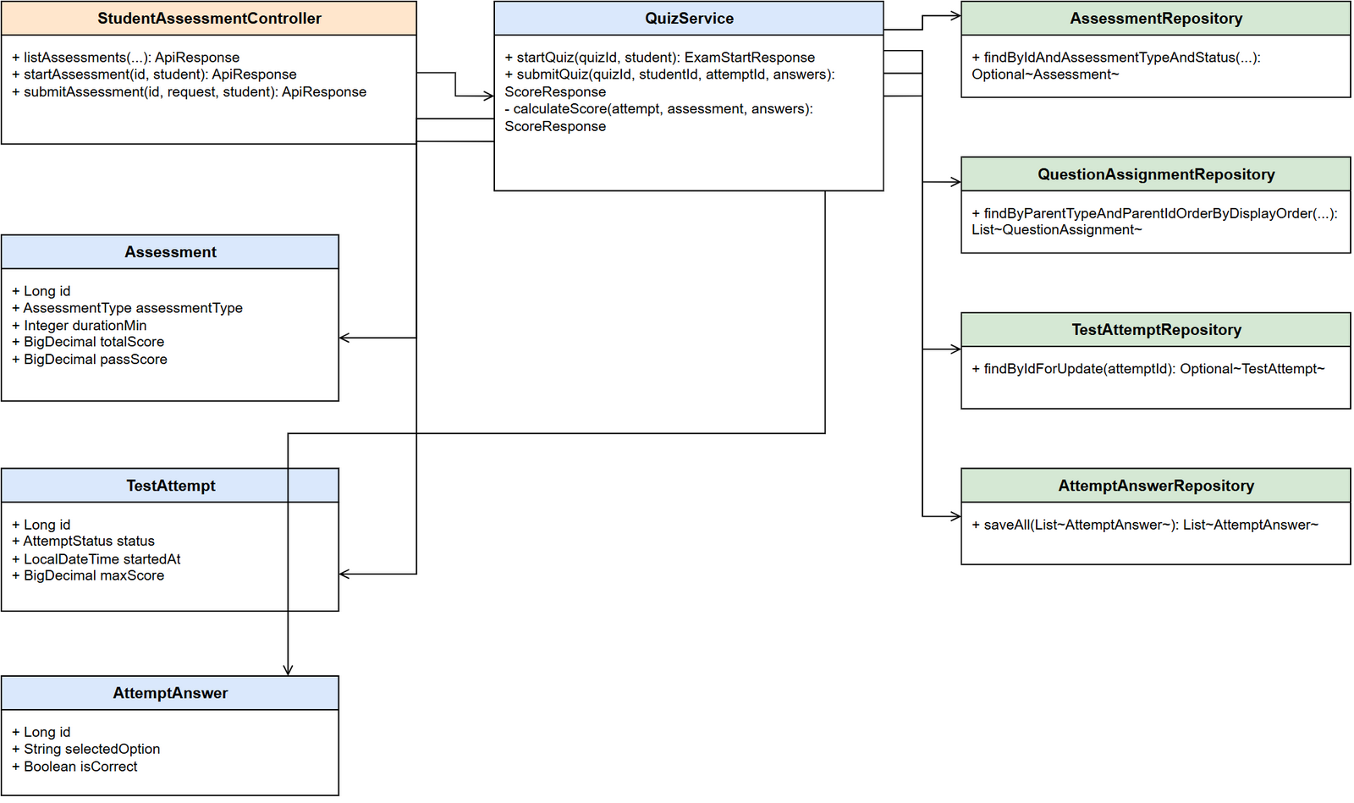
Class Specifications
QuizService Class
No | Method | Description
01 | startQuiz(quizId, student) | Input: quiz id, the current Student. Checks the quiz is PUBLISHED, loads the assigned questions (question_assignments), creates a new TestAttempt with status=IN_PROGRESS. Never returns the correct answers to the client.
02 | submitQuiz(quizId, studentId, attemptId, answers) | Locks the test_attempts row with findByIdForUpdate (pessimistic lock) to prevent a race on duplicate submission; checks attempt.student.id==studentId (blocks submitting on someone else's behalf) and status==IN_PROGRESS (blocks double submission, LESSON-005). Calls calculateScore.
03 | calculateScore(attempt, assessment, answers) | The score is computed entirely server-side, never trusting a score from the client: matches answers against each Question's correct_option, saves each AttemptAnswer, updates attempt.status=SUBMITTED.

3.2.2 Submit Quiz Sequence
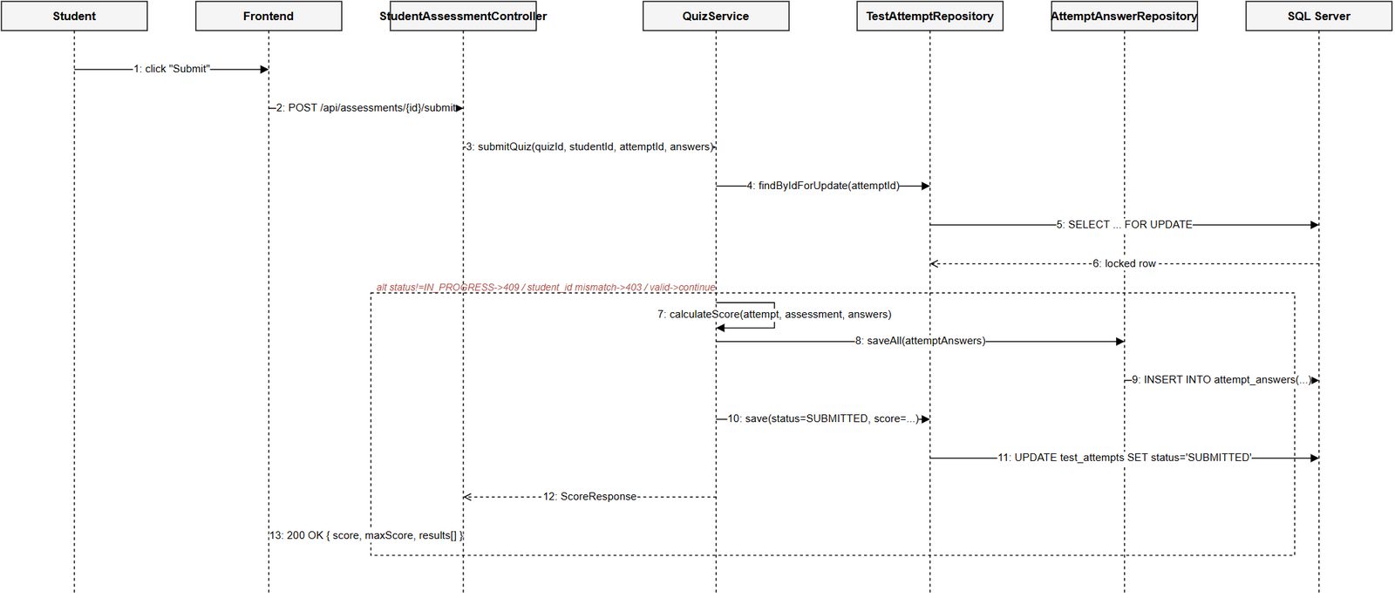
Database Queries
-- startQuiz(): check the quiz is published
SELECT * FROM assessments
WHERE id = ? AND assessment_type = 'QUIZ' AND status = 'PUBLISHED';
-- load the assigned questions, in display order
SELECT qa.* FROM question_assignments qa
WHERE qa.parent_type = 'ASSESSMENT' AND qa.parent_id = ?
ORDER BY qa.display_order;
-- create a new attempt when the student starts the quiz
INSERT INTO test_attempts (student_id, attempt_type, parent_type, parent_id, started_at, max_score, status)
VALUES (?, 'QUIZ', 'ASSESSMENT', ?, GETDATE(), ?, 'IN_PROGRESS');
-- submitQuiz(): lock the attempt row to prevent duplicate submission
SELECT * FROM test_attempts WITH (UPDLOCK, ROWLOCK) WHERE id = ?;
-- save each answer after grading
INSERT INTO attempt_answers (attempt_id, question_id, selected_option, is_correct)
VALUES (?, ?, ?, ?);
-- update the attempt after submission
UPDATE test_attempts
SET status = 'SUBMITTED', submitted_at = GETDATE(), score = ?
WHERE id = ?;

3.3 Flashcard SRS (Spaced Repetition)

3.3.1 Class Diagram
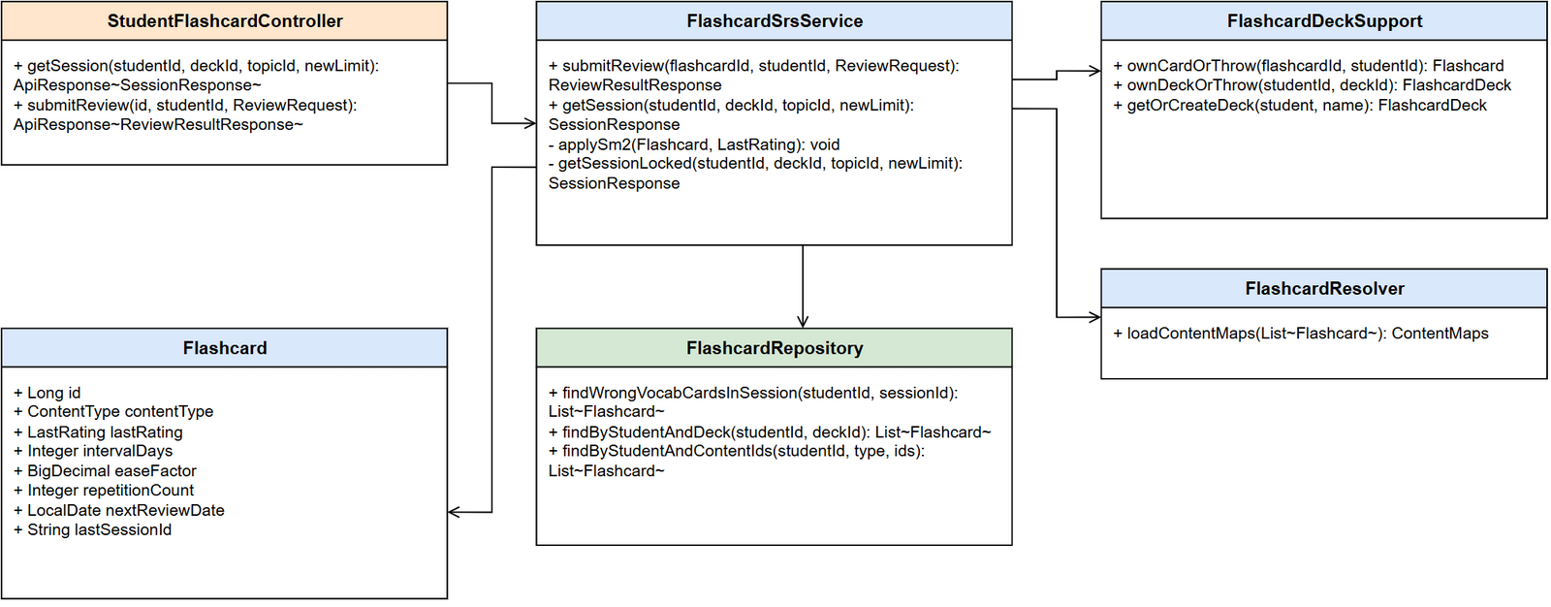
Class Specifications
FlashcardSrsService Class
No | Method | Description
01 | submitReview(flashcardId, studentId, ReviewRequest) | Verifies card ownership (ownCardOrThrow). For a multiple-choice vocabulary quiz, the server matches selectedOptionId against the correct contentId itself (never trusts a correct/incorrect flag from the client). Calls applySm2 to update the review schedule.
02 | getSession(studentId, deckId, topicId, newLimit) | Input: exactly one of deckId (personal notebook) or topicId (curriculum topic), plus a limit on new cards (default 10, cap 20). Locks on (studentId, deck/topic) to prevent two tabs creating a session at the same time. Priority order: not-yet-learned -> due for review -> the rest.
03 | applySm2(Flashcard, LastRating) | Implements the SM-2 algorithm: WRONG -> ease decreases (floor 1.30), repetitionCount resets; HARD -> ease unchanged; EASY -> ease+0.1 (cap 2.50). Always updates nextReviewDate = today + intervalDays.

3.3.2 Flashcard Review Sequence
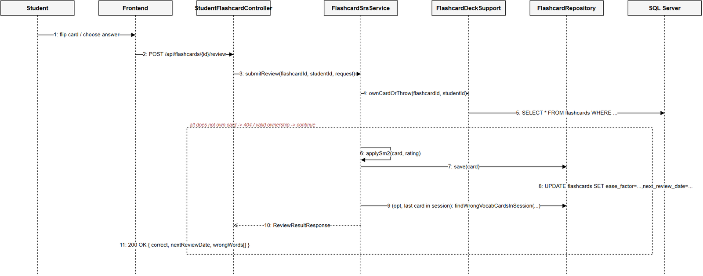
Database Queries
-- ownCardOrThrow(): verify card ownership before grading
SELECT * FROM flashcards
WHERE flashcard_id = ? AND student_id = ? AND is_deleted = 0;
-- applySm2() -> save(): update the review schedule after grading
UPDATE flashcards
SET ease_factor = ?, interval_days = ?, repetition_count = ?,
next_review_date = ?, last_reviewed_at = GETDATE(), last_rating = ?
WHERE flashcard_id = ?;
-- end of session: collect words answered wrong in THIS session
SELECT * FROM flashcards
WHERE student_id = ? AND last_session_id = ? AND content_type = 'VOCABULARY' AND last_rating = 'WRONG';

3.4 Kanji Writing Evaluation (OCR/DTW Similarity)

3.4.1 Class Diagram
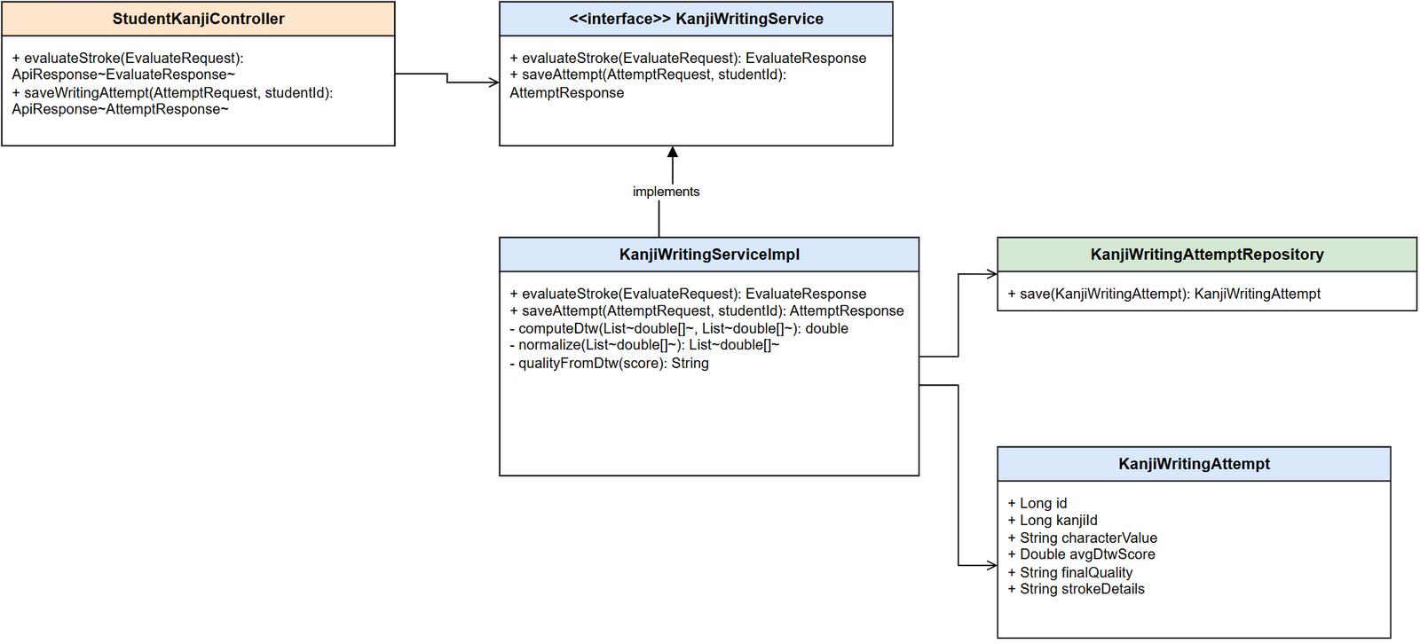
Class Specifications
KanjiWritingServiceImpl Class
No | Method | Description
01 | evaluateStroke(EvaluateRequest) | Input: the coordinates of the stroke the Student just drew + the reference stroke for that specific stroke index. Normalizes both paths (normalize+downsample to at most 20 points), computes the distance via DTW, maps it to a quality bucket using 3 fixed thresholds (300/650/1200). Synchronous, does not persist to the DB.
02 | saveAttempt(AttemptRequest, studentId) | Input: every stroke drawn for one Kanji character + the per-stroke DTW score. Computes avgDtwScore as the average of the per-stroke scores, derives finalQuality, saves one KanjiWritingAttempt row (with strokeDetails as JSON).
03 | computeDtw(s1, s2) | Classic Dynamic Time Warping (ADR-007: compares similarity % only, no stroke-order analysis like image-based OCR). Invariant to differences in drawing speed between the two paths.

3.4.2 Kanji Writing Evaluation Sequence
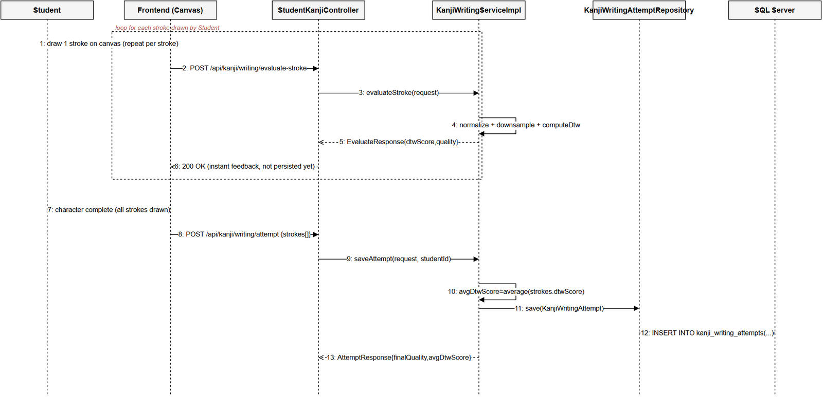
Database Queries
-- saveAttempt(): persist one completed writing attempt
INSERT INTO kanji_writing_attempts
(student_id, kanji_id, character_value, total_strokes, avg_dtw_score, final_quality, stroke_details, created_by)
VALUES (?, ?, ?, ?, ?, ?, ?, ?);
-- evaluateStroke() never queries the DB — all DTW computation happens in memory per request.

3.5 Speaking Submission Grading (Shadowing)

3.5.1 Class Diagram
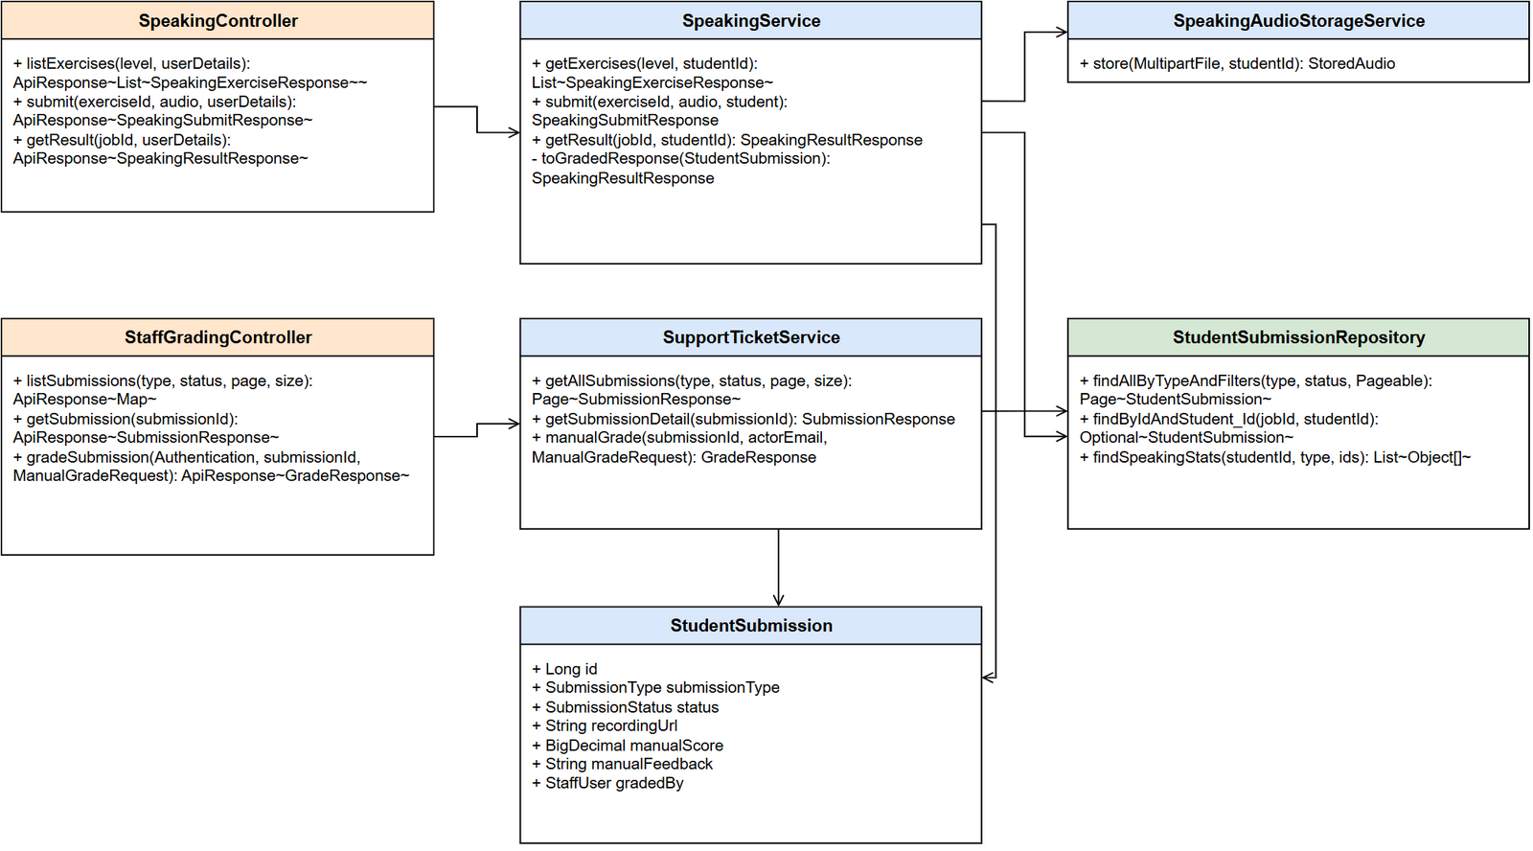
Class Specifications
SpeakingService Class
No | Method | Description
01 | getExercises(level, studentId) | Input: JLPT level + student id. Returns the list of published speaking exercises (Lesson of type SPEAKING) for that level, with attemptCount/bestScore (the student's highest teacher-graded score).
02 | submit(exerciseId, audio, student) | Input: exercise id + multipart audio file. Validates the exercise exists & is PUBLISHED, stores the file via SpeakingAudioStorageService (no BLOB in the DB, LESSON-002), creates a StudentSubmission with status=PENDING — there is no AI grading step (removed by a refactor, see the Sequence Diagram). Returns a jobId for the Student to poll.
03 | getResult(jobId, studentId) | Input: submission id + the calling student id (only ever returns that student's own submission). Returns PENDING if not yet graded (manualScore==null), COMPLETED with score/feedback once graded, FAILED if status=REJECTED.
SupportTicketService Class
No | Method | Description
01 | getAllSubmissions(submissionType, status, page, size) | Input: submissionType filter (default speaking), status, pagination. Returns a Page<SubmissionResponse> for the Staff grading queue (UC-31).
02 | getSubmissionDetail(submissionId) | Returns the detail of one submission: recordingUrl, and if already graded, manualScore/manualFeedback/gradedBy. finalScore = manualScore if present, otherwise falls back to aiOverallScore (a legacy column, always null for new data since the AI grading step was removed).
03 | manualGrade(submissionId, actorEmail, ManualGradeRequest) | Current business rule: can only grade a submission whose submissionType=SPEAKING (422 otherwise) and status != REJECTED (422 if already rejected) — no longer requires status=AI_GRADED as it used to, since the AI grading step was removed (commit db0d1648). Sets manualScore/manualFeedback/gradedBy/gradedAt, moves status to GRADED, sends a Notification (ACHIEVEMENT) and writes an AdminAuditLog.

3.5.2 Speaking Submission and Grading Sequence
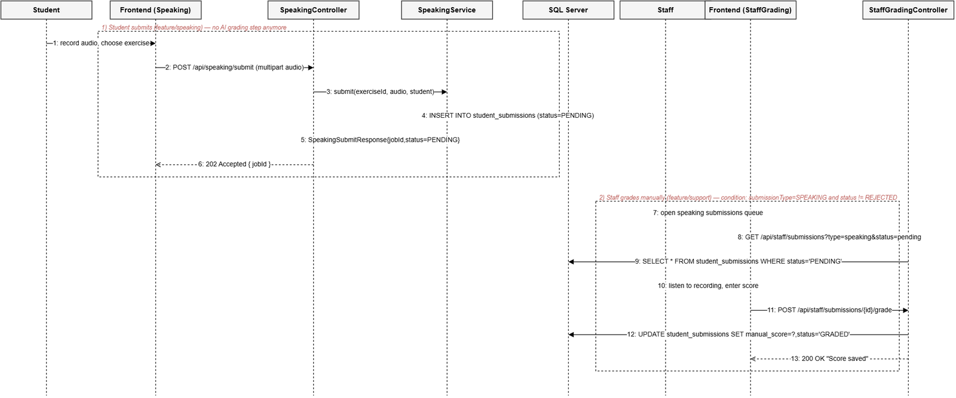
Database Queries
-- SpeakingService.submit(): create a new submission, awaiting teacher grading (no AI step anymore)
INSERT INTO student_submissions (student_id, submission_type, status, exercise_id, recording_url, created_at)
VALUES (?, 'SPEAKING', 'PENDING', ?, ?, GETDATE());
-- SupportTicketService.getAllSubmissions(): the speaking grading queue
SELECT * FROM student_submissions
WHERE submission_type = 'SPEAKING' AND (status = ? OR ? IS NULL)
ORDER BY submitted_at ASC;
-- manualGrade(): record the teacher's score, change status (no longer checks status=AI_GRADED)
UPDATE student_submissions
SET manual_score = ?, manual_feedback = ?, graded_by = ?, graded_at = GETDATE(), status = 'GRADED'
WHERE submission_id = ? AND status != 'REJECTED';
-- notify the Student once grading is done
INSERT INTO notifications (student_id, title, message, notification_type, reference_key, created_by)
VALUES (?, 'Your speaking submission has been graded', ?, 'ACHIEVEMENT', ?, ?);

3.6 Content Review (Manager Approve/Reject)

3.6.1 Class Diagram
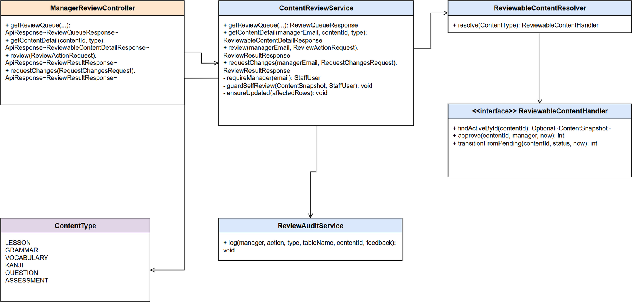
Class Specifications
ContentReviewService Class
No | Method | Description
01 | getContentDetail(managerEmail, contentId, typeStr) | Verifies managerEmail is an active STAFF_MANAGER (requireManager), resolves the right handler for the type (course/lesson/grammar/vocabulary/kanji/question/assessment), returns a snapshot (title, JLPT level, author, submission date, content).
02 | review(managerEmail, ReviewActionRequest) | Blocks reviewing one's own content (guardSelfReview). APPROVE -> handler.approve() (status=published); REJECT -> feedback is required, then handler.transitionFromPending(REJECTED). Every action is logged via ReviewAuditService.log(...).
03 | requestChanges(managerEmail, RequestChangesRequest) | Asks Staff to revise content: feedback is required, moves status back to draft (default) or rejected depending on targetStatus. Uses the same guardSelfReview + audit-log mechanism as review().
04 | ensureUpdated(affectedRows) | If the UPDATE affected 0 rows, the content is no longer in pending_review (already handled concurrently by another Manager) -> throws ConcurrentReviewException to prevent one review overwriting another.

3.6.2 Content Review Sequence
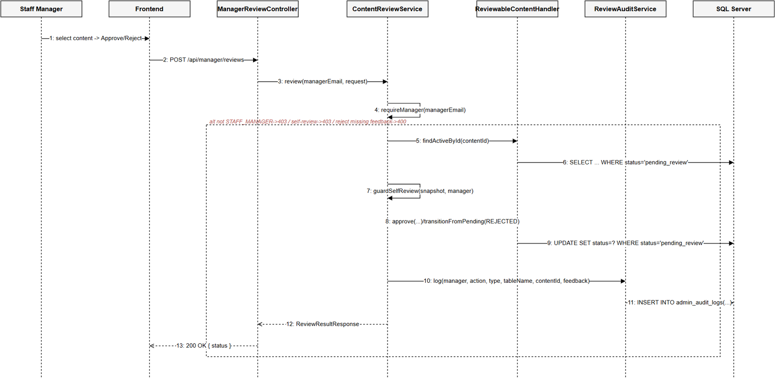
Database Queries
-- findActiveById(): fetch content awaiting review (example: the GRAMMAR handler)
SELECT * FROM grammar_points WHERE grammar_id = ? AND status = 'pending_review';
-- approve(): only updates if still pending_review (prevents double approval)
UPDATE grammar_points
SET status = 'published', approved_by = ?, published_at = GETDATE()
WHERE grammar_id = ? AND status = 'pending_review';
-- reject() / requestChanges(): move back to draft or rejected
UPDATE grammar_points
SET status = ?, updated_at = GETDATE()
WHERE grammar_id = ? AND status = 'pending_review';
-- write an audit row for every review action
INSERT INTO admin_audit_logs (staff_id, action, target_table, target_id, note, created_at)
VALUES (?, ?, ?, ?, ?, GETDATE());

