B?O C?O PROJECT ANDROID
?NG D?NG G?I M?N ?N TH?NG MINH - MEALMIND AI
TH?NG TIN SINH VI?N
T?n ?? t?i: X?y d?ng ?ng d?ng g?i ? m?n ?n th?ng minh d?a tr?n nguy?n li?u, s?c kh?e v? ng?n s?ch c? nh?n
T?n ?ng d?ng: MealMind AI - G?i M?n ?n Th?ng Minh
Sinh vi?n th?c hi?n: Nguy?n V?n H?ng
MSSV: 65131205
L?p: 65.CNTT-2
M?n h?c: L?p tr?nh thi?t b? di ??ng
Gi?ng vi?n h??ng d?n: ThS. Mai C??ng Th?
Kho m? ngu?n GitHub: https://github.com/hung090725/GoiMonAnThongMinh
1. M? T?
D? ?n G?i M?n ?n Th?ng Minh l? ?ng d?ng Android ???c x?y d?ng b?ng Java v? XML Layout. ?ng d?ng h? tr? ng??i d?ng t?m m?n ?n d?a tr?n nguy?n li?u ?ang c?, ng?n s?ch, th?i gian n?u v? m?c ti?u s?c kh?e c? nh?n.
Ng??i d?ng c? th? ??ng k? t?i kho?n, ??ng nh?p, xem danh s?ch m?n ?n, t?m ki?m m?n theo nguy?n li?u, nh?p nguy?n li?u b?ng gi?ng n?i, xem chi ti?t m?n ?n v? l?u m?n y?u th?ch. Ngo?i ra, ng??i d?ng c? th? g?i c?ng th?c m?n ?n l?n c?ng ??ng ?? ch? admin duy?t tr??c khi hi?n th? c?ng khai.
D? li?u c?a ?ng d?ng ???c l?u tr?n Firebase, g?m th?ng tin ng??i d?ng, m?n ?n, danh m?c, m?n y?u th?ch, l?ch s? t?m ki?m, l?ch s? g?i ? v? th?ng b?o. C?c m?n ?n ch? ???c hi?n th? ? ph?a ng??i d?ng khi c? tr?ng th?i status = "approved". Nh?ng m?n c? tr?ng th?i pending, rejected ho?c hidden kh?ng hi?n th? tr?n Home/Search.
2. M?C TI?U
D? ?n ???c th?c hi?n nh?m x?y d?ng m?t ?ng d?ng Android c? th? ch?y ???c c?c lu?ng ch?nh sau:
- Cho ph?p ng??i d?ng ??ng k?, ??ng nh?p v? ??ng xu?t b?ng Firebase Authentication.
- L?u h? s? ng??i d?ng g?m m?c ti?u s?c kh?e, ng?n s?ch, th?i gian n?u v? vai tr? user/admin tr?n Cloud Firestore.
- Hi?n th? danh s?ch m?n ?n ?? ???c duy?t b?ng RecyclerView.
- Cho ph?p t?m ki?m m?n ?n theo nguy?n li?u, h? tr? ti?ng Vi?t c? d?u v? kh?ng d?u.
- H? tr? nh?p nguy?n li?u b?ng gi?ng n?i th?ng qua Android SpeechRecognizer.
- G?i ? m?n ?n b?ng thu?t to?n rule-based/scoring d?a tr?n nguy?n li?u, ng?n s?ch, th?i gian n?u v? m?c ti?u s?c kh?e.
- Cho ph?p ng??i d?ng l?u m?n y?u th?ch v? xem l?i l?ch s? t?m ki?m/g?i ?.
- Cho ph?p ng??i d?ng g?i c?ng th?c m?n ?n ch? admin duy?t.
- Cho ph?p admin duy?t, t? ch?i, ?n, kh?i ph?c v? l?c m?n ?n theo tr?ng th?i.
3. PH??NG PH?P TH?C HI?N
3.1. X?y d?ng c?u tr?c project Android
Project ???c t? ch?c theo c?c package ch?nh nh? activities, fragments, adapters, models, repositories v? utils. C?c Activity v? Fragment ch?u tr?ch nhi?m hi?n th? giao di?n. C?c Repository ch?u tr?ch nhi?m l?m vi?c v?i Firebase. C?c model nh? User, Recipe, Category, Favorite, SearchHistory v? ChatMessage ???c d?ng ?? ?nh x? d? li?u t? Cloud Firestore.
C?ch t?ch package n?y gi?p m? ngu?n d? ki?m so?t h?n. V? d?, HomeFragment ch? g?i RecipeRepository ?? l?y danh s?ch m?n ?? duy?t, c?n RecipeRepository m?i l? n?i truy v?n collection recipes tr?n Firestore.
3.2. Thi?t k? giao di?n b?ng XML
Giao di?n c?a ?ng d?ng ???c x?y d?ng b?ng XML Layout k?t h?p Material Components. ?ng d?ng c? MainActivity d?ng BottomNavigationView v?i 5 tab: Trang ch?, T?m m?n, Y?u th?ch, C?ng ??ng v? H? s?.
C?c danh s?ch m?n ?n, m?n y?u th?ch, th?ng b?o, l?ch s? g?i ? v? d? li?u admin ???c hi?n th? b?ng RecyclerView. M?i d?ng d? li?u c? Adapter ri?ng nh? RecipeAdapter, AdminRecipeAdapter, PendingRecipeAdapter, NotificationAdapter v? ChatMessageAdapter.
3.3. ??ng k?, ??ng nh?p v? ph?n quy?n
??i v?i ch?c n?ng ??ng k?, ?ng d?ng s? d?ng Firebase Authentication ?? t?o t?i kho?n b?ng email v? m?t kh?u. Sau khi ??ng k? th?nh c?ng, ?ng d?ng l?u th?m th?ng tin ng??i d?ng v?o collection users tr?n Cloud Firestore, g?m uid, fullName, email, role, healthGoal, ng?n s?ch v? th?i gian n?u.
??i v?i ch?c n?ng ??ng nh?p, ?ng d?ng s? d?ng signInWithEmailAndPassword() ?? ki?m tra email v? m?t kh?u. Sau khi ??ng nh?p th?nh c?ng, ?ng d?ng ??c document users/{uid}. N?u tr??ng role = "admin" th? m? AdminDashboardActivity. N?u role = "user" ho?c ch?a c? role th? m? MainActivity.
T?i kho?n admin kh?ng ???c ??ng k? c?ng khai trong app. Admin ???c t?o b?ng c?ch g?n th? c?ng role = "admin" trong document users/{uid} tr?n Firestore. C?ch n?y tr?nh vi?c ng??i d?ng t? c?p quy?n qu?n tr?.
3.4. Hi?n th? danh s?ch m?n ?n
??i v?i ch?c n?ng hi?n th? m?n ?n, ?ng d?ng s? d?ng RecipeRepository ?? truy v?n collection recipes v?i ?i?u ki?n whereEqualTo("status", "approved"). D? li?u tr? v? ???c ?nh x? sang model Recipe, sau ?? hi?n th? tr?n HomeFragment b?ng RecyclerView v? RecipeAdapter.
Trong m?i card m?n ?n, ?ng d?ng hi?n th? ?nh, t?n m?n, m? t?, calo, chi ph?, th?i gian n?u v? ?? kh?. ?nh m?n ?n ???c t?i b?ng th? vi?n Glide t? tr??ng imageUrl. N?u imageUrl r?ng ho?c l?i, ?ng d?ng d?ng ?nh placeholder trong drawable ?? tr?nh giao di?n b? tr?ng.
3.5. Xem chi ti?t m?n ?n
Khi ng??i d?ng b?m v?o m?t m?n ?n, RecipeAdapter truy?n recipeId sang RecipeDetailActivity. Activity n?y ??c document recipes/{recipeId} tr?n Firestore ?? l?y th?ng tin chi ti?t c?a m?n, g?m ?nh, m? t?, nguy?n li?u, c?c b??c n?u, calo, chi ph?, th?i gian v? ?? kh?.
Danh s?ch nguy?n li?u v? c?ch l?m ???c x? l? ?? kh?ng b? l?i khi d? li?u null. N?t quay l?i d?ng finish() ?? tr? v? m?n h?nh tr??c. Giao di?n chi ti?t c? ScrollView ?? ng??i d?ng xem ??y ?? n?i dung m?n ?n.
3.6. T?m ki?m m?n ?n theo nguy?n li?u
??i v?i ch?c n?ng t?m ki?m, ng??i d?ng nh?p nguy?n li?u ? SearchFragment. ?ng d?ng chu?n h?a chu?i t?m ki?m b?ng c?ch chuy?n v? ch? th??ng, b? d?u ti?ng Vi?t v? lo?i b? kho?ng tr?ng th?a. Nh? ?? ng??i d?ng c? th? t?m "ca chua" ho?c "c? chua" ??u cho k?t qu? ph? h?p.
?ng d?ng ch? t?m trong c?c m?n c? status = "approved". K?t qu? ???c l?c d?a tr?n t?n m?n, m? t? v? danh s?ch ingredients. Nh?ng t? qu? ng?n ???c x? l? ch?t h?n ?? tr?nh tr??ng h?p nh?p "ga" nh?ng kh?p nh?m v?i t? kh?ng li?n quan.
3.7. G?i ? m?n ?n b?ng RecommendationEngine
Ph?n g?i ? m?n ?n ???c tri?n khai theo h??ng rule-based/scoring, kh?ng d?ng ChatGPT, Gemini ho?c API AI b?n ngo?i. ?ng d?ng t?nh ?i?m ph? h?p cho t?ng m?n b?ng RecommendationEngine.
?i?m g?i ? d?a tr?n c?c ti?u ch?: ingredientScore l? m?c ?? tr?ng gi?a nguy?n li?u ng??i d?ng nh?p v? nguy?n li?u c?a m?n; healthScore l? m?c ?? ph? h?p v?i m?c ti?u s?c kh?e; budgetScore l? m?c ?? ph? h?p ng?n s?ch; timeScore l? m?c ?? ph? h?p th?i gian n?u; favoriteScore l? ?i?m ?u ti?n s? th?ch ? m?c c? b?n.
C?ng th?c t?nh ?i?m trong project:
score = ingredientScore * 0.40 + healthScore * 0.20 + budgetScore * 0.15 + timeScore * 0.15 + favoriteScore * 0.10
Sau khi t?nh ?i?m, danh s?ch m?n ???c s?p x?p theo ?i?m gi?m d?n. ?ng d?ng ch? hi?n th? nh?ng m?n c? li?n quan ??n nguy?n li?u ho?c c? t?ng ?i?m ?? cao.
3.8. Nh?p nguy?n li?u b?ng gi?ng n?i
??i v?i ch?c n?ng gi?ng n?i, ?ng d?ng s? d?ng Android SpeechRecognizer v? RecognizerIntent. Khi ng??i d?ng b?m n?t micro, ?ng d?ng xin quy?n RECORD_AUDIO, m? b? nh?n di?n gi?ng n?i ti?ng Vi?t v?i m? ng?n ng? vi-VN v? nh?n k?t qu? d?ng v?n b?n.
K?t qu? gi?ng n?i ???c ??a v?o ? t?m ki?m ?? ng??i d?ng c? th? t?m m?n ngay. ?ng d?ng c? x? l? c?c l?i th??ng g?p nh? ch?a c?p quy?n micro, thi?t b? kh?ng h? tr? nh?n di?n gi?ng n?i, l?i m?ng ho?c kh?ng nghe th?y gi?ng n?i.
3.9. M?n y?u th?ch v? l?ch s? t?m ki?m
??i v?i ch?c n?ng y?u th?ch, khi ng??i d?ng b?m n?t tr?i tim ? chi ti?t m?n ?n, ?ng d?ng l?u th?ng tin v?o collection favorites. D? li?u y?u th?ch g?n v?i userId ?? m?i ng??i d?ng c? danh s?ch y?u th?ch ri?ng.
??i v?i l?ch s? t?m ki?m, m?i l?n ng??i d?ng t?m m?n, ?ng d?ng l?u t? kh?a, userId, s? l??ng k?t qu? v? th?i gian t?m ki?m v?o collection searchHistory. D? li?u n?y gi?p ng??i d?ng xem l?i c?c t? kh?a ?? t?m v? l? c? s? ?? m? r?ng g?i ? trong t??ng lai.
3.10. Tr? l? MealMind AI d?ng chat
?ng d?ng c? m?n h?nh SmartMealChatActivity ?? ng??i d?ng nh?p c?u t? nhi?n nh? "t?i c? tr?ng, c? chua, mu?n ?n d??i 30k". SmartMealAssistant ph?n t?ch c?u nh?p ?? l?y nguy?n li?u, ng?n s?ch, th?i gian n?u v? m?c ti?u s?c kh?e.
N?u c?u nh?p thi?u ng?n s?ch ho?c th?i gian, ?ng d?ng l?y th?m d? li?u t? h? s? ng??i d?ng trong collection users. Sau ?? SmartSuggestionRepository ??c c?c m?n approved t? collection recipes, g?i SmartMealAssistant v? RecommendationEngine ?? t?o k?t qu? g?i ?. L?ch s? h?i tho?i ???c l?u v?o collection aiSuggestionHistory.
3.11. Ng??i d?ng g?i c?ng th?c c?ng ??ng
??i v?i ch?c n?ng c?ng ??ng, ng??i d?ng c? th? m? AddRecipeActivity ?? nh?p t?n m?n, m? t?, link ?nh, calo, chi ph?, th?i gian n?u, ?? kh?, danh m?c, nguy?n li?u v? c?c b??c n?u.
Khi b?m g?i duy?t, ?ng d?ng l?y currentUser t? FirebaseAuth, ??c users/{uid} ?? l?y t?n t?c gi?, sau ?? l?u m?n v?o collection recipes v?i status = "pending". M?n pending kh?ng hi?n th? ? Home/Search cho ??n khi admin duy?t.
3.12. Admin duy?t v? qu?n l? m?n ?n
??i v?i t?i kho?n admin, sau khi ??ng nh?p ?ng d?ng m? AdminDashboardActivity. M?n h?nh n?y hi?n th? s? l??ng m?n pending, approved, rejected, hidden v? s? l??ng ng??i d?ng.
Admin c? th? m? danh s?ch m?n ch? duy?t. PendingRecipeActivity truy v?n recipes v?i status = "pending". Khi admin b?m v?o m?n, PendingRecipeDetailActivity hi?n th? chi ti?t m?n v? cho ph?p duy?t ho?c t? ch?i.
Khi duy?t, ?ng d?ng c?p nh?t status t? pending sang approved, ??ng th?i l?u reviewedBy, reviewedAt v? updatedAt. Khi t? ch?i, ?ng d?ng c?p nh?t status sang rejected v? l?u rejectReason. ?ng d?ng kh?ng x?a document ?? c? th? theo d?i l?ch s? x? l?.
? ph?n qu?n l? m?n ?n, AdminRecipeActivity cho ph?p l?c m?n theo tr?ng th?i approved, pending, rejected v? hidden. AdminRecipeDetailActivity cho ph?p ?n m?n ?? duy?t b?ng c?ch ??i status t? approved sang hidden, ho?c kh?i ph?c m?n ?n b?ng c?ch ??i status t? hidden sang approved.
3.13. Qu?n l? danh m?c, th?ng k? v? th?ng b?o
??i v?i danh m?c m?n ?n, CategoryManagerActivity l?m vi?c v?i collection categories. Admin c? th? th?m, s?a, ?n ho?c kh?i ph?c danh m?c. ?ng d?ng kh?ng x?a c?ng danh m?c m? d?ng tr??ng status ?? ki?m so?t hi?n th?.
??i v?i th?ng k?, StatisticsActivity ??c s? l??ng document trong c?c collection nh? users, recipes, favorites v? searchHistory. C?c s? li?u n?y d?ng ?? admin c? c?i nh?n t?ng quan khi demo h? th?ng.
?ng d?ng c? NotificationActivity ?? hi?n th? th?ng b?o cho ng??i d?ng. NotificationRepository ??c collection notifications theo userId hi?n t?i. Khi c?ng th?c ???c duy?t ho?c b? t? ch?i, ?ng d?ng t?o th?ng b?o t??ng ?ng ?? ng??i d?ng bi?t k?t qu? x? l?.
3.14. C? s? d? li?u Firebase
?ng d?ng s? d?ng Cloud Firestore l?m c? s? d? li?u ch?nh. C?c collection ?ang d?ng g?m users, recipes, categories, favorites, searchHistory, aiSuggestionHistory v? notifications.
Tr?ng th?i c?a recipes g?m pending, approved, rejected v? hidden. Vi?c d?ng tr??ng status gi?p app ki?m so?t d? li?u hi?n th? m? kh?ng c?n x?a document kh?i Firestore.
4. ?NH K?T QU? ??T ???C
C?c ?nh d??i ??y l? minh ch?ng c?c lu?ng ch?c n?ng ?? ch?y ???c tr?n ?ng d?ng v? Firebase.
H?nh 1. M?n h?nh ??ng nh?p b?ng Firebase Authentication.
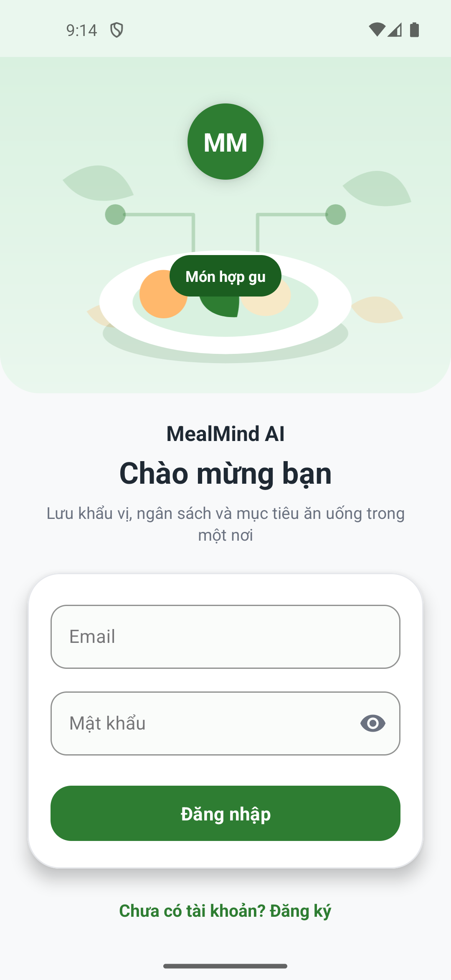
H?nh 2. M?n h?nh ??ng k? t?i kho?n user v? l?u th?ng tin l?n Firestore.
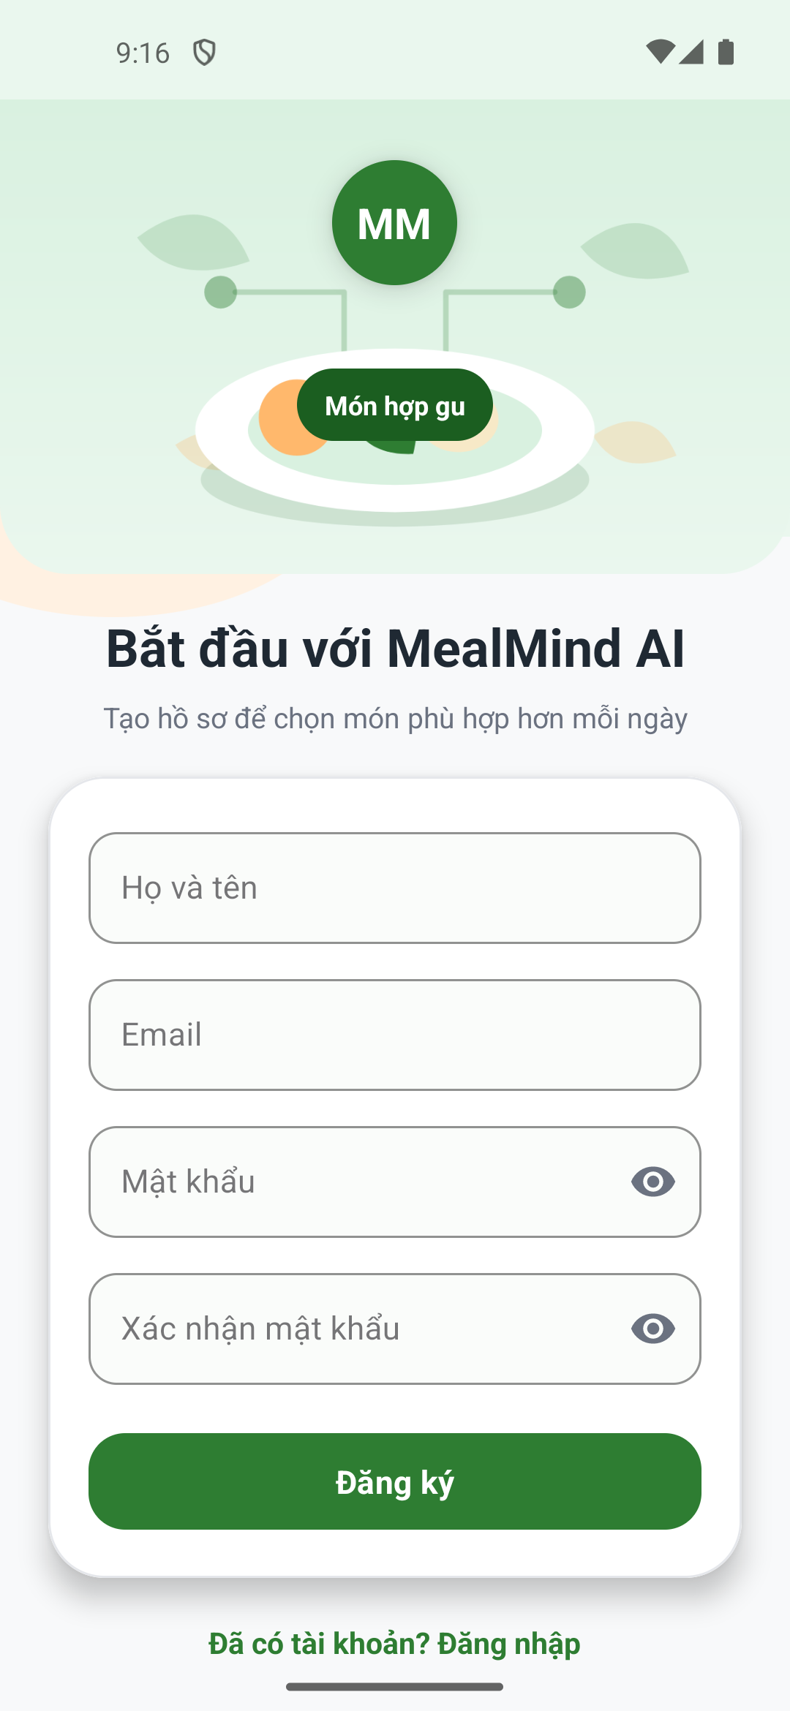
H?nh 3. Trang ch? hi?n th? m?n approved v? n?t h?i MealMind AI.
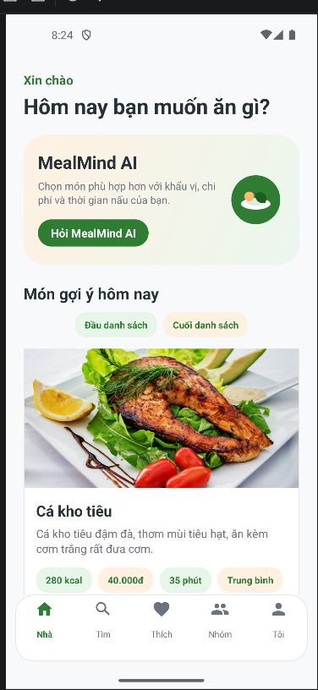
H?nh 4. T?m ki?m m?n ?n theo nguy?n li?u.
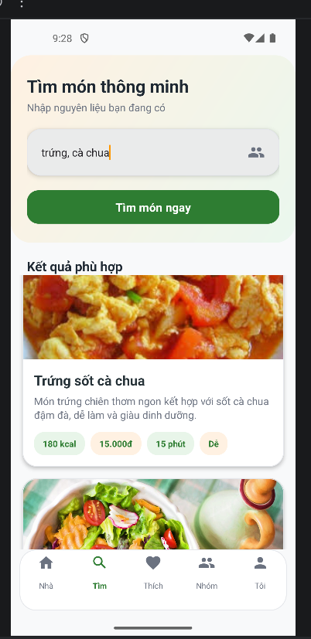
H?nh 5. Nh?p nguy?n li?u b?ng gi?ng n?i ti?ng Vi?t.
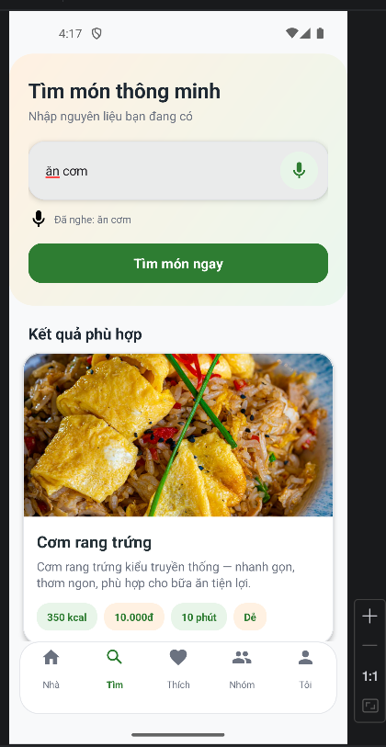
H?nh 6. M?n h?nh chi ti?t m?n ?n c? ?nh, th?ng tin, nguy?n li?u v? c?ch l?m.
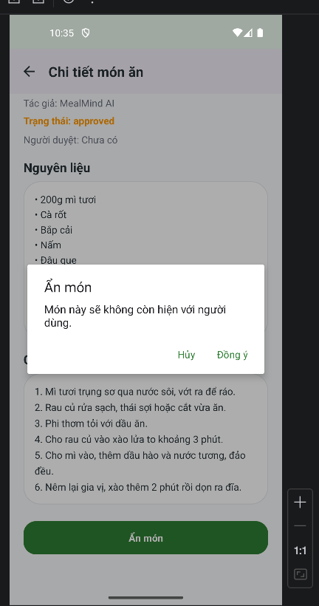
H?nh 7. Danh s?ch m?n y?u th?ch c?a ng??i d?ng.
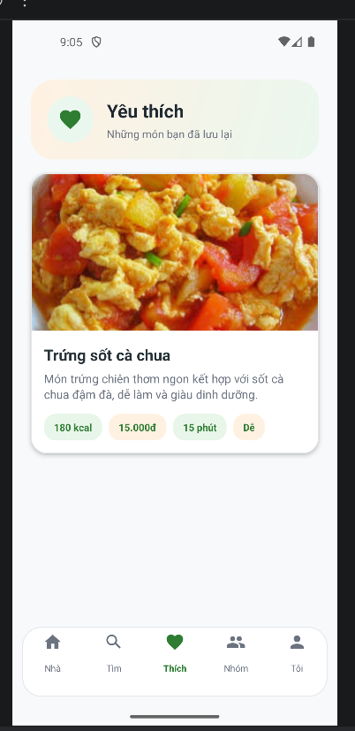
H?nh 8. M?n h?nh chat MealMind AI d?ng rule-based recommendation.
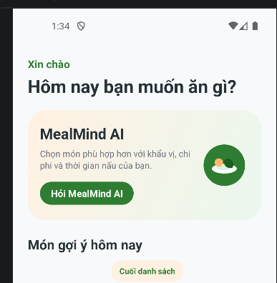
H?nh 9. L?ch s? g?i ? ???c l?u trong aiSuggestionHistory.
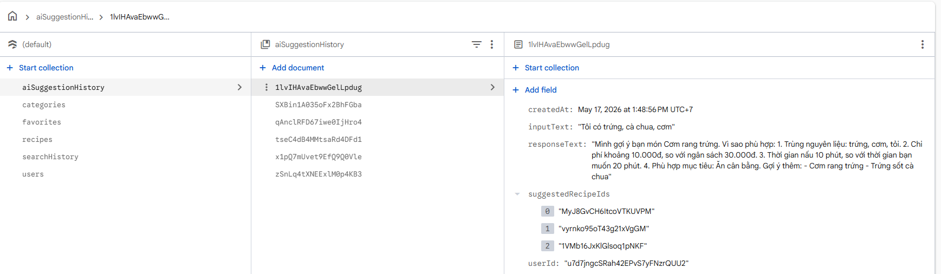
H?nh 10. M?n h?nh th?ng b?o cho ng??i d?ng.
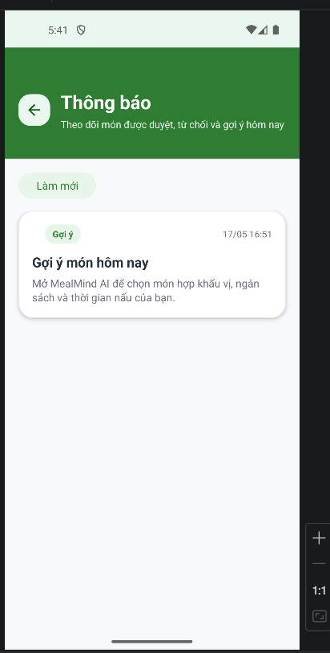
H?nh 11. Ng??i d?ng th?m c?ng th?c v? g?i ch? duy?t.
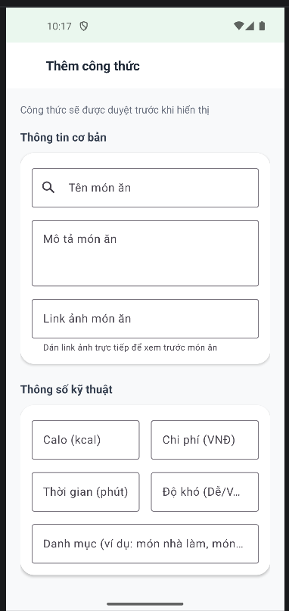
H?nh 12. C?ng th?c ???c g?i v?i tr?ng th?i pending.
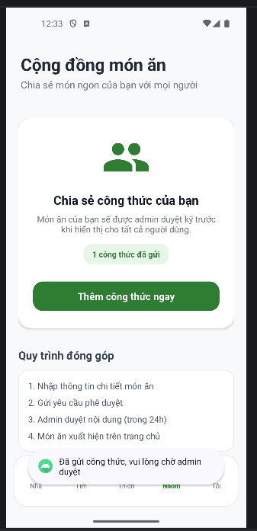
H?nh 13. Admin Dashboard sau khi ??ng nh?p b?ng t?i kho?n role admin.
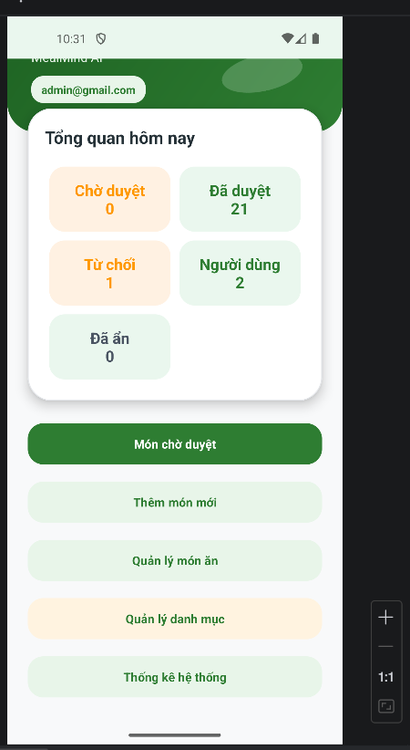
H?nh 14. Danh s?ch m?n ch? admin duy?t.
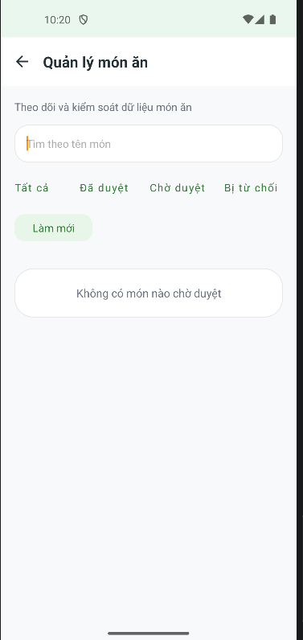
H?nh 15. Admin duy?t c?ng th?c t? pending sang approved.
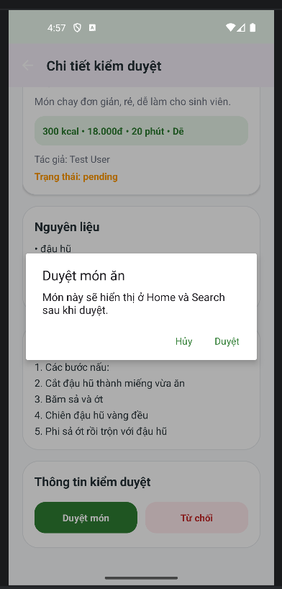
H?nh 16. Admin qu?n l? m?n ?n theo tr?ng th?i.
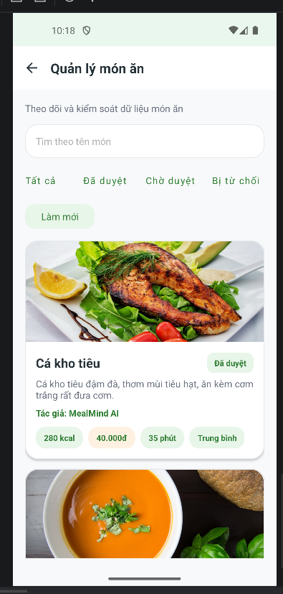
H?nh 17. Danh s?ch m?n b? t? ch?i ?? theo d?i c?ng th?c rejected.
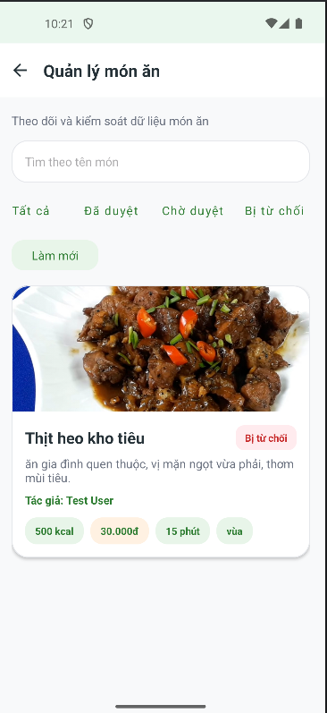
H?nh 18. Admin qu?n l? danh m?c m?n ?n.
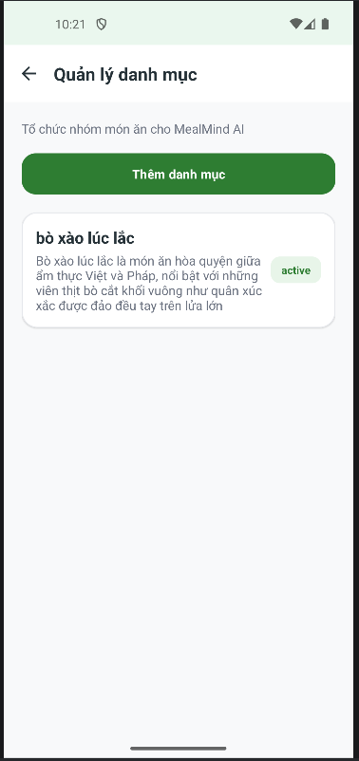
H?nh 19. M?n h?nh th?ng k? t?ng quan h? th?ng.
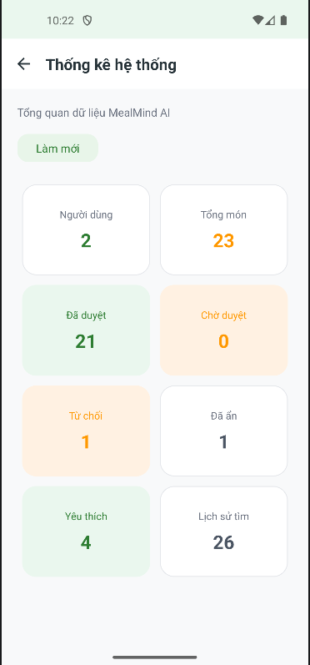
H?nh 20. D? li?u th?ng b?o ???c l?u tr?n Firestore.
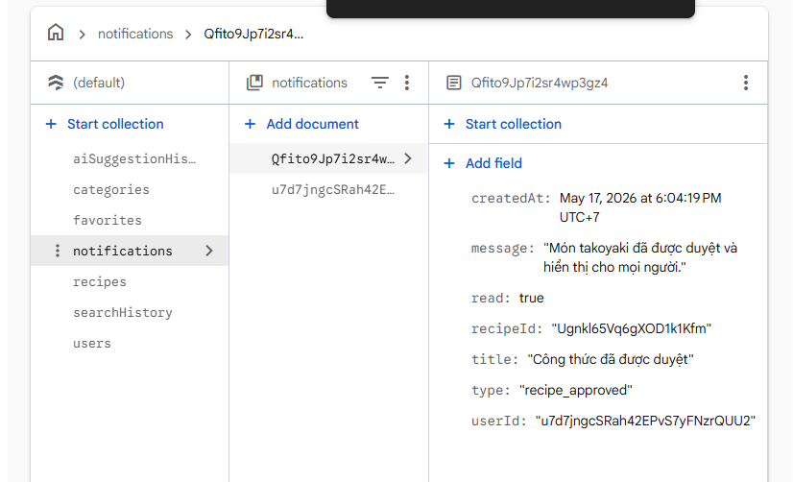
5. KI?M TH?
C?c lu?ng ?? ki?m th? g?m: ??ng k? t?i kho?n user, ??ng nh?p user/admin, ?i?u h??ng theo role, hi?n th? m?n approved, t?m ki?m m?n b?ng v?n b?n, t?m ki?m b?ng gi?ng n?i, xem chi ti?t m?n, th?m/b? y?u th?ch, g?i c?ng th?c ch? duy?t, admin duy?t/t? ch?i m?n, admin ?n/kh?i ph?c m?n, nh?n th?ng b?o v? xem l?ch s? g?i ?.
L?nh build d?ng ?? ki?m tra project:
./gradlew :app:assembleDebug
K?t qu? hi?n t?i: BUILD SUCCESSFUL.
6. H?N CH?
- D? li?u m?n ?n hi?n c?n l? d? li?u m?u, s? l??ng ch?a nhi?u.
- ?nh m?n ?n ch? y?u d?ng imageUrl ho?c ?nh drawable, ch?a upload tr?c ti?p b?ng Firebase Storage.
- Thu?t to?n g?i ? l? rule-based/scoring, ch?a ph?i m? h?nh h?c m?y.
- Nh?n di?n gi?ng n?i ph? thu?c Google Speech Services, micro v? m?ng c?a thi?t b?.
- Th?ng k? admin m?i ? m?c ??m d? li?u c? b?n.
7. H??NG PH?T TRI?N
- B? sung d? li?u m?n ?n th?t v? ?a d?ng h?n.
- T?ch h?p Firebase Storage ?? ng??i d?ng upload ?nh m?n ?n tr?c ti?p.
- Th?m th?c ??n theo ng?y ho?c theo tu?n.
- C?i thi?n thu?t to?n g?i ? d?a tr?n l?ch s? t?m ki?m v? m?n y?u th?ch.
- B? sung push notification b?ng Firebase Cloud Messaging n?u c? th?i gian.
8. K?T LU?N
D? ?n ?? x?y d?ng ???c m?t ?ng d?ng Android Java h? tr? ng??i d?ng t?m v? g?i ? m?n ?n d?a tr?n nguy?n li?u, ng?n s?ch, th?i gian n?u v? m?c ti?u s?c kh?e. ?ng d?ng s? d?ng Firebase Authentication ?? x?c th?c t?i kho?n v? Cloud Firestore ?? l?u d? li?u.
Ph?n g?i ? m?n ?n ???c tri?n khai b?ng thu?t to?n rule-based/scoring, ph? h?p v?i ph?m vi project sinh vi?n v? c? th? gi?i th?ch ???c l? do g?i ?. Ngo?i c?c ch?c n?ng ph?a ng??i d?ng, ?ng d?ng c?n c? lu?ng admin ?? ki?m duy?t v? qu?n l? d? li?u m?n ?n tr??c khi hi?n th? c?ng khai.

