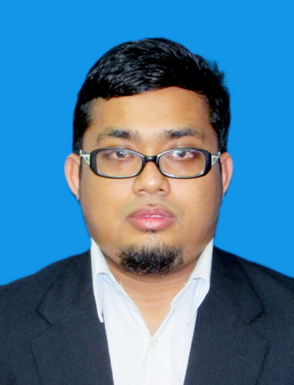
MUHAMMAD FAREEZ BIN BORHANUDIN
CAREER OBJECTIVE
To seek a management position and gaining experience, that offer skills development, personal growth, and career, advancement and organization improvement. Moreover give the best quality services and demonstrate the competence that satisfied interest of the company.
PERSO NAL PROFILE
Name | MUHAMMAD FAREEZ BIN BORHANUDIN
Faculty | Information Management
Program | Bachelor of Information Studies (Hons.) [System Information Management]
MyKad No | 920907-03-5431
Cell-phone | 0145061447
Email | fare4z@gmail.com
Date of Birth | 07-09-1992
Age | 23
Gender | Male
Nationality | Warganegara
Religion | Islam
Race | Melayu
Address | PT1085, Lorong Iqra’, Kampung Pintu Geng, 15100, Kota Baharu, Kelantan.
Expected Salary | RM 2800 (Negotiate)

EDUCATION

 | Description | Grade/CGPA | Year  In  Involved
1 | Universiti Teknologi MARA, (UiTM Malaysia)  Bachelor of Information Studies (Hons.) [System Information Management] | 3.42 | July 2013–  Jun 2015
2 | Universiti Teknologi MARA, (UiTM Malaysia)  Diploma in Information Management | 3.19 | 2010/2013
3 | Cosmopoint College  Certificate In Information Technology (IT) |  | 2010

WORKING EXPERIENCE

 | Description & Position | Organization | Duration
1 | Freelance PHP, HTML | Freelancer | 2012-Now

CURRICULAR ACTIVITIES

 | ACTIVITY | YEAR | DESCRIPTION
1 | INNOVATION,  INVENTION & DESIGN  COMPETITION | 2014 | Staff Management System (SMS)
2 | Peers UiTM Kelantan | 2010-2012 | Exco Kebajikan
3 | Peers UiTM Kelantan | 2012-2013 | Exco Multimedia
4 | Program KACA (HEP UiTM) | 2013 | Facilitator
5 | Program Kecemerlangan UPSR | 2013 | Facilitator
6 | Pertandingan Kawad Kaki Pengakap | 2008 | Pengakap
7 | Celcom X-Change | 2008 | Peringkat Negeri

SKILLS

 | Description | Details
1 | Computer Skills | - Microsoft Office  - Microsoft Project  - Macromedia Director  - Microsoft Access  - HTML  - PHP  - SQL Command  - Adobe Photoshop  - SPSS  - Content Management System (CMS)  - Joomla, Wordpress, eCommerce
2 | Language | - Fluent in Malay Language both oral and written  - Fluent in English Language both oral and written  - Arabic language – Fair
3 | Personal Skills | - Experienced in developing web using HTML,PHP,CSS & XHTML  - Experienced in developing web using CMS.  - Experienced in developing database, and using SQL commands  - Skillful in Multimedia.  - Able in troubleshoot computer.
4 | Training/Professional Certificate | - 1Citizen certificate  - Certiport certificate  - Certified Professional Ethical Hacker (CPEH)

PERSONAL REFEREE

 | Name | Organization | Contact no &  Email address
1 | Mohd Zaffian Mohd Zawawi | UiTM Kelantan | 0128088040 /09-9762000  zaffian@kelantan.uitm.edu.my
2 | Puan Izzatil Husna binti Arshad | UiTM Kelantan | 0196976693  izzatil.husna.arshad@gmail.com

