

**WEBSITE ONLINE**

**Software Requirement Specification**

– Hanoi, May 2022 –

**Table of Contents**

[**I. Overview 3**](https://docs.google.com/document/d/1QdaCh0mrjQipt1w7mvTQeeH8uL384jgq/edit#heading=h.26in1rg)

[1. Introduction 3](https://docs.google.com/document/d/1QdaCh0mrjQipt1w7mvTQeeH8uL384jgq/edit#heading=h.1fob9te)

[2. System Functions 4](https://docs.google.com/document/d/1QdaCh0mrjQipt1w7mvTQeeH8uL384jgq/edit#heading=h.3znysh7)

[3. Common Requirements 5](https://docs.google.com/document/d/1QdaCh0mrjQipt1w7mvTQeeH8uL384jgq/edit#heading=h.lnxbz9)

[**II. Functional Requirements 6**](https://docs.google.com/document/d/1QdaCh0mrjQipt1w7mvTQeeH8uL384jgq/edit#heading=h.35nkun2)

[**1.**](https://docs.google.com/document/d/1QdaCh0mrjQipt1w7mvTQeeH8uL384jgq/edit#heading=h.3dy6vkm) **Requests Management for mentees** [**6**](https://docs.google.com/document/d/1QdaCh0mrjQipt1w7mvTQeeH8uL384jgq/edit#heading=h.3dy6vkm)

[a. View search request 6](https://docs.google.com/document/d/1QdaCh0mrjQipt1w7mvTQeeH8uL384jgq/edit#heading=h.4d34og8)

[b.](https://docs.google.com/document/d/1QdaCh0mrjQipt1w7mvTQeeH8uL384jgq/edit#heading=h.2s8eyo1) View product information request 6

c. View cart request 7

d. Update requests 7

e.Add request 8

1e1

**2**[**. Login/Register/Reset password**](https://docs.google.com/document/d/1QdaCh0mrjQipt1w7mvTQeeH8uL384jgq/edit#heading=h.1ksv4uv) **12**

[a.](https://docs.google.com/document/d/1QdaCh0mrjQipt1w7mvTQeeH8uL384jgq/edit#heading=h.4d34og8) Login 12

[b.](https://docs.google.com/document/d/1QdaCh0mrjQipt1w7mvTQeeH8uL384jgq/edit#heading=h.2s8eyo1) Register 12

14

**3**[**. User profile**](https://docs.google.com/document/d/1QdaCh0mrjQipt1w7mvTQeeH8uL384jgq/edit#heading=h.1ksv4uv) **15**

[a.](https://docs.google.com/document/d/1QdaCh0mrjQipt1w7mvTQeeH8uL384jgq/edit#heading=h.4d34og8) [User profile](https://docs.google.com/document/d/1QdaCh0mrjQipt1w7mvTQeeH8uL384jgq/edit#heading=h.1ksv4uv) 15

[b.](https://docs.google.com/document/d/1QdaCh0mrjQipt1w7mvTQeeH8uL384jgq/edit#heading=h.2s8eyo1) Change password 16

c[.](https://docs.google.com/document/d/1QdaCh0mrjQipt1w7mvTQeeH8uL384jgq/edit#heading=h.2s8eyo1) Update profile information 16

**4. Home page 17**

**I. Overview**

**1. Introduction**

Context Diagram: This project aims to develop a Web Programming model for Online Sales, mainly for users (customers) to buy their favorite products on the website.

**2. System Functions**

***a. Database Schema***

***b. Screen Details***

|  |  |  |  |
| --- | --- | --- | --- |
| **STT** | **Feature** | **Screen** | **Description** |
| 1 | Search & Search Product | Home Page | Search for a Mentor by name or filter it by skill |
| 2 | Login | Sign in, register | User Login to the System |
| 3 | Register | Sign in, register | User Register for an account |
| 4 | View list Mentor | Mentor suggestion | Display detail information of Product |
| 5 | View, Update profile | User Profile | View, update user profile |
| 6 | Change password | User Profile | Change user’s login password |
| 9 | Update request | List all requests | Allow mentee to update request ( pop-up ) |
| 10 | Mentor info | List all requests | Allow mentee to see all mentor’s information ( pop-up ) |
| 11 | List all requests | List all requests | Show all requests |
| 12 | Rate and comment | List all requests | Allow mentee to rate and comment about mentor after the project is finished |
| 13 | Create request | Home Page | Allow mentee to create a request |
| 19 | View all invited requests | List invited requests | Show all requests that the mentor received from the mentee |
| 20 | Response | List invited requests | Allow the mentor to response the request by choosing reject or accept |
| 21 | Statistic of received request | List invited requests | Mentor can see the statistic of received requests |

***c. User Authorization***

|  |  |  |  |  |
| --- | --- | --- | --- | --- |
| **Screen** | **Mentor** | **Mentee** | **Admin** | **Guest** |
| Home Page | x | x | x | x |
| Sign in, Register, Reset Password | x | x | x | ... |
| User Profile | x | x | x | ... |
| Update Profile | x | x | ... | ... |
| Change Password | x | x | ... | ... |
| Create requests | x | x | ... | ... |
| Mentor suggestion for requests | x | x | ... | … |
| List all my requests | x | x | ... | ... |
| Rate and comment other mentors | x | x | ... | ... |
| Statistic my requests | x | x | ... | ... |

In which:

* **Guests**: who access the website without signing in
* **Admin**: who have available account with role Admin in database
* **Mentees**: who registered and have not created CV to be Mentors
* **Mentors**: who registered website and have CV

***d. Non-Screen Functions***

|  |  |  |  |
| --- | --- | --- | --- |
| **#** | **Feature** | **System Function** | **Description** |
| 1 | Verify email | Register | System send a message to user’s email for verifying the email that was been registered by user |
| 2 | Check email exist | Register | By using ajax, automatically check if email exists in database |
|  |  |  |  |
|  |  |  |  |

**3. Common Requirements**

II. Functional Requirements

**1. Requests Management for mentee**

**a.View Product Page**

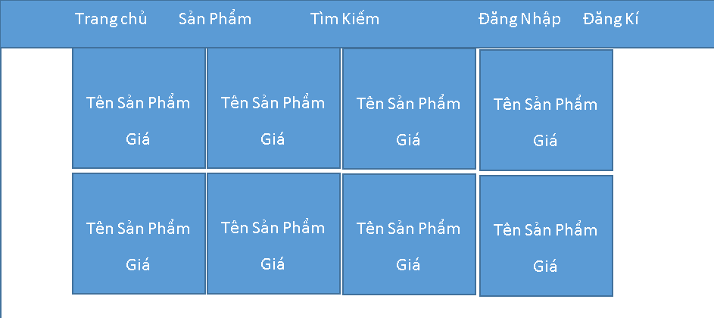

**b. View Search requests**

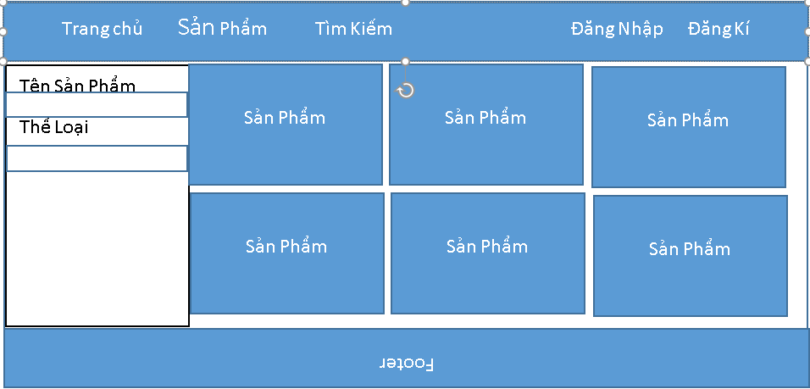

**c. View Cart**

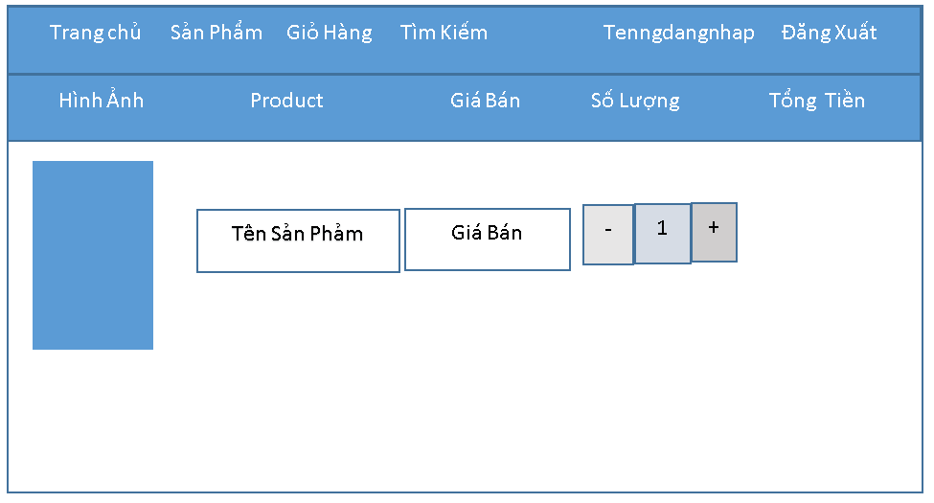

**2**[**. Login/Register/Reset password**](https://docs.google.com/document/d/1QdaCh0mrjQipt1w7mvTQeeH8uL384jgq/edit#heading=h.1ksv4uv)

**a,View register request**

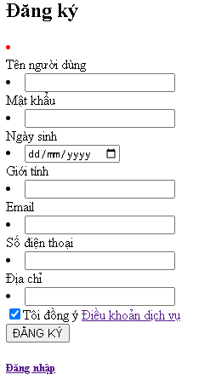

**b.View Login requests**

**3. User Profile**

1. **User Profile**

1. **Update profile information  request**

**4.  HomePage**