Student Name: Sai Hung Chau

Student ID: 301273830

Repository URL: <https://github.com/hung940801/COMP257_assignment_1_Sai_Hung_Chau_301273830.git>

Written Report

**Question 1:**

1. Random images from the mnist_784 dataset   
   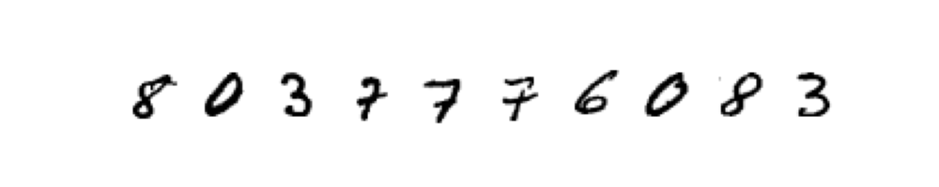
2. Plot of the variance ratio  
   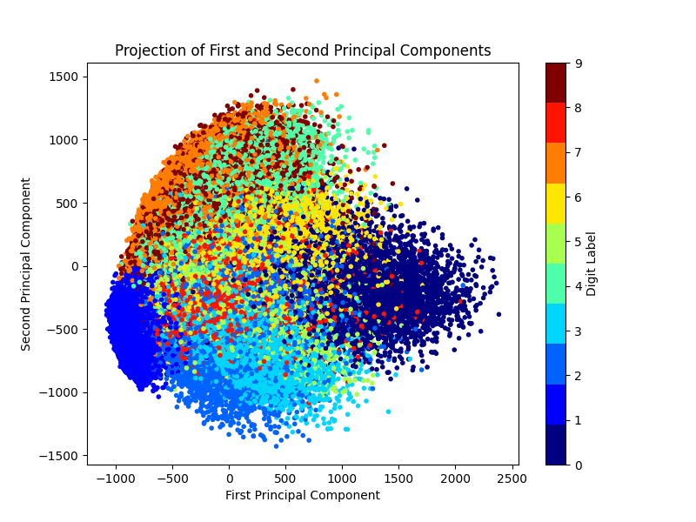
3. Plot of original digit image and compressed digit image comparison  
   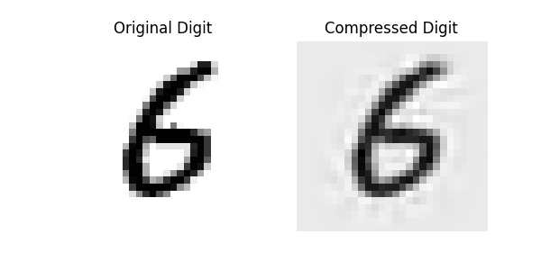
4. Result screenshot of the python program console  
   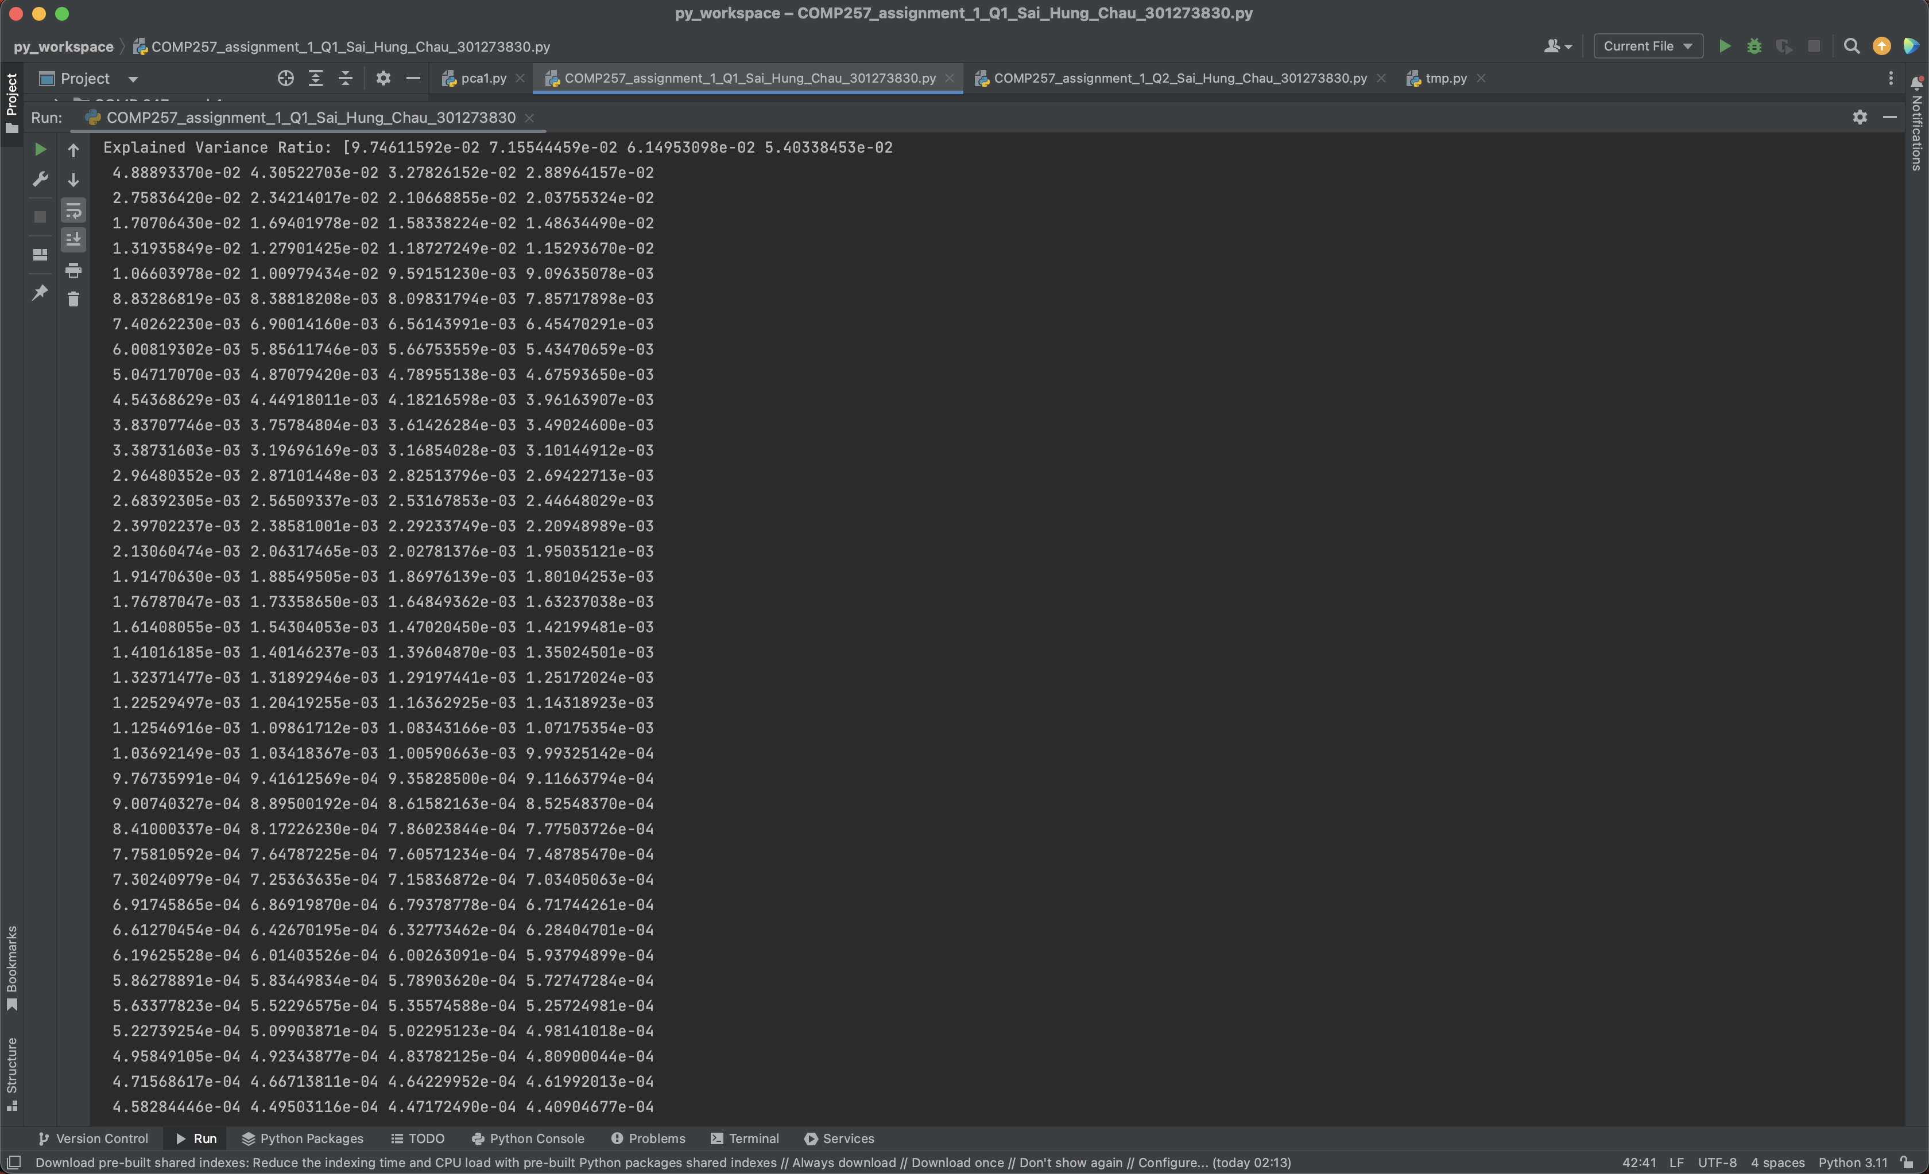

**Question 2:**

1. Plot of the dataset just created  
   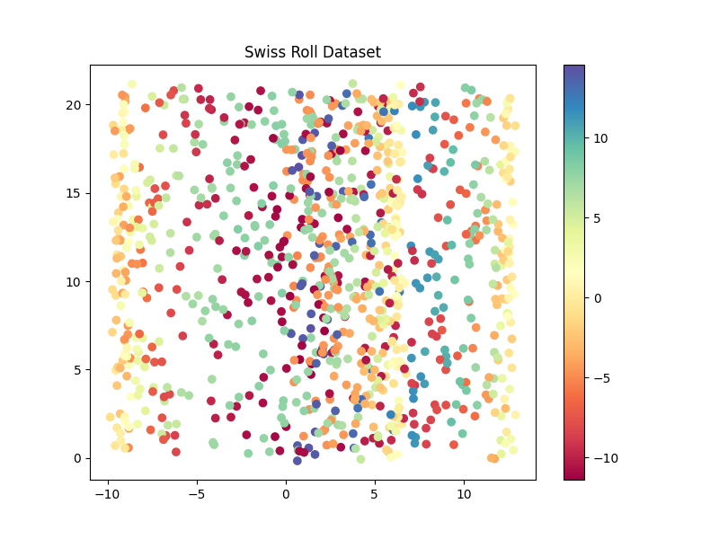
2. Plots of the dataset applied the PCA Kernel with the three kernels, linear, RBF and sigmoid  
   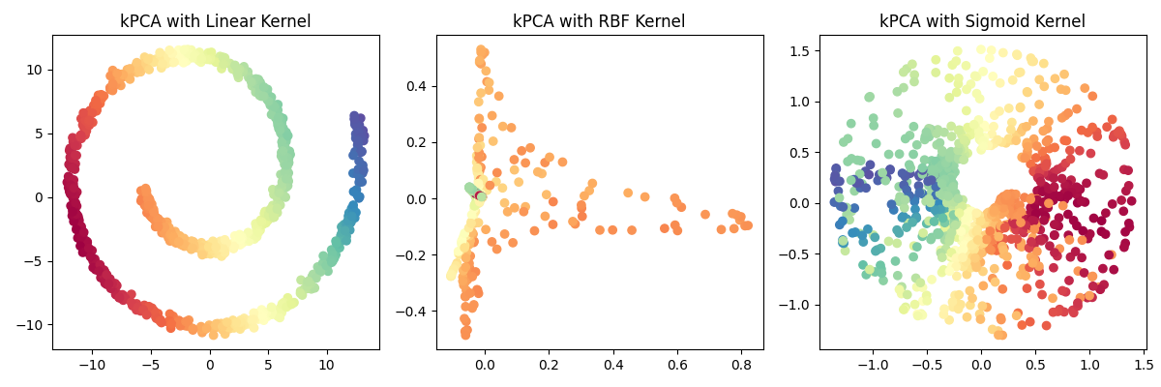
3. Plot of the grid search results  
   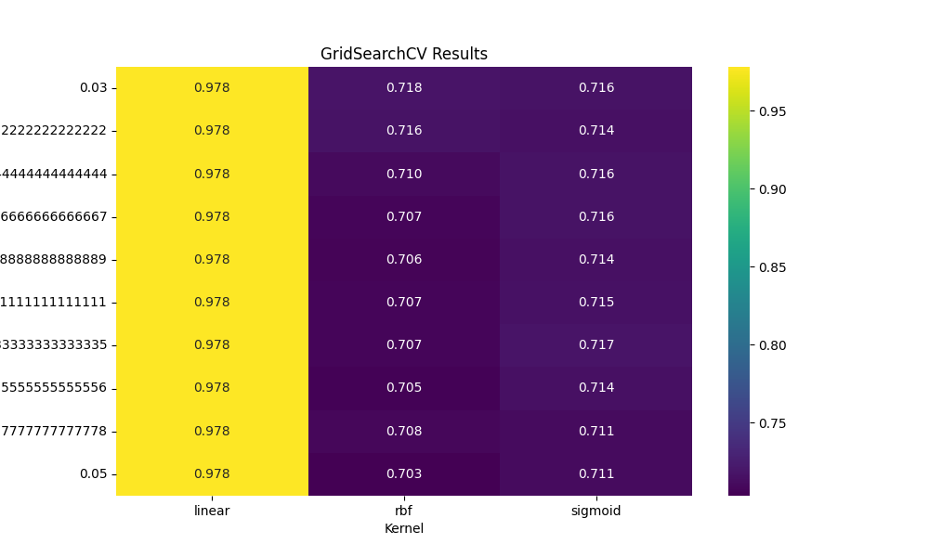  
     
   You can see that the linear kernel has the highest scores all the time, so the linear kernel is the best kernel to use in here. And the scores of the RBF and sigmoid are really close, their performances are basically the same. However, compare to linear, their scores are still far from the linear’s.
4. Result screenshot of the python program console  
   