# **MySQL Comparison Functions**

* [COALESCE](https://www.mysqltutorial.org/mysql-comparison-functions/mysql-coalesce/) – return the first non-NULL arguments, which is very handy for substitution ofNULL.
* [GREATEST & LEAST](https://www.mysqltutorial.org/mysql-comparison-functions/mysql-greatest-least/) – take n arguments and return the greatest and least values of the narguments respectively.
* [ISNULL](https://www.mysqltutorial.org/mysql-comparison-functions/mysql-isnull-function/) – return 1 if the argument is NULL, otherwise, return zero.

# **MySQL GREATEST and LEAST**

**Summary**: in this tutorial, you will learn how to use MySQL GREATEST and LEAST functions to find the greatest and smallest values of two or more fields respectively.

## **Introduction to MySQL GREATEST and LEAST functions**

Both GREATEST and LEAST functions take N arguments and return the greatest and smallest values respectively. The following illustrates the syntax of the GREATEST and LEAST function:

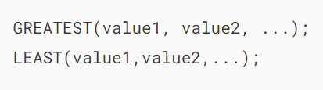

The arguments may have mixed [data types](https://www.mysqltutorial.org/mysql-basics/mysql-data-types/). The following comparison rules are applied to both functions:

* If any argument is [NULL](https://www.mysqltutorial.org/mysql-basics/mysql-null/), both functions return NULLs immediately without doing any comparison.
* If functions are used in the [INT](https://www.mysqltutorial.org/mysql-basics/mysql-int/) or REAL contexts, or all arguments are integer-valued or REAL-valued, they are compared as INT and REAL respectively.
* If arguments consist of both numbers and strings, the functions will compare them as numbers.
* If a least an argument is a non-binary (character) string, the functions will compare the arguments as non-binary strings.
* In all other cases, the functions compare arguments as binary strings.

The following examples demonstrate how the GREATEST and LEAST functions work.

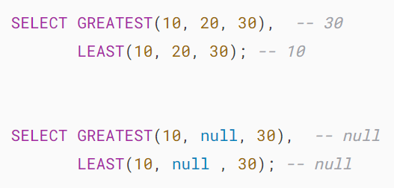

## **MySQL GREATEST and LEAST examples**

Let’s [create a new table](https://www.mysqltutorial.org/mysql-basics/mysql-create-table/) for the demonstration.

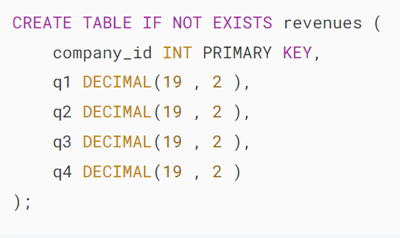

The revenues table consists of company_id as the primary key and four columns to store revenues of the company in each quarter.

The following statement [inserts](https://www.mysqltutorial.org/mysql-basics/mysql-insert/)two rows into the revenues table.

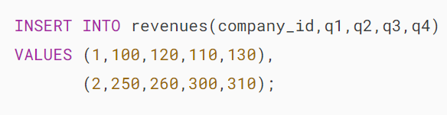

To get the highest and lowest revenues for each company, you use the GREATEST and LOWEST functions as follows:

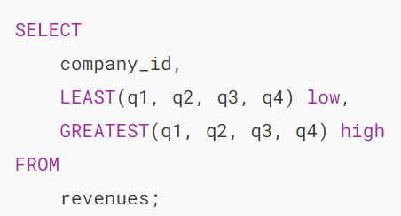



Both GREATEST and LEAST functions return NULLs if any argument is NULL which may not be what you expected.

To avoid this, you can use the [IFNULL](https://www.mysqltutorial.org/mysql-control-flow-functions/mysql-ifnull/) function to treat NULL as zero to perform the numeric comparison.

The following statement inserts a new row into the revenues table with a NULL value in the q4 column.

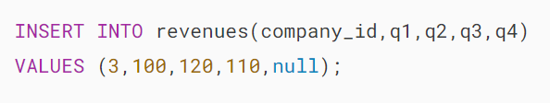

If you use the GREATEST and LEAST functions to query data, you get the result as designed.

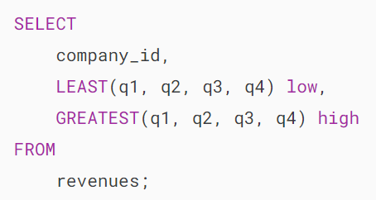

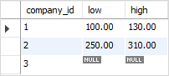

As you can see, the low and high values of the company id 3 are NULLs.

To avoid this, you can use the IFNULL function as follows:

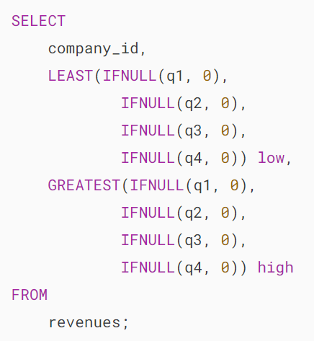

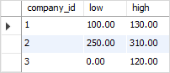

# **MySQL ISNULL Function**

**Summary**: This tutorial introduces you to the MySQL ISNULL function and how to use it to handle NULL values.

## **Introduction to MySQL ISNULL function**

The ISNULL function takes one argument and tests whether that argument is [NULL](https://www.mysqltutorial.org/mysql-basics/mysql-null/) or not. The ISNULL function returns 1 if the argument is NULL, otherwise, it returns 0.

The following illustrates the syntax of the ISNULL function:



Consider the following examples:

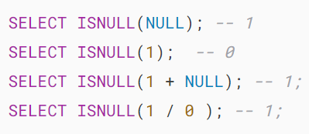

Notice that if you are trying to find the MySQL alternative to Microsoft SQL Server’s ISNULL function, you should use MySQL’s [IFNULL](https://www.mysqltutorial.org/mysql-control-flow-functions/mysql-ifnull/) function instead. Because the ISNULL function is MySQL is different from the Microsoft SQL Server’s ISNULL function.

## **MySQL ISNULL function & IS NULL operator**

The ISNULL function shares some behaviors with the IS NULL operator. For example, if you have a DATE column declared as [NOT NULL](https://www.mysqltutorial.org/mysql-basics/mysql-not-null-constraint/), you can find the special date '0000-00-00' by using the following statement:

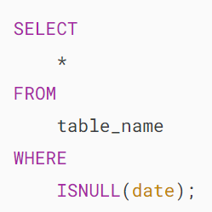

Note that MySQL purposely implemented this feature to support ODBC applications because ODBC does not support special date value '0000-00-00'.

Let’s take a look at an example.

First, [create a new table](https://www.mysqltutorial.org/mysql-basics/mysql-create-table/) named special_isnull as follows:

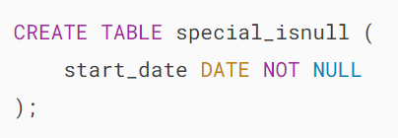

Second, [insert](https://www.mysqltutorial.org/mysql-basics/mysql-insert/)some data into the special_isnull table:



Third, [query](https://www.mysqltutorial.org/mysql-basics/mysql-select-from/) data from the special_isnull table using the ISNULLfunction:

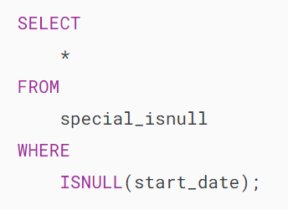MySQL ISNULL function example

The query returned one row while you may expected it will return an empty result set.

When you want to negate the IS NULL operator, you use the NOT operator i.e., IS NOT NULL. However, for the ISNULL function, you use !ISNULL.

In this tutorial, you have learned how to use the MySQL ISNULL function and its special behavior to handle NULL values.

# **MySQL COALESCE Function**

**Summary**: In this tutorial, you will learn how to use the MySQL COALESCE function to substitute NULL values.

## **Introduction to MySQL COALESCE function**

The COALESCE function takes a number of arguments and returns the first non-NULL argument. In case all arguments are NULL, the COALESCE function returns NULL.

The following illustrates the COALESCE function syntax:



For example:

## 

## **MySQL COALESCE function examples**

See the following customers table in the [sample database](https://www.mysqltutorial.org/getting-started-with-mysql/mysql-sample-database/):

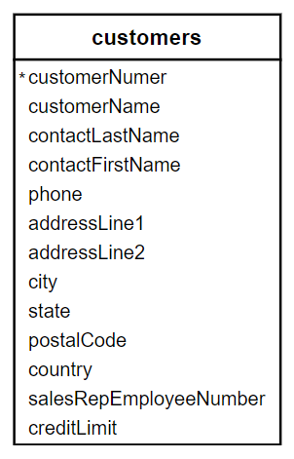

The following [query](https://www.mysqltutorial.org/mysql-basics/mysql-select-from/) returns the customer name, city, state, and country of all customers in the customers table.

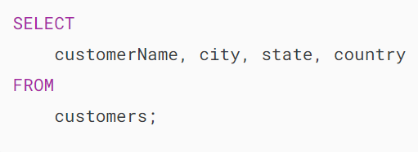



As you see, the state column has NULL values because some of this information is not applicable to the country of some customers.

To substitute the NULL value in the result set, you can use the COALESCE function as follows:

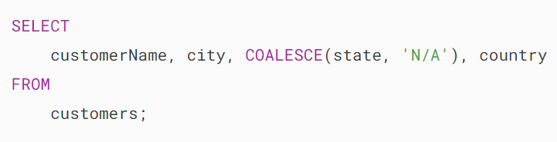



In this example, if the value in the state column is NULL, the COALESCE function will substitute it with the N/A string. Otherwise, it returns the value of the state column.

Another typical example of using the COALESCE function is to substitute the value in one column with another when the first one is NULL.

Suppose you have an articles table with the following structure:

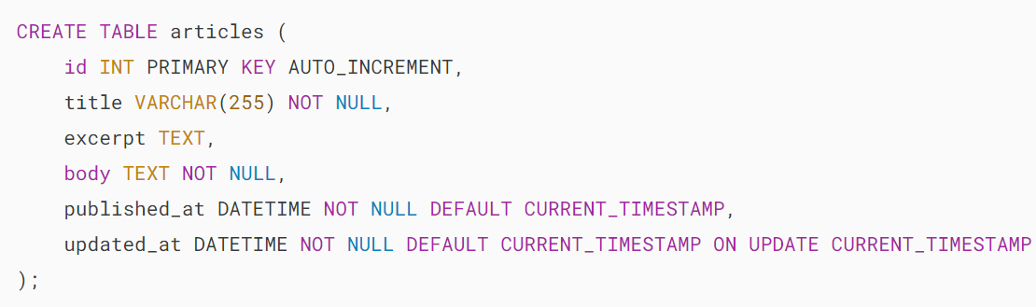

Let’s [insert some data](https://www.mysqltutorial.org/mysql-basics/mysql-insert/)into the articles table.



Imagine you have to display articles on an overview page where each article contains the title, expert, and publish date (and also the read more link to the article page). The first task you need to do is to query this data from the articles table:

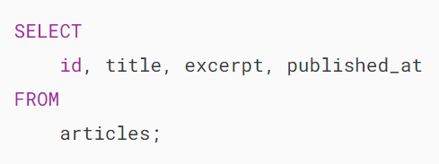



As you see the article with id 2 does not have the excerpt, which is not nice for displaying.

A typical solution is to get the first number of characters in the body of the article for displaying as the excerpt. This is why the COALESCE function comes into play.

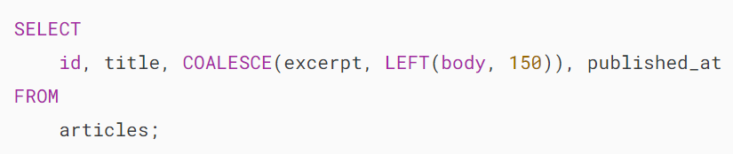



In this example, if the value in the excerpt column is NULL, the COALESCE function returns the first 150 characters of the content in the body column.

## **MySQL COALESCE and CASE expression**

Besides using the COALESCE function, you can use the [CASE](https://www.mysqltutorial.org/mysql-control-flow-functions/mysql-case-function/) expression to achieve the same effect.

The following query uses the CASE expression to achieve the same result as the example above:

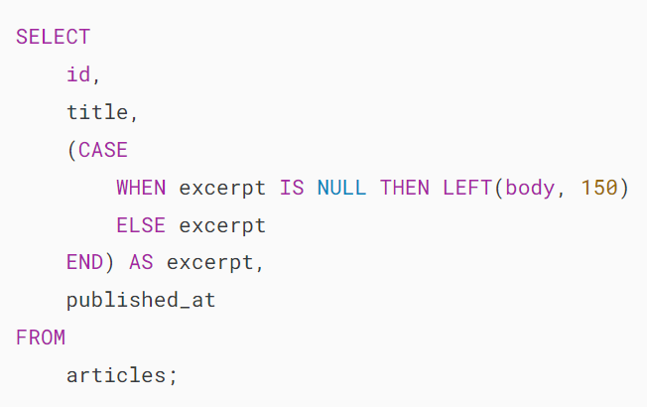

In this example, the CASE expression is more lengthy than using the COALESCE function.

## **COALESCE vs. IFNULL**

The IFNULL function takes two arguments and returns the first argument if it is not NULL, otherwise, it returns the second argument.

The IFNULL function works great with two arguments whereas the COALESCE function works with n arguments. In case the number of arguments is two, both functions are the same.

In this tutorial, you have learned how to use the MySQL COALESCE function to substitute NULL values.