# **What is MySQL**

**Summary**: What is MySQL? This tutorial will provide you with answers and reasons why MySQL is one of the world’s most popular open-source databases.

## **Introduction to databases**

You interact with data every day…

When you want to listen to your favorite songs, you open your playlist from your smartphone. In this case, the playlist is essentially a database.

When you take a photo and upload it to your account on a social network like Facebook, your photo gallery becomes a database.

When you browse an e-commerce website to buy shoes, clothes, and more, you’re using the shopping cart database.

Databases are everywhere. So what is a database?  By definition, a database is simply a structured collection of data.

The data within a database are naturally related, for example, a product belongsto a product category and isassociated with multiple tags. Hence, we use the term **relational database**.

In a relational database, we model data like products, categories, tags, etc., using tables. A table contains columns and rows, much like a spreadsheet.

Tables can relate to one another table using various types of relationships, like one-to-one and one-to-many.

Because we handle a substantial amount of data, we need a way to efficiently define databases, tables, and process data. Moreover, we want to transform data into valuable information.

This is where SQL comes into play.

## **SQL – the language of the relational database**

SQL stands for the structured query language.

SQL is the standardized language used to access the database.

ANSI/SQL defines the SQL standard and the current version of SQL is SQL:2023. When we refer to the SQL standard, we are talking about the current SQL version.

SQL is composed of three parts:

1. Data definition language (DDL) includes statements for defining the database and its objects such as tables, [views](https://www.mysqltutorial.org/mysql-views/),[triggers](https://www.mysqltutorial.org/mysql-triggers/), [stored procedures](https://www.mysqltutorial.org/mysql-stored-procedure/), etc.
2. Data manipulation language (DML) contains statements for [updating](https://www.mysqltutorial.org/mysql-basics/mysql-update/) and [querying data](https://www.mysqltutorial.org/mysql-basics/mysql-select-from/).
3. Data control language (DCL) allows you to [grant permissions](https://www.mysqltutorial.org/mysql-administration/mysql-grant/) to users to access specific data in the database.

Now that you understand databases and SQL, it’s time to answer the next question…

## **What is MySQL**

MySQL? What’s in a name?

MySQL got its name from the daughter of one of its co-founders, Monty Widenius, whose name is My. Combining ‘My’ with ‘SQL,’ we get MySQL.

MySQL is a robust database management system designed for managing relational databases. It is open-source software supported by Oracle, meaning that you can use MySQL without any cost. Additionally, you will have the flexibility to modify its source code to tailor it to your specific requirements.

Despite being open-source software, you also have the option to purchase a commercial license from Oracle, which provides access to premium support services.

When compared to other database software like Oracle Database or Microsoft SQL Server, MySQL is relatively easy to master.

MySQL is versatile and can run on various platforms, including UNIX, Linux, and Windows. You can [install it on a server or even on a desktop](https://www.mysqltutorial.org/getting-started-with-mysql/install-mysql/). What’s more, MySQL is renowned for its reliability, scalability, and speed.

The official way to pronounce MySQL is My Ess Que Ell, not My Sequel. Nevertheless, you can pronounce it as you prefer; it’s a matter of personal choice.

If you’re a web developer, MySQL is a great choice. It’s a key component of the LAMP stack, which consists of Linux, Apache, MySQL, and PHP.

# **Install MySQL**

**Summary**: in this tutorial, you will learn how to install MySQL server and its related products on Windows using the MySQL Installer.

After the tutorial, you will have a MySQL server and its tools up and running on your system for learning and practicing.

Note that for other operating systems like Linux and Ubuntu, refer to the following tutorials:

* [Install MySQL 8 on CentOS 7](https://www.mysqltutorial.org/getting-started-with-mysql/install-mysql-centos/)
* [Install MySQL 8 on Ubuntu](https://www.mysqltutorial.org/getting-started-with-mysql/install-mysql-ubuntu/)

## **Download MySQL Installer**

If you want to install MySQL on Windows, you can use the MySQL Installer. The MySQL Installer provides you with an easy-to-use wizard that helps you to install MySQL with the following main products:

* MySQL Server
* MySQL Workbench
* MySQL Shell
* MySQL Documentation
* All Available Connectors

To download the MySQL installer, go to the following link <http://dev.mysql.com/downloads/installer/>.

We’ll use the MySQL Installer 8.0.34 to install the MySQL Server and related products such as MySQL Workbench and MySQL Shell.

## **Install MySQL Server & related products using MySQL Installer**

To install MySQL using the MySQL installer, double-click on the MySQL Installer file and follow the steps below:

### **Install MySQL Step 1 Step 1: Choosing a setup type**

In this step, you need to choose the setup type that suits your use case. For tutorial purposes, you can select the last option which is **Custom** setup type:

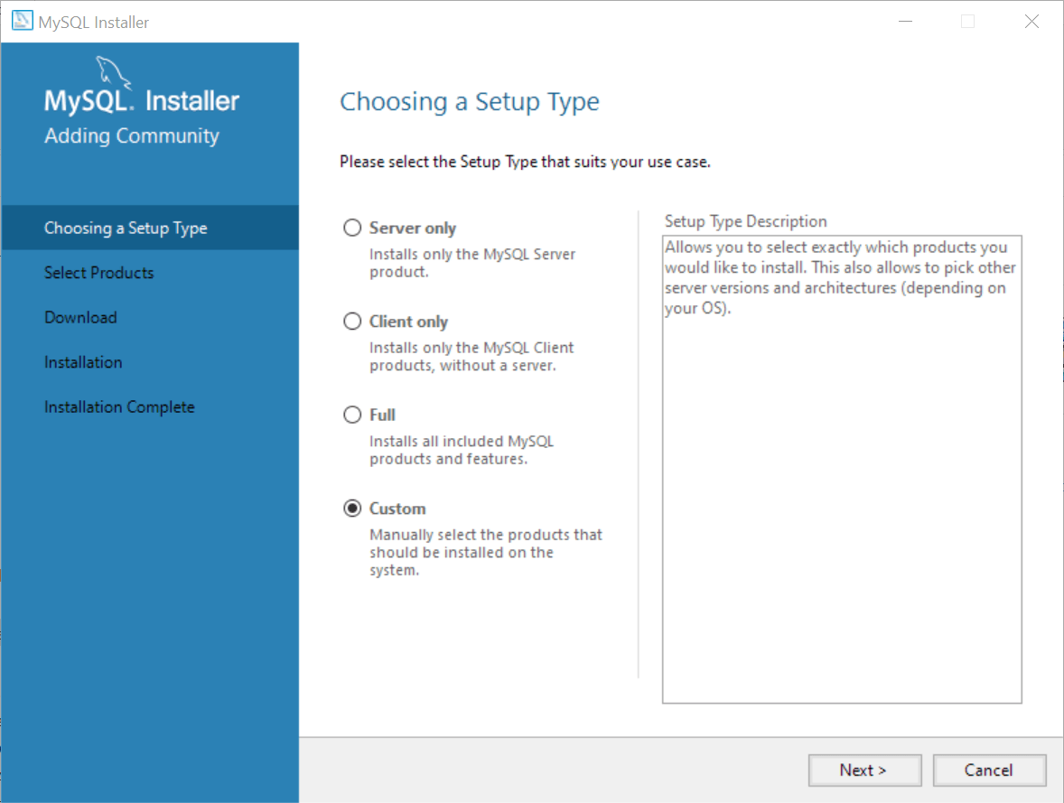

### **Step 2. Selecting products**

Since we chose the **Custom**setup type, the MySQL Installer displays available products for us to select to install.

We’ll install the following products:

* **MySQL Server** – This is the MySQL Database Server.
* **MySQL Workbench** – This is the client tool for interacting with the MySQL Database Server via GUI.
* **MySQL Shell** – This is an interactive Javascript, Python, or SQL interface supporting development and administration for the MySQL Server.

To select these products, you click the + icon on the left pane, select the product, and click the right arrow button.

Here are the paths to the selected products:

* MySQL Servers > MySQL Server > MySQL Server 8.0 > MySQL Server 8.0.34 – x64
* Applications > MySQL Workbench > MySQL Workbench 8.0 > MySQL Workbench 8.0.34 – X64
* Applications > MySQL Shell > MySQL Shell 8.0 > MySQL Shell 8.0.34 – X64

Once you select the products, you click the **Next** button to continue.

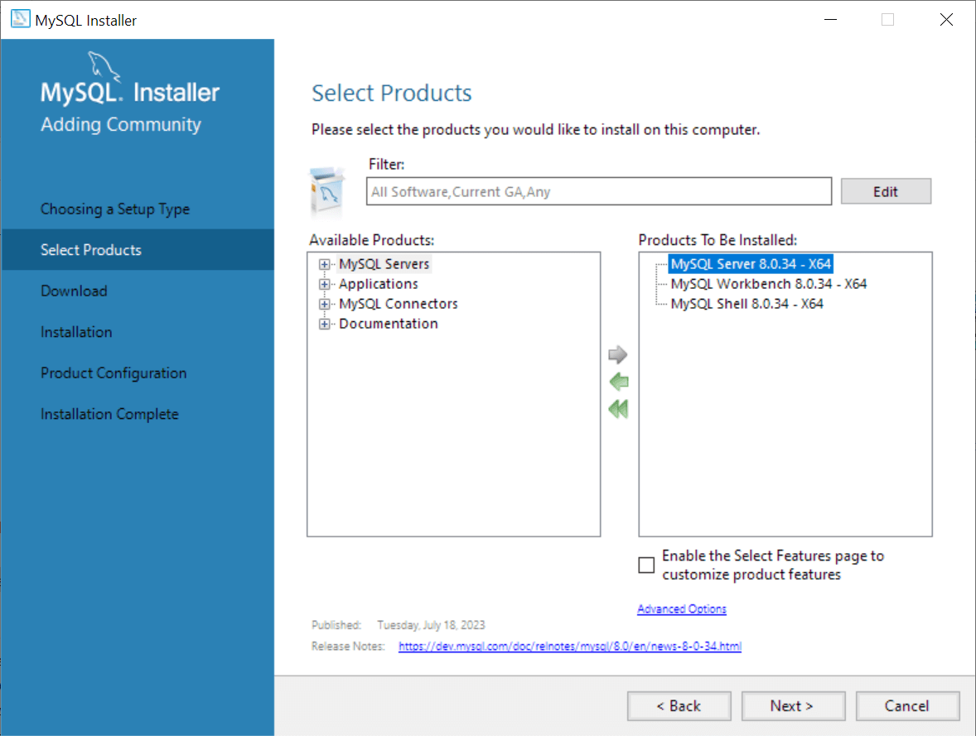

### **Step 3. Downloading the selected products**

The MySQL Installer will download the selected products from the internet. Please ensure you have an active internet connection and wait for a few minutes for the download to complete.

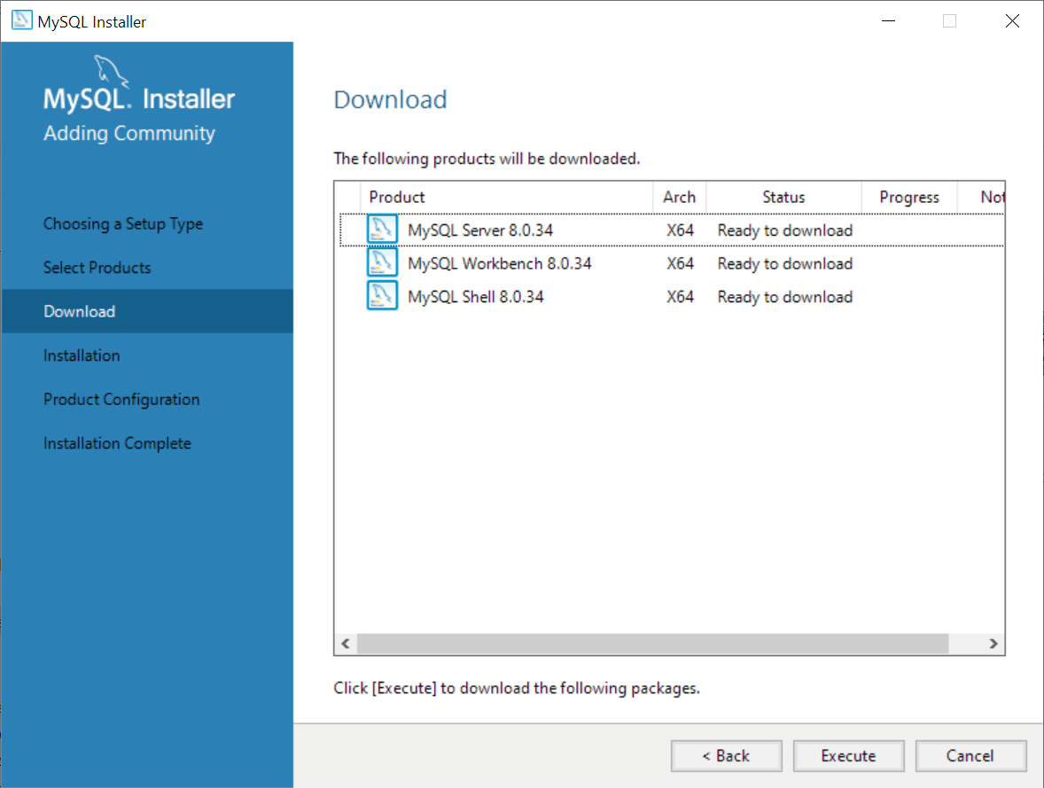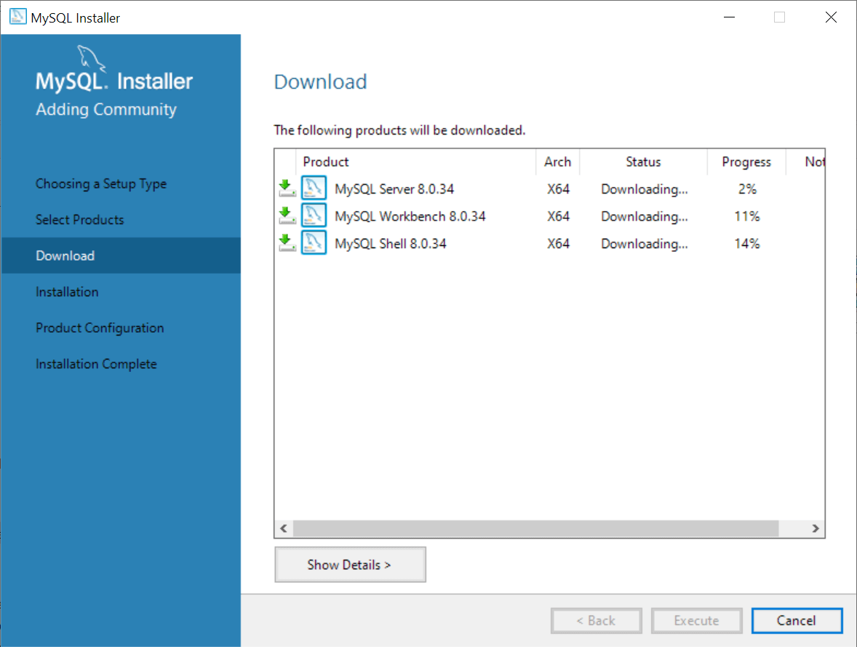

After the download is complete, click the **Execute** button to start the installation.

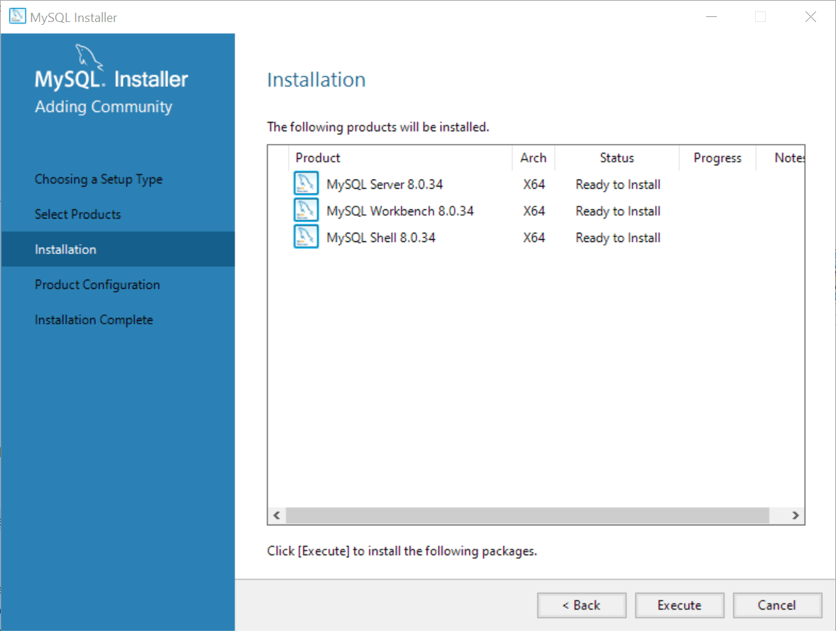

### **Step 4. Installing the selected products**

The MySQL Installer will install the selected products and this process may some time.

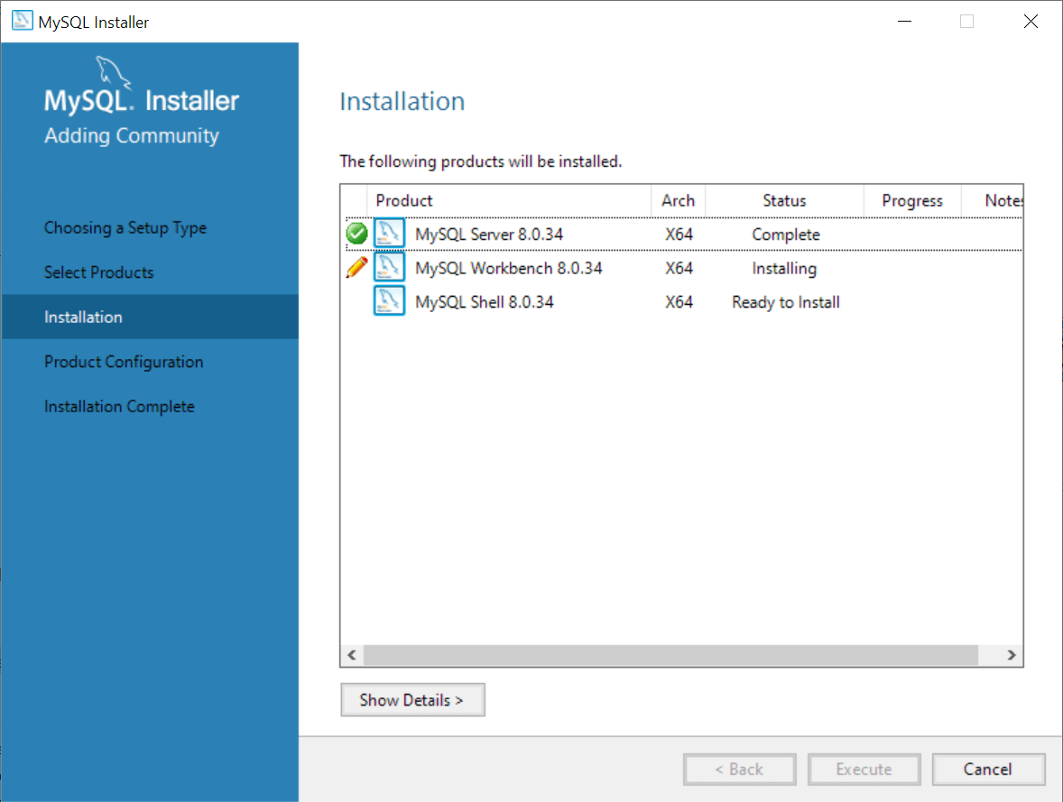

After the installation is complete, click the **Next** button to proceed to the Product Configuration.

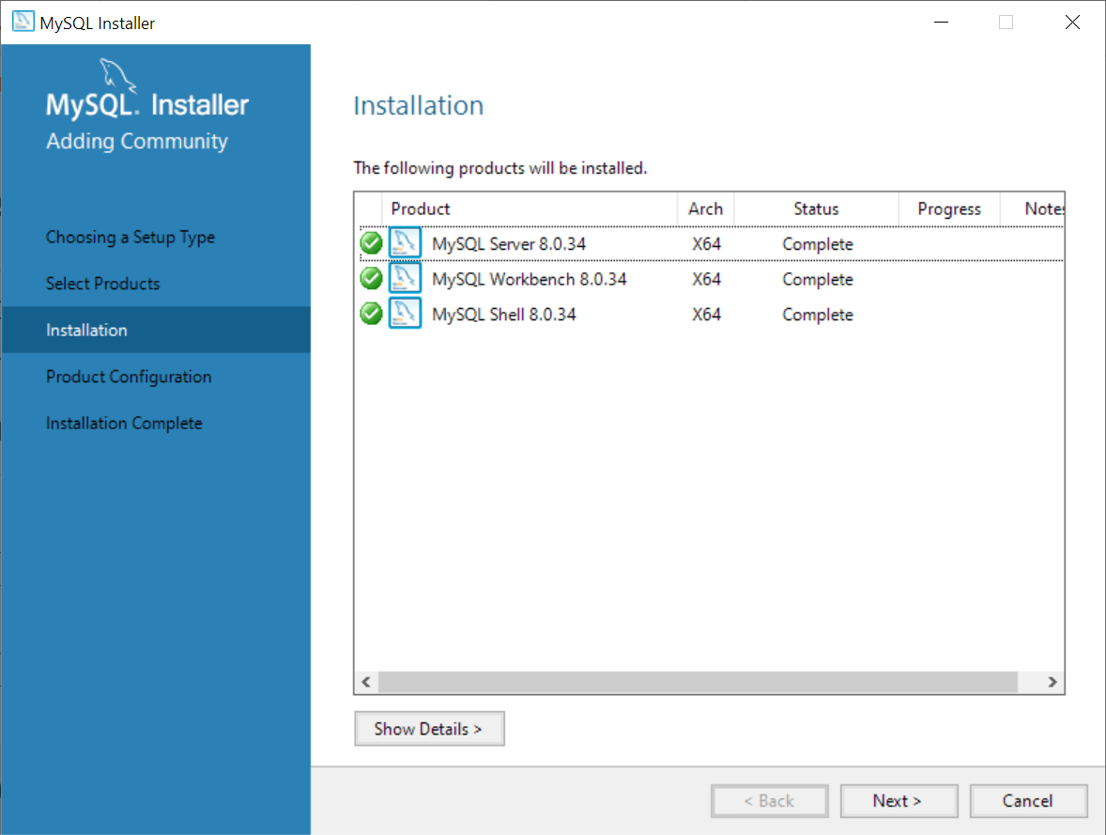

### **Step 5. Configuring the MySQL Server**

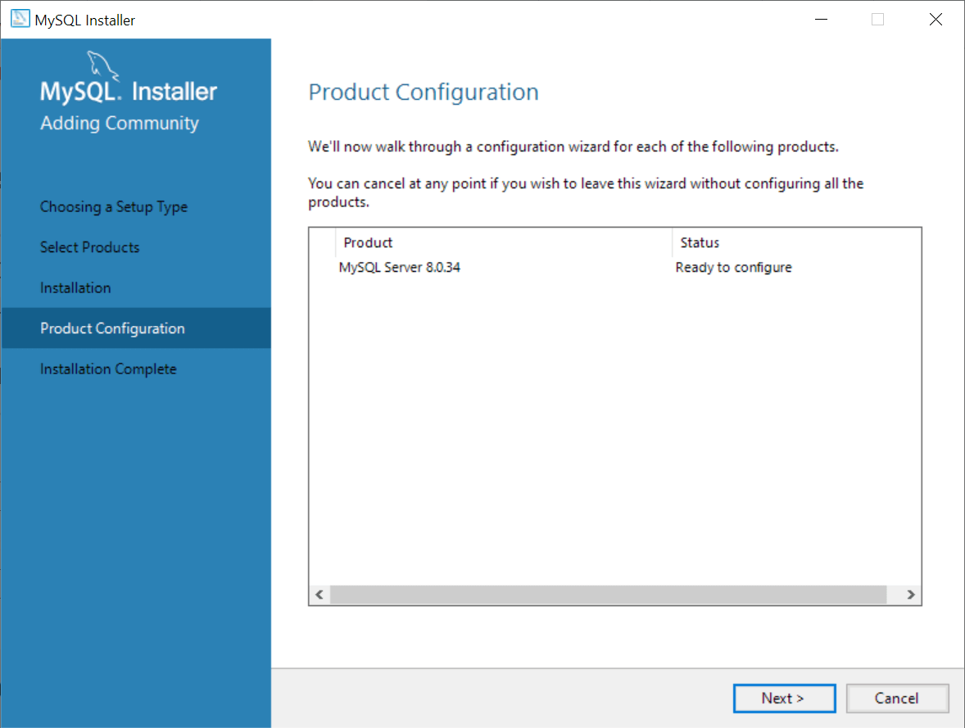

In this step, configure the MySQL Server. Choose the **Development Computer** for the server configuration type, leave the other options as they are, and click the **Next** button.

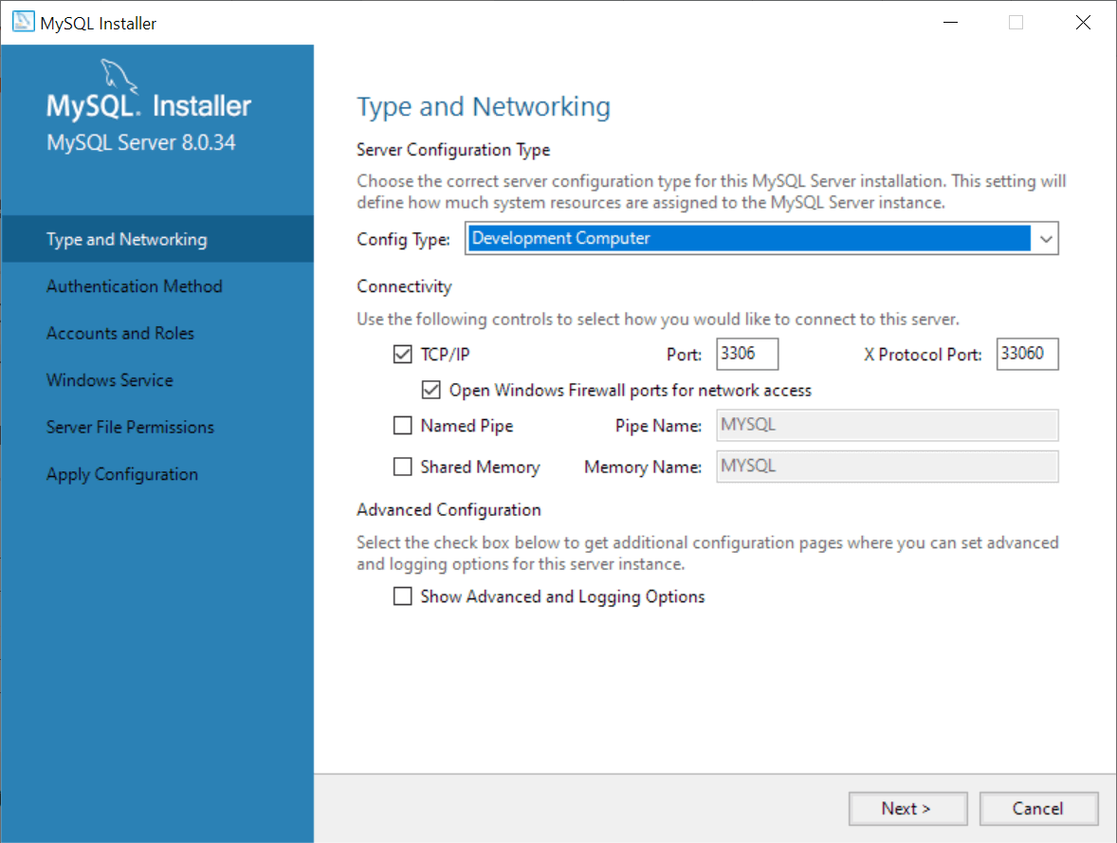

### **Step 6. Choosing an authentication method**

It’s recommended to use strong password encryption for authentication, which is the first option.

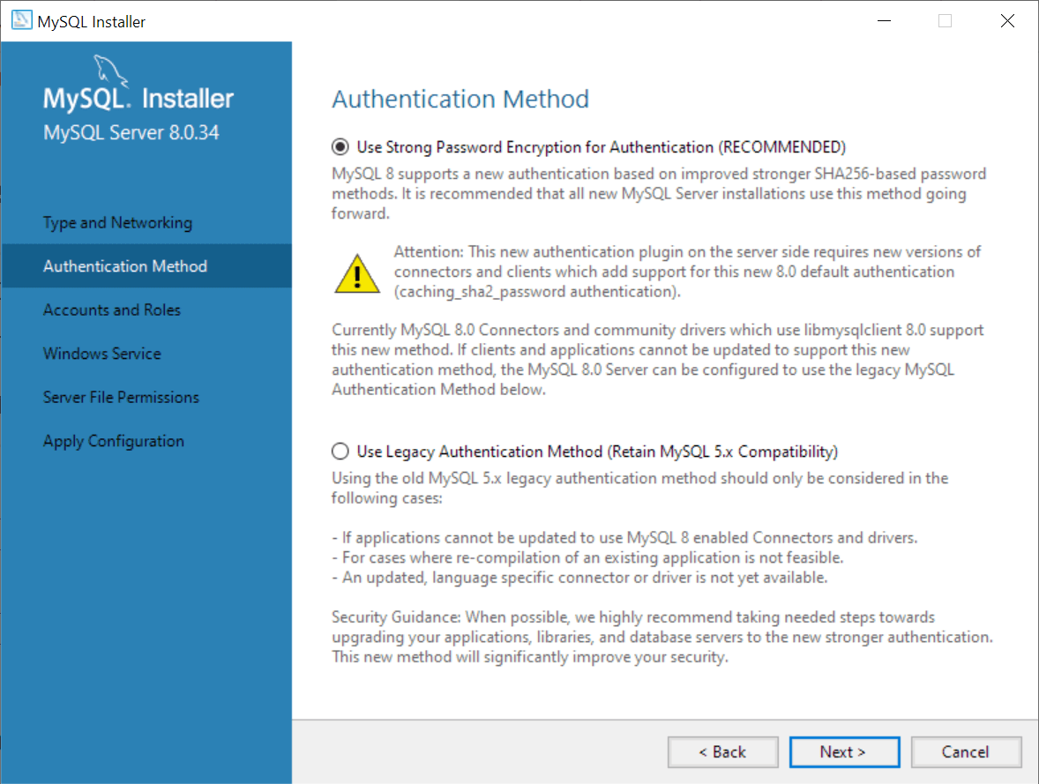

### **Step 7. Entering a password for the root account**

Enter a secure password for the root account, which has full administrative privileges.

Be sure to store it safely and use it for [connecting to the MySQL Server](https://www.mysqltutorial.org/getting-started-with-mysql/connect-to-mysql-server/) in the future.

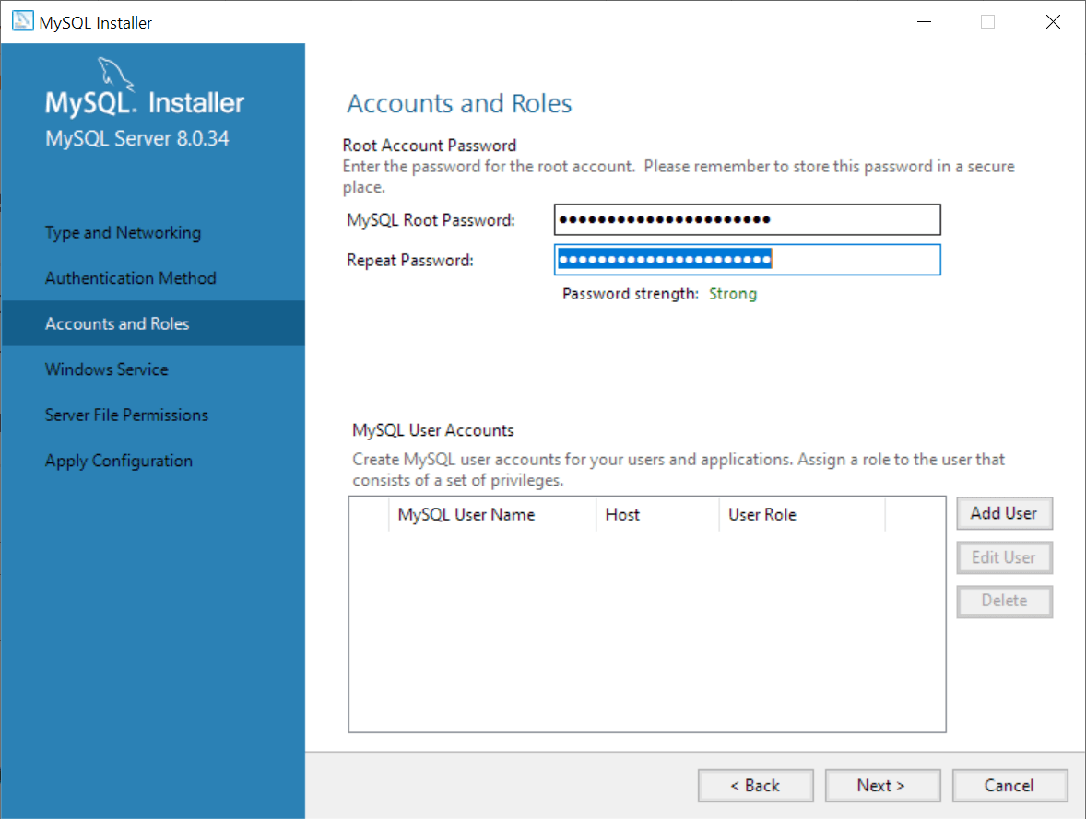

### **Step 8. Configuring MySQL Server as a Windows Service**

In this step, you can configure the MySQL Server as a Windows service, specify a service name, and choose whether to start the MySQL Server during the operating system startup.

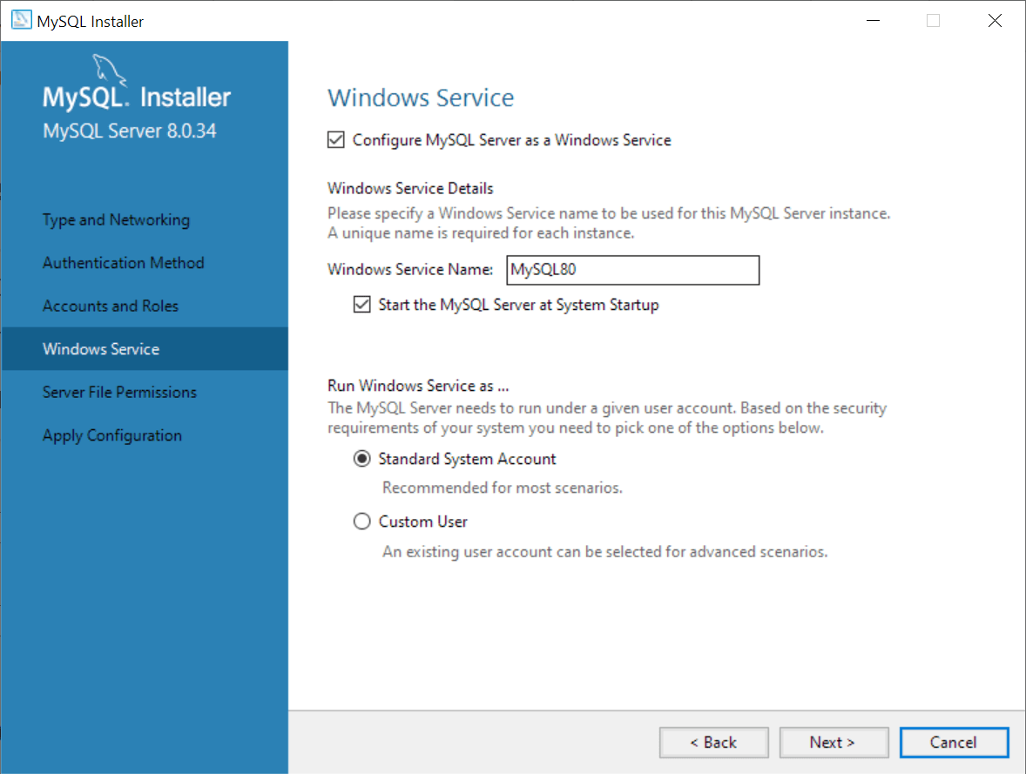

### **Step 9. Granting file permissions**

In this step, you grant permission to MySQL to access the data directory.

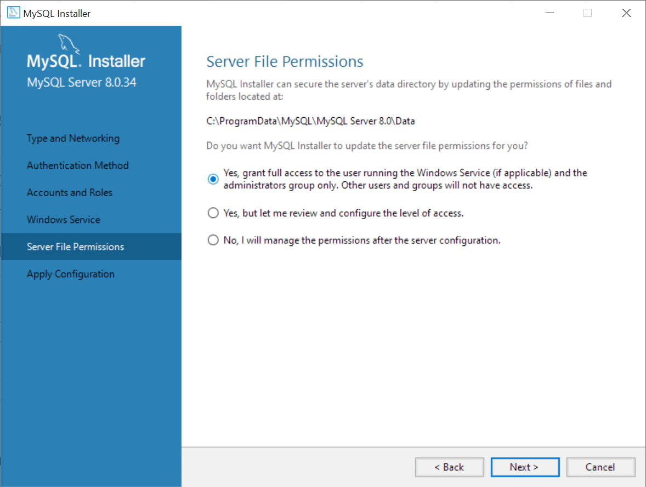

### **Step 10. Displaying the selected configuration**

The MySQL Installer displays a window with the configuration steps. Click the **Execute** button to apply the configuration.

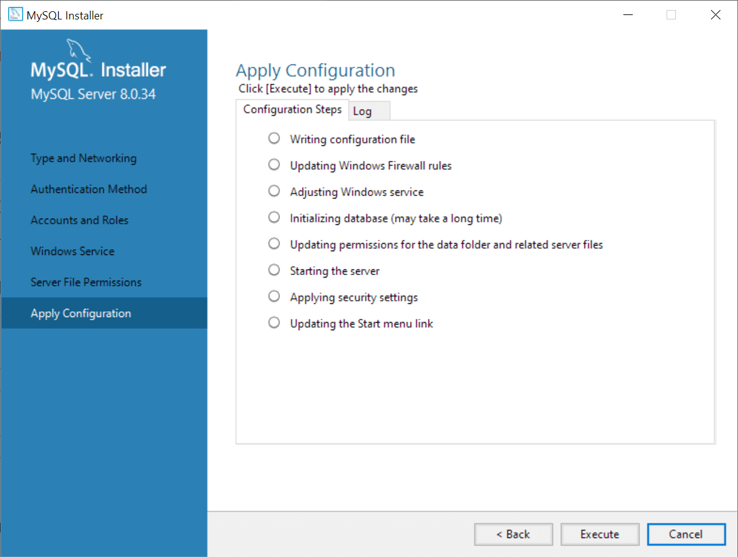

### **Step 11. Completing configuration**

After applying the configuration, the MySQL Installer displays the following window to indicate whether the MySQL Server has been configured successfully.

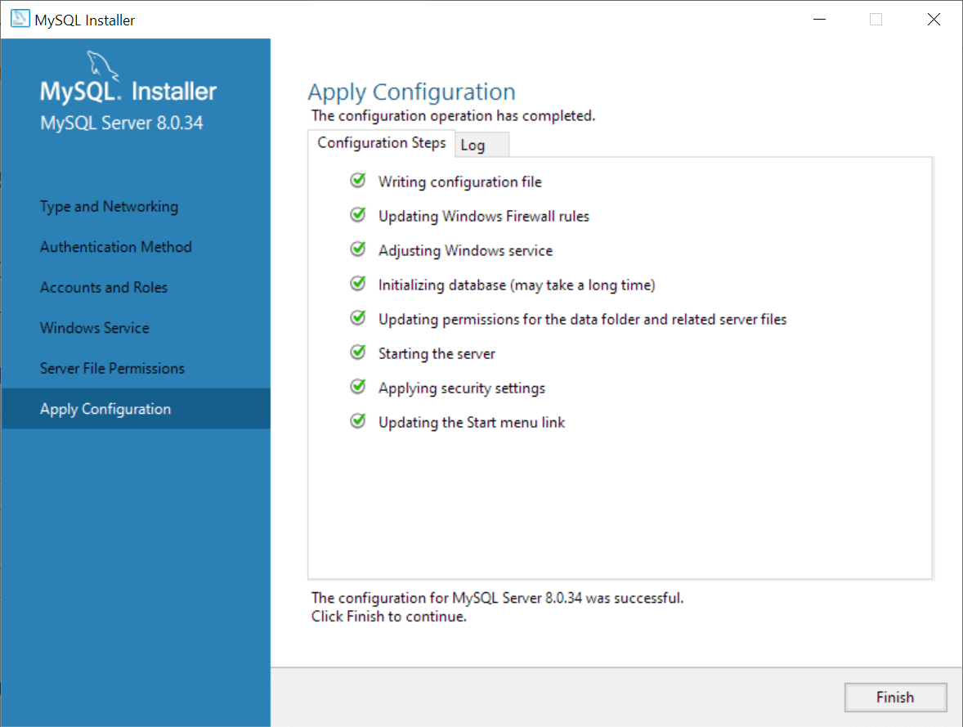

After completing the configuration, click the **Next** button to confirm and finish.

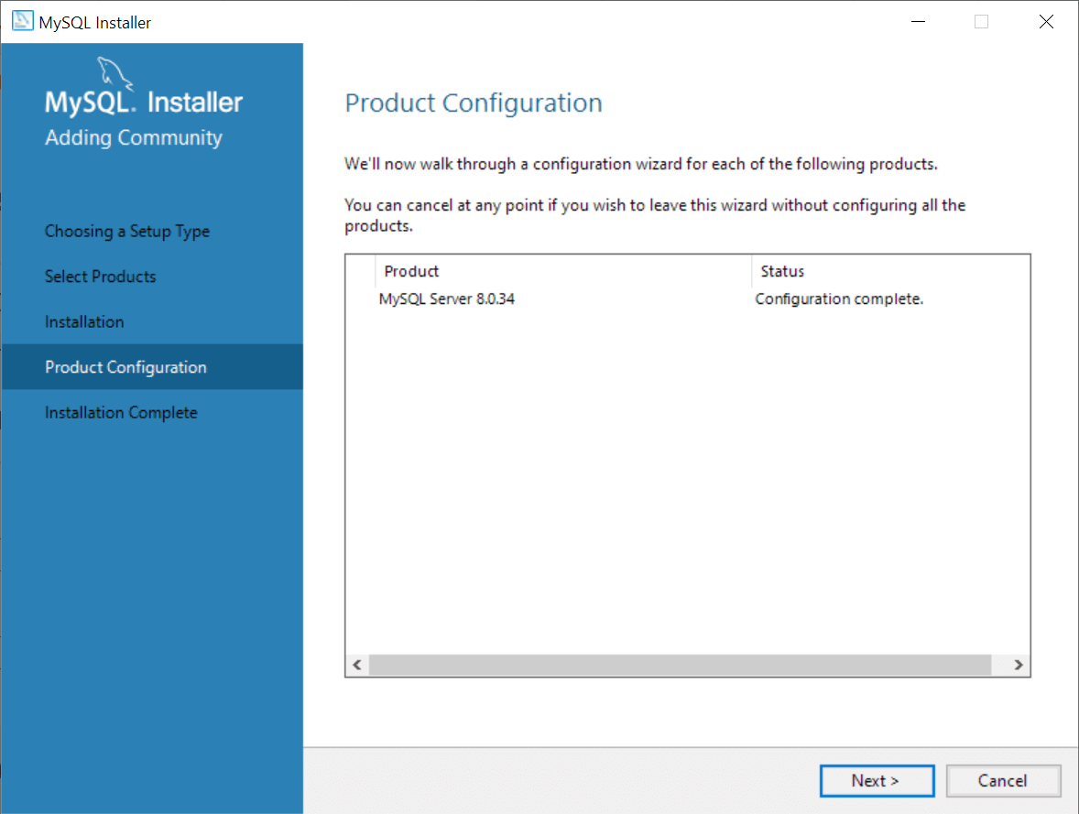

### **Step 12. Completing installation**

The MySQL Installer displays a window to notify you that the installation is complete. Click the **Finish** button to close the installer.

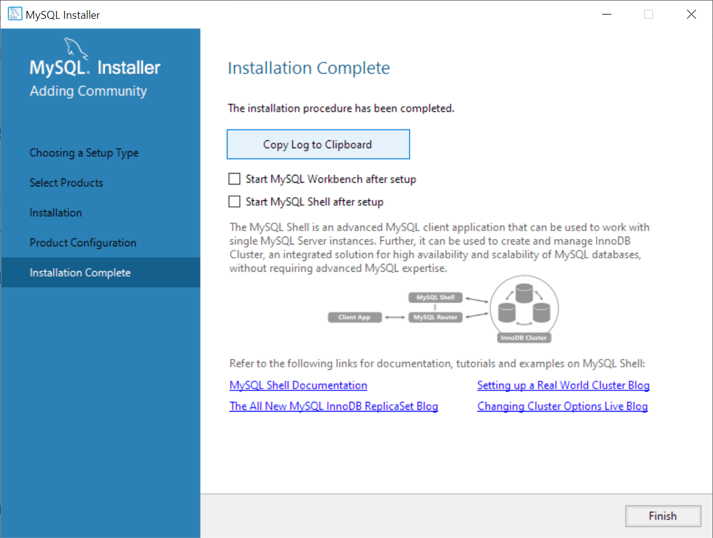

In this tutorial, you have learned how to install MySQL on your Windows using the MySQL installer.

# **Connect to MySQL Server**

**Summary**: in this tutorial, you will learn how to connect to MySQL Server using mysql command-line client and MySQL Workbench.

Once you have the [MySQL Server installed](https://www.mysqltutorial.org/getting-started-with-mysql/install-mysql/), you can connect to it using any client program such as mysql command-line client and MySQL workbench.

## **Connect to MySQL Using mysql command-line client**

The mysql is a command-line client program that allows you to interact with MySQL in interactive and non-interactive modes.

The mysql command-line client is typically located in the bin directory of MySQL’s installation directory such as C:\Program Files\MySQL\MySQL Server 8.0\bin on Windows.

To invoke the mysql program, you open the **Command Prompt** on Windows or Termina on Unix-like systems and navigate to the bin directory of the MySQL installation directory:

C:\Program Files\MySQL\MySQL Server 8.0\bin>Code language: plaintext (plaintext)

The Command Prompt is a command-line interpreter program available in Windows. The Command Prompt program allows you to interact with the computer through text-based commands for tasks like running programs, managing files, and configuring system settings.

If the bin directory is included in the PATH, you can use the mysql command from the Command Prompt without the need to navigate to the bin directory.

On Windows, the PATH is an environment variable that contains a list of directories. Windows OS uses these directories to locate executable files, making it easier to run applications from the Command Prompt without specifying the full file path.

To connect to the MySQL Server, you type this command on Command Prompt:

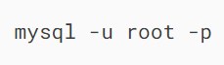

In this command:

-u root means that you connect to the MySQL Server using the user root.

-p instructs mysql to prompt for a password.

You type the password for the root user and press Enter:

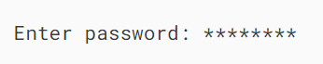

If everything is OK, you will connect to the MySQL Server and see the following command:

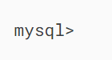

To display available databases in the current server, you enter the [SHOW DATABASES](https://www.mysqltutorial.org/mysql-administration/mysql-show-databases/) statement terminated by a semicolon (;) and press the Enter key:

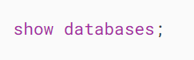

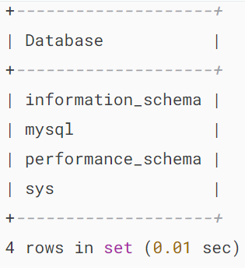

Here are the steps that occur behind the scenes:

* First, the mysql command-line client sends the query to the MySQL Server.
* Second, the MySQL server executes the query and sends the result back.
* Third, the mysql command-line client displays the result.

## **Connect to MySQL database server using MySQL Workbench**

Step 1. Launch the MySQL Workbench.

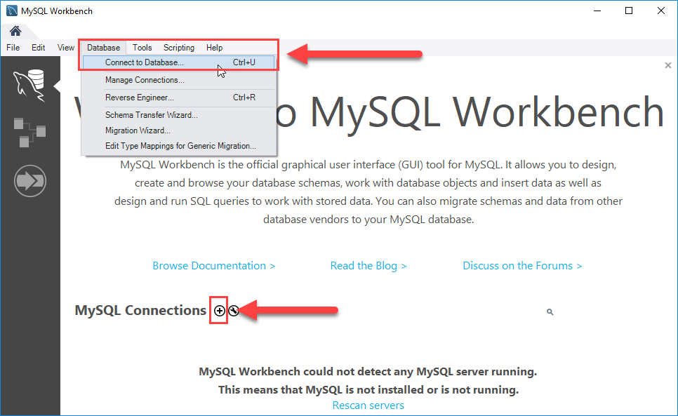

You can connect to a MySQL Server using the **Database > Connect to Database…** menu or click the + button that is located next to the MySQL Connections.

Click the + button next to the MySQL Connections to continue.

Step 2. Enter the connection name e.g., Localhost. You can name it whatever makes sense to you. By default, the username is root. If you use a different user account, you can change it in the Username textbox.

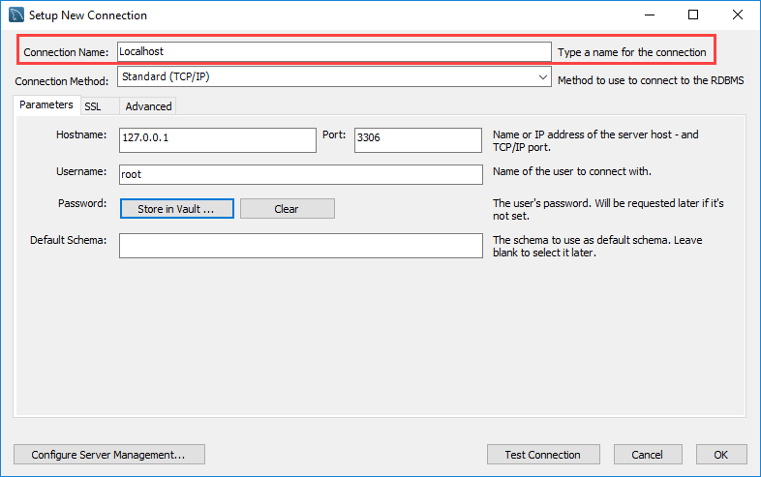

Step 3. Click the Store in Vault ... button to enter the password for the provided user account. A window will display. You enter the password and click the OK button.

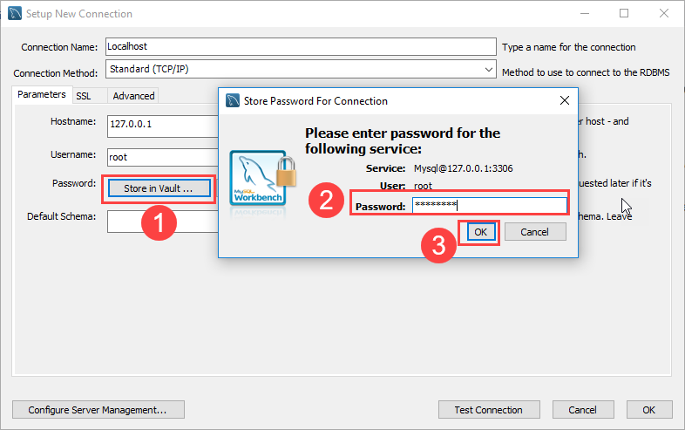

Step 4. Click the Test Connection button to test if the connection to the MySQL Server is successful or not. Then click the OK button if the connection is established successfully.

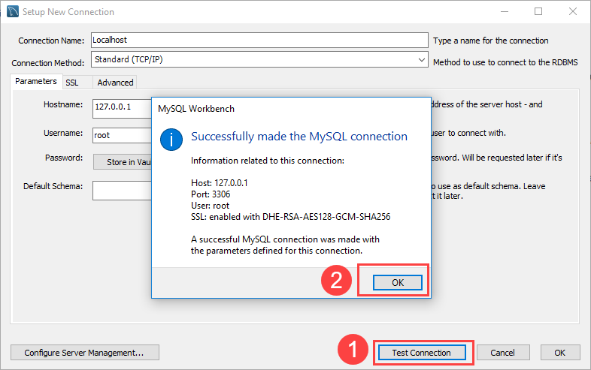

Step 5. Click the OK button to save the connection.

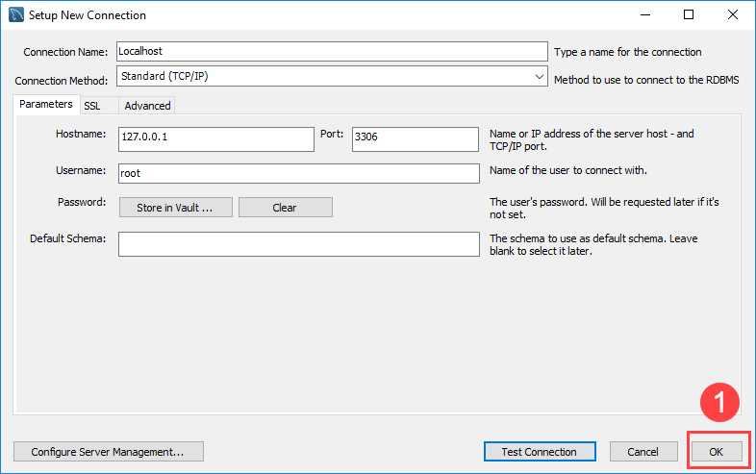

Step 6. Click the newly created connection under MySQL Connections to connect to the MySQL Server:

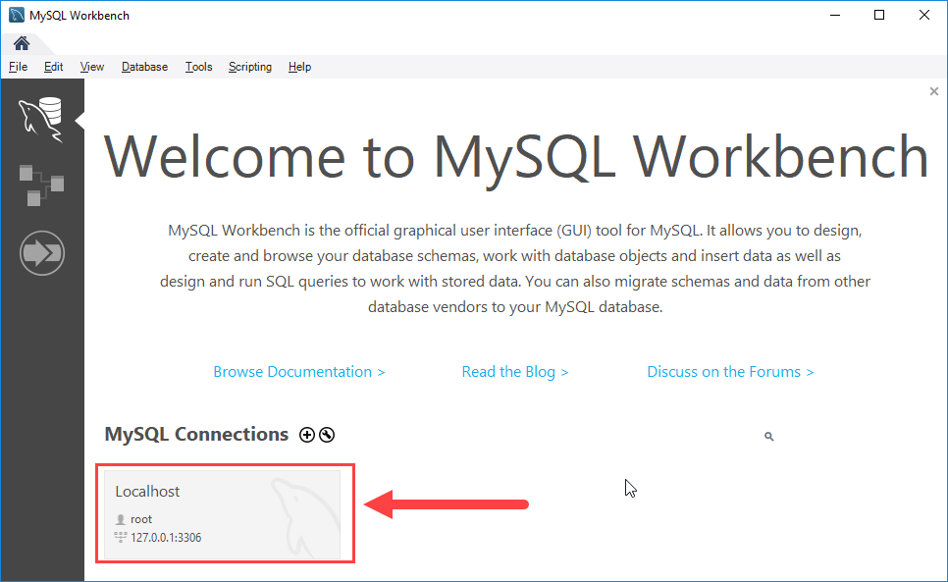

Step 7. MySQL Workbench display with the current schemas and a pane for entering queries:

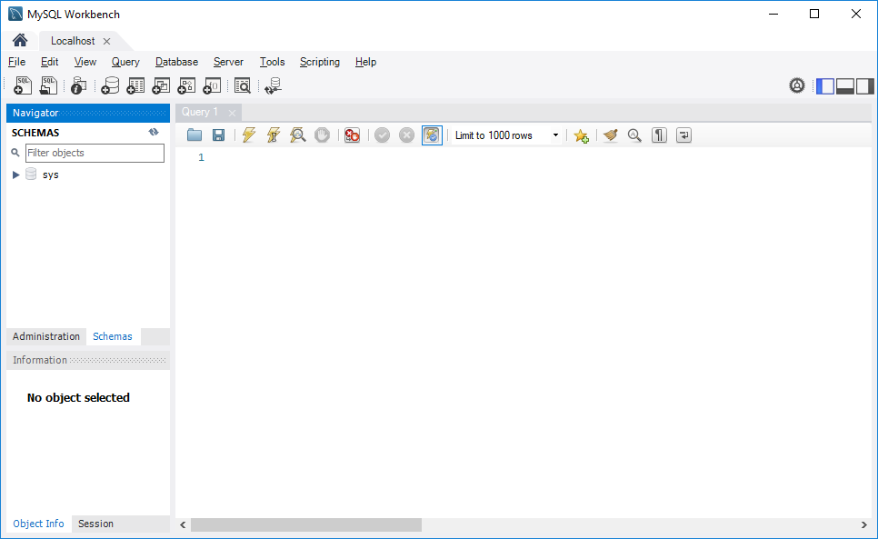

To execute a query from the MySQL Workbench, you enter the query in the query tab (1) and click the Execute button from the toolbar (2).

MySQL Workbench will send the query to the MySQL Server and get the result back (3 + 4):

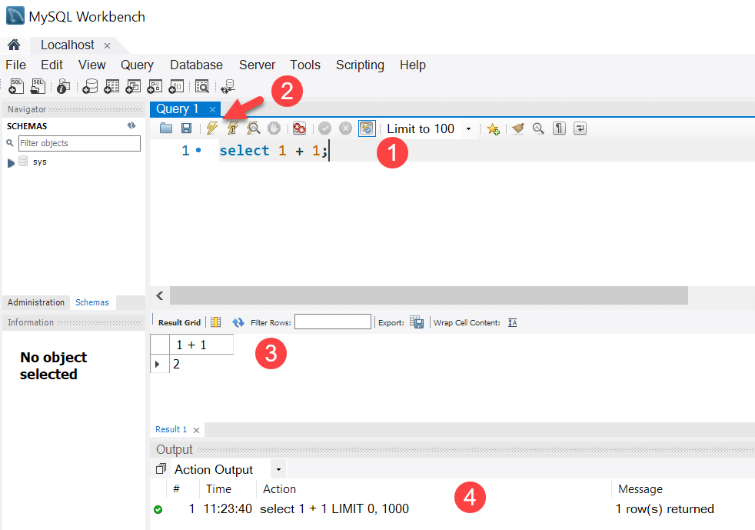

# **MySQL Sample Database**

We use the classicmodels database as a **MySQL sample database** to help you work with MySQL quickly and effectively.

The classicmodels database is a retailer of scale models of classic cars. It contains typical business data, including information about customers, products, sales orders, sales order line items, and more.

We’ll use this sample database in our [MySQL tutorials](https://www.mysqltutorial.org/) to demonstrate a wide range of MySQL features, from [simple queries](https://www.mysqltutorial.org/mysql-basics/) to complex [stored procedures](https://www.mysqltutorial.org/mysql-stored-procedure/).

## **Download MySQL Sample Database**

You can download the sample database from the following link:

[Download MySQL Sample Database](https://www.mysqltutorial.org/wp-content/uploads/2023/10/mysqlsampledatabase.zip)

The download file is in ZIP format, so you’ll need a zip program to unzip it. You can download a free zip program at [www.7-zip.org](http://www.7-zip.org/).

After uncompressing the sampledatabase.zip file, you can [load the sample database into the MySQL database](https://www.mysqltutorial.org/getting-started-with-mysql/how-to-load-sample-database-into-mysql-database-server/) server by following the tutorial on how to do so.

## **MySQL Sample Database Schema**

The MySQL sample database schema consists of the following tables:

* **customers**: stores customer’s data.
* **products**: stores a list of scale model cars.
* **productlines**: stores a list of product lines.
* **orders**: stores sales orders placed by customers.
* **orderdetails**: stores sales order line items for every sales order.
* **payments**: stores payments made by customers based on their accounts.
* **employees**: stores employee information and the organization structure such as who reports to whom.
* **offices**: stores sales office data.

The following picture illustrates the ER diagram of the sample database:

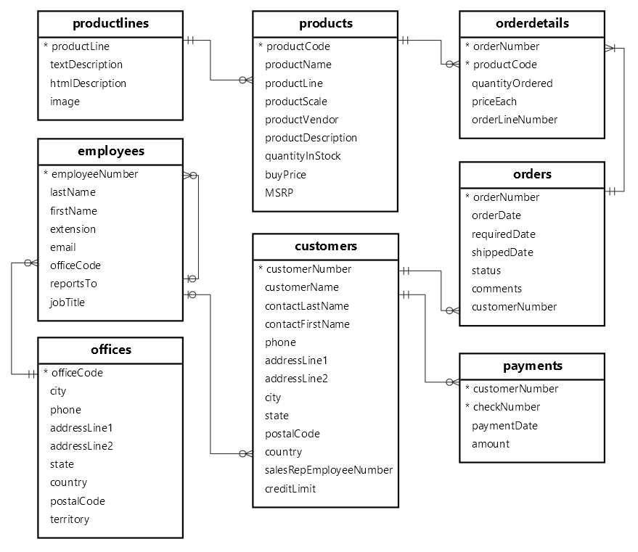

You can download the MySQL sample database ER diagram in PDF format from the following link:

[Download MySQL Sample Database Diagram PDF A4](https://www.mysqltutorial.org/wp-content/uploads/2018/04/MySQL-Sample-Database-Diagram-PDF-A4.pdf)

We recommend printing out the ER diagram and placing it on your desk to help you become familiar with the schema as you learn MySQL.

Have fun learning MySQL!

# **How to Load the Sample Database into MySQL Server**

**Summary**: in this tutorial, you will learn how to load the sample database into your MySQL Server using the mysql program.

### **Step 1**

Download the classicmodels database from the [MySQL sample database](https://www.mysqltutorial.org/getting-started-with-mysql/mysql-sample-database/) section.

### **Step 2**

Unzip the downloaded file into a temporary directory. You can use any directory you prefer, for example, C:\temp  directory.

If you use another operating system such as macOS, Linux, or Unix, please feel free to unzip it to any directory you prefer.

### **Step 3**

[Connect to the MySQL server](https://www.mysqltutorial.org/getting-started-with-mysql/connect-to-mysql-server/) using the mysql client program:

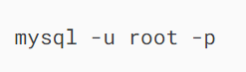

In this command:

* mysql: This is the command to start the MySQL client, which allows you to connect to interact with databases.
* -u root: This specifies the user that you want to connect to the MySQL database server. In this case, it is the root user that has full administrative privileges.
* -p: This flag will prompt you to enter the password for the root user after you execute the command.

You’ll be asked to enter the password for the root user. Note that the password for the root user is the one that you set when you [installed MySQL](https://www.mysqltutorial.org/getting-started-with-mysql/install-mysql/).

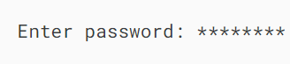

After a successful login, you’ll see the prompt that looks like this:

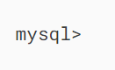

### **Step 4**

Use the [source](https://www.mysqltutorial.org/mysql-administration/execute-sql-file-in-mysql/) command to load data into the MySQL Server:

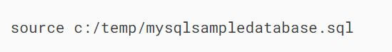

### **Step 5**

Use the [SHOW DATABASES](https://www.mysqltutorial.org/mysql-administration/mysql-show-databases/) command to list all databases in the current server:

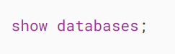

The output will look like the following including the newly created classicmodels database:

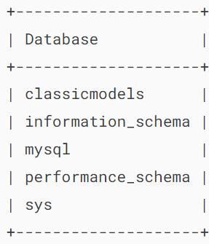

# **Install MySQL on Ubuntu**

**Summary**: in this tutorial, you will learn step-by-step how to install MySQL 8.0 on Ubuntu 22.0 (codename: jammy).

Before you begin, ensure you have root or sudo privileges on your Ubuntu system.

### **Step 1. Update APT Package List**

Update the APT package list to ensure that you have the latest information about available packages:

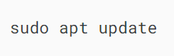

### **Step 2. Install MySQL Server**

To install MySQL, use the apt package manager. You can install MySQL using the apt package manager by running the following command:

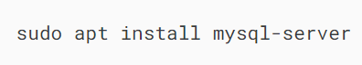

### **Step 3. Enable MySQL service to auto-start on reboot**

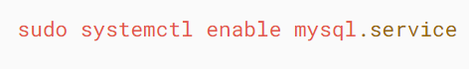

### **Step 4. Start MySQL Service**

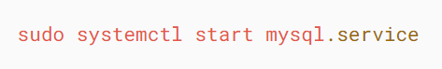

### **Step 5. Check the status of MySQL Service**

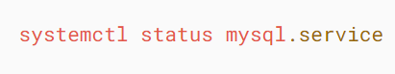

Note that you can press q to exit the message.

### **Step 6. Log in to MySQL and change the root’s password**

First, log in to the MySQL server using the following command:

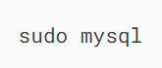

It’ll take you to the mysql command line:

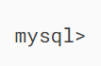

Second, change the password of the root’s account:

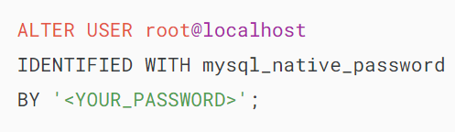

You should store the password in a secure place for logging in to the MySQL server later.

Third, exit the MySQL database server:

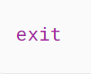

Fourth, attempt to log in to the MySQL database server with the new password:

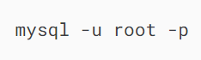

It’ll prompt you to enter a password. Please use the password that you entered in the previous step:

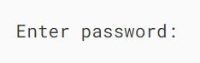

If you enter the password correctly, you’ll be logged in to the MySQL database server.

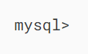

Before going to the next step, exit the mysql client tool:

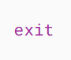

### **Step 7. Secure the MySQL installation**

Execute the following command to adjust the security of the MySQL Server:

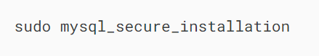

It’ll prompt you to enter the root’s password. After you enter the password correctly, you will be asked a series of questions. Press ‘Y’ or ‘N’ for the various security questions.