# **What is SQLite**

## **What is SQLite**

SQLite is a **software library** that provides a **relational database management system**. The lite in SQLite means lightweight in terms of setup, database administration, and required resources.

SQLite has the following noticeable features:

* Self-contained
* Serverless
* Zero-configuration
* Transactional

### **Serverless**

An RDBMS such as MySQL, PostgreSQL, etc., normally requires a separate server process to run. The applications that want to access the database server use TCP/IP protocol to send and receive requests. This is called client/server architecture.

The following diagram illustrates the RDBMS client/server architecture:

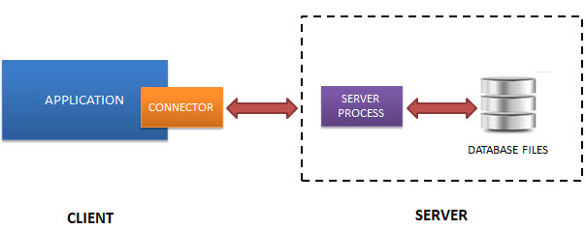

SQLite does NOT work this way.

SQLite does NOT require a server to run.

SQLite database is integrated with the application that accesses the database. The applications interact with the SQLite database reading and writing directly from the database files stored on disk.

The following diagram illustrates the SQLite server-less architecture:

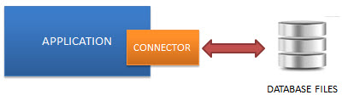

### **Self-Contained**

SQLite is self-contained, which means it requires minimal support from the operating system or external library. This makes SQLite usable in any environment, especially in embedded devices like iPhones, Android phones, game consoles, handheld media players, etc.

SQLite is developed using ANSI-C. The source code is available as a big sqlite3.c and its header file sqlite3.h. If you want to develop an application that uses SQLite, you drop these files into your project and compile them with your code.

### **Zero-configuration**

Because of the serverless architecture, you don’t need to “install” SQLite before using it. No server process needs to be configured, started, and stopped.

In addition, SQLite does not use any configuration files.

### **Transactional**

All transactions in SQLite are fully ACID-compliant, which means all queries and changes are Atomic, Consistent, Isolated, and Durable.

In other words, all changes within a transaction take place completely or not at all even when an unexpected situation like an application crash, power failure, or operating system crash occurs.

## **SQLite distinctive features**

SQLite uses dynamic types for tables. It means you can store any value in any column, regardless of the data type.

SQLite allows a single database connection to access multiple database files simultaneously. This brings many nice features like joining tables in different databases or copying data between databases in a single command.

SQLite is capable of creating in-memory databases that are very fast to work with.

# **How to Download & Install SQLite Tools**

**Summary**: in this tutorial, you will learn step-by-step how to download and use the SQLite tools on your computer.

## **Download SQLite tools**

To download SQLite tools, you open the [download page](https://www.sqlite.org/download.html) of the SQlite official website.

1. First, go to the [https://www.sqlite.org](https://www.sqlite.org/) website.
2. Second, open the download page <https://www.sqlite.org/download.html>

SQLite provides various tools for working across platforms including Windows, Linux, and Mac. You need to select an appropriate version to download.

For example, to work with SQLite on Windows, you download the command-line shell program as shown in the following screenshot:

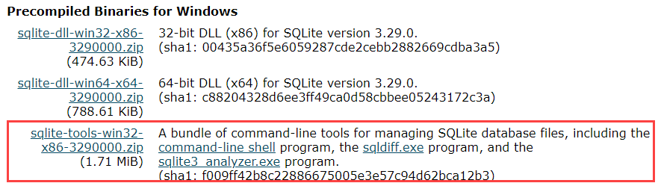

The downloaded file is in the ZIP format.

## **Run SQLite tools**

Copy the SQLite tools to a directory:

1. First, create a new directory such as C:\sqlite.
2. Second, extract the content of the file downloaded in the previous step to the C:\sqlite directory. You should see three programs in the C:\sqlite directory as shown below:



First, open the command line window:

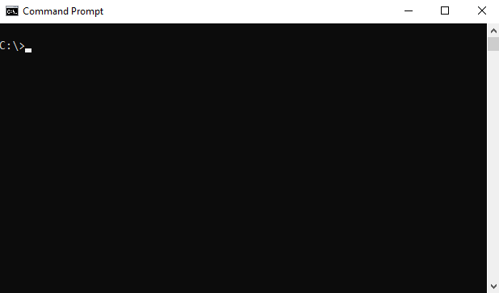

and navigate to the C:\sqlite folder.

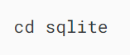

Second, type sqlite3 and press enter:



It’ll return the following output:

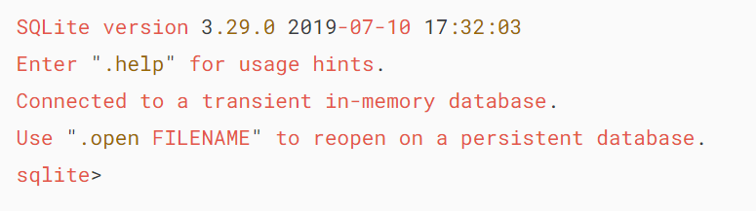

Third, you can type the .help command from the sqlite> prompt to see all available commands in sqlite3.



Output:

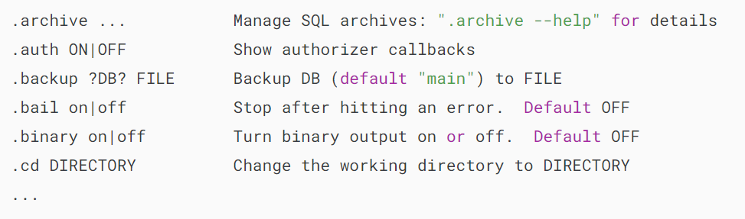

Fourth, to quit the sqlite> prompt, you use  .quit command as follows:

## 

## **Install SQLite GUI tool**

The sqlite3 shell is excellent…

However, sometimes, you may want to work with the SQLite databases using an intuitive GUI tool.

There are many GUI tools for managing SQLite databases available ranging from freeware to commercial licenses.

### **SQLiteStudio**

The SQLiteStudio tool is a free GUI tool for managing SQLite databases. It is free, portable, intuitive, and cross-platform.

SQLite tool also provides some of the most important features to work with SQLite databases such as importing and exporting data in various formats including CSV, XML, and JSON.

You can download the SQLiteStudio installer or its portable version by visiting the [download page](https://github.com/pawelsalawa/sqlitestudio/releases).  Then, you can extract (or install) the download file to a directory e.g., C:\sqlite\gui\ and launch it.

The following picture illustrates how to launch the SQLiteStudio:

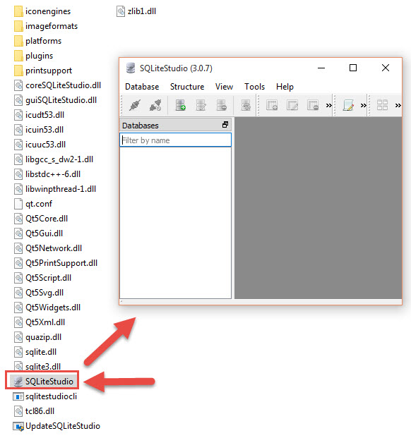

### **Other SQLite GUI tools**

Besides the SQLite Studio, you can use the following free SQLite GUI tools:

* [DBeaver](https://dbeaver.io/) is another free multi-platform database tool. It supports all popular major relational database systems MySQL, PostgreSQL, Oracle, DB2, SQL Server, Sybase.. including SQLite.
* [DB Browser for SQLite](https://sqlitebrowser.org/) – is an open-source tool to manage database files compatible with SQLite.

# **SQLite Sample Database**

**Summary**: in this tutorial, we first introduce you to an SQLite sample database. Then, we will give you the links to download the sample database and its diagram. At the end of the tutorial, we will show you how to connect to the sample database using the sqlite3 tool.

## **Introduction to the SQLite sample database**

We provide you with the SQLite sample database named Chinook. The Chinook sample database is a good database for practicing with SQL, especially SQLite.

The following database diagram illustrates the Chinook database tables and their relationships.

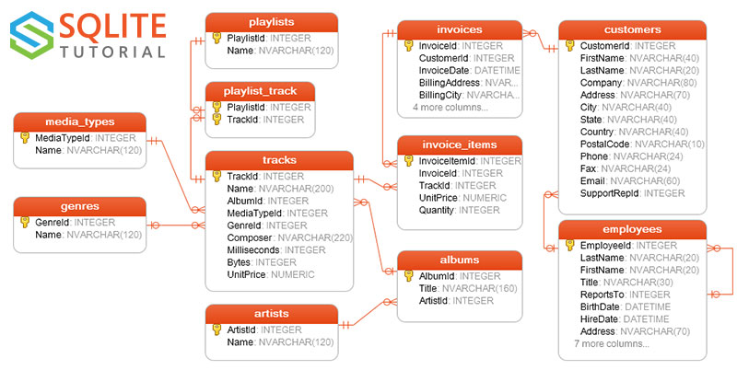

### **Chinook sample database tables**

The Chinook sample database has 11 tables as follows:

* employees table stores employee data such as id, last name, first name, etc. It also has a field named ReportsTo to specify who reports to whom.
* customers table stores customer data.
* invoices & invoice_items tables: these two tables store invoice data. The invoices table stores invoice header data and the invoice_items table stores the invoice line items data.
* artists table stores artist data. It is a simple table that contains the id and name.
* albums table stores data about a list of tracks. Each album belongs to one artist. However, one artist may have multiple albums.
* media_types table stores media types such as MPEG audio and AAC audio files.
* genres table stores music types such as rock, jazz, metal, etc.
* tracks table stores the data of songs. Each track belongs to one album.
* playlists & playlist_track tables: playlists table stores data about playlists. Each playlist contains a list of tracks. Each track may belong to multiple playlists. The relationship between the playlists and tracks tables is many-to-many. The playlist_track table is used to reflect this relationship.

## **Download SQLite sample database**

You can download the SQLite sample database using the following link.

[Download SQLite sample database](https://www.sqlitetutorial.net/wp-content/uploads/2018/03/chinook.zip)

If you want to have the database diagram for reference, you can download both black and white and color versions in PDF format.

[Download the SQLite sample database diagram](https://www.sqlitetutorial.net/wp-content/uploads/2018/03/sqlite-sample-database-diagram.pdf)

[Download the SQLite sample database diagram (color version)](https://www.sqlitetutorial.net/wp-content/uploads/2018/03/sqlite-sample-database-diagram-color.pdf)

## **How to connect to SQLite sample database**

The sample database file is in ZIP format, therefore, you need to extract it to a directory, for example, C:\sqlite\. The name of the file is chinook.db

If you don’t have Zip software installed, you can download [free Zip software such as 7-zip](http://www.7-zip.org/).

First, open the Command Prompt on Windows or a Terminal on Unix-like systems and navigate to the SQLite directory where the sqlite3.exe file is located.

Second, use the sqlite3 command to connect to the chinook sample database located in the same directory.

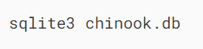

It’ll show something like this:

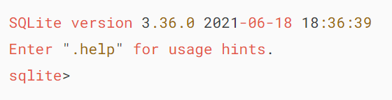

Third, show all tables in the Chinook database using the .tables command:

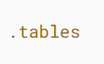

Output:

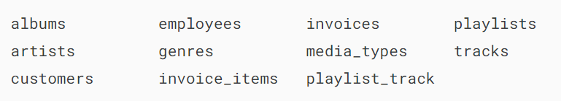

Finally, type the .exit command to quit the sqlite3 tool:

