# Social Feature Instruction

## Connect the game to the Google play service

* Create Game service for this game on your Google play developer console account
* Create a random achievement / leaderboard and get the resource by this way below:

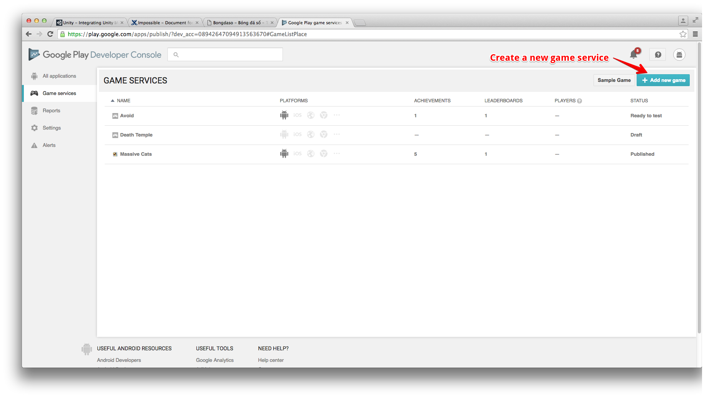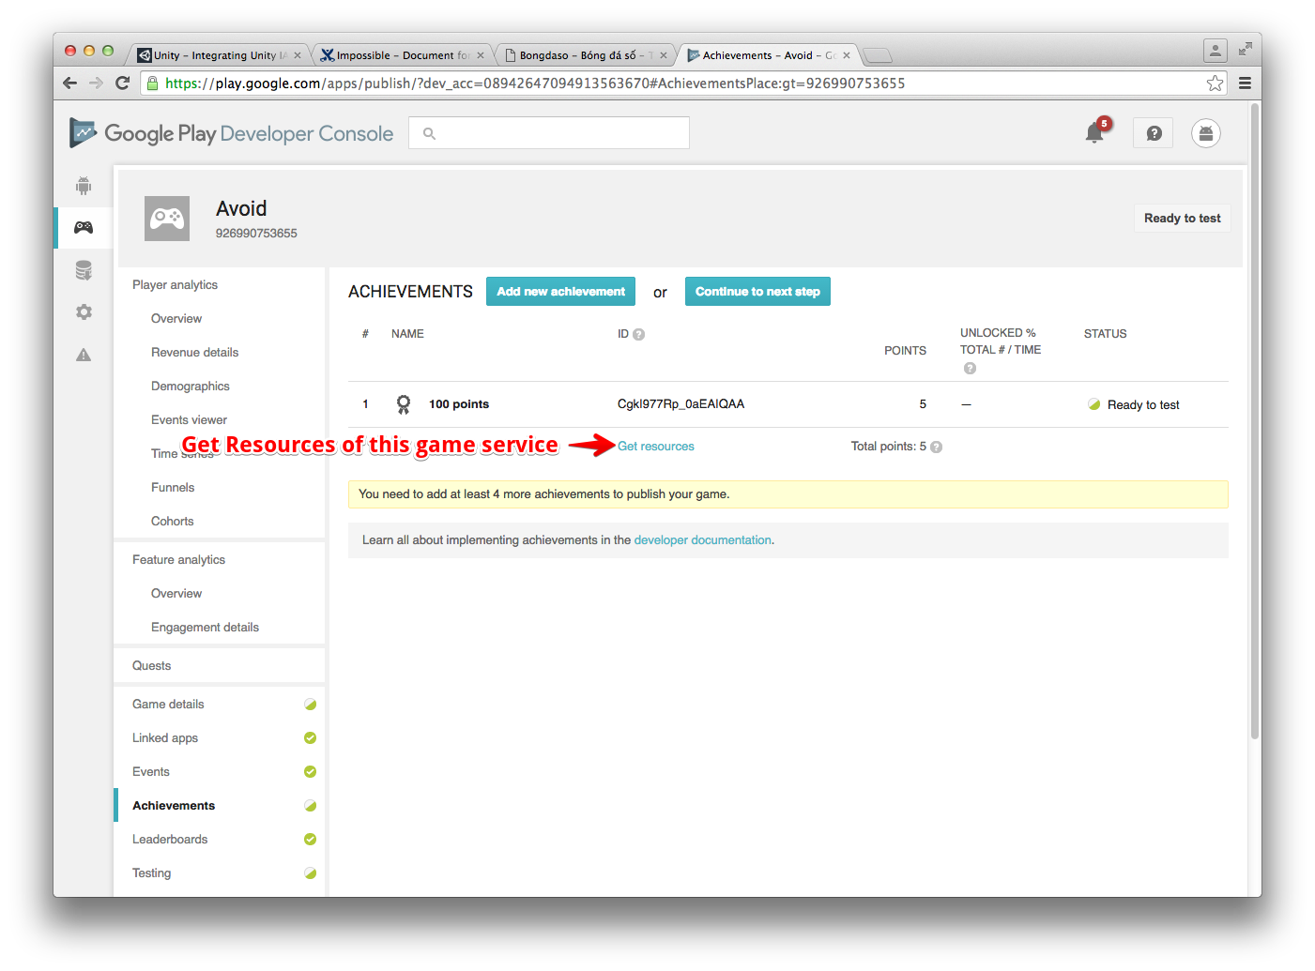

* Back to the Unity Project, on the menu bar of the Unity, go to Windows 🡪 Google play games 🡪 Setup 🡪 Android setup, and fill some necessary information (include the resources you’ve just get).

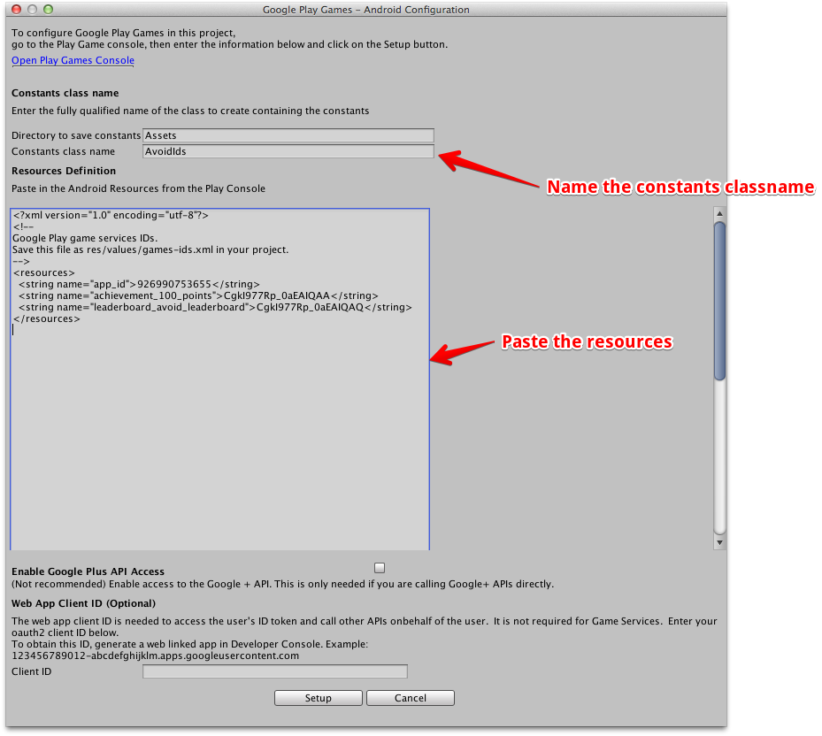

* Click Setup to finish.

## Configure leaderboard IDs

* In Game service of your game on developer console, choose “Leaderboard” tab.
* Create a new leaderboard for your game.

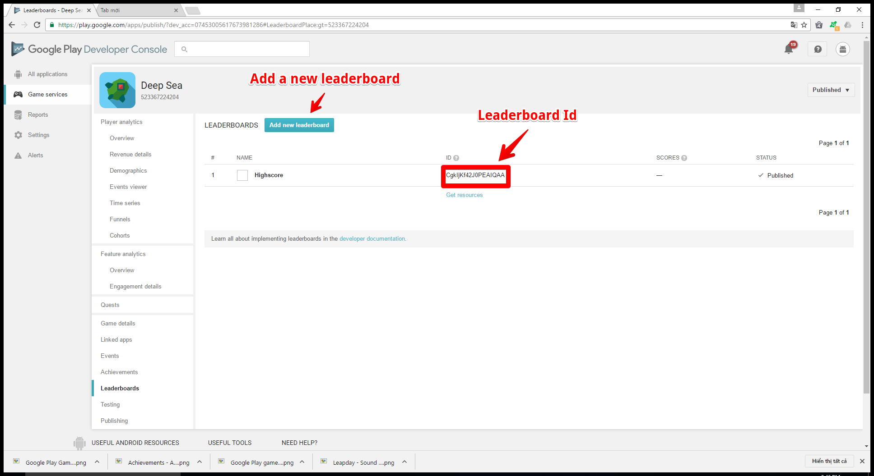

* Back to Unity project, Go to Assets/Data/LeaderboardData.assets. Add your leaderboard ID to the correct field like the picture below:

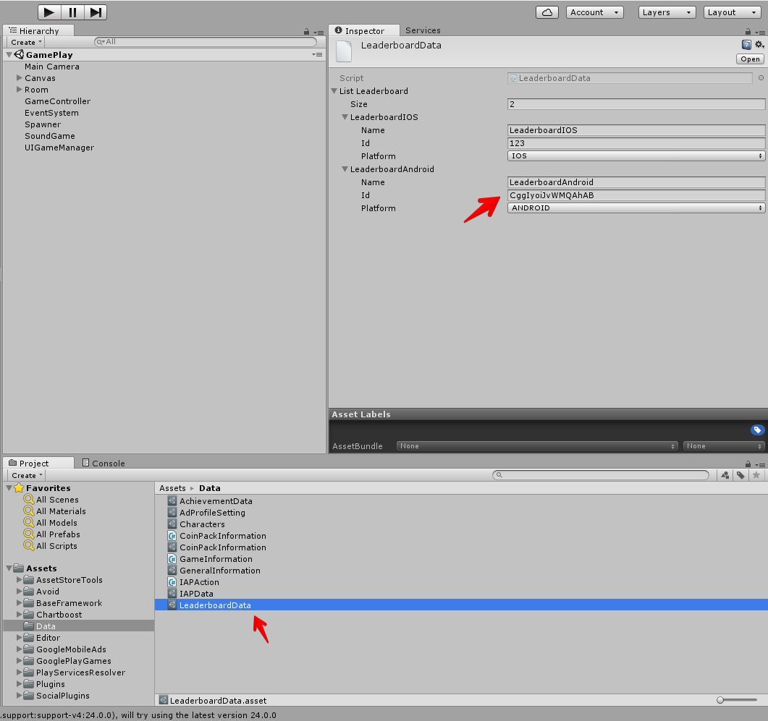

## Configure achievement Ids:

* Create your achievements on the console like creating leaderboard.

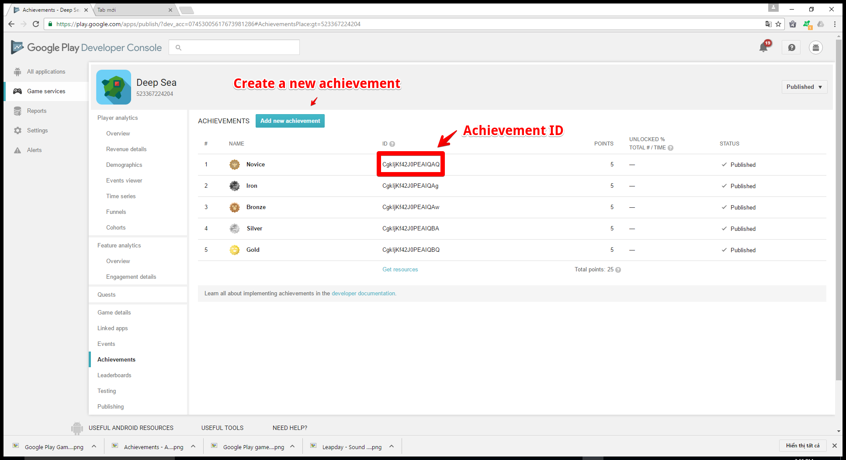

* Create all achievements which we support in the game. To know how many achievements we’ve implemented in a game, go to “Assets/Data/AchievementData”

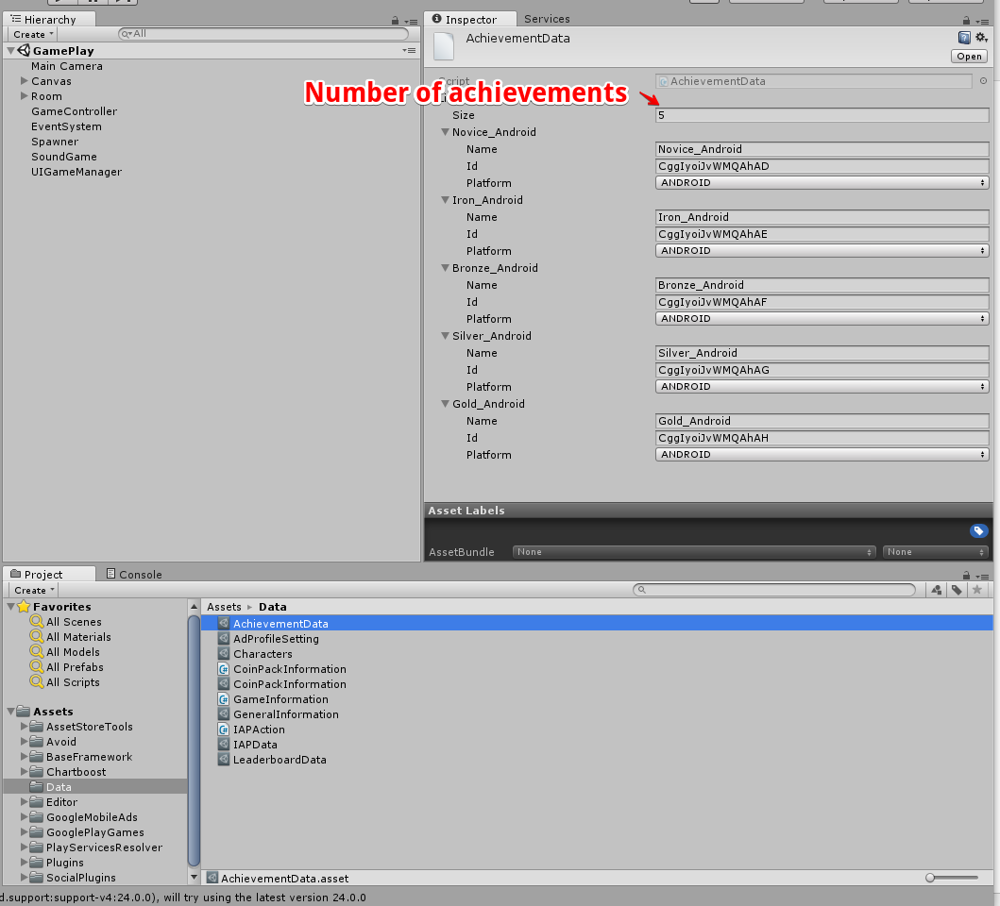

* Change the ID of each achievement in game by the achievement ID on your dev console.

## Config IAP data

* See all products we’ve provided in a game by going to Assets/Data/IAPData

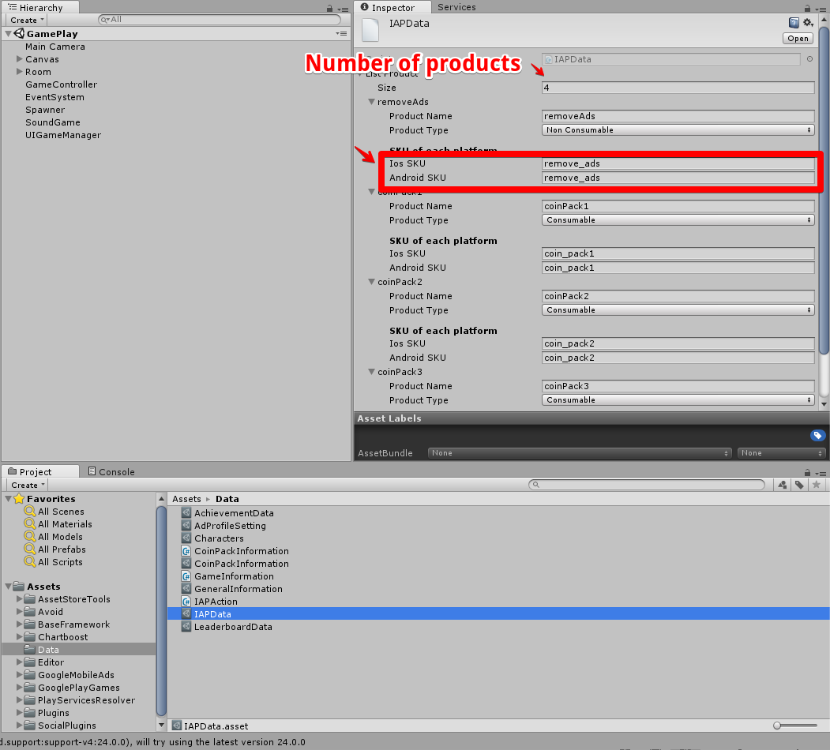

* Add your product

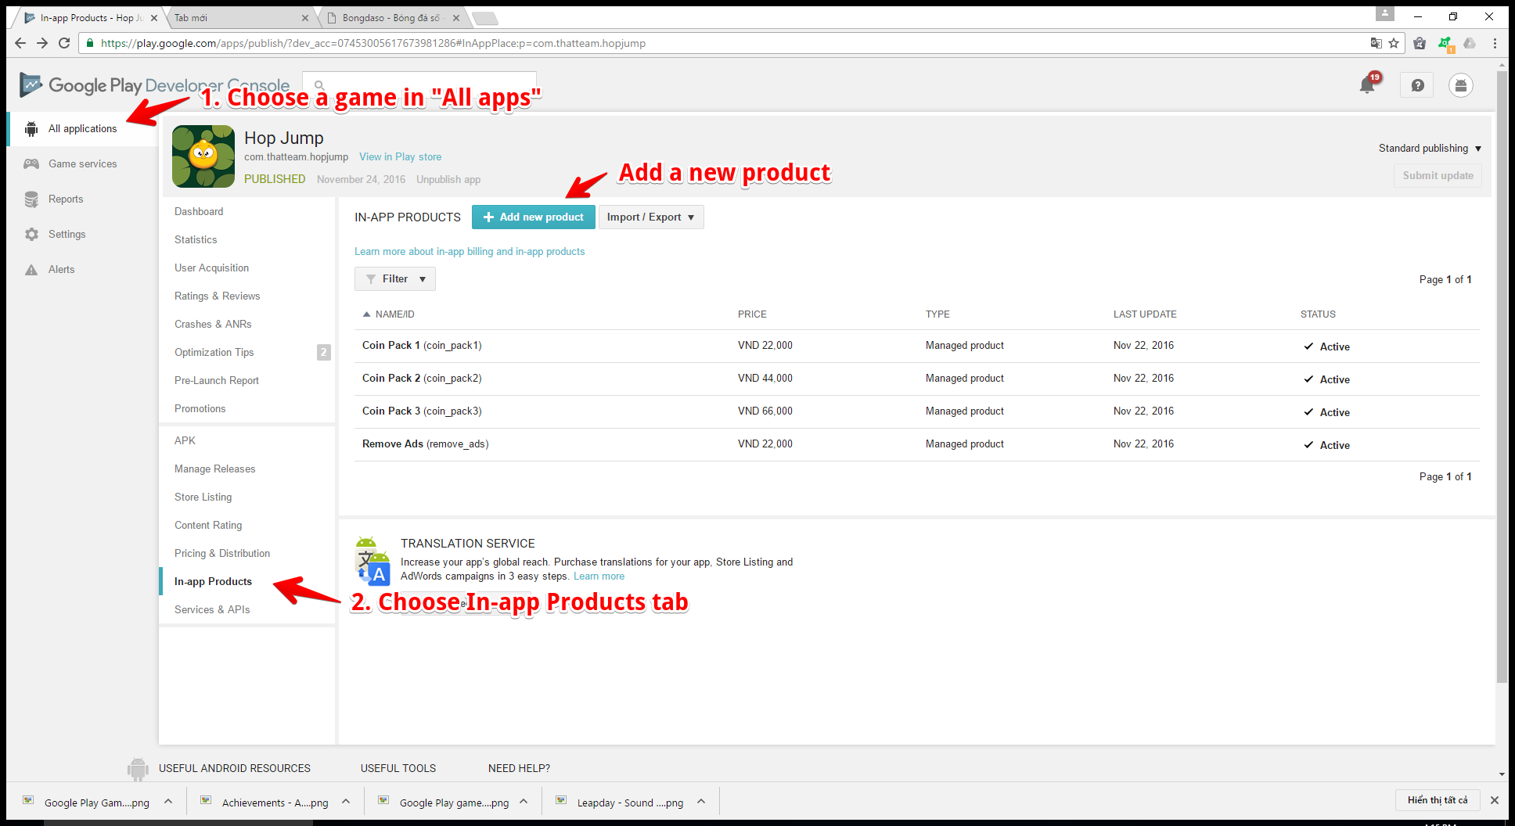

* When adding a product, you must set its SKU (Product ID) and type (Most our products are “Managed product”)

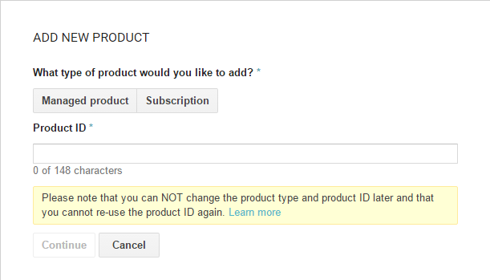

* Copy the product ID to the Android SKU field in “Assets/Data/IAPData.assets”

## ****Configure the link to the page of game on Googleplay / Itunes:****

* The page will open when player touch "Rate" button, they will go to the page of game on Google play / Itunes:

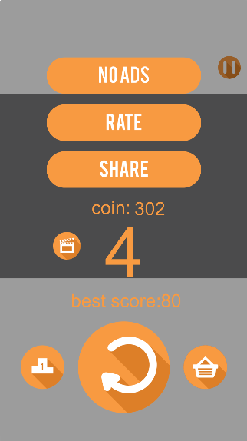

* To change the link to the page of game on Google play / Itunes, go to script Assets/BaseFramework/Script/Social/SocialManager.cs, then change information like the picture below

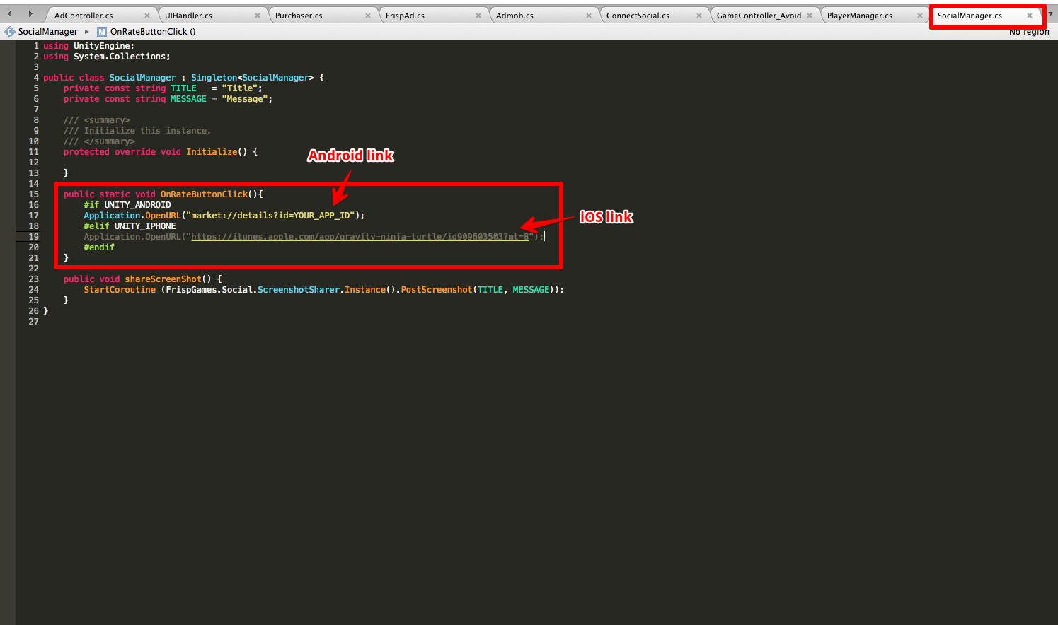

## Configure the Ads Ids:

* Go to Assets/Data/AdProfileSetting

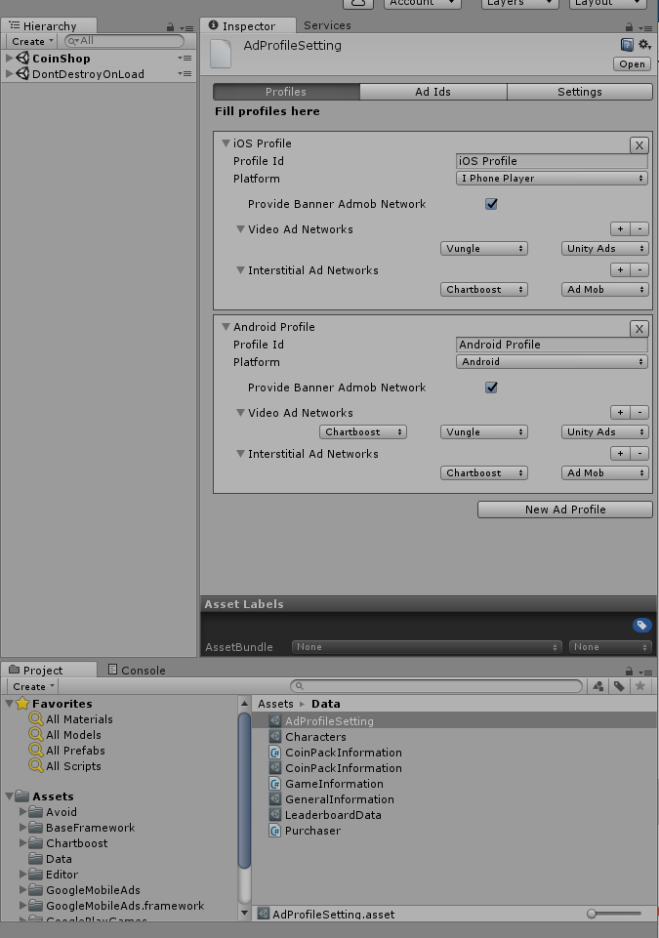

* Create new profile or use the default profile
* In tab profiles, tick "Provide Banner Admob Network" if you want to use Admob banner ad in your game (Admob banner ad is always on the top screen)
* Add Video Ad Networks in your games
* Add Interstitial Ad Networks in your games
* In tab Ad Ids, add your Unity Ads IDs, Vungle IDs, and AdMob Ids. (Don't need to care about Test Devices in Admob, it's only meaningful if you runs your game in Development Mode)

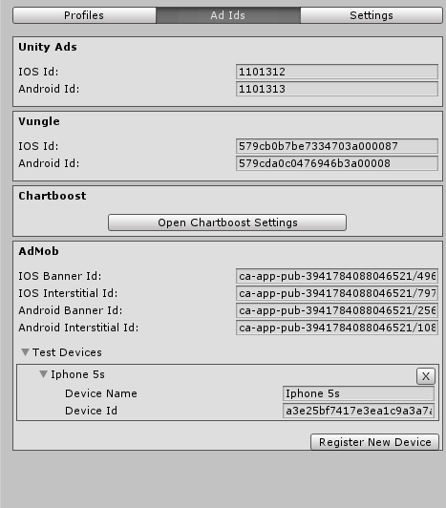

* In Tab Settings, choose your ad policies and the time out of each ad type( Ad timeout is the maximum time to load an ads of an Ads Network)
* Profile Policy is the policy to choose a profile from all profiles you have in profiles tab. There are 2 profile policies:
* First : Examining one by one profile from top to bottom, and choose the first profile that match the device platform.
* ExactID: Choose the profile with exact Id you want
* Provider Policy is the policy to choose the provider when load fullscreen ads or video ads. There are 3 provider policies:
* Keep the last: choose the provider of the last time you load interstitial / video ads
* Roll: roll the order of providers each time loading ads.
* Always from first: always choose the most left provider in your list (in Profiles tab)

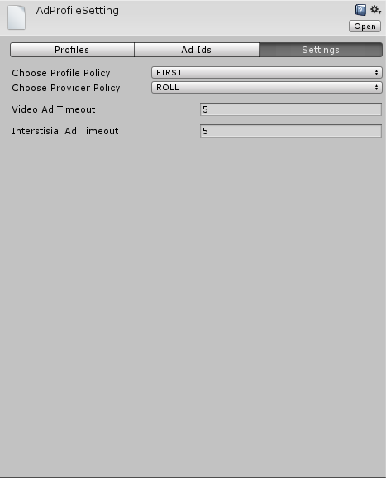

## Configure the coin packs

* There are 3 coin pack to buy through IAP by default. you can change the information of each pack in Assets/Data/CoinPackInformation

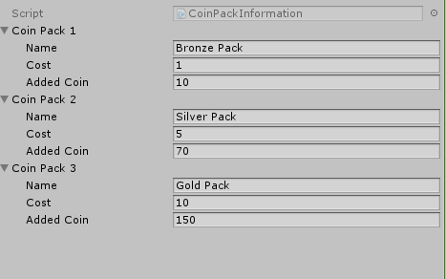

* These pack will appear in coin shop scene:

