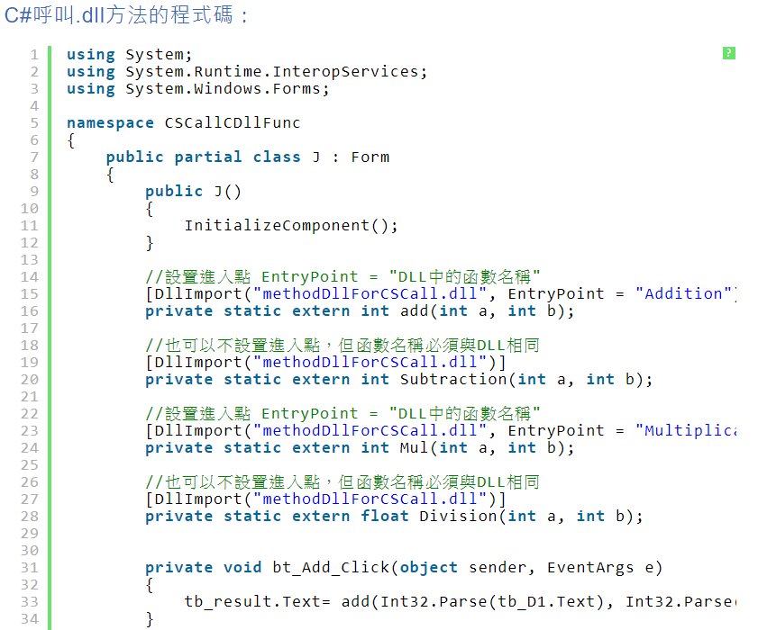

**定義**

[DllImport("IQmeasure_IQapi_Legacy.dll", EntryPoint = "LP_DualHead_ConOpen", CallingConvention = CallingConvention.Cdecl)]

private static extern int LP_DualHead_ConOpen(int tokenID, string ipAddress1, IntPtr ipAddress2 , IntPtr ipAddress3 , IntPtr ipAddress4 , UInt32 timeOutMS = 90);

[DllImport("IQmeasure_IQapi_Legacy.dll", EntryPoint = "LP_GetVersion", CallingConvention = CallingConvention.Cdecl)]

private static extern bool LP_GetVersion(ref byte buffer, int buf_size);

**Main 使用**

errStatus = LP_DualHead_ConOpen(

0, //tokenID

"192.168.100.254", //*ipAddress1

IntPtr.Zero, //*ipAddress2

IntPtr.Zero, //*ipAddress3

IntPtr.Zero, //*ipAddress4

90 //timeout

);

Byte[] ver_ret = new Byte[2048];

bool b_get = LP_GetVersion( ref ver_ret[0], 2048);

string g_version = System.Text.Encoding.Default.GetString(ver_ret, 0, ver_ret.Length);