// 建立一個 XmlDocument 物件並加入 Declaration

XmlDocument xdoc = new XmlDocument();

xdoc.AppendChild(xdoc.CreateXmlDeclaration("1.0", "UTF-8", "yes"));



// 建立根節點物件並加入 XmlDocument 中

XmlElement rootElement = xdoc.CreateElement("Employees");

xdoc.AppendChild(rootElement);



//選擇切換至此節點

XmlNode node = xdoc.SelectSingleNode("Employees/Employee");  
//添加person節點

XmlElement main = xdoc.CreateElement("newPerson");

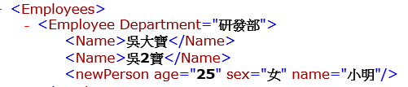

//添加節點屬性

main.SetAttribute("name", "小明");

main.SetAttribute("sex", "女");

main.SetAttribute("age", "25");

node.AppendChild(main); //將 main 節點加至 node 之下 其中 node為 "Employees/Employee"

完整的小範例 :

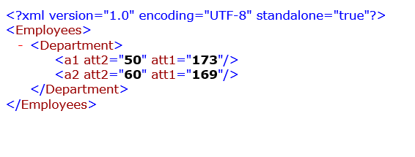

// 建立一個 XmlDocument 物件並加入 Declaration

XmlDocument xdoc = new XmlDocument();

xdoc.AppendChild(xdoc.CreateXmlDeclaration("1.0", "UTF-8", "yes"));

// 建立根節點物件並加入 XmlDocument 中 (第 0 層)

XmlElement Employees = xdoc.CreateElement("Employees");

xdoc.AppendChild(Employees);

//建立子節點

XmlElement department = xdoc.CreateElement("Department");

Employees.AppendChild(department);

XmlElement a1 = xdoc.CreateElement("a1");

a1.SetAttribute("att1","173");

a1.SetAttribute("att2", "50");

department.AppendChild(a1);

XmlElement a2 = xdoc.CreateElement("a2");

a2.SetAttribute("att1", "169");

a2.SetAttribute("att2", "60");

department.AppendChild(a2);

**但是一个结点不一定是一个元素，而一个元素一定是一个结点。**

**///////////////////////////////////////**

**// 讀取 Employees/Department/a1 的 atrrbute name and value //**

**///////////////////////////////////////**

XmlDocument doc = new XmlDocument();

doc.Load("xml_sample.xml");

//選擇節點

XmlNode nodea1 = doc.SelectSingleNode("Employees/Department/a1");

if (nodea1 == null)

return;

//取得節點內的欄位

XmlElement element = (XmlElement)nodea1;

//取得節點內的"部門名稱"內容

XmlAttributeCollection xmlcollect = element.Attributes;

foreach (XmlAttribute att in xmlcollect)

{

string data_name = att.Name.ToString();

string data_value = att.Value.ToString();

}

string data = element.GetAttribute("att1");

//取得節點內的"部門名稱"的屬性

XmlAttribute attribute = element.GetAttributeNode("att1");

//列舉節點內的屬性

**///////////////////////////////////////**

**// 讀取 Employees/Department/ 的所有 NODE NAME //**

**///////////////////////////////////////**

XmlNode nodeDepartment = doc.SelectSingleNode("Employees/Department");

if (nodeDepartment == null)

return;

//取得節點內的欄位

XmlNode element_nodeDepartment = (XmlNode)nodeDepartment;

//取得節點內的"部門名稱"內容

XmlNodeList list = element_nodeDepartment.ChildNodes;

string nodename;

foreach (XmlNode onenode in list)

{

nodename = onenode.Name.ToString();

}