***Schedule Management***

***for teacher student***

* **Team Member:**
  + - * **Nguyễn Đoàn Quang**
      * **Nguyễn Anh Hiếu**
      * **Phan Phú Hưng**

Table of Contents

1. Review 1

* **Problem Definition..…………………………………………………………………………………01**
* **Customer Request Specification………………………………………………………………**

1. Review 2

* ***Use Case Diagram***
* ***Class Diagram***
* ***Sequence Diagram***
* ***ERD***
* ***Entity Description***
* ***Table Relationship Diagram***

1. Review 3

* Interface Design………………………………………………………………………………..... 27
* Site Map……………………………………………………………………………………………… 51
* Report ………………………………………………………………………………………………..53
* Tasksheet……………………………………………………………………………………………. 56

REVIEW 1

1. **The Object Of The Project**

This project will aim at finding working , studying schedule of teacher , student This will be accessible to all user who have a valid Username and Password. This system provides the following facilities :

+ Find working , studying schedule of teacher , student

+ Arrange schedule and studying subject for teacher , student

+ Arrange Group ( Class ) for student

+ Arrange teacher teach which subject , Group

1. **Functional Requirements**

Following is a list of functionalities of the system. More functionalities that you find appropriate can be added to this list.

* User must have a valid Username and password to login to the system
* After the valid user logs in the system will check role of the account ( Admin , Teacher , Student ) and then show form depend on the role of user .
* System separate user into 3 role :

1. **Admin :**

+ Manage Student , teacher account by insert , delete .

+ Search , Add teacher .

+ Add student into group , delete student from group ( Class ) , Search student

+ Create , delete group

+ Search teacher , student account

+ Arrange schedule for Group , student , teacher

1. **Teacher :**

**+** Can see group , student list in group

**+** View teaching schedule from last week to next week .

**+** Take Attendance for student ( attendance , absent )

**+** Update mail phone in induavial profile

**+** Change induavial password

1. **Student :**

+ View studying schedule from last week to next week .

+ See Subject , group , student list in group

**+** Update mail phone in induavial profile

**+** Change induavial password

* Can save schedulele from last week and insert it for this or last week if there isn’t any change that effect on working , studying schedule .

1. **Hardware/ Software Requirements**  
   By adding echnologies such as Winform and 3-tier architecture, the web site becomes more interactive with users, security and easily updated .
2. **System Requirement**

* **For Users**
  + **Hardware**
    - CPU: Pentium IV 2.0 GHz or higher
    - RAM: 512 MB or higher
  + **Software**
    - OS: Windows 7/XP Professional/Server 2003…
    - Browser: Internet Explorer 8.0 or higher
* **For Software Developers**
  + **Hardware**
    - CPU: Pentium IV 2.0 GHz or higher
    - RAM: 2GB or higher
  + **Software**
    - OS: Windows 7 / 8 / 10…
    - Environment: Microsoft .NET Framework 3.5
    - Database Management System: Microsoft SQL Server 2008
    - IDE: Microsoft Visual Studio 2010

REVIEW 2

**USE CASE DIAGRAM**

**Student :**

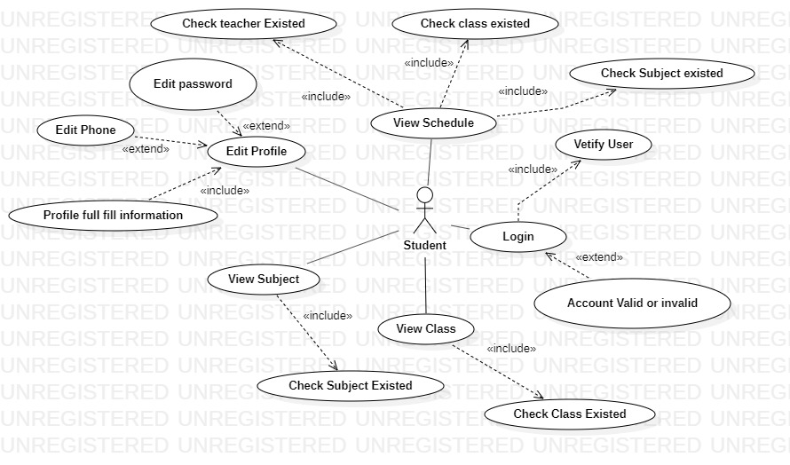

**Administrators :**

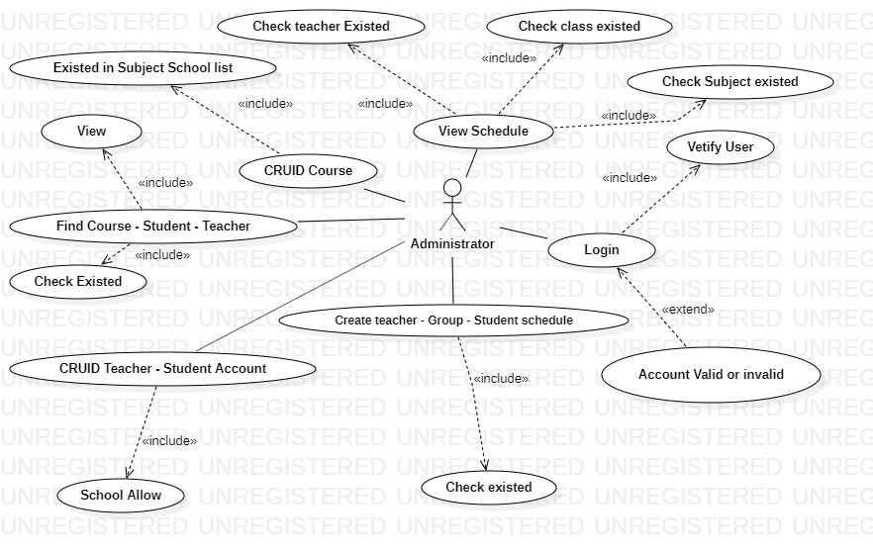

**Teacher :**

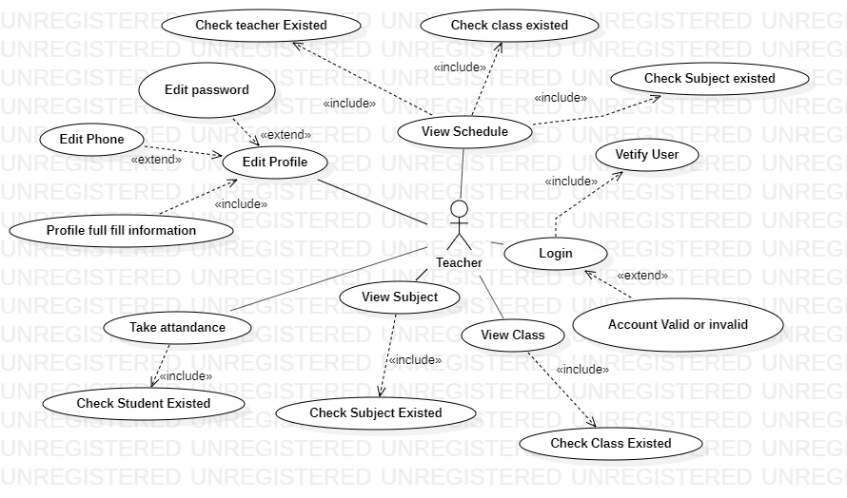

**USE CASE DESCRIPTION**

1. **Actor:**

* **Student :** Use this software to view schedule and view , edit invidual information .
* **Teacher :** The person who teach in school sse this software to view schedule and view , edit invidual information , take attendance for student .
* **Administrators :** The person(s) that manage student , teacher account , create schedule for teacher , teacher , create and manage group .

1. **Usecase:**

|  |  |
| --- | --- |
| **Usecase** | Register |
| **Short Description** | Register account by administrator of the school . |
| **Pre-Conditions** |  |
| **Post-Conditions** |  |
| **Main flow** | _ Register account by administrator of the school and create your invidual profile base on profile you supply for school when you regist studying in school and basse  _Student becomes a user of this software . |

|  |  |
| --- | --- |
| **Usecase** | Login |
| **Short Description** | Log in website to use what function depend on role . |
| **Pre-Conditions** |  |
| **Post-Conditions** |  |
| **Main flow** | _Inputs the login information :   * Login ID. * Password.   _Cclicks on the Login button.  _System check the Login ID and Password.  _If Login ID and Password are valid , check role , system will move member to page base on role .  _ If a wrong password is given accnount wrong username or password and try again . |
| **Alternative flow(s)** | _If server notifies any error when it’s processing, system must be write report into Log file. |

|  |  |
| --- | --- |
| **Usecase** | View Schedule |
| **Short Description** | View student studying schedule |
| **Pre-Conditions** |  |
| **Post-Conditions** |  |
| **Main flow** | _After log in with student role  _Student can view Schedule through a tab my schedule  _That schedule must existed in the system and create by admin |
| **Alternative flow(s)** | _If server notifies any error when it’s processing, system must be write report into Log file. |

|  |  |
| --- | --- |
| **Usecase** | View Class |
| **Short Description** | View student studying class and also student list |
| **Pre-Conditions** |  |
| **Post-Conditions** |  |
| **Main flow** | _After log in with student role  _Student can view class information through a tab my class  _That group ( class ) must existed in the system and create by admin |
| **Alternative flow(s)** | _If server notifies any error when it’s processing, system must be write report into Log file. |

|  |  |
| --- | --- |
| **Usecase** | View Class |
| **Short Description** | View student studying class and also student list |
| **Pre-Conditions** |  |
| **Post-Conditions** |  |
| **Main flow** | _After log in with student role  _Student can view class information through a tab my class  _That group ( class ) must existed in the system and create by admin |
| **Alternative flow(s)** | _If server notifies any error when it’s processing, system must be write report into Log file. |

|  |  |
| --- | --- |
| **Usecase** | View Subject |
| **Short Description** | View student subject |
| **Pre-Conditions** |  |
| **Post-Conditions** |  |
| **Main flow** | _After log in with student role  _Student can view class subject student studying  _That must existed in the system and create by admin |
| **Alternative flow(s)** | _If server notifies any error when it’s processing, system must be write report into Log file. |

|  |  |
| --- | --- |
| **Usecase** | Edit Account |
| **Short Description** | Edit teacher and student information. |
| **Pre-Conditions** |  |
| **Post-Conditions** |  |
| **Main flow** | _ teacher and student login to this software.  _They can change password , Edit phone number and their personal Email  _They edits information and save this action.  _System check this information and save it inn databse .  _System notify report to member. |
| **Alternative flow(s)** | _If any information edit are invalid, system will notify the error.  _If server notifies any error when it’s processing, system must be write report into Log file. |

|  |  |
| --- | --- |
| **Usecase** | View Schedule |
| **Short Description** | View teacher teaching schedule |
| **Pre-Conditions** |  |
| **Post-Conditions** |  |
| **Main flow** | _After log in with teacher role  _ teacher can view Schedule through a tab schedule  _That schedule must existed in the system and create by admin |
| **Alternative flow(s)** | _If server notifies any error when it’s processing, system must be write report into Log file. |

|  |  |
| --- | --- |
| **Usecase** | View Class |
| **Short Description** | View class the teacher teaching |
| **Pre-Conditions** |  |
| **Post-Conditions** |  |
| **Main flow** | _After log in with teacher role  _ teacher can view class information through class  _That group ( class ) must existed in the system and create by admin |
| **Alternative flow(s)** | _If server notifies any error when it’s processing, system must be write report into Log file. |

|  |  |
| --- | --- |
| **Usecase** | View Subject |
| **Short Description** | View subject the teacher teaching |
| **Pre-Conditions** |  |
| **Post-Conditions** |  |
| **Main flow** | _After log in with teacher role  _ teacher can view subject information the teacher teaching  _That subject must existed in the system and create by admin |
| **Alternative flow(s)** | _If server notifies any error when it’s processing, system must be write report into Log file. |

|  |  |
| --- | --- |
| **Usecase** | Take Attendance |
| **Short Description** | Teacher take attendance for student |
| **Pre-Conditions** |  |
| **Post-Conditions** |  |
| **Main flow** | _After log in with teacher role  _ teacher can take attendance like like attendance for present in class and absent is not present in class  _That student must existed in the system and create by admin , existed in that class . |
| **Alternative flow(s)** | _If server notifies any error when it’s processing, system must be write report into Log file. |

|  |  |
| --- | --- |
| **Usecase** | Admin View Schedule |
| **Short Description** | Admin View Schedule of student and teacher |
| **Pre-Conditions** |  |
| **Post-Conditions** |  |
| **Main flow** | _After log in with Admin role  _ Admin can view student and teacher Schedule through a tab schedule ,  _Schedule existed if it have enough information of teacher , student , group , course  _That schedule must existed in the system . |
| **Alternative flow(s)** | _If server notifies any error when it’s processing, system must be write report into Log file. |

|  |  |
| --- | --- |
| **Usecase** | CRUID Course |
| **Short Description** | Admin CRUID Course |
| **Pre-Conditions** |  |
| **Post-Conditions** |  |
| **Main flow** | _After log in with Admin role  _ Admin can create , update , delete course  _Admin can do this if school leader allow and have that course in school program . |
| **Alternative flow(s)** | _If server notifies any error when it’s processing, system must be write report into Log file. |

|  |  |
| --- | --- |
| **Usecase** | Admin Find course – Student - Teacher |
| **Short Description** | Admin Find course – Student - Teacher |
| **Pre-Conditions** |  |
| **Post-Conditions** |  |
| **Main flow** | _After log in with Admin role  _ Admin view find course , student , teacher if all they existed and find them through coursed, studentID , teacherID |
| **Alternative flow(s)** | _If server notifies any error when it’s processing, system must be write report into Log file. |

|  |  |
| --- | --- |
| **Usecase** | CRUID Student – Teacher Account |
| **Short Description** | CRUID Student – Teacher Account |
| **Pre-Conditions** |  |
| **Post-Conditions** |  |
| **Main flow** | _After log in with Admin role  _ Admin can create , update , delete student – teacher account  _Admin can do this if school leader allow and have that student , teacher in school . |
| **Alternative flow(s)** | _If server notifies any error when it’s processing, system must be write report into Log file. |

|  |  |
| --- | --- |
| **Usecase** | Create Student – Group – Teacher schedule |
| **Short Description** | Create Student – Group – Teacher schedule |
| **Pre-Conditions** |  |
| **Post-Conditions** |  |
| **Main flow** | _After log in with Admin role  _ Admin can create Student – Group – Teacher schedule if they existed in Database and have the allow from school |
| **Alternative flow(s)** | _If server notifies any error when it’s processing, system must be write report into Log file. |

**CLASS DIAGRAM**

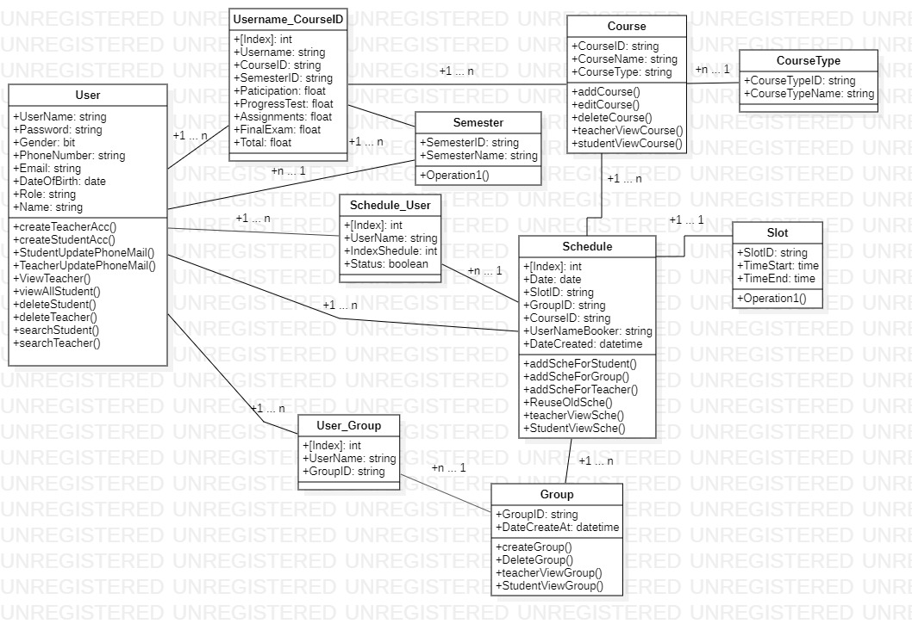

**TABLE RELATIONSHIP DIAGRAM**

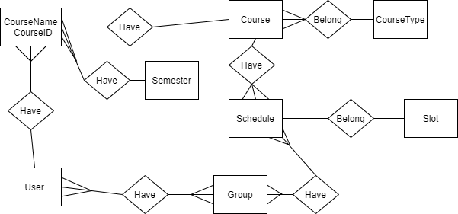

Entity

Entity Relationship

One to  
 many relationship

**ENTITY DESCRIPTION**

1. **User :**

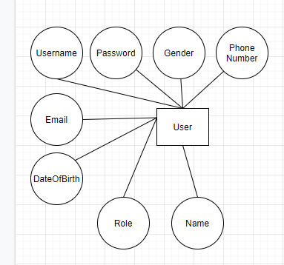

1. **Group :**

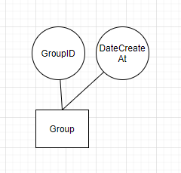

1. **Course :**

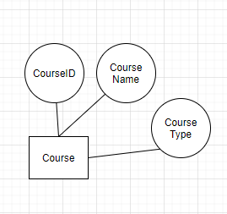

1. **CourseType :**

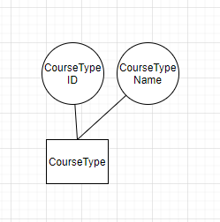

1. **Semester :**

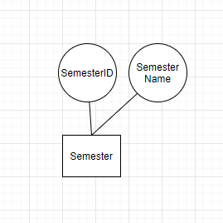

1. **Schedule :**

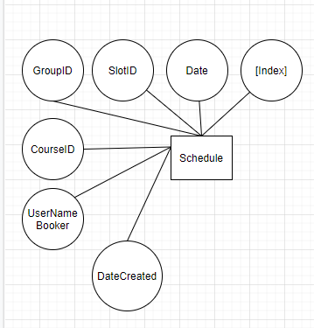

1. **Slot**

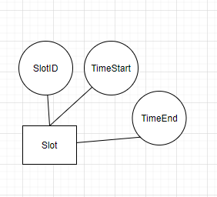

1. **Username_CourseID**

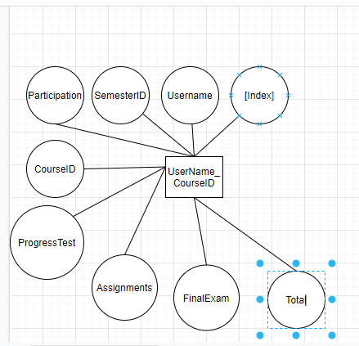

**TABLE DESIGN**

1. **User**

|  |  |  |  |  |  |
| --- | --- | --- | --- | --- | --- |
| **No** | **Column Name** | **Data Type** | **Size** | **Check** | **Description** |
| 1 | **🗝**UserName | varchar | 30 | Not Null | Username login |
| 2 | Password | varchar | 30 | Null | Password Login |
| 3 | Gender | bit |  | Null | Gender |
| 4 | PhoneNumber | varchar | 15 | Null | Phone number |
| 5 | Email | nvarchar | 50 | Null | Email |
| 6 | DateOfBirth | date |  | Null | Date of birth |
| 7 | Role | Varchar | 20 | Null | role |
| 8 | Name | varchar | 30 | Null | Name of user |

1. **Schedule_User**

|  |  |  |  |  |  |
| --- | --- | --- | --- | --- | --- |
| **No** | **Column Name** | **Data Type** | **Size** | **Check** | **Description** |
| 1 | **🗝**[Index] | Int |  | Not Null | ID |
| 2 | UserName | varchar | 30 | Null | Username |
| 3 | IndexShedule | Int |  | Null | Schedule number id |
| 4 | Status | Bit |  | Null | Status schedule |

1. **Semester**

|  |  |  |  |  |  |
| --- | --- | --- | --- | --- | --- |
| **No** | **Column Name** | **Data Type** | **Size** | **Check** | **Description** |
| 1 | **🗝**SemesterID | varchar | 10 | Not Null | Semester ID |
| 2 | SemesterName | varchar | 15 | Null | Semester name |

1. **UserName_CourseID**

|  |  |  |  |  |  |
| --- | --- | --- | --- | --- | --- |
| **No** | **Column Name** | **Data Type** | **Size** | **Check** | **Description** |
| 1 | **🗝**[Index] | Int |  | Not Null | Semester ID |
| 2 | UserName | varchar | 30 | Null | Semester name |
| 3 | CourseID | varchar | 15 | Null |  |
| 4 | SemesterID | varchar | 10 | Null |  |
| 5 | Participation | float |  | Null |  |
| 6 | ProgressTest | float |  | Null |  |
| 7 | Assignments | float |  | Null |  |
| 8 | FinalExam | float |  | Null |  |
| 9 | Total | float |  | Null |  |

1. **Course**

|  |  |  |  |  |  |
| --- | --- | --- | --- | --- | --- |
| **No** | **Column Name** | **Data Type** | **Size** | **Check** | **Description** |
| 1 | **🗝**CourseID | varchar | 15 | Not Null |  |
| 2 | CourseName | varchar | 30 | Null |  |
| 3 | CourseType | varchar | 30 | Null |  |

1. **User_Group**

|  |  |  |  |  |  |
| --- | --- | --- | --- | --- | --- |
| **No** | **Column Name** | **Data Type** | **Size** | **Check** | **Description** |
| 1 | **🗝**[Index] | int |  | Not Null |  |
| 2 | UserName | varchar | 30 | Null |  |
| 3 | GroupID | varchar | 15 | Null |  |

1. **Schedule**

|  |  |  |  |  |  |
| --- | --- | --- | --- | --- | --- |
| **No** | **Column Name** | **Data Type** | **Size** | **Check** | **Description** |
| 1 | **🗝**[Index] | int |  | Not Null |  |
| 2 | Date | Date |  | Null |  |
| 3 | SlotID | varchar | 10 | Null |  |
| 4 | GroupID | varchar | 15 | Null |  |
| 5 | CourseID | varchar | 15 | Null |  |
| 6 | UserNameBooker | varchar | 30 | Null |  |
| 7 | DateCreated | datetime |  | Null |  |

1. **Group**

|  |  |  |  |  |  |
| --- | --- | --- | --- | --- | --- |
| **No** | **Column Name** | **Data Type** | **Size** | **Check** | **Description** |
| 1 | **🗝**GroupID | varchar | 15 | Not Null |  |
| 2 | DateCreateAt | datetime |  | Null |  |

1. **Slot**

|  |  |  |  |  |  |
| --- | --- | --- | --- | --- | --- |
| **No** | **Column Name** | **Data Type** | **Size** | **Check** | **Description** |
| 1 | **🗝**[SlotID | varchar |  | Not Null |  |
| 2 | TimeStart | Time | 7 | Null |  |
| 3 | TimeEnd | Time | 7 | Null |  |

1. **CourseType**

|  |  |  |  |  |  |
| --- | --- | --- | --- | --- | --- |
| **No** | **Column Name** | **Data Type** | **Size** | **Check** | **Description** |
| 1 | **🗝** CourseTypeID | varchar | 30 | Not Null |  |
| 2 | CourseTypeName | varchar | 30 | Null |  |



REVIEW 3

**INTERFACE DESIGN**

1. **Login Form**

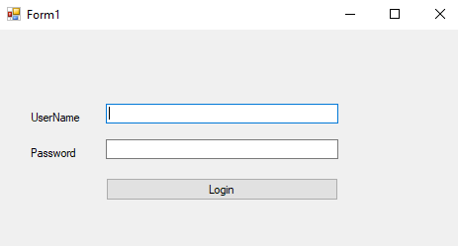

|  |  |  |  |  |  |
| --- | --- | --- | --- | --- | --- |
| **Name** | **Type** | **Event** | **Validation** | **Description** | **Status** |
| UserName | TextBox |  | String, not null | Input Customer’s user name |  |
| Password | TextBox |  | String, not null, | Input Customer’s password |  |

1. **Admin Manage Student**

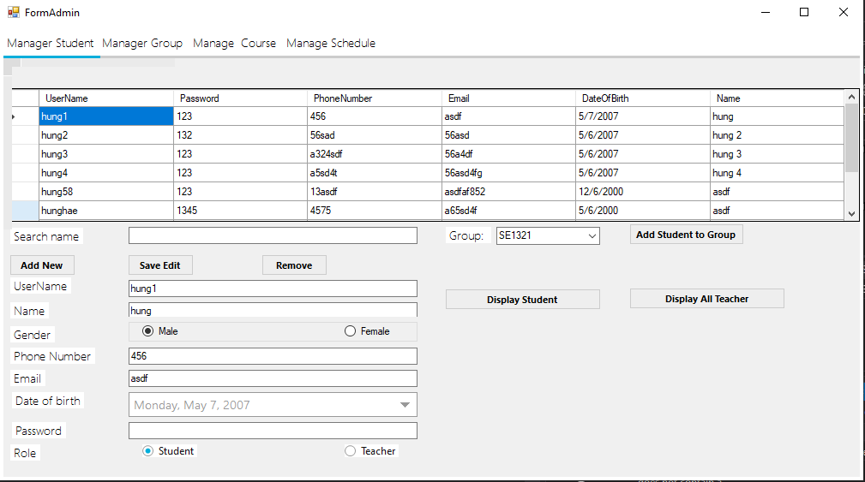

|  |  |  |  |  |  |
| --- | --- | --- | --- | --- | --- |
| **Name** | **Type** | **Event** | **Validation** | **Description** | **Status** |
| SearchName | TextBox |  | String, not null | Admin input name to search |  |
| Username | TextBox |  | String, not null, | Input Student username |  |
| Name | TextBox |  | String, not null, | Input Student Name |  |
| Gender | TextBox |  | Bit | Select gender |  |
| Email | TextBox |  | String, not null, | Input Student Email |  |
| Date of Birth | MetroDateTime |  | Date | Input date of birth |  |
| Password | TextBox |  | String, not null, | Input student password |  |
| Role | checkedBox |  | String, not null, | Create role |  |
| addNew | button | click |  | Add Student |  |
| SaveEdit | button | click |  | Save Edit |  |
| Remove | button | click |  | Delete student |  |
| Display Student | button | click |  | Display Student |  |
| Display all Teacher | button | click |  | Display Teacher |  |
| Add student to group | button | click |  | Add student to existed group |  |

1. **Admin Manage Group**

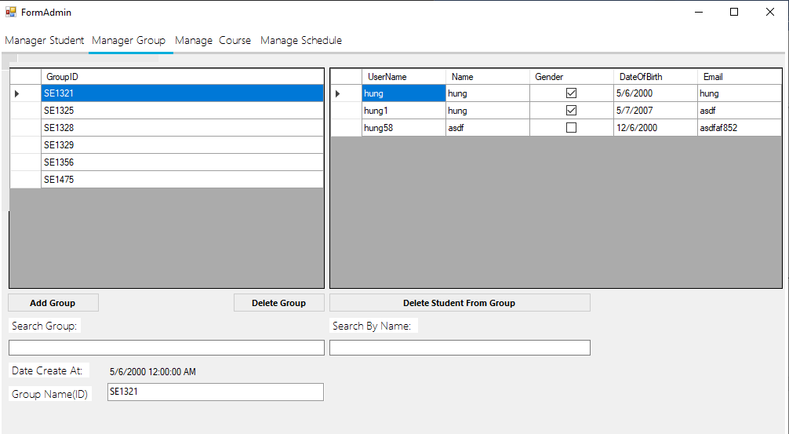

|  |  |  |  |  |  |
| --- | --- | --- | --- | --- | --- |
| **Name** | **Type** | **Event** | **Validation** | **Description** | **Status** |
| SearchGroup | TextBox |  | String, not null | Admin input name to search |  |
| SearchByName | TextBox |  | String, not null, | Input Student username |  |
| Group Name | TextBox |  |  | Input Student Name |  |
| DeleteGroup | button | Click |  | Delete Group |  |
| Delete Student From Group | button | Click | , | Delete Student from Group |  |
| Add Group | button | Click |  | Add Group |  |
| GroupName (ID) | TextBox |  | String, not null, | View group nam to text box |  |
| GridViewGroup | dataGridViews |  |  | View Groups |  |
| GridViewStudent | dataGridViews |  |  | View Student |  |

1. **Admin Manage Course**

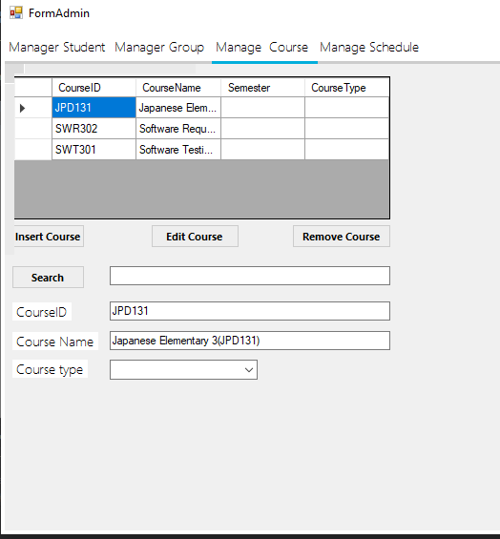

|  |  |  |  |  |  |
| --- | --- | --- | --- | --- | --- |
| **Name** | **Type** | **Event** | **Validation** | **Description** | **Status** |
| Search | TextBox |  | String, not null | Get Value from admin input |  |
| btnSearch | button | Click |  | Click to get value and action |  |
| CourseID | TextBox |  | String, not null | Input Course ID |  |
| Course Name | TextBox |  | String, not null, | Input course name |  |
| Course Type | TextBox |  | , String, not null, | Delete Student from Group |  |
| InsertCourse | button | Click |  | Insert Course |  |
| EditCourse | button | Click |  | Edit Course |  |
| RemoveCourse | button | Click |  | Remove Course |  |
| GridViewCourse | DataGridViews |  |  | Display course |  |

1. **Admin Manage Schedule**

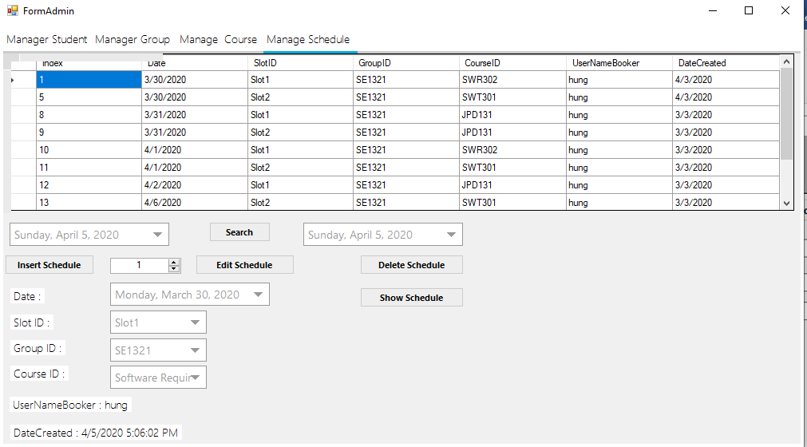

|  |  |  |  |  |  |
| --- | --- | --- | --- | --- | --- |
| **Name** | **Type** | **Event** | **Validation** | **Description** | **Status** |
| btnSearch | button |  | String, not null | Get Value from MetroDateTime and Search |  |
| EditSchedule | button | Click |  | Edit Schedule |  |
| DeleteSchedule | button | Click |  | Delete Schedule |  |
| ShowSchedule | button | Click |  | Show Schedule to gridviews |  |
| Date | button | Click |  | Click to get value and action |  |
| Slot | TextBox |  | String, not null | Input Course ID |  |
| CourseID | TextBox |  | String, not null, | Input course name |  |
| GroupID | TextBox |  | , String, not null, | Delete Student from Group |  |
| UsernameBooker | TextBox |  | , String, not null, | Insert Course |  |
| DateCreate | TextBox |  | , String, not null, | Edit Course |  |
| GridViewSchedule | DataGridViews |  |  | Display Schedule |  |

1. **Search Course , Group , student list**

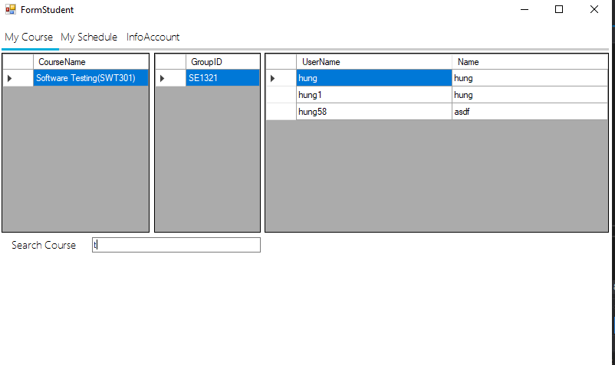

|  |  |  |  |  |  |
| --- | --- | --- | --- | --- | --- |
| **Name** | **Type** | **Event** | **Validation** | **Description** | **Status** |
| txtSearch | textbox | textChanged | String, not null | Search Course |  |
| GridViewCourse | DataGridViews |  |  | Show student Course |  |
| GridViewGroup | DataGridViews |  |  | Show student Group |  |
| GridViewDetail | DataGridViews |  |  | Show Student list in Group |  |

1. **View Studying Schedule**

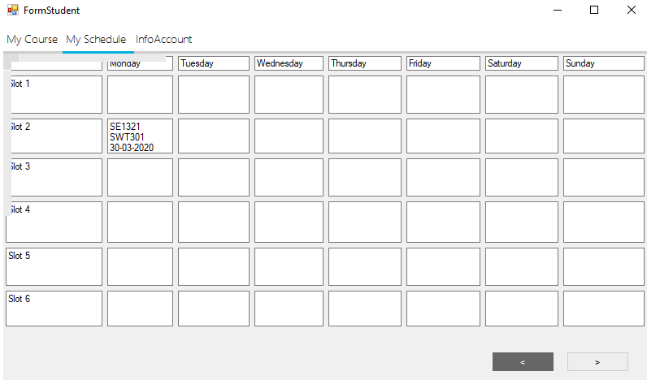

|  |  |  |  |  |  |
| --- | --- | --- | --- | --- | --- |
| **Name** | **Type** | **Event** | **Validation** | **Description** | **Status** |
| WhiteBox | textbox |  | String, not null | Show Schedule |  |
| btnNextWeek | button | click |  | Move to next week |  |
| btnLastWeek | button | click |  | Move back last week |  |

1. **Student Update phone number , email and change password**

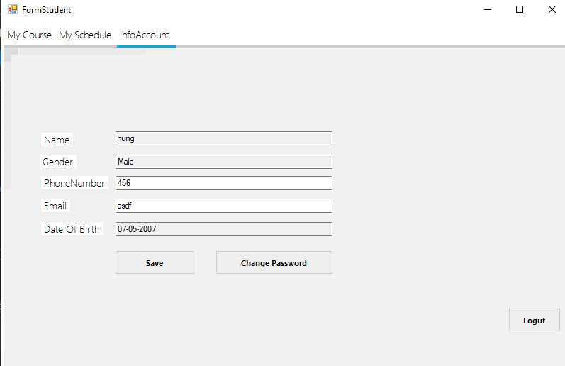

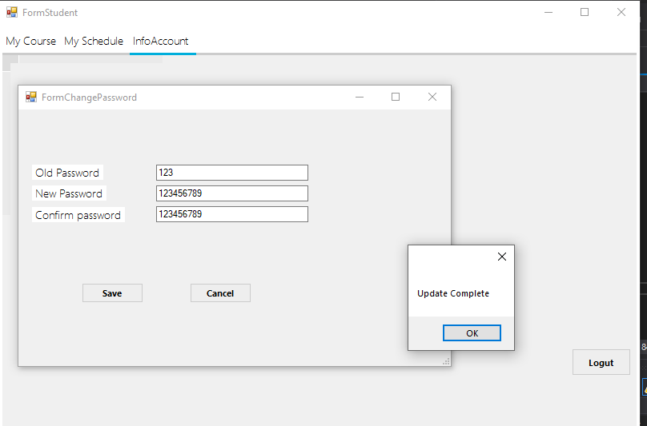

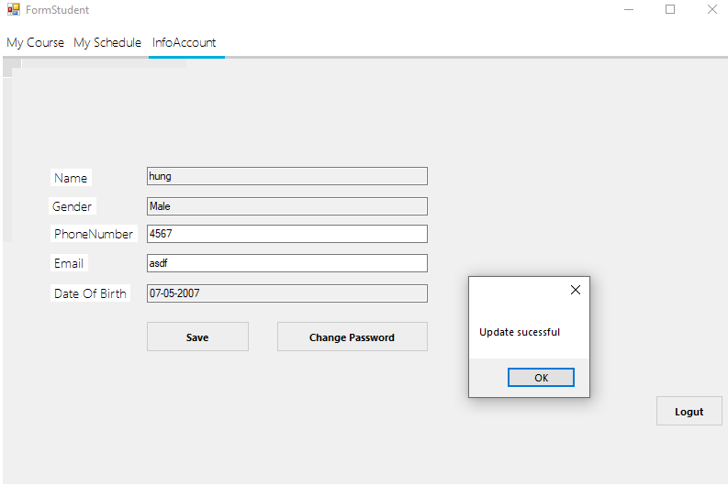

1. **Teacher View Schedule**

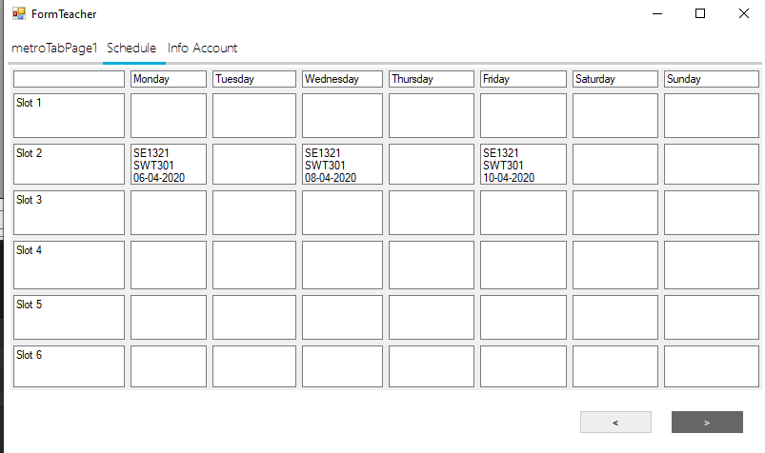

1. **Teacher Update phone , Email , change password**

