Project: Todo List

Link mockup design:

[https://wireframepro.mockflow.com/view/Mdab887a4c13f1076aad51db6687a2c8e15935390761 38#/page/3d47feb9951d457bbdc7e64b49f9f904](https://wireframepro.mockflow.com/view/Mdab887a4c13f1076aad51db6687a2c8e1593539076138#/page/3d47feb9951d457bbdc7e64b49f9f904)

Features:

1. Base on the mock design, build the website interface

2. Create a new task: Users can enter information and create new tasks in the form on the left side of the screen.

a. **Task title** is a required field.

b. **Due date** has the default value which is today, do not accept days in the past as due date

c. **Priority** field has three values: **low**, **normal** and **high**. The default value is **normal.**

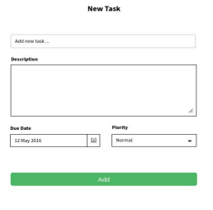

3. The created tasks will be sorted by Due date from the near future to far future. Each task will be displayed as same as the picture bellow

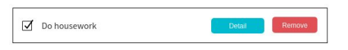

a. When you tick the checkbox, the screen will display a bulk action box https://lh4.googleusercontent.com/EiXjtwSGw8lZseA4wH1eVsCCN1a2vGd0T3VSEYKa9_D4nhoEwdRvS781FjkXUnw7b-QWu8EGt5Z0ipB4SLqQAsgjK2PQ75PuvZxeyqhGHqSMaGArtvplCHaBCJ91gHCUP1n9u4lZ

The bulk action will execute the action for all tasks that have been checked in the checkbox. Temporarily ignore the Done method. The Remove method removes the tasks.

b. When you click the “detail” button, the task item will display detailed information 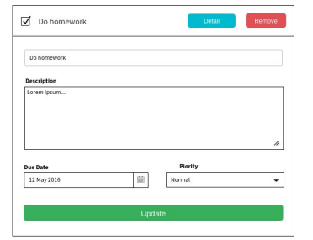c. Users can update task data in this form

d. When you click the Remove button, this task will be deleted.

4. Users can search tasks by task title. Each time the user enters text, the task list will be filtered and displayed

* Please push your code to a git repository and send it to us   
* Deploying your app with github page or netflix or surge or heroku is big plus

* Please do not integrate with BE as we want to know how you handle the FE side

Coding Requirement:

- Implement TodoList app base on your framework (angular/ reactjs/ vuejs) - Complete all the functions

- Naming convention, es6 or later.

- The code is broken into reasonable components

- Store data to LocalStorage is a plus

- The [code smells](https://en.wikipedia.org/wiki/Code_smell) good

- Not using libraries for CSS is a plus.

- Nice and responsive interface is a plus.