Coding Convention

v0.0.5
Last updated: 21st February 2008

1. Variable naming

m_ : class member
s_ : static
b : byte
c : char
s : short
i : int
l : long
is/was/has/... : boolean (because it’s a yes-no question)
a<x> : array of <x>. For example: int [] m_aiCards (array of int)
str : String
spr : ASprite object
ani : CAnim object
img : Image
gra : Graphics
CAPITALIZE : constant

Of course you don't need to always follow those prefix conventions. In some cases where a variable’s name is meaningful enough, there’s no need to add a redundant prefix for it. For example:
static Graphics s_currentGraphics;

Capitalize all letters of constant's name. Example:

final static int CANVAS_WIDTH = 176;

* A few examples:

Member variables

private static int s_iCurrentScore;
public boolean m_wasKeyPressed;
public static Image s_imgBackBuffer = Image.createImage(...);
public Graphics m_graBackBuffer = m_imgBackBuffer.getGraphics();

Local variables:

String strItemPrice;
long lCurrentTime; // in mili seconds
byte bBitMask;

* Preprocessor macros:

- Use uppercase for preprocessor directives. For example:

#define USE_SOUND 1
#define USE_SIMPLE_AI 0
#define KEEP_BACKGROUND 0

- Whenever possible, use defines that mean something. For example:
good:
#if USE_CUSTOM_UTF8_DECODING

NOT good:
#ifdef SONYERICSSON_K800 || SONYERICSSON_K500
NOT good either:
#ifdef FIX_BUG_FREEZE_WITH_UTF8_STRING

- Use positive defines. For example:
good:
#if KEEP_BACKGROUND
or
#if !KEEP_BACKGROUND

NOT good:
#if DONT_KEEP_BACKGROUND

2. Method naming

Capitalize the first letter of each word. For example:

UpdateCarPosition()
DrawPlayerHand()
Keypad_Update()
...

3. Comments

Use Doxygen documenting style.
(see GameloftCodingGuideline107.pdf, part 10)

* Tags:
Certain tags are used in comments to assist in indexing common issues. Such tags can be searched with common programming tools, such as the UNIX grep utility or can be filtered by some IDE such as Eclipse.
- TODO is used to indicate planned enhancements.
- FIXME is used to mark potential problematic code that requires special attention and/or review.
- NOTE is used to document inner workings of code and indicate potential pitfalls.
- BUGFIX #id_number is used to indicate that the piece of code is added/modified in order to fix some bug.

Example of Eclipse’s tasks Window:
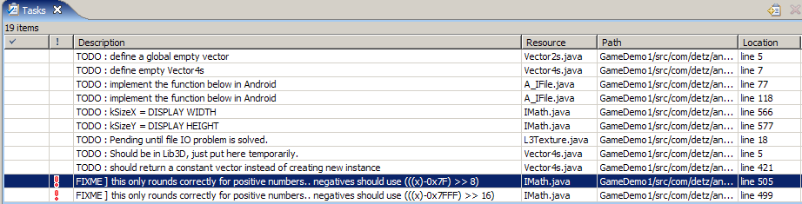

Example 1:

// [phong] TODO: implement binary search for better optimization
public int findElement(int[] array, int element)
{
for (int i = 0; i < array.length; i++)
{
if (array[i] == element)
{
return i;
}
}

return -1;
}

Example 2:

public static void UpdatePlayerPos(int dx, int dy)
{
m_player.m_posX += dx;
m_player.m_posY += dy;

// [phong] FIXME: this only works on 240x320 design!!
if (m_player.m_posY > 212)
{
m_isGameOver = true;
}
////
}

Example 3:

// NOTE: Make sure this is called before using SetStringParamStringID
void ResetStringParamString()
{
for (int i = 0; i < FONT_MAX_ESCAPE_STRINGS; i++)
{
m_strValues[i] = null;
}
}

Example 4:

// [phong] BUGFIX #469756 (Day 3: Random freeze when the cat breaks
// the coffee cup)
if (tile >= m_tileMapLayer[0].length)
{
return;
}
////

