

**<<Project name>>**

**Software Design Document**

– Hanoi, August 2019 –

**Table of Contents**

I. Overview 3

1. Code Packages 3

2. Database Schema 3

II. Code Designs 4

1. <Feature/Function Name1> 4

a. Class Diagram 4

b. Class Specifications 4

c. Sequence Diagram(s) 4

d. Database queries 5

2. <Feature/Function Name2> 5

III. Database Tables 5

1. <Table name 1> 5

2. <Table name 2…> 5

# I. Overview

## 1. Code Packages/Namespaces

*[Provide the package diagram for each sub-system. The content of this section including the overall package diagram, the explanation, package and class naming conventions in each package. Please see the sample and description table format below – following Java project naming convention]*

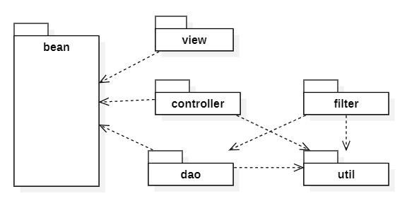

***Package descriptions & package class naming conventions***

|  |  |  |
| --- | --- | --- |
| **No** | **Package** | **Description** |
| *01* | *<Package name>* | *<Description of the package>*  *<Class naming convention>* |
| *02* |  |  |

## 2. Coding Conventions

# II. Code Designs

## 1. <Feature/Function Name1>

*[Provide the detailed design for the function <Feature/Function Name1>. It include Class Diagram, Class Specifications, and Sequence Diagram(s)]*

### a. Class Diagram

*[This part presents the class diagram for the relevant feature]*

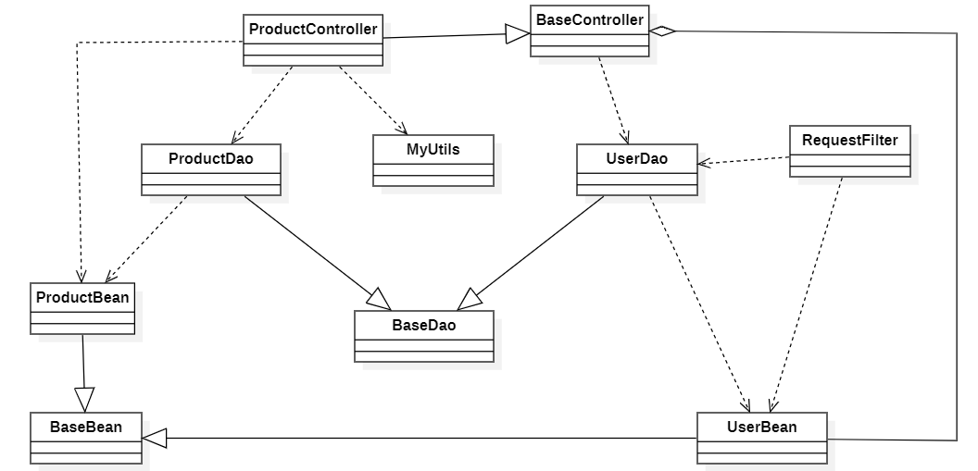

### b. Class Specifications

*[Provide the description for each class and the methods in each class, following the table format as below]*

#### XYZ Class

*[Provide the detailed description for the class methods]*

|  |  |  |
| --- | --- | --- |
| **No** | **Method** | **Description** |
| *01* | *<method name>* | *<Description of the method, including the inputs, outputs & internal method processing>* |
|  |  |  |

#### ABC Class

***Class Methods***

*[Provide the detailed description for the class methods]*

|  |  |  |
| --- | --- | --- |
| **No** | **Method** | **Description** |
| *01* | *<method name>* | *<Description of the method, including the inputs, outputs & internal method processing>* |
|  |  |  |

### c. Sequence Diagram(s)

*[Provide the sequence diagram(s) for the feature, see the sample below]*

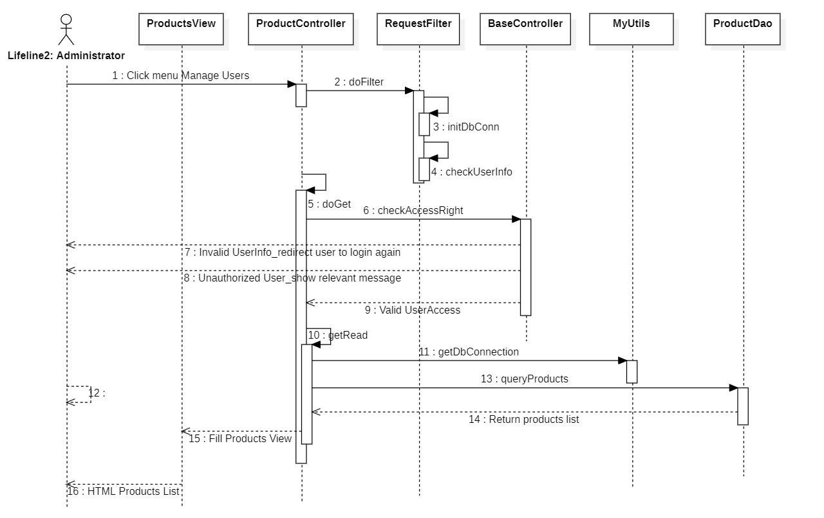

### d. Database queries

*[Provide the detailed SQL (select, insert, update...) which are used in implementing the function/screen]*

## 2. <Feature/Function Name2>

…

# III. Database Design

## 1. Database Schema

*[Provide the tables relationship like example below – following MySQL database naming convention]*

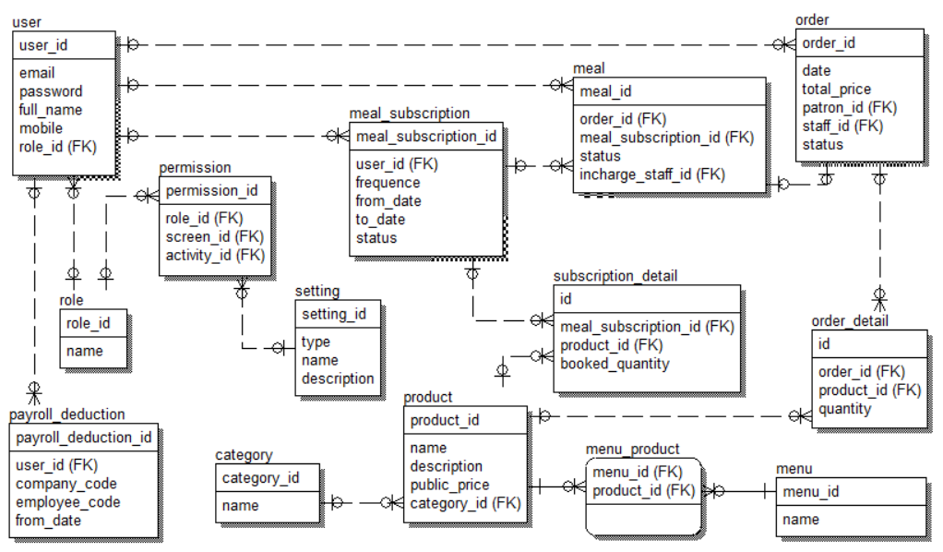

## 2. Table Description

|  |  |  |
| --- | --- | --- |
| **No** | **Table** | **Description** |
| *01* | *<Table name>* | *<Description of the table>*  *- Primary keys: <<list of primary key fields>>*  *- Foreign keys: <<list of foreign key fields>>* |
| *02* |  |  |