＜Revision History＞
VIETTEL SEMI

Document number：01
Sync_5M IP Verification Strategy

Revision | Publication Date | Approval | Collation | Creating
1.0 | Oct-27-2026 | - | - | Hungpv79

＜Revision content＞
Revision | No | Revision content
0.1 | - | New creation: verification strategy of the Sync_5M IP

＜Table of contents＞
1. Introduction 6
1.1. About this book 6
1.1.1. Document structure 6
1.1.2. Attached document 7
1.2. Input documents 7
1.3. Output documents 7
1.4. Abbreviation: 8
2. Verification strategy: 9
2.1. Outline: 9
2.2. Policies: 9
2.2.1. Verification level: 9
2.2.2. Verification goal: 9
2.2.3. Verification priority: 12
2.2.4. Verification methodology/EDA: 12
2.3. Schedule: 13
2.4. Test-bench: 14

＜Table of figures＞
Figure 2.2-1: Verification schedule 2
Figure 2.3-1: DUV test-bench 2

＜Table of tables＞
Table 1.1-1: Structure of this document 6
Table 1.1-2: Attached documents list 7
Table 1.2-1: Input documents list 7
Table 1.3-1: List of output documents 7
Table 2.2-1: Code coverage target 10

Introduction

About this book

Document structure
For an overview of this document and each chapter, it is shown in Table 1.1-1.

Table 1.1-1: Structure of this document
Chapter | Title | Overview | Note
1 | Introduction | Describes this document: structure, list of input/output documents, abbreviations and notation used in this book.
2 | Verification strategy | Describes the verification strategy of the Sync_5M IP: outline, policies (level, goal, priority, methodology/EDA), schedule and testbench.

Attached document
The attached documents of this book, it is shown in Table 1.1-2.

Table 1.1-2: Attached documents list
No. | Appendix number | Title | Content
1 | NA | NA | NA

Input documents
The input document of this book, it is shown in Table 1.2-1.

Table 1.2-1: Input documents list
No. | Document name | Issuer | Version | Described name in the book | Note
1 | Sync_IP_User_Guide.docx | Trungld13 | 0.7 | IP specification | -
2 | Chi_tieu_ky_thuat_Sync_5MHz.docx | Hoangnvn2 | 1.0 | Requirement specification | -
3 | Tai_lieu_kiem_thu_Sync_5MHz.docx | Hoangnvn2 | 1.0 | Reference model specification | -

Output documents
These are deliverable documents. It is shown in Table 1.3-1.

Table 1.3-1: List of output documents
No. | Document name | Issuer | File type | Release schedule | Note
1 | Verification strategy | Hungpv79 | Microsoft word | Oct. 2026
2 | Verification items | NA | Microsoft excel | Oct. 2026 | Part of the Verification Checklist.
3 | Verification scenario spec | NA | Microsoft excel | Oct. 2026 | Part of the Verification Checklist.
4 | Verification result report | NA | Microsoft excel | Dec. 2026
5 | Verification environment instruction document | NA | Microsoft word | Dec. 2026

Abbreviation:
No. | Abbreviation | Meaning
1 | AWGN | Additive White Gaussian Noise
2 | AXI4 | Advanced eXtensible Interface 4
3 | CDC | Clock Domain Crossing
4 | CFO | Carrier Frequency Offset
5 | CP | Cyclic Prefix
6 | CORDIC | Coordinate Rotation Digital Computer
7 | DUV | Design Under Verification
8 | EDA | Electronic Design Automation
9 | FFO | Fractional Frequency Offset
10 | IP | Intellectual Property
11 | LTE | Long Term Evolution
12 | NCO | Numerically Controlled Oscillator
13 | NMSE | Normalized Mean Square Error
14 | PSS | Primary Synchronization Signal
15 | RTL | Register Transfer Level
16 | SNR | Signal-to-Noise Ratio
17 | SVA | SystemVerilog Assertion
18 | UVM | Universal Verification Methodology
19 | VIP | Verification IP
20 | W1C | Write-1-to-Clear

Verification strategy:

Outline:
- DUV: Sync_5M IP with two clock domains: clk (AXI/register interface) and clk_250_MHz (datapath). The IP performs timing synchronization on a complex baseband I/Q sample stream based on the LTE PSS: it finds the PSS position, aligns the sample stream to the subframe grid, tracks the position in every half-frame, estimates and compensates the fractional frequency offset (FFO), and outputs phase-compensated data.

- Interfaces: AXI4 slave for 6 registers (clk domain), one level interrupt, AXI4-Stream style sample input and output without tready (clk_250MHz domain), half_frame_trigger, status/interrupt outputs: pos / pos_valid / tracking_error, interrupt / interrupt_clear.

- Requirement (Requirement specification): the IP RTL shall be bit-exact with the reference model, i.e. NMSE = −∞ dB for every quantity in every scenario. NMSE ≤ −60 dB is accepted only for vector quantities and only when the rounding difference has been agreed.

Policies:

Verification level:
DUV block verification: Synchronization_4G_top (IP top-level) is the DUV.

Verification goal:

Scope:
- Black-box verification: stimulus and checks against the reference model on the top-level ports of Synchronization_4G_top: AXI4 slave (s_axi_*), s_axis_tdata/s_axis_tvalid, half_frame_trigger, m_axis_tdata/m_axis_tvalid, pos/pos_valid/tracking_error, interrupt/interrupt_clear.
- White-box verification: check the register values of the IP through the AXI4 interface.

Configuration/mode:
- Parameters: Use the default parameters as specified in the IP specification (The value listed below are prioritized for initial verification. Other valid parameter values may also be supported and will be verified as needed):
- THRESHOLD = ${10}^{7}$(Default value, other values may be supported).
- DATA_WIDTH = 16 (Fixed value, must remain unchanged for verification).
- POS_WIDTH = 32 (Default value, other values may be supported).
- ANGLE_WIDTH = 32 (Fixed value, must remain unchanged for verification).
- REG_FILE = 8 (Default value, other values may be supported).
- MEM_ADDR_WIDTH = 12 (unused).
- MAX_COUNTER = 38400 (Fixed value, must remain unchanged for verification).
- MUL_DELAY = 1 (Default value, other values may be supported).
- DOWN_RATE = 4 (Fixed value, must remain unchanged for verification).
- ACQ_SKIP_FIRST = 0 (unused).
- AXI_DATA_WIDTH = 32 (Fixed value, must remain unchanged for verification).
- AXI_ADDR_WIDTH = 16 (Default value, other values may be supported).
- AXI_ID_WIDTH = 8 (Default value, other values may be supported).
- REG_ADDR_WIDTH = 9 (Fixed value, must remain unchanged for verification).
- FIFO_WRAP_WIDTH = 16 (Default value, other values may be supported).
- VERSION = 0 (Default value, other values may be supported).
- CLR_CYCLES = 16 (Default value, other values may be supported).
- FFO_PHA_WIDTH = 18 (Default value, other values may be supported).
- FFO_N_ITER = 16 (Default value, other values may be supported).
- Synchronous operation: output data, pos_valid/pos with reference model. And the tracking_error output: 1-cycle pulse only when the receive chain resets while in synchronous operation or out of synchronization occurs.
- Mode: interrupt mode and polling mode; IP enable (SYNC_CTRL.EN) on/off; software reset (SYNC_SWRS).

Item:
- Code coverage:
- It is shown in Table 2.2-1.

Table 2.2-1: Code coverage target
No. | Coverage item | Target | Note
1 | Toggle | 100% for top input/output ports
2 | Line | 100%
3 | Cond | 100%
4 | Branch | 100%
5 | FSM | 100%

- Functional coverage:
- Clock of AXI4-domain registers with many frequency (Ex: 25Mhz, 250Mhz, 1Ghz, …).
- Reset on the fly (both rstn and rstn_250MHz, and only rstn, and only rstn_250MHz), asynchronous assertion with different timing (rstn first / rstn_250MHz first)
- Reset on the fly through SYNC_SWRS
- AXI4-Full (slave, clk domain): Handshake, Single-beat access, INCR/WRAP burst, Byte-lane write strobes (WSTRB), Response codes (xRESP).
- Register: Reset value, Read-write access, Alias register, Reserved address.
- Synchronous behavior: Interrupt mode, Polling mode, NMSE, and pos (output data check).
- Planned coverpoint: AXI4 transaction (address, burst type, WSTRB, xRESP), register value (RW, RO, W1C, WO-P), interrupt, pos value, …
- Timing check:
- Spacing of two s_axis_tvalid samples ≥ 16 clk_250_MHz cycles (4·(MUL_DELAY + 3)).
- pos_valid, tracking_error and are 1-cycle pulses; m_axis_tvalid is deasserted after tracking_error, software reset or EN = 0.
- STAT.VLD/STAT.ERR and interrupt rise within the specified delay after pos_valid/tracking_error; interrupt = (INTE.ERRE & STAT.ERR) | (INTE.VLDE & STAT.VLD).
- clk with many frequency (Ex: 25Mhz, 250Mhz, 1Ghz, …).
- Software reset: core held in reset for CLR_CYCLES + 1 clk_250_MHz cycles, ignored when SYNC_CTRL.EN = 1.
- Connection check:
- NA
- Synchronizer circuit check:
- Check input and output of the synchronizer circuits by SVA: Sync_enable (clk to clk_250_MHz, level), Sync_clear (SYNC_SWRS pulse, toggle synchronizer), pos_valid/tracking_error/pos (clk_250_MHz to clk, toggle synchronizer).
- Data check:
- Reference model comparison: output data of every sync call (Table 4.1 of the Requirement specification) are compared by NMSE (Table 5.1 of the Requirement specification).
- Register/status check: SYNC_POS equals pos at pos_valid; SYNC_STAT VLD/ERR set and W1C clear (interrupt_clear has highest priority); reset values and access types of all registers.

Verification priority:
Priority | Concept
1 | Reset, software reset, reset value, read/write access register through AXI4
2 | - Synchronous operation: bit-exact matching of the sync function with the reference model. Output value: pos, tracking_error  - Interrupt mode, Polling mode
3 | Test with other supported parameters, parameters fixed by are not varied. Refer 2.2.2.b
Note: Verification priorities are ranked from 1 to 3, where Priority 1 is the highest priority and Priority 3 is the lowest.

Verification methodology/EDA:

Environment:
- Create new UVM environment (SystemVerilog IEEE 1800, UVM-1.1d).
- Use AXI4/AXI4-Stream VIP of Cadence
- Use reference model of algorithm team, through DPI-C

Methodology:

UVM and constrained-random verification, combined with directed tests and corner cases.

Coverage-driven verification: coverage closure based on code coverage, functional coverage, and assertion coverage.

Assertion-based verification: SVA assertions for timing check (if neccessary) and selected white-box checks.

EDA tool:
Number | EDA Tools (Cadence vendor) | Version
1 | Xcelium | 25-09-003
2 | Verisium Debug | 25-09-003
3 | IMC | 25-09-003

- Number of licenses: 7

Schedule:
Phase | Concept | Time
1 | Verification strategy | Week 1
2 | Verification checklist | Week 2, 3
3 | Build UVM testbench, integrate reference model | Week 2, 3, 4
4 | Basic testcase | Week 3, 4
5 | Test random, corner case | Week 5,6,7,8
6 | Regression, closure coverage | Week 8, 9
7 | Result report, environment instruction | Week 10

Figure 2.3-1: Verification schedule

Test-bench:
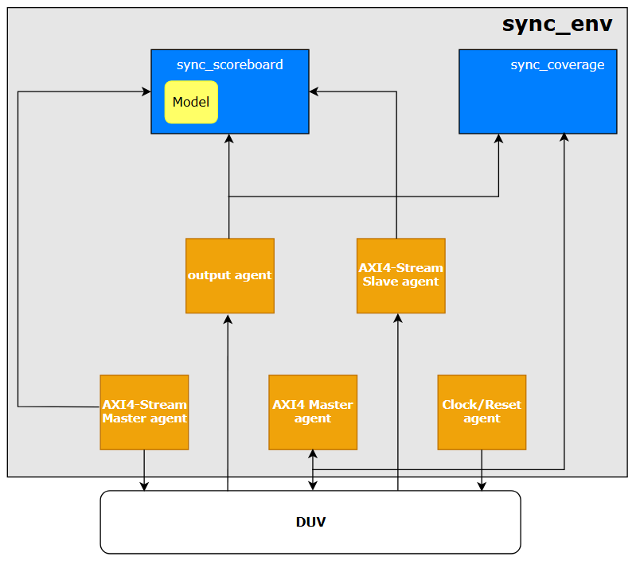

Figure 2.4-1: DUV test-bench

Legend of color:

Create new

Model

Reused and Modified

Create new (environment)

