EXC9200 Excitation System Instruction Manual

Chapter 10

Electric braking function

China National Electric Apparatus Research Institute Co., Ltd
Guangzhou Kinte Industrial Co., Ltd.
CONTENTS

10-1. Brief introduction 3
10-2. Principle of electric braking 3
10-3. Circuit of electric braking 4
10-4. Working procedure of electric braking 5
10-5. The output current control of the excitation system 9

10-1. Brief introduction
- Our company has a great knowledge and rich experience in the electric braking device. On the basis of the excitation system, taking the clients’ needs into consideration, we develop the function of soft electric braking. The case of normal power generation and electric braking operation share the rectifier bridge and de-excitation circuit.
This function of electric braking can only be applied to the water turbine.

10-2. Principle of electric braking
After generator offline and de-excitation, when generator speed drops to 50%~60%, short circuit the 3 phases of the stator at generator terminal. The excitation system enters the soft electrical braking process, the excitation system turns into electric braking mode and adds braking current to the rotor, then the stator will create short-circuit current. It produces force moment whose direction is opposite to the rotor rotation and that will play a role of braking.
There are 2 main distinguished characteristics of electric braking:
- The electric braking force moment is proportionate to square of the stator short circuit current.
- The electric braking force moment is inversely proportionate to generator speed. In the process of electric braking, the stator short circuit current remains almost the same, so as generator speed drops, the electric braking force moment increases. When generator stops, the force moment reaches it maximum value.
According to the above characteristics, in order to get the utmost force moment, we should make full use of the stator capacity to make the stator short circuit current equal to the rated value. Thus, the excitation current should reach rated no load excitation current.
The electric braking is generally started at 60% rated generator speed, the command is sent by monitoring system. PLC will finish the control steps of electric braking procedure.
In the electric braking process, the regulator is in manual mode. Excitation system sends out the constant excitation current to the rotor.
The braking current can be set through the commissioning software.

10-3. Circuit of electric braking
In the process of electric braking, external power is needed. It is closely related to the structure of the main circuit of excitation system. Usually there are 2 wiring ways, see figure 10-1 and figure10-2.
In Graph 10-1, the excitation system is wired in the way of self-shunt. When generator terminal is short circuit, there will be no power to excitation transformer. The electric braking power supply comes from electric braking transformer which is connected to service transformer. That is, in condition of generating and electric braking, the rectifier power needs to be switched through breakers QL1 and QL2.
In Graph 10-2, the wiring way is separate excitation wring. I.e. excitation transformer is connected outside of generator circuit breaker. In both conditions of generating and electric braking, the rectifier power is supplied by excitation transformer.
Compare the above 2 ways, the second way is simpler, which doesn’t need electric braking transformer and relevant circuit breaker and control logic is shorter.
Under the mode of self-shunt, the excitation transformer is generally connected to generator terminal. It is more popular. In the electric braking process, the excitation current won’t exceed the rated no load excitation current. As a result, the capacity of the electric braking transformer can be selected at a small amount.
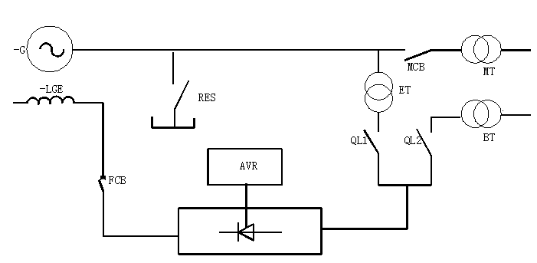
Figure 10-1 self and parallel wring mode

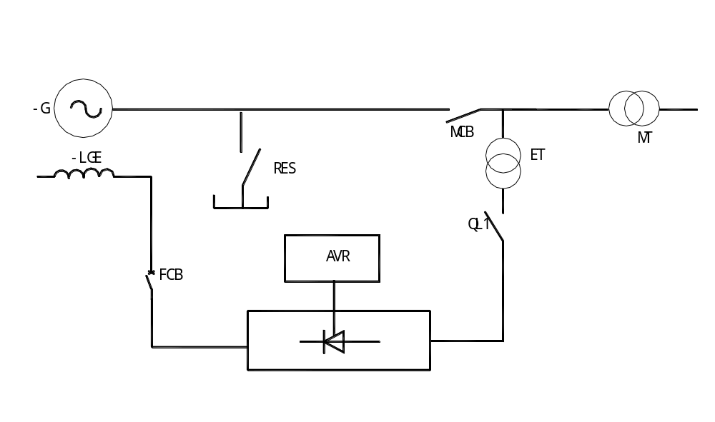
Figure 10-2 other-excitation wring mode

10-4. Working procedure of electric braking
The working procedure of electric braking is realized by PLC, which plays an important role in the whole procedure. Take Figure 10-1 as an example, the working procedure of electric braking is described as below, Figure 10-3.
PLC fulfills the following functions:
1、Check the conditions for the electric braking
In normally stopping procedure, after generator is offline, the monitoring system will send a stop command to excitation system and the regulator reverse for de-excitation. Usually, when the following conditions are met, the monitoring system sends electric braking command to excitation system.
1)Generator circuit breaker is tripped
2) Generator stops
3)Guide vanes are all closed
4) Generator has no fault
5) Generator speed drops to less than 60% rated
2、When the conditions are met, PLC will lock the generator protection, open switch QL1, close RES and switch QL2 in sequence.

3、The excitation regulator transfers to electric braking mode and sends current to the rotor, forming a force moment to carry out electric braking process.
4、In the process, if any step doesn’t meet the requirement, PLC would send signals to begin mechanical brake as well as alarm to the monitoring system. The electric braking will exit and at the same time go to step 7.
5、When generator speed is less than 5% rated, electric braking will be finished. PLC sends de-excitation signals to the regulator, after the success of de-excitation, go to step 7.
6、If reversion fails, PLC will open field circuit breaker, then go to step 7.
7、When steps3~steps 6 are finished, PLC sends commands to switch QL2, RES and QL1, generator protection is released, excitation system restores to normal standby state
In the electric braking process, PLC will continuously monitor the whole process. When any of the following problems occurs, PLC will send alarm signal to the monitoring system, and terminate the process. Therefore, the monitoring system should send a command to transfer it to mechanic braking.
1)、QL1 cannot be switched off, RES or QL2 cannot be switched on
2）、Time of electric braking is too long.
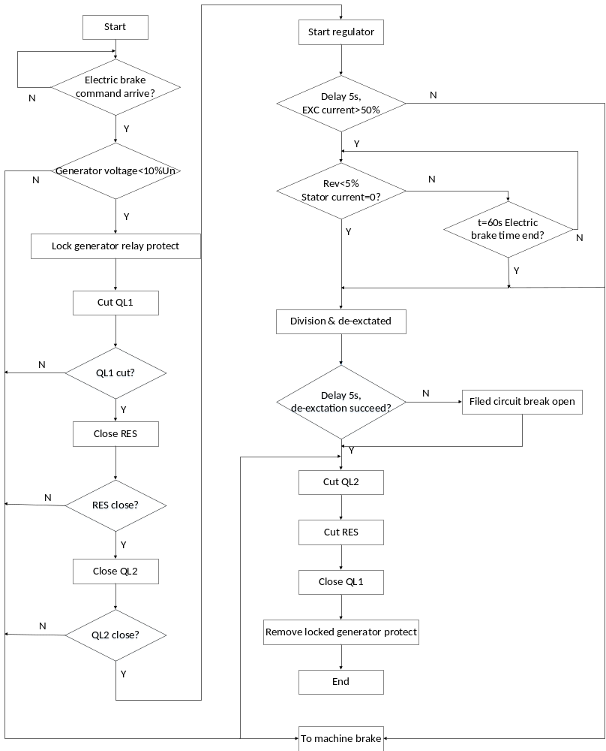
Figure 10-3 Electric breaking function flow-chart

10-5. The output current control of the excitation system
Considering the different running conditions of different power plants, in the process of electric braking, the excitation current is not all the same. For the convenience of regulating the current output, the parameter in the commissioning software ID [17F] can be modified according to the actual requirement.

