TRUONG DAI HOC FPT - CO SO DA NANG
KHOA CONG NGHE THONG TIN - BO MON KY THUAT PHAN MEM

HUONG DAN KIEM THU THUC NGHIEM
SAGA ORCHESTRATION PATTERN
Slot 14 - Kiem thu 8 Kich ban (KB1 den KB8)
Thong tin | Chi tiet
Mon hoc | MSS301 - Microservices & Distributed Architecture
Sinh vien | Phan Thanh Hung
Ngay thuc hien | 23 / 10 / 2026
Cong nghe | Spring Boot 4.1.1 - Java 23 - MySQL - MongoDB - SQL Server - Docker
Muc tieu | Kiem thu step-by-step & chup hinh tat ca 8 kich ban muc 6.3

MUC LUC
Muc | Noi dung | Trang
1 | TONG QUAN HE THONG VA CACH KHOI DONG
1.1 | Kien truc 3 Service - 3 Database
1.2 | Cach A: Chay DB trong Docker, Service qua IntelliJ / JAR
1.3 | Cach B: Tat ca chay Docker Compose
1.4 | Reset du lieu ve trang thai ban dau (Quan trong truoc khi test)
1.5 | Import Postman Collection
2 | HUONG DAN CHUNG: CAC BUOC KIEM THU MOI KICH BAN
3 | KIEM THU KB1 - Dat hang thanh cong (Happy Path)
3.1 | Muc tieu
3.2 | Dieu kien tien quyet
3.3 | Payload Request
3.4 | Ket qua mong doi
3.5 | Huong dan buoc chup hinh
4 | KIEM THU KB2 - Thanh toan that bai (402) + Compensating Transaction
4.1 | Muc tieu
4.2 | Dieu kien tien quyet
4.3 | Payload Request
4.4 | Co che hoat dong ben trong (de hieu khi doc log)
4.5 | Ket qua mong doi
5 | KIEM THU KB3 - Het hang ton kho (409 Out of Stock)
5.1 | Muc tieu
5.2 | Payload Request
5.3 | Ket qua mong doi
5.4 | Huong dan chup hinh
6 | KIEM THU KB4 - San pham khong ton tai (404 Not Found tai Inventory)
6.1 | Payload Request
6.2 | Ket qua mong doi
6.3 | Huong dan chup hinh
7 | KIEM THU KB5 - Vi khong ton tai (404 Not Found tai Payment)
7.1 | Muc tieu
7.2 | Payload Request
7.3 | Ket qua mong doi
7.4 | Huong dan chup hinh
8 | KIEM THU KB6 - Payment-service bi tat (Network / Service Unreachable)
8.1 | Muc tieu
8.2 | Quy trinh thuc hien
8.3 | Ket qua mong doi
9 | KIEM THU KB7 - Tinh Idempotent (Goi lap lai nhieu lan)
9.1 | Muc tieu
9.2 | Cac test case trong KB7
9.3 | Huong dan chup hinh
10 | KIEM THU KB8 - Compensation cung loi (He thong treo o COMPENSATING)
10.1 | Muc tieu
10.2 | Buoc 1: Cau hinh order-service voi do tre 15 giay
10.3 | Buoc 2: Chup Snapshot truoc khi test
10.4 | Buoc 3: Gui Request KB8 tu Postman
10.5 | Buoc 4: TRONG 15 GIAY khi request dang cho - Tat inventory-service VA payment-service
10.6 | Buoc 5: Cho response va chup ket qua
10.7 | Buoc 6: Chup Saga Logs
10.8 | Buoc 7: Chup trang thai ton kho bi treo
10.9 | Buoc 8: Phuc hoi thu cong (Minh chung Idempotent + Recovery)
10.10 | Buoc 9: Don dep moi truong sau KB8
11 | DANH GIA KY THUAT VA KET LUAN
11.1 | Tong ket 3 tinh chat cot loi da kiem chung
11.2 | So sanh Saga vs @Transactional
12 | PHU LUC: Lenh truy van Database truc tiep de doi chieu
12.1 | MySQL - orderdb (Kiem tra trang thai Order va SagaLog)
12.2 | MongoDB - inventorydb (Kiem tra kho va Reservation)
12.3 | SQL Server - paymentdb (Kiem tra Wallet va Payment)
12.4 | Kiem tra qua REST API (Postman hoac cURL)
Nhấp chuột phải vào đây và chọn Update Field → Update entire table để hiện mục lục có liên kết tới từng bước và hình ảnh.

1. TONG QUAN HE THONG VA CACH KHOI DONG

1.1. Kien truc 3 Service - 3 Database
He thong Saga Demo gom 3 Microservice, moi service su dung mot loai database khac nhau:

Service | Cong Host | Database | Container | Local Transaction | Compensating TX
order-service | 8081 | MySQL 8.4 (orderdb) | saga-mysql:3307 | createPendingOrder -> PENDING | cancelOrder -> CANCELLED
inventory-service | 8082 | MongoDB 8.0 | saga-mongodb:27018 | reserve() - giu kho | release() - tra lai kho
payment-service | 8083 | SQL Server 2022 | saga-sqlserver:14330 | pay() - tru tien vi | refund() - hoan tien vi

1.2. Cach A: Chay DB trong Docker, Service qua IntelliJ / JAR

1.2.1. Mo Docker Desktop. Tu thu muc Slot14, chay lenh khoi dong 3 container DB:
cd D:\Fall2026\MSS301_SU26\Code\MSS301_FA26_PhanThanhHung\Slot14
docker compose up -d mysql sqlserver mongodb
# Cho den khi 3 container deu o trang thai (healthy)
docker compose ps

1.2.2. Mo IntelliJ IDEA, chay lan luot theo dung thu tu:
- inventory-service (port 8082) -> Cho log "Started InventoryServiceApplication"
- payment-service (port 8083) -> Cho log "Started PaymentServiceApplication"
- order-service (port 8081) -> Cho log "Started OrderServiceApplication"

1.2.3. Hoac chay bang JAR thu cong (khong can IntelliJ):
java -jar inventory-service\target\inventory-service-0.0.1-SNAPSHOT.jar
java -jar payment-service\target\payment-service-0.0.1-SNAPSHOT.jar
java -jar order-service\target\order-service-0.0.1-SNAPSHOT.jar

1.3. Cach B: Tat ca chay Docker Compose
cd D:\Fall2026\MSS301_SU26\Code\MSS301_FA26_PhanThanhHung\Slot14
docker compose up -d --build
docker compose ps
# Xem log realtime order-service (Saga logs)
docker compose logs -f order-service

1.4. Reset du lieu ve trang thai ban dau (Quan trong truoc khi test)
LUU Y: PHAI thuc hien buoc Reset truoc khi chay test de dam bao so lieu P1=10, P2=5, C1=5000, C2=100 dung nhu ket qua mong doi trong tai lieu.

# Dung va xoa toan bo container + volume
docker compose down -v
# Khoi dong lai (database se duoc seed du lieu moi)
docker compose up -d mysql sqlserver mongodb
# Cho healthy roi start lai services
Kiem tra du lieu ban dau sau khi reset:
# Kiem tra ton kho (P1=10, P2=5)
curl http://localhost:8082/api/inventory/products

# Kiem tra so du vi (C1=5000, C2=100)
curl http://localhost:8083/api/payments/wallets

1.5. Import Postman Collection

1.5.1. Mo Postman -> Click nut Import (goc tren trai)

1.5.2. Chon file Saga_Postman_Collection.json trong thu muc Slot14

1.5.3. Collection "MSS301 - Saga Demo (Spring Boot 4.1.1)" se xuat hien trong sidebar

1.5.4. Kiem tra Collection Variables: orderUrl = http://localhost:8081, inventoryUrl = http://localhost:8082, paymentUrl = http://localhost:8083

1.5.5. Chay thu nhom "0 - Kiem tra service" de xac nhan 3 service deu OK

2. HUONG DAN CHUNG: CAC BUOC KIEM THU MOI KICH BAN
Moi kich ban deu duoc thuc hien theo 5 buoc chuan sau. Tai moi buoc, sinh vien chup hinh man hinh tuong ung:

Buoc | Hanh dong | Noi dung can chup hinh
1 | Snapshot - Kiem tra trang thai du lieu TRUOC khi test | Ket qua GET /products (ton kho) va GET /wallets (so du vi)
2 | Gui Request - POST /api/orders voi payload tuong ung | Cua so Postman: Request body va Response JSON tra ve
3 | Kiem tra Response - Doc status, sagaStatus, failureReason | Dong khung noi dung phan Response JSON, highlight cac field quan trong
4 | Saga Logs - GET /api/orders/{id}/saga-logs | Chuoi cac step: CREATE_ORDER, RESERVE, PROCESS_PAYMENT, CONFIRM/SAGA/COMPENSATION...
5 | Verify DB - Kiem tra ton kho va so du sau test | GET /products va GET /wallets so sanh voi Snapshot

LUU Y: Doi voi Cach A (IntelliJ), sinh vien nen chup them Console Log cua order-service tai buoc 2 de thay log WARN/INFO cua Orchestrator khi Saga that bai/hoan tac.

3. KIEM THU KB1 - Dat hang thanh cong (Happy Path)

3.1. Muc tieu
Chung minh toan bo luong Saga Orchestration chay thanh cong qua 3 service, 3 database: MySQL -> MongoDB -> SQL Server. Day la kich ban co so (baseline) de doi chieu voi cac kich ban loi.

3.2. Dieu kien tien quyet
- Da reset DB: P1 = 10 stock, C1 = 5000 balance.
- Tat ca 3 service dang chay va healthy.

3.3. Payload Request
POST http://localhost:8081/api/orders
Content-Type: application/json

{"customerId": "C1", "productId": "P1", "quantity": 2, "amount": 2000.0}

3.4. Ket qua mong doi
Diem kiem tra | Gia tri mong doi
HTTP Status Code | 200 OK
response.status | "CONFIRMED"
response.sagaStatus | "COMPLETED"
response.failureReason | null
GET /products -> P1.stock | 8 (giam 2 so voi ban dau)
GET /wallets -> C1.balance | 3000.0 (giam 2000 so voi ban dau)
Saga Logs: thu tu step | CREATE_ORDER -> RESERVE_INVENTORY -> PROCESS_PAYMENT -> CONFIRM_ORDER
Saga Logs: tat ca result | SUCCESS

3.5. Huong dan buoc chup hinh

3.5.1. Chup GET /products va GET /wallets TRUOC khi test (Snapshot)
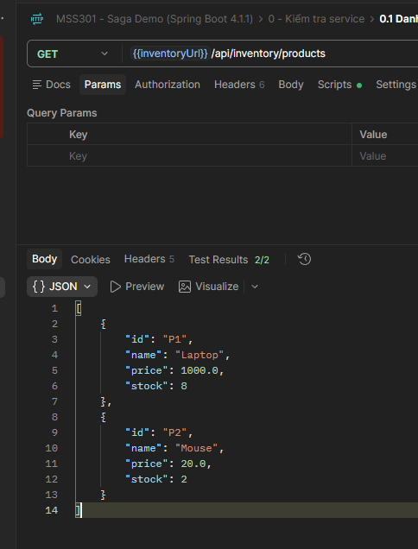
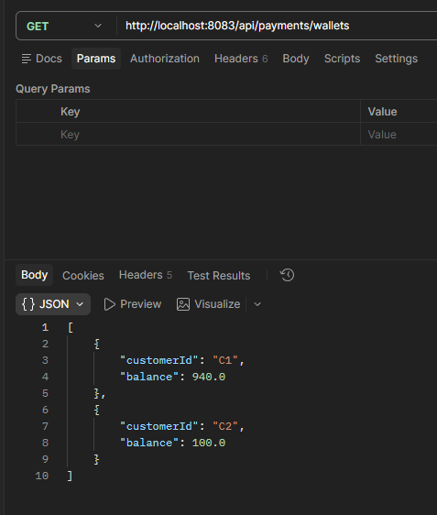

3.5.2. Gui POST /api/orders voi payload tren -> Chup toan bo Request + Response trong Postman
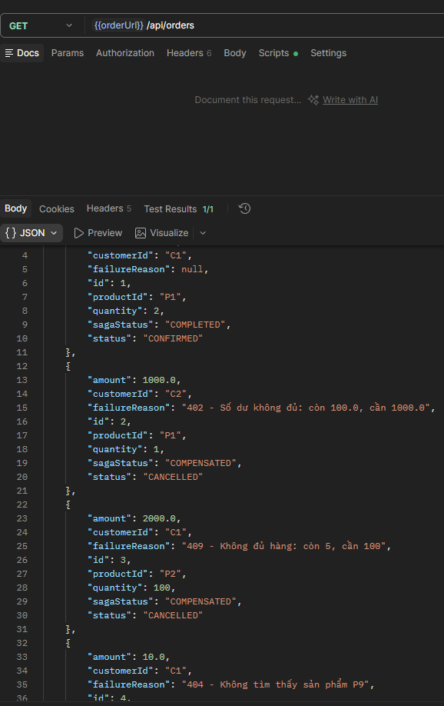

3.5.3. Highlight field status = "CONFIRMED", sagaStatus = "COMPLETED" trong Response

3.5.4. Gui GET /api/orders/{id}/saga-logs -> Chup danh sach 4 steps deu SUCCESS
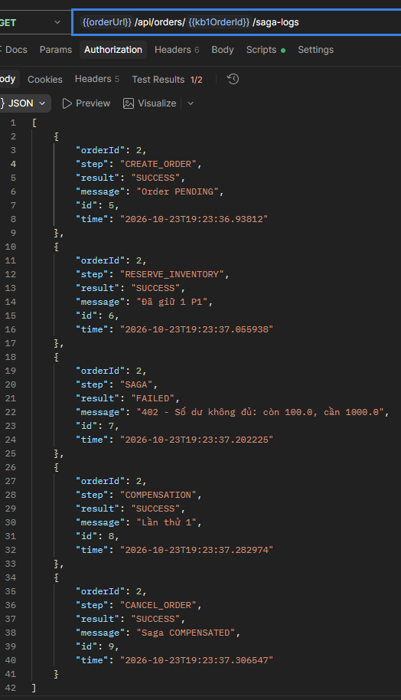

3.5.5. Chup GET /products va GET /wallets SAU khi test (P1=8, C1=3000)
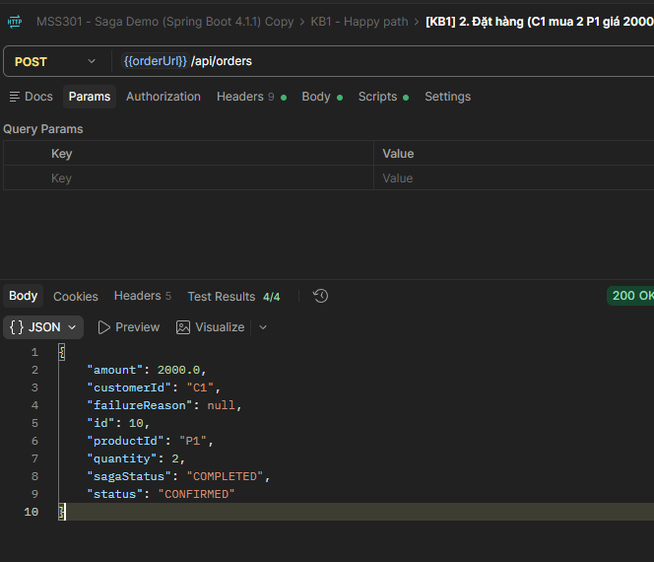
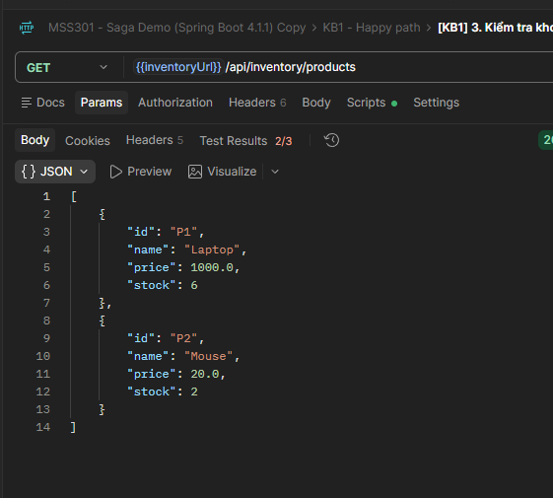

3.5.6. [IntelliJ] Chup Console log order-service the hien 4 buoc INFO
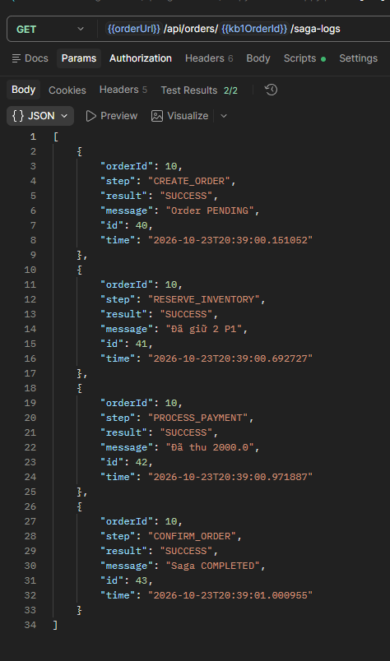

4. KIEM THU KB2 - Thanh toan that bai (402) + Compensating Transaction

4.1. Muc tieu
Day la kich ban TRONG TAM cua Saga Pattern. Khi payment-service tu choi thanh toan do so du khong du (HTTP 402), Orchestrator phai tu dong kich hoat compensating transaction (release) de hoan tra kho hang da giu, dam bao tinh nhat quan giua MySQL va MongoDB va SQL Server.

4.2. Dieu kien tien quyet
- P1 stock: 8 (ket qua sau KB1) HOAC 10 neu da reset
- C2 balance: 100.0 (giu nguyen sau KB1 vi KB1 dung C1)
- Ca 3 service dang chay.

4.3. Payload Request
POST http://localhost:8081/api/orders
Content-Type: application/json

{"customerId": "C2", "productId": "P1", "quantity": 1, "amount": 1000.0}

// Giai thich: C2 chi co 100.0 nhung order can 1000.0 -> Payment nem 402

4.4. Co che hoat dong ben trong (de hieu khi doc log)
Thu tu | Service | Hanh dong | Ket qua
1 | order-service | Tao Order PENDING (MySQL) | SUCCESS -> push cancelOrder vao stack compensation
2 | inventory-service | reserve() - giu 1 P1 tai MongoDB (stock: 8 -> 7) | SUCCESS -> push release() vao stack compensation
3 | payment-service | pay() - tru 1000.0 tu vi C2 tai SQL Server | THAT BAI -> 402 (So du 100 < 1000) -> throw exception
4 | order-service (Orchestrator) | Bat exception -> goi compensation stack (LIFO) | release() order -> MongoDB tra P1 ve (stock: 7 -> 8)
5 | order-service | cancelOrder() - chuyen Order sang CANCELLED | sagaStatus = COMPENSATED

4.5. Ket qua mong doi
Diem kiem tra | Gia tri mong doi
HTTP Status Code | 200 OK
response.status | "CANCELLED"
response.sagaStatus | "COMPENSATED"
response.failureReason | "402 - So du khong du: con 100.0, can 1000.0"
GET /products -> P1.stock | Giu nguyen so voi truoc (release da thanh cong)
GET /wallets -> C2.balance | 100.0 (giu nguyen, vi khong bi tru)
Reservation (MongoDB) | status = "RELEASED"
Saga Logs: thu tu step | CREATE_ORDER -> RESERVE_INVENTORY -> SAGA(FAILED) -> COMPENSATION(SUCCESS) -> CANCEL_ORDER
Saga Logs: SAGA | result = "FAILED"
Saga Logs: COMPENSATION | result = "SUCCESS", message = "Lan thu 1"

4.5.1. GET /products va GET /wallets
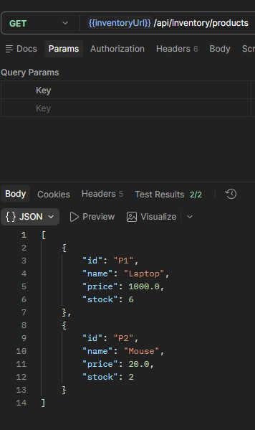

4.5.2. POST /api/orders voi payload
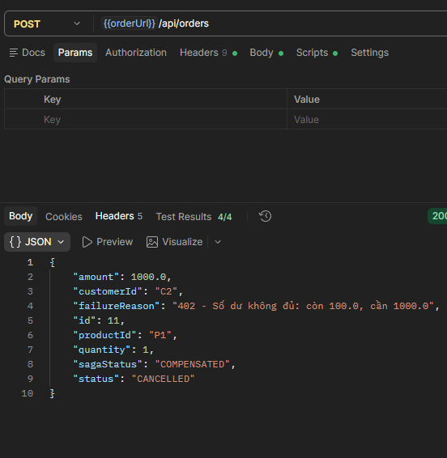

4.5.3. Highlight 3 field quan trong: status = CANCELLED, sagaStatus = COMPENSATED, failureReason bat dau bang "402"
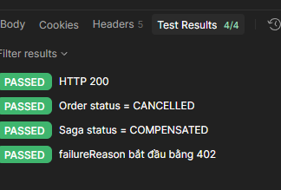

4.5.4. Gui GET /api/orders/{orderId}/saga-logs -> Chup danh sach 5 steps (dac biet buoc SAGA FAILED va COMPENSATION SUCCESS)
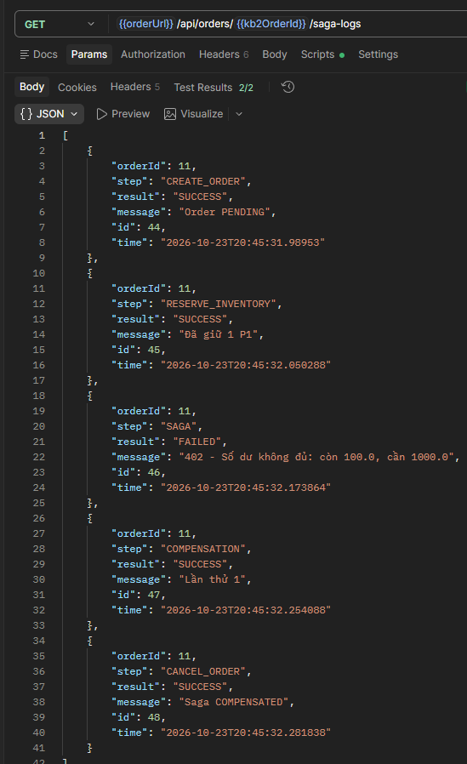

4.5.5. GET /products va GET /wallets (P1 tro ve so cu, C2 van 100)
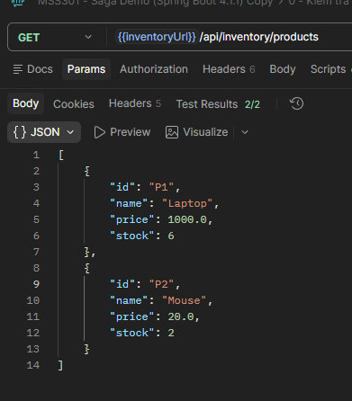

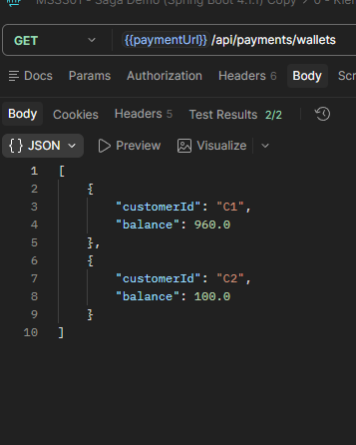

4.5.6. Console order-service: dong WARN "Saga order=X that bai: 402..." + cac dong goi release

4.5.7. Chup Console payment-service: dong WARN "Khach hang C2 khong du tien..."

5. KIEM THU KB3 - Het hang ton kho (409 Out of Stock)

5.1. Muc tieu
Kiem tra kich ban loi xay ra ngay tai buoc Inventory. Vi chua co du lieu nao trong compensation stack o thoi diem phat sinh loi, Orchestrator khong can goi release ma chi cancelOrder.

5.2. Payload Request
POST http://localhost:8081/api/orders

{"customerId": "C1", "productId": "P2", "quantity": 100, "amount": 2000.0}

// P2 chi con toi da 5 trong kho, dat 100 se bi tu choi ngay

5.3. Ket qua mong doi
Diem kiem tra | Gia tri mong doi
response.status | "CANCELLED"
response.sagaStatus | "COMPENSATED"
response.failureReason | "409 - Khong du hang: con [N], can 100"
Kho P2 sau test | Giu nguyen (KHONG bi tru vi loi truoc khi reserve thanh cong)
Saga Logs: thu tu step | CREATE_ORDER -> SAGA(FAILED) -> CANCEL_ORDER (3 steps, khong co RESERVE)
Nhan xet quan trong | Stack compensation rong -> khong goi release, chi cancelOrder

5.4. Huong dan chup hinh

5.4.1. Chup Snapshot truoc (P2 stock hien tai)
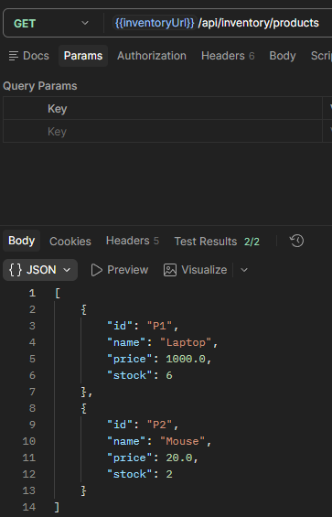

5.4.2. Gui Request -> Chup Response (failureReason bat dau "409")
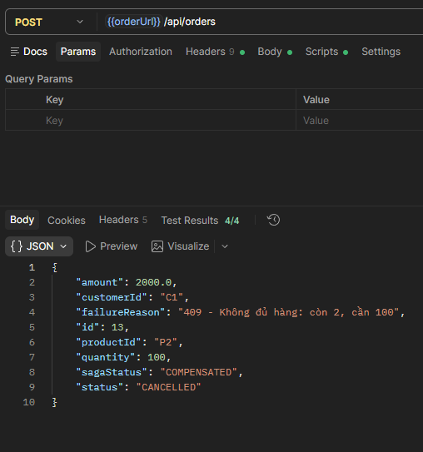

5.4.3. Chup Saga Logs - chu y chi co 3 buoc, KHONG co RESERVE_INVENTORY
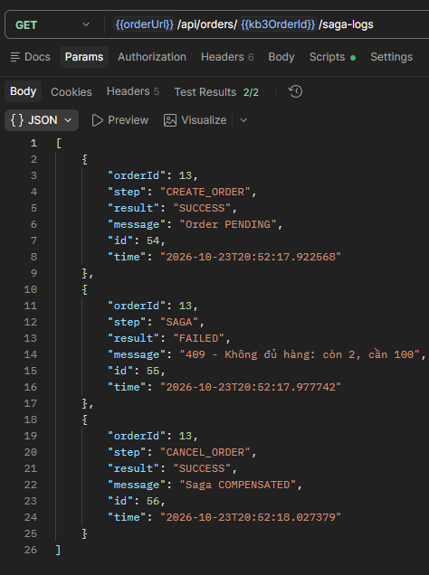

5.4.4. Chup GET /products SAU -> P2 khong doi (chung minh kho khong bi tru)
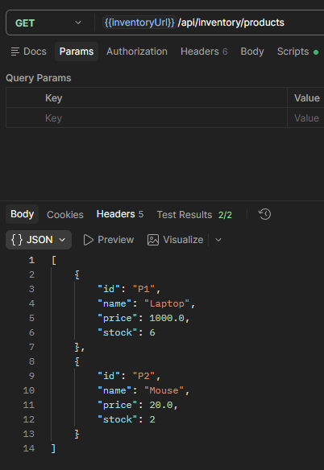

6. KIEM THU KB4 - San pham khong ton tai (404 Not Found tai Inventory)

6.1. Payload Request
POST http://localhost:8081/api/orders

{"customerId": "C1", "productId": "P9", "quantity": 1, "amount": 10.0}

// P9 khong ton tai trong MongoDB

6.2. Ket qua mong doi
Diem kiem tra | Gia tri mong doi
response.status | "CANCELLED"
response.sagaStatus | "COMPENSATED"
response.failureReason | "404 - Khong tim thay san pham P9"
Kho va vi | Khong co gi thay doi
Saga Logs: thu tu step | CREATE_ORDER -> SAGA(FAILED) -> CANCEL_ORDER

6.3. Huong dan chup hinh

6.3.1. Gui Request -> Chup Response (failureReason bat dau "404 - Khong tim thay san pham")
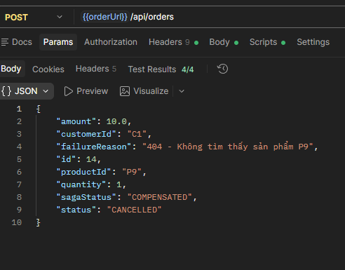

6.3.2. Chup Saga Logs - 3 buoc, khong co RESERVE_INVENTORY
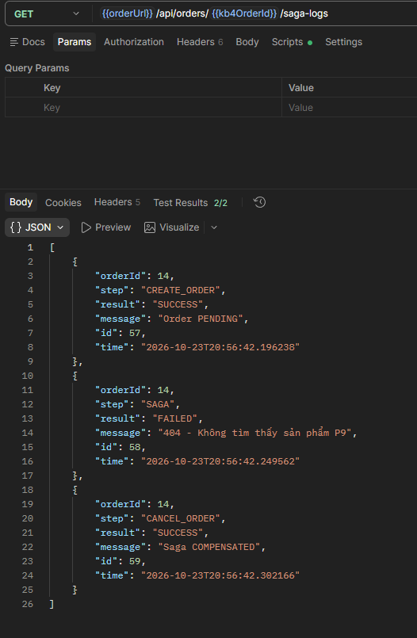

6.3.3. Chup GET /products SAU -> P1, P2 khong doi
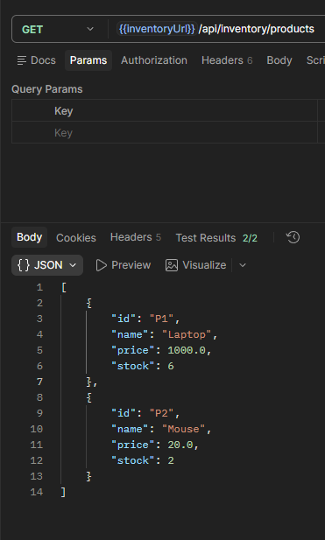

7. KIEM THU KB5 - Vi khong ton tai (404 Not Found tai Payment)

7.1. Muc tieu
Kich ban tuong tu KB2 ve luong compensation. Inventory giu kho thanh cong, nhung payment-service tra 404 vi khach hang C9 chua co vi. Compensation phai giai phong kho truoc khi huy order.

7.2. Payload Request
POST http://localhost:8081/api/orders

{"customerId": "C9", "productId": "P2", "quantity": 1, "amount": 20.0}

// C9 khong co vi trong SQL Server -> Payment nem 404

7.3. Ket qua mong doi
Diem kiem tra | Gia tri mong doi
response.status | "CANCELLED"
response.sagaStatus | "COMPENSATED"
response.failureReason | "404 - Khong tim thay vi cua C9"
Kho P2 sau test | Giu nguyen (giu roi release thanh cong)
Saga Logs: thu tu step | CREATE_ORDER -> RESERVE_INVENTORY -> SAGA(FAILED) -> COMPENSATION(SUCCESS) -> CANCEL_ORDER
Nhan xet | Giong KB2 ve luong nhung loi khac: 404 thay vi 402

7.4. Huong dan chup hinh

7.4.1. Snapshot P2 stock truoc test
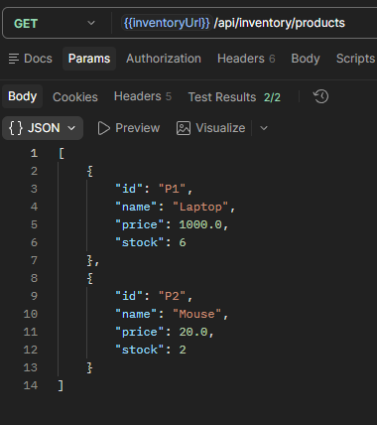

7.4.2. Gui Request -> Chup Response (failureReason bat dau "404 - Khong tim thay vi")
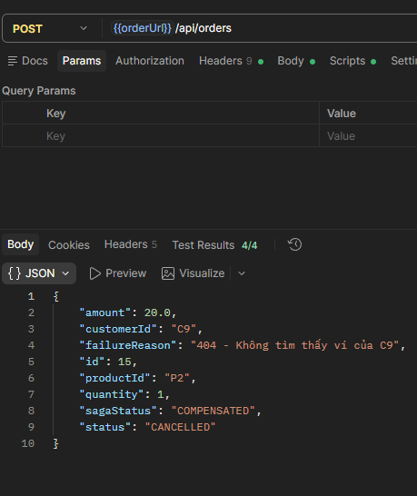

7.4.3. Chup Saga Logs - 5 buoc, co ca RESERVE va COMPENSATION
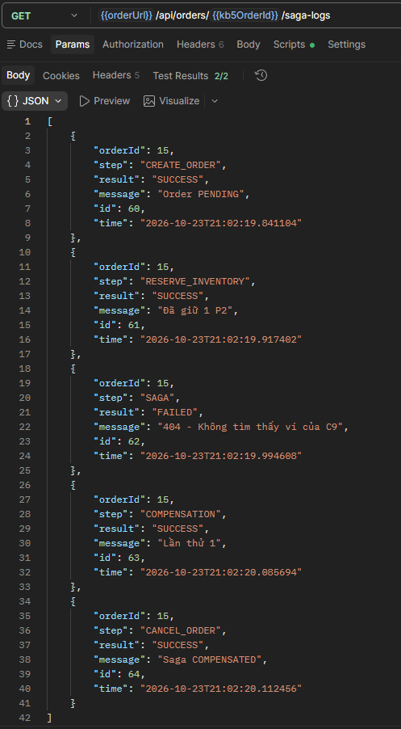

7.4.4. Chup GET /products SAU -> P2 tro ve so cu (release da chay thanh cong)
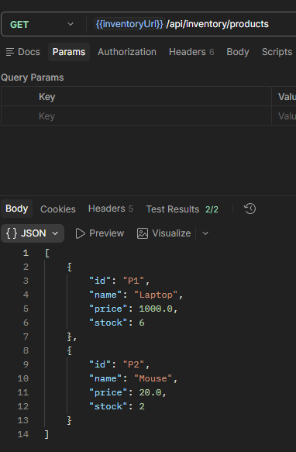

8. KIEM THU KB6 - Payment-service bi tat (Network / Service Unreachable)

8.1. Muc tieu
Mo phong loi ha tang: payment-service hoan toan khong phan hoi. Orchestrator phai xu ly RestClientException (I/O error) va kich hoat compensation giai phong kho.

8.2. Quy trinh thuc hien
LUU Y: KB6 phai thuc hien THU CONG theo dung thu tu. Khong the chay bang Collection Runner.

8.2.1. Snapshot GET /products (P2 stock) va GET /wallets
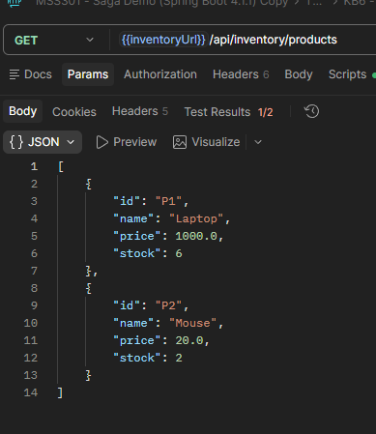

8.2.2. Tat payment-service:
# Neu dung Docker:
docker compose stop payment-service

# Neu dung IntelliJ/JAR: Stop process payment-service trong IntelliJ hoac Ctrl+C trong terminal

8.2.3. Chup hinh xac nhan payment-service da tat (docker compose ps hoac IntelliJ khong co process)

8.2.4. Gui POST /api/orders voi payload sau:
POST http://localhost:8081/api/orders

{"customerId": "C1", "productId": "P2", "quantity": 1, "amount": 20.0}

8.2.5. Chup Response (request co the mat 5-7s do timeout)
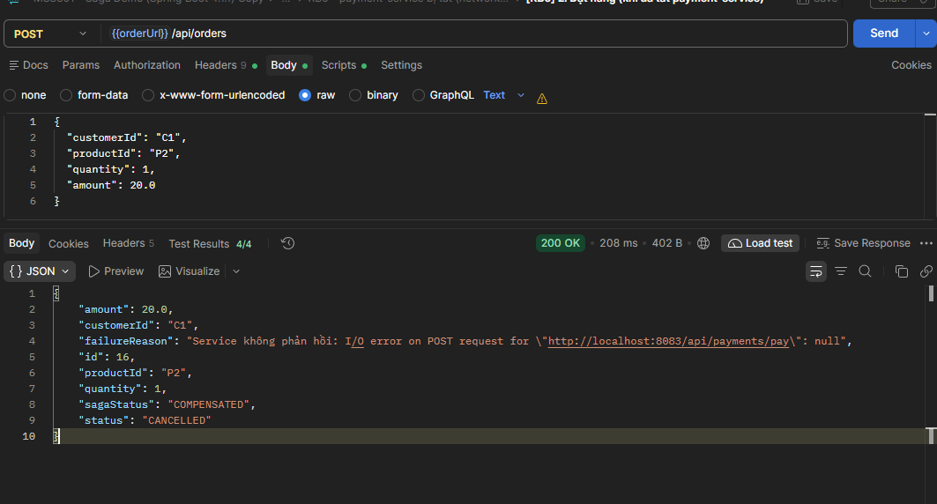

8.2.6. Chup Saga Logs - tuong tu KB2 nhung SAGA message bat dau bang "Service khong phan hoi: I/O error..."
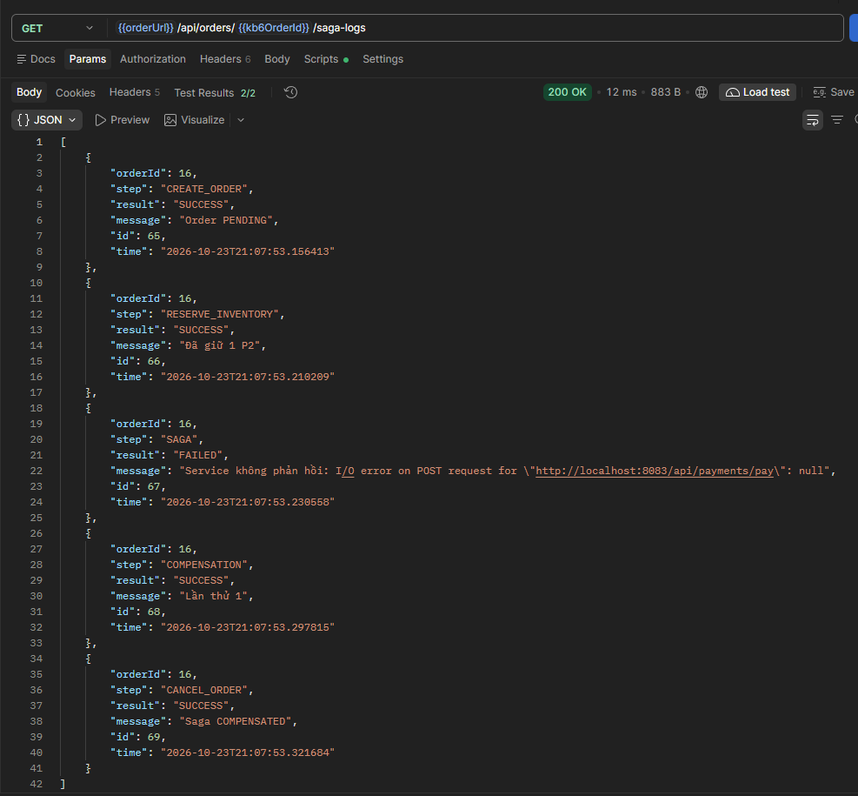

8.2.7. Bat lai payment-service:
# Docker:
docker compose start payment-service

# Hoac chay lai JAR payment-service

8.2.8. Chup GET /products SAU -> P2 tro ve so cu (release thanh cong)
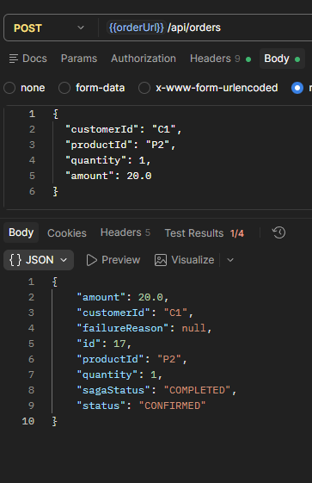
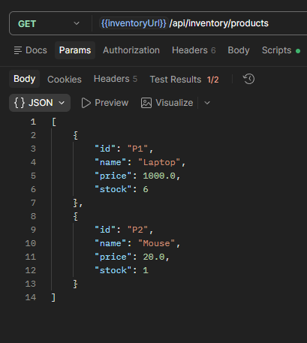

8.3. Ket qua mong doi
Diem kiem tra | Gia tri mong doi
response.status | "CANCELLED"
response.sagaStatus | "COMPENSATED"
response.failureReason | "Service khong phan hoi: I/O error on POST request for .../payments/pay..."
Kho P2 sau test | Giu nguyen so voi truoc (release da chay thanh cong)
Saga Logs: thu tu step | CREATE_ORDER -> RESERVE_INVENTORY -> SAGA(FAILED) -> COMPENSATION(SUCCESS) -> CANCEL_ORDER

9. KIEM THU KB7 - Tinh Idempotent (Goi lap lai nhieu lan)

9.1. Muc tieu
Chung minh cac API compensation (release, refund) va cac API giao dich (reserve, pay) deu co tinh IDEMPOTENT: goi nhieu lan voi cung tham so khong gay ra sai lech du lieu (khong tru kho lan 2, khong cong tien thua, khong bao loi).
LUU Y: KB7 dung orderId tu KB1 (orderId=1) va KB2 (orderId=2) da tao truoc do. Chay KB7 SAU KB1 va KB2.

9.2. Cac test case trong KB7
Test | Request | Ket qua mong doi | Y nghia
7a | POST /api/inventory/release/2 (lan 1) | status = "RELEASED" | Lan dau goi release -> thuc hien binh thuong
7b | POST /api/inventory/release/2 (lan 2) | status = "RELEASED", khong thay doi kho | Goi lai -> bo qua, kho khong cong them
7c | POST /api/inventory/reserve body {orderId:1,productId:P1,qty:2} | Reservation cu duoc tra ve, kho KHONG tru lan 2 | Reserve trung orderId -> idempotent
7d | POST /api/payments/pay body {orderId:1,customerId:C1,amount:2000} | Payment cu duoc tra ve, vi KHONG tru lan 2 | Pay trung orderId -> idempotent
7e | POST /api/payments/refund/2 (order 2 chua tung thanh toan) | OK, khong loi, so du vi khong thay doi | Refund an toan cho don chua tra

9.3. Huong dan chup hinh

9.3.1. Snapshot GET /products va GET /wallets truoc KB7
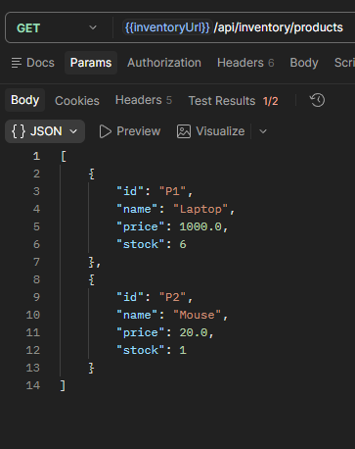

9.3.2. Gui test 7a -> Chup Response (RELEASED)
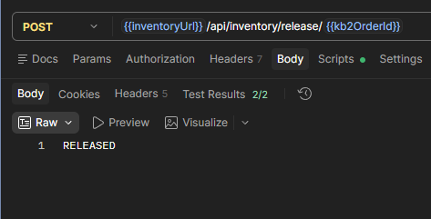

9.3.3. Gui test 7b -> Chup Response (van RELEASED) + Chup GET /products (stock khong tang)
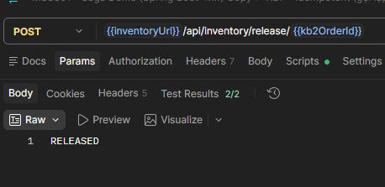

9.3.4. test 7c -> Response (reservation cu) + GET /products (stock khong thay doi)
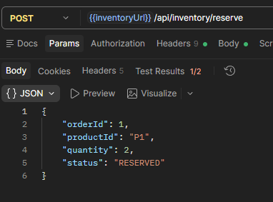

9.3.5. test 7d -> Response (payment cu) + GET /wallets (balance khong thay doi)
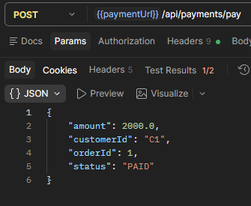

9.3.6. test 7e -> Response (OK khong loi) + GET /wallets (C2 van 100)
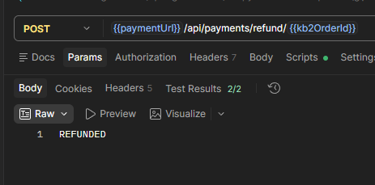

10. KIEM THU KB8 - Compensation cung loi (He thong treo o COMPENSATING)

10.1. Muc tieu
Mo phong truong hop toi te nhat: ca payment-service VA inventory-service deu khong kha dung trong luc Orchestrator dang chay compensation. Sau 3 lan thu (RetryTemplate), Orchestrator KHONG bao COMPENSATED gia ma giu nguyen COMPENSATING de canh bao admin.
LUU Y: KB8 la kich ban thu cong PHUC TAP NHAT, doi hoi thao tac nhanh trong cua so 15 giay. Doc ky toan bo huong dan TRUOC khi thuc hien.

10.2. Buoc 1: Cau hinh order-service voi do tre 15 giay
# Neu dung Docker:
$env:PAYMENT_DELAY_MS=15000
docker compose up -d order-service

# Neu dung JAR:
java "-Dsaga.demo.payment-delay-ms=15000" -jar order-service\target\order-service-0.0.1-SNAPSHOT.jar

# Neu dung IntelliJ:
# Run/Edit Configuration -> Environment Variables -> PAYMENT_DELAY_MS=15000
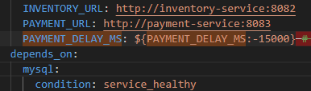

10.3. Buoc 2: Chup Snapshot truoc khi test
GET /products (P2 stock hien tai) va GET /wallets. 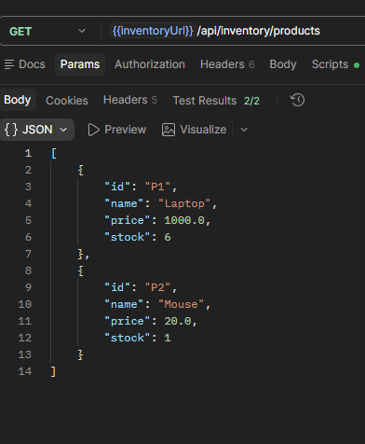

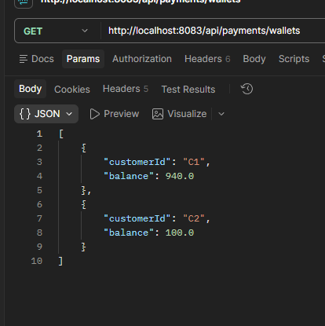

10.4. Buoc 3: Gui Request KB8 tu Postman
POST http://localhost:8081/api/orders

{"customerId": "C1", "productId": "P2", "quantity": 1, "amount": 20.0}

// Request se TREO khoang 15 giay truoc khi co response
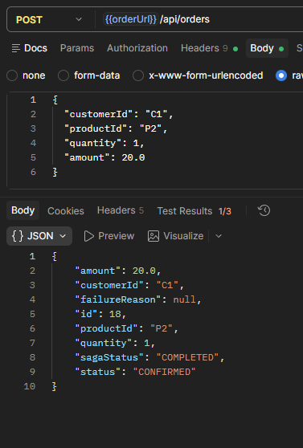

10.5. Buoc 4: TRONG 15 GIAY khi request dang cho - Tat inventory-service VA payment-service
LUU Y: Thao tac nhanh! Sau khi click Send trong Postman, lap tuc chay lenh tat service trong terminal khac.

# Docker (chay trong terminal khac ngay sau khi gui request):
docker compose stop payment-service inventory-service

# Hoac IntelliJ: Stop ca 2 process inventory-service va payment-service
# Hoac Task Manager: kill 2 process java tuong ung
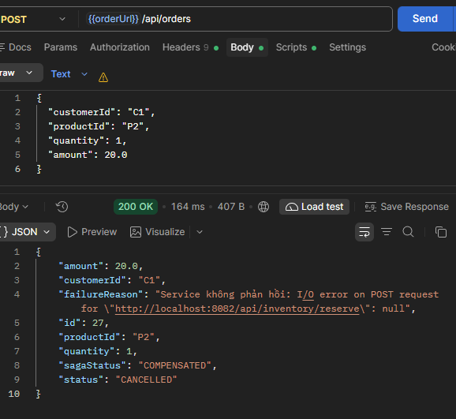

10.6. Buoc 5: Cho response va chup ket qua
Sau ~20-25 giay (15s delay + 3 lan retry), Postman se nhan duoc response:
{
"id": ...,
"status": "PENDING",
"sagaStatus": "COMPENSATING",
"failureReason": "Service khong phan hoi: I/O error on POST request..."
}

10.7. Buoc 6: Chup Saga Logs
GET /api/orders/{orderId}/saga-logs -> Chup ket qua. Can thay DAC BIET: 3 dong COMPENSATION voi result = FAILED:
Step | Result | Message mong doi
CREATE_ORDER | SUCCESS | Order PENDING
RESERVE_INVENTORY | SUCCESS | Da giu 1 P2
SAGA | FAILED | Service khong phan hoi: I/O error on POST request for .../payments/pay...
COMPENSATION | FAILED | Lan thu 1: I/O error on POST request for .../inventory/release/...
COMPENSATION | FAILED | Lan thu 2: I/O error on POST request for .../inventory/release/...
COMPENSATION | FAILED | Lan thu 3: I/O error on POST request for .../inventory/release/...
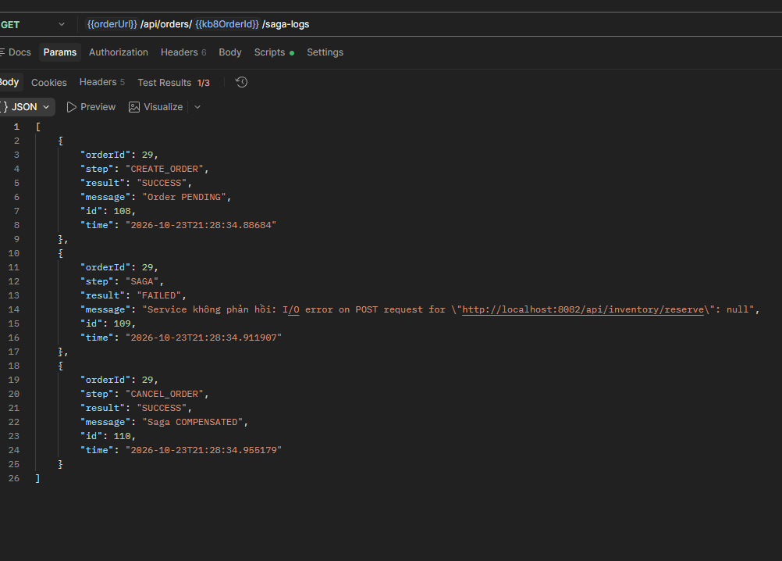

10.8. Buoc 7: Chup trang thai ton kho bi treo
Bat lai inventory-service -> Goi GET /products -> Chup P2 stock bi giu (giam 1 so voi truoc test). Chung minh can khoi phuc thu cong.
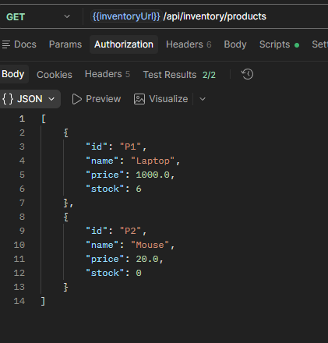

10.9. Buoc 8: Phuc hoi thu cong (Minh chung Idempotent + Recovery)
# Goi tay de giai phong kho (idempotent - an toan khi goi nhieu lan):
POST http://localhost:8082/api/inventory/release/{orderId}

# Kiem tra kho sau khi release
GET http://localhost:8082/api/inventory/products

10.9.1. Chup lenh release thu cong + Response
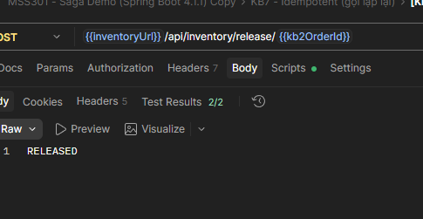

10.9.2. Chup GET /products sau khi release - P2 da ve so cu

10.10. Buoc 9: Don dep moi truong sau KB8
# Khoi dong lai order-service KHONG co delay:
# Docker: $env:PAYMENT_DELAY_MS=0; docker compose up -d order-service
# JAR: java -jar order-service-0.0.1-SNAPSHOT.jar (khong co -D)
# IntelliJ: Xoa bien PAYMENT_DELAY_MS khoi Run Config

11. DANH GIA KY THUAT VA KET LUAN

11.1. Tong ket 3 tinh chat cot loi da kiem chung
Tinh chat | Mo ta | Kich ban kiem chung | Bang chung
Reversible (Dao nguoc) | Moi Local Transaction deu co Compensating TX hoan tac | KB2, KB5, KB6 | P1/P2 stock va vi tro ve dung trang thai ban dau sau compensation
Idempotent (Bat bien) | Goi nhieu lan cung TX khong gay sai lech du lieu | KB7 | release x2, reserve lai, pay lai -> kho va vi khong thay doi them
Reliable (Tin cay) | RetryTemplate thu lai 3 lan; treo COMPENSATING thay vi bao gia | KB8 | 3 dong COMPENSATION FAILED; he thong khong tu dong bao COMPENSATED

11.2. So sanh Saga vs @Transactional
Tieu chi | @Transactional (mot DB) | Saga Orchestration (multi-DB)
Rollback cross-service | Khong the (chi 1 DB) | Co -> Compensating Transaction
Ho tro multi-DB khac loai | Khong (MySQL + MongoDB + SQL Server) | Co (database per service)
Eventual Consistency | ACID ngay tuc thi | Dam bao cuoi cung (eventual)
Xu ly partial failure | Khong tu dong | Co: COMPENSATING -> COMPENSATED
Visibility | An ben trong DB transaction | Co SagaLog theo doi tung buoc

12. PHU LUC: Lenh truy van Database truc tiep de doi chieu

12.1. MySQL - orderdb (Kiem tra trang thai Order va SagaLog)
# Ket noi vao container MySQL:
docker exec -it saga-mysql mysql -uroot -proot orderdb

# Xem tat ca orders:
SELECT id, customer_id, product_id, quantity, amount, status, saga_status, failure_reason FROM orders;

# Xem Saga Logs cua mot order cu the:
SELECT id, order_id, step, result, message, time FROM saga_log WHERE order_id = 2 ORDER BY id;

# Lenh nhanh tu terminal Windows:
docker exec -it saga-mysql mysql -uroot -proot orderdb -e "SELECT * FROM orders;"

12.2. MongoDB - inventorydb (Kiem tra kho va Reservation)
# Ket noi vao container MongoDB:
docker exec -it saga-mongodb mongosh inventorydb --quiet

# Xem tat ca san pham va ton kho:
db.product.find().pretty()

# Xem Reservation cua mot order cu the:
db.reservation.find({orderId: 2}).pretty()

# Lenh nhanh tu terminal:
docker exec -it saga-mongodb mongosh inventorydb --quiet --eval "db.product.find(); db.reservation.find()"

12.3. SQL Server - paymentdb (Kiem tra Wallet va Payment)
# Ket noi vao container SQL Server:
docker exec -it saga-sqlserver /opt/mssql-tools18/bin/sqlcmd -S localhost -U sa -P "Saga@12345" -C -d paymentdb

# Xem tat ca Wallet (so du vi):
1> SELECT customer_id, balance FROM wallet;
2> GO

# Xem Payment (lich su thanh toan):
1> SELECT id, order_id, amount, status FROM payment;
2> GO

# Lenh nhanh tu terminal:
docker exec -it saga-sqlserver /opt/mssql-tools18/bin/sqlcmd -S localhost -U sa -P "Saga@12345" -C -d paymentdb -Q "SELECT * FROM wallet; SELECT * FROM payment;"

12.4. Kiem tra qua REST API (Postman hoac cURL)
Muc dich | HTTP Method + URL
Xem tat ca san pham + ton kho | GET http://localhost:8082/api/inventory/products
Xem tat ca vi + so du | GET http://localhost:8083/api/payments/wallets
Xem tat ca don hang | GET http://localhost:8081/api/orders
Xem chi tiet mot don hang | GET http://localhost:8081/api/orders/{id}
Xem Saga Logs cua don hang | GET http://localhost:8081/api/orders/{id}/saga-logs
Release kho thu cong (KB8 recovery) | POST http://localhost:8082/api/inventory/release/{orderId}

