B1 tìm kiếm chọn nguồn uy tín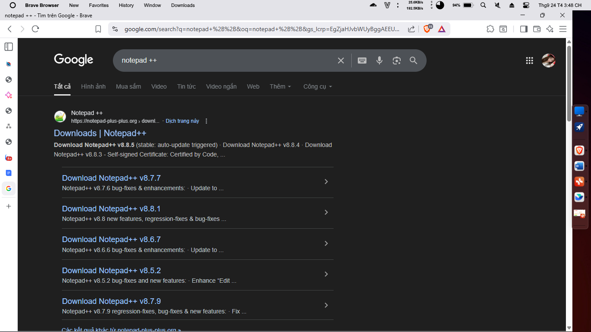

B2 tải

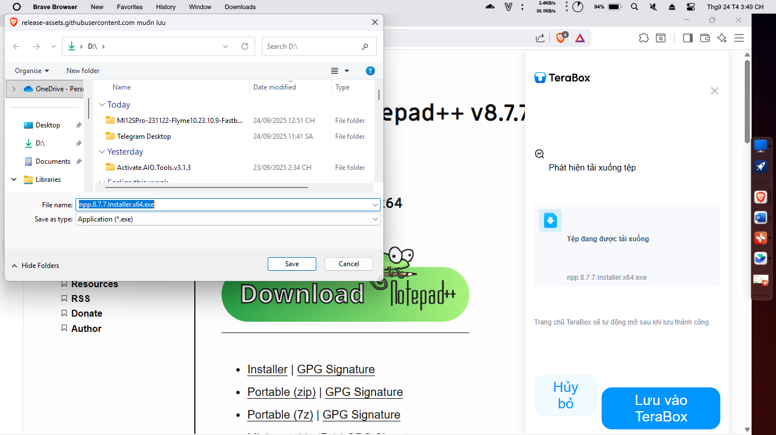

B3 chạy file exe

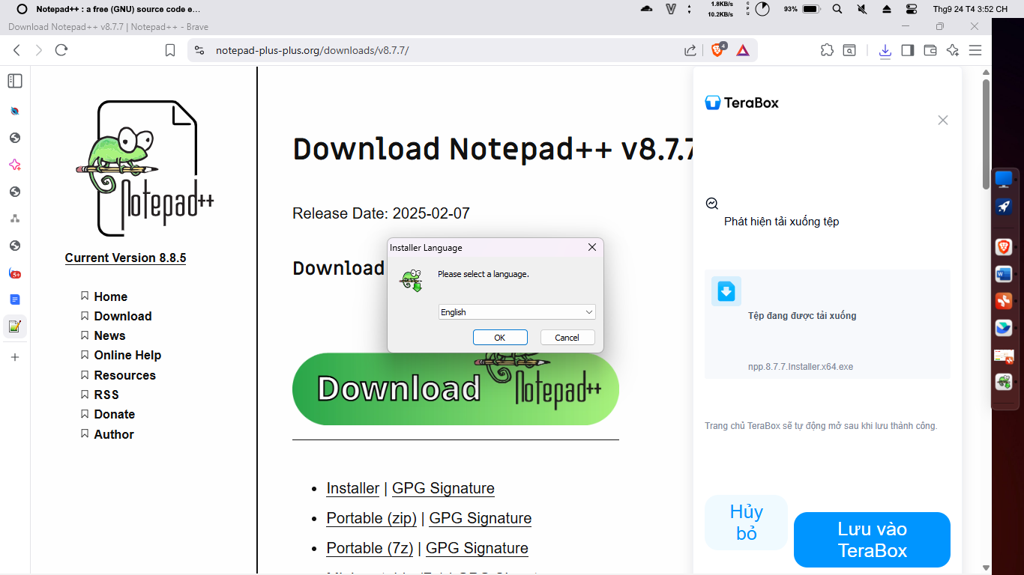

B4 next liên tục

B5 finish

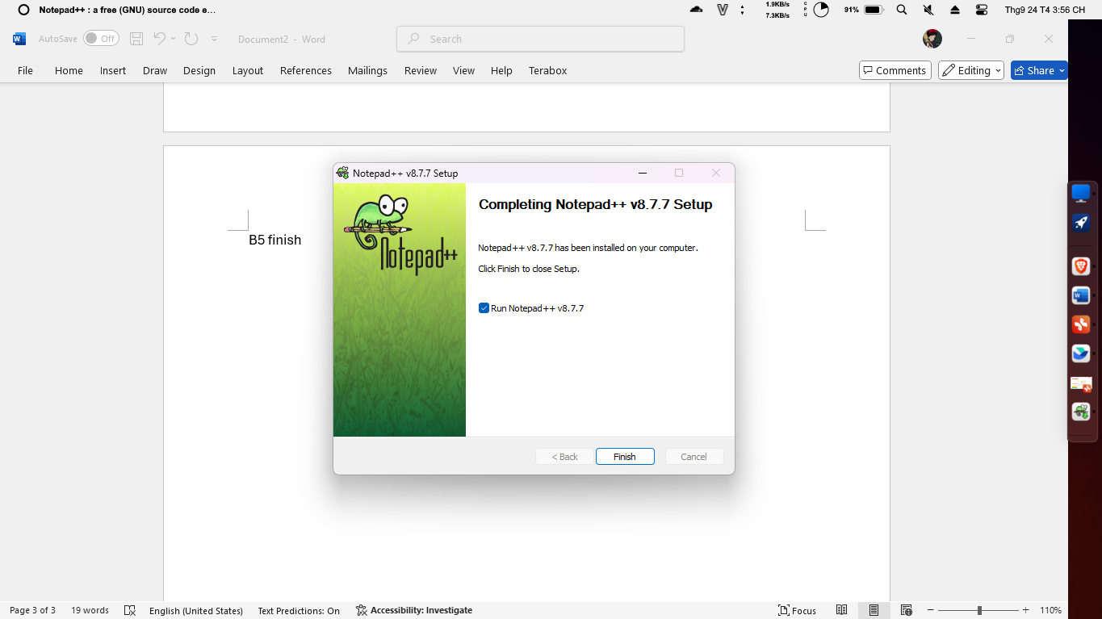

Để gỡ app b1 win + s tìm controlpanel

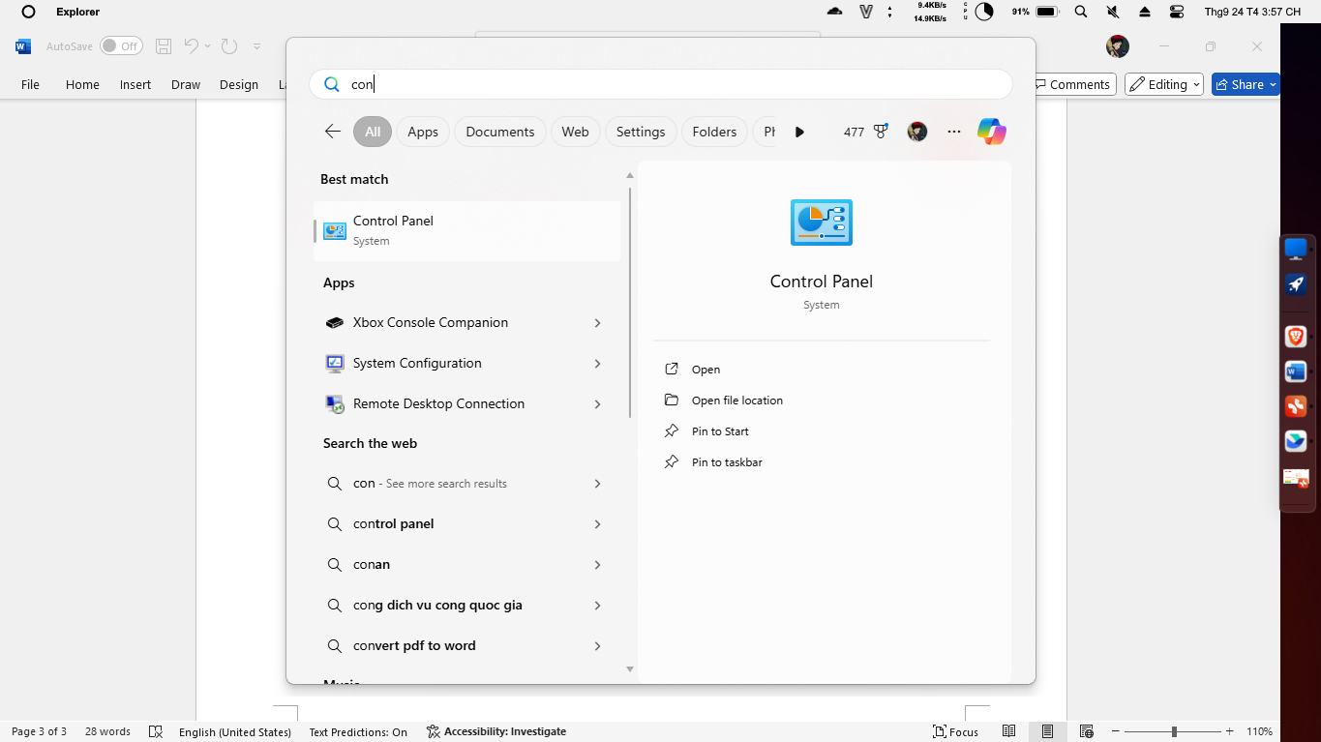

B2 mở app

Chọn uninstall

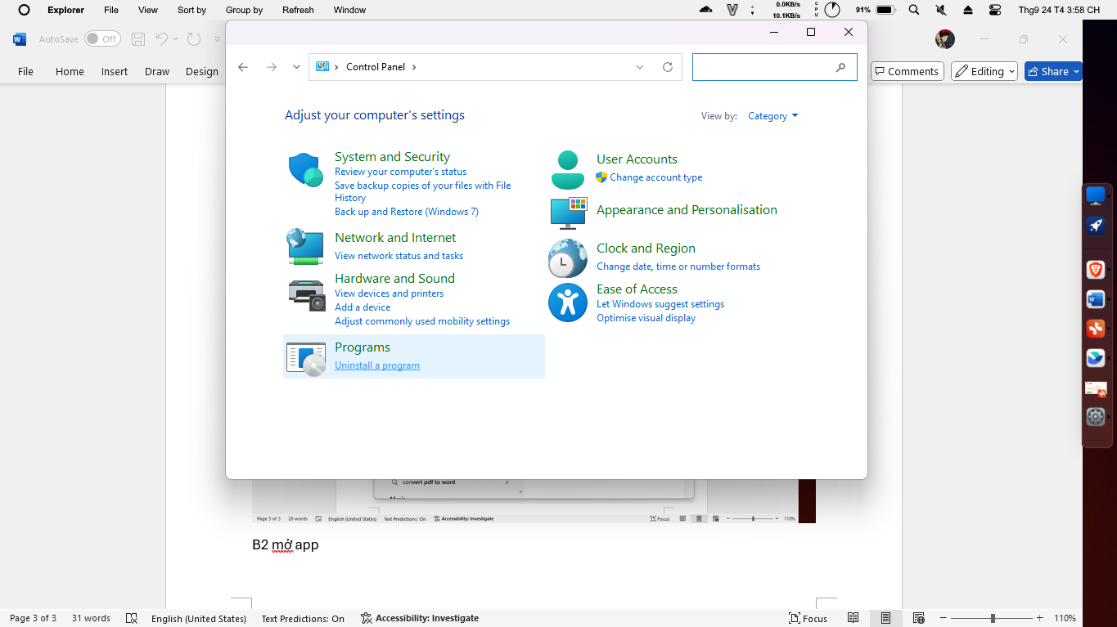

B4 tìm app cần gỡ

Chuột phải uninstall

B5 uninstall

B8 hết