Steps

Next

**Step 1: (‎24/‎09/‎2025 6:51:51 CH)** User right click on "Name (edit)" in "New folder - File Explorer"

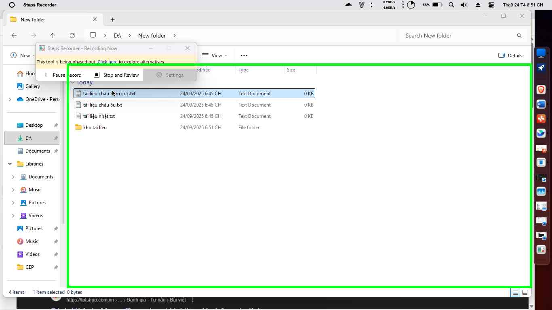Step 1 screenshot.

Previous Next

**Step 2: (‎24/‎09/‎2025 6:51:54 CH)** User left click on "Copy (menu item)"

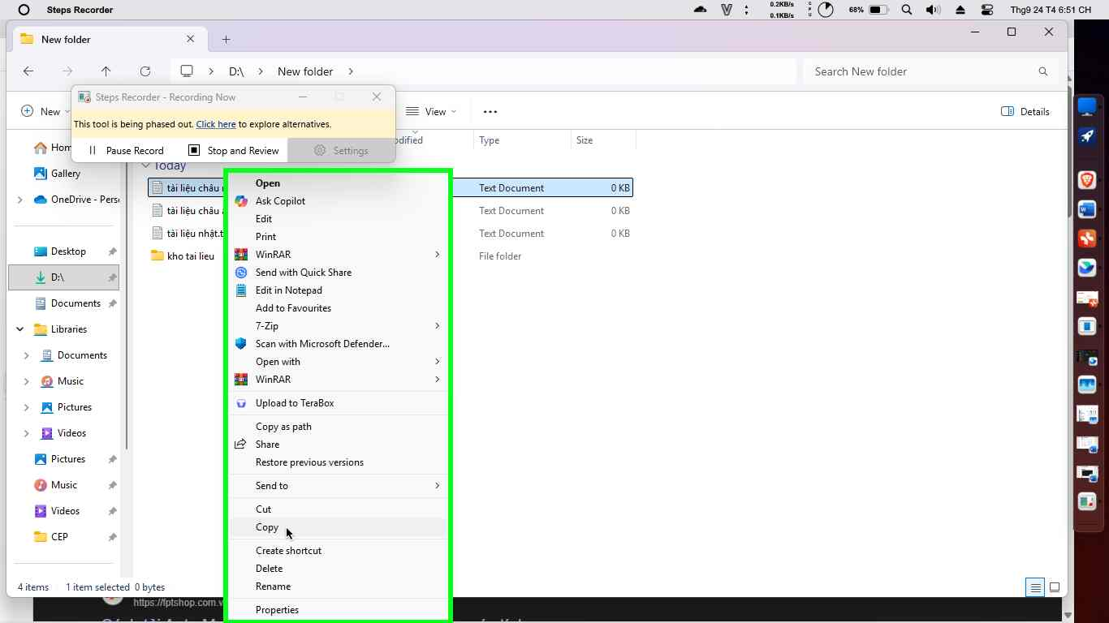Step 2 screenshot.

Previous Next

**Step 3: (‎24/‎09/‎2025 6:51:57 CH)** User left double click on "Name (edit)" in "New folder - File Explorer"

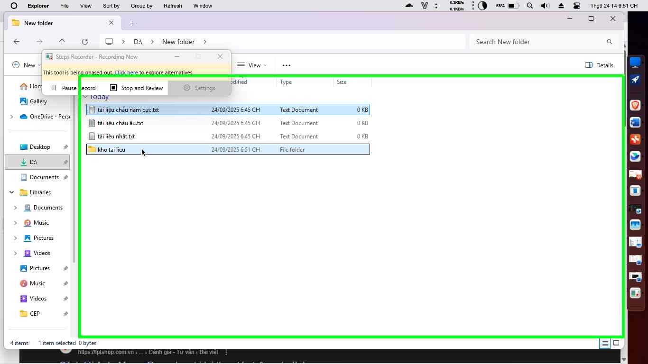Step 3 screenshot.

Previous Next

**Step 4: (‎24/‎09/‎2025 6:51:59 CH)** User right click on "Items View (list)" in "kho tai lieu - File Explorer"

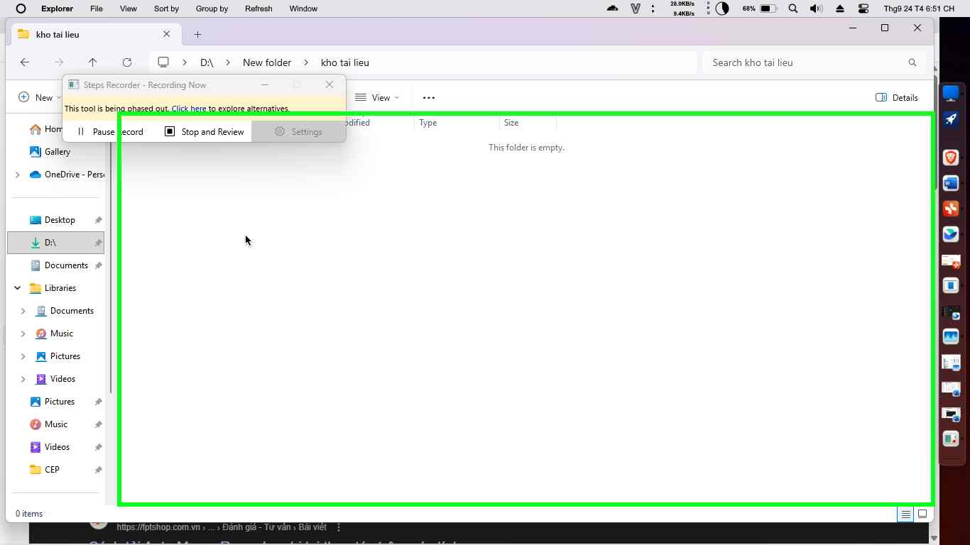Step 4 screenshot.

Previous Next

**Step 5: (‎24/‎09/‎2025 6:52:03 CH)** User left click on "Paste (menu item)"

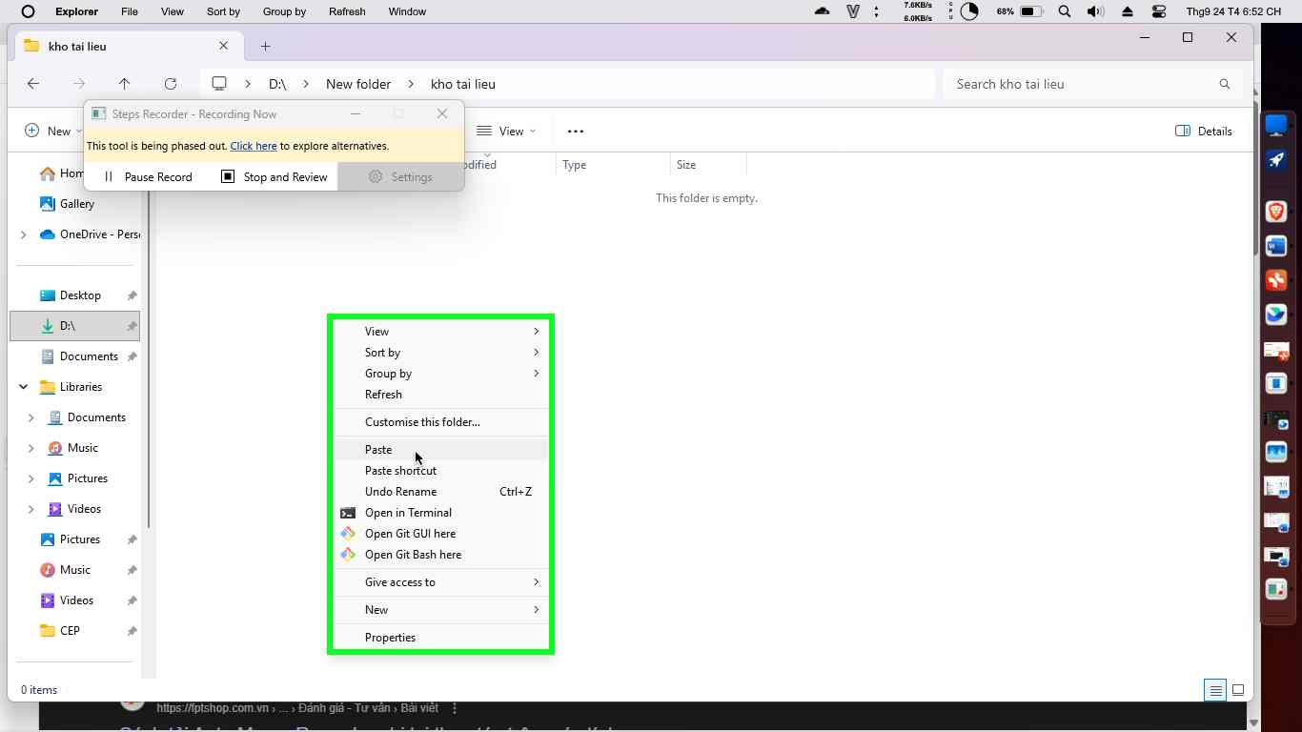Step 5 screenshot.

Previous Next

**Step 6: (‎24/‎09/‎2025 6:52:08 CH)** User left click on "Back (app bar button)" in "kho tai lieu - File Explorer"

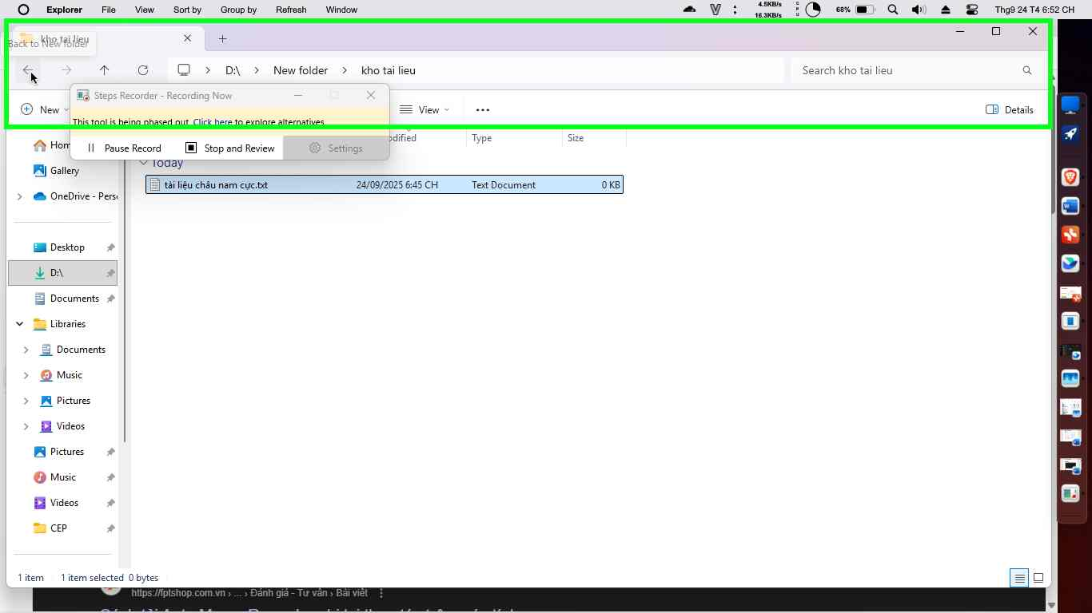Step 6 screenshot.

Previous Next

**Step 7: (‎24/‎09/‎2025 6:52:11 CH)** User right click on "Name (edit)" in "New folder - File Explorer"

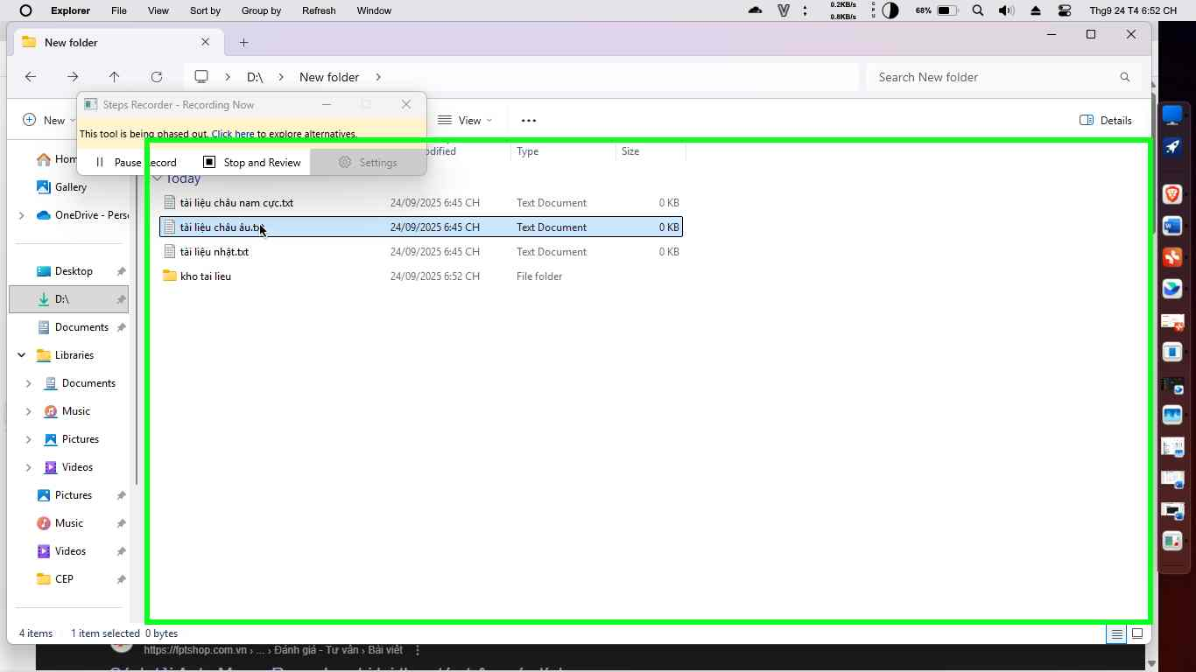Step 7 screenshot.

Previous Next

**Step 8: (‎24/‎09/‎2025 6:52:15 CH)** User left click on "Cut (menu item)"

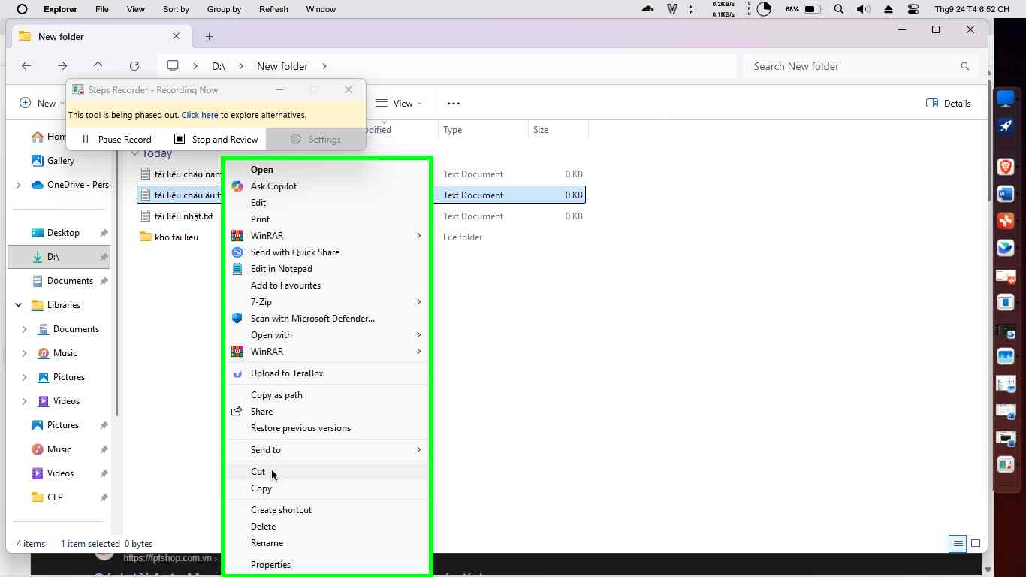Step 8 screenshot.

Previous Next

**Step 9: (‎24/‎09/‎2025 6:52:19 CH)** User left double click on "Name (edit)" in "New folder - File Explorer"

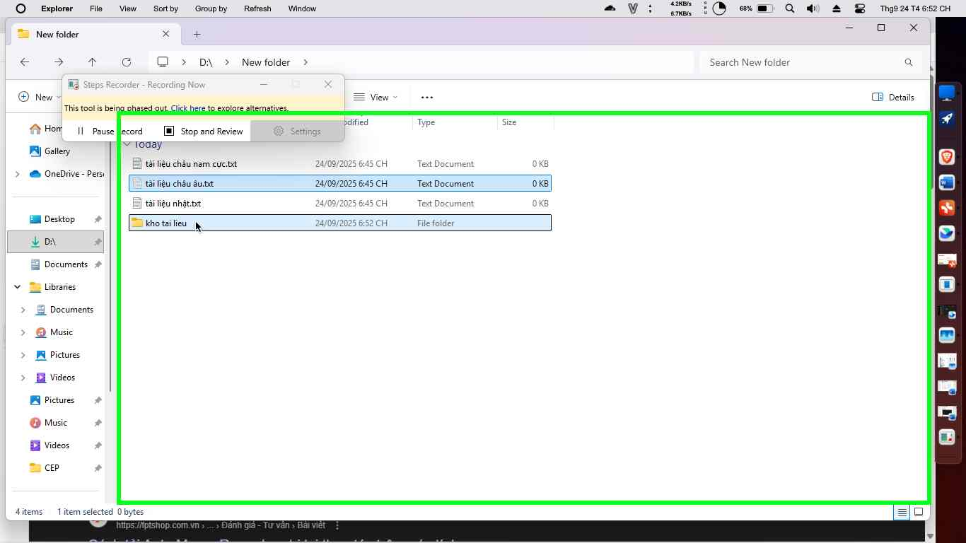Step 9 screenshot.

Previous Next

**Step 10: (‎24/‎09/‎2025 6:52:21 CH)** User right click on "Items View (list)" in "kho tai lieu - File Explorer"

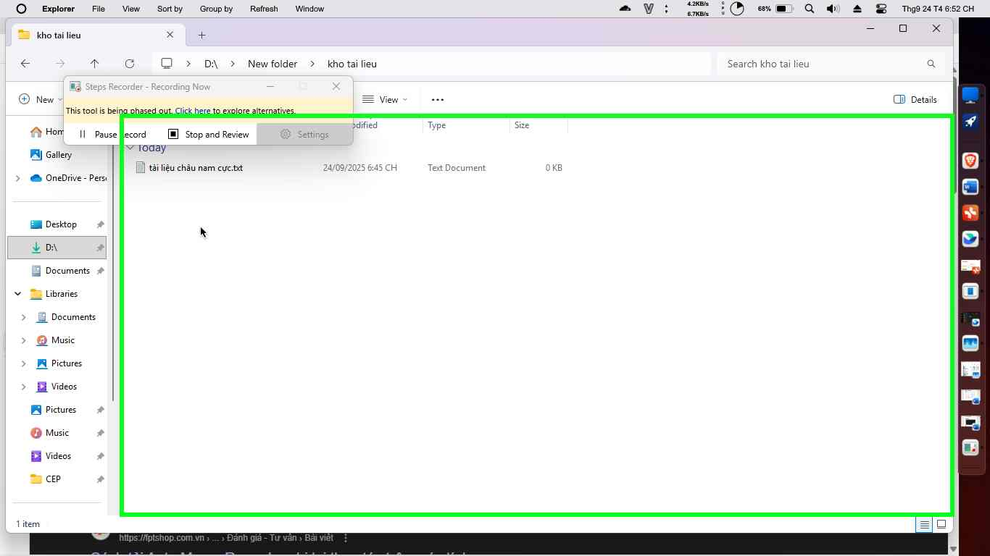Step 10 screenshot.

Previous Next

**Step 11: (‎24/‎09/‎2025 6:52:23 CH)** User left click on "Paste (menu item)"

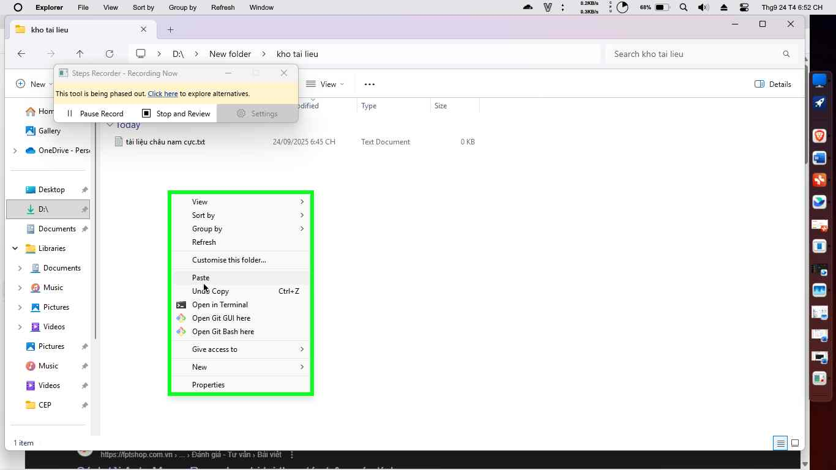Step 11 screenshot.

Previous Next

**Step 12: (‎24/‎09/‎2025 6:52:27 CH)** User left click on "Back (app bar button)" in "kho tai lieu - File Explorer"

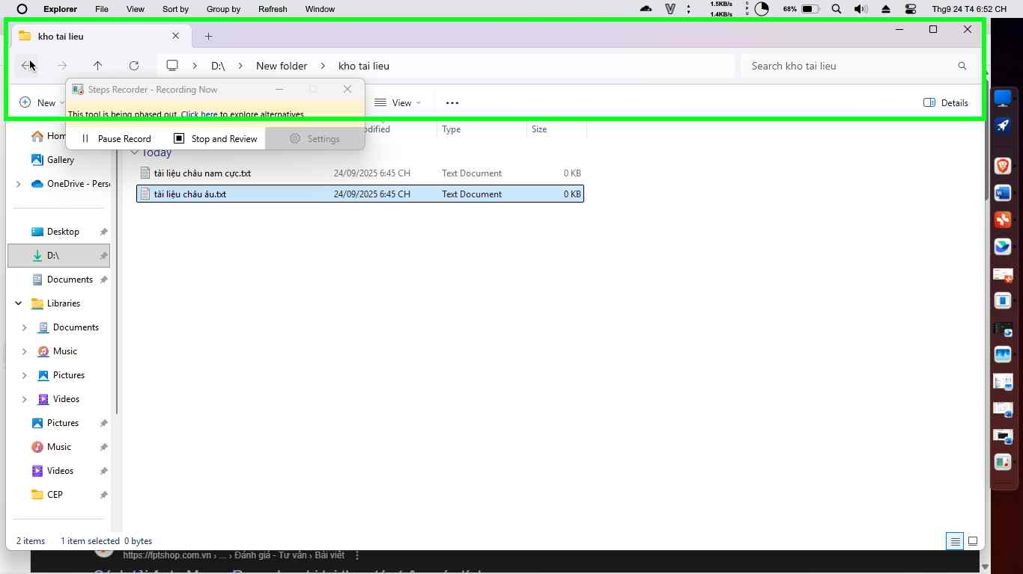Step 12 screenshot.

Previous Next

**Step 13: (‎24/‎09/‎2025 6:52:30 CH)** User right click on "Name (edit)" in "New folder - File Explorer"

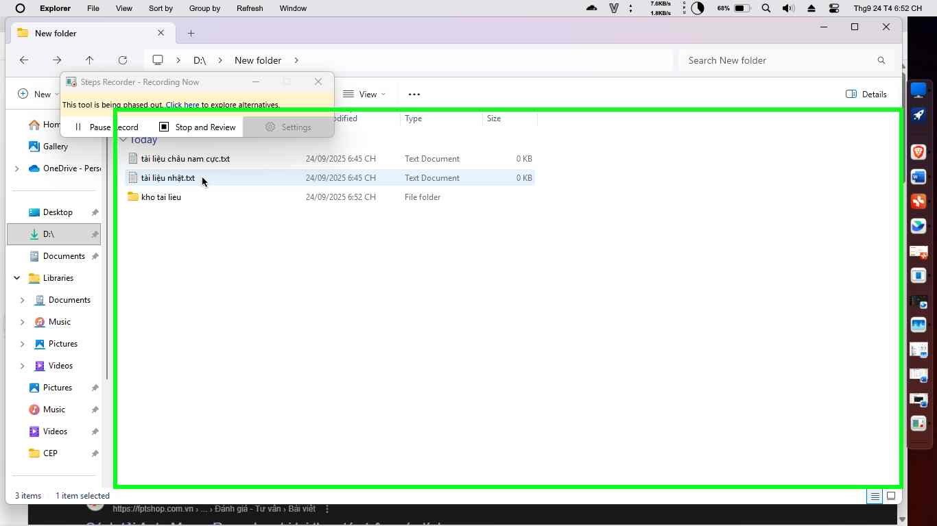Step 13 screenshot.

Previous Next

**Step 14: (‎24/‎09/‎2025 6:52:33 CH)** User left click on "Name (edit)" in "New folder - File Explorer"

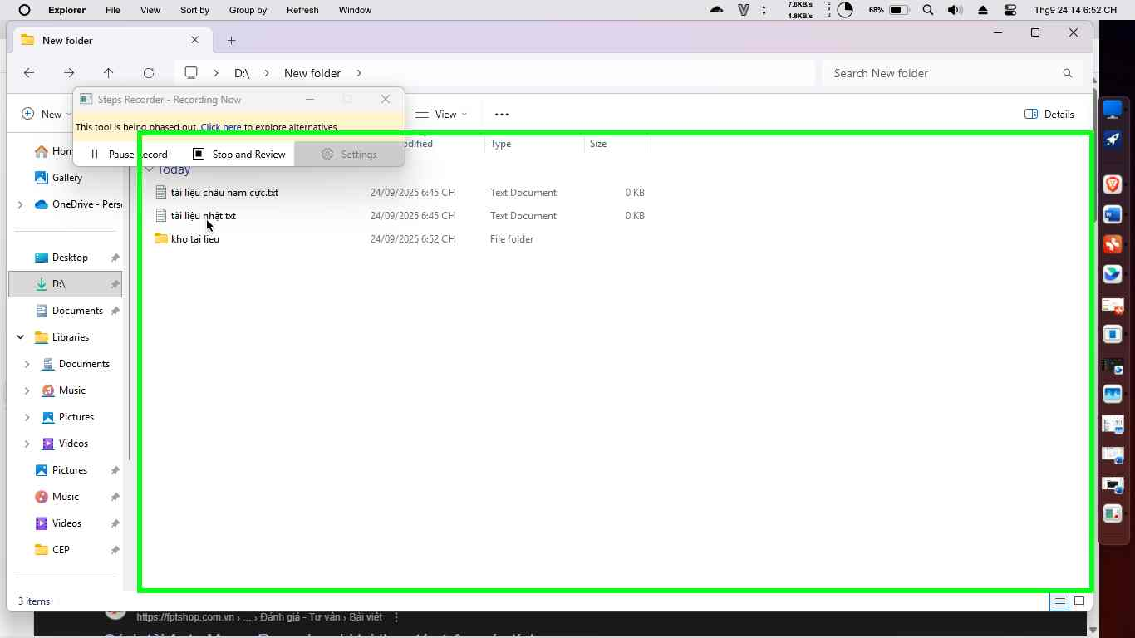Step 14 screenshot.

Previous Next

**Step 15: (‎24/‎09/‎2025 6:52:34 CH)** User right click on "Name (edit)" in "New folder - File Explorer"

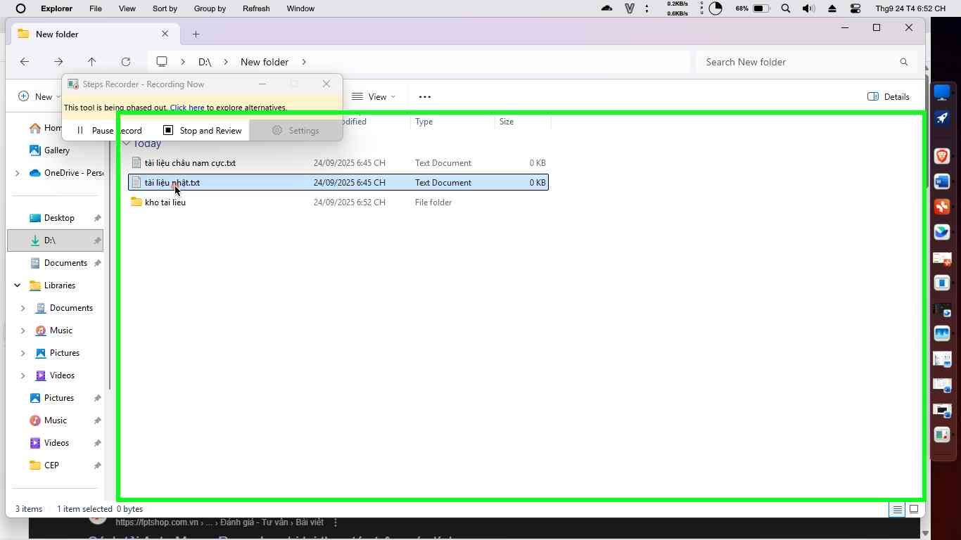Step 15 screenshot.

Previous Next

**Step 16: (‎24/‎09/‎2025 6:52:38 CH)** User left click on "Delete (menu item)"

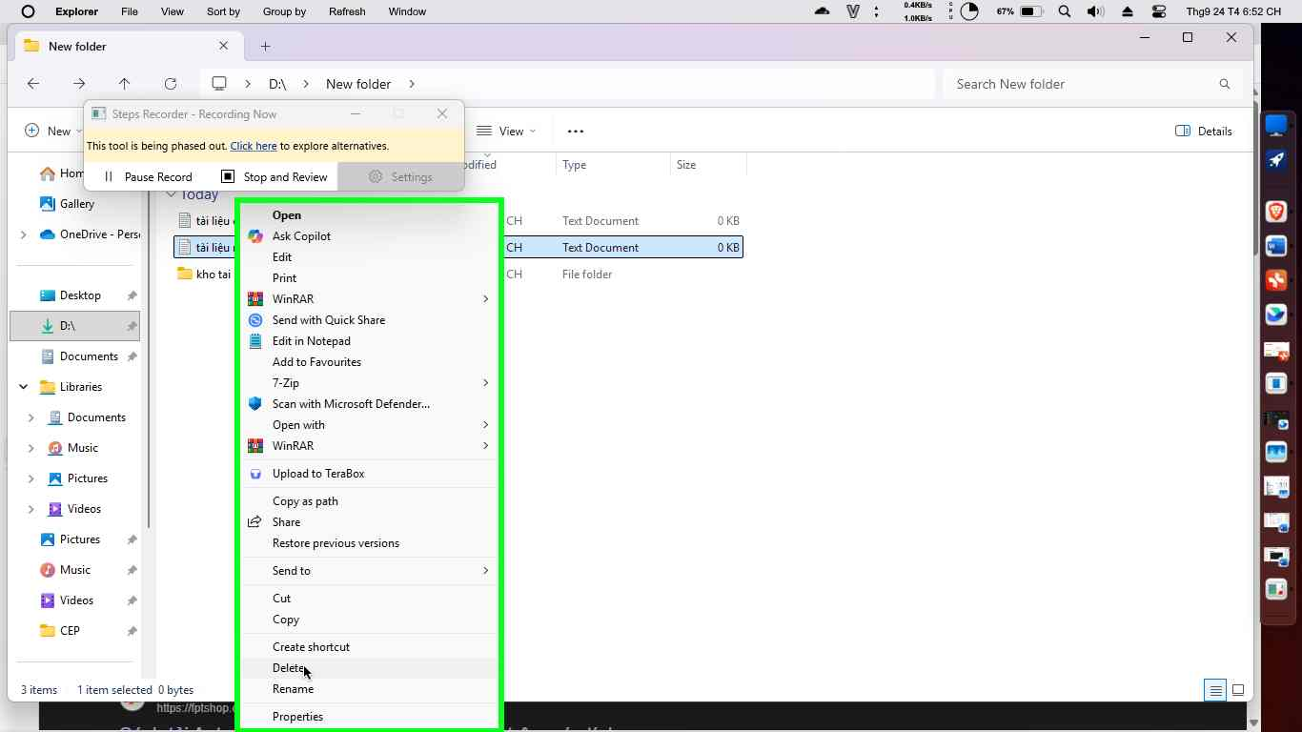Step 16 screenshot.

Previous Next

**Step 17: (‎24/‎09/‎2025 6:52:42 CH)** User keyboard input on "Items View (list)" in "New folder - File Explorer" [... Win-D]

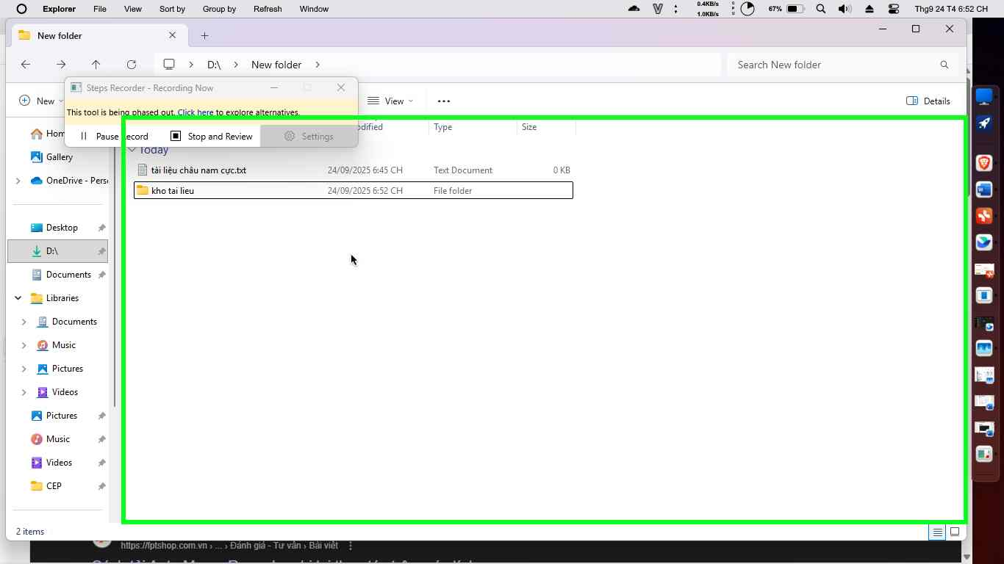Step 17 screenshot.

Previous Next

**Step 18: (‎24/‎09/‎2025 6:52:46 CH)** User left double click on "Recycle Bin (list item)" in "Program Manager"

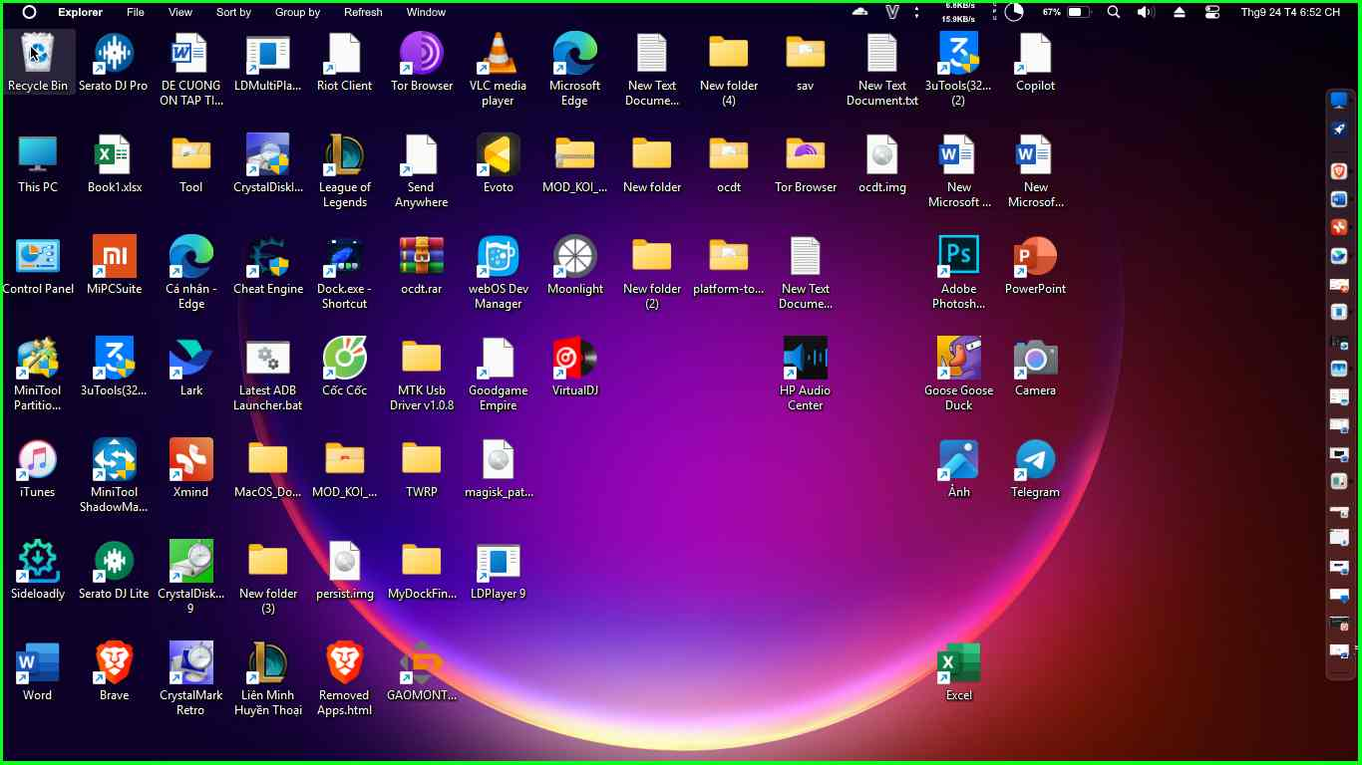Step 18 screenshot.

Previous Next

**Step 19: (‎24/‎09/‎2025 6:52:51 CH)** User right click on "Name (edit)" in "Recycle Bin - File Explorer"

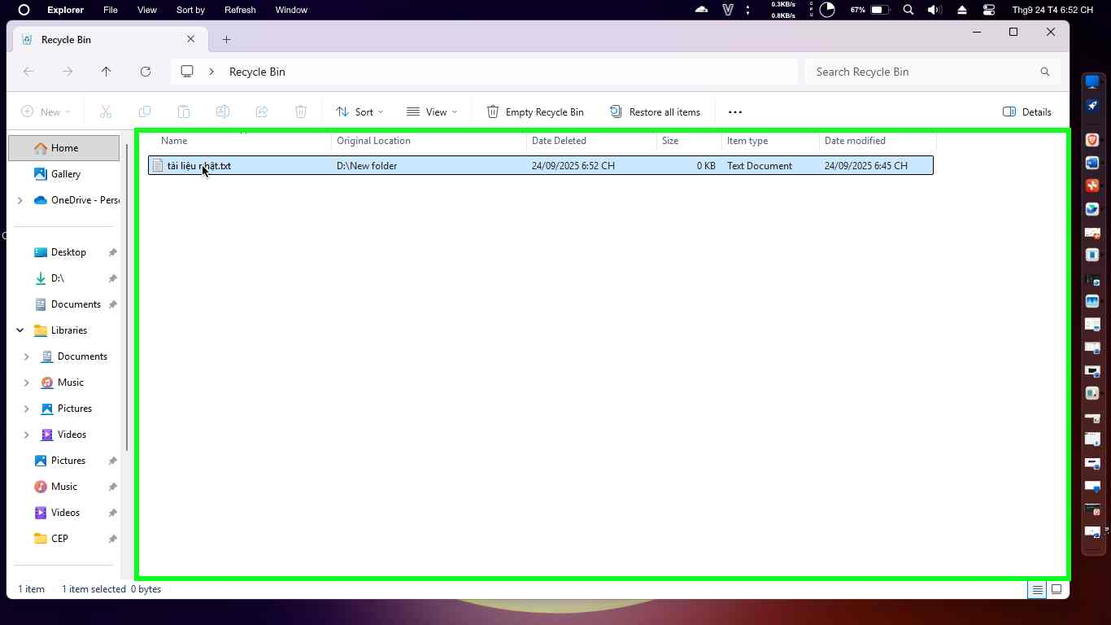Step 19 screenshot.

Previous Next

**Step 20: (‎24/‎09/‎2025 6:52:53 CH)** User left click on "Restore (menu item)"

