**Pseudo code:**

Begin

Input USD

VND = USD x 23000

Display VND

End

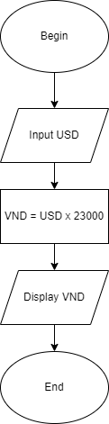**Flowchart:**