**Pseudo Code: Flowchart:**

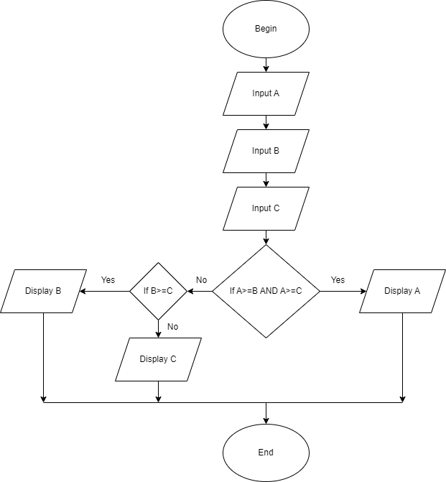Begin

Input A

Input B

Input C

If A>=B and A>=C

Display A

Else

If B>=C

Display B

Else

Display C

End If

End If

End