**Pseudo Code: Flowchart:**

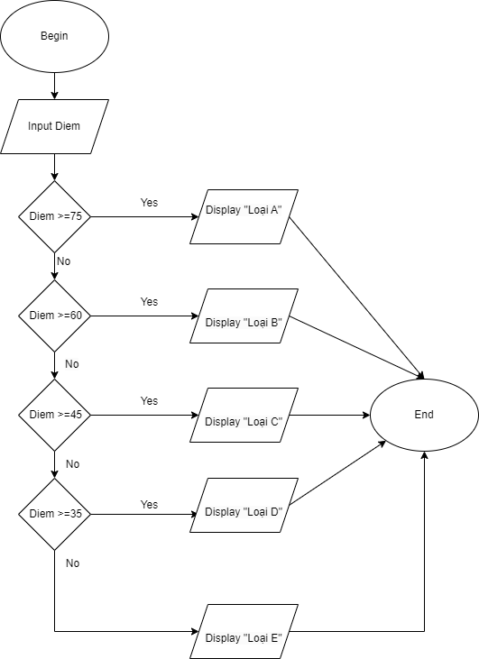Begin

Input Diem

If Diem >= 75

Display “Loai A”

Else

If Diem >=60

Display “Loai B”

Else

If Diem >= 45

Display “Loai C”

Else

If Diem >= 35

Dislay “Loai D”

Else Display “Loai E”

End If

End If

End if

End if

End