Technical Analysis of Stocks Using Charts

Hung P. Nguyen

University of Illinois - Urbana Champaign

Abstract

Stock traders can strike it big by making the right decisions at the right time. Fortunately, finance experts have come up with many different technical analysis to help traders in their stock trading decisions. Technical analysis can be visualized via line charts. This paper goes over a project that visualizes stocks and several technical analysis indicators on a WebApp [1][2] .

**Keywords**: Stocks, technical analysis, simple moving average, moving average convergence divergence, relative strength index.

# Introduction

Technical analysis indicators are used on the history of stock prices to help traders decide when to buy and sell stock. This paper goes over a project of an app that visualizes the history of stock prices and several indicators as charts. Specifically, the following three indicators are covered: simple moving average (SMA), moving average convergence divergence (MACD), and relative strength index (RSI).  
  
This paper is organized into two main sections. The first section will go over the general design and layout of the app. The second section will go over more details about the three indicators and how they are incorporated into the app.

# General Design of the App

Figure 1 shows the layout of the app as seen by the user.

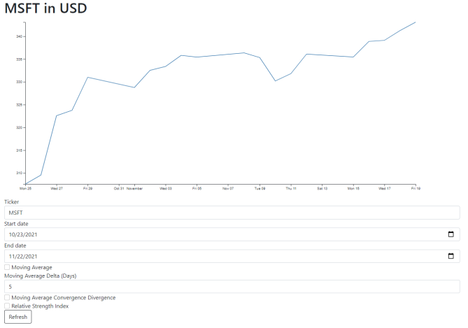

1. Layout of the app with default settings.

The app uses Flask, a micro web framework in Python, to generate the frontend (HTML webpage) of the app. Flask acts as the backend server, collecting stock data and user input to send over to the frontend visualizing the charts of stock prices and indicators. The *yfinance* Python package is used to download stock data from Yahoo! Finance's API. User input is sent by the POST method from the frontend's user form.

Given data from *yfinance*, the D3.js JavaScript library is used to create a line chart of the closing prices of the specified stock during the specified times.

As seen in Figure 1, the user is able to specify the stock ticker and date ranges. The user is also able to specify whether to display the SMA, MACD, and/or RSI indicators (see Section 3 for more details). After the user presses the "Refresh" button, a POST method is sent to the server which triggers Flask to send updated stock data specified by the user to the frontend. The frontend then automatically updates the visualization of the charts using the D3.js.

# Technical Analysis Indicators

SMA, MACD, and RSI are technical analysis indicators that are highly effective at communicating the trend of stock prices to aide traders in making buy and sell decisions. Figure 2 shows all three indicators on the app.

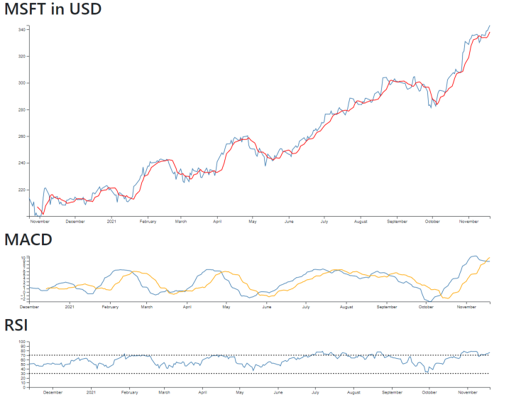

1. App with SMA, MACD, and RSI indicators

## Simple Moving Average [3]

SMA calculates the average closing prices of the stock over a given time (e.g. 5 trading days). It is visualized as the redline in Figure 2. The formula for SMA is:

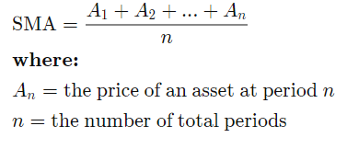

The app allows the user to specify the delta days, but by default it is 5 days.

SMA is very useful in aiding to determine if an asset price of the stock will continue or if it will reverse a bull or bear trend. The calculation for SMA was easily done in JavaScript on the frontend.

## Moving Average Convergence Divergence [4]

MACD calculates the difference the 26-day EMA from the 12-day EMA. EMAs are very similar to SMA, except they place heavier weights on more recent dates. The formula for an EMAs is:

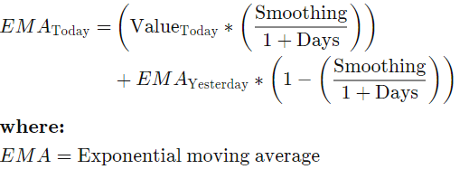

A signal line accompanies the MACD, which is a 9-day EMA of the MACD. When the MACD line crosses below the signal line, it's a trigger to sell the stock. When the MACD line crosses above the signal line, it's a trigger to buy the stock. In Figure 2, the MACD line is visualized as the blue line and the signal line is visualized as the orange line.

Like SMA, the MACD was also very easily calculated in JavaScript on the frontend.

## Relative Strength Index [5]

RSI is a momentum indicator to evaluate how heavily stocks are overly bought (or sold) over the last 14 trading days. The first RSI from the first 14 days is calculated by the following formula:

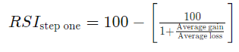

The days after that can be calculated by the following formula:

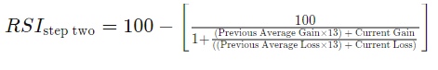

RSI values above 70 indicate the stock is overbought or overvalued a corrective reversal could happen soon. RSI values below 30 is the opposite; it indicates oversold or undervalued stocks.

RSI was also easily calculated in JavaScript on the frontend.

# Conclusion

Stock trading is a highly complex field, and there are many technical analysis indicators to aide traders in making decisions. As shown by this paper, the SMA, MACD and RSI indicators were easily visualized in the app. With the powerful capabilities of modern visualization techniques via Flask and D3.js, many other technical analysis indicators can be shown to traders in a beautiful way to help them get a better understanding of the trends in the stock of interest.

References

1. H. Nguyen. Stock Charting App.  
   *<http://stock-charts-hpn.herokuapp.com/>*
2. H. Nguyen. Stock Charting App Source Code.  
   *<https://github.com/hungn2/stock_charts>*
3. Adam Hayes. "Simple Moving Average (SMA)". *Investopedia*. *<https://www.investopedia.com/terms/s/sma.asp>.* October 30, 2021.
4. Jason Fernando "Moving Average Convergence Divergence (MACD)". *Investopedia*. *<https://www.investopedia.com/terms/m/macd.asp>.* September 04, 2021.
5. Jason Fernando. "Relative Strength Index (RSI)". *Investopedia*. *<https://www.investopedia.com/terms/r/rsi.asp>.* October 30, 2021.