05 Weisstanner Replication

Cannot knit in current format because of the source() call, fix eventually.

pacman::p_load("tidyverse",   
 "countrycode",  
 "readstata13",  
 "lme4",  
 "sjPlot",  
 "ragg")  
  
options(scipen = 999, digits = 3)  
knitr::opts_chunk$set(message = F, warning = F)

## Data

df_macro <- readRDS(here::here("data", "df_macro.RDS"))  
df_na <- readRDS(here::here("data", "df_na.RDS"))  
df_rep <- readstata13::read.dta13(here::here("weisstanner_replication","REPLICATION DATA","AbsRel_FINAL_REP.dta"))  
  
# select out heuristic vars  
df_macro <- df_macro %>%  
 dplyr::select(iso3c, wave, libZ_i, lib_redistZ_i, noconf_govZ_i, cpiZ_i)  
#merge  
# NA and age selection  
  
df_rep <- df_rep %>%  
 subset(!is.na(redist3) & age > 17 & age < 66) %>%  
 mutate(iso3c = countrycode(country, "country.name", "iso3c"),  
 redist_ineq = ifelse(incdiff == "Strongly agree", 5, ifelse(incdiff == "Agree", 4, ifelse(incdiff == "Neither nor", 3, ifelse(incdiff == "Disagree", 2, ifelse(incdiff == "Strongly disagree", 1, NA)))))) %>%  
 left_join(df_macro, by = c("iso3c","wave"))

## Original Model

Results are identical as those when running the xtreg Stata command using the modified original code

m02 <- lmer(redist_dum ~ absgr5_wa*relgr5_wa + hinc_decile + factor(educ_tert) + female + age + factor(unemployed) + factor(wave) + unemp + socexp + gini_mkt + gdppc + (1 | cwave), data = subset(df_rep, !is.na(df_rep$libZ_i)))  
  
m03 <- lmer(redist_dum ~ relgr5_wa + absgr5_wa*hinc_decile + factor(educ_tert) + female + age + factor(unemployed) + factor(wave) + unemp + socexp + gini_mkt + gdppc + (1 | cwave), data = subset(df_rep, !is.na(df_rep$libZ_i)))  
  
#summary(m02)

## Original Model Stripped

We test removing the country level variables given that we now have only 36 country-wave units. Results for absolute and relative are nearly identical, therefore we proceed with this model for parsimony. We remove GDP also (see note in next chunk)

m02s <- lmer(redist_dum ~ absgr5_wa*relgr5_wa + hinc_decile + factor(educ_tert) + female + age + factor(unemployed) + factor(wave) + (1 | cwave), data = subset(df_rep, !is.na(df_rep$libZ_i)))  
  
#summary(m02s)

Replicated Results

tab_model(m02, m03, p.style = "stars", show.ci = F)

redist_dum

redist_dum

Predictors

Estimates

Estimates

(Intercept)

0.37

0.35

absgr5 wa

0.03 *

0.04 **

relgr5 wa

-0.03 *

-0.04 *

hinc decile

-0.03 ***

-0.03 ***

educ tert [1]

-0.05 ***

-0.05 ***

female

0.05 ***

0.05 ***

age

0.00 ***

0.00 ***

unemployed [1]

0.04 ***

0.04 ***

wave [1992]

0.05

0.05

wave [1999]

0.08

0.08

wave [2009]

0.12

0.12

unemp

0.00

0.00

socexp

0.02 ***

0.02 ***

gini mkt

0.00

0.00

gdppc

-0.00

-0.00

absgr5 wa * relgr5 wa

-0.00 *

absgr5 wa * hinc decile

-0.00

Random Effects

σ2

0.21

0.21

τ00

0.01 cwave

0.01 cwave

ICC

0.05

0.05

N

35 cwave

35 cwave

Observations

32978

32978

Marginal R2 / Conditional R2

0.091 / 0.137

0.091 / 0.137

* p<0.05   ** p<0.01   *** p<0.001

## Heuristics Added

## Models

### First Association

We first observe that government heuristics associate with support for government redistribution.

We also remove GDP because these are all rich countries, and we’ve seen in both our models and in his models, that GDP is not a strong predictor, but it introduces endogeneity due to its correlation with our heuristic variables.

Something striking is that people in more corrupt societies are more likely to support government redistribution.

#### Models

m04_1 <- lmer(redist_dum ~ absgr5_wa*relgr5_wa + hinc_decile + factor(educ_tert) + female + age + factor(unemployed) + factor(wave) + libZ_i + (1 | cwave), data = subset(df_rep, !is.na(df_rep$libZ_i)))   
  
m04_2 <- lmer(redist_dum ~ absgr5_wa*relgr5_wa + hinc_decile + factor(educ_tert) + female + age + factor(unemployed) + factor(wave) + lib_redistZ_i + (1 | cwave), data = subset(df_rep, !is.na(df_rep$libZ_i)))  
  
m04_3 <- lmer(redist_dum ~ absgr5_wa*relgr5_wa + hinc_decile + factor(educ_tert) + female + age + factor(unemployed) + factor(wave) + noconf_govZ_i + (1 | cwave), data = subset(df_rep, !is.na(df_rep$libZ_i)))  
  
m04_4 <- lmer(redist_dum ~ absgr5_wa*relgr5_wa + hinc_decile + factor(educ_tert) + female + age + factor(unemployed) + factor(wave) + cpiZ_i + (1 | cwave), data = subset(df_rep, !is.na(df_rep$libZ_i)))

#### Results

tab_model(m04_1, m04_2, m04_3, m04_4, p.style = "stars", show.ci = F)

redist_dum

redist_dum

redist_dum

redist_dum

Predictors

Estimates

Estimates

Estimates

Estimates

(Intercept)

0.67 ***

0.62 ***

0.58 ***

0.71 ***

absgr5 wa

0.02

0.03

0.03

0.04 *

relgr5 wa

-0.01

-0.03

-0.03

-0.04 *

hinc decile

-0.03 ***

-0.03 ***

-0.03 ***

-0.03 ***

educ tert [1]

-0.05 ***

-0.05 ***

-0.04 ***

-0.05 ***

female

0.05 ***

0.05 ***

0.05 ***

0.05 ***

age

0.00 ***

0.00 ***

0.00 ***

0.00 ***

unemployed [1]

0.04 ***

0.04 ***

0.04 ***

0.04 ***

wave [1992]

0.13

0.11

0.07

0.06

wave [1999]

0.07

0.04

0.06

-0.00

wave [2009]

0.09

0.13

0.14

0.10

libZ i

-0.10 **

absgr5 wa * relgr5 wa

-0.00 *

-0.00 *

-0.00 *

-0.00 *

lib redistZ i

-0.06

noconf govZ i

0.08 *

cpiZ i

0.14 **

Random Effects

σ2

0.21

0.21

0.21

0.21

τ00

0.02 cwave

0.02 cwave

0.02 cwave

0.02 cwave

ICC

0.07

0.08

0.08

0.07

N

35 cwave

35 cwave

34 cwave

35 cwave

Observations

32978

32978

32250

32978

Marginal R2 / Conditional R2

0.065 / 0.133

0.056 / 0.134

0.057 / 0.131

0.067 / 0.132

* p<0.05   ** p<0.01   *** p<0.001

### Add Att to Inequality

This of course removes the effects we aim to recover, but demonstrates that even when absolute and relative are in the model, we can still observe the impact of government heuristics (negative in all cases for these rich countries)

#### Models

m04_1i <- lmer(redist_dum ~ absgr5_wa*relgr5_wa + hinc_decile + factor(educ_tert) + female + age + factor(unemployed) + factor(wave) + redist_ineq*libZ_i + (1 | cwave), data = df_rep)   
  
m04_2i <- lmer(redist_dum ~ absgr5_wa*relgr5_wa + hinc_decile + factor(educ_tert) + female + age + factor(unemployed) + factor(wave) + redist_ineq*lib_redistZ_i + (1 | cwave), data = df_rep)  
  
m04_3i <- lmer(redist_dum ~ absgr5_wa*relgr5_wa + hinc_decile + factor(educ_tert) + female + age + factor(unemployed) + factor(wave) + redist_ineq*noconf_govZ_i + (1 | cwave), data = df_rep)  
  
m04_4i <- lmer(redist_dum ~ absgr5_wa*relgr5_wa + hinc_decile + factor(educ_tert) + female + age + factor(unemployed) + factor(wave) + redist_ineq*cpiZ_i + (1 | cwave), data = df_rep)

#### Results

tab_model(m04_1i, m04_2i, m04_3i, m04_4i, p.style = "stars", show.ci = F)

redist_dum

redist_dum

redist_dum

redist_dum

Predictors

Estimates

Estimates

Estimates

Estimates

(Intercept)

-0.23 ***

-0.23 ***

-0.23 ***

0.02

absgr5 wa

0.01

0.03

0.02

0.03 *

relgr5 wa

-0.01

-0.03

-0.03

-0.03

hinc decile

-0.02 ***

-0.02 ***

-0.02 ***

-0.02 ***

educ tert [1]

-0.01

-0.01

-0.01

-0.01

female

0.02 ***

0.02 ***

0.02 ***

0.02 ***

age

-0.00

-0.00

-0.00

-0.00

unemployed [1]

0.01

0.01

0.01

0.01

wave [1992]

0.06

0.04

0.01

0.01

wave [1999]

0.02

-0.00

0.00

-0.02

wave [2009]

0.03

0.06

0.07

0.05

redist ineq

0.24 ***

0.23 ***

0.22 ***

0.17 ***

libZ i

0.03

absgr5 wa * relgr5 wa

-0.00

-0.00

-0.00

-0.00

redist ineq * libZ i

-0.03 ***

lib redistZ i

0.02

redist ineq * lib redistZi

-0.02 ***

noconf govZ i

0.07

redist ineq * noconf govZi

-0.01 *

cpiZ i

0.30 ***

redist ineq * cpiZ i

-0.06 ***

Random Effects

σ2

0.17

0.17

0.17

0.17

τ00

0.01 cwave

0.01 cwave

0.01 cwave

0.01 cwave

ICC

0.06

0.07

0.07

0.07

N

35 cwave

35 cwave

34 cwave

35 cwave

Observations

32578

32578

31851

32578

Marginal R2 / Conditional R2

0.250 / 0.293

0.241 / 0.291

0.241 / 0.293

0.246 / 0.300

* p<0.05   ** p<0.01   *** p<0.001

### Counterfactual Gov Support

We now calculate the predicted association based on heuristic and att to inequality.

#### Prediction Models

m04_1p <- lm(redist_dum ~ factor(wave) + redist_ineq*libZ_i + (1 | cwave), data = df_rep)   
  
m04_2p <- lm(redist_dum ~ factor(wave) + redist_ineq*lib_redistZ_i + (1 | cwave), data = df_rep)  
  
m04_3p <- lm(redist_dum ~ factor(wave) + redist_ineq*noconf_govZ_i + (1 | cwave), data = df_rep)  
  
m04_4p <- lm(redist_dum ~ factor(wave) + redist_ineq*cpiZ_i + (1 | cwave), data = df_rep)  
# create dataframe where heuristics are lowest  
  
df_rep_x <- df_rep %>%  
 mutate(libZ_i = -2,  
 lib_redistZ_i = -2,  
 noconf_govZ_i = -2,  
 cpiZ_i = -1.5)  
  
# get predicted values  
df_rep$redist_dum_a1 <- predict.lm(m04_1p, newdata = df_rep_x)  
  
df_rep$redist_dum_a2 <- predict.lm(m04_2p, newdata = df_rep_x)  
  
df_rep$redist_dum_b <- predict.lm(m04_3p, newdata = df_rep_x)  
  
df_rep$redist_dum_c <- predict.lm(m04_4p, newdata = df_rep_x)  
  
#trim into categories  
df_rep <- df_rep %>%  
 mutate(redist_dum_a1 = ifelse(redist_dum_a1 < 0, 0, ifelse(redist_dum_a1 > 1, 1, redist_dum_a1)),  
 redist_dum_libZ_i = round(redist_dum_a1, 0),  
 redist_dum_a2 = ifelse(redist_dum_a2 < 0, 0, ifelse(redist_dum_a2 > 1, 1, redist_dum_a2)),  
 redist_dum_libZ_redist_i = round(redist_dum_a2, 0),  
 redist_dum_b = ifelse(redist_dum_b < 0, 0, ifelse(redist_dum_b > 1, 1, redist_dum_b)),  
 redist_dum_notrust = round(redist_dum_b, 0),  
 redist_dum_c = ifelse(redist_dum_c < 0, 0, ifelse(redist_dum_c > 1, 1, redist_dum_c)),  
 redist_dum_cpi = round(redist_dum_c, 0))

#### Replication Models

m02_rep_a1 <- lmer(redist_dum_libZ_i ~ absgr5_wa*relgr5_wa + hinc_decile + factor(educ_tert) + female + age + factor(unemployed) + factor(wave) + unemp + socexp + gini_mkt + gdppc + (1 | cwave), data = df_rep)  
  
m02_rep_a2 <- lmer(redist_dum_libZ_redist_i ~ absgr5_wa*relgr5_wa + hinc_decile + factor(educ_tert) + female + age + factor(unemployed) + factor(wave) + unemp + socexp + gini_mkt + gdppc + (1 | cwave), data = df_rep)  
  
m02_rep_b <- lmer(redist_dum_notrust ~ absgr5_wa*relgr5_wa + hinc_decile + factor(educ_tert) + female + age + factor(unemployed) + factor(wave) + unemp + socexp + gini_mkt + gdppc + (1 | cwave), data = df_rep)  
  
m02_rep_c <- lmer(redist_dum_cpi ~ absgr5_wa*relgr5_wa + hinc_decile + factor(educ_tert) + female + age + factor(unemployed) + factor(wave) + unemp + socexp + gini_mkt + gdppc + (1 | cwave), data = df_rep)

#### Results

tab_model(m02_rep_a1, m02_rep_a2, m02_rep_b, m02_rep_c, p.style = "stars", show.ci = F)

redist_dum_libZ_i

redist_dum_libZ_redist_i

redist_dum_notrust

redist_dum_cpi

Predictors

Estimates

Estimates

Estimates

Estimates

(Intercept)

0.68 **

0.17

0.17

0.17

absgr5 wa

0.00

0.02

0.02

0.02

relgr5 wa

0.00

-0.01

-0.01

-0.01

hinc decile

-0.01 ***

-0.02 ***

-0.02 ***

-0.02 ***

educ tert [1]

-0.06 ***

-0.07 ***

-0.07 ***

-0.07 ***

female

0.05 ***

0.06 ***

0.06 ***

0.06 ***

age

0.00 ***

0.00 ***

0.00 ***

0.00 ***

unemployed [1]

0.02 **

0.04 ***

0.04 ***

0.04 ***

wave [1992]

0.07 *

0.10

0.10

0.10

wave [1999]

0.09 *

0.09

0.09

0.09

wave [2009]

0.07

0.06

0.06

0.06

unemp

-0.00

0.00

0.00

0.00

socexp

0.00

0.01 **

0.01 **

0.01 **

gini mkt

0.00

0.01

0.01

0.01

gdppc

-0.00

-0.00

-0.00

-0.00

absgr5 wa * relgr5 wa

-0.00 ***

-0.00 ***

-0.00 ***

-0.00 ***

Random Effects

σ2

0.10

0.17

0.17

0.17

τ00

0.00 cwave

0.01 cwave

0.01 cwave

0.01 cwave

ICC

0.02

0.04

0.04

0.04

N

36 cwave

36 cwave

36 cwave

36 cwave

Observations

33726

33726

33726

33726

Marginal R2 / Conditional R2

0.047 / 0.067

0.063 / 0.099

0.063 / 0.099

0.063 / 0.099

* p<0.05   ** p<0.01   *** p<0.001

### M03 with new DV

# for decile figure  
m03lib <- lmer(redist_dum_libZ_i ~ relgr5_wa + absgr5_wa*hinc_decile + factor(educ_tert) + female + age + factor(unemployed) + factor(wave) + unemp + socexp + gini_mkt + gdppc + (1 | cwave), data = subset(df_rep, !is.na(df_rep$libZ_i)))  
  
tab_model(m03, m03lib, p.style = "stars", show.ci = F)

redist_dum

redist_dum_libZ_i

Predictors

Estimates

Estimates

(Intercept)

0.35

0.66 ***

relgr5 wa

-0.04 *

-0.01

absgr5 wa

0.04 **

0.01

hinc decile

-0.03 ***

-0.01 ***

educ tert [1]

-0.05 ***

-0.07 ***

female

0.05 ***

0.05 ***

age

0.00 ***

0.00 ***

unemployed [1]

0.04 ***

0.02 **

wave [1992]

0.05

0.07 **

wave [1999]

0.08

0.08 **

wave [2009]

0.12

0.08 *

unemp

0.00

-0.00

socexp

0.02 ***

0.01 **

gini mkt

0.00

0.00

gdppc

-0.00

-0.00

absgr5 wa * hinc decile

-0.00

-0.00

Random Effects

σ2

0.21

0.10

τ00

0.01 cwave

0.00 cwave

ICC

0.05

0.01

N

35 cwave

35 cwave

Observations

32978

32578

Marginal R2 / Conditional R2

0.091 / 0.137

0.047 / 0.060

* p<0.05   ** p<0.01   *** p<0.001

## Compare Margins

We use Stata to compare our new marginal graphs with those of the original study.

See file “AbsRel_4_Models_Adjusted.do”

#make smaller  
  
df_rep <- df_rep %>%  
 select(c(redist_dum_libZ_i, redist_dum, redist_dum_libZ_redist_i, redist_dum_notrust, redist_dum_cpi, absgr5_wa, relgr5_wa, hinc_decile, educ_tert, female, age, unemployed, wave, unemp, socexp, gini_mkt, gdppc, incdiff, iso3c, cwave))  
  
save.dta13(df_rep, here::here("weisstanner_replication", "REPLICATION DATA", "AbsRel_ADJUSTED.dta"))  
  
rm(df_rep_x)

Case study USA and FIN

Liberal values are very strong in USA, we can build a counterfactual to see how absolute and relative inequality affects income deciles.

# 1st idea was to map values  
df_rep_p <- df_rep %>%  
 mutate(hinc_3 = ifelse(hinc_decile == 1 | hinc_decile == 2, 1,  
 ifelse(hinc_decile == 4 | hinc_decile == 5, 2,  
 ifelse(hinc_decile == 9 | hinc_decile == 10, 3, NA)))) %>%  
 subset(iso3c = "USA") %>%  
 select(hinc_3, absgr5_wa, relgr5_wa, redist_dum, redist_dum_libZ_i, redist_dum_libZ_redist_i, redist_dum_notrust, redist_dum_cpi, wave) %>%  
 group_by(hinc_3, wave) %>%  
 summarise_all(c(mean, sd), na.rm = T) %>%  
 subset(!is.na(hinc_3)) %>%  
 mutate(hinc_cat = ifelse(hinc_3 == 1, "Low",  
 ifelse(hinc_3 == 2, "Mid",  
 ifelse(hinc_3 == 3, "High"))),  
 label = paste(hinc_cat,wave, sep = "_"))

### Call margins function

source(here::here("weisstanner_replication", "margin_function.R"))

#### Fig 6A USA Orig

agg_png(here::here("weisstanner_replication","REPLICATION DATA","results","Fig6a.png"), width = 550, height = 500, res = 144)  
df_rep_marg%>%  
 ggplot() +  
 #USA  
 geom_point(aes(x = factor(hinc_decile), y = redist_usa, color = lib)) +  
 geom_errorbar(aes(x = factor(hinc_decile), ymin = redist_usa-(redist_usa_sd), ymax = redist_usa+(redist_usa_sd), color = lib), width = 0.2) +  
 theme_classic() +  
 labs(x = "Income Decile", y = "Average Marginal\nSupport for Redistribution", color = "Liberal Values I") +  
 scale_color_manual(values = c("#39568CFF",  
 "#3CBB75FF")) +  
 scale_y_continuous(labels = scales::percent,  
 limits = 0:100) +  
 theme(  
 legend.position = "none"  
 )  
dev.off()

## png   
## 2

knitr::include_graphics(here::here("weisstanner_replication","REPLICATION DATA","results","Fig6a.png"))

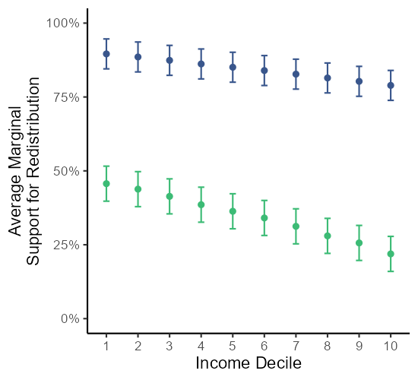 #### Fig 6B USA Low Abs

agg_png(here::here("weisstanner_replication","REPLICATION DATA","results","Fig6b.png"), width = 550, height = 600, res = 144)  
df_rep_marg%>%  
 ggplot() +  
 #USA  
 geom_point(aes(x = factor(hinc_decile), y = redist_usa_lo, color = lib)) +  
 geom_errorbar(aes(x = factor(hinc_decile), ymin = redist_usa_lo-(redist_usa_lo_sd), ymax = redist_usa_lo+(redist_usa_lo_sd), color = lib), width = 0.2) +  
 theme_classic() +  
 labs(x = "Income Decile", y = "Average Marginal\nSupport for Redistribution", color = "Liberal\nValues I") +  
 scale_color_manual(values = c("#39568CFF",  
 "#3CBB75FF")) +  
 scale_y_continuous(labels = scales::percent,  
 limits = 0:100) +  
 guides(color = guide_legend(nrow = 2)) +  
 theme(legend.position = "bottom")  
dev.off()

## png   
## 2

knitr::include_graphics(here::here("weisstanner_replication","REPLICATION DATA","results","Fig6b.png"))

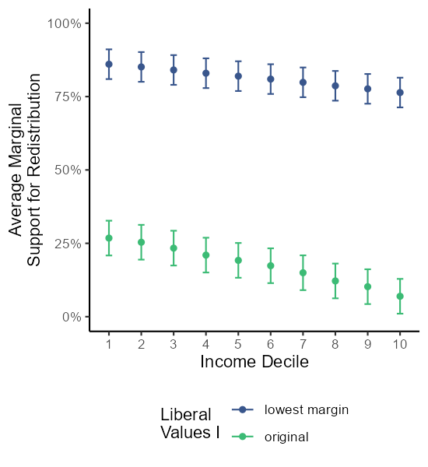 #### Fig 6C FIN Orig

agg_png(here::here("weisstanner_replication","REPLICATION DATA","results","Fig6c.png"), width = 525, height = 500, res = 144)  
df_rep_marg%>%  
 ggplot() +  
 #FIN  
 geom_point(aes(x = factor(hinc_decile), y = redist_fin, color = lib)) +  
 geom_errorbar(aes(x = factor(hinc_decile), ymin = redist_fin-(redist_fin_sd), ymax = redist_fin+(redist_fin_sd), color = lib), width = 0.2) +  
 theme_classic() +  
 ylim(0.15,1) +  
 labs(x = "Income Decile", y = "", color = "Liberal Values I") +  
 scale_color_manual(values = c("#453781FF",  
 "#20A387FF")) +  
 scale_y_continuous(labels = scales::percent,  
 limits = 0:100) +  
 theme(  
 legend.position = "none"  
 )  
dev.off()

## png   
## 2

knitr::include_graphics(here::here("weisstanner_replication","REPLICATION DATA","results","Fig6c.png"))

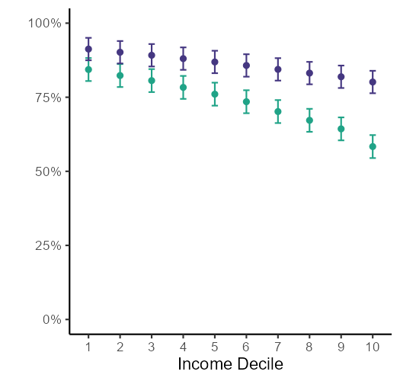 ### Fig 6D FIN Abs Low

agg_png(here::here("weisstanner_replication","REPLICATION DATA","results","Fig6d.png"), width = 525, height = 600, res = 144)  
df_rep_marg%>%  
 ggplot() +  
 #USA  
 geom_point(aes(x = factor(hinc_decile), y = redist_fin_lo, color = lib)) +  
 geom_errorbar(aes(x = factor(hinc_decile), ymin = redist_fin_lo-(redist_fin_lo_sd), ymax = redist_fin_lo+(redist_fin_lo_sd), color = lib), width = 0.2) +  
 theme_classic() +  
 labs(x = "Income Decile", y = "", color = "Liberal\nValues I") +  
 scale_color_manual(values = c("#453781FF",  
 "#20A387FF")) +  
 scale_y_continuous(labels = scales::percent,  
 limits = 0:100) +  
 guides(color = guide_legend(nrow = 2)) +  
 theme(legend.position = "bottom",  
 legend.box = "vertical")   
dev.off()

## png   
## 2

knitr::include_graphics(here::here("weisstanner_replication","REPLICATION DATA","results","Fig6d.png"))

