Assignment name: Assignment 2

Student name:

Student ID:

Tutor:
Table of Contents

Introduction 3

I. Development documentation 4

II. IDE evaluation 6

III. Debugging evaluation 6

IV. Coding standard evaluation 7
Introduction

With 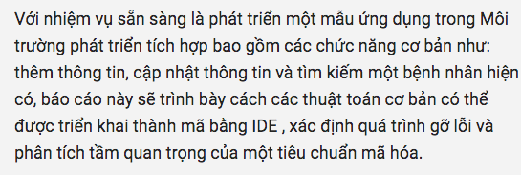

I. Development documentation

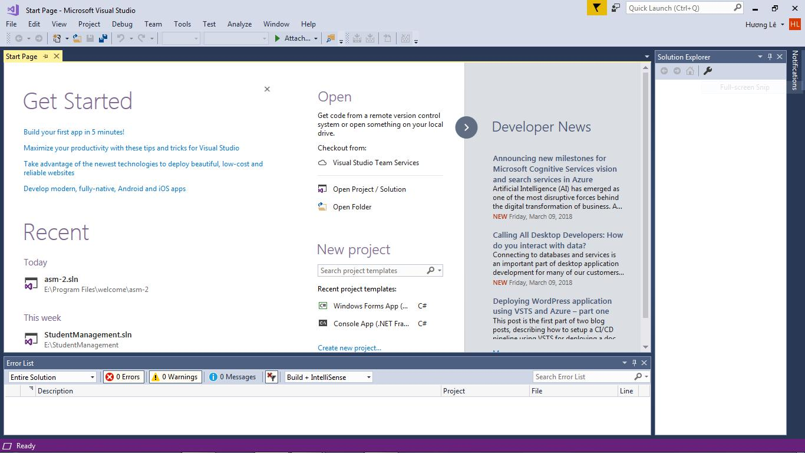
The 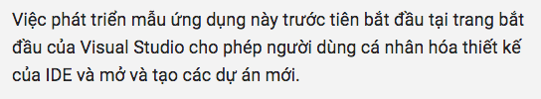

Figure 1: Microsoft Visual Studio start page
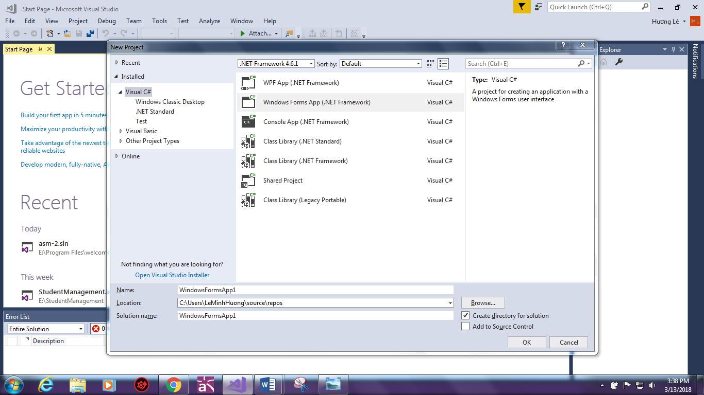

Figure 2: Creating a new project in VS.

Now 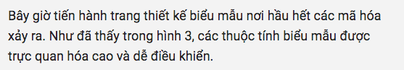
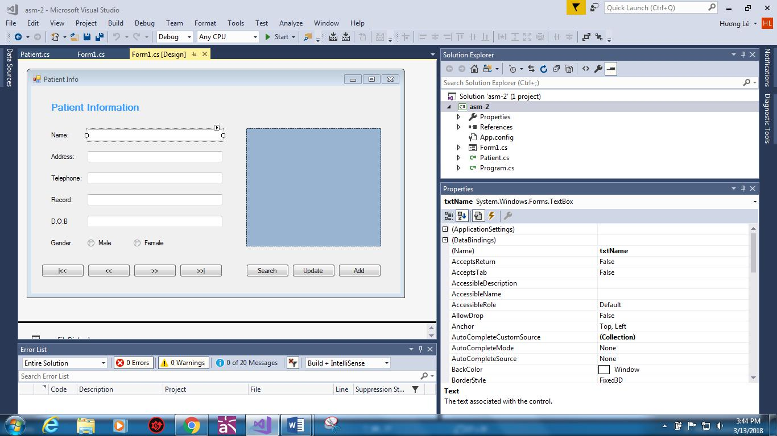

Figure 3: The form properties.
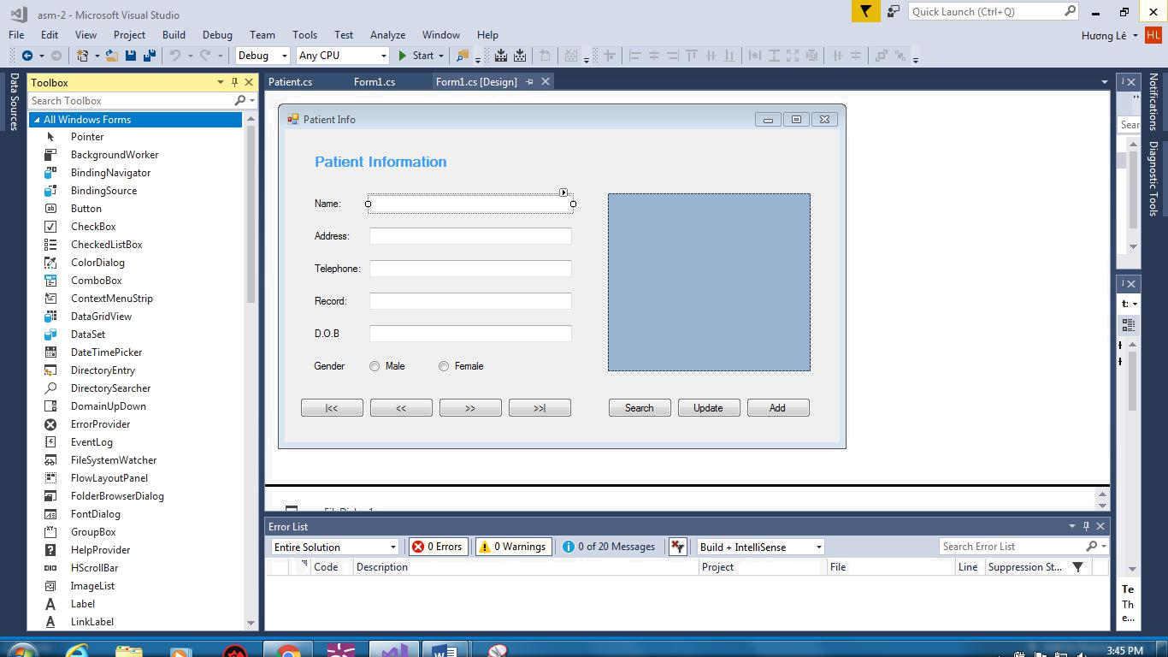

Figure 4: Adding components to the form.

While 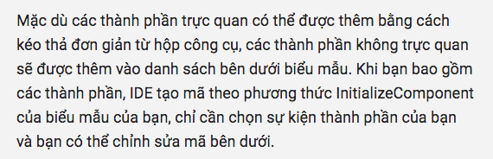

II. IDE evaluation

IDEs 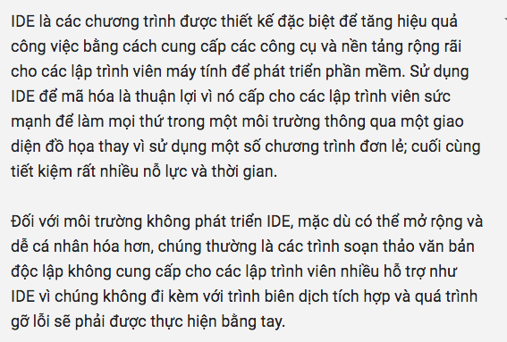
III. Debugging evaluation

Debugging 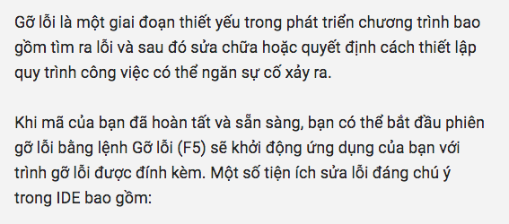:

- 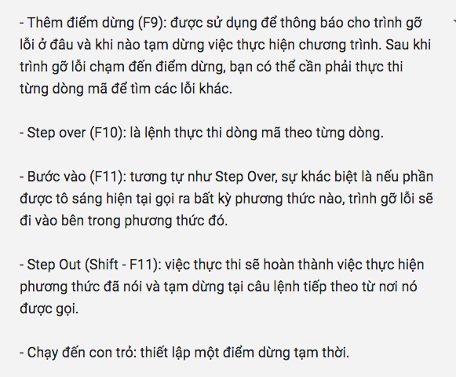

With 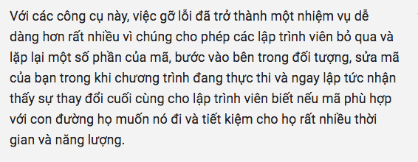

IV. Coding standard evaluation

One 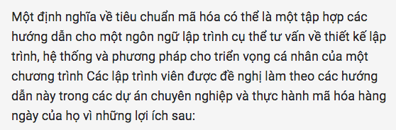:

- 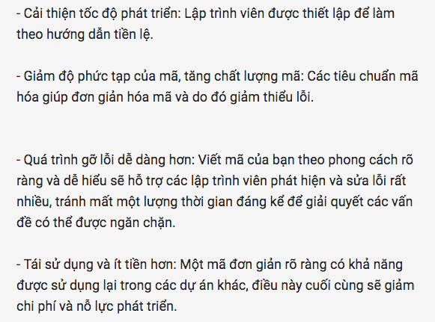

Examples 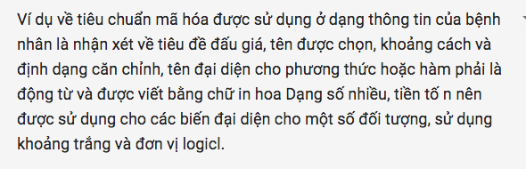s.
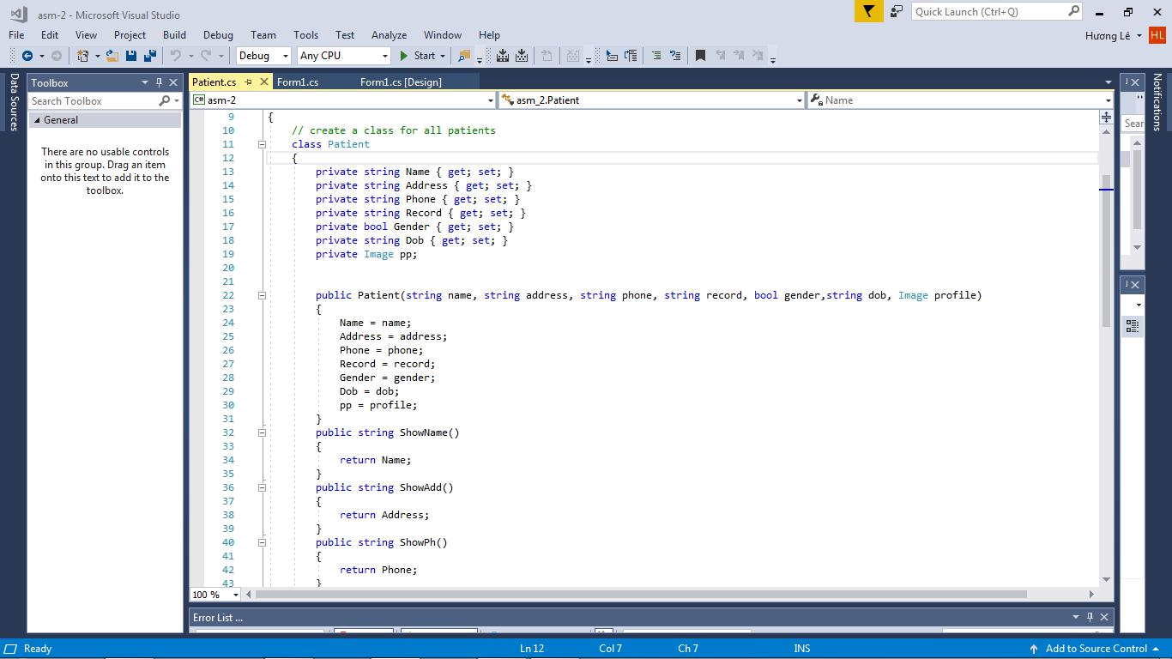

Figure 5: Coding standard example
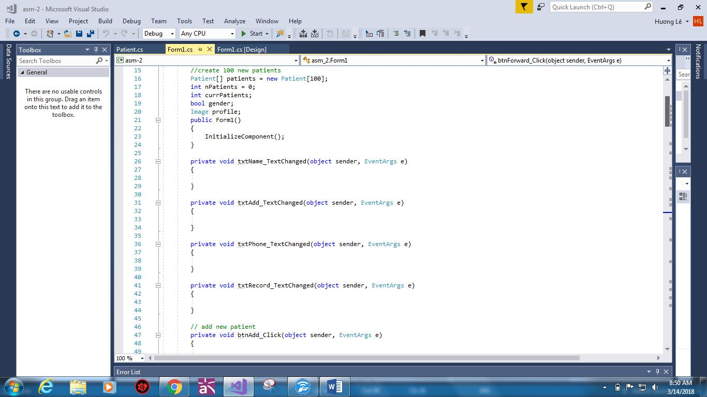

Figure 6: Example of coding standard

