MINISTRY OF EDUCATION AND TRAINING



**HOTEL WEBSITE**

**Software Architecture**

**Project code: HOWE**

**Document code: HOWESAD-v1.0**

Hanoi, Jun 25, 2017

Record of change

*A - Added M - Modified D - Deleted

|  |  |  |  |  |
| --- | --- | --- | --- | --- |
| **Effective Date** | **Changed Items** | **A* M, D** | **Change Description** | **New Version** |
|  |  |  |  |  |
|  |  |  |  |  |
|  |  |  |  |  |
|  |  |  |  |  |
|  |  |  |  |  |
|  |  |  |  |  |
|  |  |  |  |  |
|  |  |  |  |  |
|  |  |  |  |  |
|  |  |  |  |  |
|  |  |  |  |  |
|  |  |  |  |  |
|  |  |  |  |  |
|  |  |  |  |  |
|  |  |  |  |  |
|  |  |  |  |  |

SIGNATURE PAGE

**ORIGINATOR:** Name: Tran Ba Quyen Date: 22 June 2017

Name: Vu Tran Hoang

**REVIEWERS:** Name: Nguyen Viet Hung Date:

**APPROVAL:** Name: Phan Truong Lam Date:

Position: Instructor

Contents

1 Introduction 5

2 Architecture representation 5

3 Architecture Goals and Constrains 5

4 Use-Case View 5

5 Logical View 5

6 Process View 5

7 Deployment View 5

8 Implementation View 5

9 Data View 5

10 Size and Performance 5

11 Quality 5

12 Others Considerations 5

# Introduction

## Purpose

Tài liệu này mô tả toàn bộ cấu trúc của hệ thống, xác định các mối quan hệ, ràng buộc giữa các thành phần cấu trúc hệ thống(architecture elements). Một số architecture view được sử dụng để thể hiện các khía cạnh khác nhau của hệ thống.

Dựa trên các đặc tả yêu cầu hệ thống được mô tả trong bản SRS, những yêu cầu này được cấu trúc hóa thông qua các architecture view để giúp developer, designer hiểu chi tiết về cấu trúc hệ thống. thêm vào đó bản tài liệu này cũng là cơ sở cho quá trình code, test trong quy trình phát triển sản phẩm

## Scope

## Definitions, Acronyms, Abbreviations

|  |  |  |
| --- | --- | --- |
| Acronym | **Definition** | **Note** |
| HOWE | Hotel Website | Project’s name |
|  |  |  |

## References

|  |  |  |
| --- | --- | --- |
| No. | **Document** | **Source/Web Address** |
| 1 | System Requirements Specification Template | FPT University |

## Overview

Các mục chính được đề cập trong tài liệu này gồm:

# Architecture representation

# Architecture Goals and Constrains

# Use-Case View

## Guest View

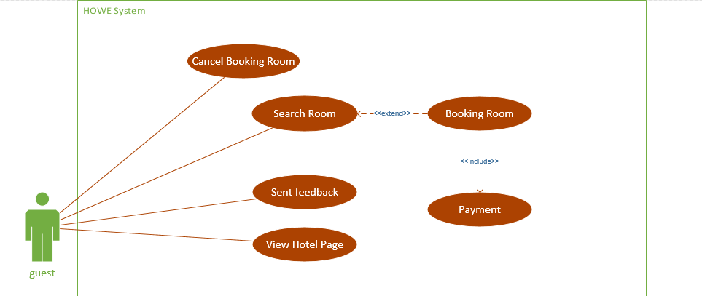

## Receptionist View

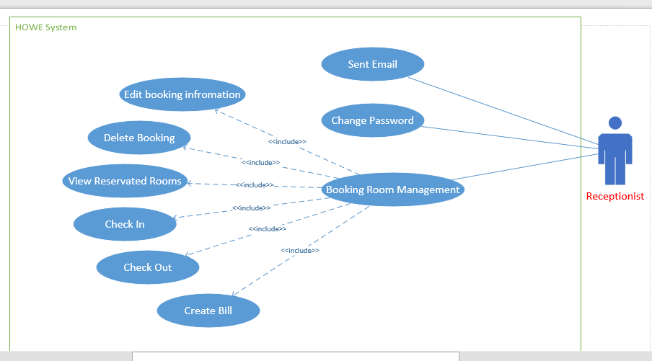

## Manager View

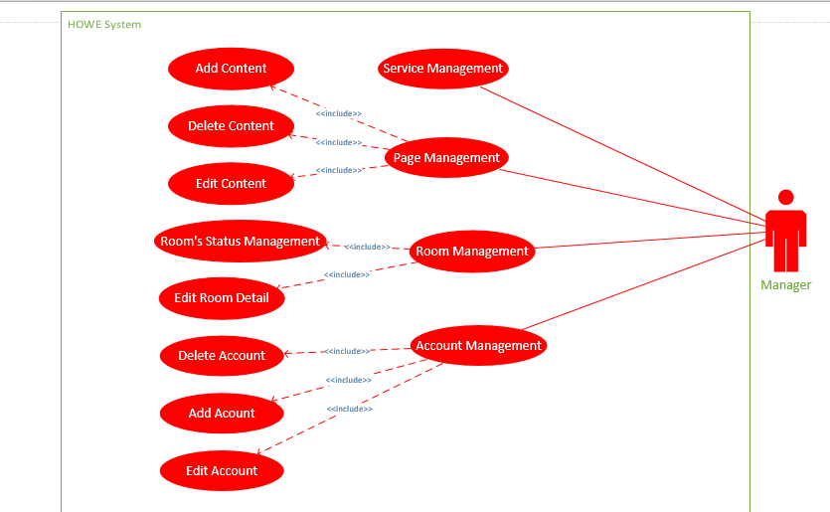

## Accounting View

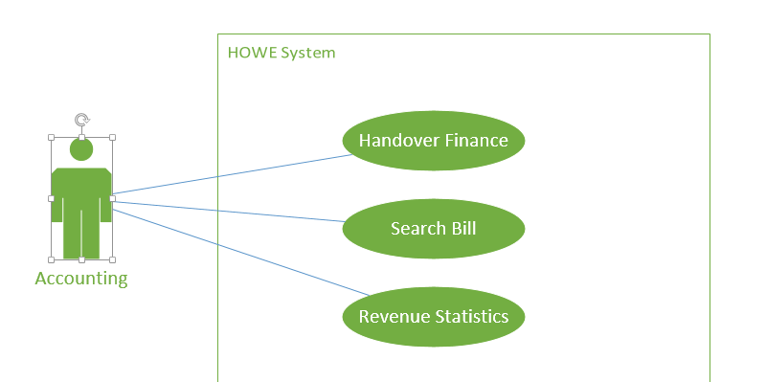

# Logical View

Sử dụng class, sequence diagram

# Development View

Sử dụng component, package diagram 🡪 đánh gia các non-function

# Process View

Activity diagram 🡪 đánh giá các non-function

# Data View

## Database design

## Database detail

### Table tbl_user

|  |  |  |  |  |  |
| --- | --- | --- | --- | --- | --- |
| No | **Field Name** | **Type** | Max Length | **Allow Null** | **Description** |
|  | user_id | Varchar | 20 | No | Username login to system  Primary key |
|  | user_name | Varchar | 50 | No | Staff’s full name |
|  | login_pwd | Varchar | 50 | No | Staff’s password |
|  | pwd_regs_ymd | Varchar | 8 |  | Password registration date |
|  | acc_lock_flg | Varchar | 1 |  | 0: enable  1: disable |
| 6 | delete_flg | Varchar | 1 |  | 0: In use  1: deleted |
| 7 | phone | Varchar | 20 |  | Staff’s phone number |
| 8 | mail | Varchar | 50 |  | Mail address of staff |
| 9 | identity_card | Varchar | 12 |  | Staff’s identity number |
| 10 | tax_code | Varchar | 20 |  | Staff’s tax code number |
| 11 | identity_card_location | Varchar | 100 |  | Place that the identity card is issued |
| 12 | address | Varchar | 100 |  | Staff’s address |
| 13 | create_ymd | timestamp |  |  | Register day |
| 14 | register_cd | Varchar | 7 |  | Register code |
| 15 | register_nm | Varchar | 20 |  | Register name |
| 16 | update_ymd | Timestamp |  |  | Last update date |
| 17 | last_register_cd | Varchar | 7 |  | Last register code |
| 18 | last_register_nm | Varchar | 20 |  | Last register name |

### Table tbl_group

|  |  |  |  |  |  |
| --- | --- | --- | --- | --- | --- |
| No | Field Name | Type | Max Length | Allow Null | Description |
| 1 | group_cd | Varchar | 7 | No | Group staff’s code, primary key |
| 2 | group_name | Varchar | 50 | No | Group staff’s name |
| 3 | create_ymd | timestamp |  |  | Registration date |
| 4 | register_cd | Varchar | 7 |  | Registration code |
| 5 | register_nm | Varchar | 20 |  | Registration name |
| 6 | update_ymd | timestamp |  |  | Last update date |
| 7 | last_register_cd | Varchar | 7 |  | Last register code |
| 8 | last_register_nm | Varchar | 20 |  | Last register name |

### Table tbl_user_group

|  |  |  |  |  |  |
| --- | --- | --- | --- | --- | --- |
| No | Field Name | Type | Max Length | Allow Null | Description |
| 1 | seq_no | Auto incremental |  | No | Primary key |
| 2 | user_id | Varchar | 20 | No | Staff’s code |
| 3 | group_cd | Varchar | 7 | No | Group’s code |
| 4 | create_ymd | timestamp |  |  | Registration date |
| 5 | register_cd | Varchar | 7 |  | Registration code |
| 6 | register_nm | Varchar | 20 |  | Registration name |
| 7 | update_ymd | timestamp |  |  | Last update date |
| 8 | last_register_cd | Varchar | 7 |  | Last register code |
| 9 | last_register_nm | Varchar | 20 |  | Last register name |

### Table tbl_status

|  |  |  |  |  |  |
| --- | --- | --- | --- | --- | --- |
| No | Field Name | Type | Max Length | Allow Null | Description |
| 1 | status_id | Varchar | 10 | No | ID of room status, primary key |
| 2 | status_type | Varchar | 2 | No | Status’s type |
| 3 | status_name | Varchar | 50 | No | Status’s name |
| 4 | description | Varchar | 255 |  |  |
| 5 | update_ymd | timestamp |  |  | Update date |
| 6 | create_ymd | timestamp |  |  | Create date |

### Table tbl_room_type

|  |  |  |  |  |  |
| --- | --- | --- | --- | --- | --- |
| No | Field Name | Type | Max Length | Allow Null | Description |
| 1 | room_type_id | Varchar | 5 | No | Room type’s ID, primary key |
| 2 | type_name | Varchar | 30 | No | Room type’s name |
| 3 | adult | Integer |  | No | Adult number |
| 4 | children | Integer |  | No | Children number |
| 5 | description | Varchar | 100 |  |  |
| 6 | image_url | Varchar | 100 |  | Image stores address |
| 7 | price | Integer |  | No | Price of room type |
| 8 | create_ymd | Timestamp |  |  | Create date |
| 9 | update_ymd | Timestamp |  |  | Update date |

### Table tbl_room

|  |  |  |  |  |  |
| --- | --- | --- | --- | --- | --- |
| No | Field Name | Type | Max Length | Allow Null | Description |
| 1 | room_id | Varchar | 5 | No | Room’s ID and it is primary key |
| 2 | room_type_id | Varchar | 5 | No | Foreign key |
| 3 | floor | Integer |  |  |  |
| 4 | status_id | Varchar | 10 | No | Foreign key |
| 5 | room_number | Varchar | 5 | No | Name of the room |
| 6 | note | Varchar | 255 |  |  |
| 7 | create_ymd | Timestamp |  |  | Create date |
| 8 | update_ymd | Timestamp |  |  | Update date |

### Table tbl_room_accessory

|  |  |  |  |  |  |
| --- | --- | --- | --- | --- | --- |
| No | Field Name | Type | Max Length | Allow Null | Description |
| 1 | id | Auto incremental |  | No | Primary key |
| 2 | room_type_id | Varchar | 5 | No | Foreign key |
| 3 | accessory_name | Varchar | 20 | No | Name of accessory in the room |
| 4 | quantity | Integer |  |  | Accessory quantity |
| 5 | price | Integer |  |  | Price of accessory |
| 6 | description | Varchar | 100 |  |  |
| 7 | create_ymd | Timestamp |  |  | Create date |
| 8 | update_ymd | Timestamp |  |  | Update date |

### Table tbl_guest

|  |  |  |  |  |  |
| --- | --- | --- | --- | --- | --- |
| No | Field Name | Type | Max Length | Allow Null | Description |
| 1 | id | Auto incremental |  | No | Primary key |
| 2 | name | Varchar | 50 | No | Guest’s name |
| 3 | phone | Varchar | 20 |  | Guest’s phone number |
| 4 | mail | Varchar | 50 |  | Guest’s e-mail address |
| 5 | identity_card | Varchar | 12 |  | Guest’s identity number |
| 6 | company | Varchar | 50 |  | Company name |
| 7 | address | Varchar | 100 |  | Guest’s address |
| 8 | company_phone | Varchar | 20 |  | Company’s phone number |
| 9 | country | Varchar | 50 |  | Guest’s nationality |
| 10 | create_ymd | Timestamp |  |  | Create date |
| 11 | update_ymd | Timestamp |  |  | Update date |

### Table tbl_reservation

|  |  |  |  |  |  |
| --- | --- | --- | --- | --- | --- |
| No | Field Name | Type | Max Length | Allow Null | Description |
| 1 | id | Auto incremental |  | No | Primary key |
| 2 | status_id | Varchar | 10 | No | Foreign key |
| 3 | guest_id | Integer |  | No | Foreign key |
| 4 | check_in | Varchar | 8 | No | Check in date |
| 5 | check_out | Varchar | 8 | No | Check out date |
| 6 | number_of_room | Integer |  |  | Number of room in the reservation |
| 7 | number_of_adult | Integer |  | No | Number of adult in the reservation |
| 8 | number_of_children | Integer |  | No | Number of children in the reservation |
| 9 | note | Varchar | 200 |  |  |
| 10 | editer | Varchar | 50 |  | Username when staff login |
| 11 | update_ymd | timestamp |  |  | Updating reservation date |
| 12 | create_ymd | timestamp |  |  | Creating reservation date |

### Table tbl_reservation_detail

|  |  |  |  |  |  |
| --- | --- | --- | --- | --- | --- |
| No | Field Name | Type | Max Length | Allow Null | Description |
| 1 | id | Auto incremental |  | No | Primary key |
| 2 | reservation_id | Integer |  | No | Foreign key |
| 3 | room_id | Varchar | 5 | No | Foreign key |
| 4 | customer_name | Varchar | 50 |  | Customer name |
| 5 | date_in | Varchar | 8 |  | Check-in actually date |
| 6 | date_out | Varchar | 8 |  | Check-out actually date |
| 7 | check_in_flag | Integer |  |  | 0: not check-in  1: checked-in |
| 8 | check_out_flag | Integer |  |  | 0: not check-out  1: checked-out |
| 9 | note | Varchar | 200 |  | Note of reservation |
| 10 | customer_identity_card | Varchar | 12 |  | Customer identity card number |
| 11 | customer_phone | Varchar | 20 |  | Customer’s phone number |
| 12 | customer_email | Varchar | 50 |  | Customer’s email |
| 13 | update_ymd | Timestamp |  |  | Update reservation date |
| 14 | create_ymd | Timestamp |  |  | Creating reservation date |

### Table tbl_payment_type

|  |  |  |  |  |  |
| --- | --- | --- | --- | --- | --- |
| No | Field Name | Type | Max Length | Allow Null | Description |
| 1 | Id | Auto incremental |  | No | Primary key |
| 2 | type_name | Varchar | 50 | No | Payment type name |
| 3 | create_ymd | Timestamp |  |  | Create date |
| 4 | update_ymd | Timestamp |  |  | Update date |

### Table tbl_invoice

|  |  |  |  |  |  |
| --- | --- | --- | --- | --- | --- |
| No | Field Name | Type | Max Length | Allow Null | Description |
| 1 | id | Auto incremental |  | No | Primary key |
| 2 | payment_type_id | Integer |  | No | Foreign key |
| 3 | reservation_id | Integer |  | No | Foreign key |
| 4 | guest_id | Integer |  | No | Foreign key |
| 5 | tax_code | Varchar | 10 |  | Tax code number |
| 6 | create_ymd | Timestamp |  |  | Create date |
| 7 | update_ymd | Timestamp |  |  | Update date |
| 8 | creater_nm | Varchar | 50 |  | Register’s name |
| 9 | updater_nm | Varchar | 50 |  | Updater’s name |

### Table tbl_invoice_detail

|  |  |  |  |  |  |
| --- | --- | --- | --- | --- | --- |
| No | Field Name | Type | Max Length | Allow Null | Description |
| 1 | id | Auto incremental |  | No | Primary key |
| 2 | invoice_id | Integer |  | No | Primary key |
| 3 | item_id | Varchar | 5 |  |  |
| 4 | Item_type | Varchar | 50 |  |  |
| 5 | quantity | Integer |  |  |  |
| 6 | price | Integer |  |  |  |
| 7 | desciption | Varchar |  |  |  |
| 8 | amount_total | Integer |  |  |  |
| 9 | room_id | Varchar | 5 |  | Foreign key |
| 10 | creater_nm | Varchar | 50 |  | Creater’s name |
| 11 | updater_nm | Varchar | 50 |  | Updater’s name |
| 12 | update_ymd | Timestamp |  |  | Update date |
| 13 | create_date | Timestamp |  |  | Create date |
| 14 | payment_flag | Integer |  |  | 0: not paid  1: paid |

### Table tbl_service

|  |  |  |  |  |  |
| --- | --- | --- | --- | --- | --- |
| No | Field Name | Type | Max Length | Allow Null | Description |
| 1 | service_id | Varchar | 5 | No | Primary key |
| 2 | name | Varchar | 50 | No | Name of service |
| 3 | price | integer |  | No | Price of service |
| 4 | create_ymd | Timestamp |  |  | Create date |
| 5 | update_ymd | Timestamp |  |  | Update date |

### Table tbl_service_bill

|  |  |  |  |  |  |
| --- | --- | --- | --- | --- | --- |
| No | Field Name | Type | Max Length | Allow Null | Description |
| 1 | id | Auto incremental |  | No | Primary key |
| 2 | invoice_id | Integer |  | No | Foreign key |
| 3 | Service_name | Varchar | 50 | No | Name of service |
| 4 | unit | Varchar | 20 | No | Unit of service |
| 5 | quantity | Integer |  |  | Quantity of service |
| 6 | unit_price | Numeric | 11 |  | With 2 digits after decimal point |

### Table tbl_function

|  |  |  |  |  |  |
| --- | --- | --- | --- | --- | --- |
| No | Field Name | Type | Max Length | Allow Null | Description |
| 1 | func_id | Varchar | 7 | No | Primary key |
| 2 | screen_id | Varchar | 7 | No | Primary key |
| 3 | screen_name | Varchar | 50 |  | Name of screen |
| 4 | screen_url | Varchar | 1000 |  | Addressing of the screen |
| 5 | create_ymd | Timestamp |  |  | Registration date |
| 6 | register_cd | Varchar | 7 |  | Registration code |
| 7 | register_nm | Varchar | 20 |  | Registration name |
| 8 | update_ymd | Timestamp |  |  | Last up date function |
| 9 | last_register_cd | Varchar | 7 |  | Last registration code |
| 10 | last_register_name | Varchar | 20 |  | Last registration name |

### Table tbl_permission

|  |  |  |  |  |  |
| --- | --- | --- | --- | --- | --- |
| No | Field Name | Type | Max Length | Allow Null | Description |
| 1 | role_seq | Auto incremental |  | No | Primary key |
| 2 | group_cd | Varchar | 7 | No | Group’s code |
| 3 | screen_id | Varchar | 7 | No | Screen’s code |
| 4 | use_flg | Varchar | 1 | No |  |
| 5 | create_ymd | Timestamp |  |  | Registration date |
| 6 | register_cd | Varchar | 7 |  | Registration code |
| 7 | register_nm | Varchar | 20 |  | Registration name |
| 8 | update_ymd | Timestamp |  |  | Last update date |
| 9 | last_register_cd | Varchar | 7 |  | Last register code |
| 10 | last_register_nm | Varchar | 20 |  | Last register name |

# Size and Performance

# Quality

# Others Considerations