MINISTRY OF EDUCATION AND TRAINING



**Capstone Project Document**

**Hotel Website**

**Project Code: HOWE**

**SOFTWARE REQUIREMENT SPECIFICATION**

Contents

1 INTRODUCTION 3

1.1 Purpose 3

1.2 Scope 3

1.3 References 3

1.4 Overview 3

2 OVERALL DESCRIPTION 3

2.1 Product Perspective 3

2.2 Use case diagram 3

2.3 Product Functions 3

2.4 User characteristics 3

2.5 User documentation 4

2.6 Assumption 4

3 Entity Relation Model 4

3.1 Entity Relation Diagram 4

3.2 Entity Detail 4

4 Specific Requirements 4

4.1 Business Rules 4

4.2 Functional requirement specification 4

4.3 Non-functional requirement specification 4

# INTRODUCTION

## Purpose

This is a document created to introduce the HOWE system, including descriptions of all functions along with description of non-functional systems. This is also a document to illustrate the next steps in the development of the HOWE project, including detail design, testing and validation. This document provides the most overview of the system for both developers and system users.

## Scope

The HOWE system is built on the basis of the Website to create a fast, easy link to the user and manage the system. With easy to understand designs suitable for all users who are able to use website services, but those who wish to use the services that the website provides in a direct way quickly.

## References

|  |  |  |
| --- | --- | --- |
| No. | Document | Source/Web Address |
| 1 | System Requirements Specification Template | FPT Software Cop. |

## Overview

The main functions mentioned in this document including 4 parts:

* Introduction: provide general information about SRS. Includes items purpose, scope, references and overview.
* Overall description: describe the basic factors that affect the project and the requirements of the system.
* Entity relation model: describe the database structure used in the system and its details information.
* Specific requirement: presents detailed descriptions of system functions, as well as descriptions of non-functions.

# OVERALL DESCRIPTION

## Product Perspective

When using HOWE, users can easily find information about the hotel, room status as well as the facilities and services of the hotel, giving customers the most intuitive view of the hotel without go to the place. With online booking function, customers can minimize their time, save money and improve their work efficiency.

Moreover, the HOWE system also provides users with the most up-to-date information about the resort, food, entertainment to get the most out of their options.

## Use case diagram



*Figure 1: List Use Case of HOWE*

## Product Functions

## User characteristics

HOWE is developed towards all those who wish to search, rent hotel rooms, along with information on many other services. Therefore, the system is divided into three main groups:

* Guest: with this group of user they can use the main functions such as:
  + Booking room
  + Sent feedbac006B
  + View public page
* Staff: are user who have had accounts at HOWE. With this group of users they can use the functions that are mentioned below:
  + Login
  + Logout
  + Booking room manage
  + Page management
  + Room management
* Administrator(Admin): manage all staff and accounts information. Admin can use the functions that are mentioned below:
  + Account management

## User documentation

|  |  |
| --- | --- |
| Name | Description |
| User Guide | Provide detailed explanation about the system, screens and guide users how to use all features of HOWE. |

## Assumption

# Entity Relation Model

## Entity Relation Diagram

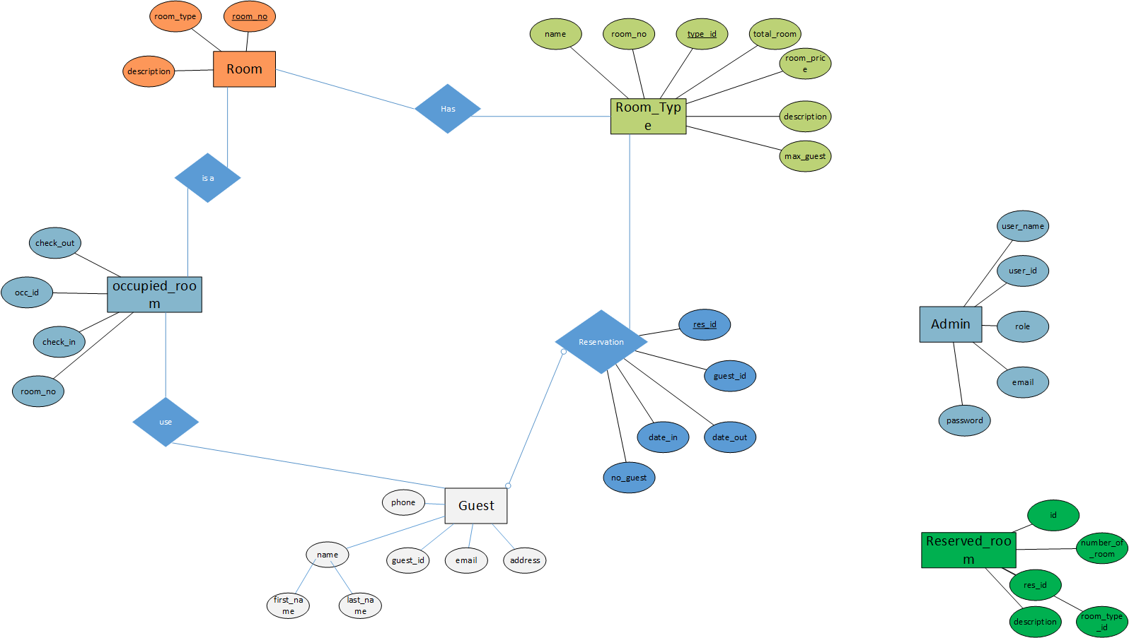

## Entity Detail

# Specific Requirements

## Business Rules

## Functional requirement specification

## Non-functional requirement specification

Availability

Supportability

Performance Requirements

User Interface

Design Constraints

Usability

Reliability

Scalability

Security