PFP - Labwork 01

Q1 (5 marks). Write a program that performs the following tasks:
- Calculate the multiplication or sum of two numbers:
- Two numbers are inputted from keyboard, use try - except for error control;
- If the multiplication of two numbers is not greater than 1000 → Print out the multiplication;
- If the multiplication of two numbers is greater than 1000 → Print out the sum instead;

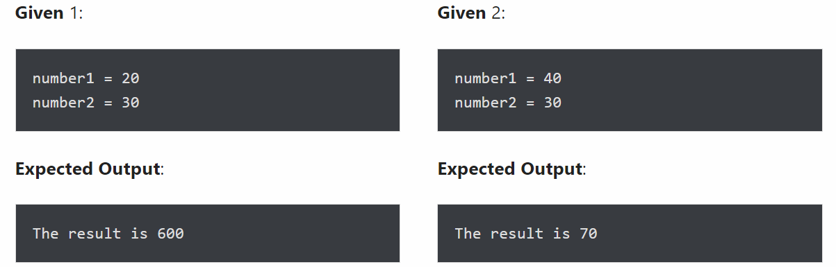

- Display three string “Name”, “Is”, “James” as “Name**Is**James”
Use the print() function to format the given words in the mentioned format. Display the ** separator between each string.
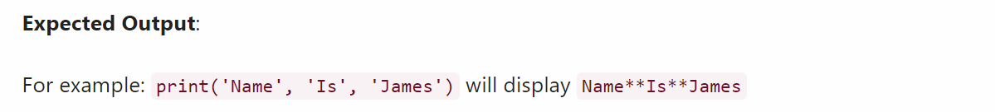

Q2 (5 marks).
- Convert Decimal number to octal using print() output formatting
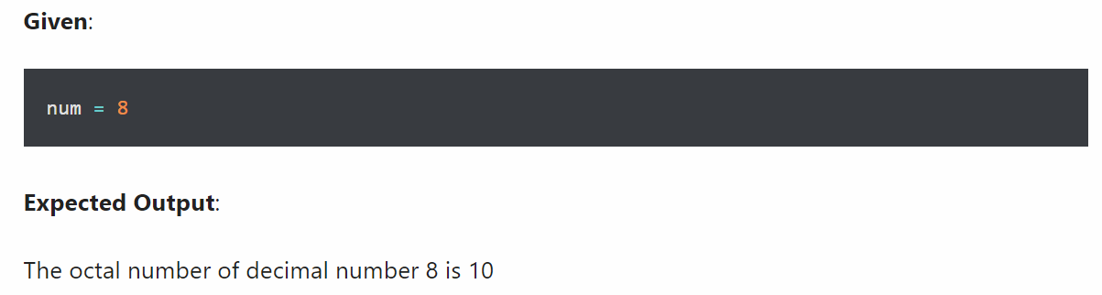

- Display float number with 2 decimal places using print()
