Add your app to Goggle play or AppStore and manage your IAP in store side
1. Google play manual
2. Apple AppStore manual

Manage your IAP in game side.
- Open first scene – Lobby.
- Select in hierarchy Purchaser.
- Select Inspector tab.
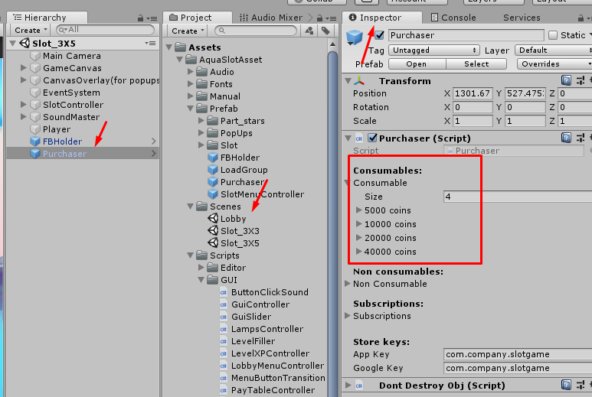

You can see 3 types of goods (Consumables, Non consumables and Subscription).
We use consumable (only for example).
Fold out the item
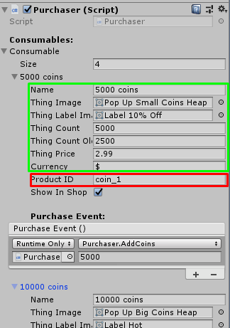  In green frame – settings for shop window  In red frame – unique ID for store. | 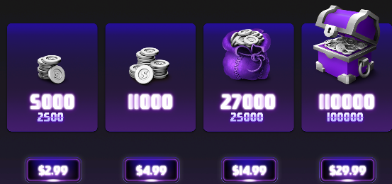
Keys for stores(Apple and Goggle) – your keys | 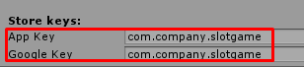

- Add or remove items
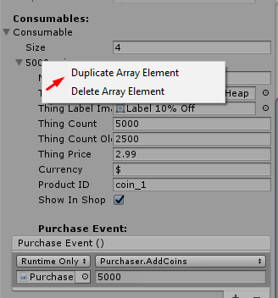

Set up purchase event for each item (what happened after succesfully purchasing)

