Import any sound clips in your app.
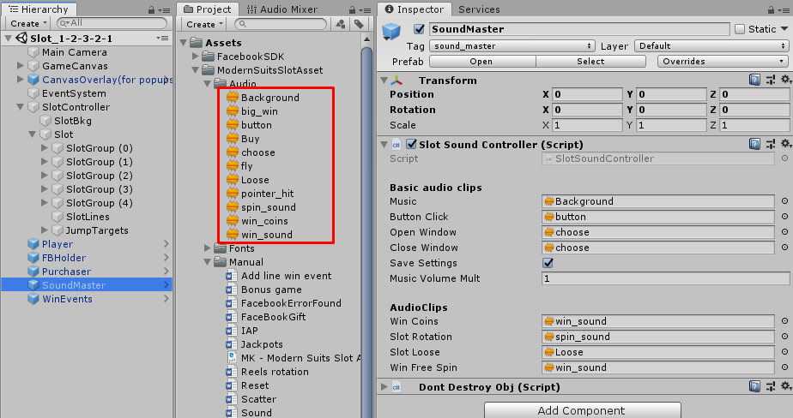
Open Lobby scene.
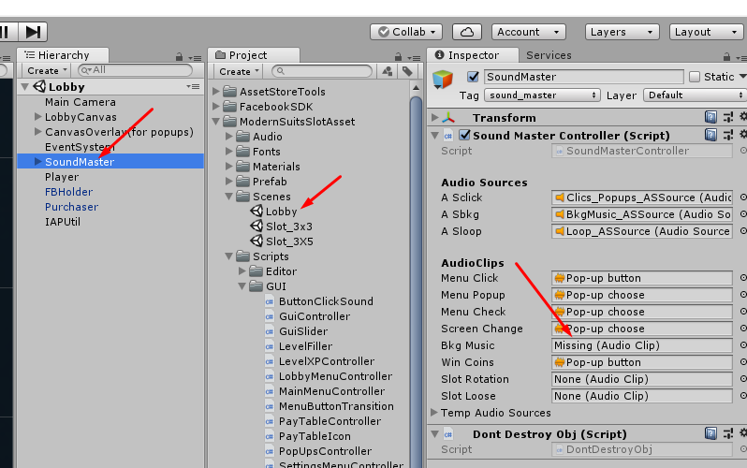

1.Spin Sound.

Select SoundMaster  Drag spin clip in to Slot Rotation field | 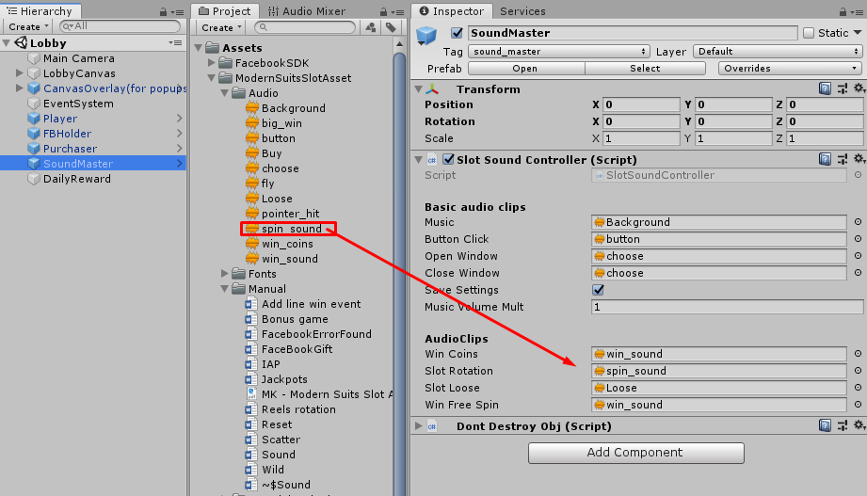
Click apply. | 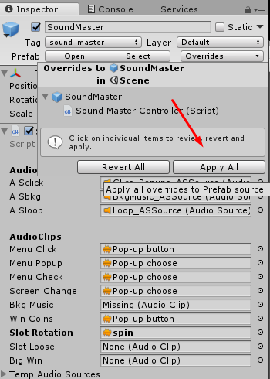
Play scene and test.  Don’t forget enable sounds. | 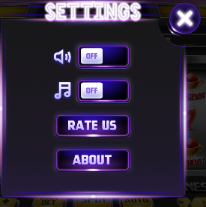

Add your clip

Open SlotSoundController.cs script | 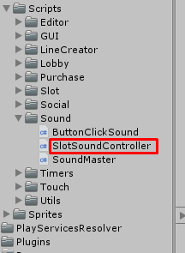
Add field BonusGame for your clip | 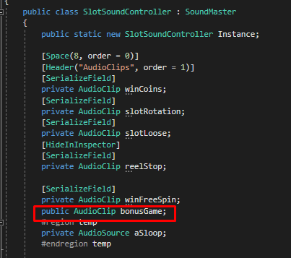  public AudioClip bonusGame;
Add method  SoundPlayBonusGame for your clip | 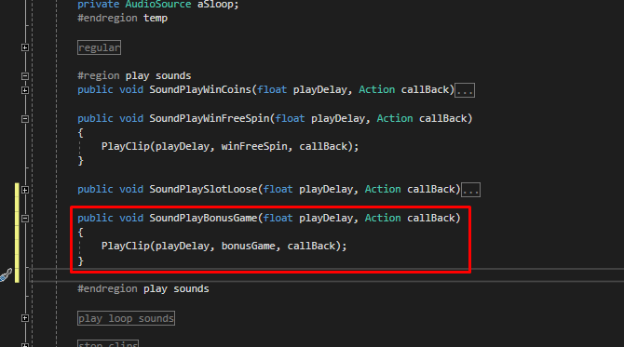  public void SoundPlayBonusGame(float playDelay, Action callBack)  {  PlayClip(playDelay, bonusGame, callBack);  }
Drag your clip in to Bonus Game field | 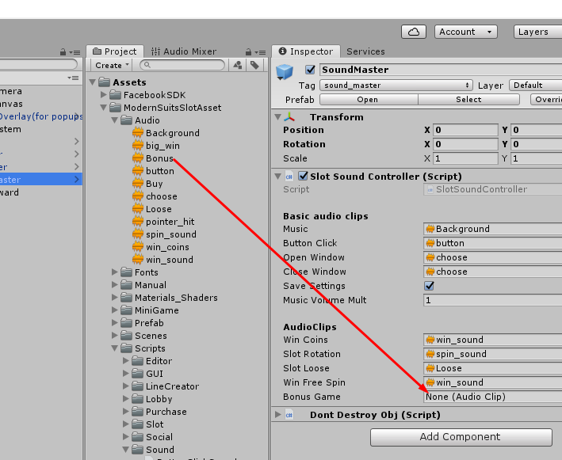
To play your clip from any code place - call | SlotSoundController.Instance.SoundPlayBonusGame(delay time, callBack or null);

