Wild
One of the most important symbols in the game is the Wild symbol.
You can select symbol flag Use Wild Substitute. Wilds substitute this symbols and generate wins by completing winning line combinations.
I disable wild susbstite for all special symbols
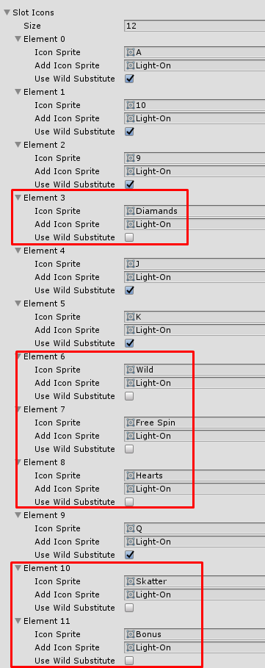

Select wild Symbol
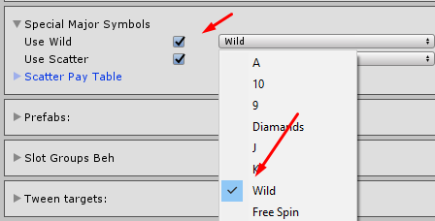
You can check paytable with used wild
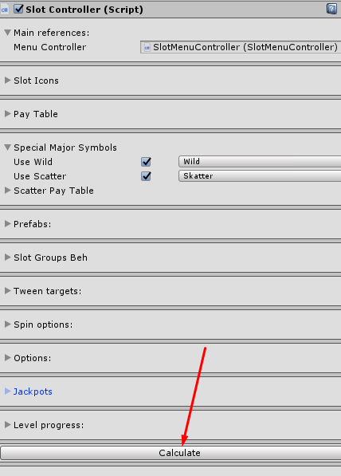
Use wild (we have additional paylines)
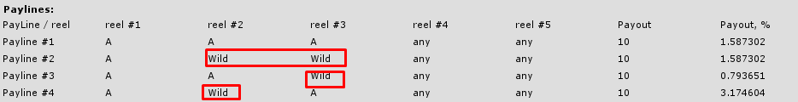
Don’t use wild

