CertiCut: Capacitated K-Way Partitioning with Anytime Bounds for Sampling-Aware Circuit Cutting
Anonymous Authors
Abstract
Circuit cutting trades quantum-device width for a quasiprobability sampling cost that grows multiplicatively with the severed interactions. Yet a partition returned under a time limit is difficult to assess unless its optimization gap is expressed in the same sampling-cost units. We introduce CertiCut, a certifiable formulation for exact balanced two-fragment gate cutting under an independent quasiprobability-decomposition (QPD) model. Aggregating gate costs in the log domain reduces the problem exactly to weighted minimum bisection. Consequently, global bounds $LB≤OPT≤UB$ imply $Γ_{inc}/Γ^{*}≤exp(UB−LB)$. We show that metric inequalities alone cannot strengthen the complete-pair baseline; balanced-cut cardinality is required to couple metric structure to weighted interactions. On 24 circuit-derived instances, their combination improves every root bound and closes 12. In a 120-instance heterogeneous-QPD corpus with no identity gates, 13.3% of minimum-cut plans incur unavoidable QPD regret; every reversal accepts additional cuts to reduce modeled overhead. Across 420 CNOT-only instances, 88.3% return solver-tolerance certificates after 2 s; all do so and 99.3% close their gaps by 60 s. A separate SCIP audit finds no general speed advantage for the custom search. The scope is balanced $K​=​2$ cutting, independent QPD costs, logical all-to-all connectivity, and numerical bounds at the stated solver tolerance.
quantum circuit cutting, quasiprobability decomposition, anytime optimization, branch-and-bound, cut polytope, linear programming relaxation, certified optimization

INTRODUCTION
Near-term quantum processors remain limited in qubit count, fidelity, and connectivity [1]. Circuit cutting mitigates the width constraint by decomposing a circuit into smaller, independently executable fragments and recovering the target quantity through classical post-processing [2], [3], [4]. This tradeoff can be expensive: every severed interaction contributes a gate-dependent quasiprobability sampling factor, and these factors multiply across cuts. Minimizing the number of cuts therefore need not minimize the resulting sampling overhead.
Automatic cutting workflows commonly report a partition and a solver-specific status. Although generic mixed-integer programming (MIP) solvers can expose primal and dual bounds, those bounds are rarely translated into a circuit-cutting resource guarantee. Such a translation matters because an additive objective gap can represent orders of magnitude in multiplicative sampling cost. Working in the log-overhead domain makes the connection exact: a global optimization gap immediately yields a worst-case overhead ratio.
We present CertiCut, a circuit-cutting formulation and reference optimizer that make this guarantee explicit. The formulation targets exact balanced two-fragment ($K​=​2$) partitioning on logical all-to-all interaction graphs, using independent gate-level QPD costs from Qiskit Addon Cutting 0.10 [5]. In exact arithmetic, global bounds at a safe stopping boundary imply the overhead factor $F=exp(UB−LB)$; the implementation reports their floating-point counterparts at tolerance ${10}^{−9}$. The method does not address arbitrary fragment counts, hardware topology, noise, or joint-QPD decompositions.
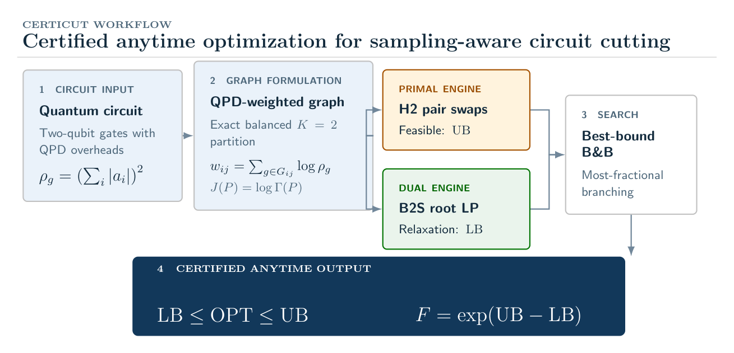
Overview of the CertiCut workflow. A circuit is reduced to a QPD-weighted interaction graph. H2 constructs an upper bound, B2S computes a lower bound, and best-bound branch-and-bound refines both. In exact arithmetic, $LB≤OPT≤UB$ implies $F=exp(UB−LB)$; the implementation reports numerical bounds at tolerance ${10}^{−9}$.
This work makes four contributions:
- A certifiable sampling-aware formulation. We reduce independent-QPD optimization for exact balanced $K​=​2$ cutting to weighted minimum bisection in the log domain and translate any global optimization gap into the guarantee $Γ_{inc}/Γ^{*}≤exp(UB−LB)$.
- A complementary polyhedral strengthening. We prove that metric inequalities alone cannot strengthen the complete-pair baseline and show empirically that adding balanced-cut cardinality makes them effective: the combination improves all 24 audited roots and closes 12. Against a sparse assignment relaxation, numerical gap closure rises from 41/90 to 90/90 within 100 nodes.
- Evidence that gate-dependent costs matter. In a 120-instance companion corpus containing only nonidentity Qiskit-derived gates, 16 cases (13.3%) have unavoidable QPD regret even after optimizing QPD cost over all minimum-cut plans. Every reversal requires a QPD-optimal plan with more cuts.
- Representation and reconstruction checks. Paired native/CX experiments quantify representation sensitivity, while two exact Qiskit reconstructions test cost accounting and pipeline compatibility.
The remainder of the paper develops the formulation and bound semantics, then evaluates polyhedral strength, anytime behavior, representation sensitivity, and reconstruction accuracy. Throughout, we separate the circuit-cutting model from the performance of any particular MIP engine.

BACKGROUND AND PROBLEM FORMULATION

Independent QPD Circuit Cutting
Gate cutting replaces selected two-qubit channels by quasiprobability decompositions (QPDs) over fragment-local channels [2], [6]. For a cuttable channel Ug=i​ag,iEg,i, the corresponding independent sampling overhead is
ρg=i​|ag,i|​2.
For a partition $P$ with crossed-gate set $S(P)$, independent sampling across gates gives
Γ(P)=g∈S(P)​ρg, J(P)=logΓ(P)=g∈S(P)​logρg.
This objective matches the independent gate-level model in Qiskit Addon Cutting 0.10 [5]; it is not a model of joint decompositions, finite-shot variance, or hardware noise. Because the QPD coefficient one-norm is at least one, $ρ_{g}≥1$ and all log weights are nonnegative. We validated the gate costs against the Qiskit QPD registry: $ρ_{CX}=ρ_{CZ}=9$, $ρ_{iSWAP}=ρ_{DCX}=49$, $ρ_{CS}=3+2\sqrt{2}≈5.828$, and $ρ_{RZZ(θ)}=(1+2|sinθ|)^{2}$ for numerically bound rotations.

Log-Domain Interaction Graph
Let $V=\{0,…,n−1\}$ be the circuit qubits, and let $G_{ij}$ contain the two-qubit gate occurrences acting on pair $(i,j)$. We assign the nonnegative interaction weight
wij=g∈Gij​logρg.
With partition labels $z_{i}∈\{0,1\}$ and pairwise cut variables $x_{ij}=|z_{i}−z_{j}|$, the objective becomes
J(P)=i<j​wij xij.
Proposition 1 (Objective equivalence). Under independent gate-level QPD, minimizing [eq:objective] is equivalent to minimizing [eq:graph-objective].
Proof. Every $g∈G_{ij}$ is cut exactly when $z_{i}≠z_{j}$. Regrouping the gate-level sum by qubit pair yields i<j​(g∈Gij​logρg)xij, which is [eq:graph-objective]. $▫$

Exact Balanced $K​=​2$ Partition Problem
All evaluated circuits have even $n$. We require $n/2$ qubits per fragment and fix $z_{0}=0$ to remove label symmetry:
minz∈{0,1}ni<j​wij |zi−zj| s.t. i​zi=n/2, z0=0.
Every feasible bisection cuts exactly $(n/2)^{2}$ pairs in the complete-pair representation:
i<j​xij=n2/4.
This identity is central to the strengthened relaxation below.

THE CERTICUT OPTIMIZER

Exact MILP Validation Oracle
We use a compact MIP and brute-force enumeration as independent validation oracles. For one pair $(i,j)$, the convex hull of $x_{ij}=|z_{i}−z_{j}|$ is described by
$$\begin{aligned}x_{ij}&≥z_{i}−z_{j},&x_{ij}&≥z_{j}−z_{i}, \\ x_{ij}&≤z_{i}+z_{j},&x_{ij}&≤2−z_{i}−z_{j}.\end{aligned}$$
The implementation uses an equivalent one-hot assignment model. Its MIP retains only the two lower inequalities in [eq:xor] and declares $x_{ij}$ binary; for positive-weight interacting pairs, minimization sets $x_{ij}$ to its exact XOR value. Zero-weight pairs do not affect the objective. SciPy/HiGHS solves this MIP, while exhaustive enumeration supplies a second oracle through 16 qubits. Neither oracle contributes bounds to the anytime results.

Basic Assignment Relaxation
The basic reference LP, denoted A0, uses one-hot assignment variables on qubits and cut variables only for interacting pairs. It retains exact balance and the two lower XOR inequalities from [eq:xor], then relaxes all variables to $[0,1]$. Because the weights are nonnegative, this is a valid lower relaxation. It is nevertheless weak: fractional assignments can make many weighted cut variables small simultaneously.

B2S Polyhedral Strengthening
B2S lifts A0 to the complete pair space, imposes the full XOR hull [eq:xor], and adds two families of valid constraints. To isolate the added families independently of this representation change, Sec. V compares them against a complete-pair baseline, denoted CP0.
Balanced-cut cardinality. Equality [eq:cardinality] fixes the total cut mass over all qubit pairs.
Metric inequalities. For each triple $(i,j,k)$, the cut polytope satisfies [7]
$$\begin{aligned}x_{ij}−x_{ik}−x_{jk}&≤0, \\ x_{ik}−x_{ij}−x_{jk}&≤0, \\ x_{jk}−x_{ij}−x_{ik}&≤0, \\ x_{ij}+x_{ik}+x_{jk}&≤2.\end{aligned}$$
Among three binary labels, the number of pairwise disagreements is zero or two; inequalities [eq:tri1]–[eq:tri4] exclude the fractional analogues of one or three disagreements. B2S solves the root LP, separates violated inequalities, and repeats until no violation remains or the separation budget is exhausted. The resulting pool is then reused throughout the search tree; no node-level separation is performed.
Proposition 2 (Metric redundancy without cardinality). For nonnegative weights, adding [eq:tri1]–[eq:tri4] to CP0 does not change its optimal value.
Proof. Take an optimal CP0 solution and retain its label vector $z$. Set $x_{ij}=|z_{i}−z_{j}|$ for every pair. This extension satisfies the pairwise XOR hull and all metric inequalities because absolute distance on the line is a metric and, for $z_{i}∈[0,1]$, $|z_{i}−z_{j}|+|z_{i}−z_{k}|+|z_{j}−z_{k}|≤2$. For fixed $z$, these are the smallest feasible pair values; nonnegative weights therefore ensure that the objective does not increase. Hence the metric-augmented optimum is no larger than the CP0 optimum. The reverse inequality follows because constraints were added. $▫$
Proposition 3 (Relaxation validity). The B2S LP optimum is a valid lower bound on $OPT$.
Proof. For binary labels, $x_{ij}=|z_{i}−z_{j}|$ satisfies [eq:xor]. A balanced partition cuts $|F_{0}||F_{1}|=n^{2}/4$ complete-graph pairs, and each label triple satisfies [eq:tri1]–[eq:tri4]. Hence every feasible integral bisection remains feasible in the relaxation, whose minimum cannot exceed $OPT$. $▫$

H2 Primal Heuristic
H2 constructs feasible bisections from deterministic degree-based orderings and a spectral initialization based on the graph Laplacian’s Fiedler vector. Each candidate undergoes best-improving Kernighan–Lin-style swaps between fragments until no improving swap remains. The best candidate initializes $UB$; H2 does not establish a lower bound or certify optimality.

Certified Best-Bound Branch-and-Bound
The reference optimizer maintains open nodes in nondecreasing order of their LP bounds. It expands the best-bound node, updates the incumbent when an integral solution improves $UB$, and otherwise branches on the most fractional label. Child LPs reuse the root cut pool; any child whose lower bound is at least $UB$ is pruned. After all LP solves associated with an expansion have completed, the algorithm reaches a safe boundary and computes
$$LB=min​\left(UB, \min_{N∈F}{LB}_{N}\right),$$
where $F$ denotes the open frontier. The additive log-domain gap and the corresponding multiplicative overhead factor are
$$Δ=UB−LB, F=exp(Δ).$$
Proposition 4 (Anytime certificate). In exact arithmetic, every safe stopping boundary satisfies $LB≤OPT≤UB$ and $Γ_{inc}/Γ^{*}≤F$.
Proof. Feasibility of the incumbent gives $OPT≤UB$. Every unexplored feasible solution belongs to a frontier subtree whose LP value lower-bounds all integral completions in that subtree. Equation [eq:global-lb] therefore gives $LB≤OPT$. Finally, $Γ=exp(J)$ implies $Γ_{inc}/Γ^{*}=exp(UB−OPT)≤exp(UB−LB)=F$. $▫$
Experimental deadlines are soft: the optimizer stops only at a safe boundary. We report the actual boundary time and never assign a later certificate to an earlier checkpoint. The implementation uses floating-point HiGHS bounds with tolerance ${10}^{−9}$; accordingly, empirical “certificates” and “gap closure” are numerical, solver-tolerance statements rather than independently verified exact certificates.
The CertiCut certified anytime search procedure for exact balanced $K​=​2$ partitioning.

EXPERIMENTAL METHODOLOGY

Experimental Protocol
All reported results come from an evidence corpus frozen on August 11–12, 2026. The environment uses Python 3.11.9, Qiskit 2.5.1, Qiskit Addon Cutting 0.10.0, SciPy 1.17.1 [8], KaHIP 3.25 [9], MQT Bench 2.2.2 [10], PySCIPOpt 6.2.1, and SCIP 10.0 [11]. Experiments ran on Windows 11 Education (build 26200), an Intel Core i5-14400 (10 physical cores, 16 logical processors), and 31.69 GB RAM. No explicit OpenMP, OpenBLAS, or MKL thread limits were set. We use an LP tolerance of ${10}^{−9}$, fixed random seeds, and fresh isolated processes for E1 deadlines. A manifest records exact versions, machine protocol, experiment counts, and SHA-256 hashes of raw results.
We evaluate five experiment sets:
- E1: 420 CNOT-only balanced instances spanning seven graph families, six sizes $n∈\{16,20,24,26,32,40\}$, and ten seeds per family–size cell. Each run uses a fresh process and a 60-s soft deadline.
- E2: 25 MQT Bench circuits at $n∈\{8,12,16,20,24\}$, normalized to the $\{RZ,SX,X,CX\}$ basis.
- E3: 15 circuits from the same sources, preserving supported native gates such as $RZZ$ and $CZ$.
- E4: 60 Qiskit automatic cut-finder runs under practical $Q_{max}$ semantics. Because these runs use different fragment constraints and backjump budgets, we report them as contextual rather than equal-time baselines.
- E5: 120 exact balanced heterogeneous-QPD instances across five deterministic families, $n∈\{12,14,16\}$, and eight seeds per cell. Every circuit contains CX, CZ, iSWAP, $RZZ(π/8)$, $RZZ(π/4)$, and $RZZ(π/2)$; all costs are queried from the Qiskit QPD registry. Exhaustive enumeration computes both the canonical count-optimal and QPD-optimal plans.

Metrics and Baselines
We report numerical gap closure, certificate availability, factor $F$, optimizer and end-to-end runtime, and peak resident memory. Every E1 checkpoint uses the full denominator of 420; a run that has not reached a safe boundary is counted as unavailable. Because the corpus is a fixed factorial grid rather than an IID sample, we report descriptive proportions without inferential confidence intervals.
KaHIP supplies fast feasible bisections for CNOT-only instances but no optimality certificate. Qiskit’s automatic cut finder [5] provides a practical multi-fragment reference; we retain its reported “minimum reached” status.

Mature-MIP Audit
Because gate aggregation yields weighted minimum bisection, a mature MIP audit is necessary. On a deterministic 90-instance pilot (six families, $n∈\{16,20,24\}$, five seeds, 2-s cap), basic SCIP closes 90/90 instances in 0.0640 s median wall-clock time. The B2S-root+H2 reference optimizer also closes 90/90, in 0.0692 s median time. Statically adding cardinality or the full triangle system to SCIP closes 81/90 and 76/90, respectively; all closed objectives agree within ${10}^{−8}$. This pilot neither implements B2S as a SCIP separator nor covers the full E1 protocol. It therefore supports no claim that the custom search outperforms mature MIP software.

EXPERIMENTAL RESULTS

Gate Costs Change the Optimization Target
Unweighted cut count can rank feasible plans incorrectly. Two iSWAP cuts have modeled overhead ${49}^{2}=2,401$, whereas three CNOT cuts cost $9^{3}=729$; the three-cut plan is cheaper. Likewise, two CS cuts cost $(3+2\sqrt{2})^{2}≈33.97$, compared with 81 for two CNOT cuts. Equation [eq:weight] preserves these gate-dependent distinctions.
E5 tests this distinction beyond constructed examples. It uses validated Qiskit costs for CX, CZ, iSWAP, and three nonzero $RZZ$ angles on 120 deterministic circuits; no operation has unit QPD overhead. To avoid tie-breaking artifacts, we compare $\min_{P: c(P)=c^{*}}J(P)$, the best QPD objective among all minimum-cut partitions, with $\min_{P}J(P)$; both values are obtained by exhaustive enumeration. This stronger regret is strict in 16/120 cases (13.3%). Its conditional factor has median $5.30$, 90th percentile $27.47$, and maximum $181.11$. Every strict reversal requires more cuts under a QPD-optimal plan, with median count increase one and maximum three. Across the 16 reversals, QPD-optimal plans cut 28 fewer iSWAP gates while accepting 47 additional lower-overhead gates (CX, CZ, and $RZZ$). All 120 QPD optimization runs close numerically within the 30-s deadline; 90 close at the B2S root. Thus E5 establishes objective sensitivity, not a new hard-anytime scaling result.
As a bounded real-circuit check, we exhaustively evaluate the nine E3 native circuits at $n∈\{8,12,16\}$. None exhibits strict regret. This negative result is unsurprising: the QAOA instances contain only native $RZZ$ gates, while BV and VQE use equal-cost gate types. It reinforces that E5 demonstrates a heterogeneous-cost mechanism rather than prevalence over arbitrary real circuits.
Identity-free heterogeneous-QPD companion corpus (E5). All costs come from Qiskit’s independent-QPD registry.
Metric | Value | Scope
Instances | 120 | 5 families, $n∈\{12,14,16\}$
Strict reversals | 16 (13.3%) | best count optimum has higher QPD cost
Median / p90 regret | $5.30×$ / $27.47×$ | strict reversals only
Extra cuts, median / max | 1 / 3 | strict reversals only
Avoided iSWAP cuts | 28 | aggregate over strict reversals
Numerically closed | 120/120 | B2S-root, 30-s deadline

Cardinality and Metrics Are Complementary
To isolate the source of root-bound strength, we compare four relaxations with identical complete-pair variables and the same LP backend: CP0; CP0 plus cardinality (C); CP0 plus separated metric inequalities (T); and their combination (CT). The study contains 24 circuit-derived instances from the random, dense, weighted-random, and noisy-community families at $n∈\{16,24\}$, with three seeds per cell. C and T each reproduce the CP0 bound on every instance. Proposition 2 explains the CP0+T equality structurally. CT improves all 24 bounds and closes 12 roots, showing empirically that cardinality activates the metric system strongly on this corpus by supplying global cut mass that the metric geometry must distribute.
Root-relaxation decomposition on 24 circuit-derived instances. C and T separately match CP0 on every instance; CT denotes their combination. Gaps are in log-overhead units.
Root formulation | Exact | Med. gap | p90 gap | Med. time
CP0 | 0/24 | 26.2935 | 52.4468 | 0.3211 s
CP0 + C | 0/24 | 26.2935 | 52.4468 | 0.3429 s
CP0 + T | 0/24 | 26.2935 | 52.4468 | 0.2832 s
CP0 + C + T | 12/24 | 0.2848 | 3.8761 | 2.3222 s
Separating all violated triangles at $n∈\{32,40\}$ exceeded the 10-min audit budget before a complete matrix was obtained; we therefore report no tail result for this study.

Strengthening Drives Proof Completion
Table 3 reports a controlled 90-instance ablation with a common 100-node budget. A0 closes 41 gaps, regardless of whether H2 is enabled. Both B2S-root configurations close all 90 with a median of one explored node. Within this protocol, the complete-pair strengthening, rather than incumbent construction, explains the change. Because A0 and B2S use different pair spaces, this ablation measures the package rather than only C and T; Table 2 provides the matched-representation isolation. The SCIP audit above further shows that neither result establishes general solver superiority.
Controlled ablation on 90 synthetic balanced instances under a 100-node budget. “Closed” means numerical gap at most ${10}^{−9}$; node-limited runs may also be closed.
Configuration | Closed | Node-lim. | Med. nodes | Root / Tree (s)
A0 + H0 (basic) | 41/90 | 56 | 100 | 0.000 / 2.059
A0 + H2 | 41/90 | 52 | 100 | 0.000 / 2.072
B2S-root + H0 | 90/90 | 0 | 1 | 0.260 / 0.060
B2S-root + H2 | 90/90 | 0 | 1 | 0.256 / 0.063

Anytime Certificate Availability
Fig. 3 and Table 4 summarize E1 using all 420 instances at every checkpoint. After 0.5 s, 278 runs (66.2%) have reached a safe boundary and 245 (58.3%) have closed numerical gaps. At 2 s, certificate coverage is 371/420 (88.3%), while 343/420 gaps are closed (81.7%). Coverage reaches 99.3% at 10 s. By 60 s, every run has a certificate and 417 (99.3%) have closed gaps.
The three remaining runs retain finite lower and upper bounds and therefore numerical multiplicative guarantees at the stated tolerance. Certificate availability is distinct from gap closure: an interrupted run can still quantify its incumbent’s solver-reported worst-case suboptimality.
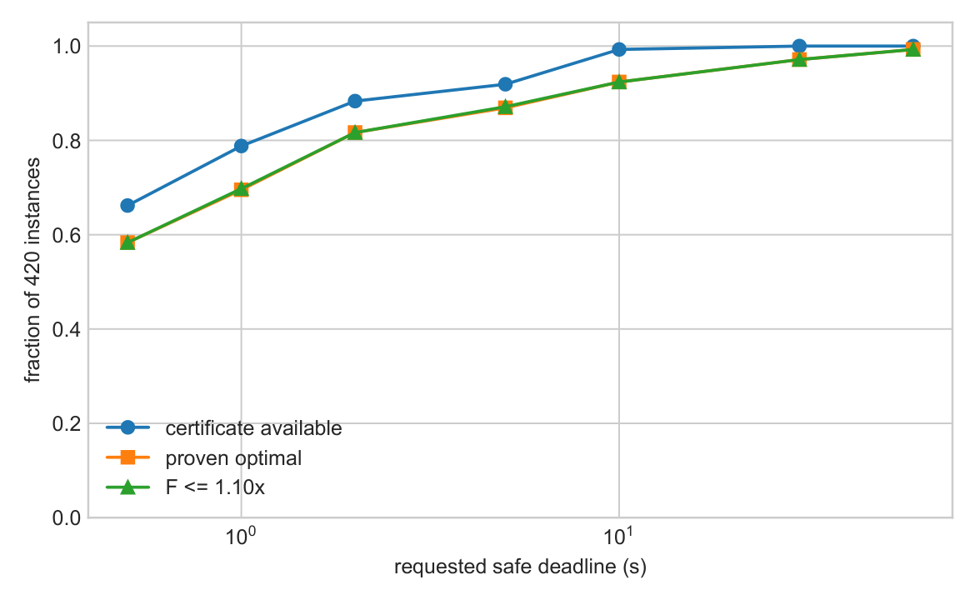
Certificate availability and numerical gap closure on E1. Each proportion uses all 420 instances; runs without a completed safe boundary remain in the denominator.
Anytime results on E1. Every row uses the full denominator of 420. Factor counts include all runs whose returned certificate meets the threshold.
Time | Cert. avail. | Closed | $F≤1.01$​ | $F≤1.10$​
0.5 s | 278 (66.2%) | 245 (58.3%) | 245 | 245
1 s | 331 (78.8%) | 292 (69.5%) | 292 | 293
2 s | 371 (88.3%) | 343 (81.7%) | 343 | 343
5 s | 386 (91.9%) | 365 (86.9%) | 365 | 366
10 s | 417 (99.3%) | 388 (92.4%) | 388 | 388
30 s | 420 (100%) | 408 (97.1%) | 408 | 408
60 s | 420 (100%) | 417 (99.3%) | 417 | 417

Scaling and Structural Variation
Table 5 stratifies E1 by circuit size. All 70 instances at each size through $n=32$ close, with median optimizer time increasing from 41 ms at $n=16$ to 0.96 s at $n=32$. At $n=40$, 67/70 close; median and 90th-percentile times are 7.8 s and 42.7 s. Median peak resident memory rises from 109 MB to 136 MB over the same range.
The three open cases belong to the weighted-random and noisy-community families. Fig. 4 shows that root strengthening and tree search dominate runtime at larger $n$, while preprocessing remains small. The appendix, Table 8, further shows median times below 2 s for community and nearest-neighbor instances at $n=40$, versus 18–37 s for random, dense, and weighted-random instances. These are descriptive differences within the sampled corpus, not evidence that density or family membership causes computational difficulty.
Scaling behavior across circuit sizes in the E1 corpus. Each size stratum contains 70 instances (seven families $×$ ten seeds).
$n$​ | Closed | Med. opt. (s) | p90 opt. (s) | Med. (MB) | p90 (MB)
16 | 70/70 | 0.041 | 0.120 | 109.2 | 109.8
20 | 70/70 | 0.099 | 0.250 | 111.2 | 112.0
24 | 70/70 | 0.226 | 1.015 | 114.2 | 115.1
26 | 70/70 | 0.651 | 1.846 | 116.3 | 117.0
32 | 70/70 | 0.961 | 6.050 | 123.2 | 125.8
40 | 67/70 | 7.805 | 42.665 | 136.0 | 138.8
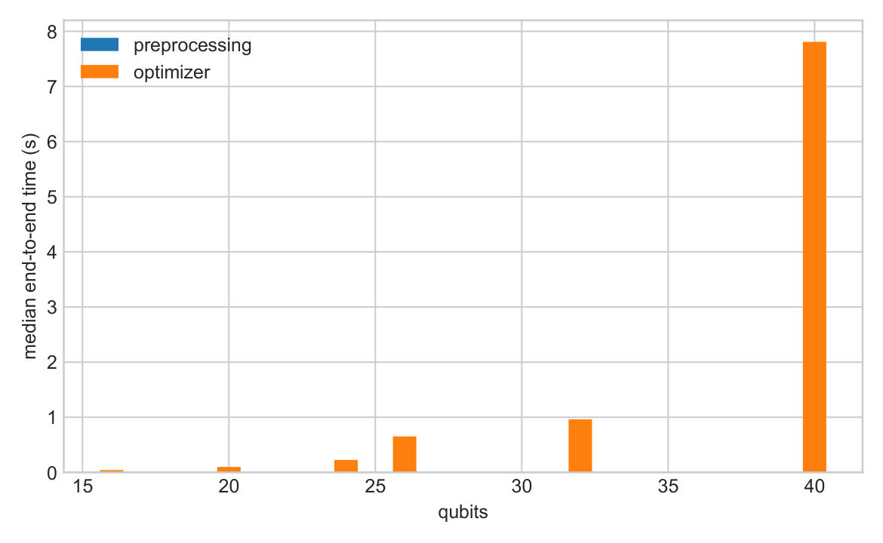
Runtime composition across E1. Root strengthening and tree search dominate at $n=40$; graph construction and cost lookup remain small.

Representation Sensitivity
We compare paired representations of identical MQT Bench source circuits, binding QAOA [12] parameters to $π/4$. One representation uses the CX-normalized basis $\{RZ,SX,X,CX\}$; the other preserves supported native two-qubit gates. For QAOA at $n=16$, the native $RZZ$ circuit contains 114 two-qubit gates rather than 228 and reduces the optimum from $J_{CX}^{*}=158.200$ to $J_{native}^{*}=79.100$. Exponentiating the difference gives a modeled overhead ratio of $2.25×{10}^{34}$. Bernstein–Vazirani (BV) and VQE [13], [14] provide negative controls: their paired $CZ$ or $CX$ representations yield ratio one.
These ratios compare representation-dependent independent-QPD objectives under Qiskit Addon Cutting 0.10. They do not imply an intrinsic reduction in the physical shot complexity of the underlying algorithms.
Optimal objectives under paired CX-normalized and native representations. QAOA is representation-sensitive; BV and VQE are ratio-one controls.
Family | $n$​ | CX 2q | Native 2q | $J_{CX}^{*}$​ | $J_{native}^{*}$​
QAOA | 8 | 56 | 28 | 52.733 | 26.367
QAOA | 12 | 144 | 72 | 114.256 | 57.128
QAOA | 16 | 228 | 114 | 158.200 | 79.100
BV | 8/12/16 | 3/5/7 | 3/5/7 | 0 | 0
VQE | 8/12/16 | 21/33/45 | 21/33/45 | 6.592 | 6.592
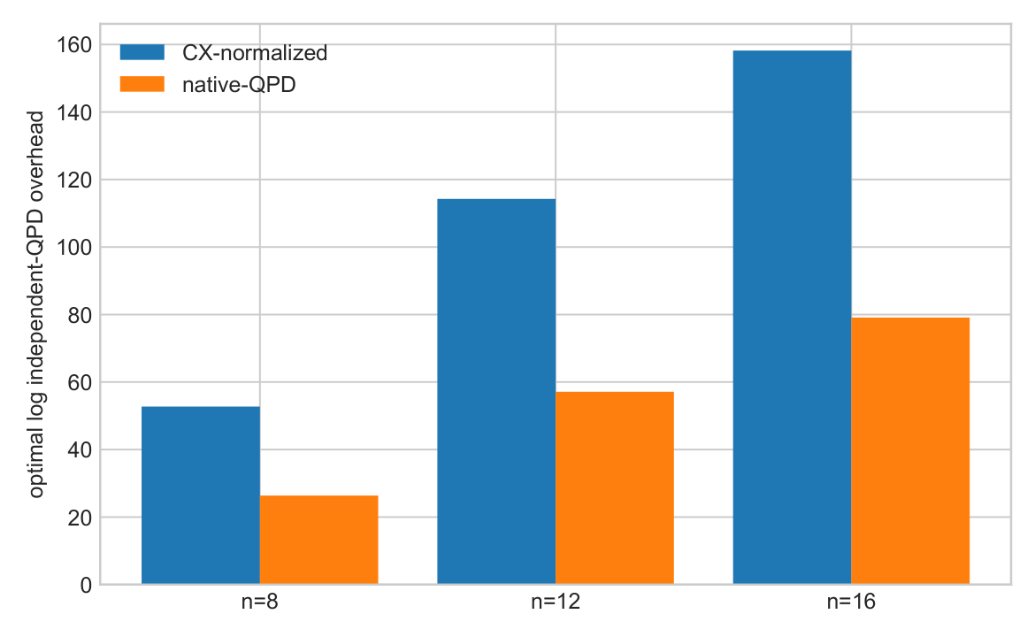
QAOA representation sensitivity under the independent-QPD model. Native $RZZ$ circuits contain fewer two-qubit gates and incur a smaller modeled optimum than their CX-normalized counterparts.

Comparison with Practical Automatic Cutting
E4 contains 60 Qiskit cut-finder records for QAOA, BV, and VQE at $n∈\{8,12,16\}$. Qiskit marks 24 records as “minimum reached.” For these records, the best balanced-$K=2$ objective equals the reported practical objective within numerical tolerance: the median, 90th percentile, and maximum restriction factors are 1.0, 1.0, and $1.000000000000007$. The agreement includes BV cases where Qiskit returns more than two fragments.
This is a narrow overlap result, not evidence of equivalence between balanced bisection and unconstrained practical cutting. It covers three circuit families, three sizes, one QPD model, and only records carrying Qiskit’s own optimality flag.

Exact Reconstruction Check
We pass two selected partitions through Qiskit’s complete gate-cutting pipeline: QPD replacement, fragment-experiment generation, exact statevector evaluation of every subexperiment, and observable reconstruction. For a six-qubit QAOA circuit, two native $RZZ$ cuts give predicted and executed overhead $Γ=33.9706$ and absolute reconstruction error $1.39×{10}^{−17}$. For a six-qubit VQE circuit, one CX cut gives overhead 9 and error $5.55×{10}^{−17}$. In both cases, the reconstructed expectation agrees with the uncut statevector to machine precision.
This small-scale test checks cost accounting and pipeline compatibility. It does not evaluate finite-shot variance: every QPD basis term is evaluated exactly.
Exact reconstruction check. Predicted and Qiskit-derived overheads agree; “Abs. error” compares reconstructed and uncut observables.
Circuit | Cuts | Pred. $Γ$ | Exec. $Γ$ | Abs. error
QAOA $n​=​6$, native $RZZ$ | 2 | 33.9706 | 33.9706 | $1.39​×​{10}^{−17}$​
VQE $n​=​6$, CX | 1 | 9 | 9 | $5.55​×​{10}^{−17}$​

RELATED WORK
Peng et al. [2] introduced circuit cutting for evaluating circuits wider than the available quantum device, building on quasiprobability simulation [3]. Mitarai and Fujii developed virtual-gate constructions and overhead bounds for nonlocal channel simulation [6], [15]. CutQC couples automatic partitioning with classical recombination [4], while Qiskit Addon Cutting implements gate-level QPD experiment generation and reconstruction [5]. Complementary directions include maximum-likelihood fragment tomography [16], fragmentation for error reduction [17], operator backpropagation [18], joint treatment of multiple two-qubit unitaries [19], and sampling bounds beyond bipartitions [20].
CertiCut addresses a narrower question: how to quantify the quality of a partition under a specified independent-QPD objective. Weighted bisection, branch-and-bound bounds, balanced-cut cardinality, and metric inequalities are established optimization machinery [7], [21]; we do not claim them as new. The contribution lies in connecting that machinery to gate-dependent QPD costs, proving the metric-redundancy result, translating global gaps into multiplicative sampling factors, and evaluating the resulting solver-tolerance protocol. Multilevel partitioners such as KaHIP [9] provide strong feasible bisections but do not supply the same global bound.

LIMITATIONS AND CONCLUSION

Limitations
The study has five principal limitations. First, exact balance and $K=2$ exclude unequal and multi-fragment decompositions. Second, the objective is the independent gate-level QPD model of Qiskit Addon Cutting 0.10; it excludes joint decompositions, routing, noise, and finite-shot effects, and its representation results depend on the chosen basis and software version. Third, E5 establishes heterogeneous-objective sensitivity only through deterministic synthetic circuits at $n≤16$; its 120 runs are not a large-scale real-circuit performance benchmark, and the nine small native E3 checks show no reversal. Fourth, the empirical scale ends at $n=40$, unrestricted triangle separation already becomes costly there, and reconstruction covers only two six-qubit statevector cases. Fifth, the reported bounds come from floating-point LP solves and are not verified by directed rounding or rational reconstruction. They are solver-tolerance certificates, not formal numerical proofs. The mature-SCIP pilot also gives no evidence that the custom tree manager is faster than a mature MIP backend.
The frozen manifest records software versions, solver tolerance, seeds, experiment counts, and SHA-256 hashes. Reproducing the reported numbers requires this protocol; changing the solver stack requires regenerating the evidence.

Conclusion
CertiCut maps a global log-domain optimization gap to a circuit-cutting overhead factor $exp(UB−LB)$. We prove that metric inequalities are redundant for CP0 without balanced-cut cardinality; once cardinality is present, they improve every audited root. E5 directly validates the QPD-aware objective without zero-cost gates: even the best minimum-cut plan incurs strict QPD regret in 13.3% of a heterogeneous, registry-derived corpus. In the 420-instance CNOT-only corpus, all runs return solver-tolerance certificates and 99.3% close their numerical gaps within 60 s.
The result is intentionally scoped to balanced $K=2$, independent QPD, and logical all-to-all connectivity. Within that scope, the mathematical formulation is backend-independent and can be paired with either the reference implementation or a mature MIP solver. Extending it to verified numerical bounds, joint-QPD objectives, finite-shot estimators, hardware-aware routing, and general multi-fragment cutting remains open.

ACKNOWLEDGMENT
The authors gratefully acknowledge the open-source communities behind Qiskit, Qiskit Addon Cutting, SciPy/HiGHS, KaHIP, and MQT Bench, whose software made the implementation and evaluation of this work possible.

FAMILY-LEVEL RESULTS AT $n=40$
Table 8 breaks down the largest evaluated size by graph family. Median time ranges from 0.809 s for community instances to 37.215 s for weighted-random instances. These values describe the evaluated samples; they do not establish a causal relationship between graph structure and computational difficulty.
Family-level performance breakdown at $n=40$. Each family contains ten seeded instances.
Family | Proven | Med. time (s) | p90 time (s)
Community | 10/10 | 0.809 | 1.186
Nearest-neighbor | 10/10 | 1.646 | 1.764
QAOA ring | 10/10 | 5.367 | 6.173
Noisy-community | 9/10 | 2.419 | 18.188
Random | 10/10 | 18.344 | 41.224
Dense | 10/10 | 24.070 | 52.669
Weighted-random | 8/10 | 37.215 | 60.067

CERTIFICATE SEMANTICS
We evaluate $F$ in the log domain to avoid overflow. “Closed” means a solver-reported gap $UB−LB≤{10}^{−9}$; it is not an independently verified exact proof. “Certificate unavailable” means that no safe boundary has completed by the checkpoint. At 60 s, all E1 runs have finite bounds; the three open runs retain positive gaps and nonempty frontiers and are classified as time-limit certificates.

REFERENCES

REFERENCES
[1] J. Preskill, Quantum computing in the NISQ era and beyond, Quantum, vol. 2, pp. 79, 2018.
[2] T. Peng, A. W. Harrow, M. Ozols, X. Wu, Simulating large quantum circuits on a small quantum computer, Physical Review Letters, vol. 125, pp. 150504, 2020.
[3] S. Bravyi, G. Smith, J. A. Smolin, Trading classical and quantum computational resources, Physical Review X, vol. 6, pp. 021043, 2016.
[4] W. Tang, T. Tomesh, M. Suchara, J. Larson, M. Martonosi, CutQC: Using small quantum computers for large quantum circuit evaluations, Proceedings of the 26th ACM international conference on architectural support for programming languages and operating systems, pp. 473–486, 2021.
[5] A. M. Branczyk, A. Carrera Vazquez, D. J. Egger, others, Qiskit addon: Circuit cutting, 2024.
[6] K. Mitarai, K. Fujii, Constructing a virtual two-qubit gate by sampling single-qubit operations, New Journal of Physics, vol. 23, pp. 023021, 2021.
[7] M. M. Deza, M. Laurent, Geometry of cuts and metrics, 1997.
[8] P. Virtanen, R. Gommers, T. E. Oliphant, others, SciPy 1.0: Fundamental algorithms for scientific computing in python, Nature Methods, vol. 17, pp. 261–272, 2020.
[9] P. Sanders, C. Schulz, Think locally, act globally: Highly balanced graph partitioning, Experimental algorithms, vol. 7933, pp. 164–175, 2013.
[10] N. Quetschlich, L. Burgholzer, R. Wille, MQT bench: Benchmarking software and design automation tools for quantum computing, Quantum, vol. 7, pp. 1062, 2023.
[11] K. Bestuzheva, P. Beskrovny, L. Eifler, others, The SCIP optimization suite 8.0, ACM Transactions on Mathematical Software, vol. 49, pp. 11:1–11:47, 2023.
[12] E. Farhi, J. Goldstone, S. Gutmann, A quantum approximate optimization algorithm, arXiv preprint arXiv:1411.4028, 2014.
[13] A. Peruzzo, J. McClean, P. Shadbolt, M.-H. Yung, X.-Q. Zhou, P. J. Love, A. Aspuru-Guzik, J. L. O’Brien, A variational eigenvalue solver on a photonic quantum processor, Nature Communications, vol. 5, pp. 4213, 2014.
[14] J. R. McClean, J. Romero, R. Babbush, A. Aspuru-Guzik, The theory of variational hybrid quantum-classical algorithms, New Journal of Physics, vol. 18, pp. 023023, 2016.
[15] K. Mitarai, K. Fujii, Overhead for simulating a non-local channel with local channels by quasiprobability sampling, Quantum, vol. 5, pp. 388, 2021.
[16] M. A. Perlin, Z. H. Saleem, M. Suchara, J. C. Osborn, Quantum circuit cutting with maximum-likelihood tomography, npj Quantum Information, vol. 7, pp. 64, 2021.
[17] S. Basu, A. Das, A. Saha, A. Chakrabarti, S. Sur-Kolay, FragQC: An efficient quantum error reduction technique using quantum circuit fragmentation, Journal of Systems and Software, vol. 214, pp. 112085, 2024.
[18] D. Pal, R. Majumdar, Low overhead circuit cutting with operator backpropagation, Quantum Information Processing, vol. 25, pp. 274, 2026.
[19] L. Schmitt, C. Piveteau, D. Sutter, Cutting circuits with multiple two-qubit unitaries, Quantum, vol. 9, pp. 1634, 2025.
[20] J. Nakamura, T. Satoh, S. Sanji, Improved sampling bounds and scalable partitioning for quantum circuit cutting beyond bipartitions, Physical Review A, vol. 112, pp. 042422, 2025.
[21] E. L. Lawler, D. E. Wood, Branch-and-bound methods: A survey, Operations Research, vol. 14, pp. 699–719, 1966.

