Proposed Solution

Preliminary Architecture
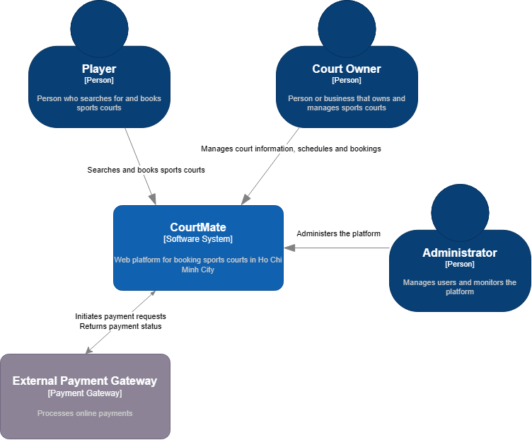
C4 System Context diagram of CourtMate
The proposed system is a web-based sports court booking platform designed for customers and sports facility owners in Ho Chi Minh City.
Customers can search for sports courts by location, sport type, price range, and available time slots. They can view court details, check availability, create bookings, and manage their booking history.
Court owners can manage court information, operating schedules, pricing, and reservations. Administrators are responsible for managing user accounts, verifying court information, and monitoring system activities.
The system may integrate with external payment gateways to process online payments and email services to send booking confirmations and reservation updates. These integrations will be implemented according to the project's functional requirements.
The architecture separates user interactions, business logic, and data management to improve maintainability, security, and future extensibility.

Technology Stack
Layer | Technology | Reason for choice
Front end | ReactJS, Vite | Builds a responsive and interactive user interface.
Back end | Python + FastApi | Provides REST APIs and handles booking operations.
Database | Postgres | Stores user accounts, court information, schedules, and bookings.
Hosting / deployment | Vercel, Neon, Render | Deploys the frontend and backend online.
Testing & CI | Pytest, FastAPI TestClient, Github Action | Tests API functionality and automates testing when code changes.

Hardware and Operating Environment
Hardware Requirements
The project can be developed and tested on standard desktop or laptop computers with the following recommended specifications:
- Processor: Dual-core processor or higher.
- Memory: Minimum 8 GB RAM, with 16 GB recommended for smoother development.
- Storage: At least 10 GB of available disk space for source code, dependencies, and development tools.
- Network: A stable Internet connection for accessing cloud services, the source code repository, and the deployed application.
Software and Development Environment
- Operating System: Windows 10/11, macOS, or Linux.
- Development Tools: Visual Studio Code and Git for coding and version control.
- Frontend Environment: ReactJS and Node.js with npm for developing and running the frontend.
- Backend Environment: Python and FastAPI for implementing RESTful APIs and business logic.
- Database: PostgreSQL hosted on Neon for storing user accounts, sports court information, schedules, and booking records.
- Testing and CI: Pytest and FastAPI TestClient for backend testing, with GitHub Actions for automated testing and continuous integration.
- Web Browsers: Google Chrome, Microsoft Edge, or Mozilla Firefox for testing functionality and responsive layouts.
Deployment Environment
The frontend is deployed on Vercel, while the FastAPI backend is hosted on Render. Neon provides the managed PostgreSQL database. These cloud services allow the team to deploy and access the application online without maintaining dedicated physical servers.
Environment variables are used to configure database connections, API URLs, and other sensitive settings. Access credentials must be kept out of the source code repository. HTTPS and appropriate access controls should be enabled to protect communication and application data.

