Project Plan

Process and Phase Gates
CourtMate follows the course's Waterfall phase-gate process. Each Project Assignment (PA) produces a reviewed deliverable that becomes the baseline for the next phase; approved changes must be documented in the subsequent PA. PA0 requires TA approval before PA1 officially proceeds. Exact submission times must be checked on Moodle.
Table 4.1. Project phase gates and exit criteria
PA | Phase | Due | Exit criteria
PA1 | Initiation & planning | End of week 3 | Reviewed vision, C4 Context, WBS, effort, Gantt, roles, risk register and collaboration setup.
PA2 | Requirements | End of week 5 | Numbered functional/nonfunctional requirements, use cases, mockups and traceability reviewed.
PA3 | Design | End of week 7 | Reviewed C4/ADRs, database ERD, UML diagrams and UI/API specifications.
PA4 | Test planning | End of week 8 | Test plan with EP, BVA, decision tables, repeatable test cases and requirement coverage.
PA5 | Implementation, testing & deployment | End of week 10 | Must-have system deployed; tests, defects, coverage, CI, automated scenarios and demo evidence.
Final | Presentation & demo | Week 11 | Live demo, presentation, individual Q&A and final handoff.

Work Breakdown Structure (WBS)
The WBS has three levels: Level 1 = project phase; Level 2 = deliverable/workstream; Level 3 = a work package with a single accountable owner and estimated effort. The current plan contains 38 Level-3 work packages across PA1–PA5, Final and ongoing management. After approval, each package should be tracked as an Issue with an owner and due date in GitHub Projects.
Level 2 workstreams: 1.1 Vision; 1.2 Solution; 1.3 Planning; 2.1 Analysis; 2.2 Validation; 3.1 Architecture; 3.2 Detailed Design; 4.1 Test Strategy; 4.2 Test Cases; 5.1 Core Platform; 5.2 Booking & Release; 6.1 Presentation; 7.1 Management.
The full 38-package WBS (one accountable owner and effort estimate per package) is shown in the Estimation table below. The live spreadsheet additionally contains reviewers, start/due dates, dependencies, deliverables and the detailed Gantt:
Supporting workbook: T05-CourtMate — WBS, Gantt, CPM & Cost

Estimation
Method: experience-based expert judgement and analogy with student web/API, documentation, design and testing work. One person-hour is one person's hour of work, NOT elapsed schedule time. Numbers are initial planning estimates and must be confirmed by their task owners.
Table 4.2. Level-3 work packages and effort estimates (38 packages)
WBS ID | Work package | Owner | Effort (h) | Method / assumptions
1.1.1 | Problem & product position statement | Quang | 6 | Expert judgement
1.1.2 | Stakeholders, MoSCoW & exclusions | Quang | 6 | Expert judgement
1.2.1 | C4 System Context diagram | Hiếu | 4 | Expert judgement
1.2.2 | Technology stack & operating environment | Hiếu | 4 | Expert judgement
1.3.1 | WBS, estimates, Gantt, CPM, roles & cost | Hưng | 9 | Expert judgement
1.3.2 | Risk register & mitigation | Trung | 5 | Expert judgement
1.3.3 | Tools, collaboration & PA1 integration | Hưng | 7 | Expert judgement
2.1.1 | Actors, roles & booking business rules | Quang | 6 | Expert judgement
2.1.2 | Functional / nonfunctional requirements & AC | Quang | 9 | Expert judgement
2.1.3 | Use-case model and specifications | Trung | 8 | Expert judgement
2.2.1 | Main UI mockups and user journeys | Hiếu | 8 | Analogy / UI
2.2.2 | Traceability, review & PA2 submission | Hưng | 7 | Expert judgement
3.1.1 | C4 Container / deployment & ADRs | Hiếu | 9 | Expert judgement
3.1.2 | Database ERD, constraints & indexes | Quang | 9 | Expert judgement
3.2.1 | Class, sequence & state diagrams | Hiếu | 10 | Expert judgement
3.2.2 | UI specifications & API contracts | Hưng | 8 | Analogy / UI
3.2.3 | Consistency review & PA3 submission | Trung | 6 | Expert judgement
4.1.1 | Test plan, levels & environment | Trung | 5 | Expert judgement
4.1.2 | EP, BVA & decision tables | Quang | 6 | Expert judgement
4.2.1 | Repeatable test cases & requirement coverage | Hiếu | 9 | Expert judgement
4.2.2 | PA4 peer review & submission | Trung | 3 | Expert judgement
5.1.1 | Backend/frontend scaffold, database & CI | Hưng | 6 | Expert judgement
5.1.2 | Authentication & profile APIs + unit tests | Hưng | 8 | Expert judgement
5.1.3 | Court, schedule & availability APIs | Quang | 10 | Expert judgement
5.1.4 | Browse/search/detail screens | Hiếu | 7 | Analogy / UI
5.1.5 | Login and profile screens | Hiếu | 5 | Analogy / UI
5.2.1 | Atomic booking API & concurrency tests | Hưng | 11 | Analogy + risk buffer
5.2.2 | Cancellation & owner booking APIs | Quang | 8 | Expert judgement
5.2.3 | Booking/My Bookings/owner screens | Hiếu | 11 | Analogy / UI
5.2.4 | Unit coverage, E2E automation, regression | Trung | 12 | Expert judgement
5.2.5 | Staging, production deploy & CI verification | Quang | 8 | Expert judgement
5.2.6 | Regression results & defect report | Trung | 5 | Expert judgement
5.2.7 | Final smoke check, demo video & PA5 evidence | Trung | 4 | Expert judgement
6.1.1 | Presentation slides & demo storyline | Hiếu | 6 | Expert judgement
6.1.2 | Team rehearsal & demonstration checks | Hưng | 5 | Expert judgement
6.1.3 | Retrospective, Q&A & final delivery | Trung | 5 | Expert judgement
7.1.1 | W02–W10 weekly reports & meetings | Hưng | 9 | Expert judgement
7.1.2 | Board updates, decisions & risk follow-up | Quang | 7 | Expert judgement

Estimated effort by phase (see live Sheet for all work packages):
Table 4.3. Effort allocation by project phase (271 person-hours)
Phase | Effort (person-hours) | Planned weeks
PA1 — Initiation & planning | 41 | W02–W03
PA2 — Requirements | 38 | W04–W05
PA3 — Design | 42 | W06–W07
PA4 — Test planning | 23 | W08
PA5 — Implementation/testing | 95 | W09–W10
Final — Presentation | 16 | W11
Ongoing — Weekly management | 16 | W02–W10
TOTAL | 271
Proposed member effort: Hưng 70 h; Quang 75 h; Hiếu 73 h; Trung 53 h. These are estimates, not completed-work statistics or member contribution percentages.
Feasibility warning: PA5 alone requires 95 person-hours over two weeks (Hưng 25 h, Quang 26 h, Hiếu 23 h, Trung 21 h). The team must confirm this workload against the 5–7 hours/member/week norm in PA0, or adjust resources/timing and obtain TA approval before changing any Must-have scope.

Schedule
The Gantt, milestones, dependencies and critical-path assumptions are summarized below.
Phase windows (assuming W02 = 05–11 Oct 2026): PA1 W02–W03, PA2 W04–W05, PA3 W06–W07, PA4 W08, PA5 W09–W10 and Final W11. Week-level milestones come from the course; exact Moodle cut-off times remain to be confirmed.
Figure 1. CourtMate phase Gantt (weekly timeline, proposed)
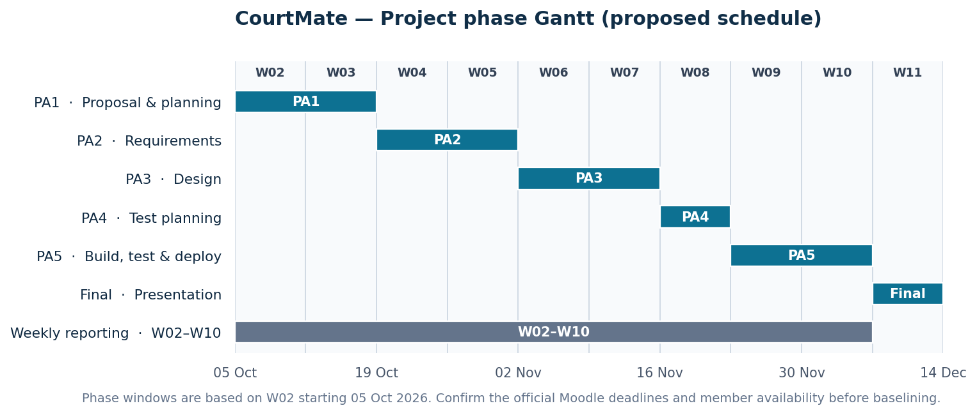
Detailed schedule and task dependencies: Open WBS/Gantt workbook
Key dependencies: PA0 approval → PA1 proposal → PA2 requirements → PA3 design → PA4 test planning → PA5 build/test/deployment → Final demo. Tasks inside a phase may overlap when dependencies and member availability allow.
Critical path (phase-gate level): PA1 (2 weeks) → PA2 (2) → PA3 (2) → PA4 (1) → PA5 (2) → Final (1) = 10 calendar weeks (W02–W11) with zero slack under the fixed phase-gate assumptions.
Booking subnetwork CPM (illustrative): Scaffold A (2 days) → Court/availability API B (5) → Atomic booking API D (3) → Booking UI integration E (3) → Release/demo gate F (1) = 14 elapsed days, from 23 Nov to 06 Dec. Browse/detail UI C (5 days) runs in parallel after A with 3 days of float. This is NOT the verified whole-project critical path; task durations and resource constraints still require team approval.
PA1 internal drafts due Friday 16 Oct; peer review due Saturday 17 Oct. Submission follows the Moodle due time.

Roles and Responsibilities
Table 4.4. Project roles and responsibilities
Role | Main | Backup | Responsibilities
Team lead / Project manager | Hưng | Quang (proposed) | Scope, assignments, schedule, risk escalation, weekly reports and TA contact
Business analyst | Quang | Trung (proposed) | Elicit rules and requirements; organize review and traceability
Designer / Architect | Hiếu | Quang (proposed) | C4/UML, UI design, API and database architecture coordination
Developers | Hưng, Quang, Hiếu | Trung (support) | Implement and unit-test modules; review PRs and integrate functionality
Software tester | Trung | Hiếu (proposed) | Test plan, EP/BVA, test cases, automation and defect/test reports

PA1 review ownership: Quang drafts §2 (Hưng reviews); Hiếu drafts §3 (Trung reviews); Hưng drafts §§4 and 6 (Quang reviews); Trung drafts §5 (Hiếu reviews). Backups for later PAs are proposals pending member agreement.

Human Resources and Cost Estimate
The project uses four student laptops and open-source tools. Proposed hosting: Vercel (React), Render (FastAPI), Neon (PostgreSQL), subject to free-tier availability and a successful deployment test. Labor below represents a hypothetical economic value, not cash wages.
Table 4.5. Cost estimation and assumptions
Item | Calculation / assumption | VND
Equivalent labor value | 271 h × 80,000 VND/h | 21,680,000
Contingency | 10% × labor value | 2,168,000
Optional domain | Illustrative allowance | 250,000
Hosting/database | Provisional free-tier budget | 0
TOTAL (illustrative) | Including optional domain | 24,098,000
At an assumed 80,000 VND/hour, labor is not an actual payment by the team. Expected direct cash expenditure is 0 VND on free tiers without a domain, or about 250,000 VND with the optional domain; provider overages are excluded. Check the hosting quotas and workload assumptions before finalizing PA1.
Planning figures are estimates, not actual effort or confirmed delivery results. Detailed calculations and dependencies are maintained in the linked project workbook and will be updated through the team review process.

