4 Object-Oriented Design
CourtMate uses a layered client-server design with a single modular FastAPI backend. The logical object model below separates persistent entities from application service interfaces. PA1 supplies the product scope and stack; the team-confirmed PA2 baseline of 10 November 2026 supplies the detailed business rules (49 FR, 5 NFR, 10 BR and 17 UC). PA2 refines F09 with Owner-configured automatic activation of a fixed slot offer; it does not introduce an automatic repricing engine.
Implementation mapping: entity classes map to SQLAlchemy models; the Bookings, Courts, Rooms and Offers service interfaces map to existing Python service modules. Their operations are design contracts, not an assertion that the current code implements Python instance methods. REST boundaries map to FastAPI route modules and their function-scope session dependency. No additional framework, repository layer, account role or database is required.
4.1 Domain Model
Figures 4.1a and 4.1b are two views of one conceptual model. They show business concepts and relationship multiplicities without operations. User has one account role, Player or Court Owner. Visitor describes unauthenticated access; Organizer is the Player who owns the source booking and creates its room.
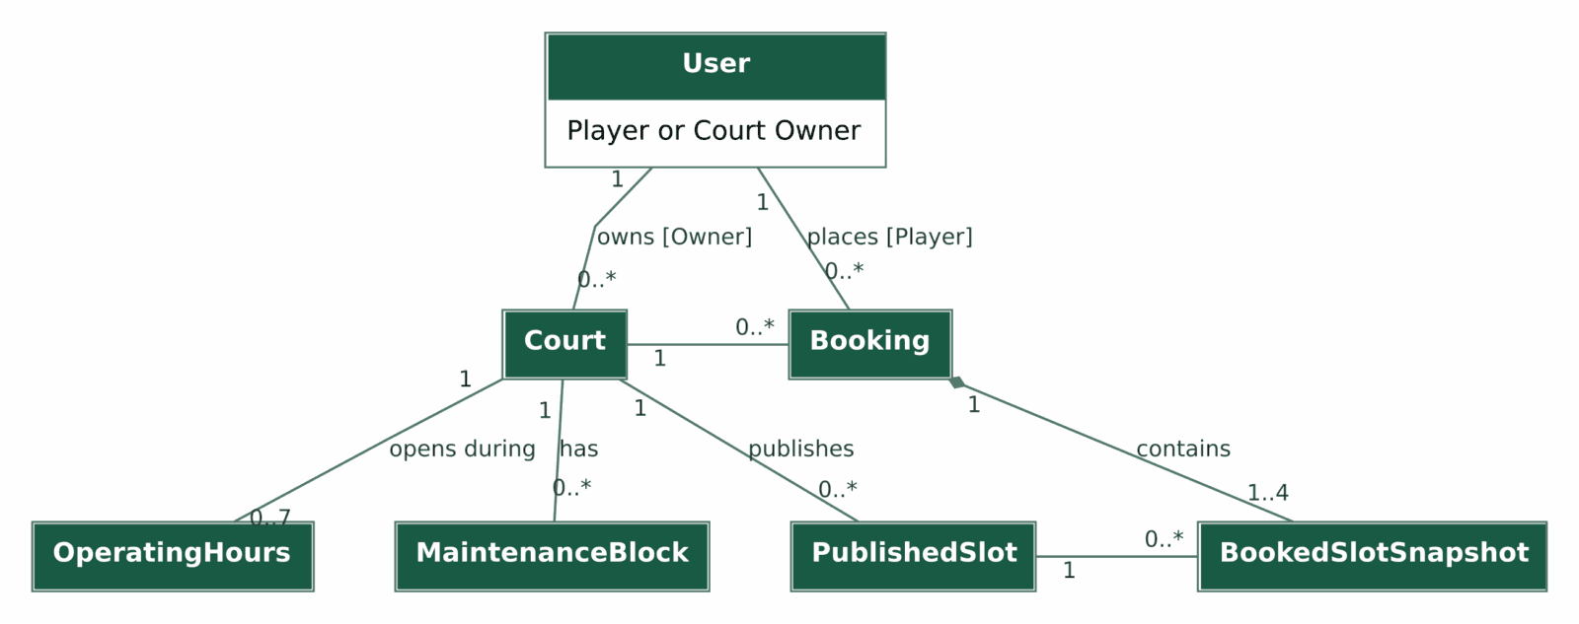
Figure 4.1a. Domain model for court scheduling and whole-booking reservations.
A Booking covers one court and local playing date, with 1-4 strictly consecutive selected slots and a combined duration of 60-240 minutes. The upper bound of four follows from the minimum 60-minute slot duration and maximum 240-minute booking. Snapshots preserve the times and prices accepted at confirmation.
Open Play and optional offers
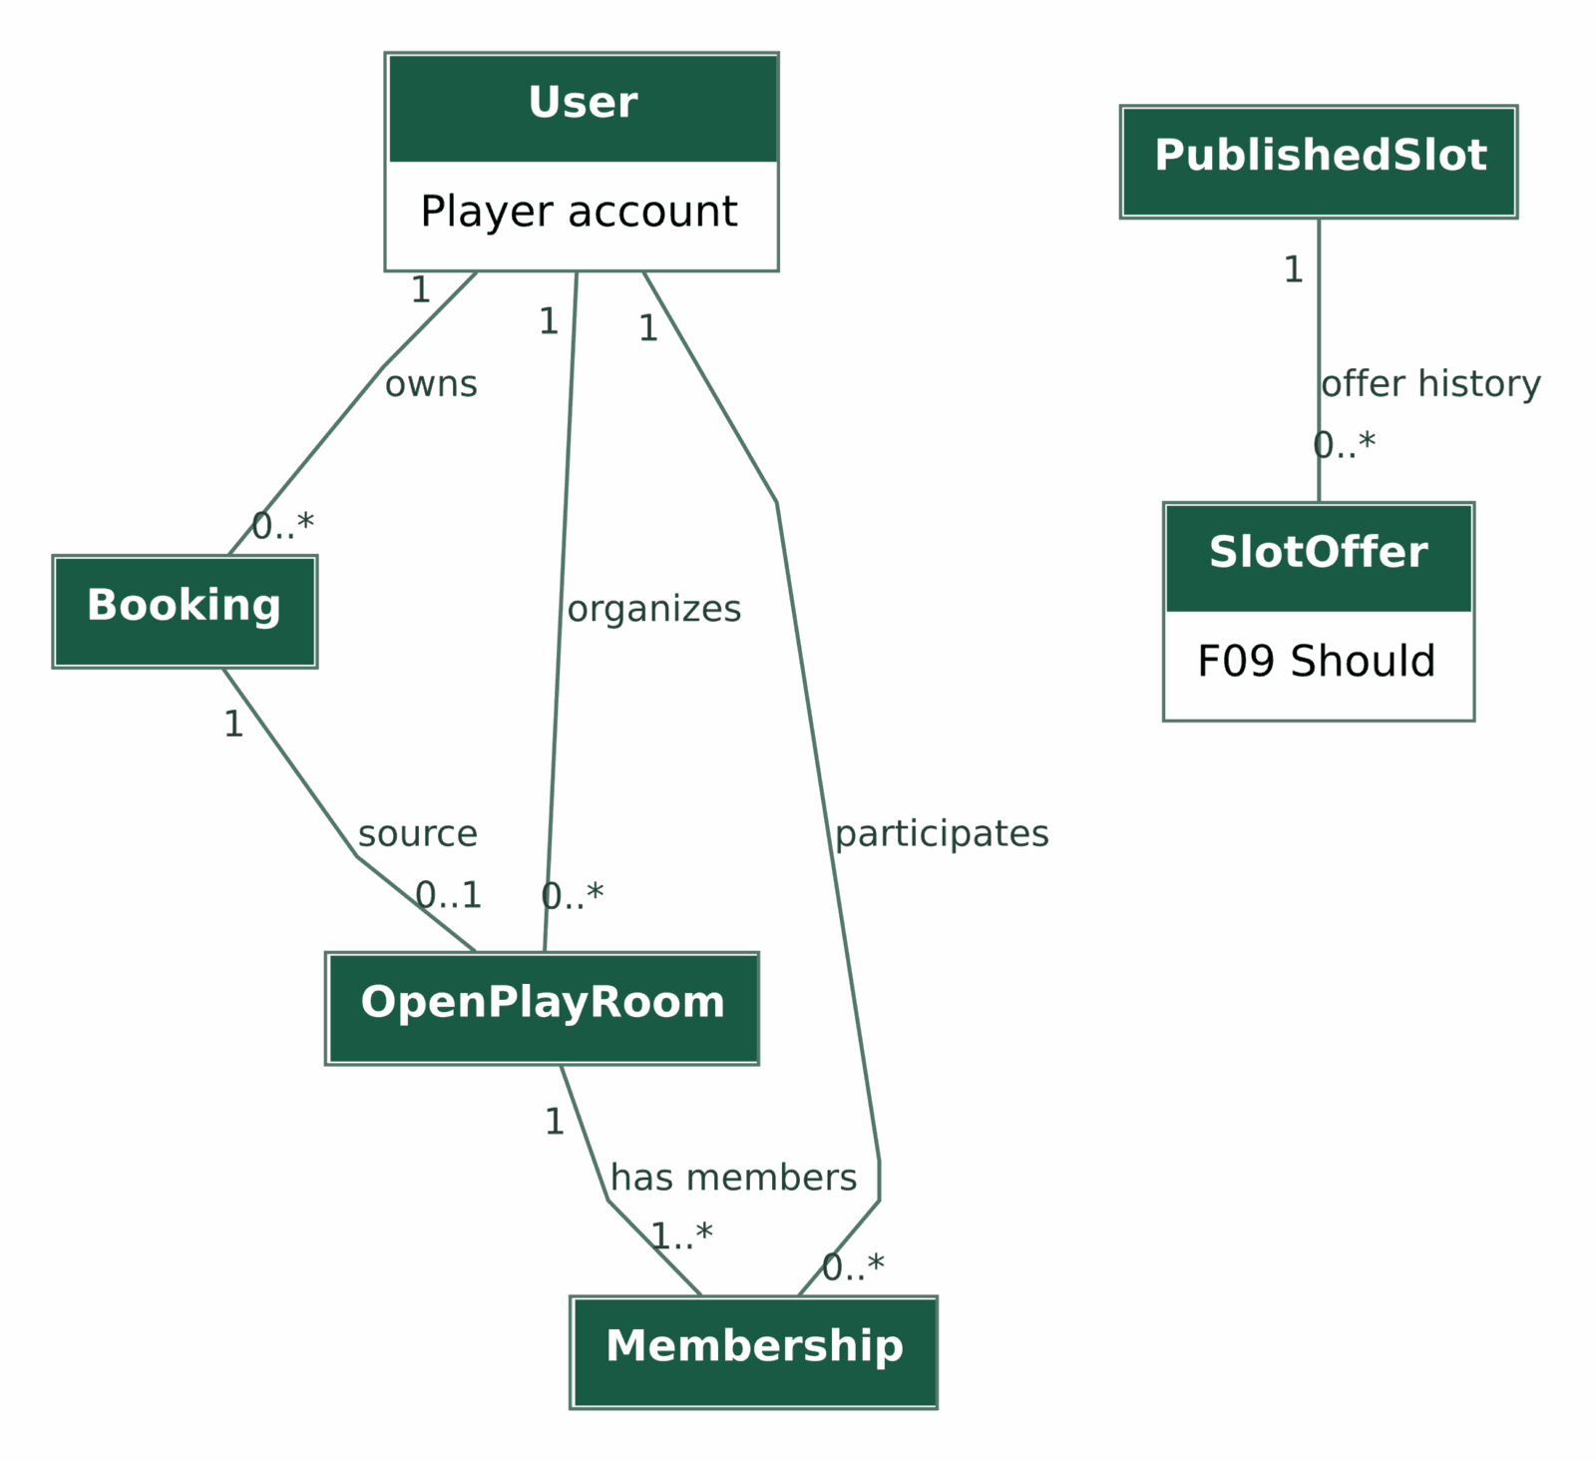
Figure 4.1b. Domain model for room participation and slot-specific offers.
Every Room has one source Booking and one Organizer; a Booking can have at most one Room over its entire history. The organizer is the first member and cannot leave independently. Room membership is bounded by its capacity, which is between 2 and twice the court max_players. Closing a room retains its roster and does not cancel its booking. A Slot can have multiple historical offers but at most one SCHEDULED or ACTIVE configuration.
Business trace: court/schedule concepts support UC-03/04/08/09; Booking and snapshots support UC-05/06/07/10; Room and Membership support UC-11/12/13/14/17; SlotOffer supports UC-16 (Should). BR-01 through BR-10 define the associated constraints.
4.2 Class Diagram
Notation: + means public state or operation; / marks a derived property; ? means nullable. Multiplicities are written at association endpoints. A filled diamond denotes a Booking-owned snapshot whose lifetime follows the booking history; cancellation retains the aggregate. All other entity connections are associations, not inheritance. Money is a positive whole-VND integer; Instant is timezone-aware.
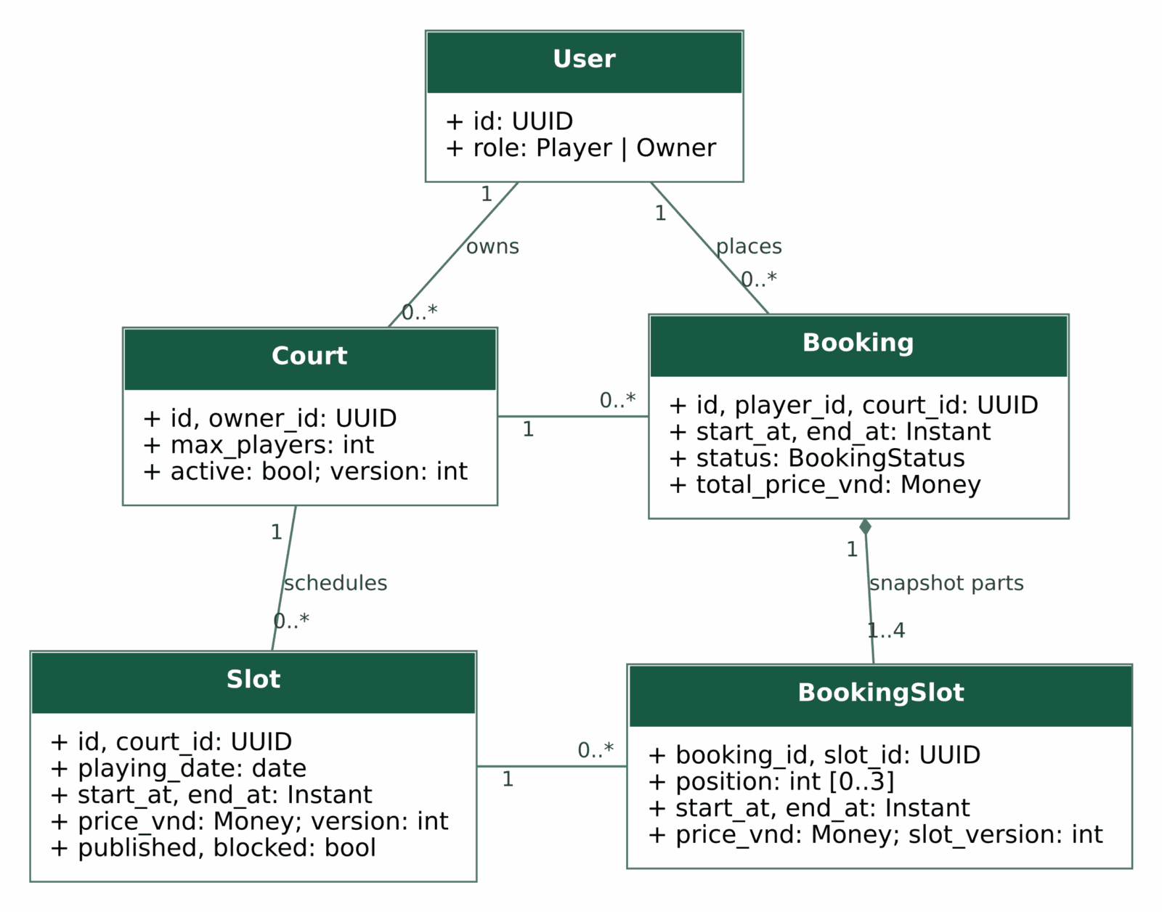
Figure 4.2a. Entity classes for courts, slots and booking snapshots.
Room and offer classes
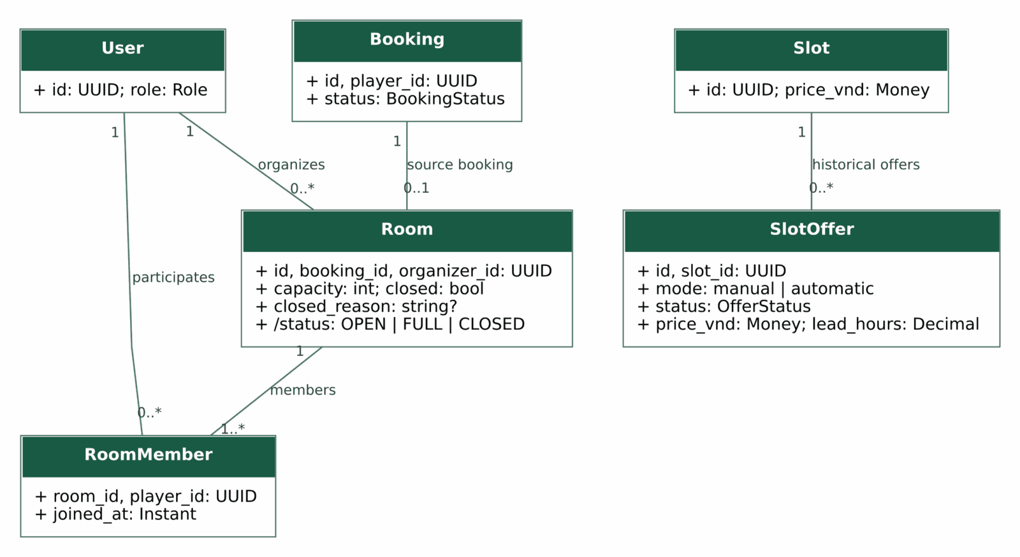
Figure 4.2b. Entity classes for room membership and optional slot offers.
Supporting persistence classes OperatingHours, MaintenanceBlock and SlotClaim appear in the ERD. Slot availability and Room OPEN/FULL are derived; the persisted closed flag makes closure irreversible. Room.organizer_id must equal the Player of its source booking. SlotOffer.mode and status are constrained enumerations, represented by checked strings in PostgreSQL.
Application service interfaces
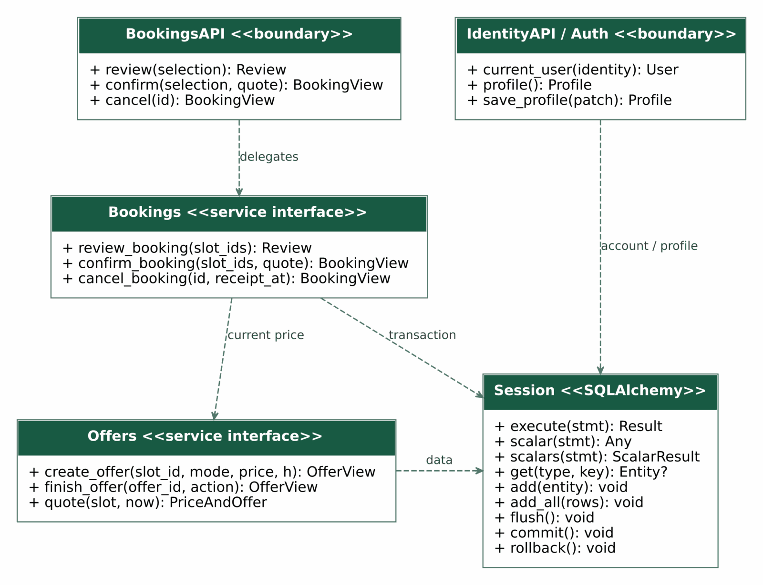
Figure 4.2c. Booking, offer and identity contracts with the SQLAlchemy Session.
Schedule and room service interfaces
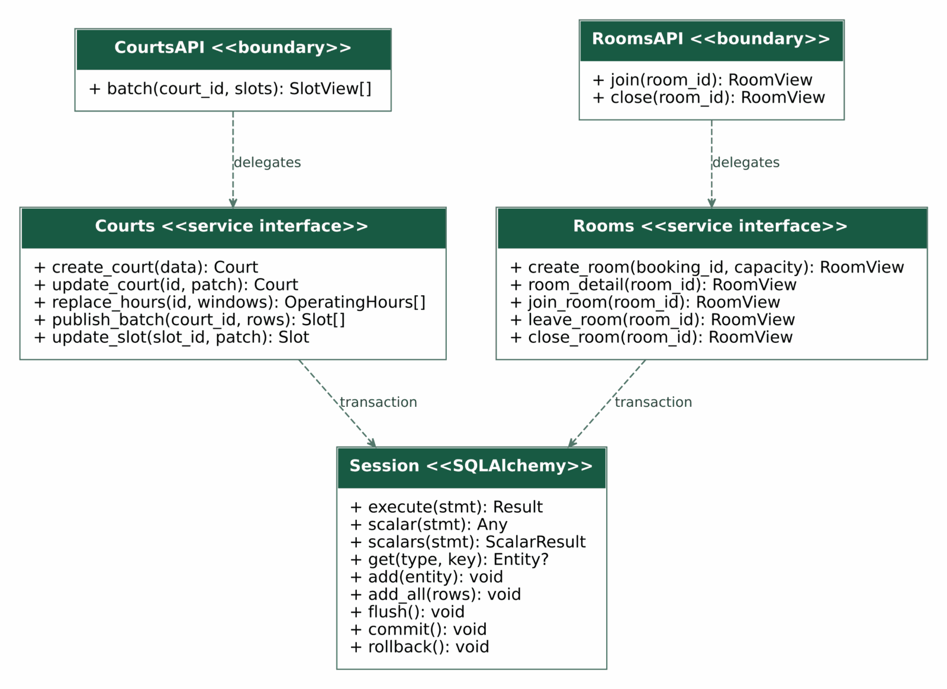
Figure 4.2d. Schedule and room service contracts; the same Session is shown again.
The common session: Session, authenticated user: User and server clock are injected and omitted from Figures 4.2c-d. IdentityAPI / Auth groups the existing account routes and authentication dependency; current_user receives verified provider claims. Profile and DTO types are logical response contracts. Section 4.3 uses the same operation names and ownership; query guards remain outside the entity classes. Dashed dependencies mean uses/delegates within the modular backend.
Design element | Implementation and responsibility
BookingsAPI / Bookings | api/bookings.py / services/bookings.py: review, confirm and cancel one aggregate; accepted price and active claims.
CourtsAPI / Courts | api/courts.py / services/courts.py: Owner mutations, schedule validation and batch publication.
RoomsAPI / Rooms | api/rooms.py / services/rooms.py: source-booking ownership, membership, capacity and sticky closure.
Offers | services/offers.py and api/offers.py: create, evaluate, cancel/deactivate one slot configuration; return effective quotes.
Session | SQLAlchemy Session; db/session.py commits after successful route completion and rolls back unhandled failures before an HTTP success is sent.
IdentityAPI / Auth | api/identity.py and core/auth.py: resolve current_user from verified claims; read/update only permitted profile fields.

4.3 Class Specifications
The eight principal entity specifications below use the template fields: superclass, responsibility, attributes with type/visibility/constraints, and associated operations with parameters and return. Each entity extends SQLAlchemy Base. Business operations belong to the service interface named in the operation column; they are not entity instance methods. Parameter abbreviations follow Section 4.2, and injected session/user/clock remain mandatory in implementation.
Class C1 User
Superclass: SQLAlchemy Base. Responsibility: Identity and one immutable-after-registration application role.
Attribute | Type | Vis. | Constraint | Description
id / firebase_uid | UUID / string(128) | + | PK / UQ, NN | Account and verified provider identifier
role | Role: player | owner | + | NN; checked | Role selected at legitimate initial registration; backend enforces subsequent immutability
registration_email | string(320)? | + | nullable | Owner-visible booking contact when present
display_name / contact_preferences | string(100/500) | + | NN; default empty | Basic optional profile fields
created_at | Instant | + | NN | Account creation

Owner | Operation / parameters / return | Vis. | Behavior
IdentityAPI / Auth | current_user(identity: Claims) -> User | + | Verify provider identity and resolve backend account; enforce role/resource ownership at protected routes.
IdentityAPI / Auth | profile() / save_profile(patch: ProfilePatch) -> Profile | + | FR-039/040 Should; only display_name and contact_preferences are writable. Role and provider identity remain protected.

Class C2 Court
Superclass: SQLAlchemy Base. Responsibility: An Owner-managed venue and the serialization root for schedule writes.
Attribute | Type | Vis. | Constraint | Description
id / owner_id | UUID / UUID | + | PK / FK User, NN | One owning Court Owner
name / sport / area / address | string(150/80/120/300) | + | NN | Discovery and venue detail
description / contact / photo_urls | string(4000/200) / string[] | + | NN; optional empty values | Published information
base_price_vnd / max_players | Money / int | + | >0 / 2..30 | Hourly display reference / court capacity
active / version | bool / int | + | NN / >0 | New-booking eligibility and quote version

Owner | Operation / parameters / return | Vis. | Behavior
Courts | create_court(data) / update_court(id, patch) -> Court | + | Owner-only changes; reject effects that invalidate CONFIRMED reservations.
Courts | replace_hours(id, windows) -> OperatingHours[] | + | Validate weekly windows and protected bookings; serialize through Court lock.

Class C3 Slot
Superclass: SQLAlchemy Base. Responsibility: A dated Owner-published court interval and regular full-slot quote.
Attribute | Type | Vis. | Constraint | Description
id / court_id | UUID / UUID | + | PK / FK Court, NN | One source court
playing_date / start_at / end_at | date / Instant / Instant | + | NN; grid and interval checks | Vietnam local date; 30-minute boundaries; duration 60-240 minutes
price_vnd / version | Money / int | + | >0 / >0 | Regular full-slot quote and version
published / blocked | bool / bool | + | NN | Publication and Owner block flags
/availability | AVAILABLE | BOOKED | BLOCKED | UNAVAILABLE | + | derived | Read from court/time/schedule/claims; not Slot.status in the DB

Owner | Operation / parameters / return | Vis. | Behavior
Courts | publish_batch(court_id, rows: Draft[]) -> Slot[] | + | Validate all rows before insert; one transaction; no fixed two-slot publication limit.
Courts | update_slot(slot_id, patch) -> Slot | + | Reject edits of a CONFIRMED booked slot; re-evaluate offer eligibility.

Class C4 Booking
Superclass: SQLAlchemy Base. Responsibility: One atomic reservation with immutable accepted time and total snapshots.
Attribute | Type | Vis. | Constraint | Description
id / player_id / court_id | UUID | + | PK / FK User / FK Court | One Player and one court
start_at / end_at | Instant | + | NN; total duration 60-240 minutes | First selected start and last selected end
status | CONFIRMED | CANCELLED | + | NN; checked | No persisted partial/PENDING booking
total_price_vnd | Money | + | NN; >0 | Sum of accepted per-slot prices
created_at / cancelled_at | Instant / Instant? | + | cancelled_at iff CANCELLED | Audit timestamps

Owner | Operation / parameters / return | Vis. | Behavior
Bookings | review_booking(slot_ids: UUID[]) -> Review | + | Revalidate selection and return a quote; does not reserve slots.
Bookings | confirm_booking(slot_ids, quote: string) -> BookingView | + | Lock and recheck; atomically create Booking, BookingSlot and SlotClaim rows.
Bookings | cancel_booking(id: UUID, receipt_at: Instant) -> BookingView | + | Own CONFIRMED booking; >=6 hours at authoritative receipt; release all claims and close linked room.

Class C5 BookingSlot
Superclass: SQLAlchemy Base. Responsibility: The ordered accepted snapshot of one selected slot.
Attribute | Type | Vis. | Constraint | Description
booking_id / slot_id | UUID / UUID | + | composite PK; two FKs | One historical slot per booking
position | int | + | 0..3; UQ(booking_id,position) | Chronological order
start_at / end_at | Instant | + | NN; end > start | Accepted playing interval
price_vnd / slot_version | Money / int | + | >0 / validated >0 | Accepted price and slot version

Owner | Operation / parameters / return | Vis. | Behavior
Bookings | confirm_booking(slot_ids, quote) -> BookingView | + | Constructs all snapshots internally; there is no independent snapshot CRUD endpoint.
Bookings | cancel_booking(id, receipt_at) -> BookingView | + | Retains snapshots while releasing the corresponding active claims.

Class C6 Room
Superclass: SQLAlchemy Base. Responsibility: One public room linked to one future confirmed booking.
Attribute | Type | Vis. | Constraint | Description
id / booking_id / organizer_id | UUID | + | PK / UQ FK Booking / FK User | Organizer equals the source booking Player
capacity | int | + | 2..60; service <=2 x court.max_players | Includes organizer
closed / closed_reason | bool / string(32)? | + | sticky closure / nullable reason | ORGANIZER_CLOSED, BOOKING_CANCELLED or PLAY_STARTED
/status | OPEN | FULL | CLOSED | + | derived | Closure has priority over count
created_at | Instant | + | NN | Room creation

Owner | Operation / parameters / return | Vis. | Behavior
Rooms | create_room(booking_id: UUID, capacity: int) -> RoomView | + | Own eligible booking; no previous room; insert organizer membership in same transaction.
Rooms | close_room(room_id: UUID) -> RoomView | + | Organizer only; OPEN/FULL can close; repeat closure returns current state and preserves its reason.
Rooms | room_detail(room_id: UUID) -> RoomView | + | Re-evaluate effective state and return roster and informational estimate.

Class C7 RoomMember
Superclass: SQLAlchemy Base. Responsibility: A Player participation record; it creates no payment obligation.
Attribute | Type | Vis. | Constraint | Description
room_id / player_id | UUID / UUID | + | composite PK; FKs Room/User | Prevents duplicate membership
joined_at | Instant | + | NN | Current roster order

Owner | Operation / parameters / return | Vis. | Behavior
Rooms | join_room(room_id: UUID) -> RoomView | + | Player only, not already a member, OPEN and below capacity; locks serialize the final place.
Rooms | leave_room(room_id: UUID) -> RoomView | + | Non-organizer current member and non-CLOSED room; delete membership and recompute estimate.

Class C8 SlotOffer
Superclass: SQLAlchemy Base. Responsibility: An Owner-configured fixed slot discount, F09 Should.
Attribute | Type | Vis. | Constraint | Description
id / slot_id | UUID / UUID | + | PK / FK Slot | Exactly one target slot
mode | manual | automatic | + | NN; checked | Immediate manual or configured threshold activation
price_vnd / lead_hours | Money / Decimal | + | >0; service < regular / 0<h<=24 | Manual mode uses h=24; fractional automatic thresholds allowed
status | OfferStatus | + | five checked states | SCHEDULED, ACTIVE, CANCELLED, DEACTIVATED, EXPIRED
created_at | Instant | + | NN | Configuration audit

Owner | Operation / parameters / return | Vis. | Behavior
Offers | create_offer(slot_id, mode, price: Money, h: Decimal) -> OfferView | + | Owned eligible slot; at most one nonterminal configuration; manual window <=24h.
Offers | finish_offer(offer_id: UUID, action: cancel|deactivate) -> OfferView | + | Re-evaluate state, then cancel SCHEDULED or deactivate ACTIVE with explicit confirmation.
Offers | quote(slot: Slot, now: Instant) -> PriceAndOffer | + | Uses current eligibility; never alters an existing booking total.

4.4 Sequence Diagrams
Five key PA2 use cases are shown with true alt combined fragments. Solid arrows call operations in Figures 4.2c-d; dashed arrows return results/errors through the service and REST boundary. UI events use the route-operation name. The REST boundary includes authorization dependencies and get_session() finalization, so commit/rollback precedes the HTTP result. UC-05 is split into review and confirmation stages; they are separate requests, not one long transaction.
UC-05 Review stage
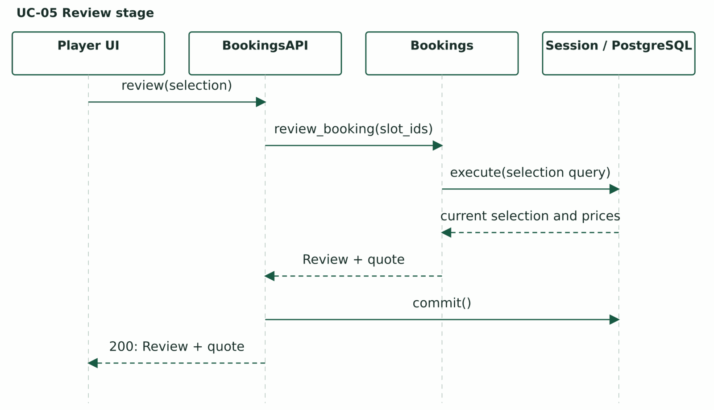
Figure 4.4a1. UC-05 review returns an explicit quote without reserving slots.
The Player explicitly accepts the displayed quote before the next confirmation request. Review is not a reservation.
UC-05 Review and confirm booking
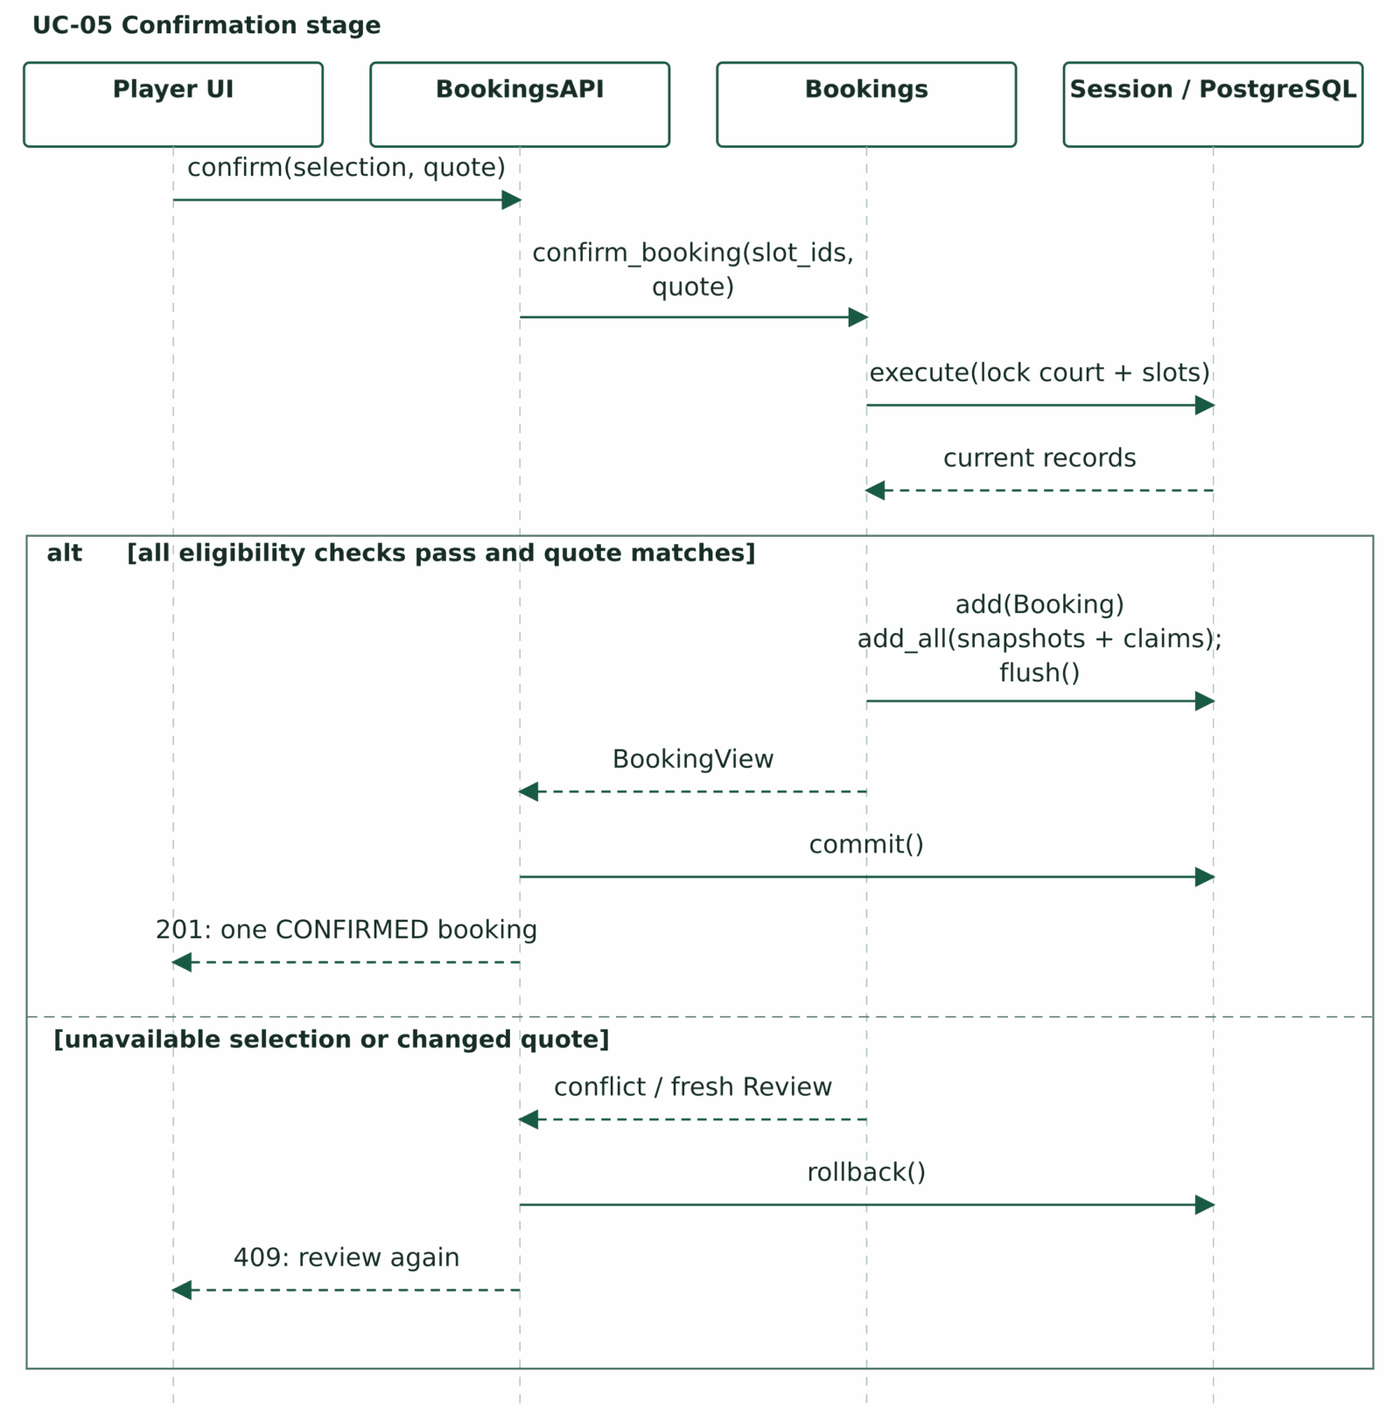
Figure 4.4a. UC-05 Review and confirm booking.
Endpoint: POST /api/bookings/review; POST /api/bookings.
Trace: FR-014-018, FR-044/045 when F09 applies; BR-01/03/07/10; NFR-02.
Validate role, active court, future/consecutive same-date slots, no conflicts and current effective prices under the locks.
UC-07 Cancel whole booking
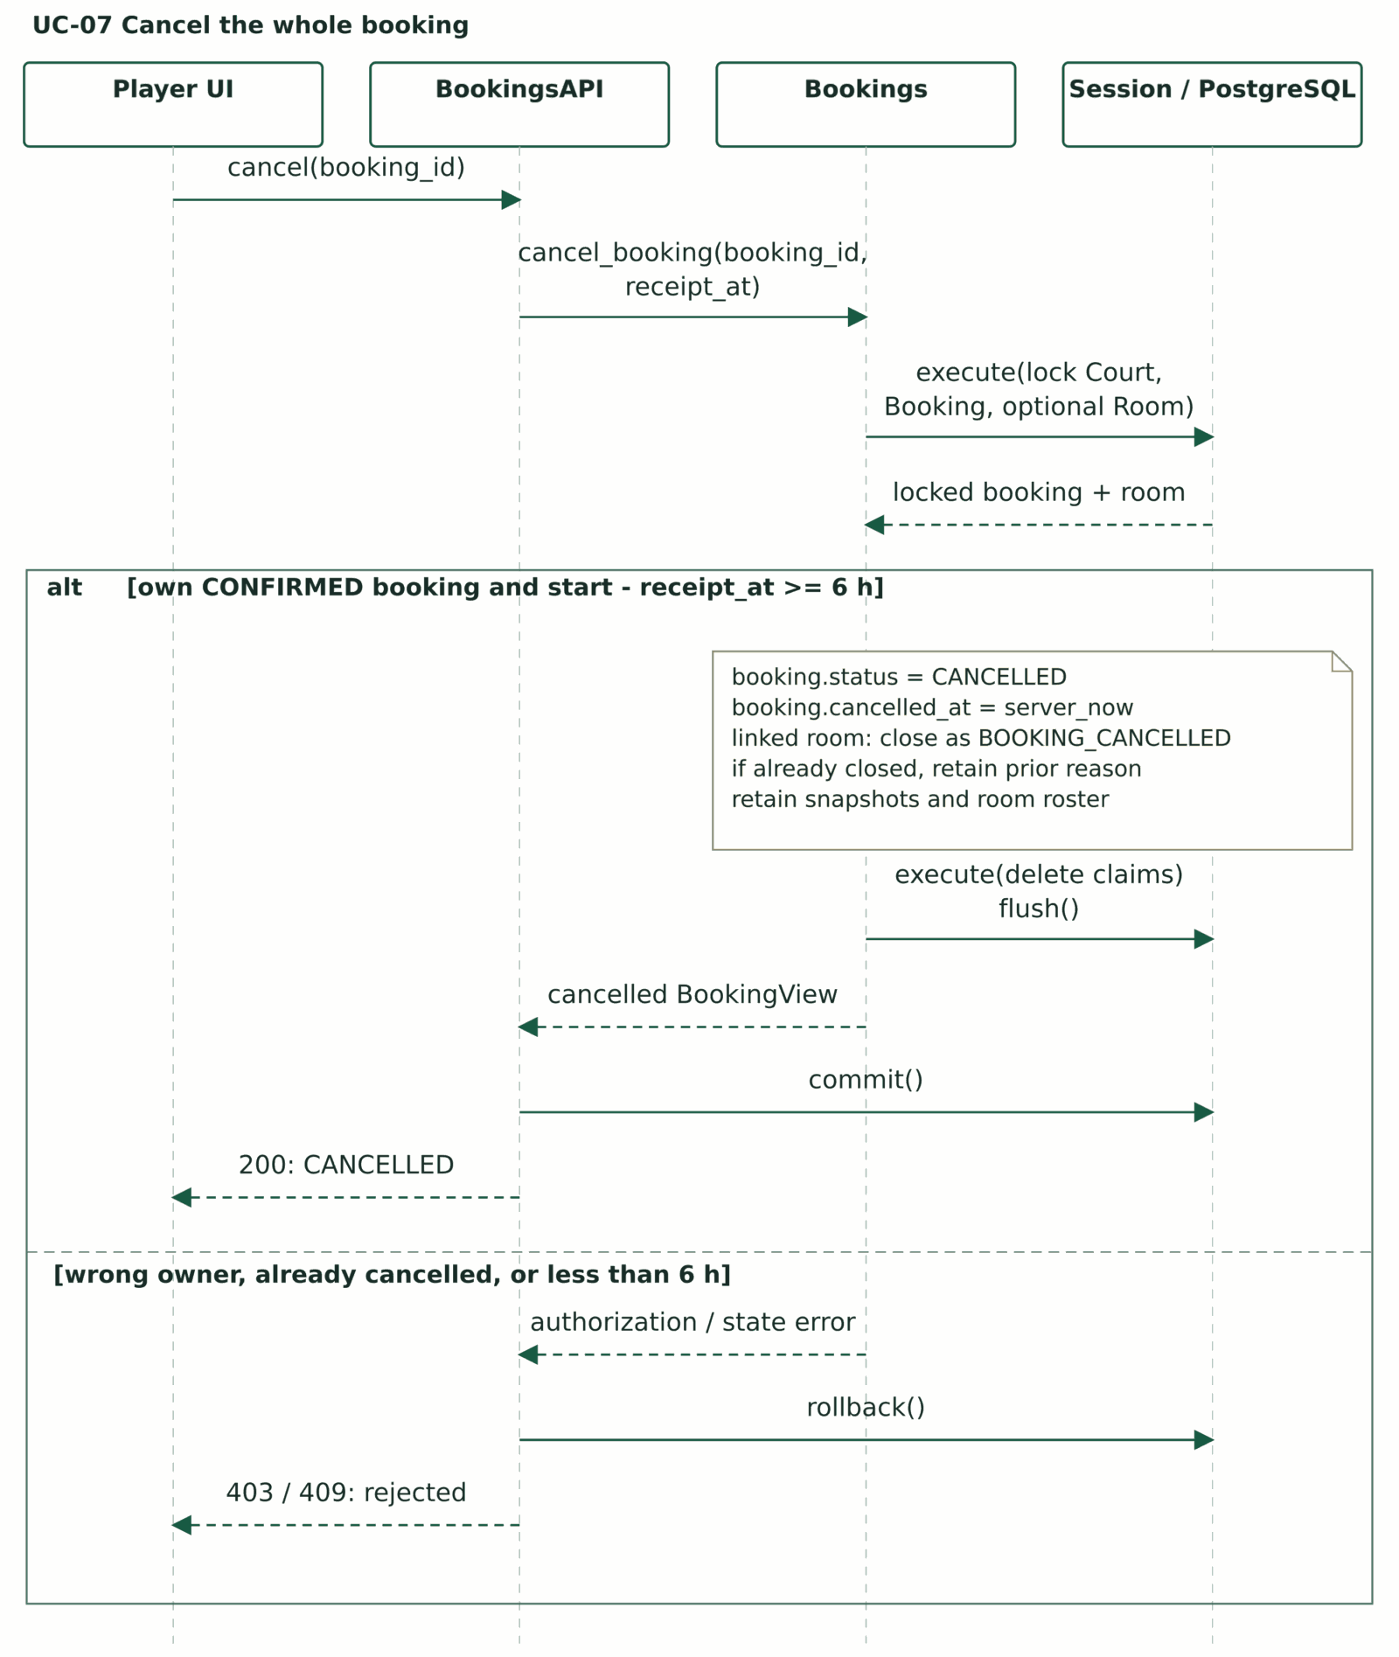
Figure 4.4b. UC-07 Cancel whole booking.
Endpoint: POST /api/bookings/{booking_id}/cancel.
Trace: FR-020-022; BR-02/03/06/10. Exactly six hours is allowed.
The request middleware captures authoritative receipt_at before database lock waiting. The browser does not supply this time.
Set booking CANCELLED and cancellation timestamp; close a linked room while retaining snapshots and its roster.
UC-09 Publish multiple slots
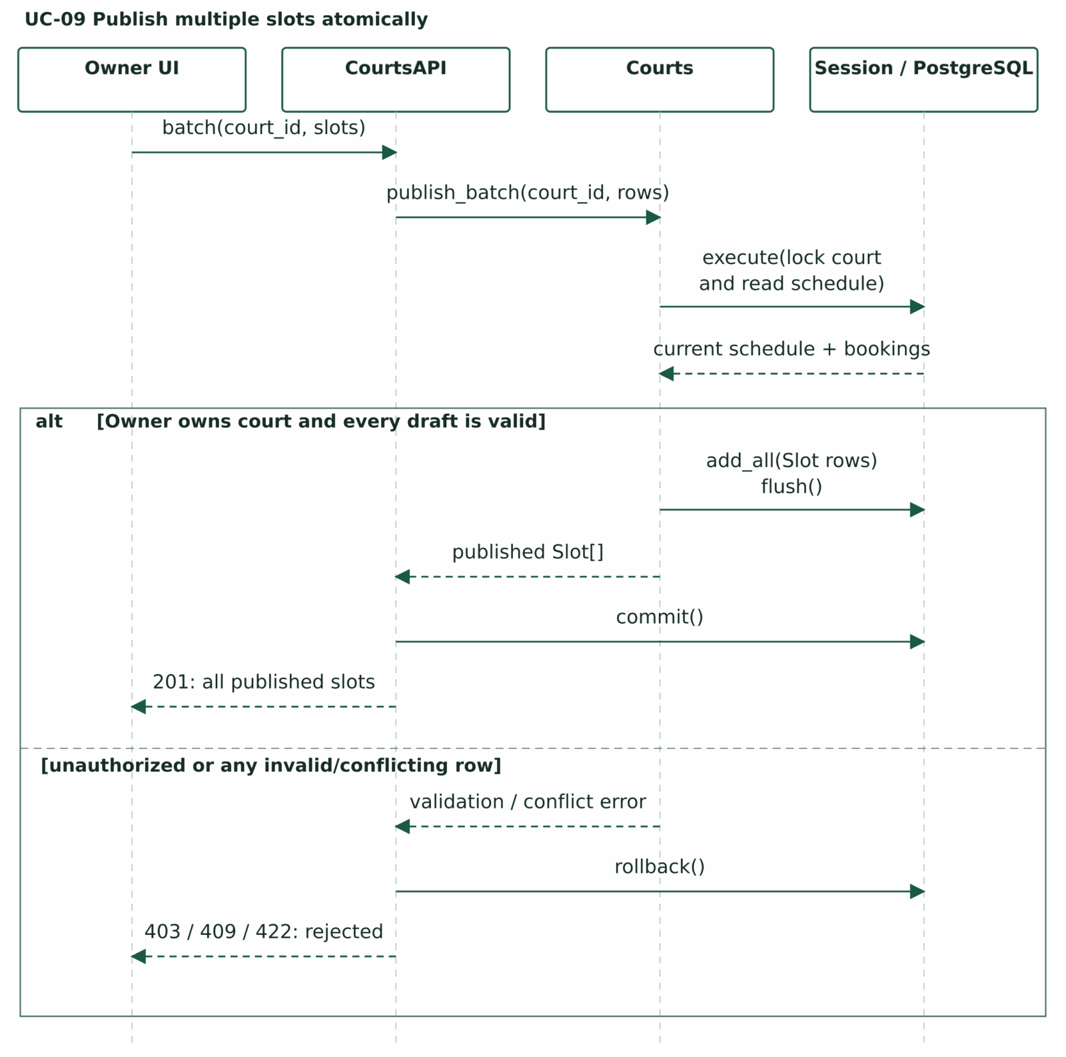
Figure 4.4c. UC-09 Publish multiple slots.
Endpoint: POST /api/owner/courts/{court_id}/slots/batch.
Trace: FR-025-027; BR-01/03; NFR-02.
Owner prepares and reviews all draft rows locally, then explicitly confirms Publish. This is one batch request.
Validate every row, common playing date, 30-minute grid, duration, positive quote, hours and pairwise non-overlap before insertion.
UC-13 Join Open Play Room
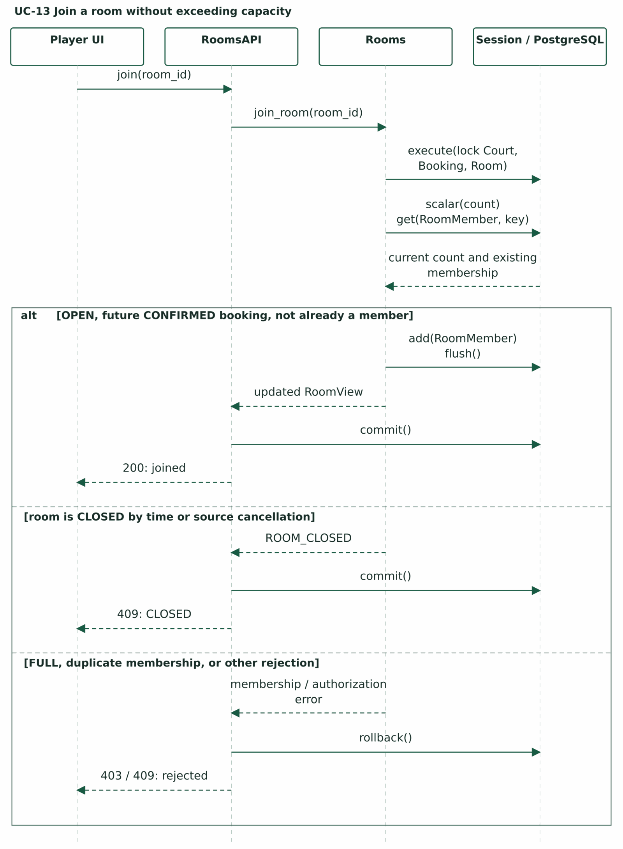
Figure 4.4d. UC-13 Join Open Play Room.
Endpoint: POST /api/rooms/{room_id}/join.
Trace: FR-034/035/038; BR-05/06/08; NFR-03.
CLOSED branch only: insert no membership; commit the sticky closure before returning HTTP 409.
UC-17 Close organizer room
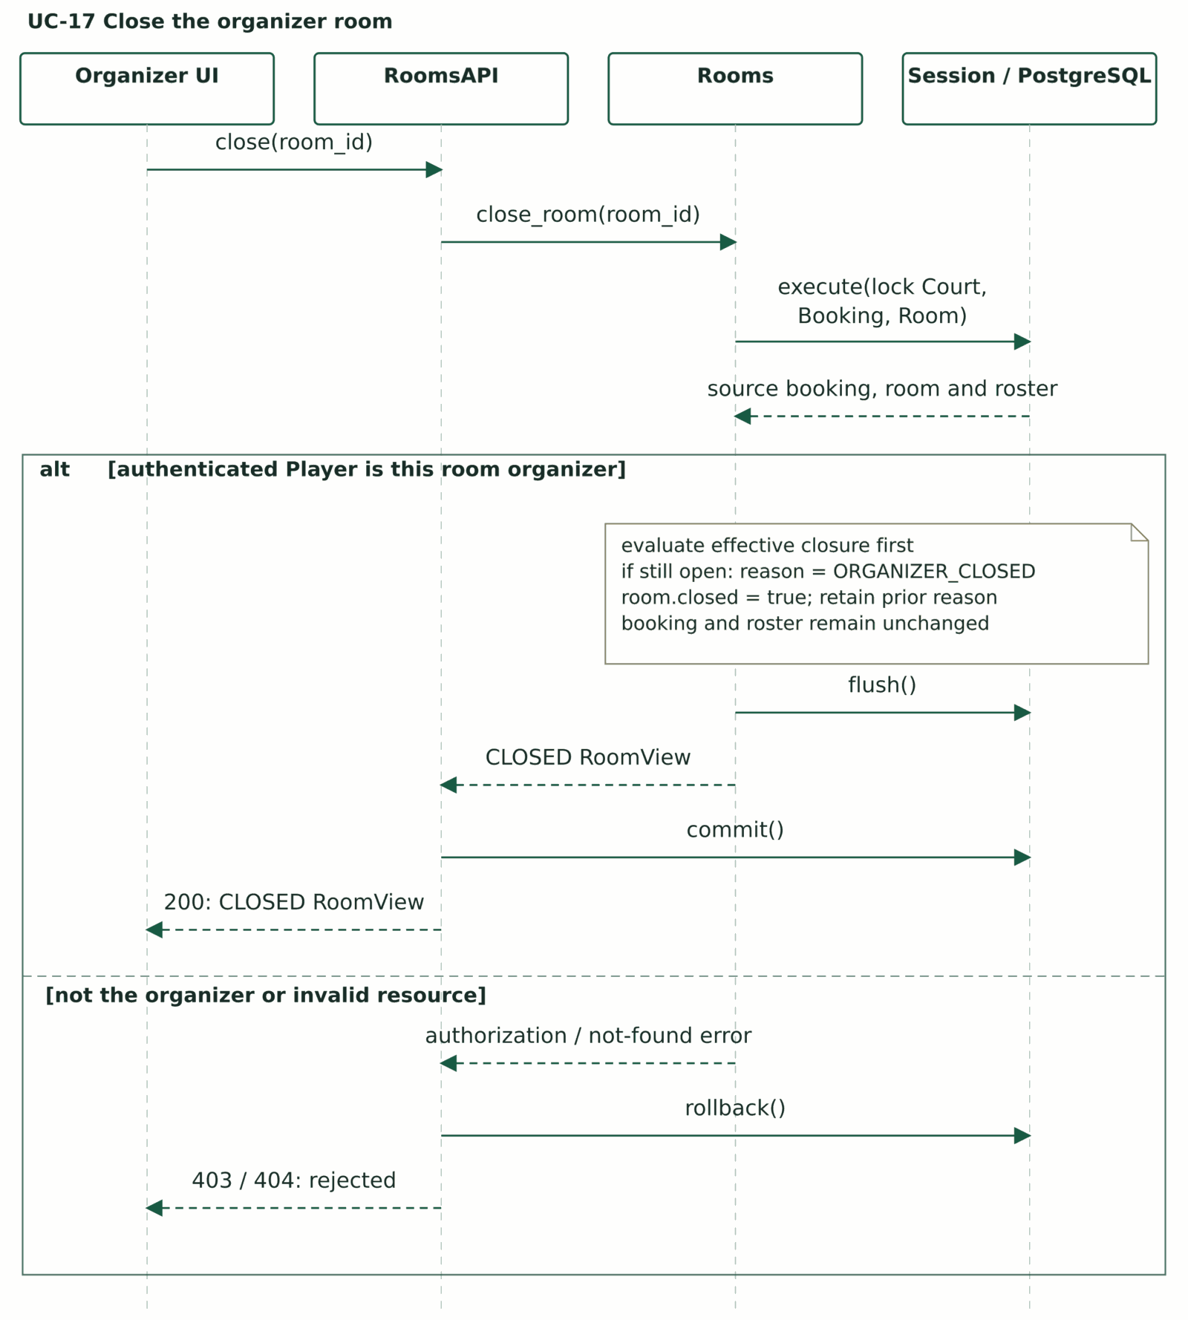
Figure 4.4e. UC-17 Close organizer room.
Endpoint: POST /api/rooms/{room_id}/close.
Trace: FR-004/005/037/038; BR-04/06/08/09; NFR-03/04.
Organizer is a Player relationship. UI explains that closure is irreversible and does not cancel the booking; Keep Open makes no mutation.
From OPEN or FULL, set closed=true and ORGANIZER_CLOSED. If already closed, preserve its reason and return current state. Booking and roster stay intact.
4.5 State Machine Diagrams
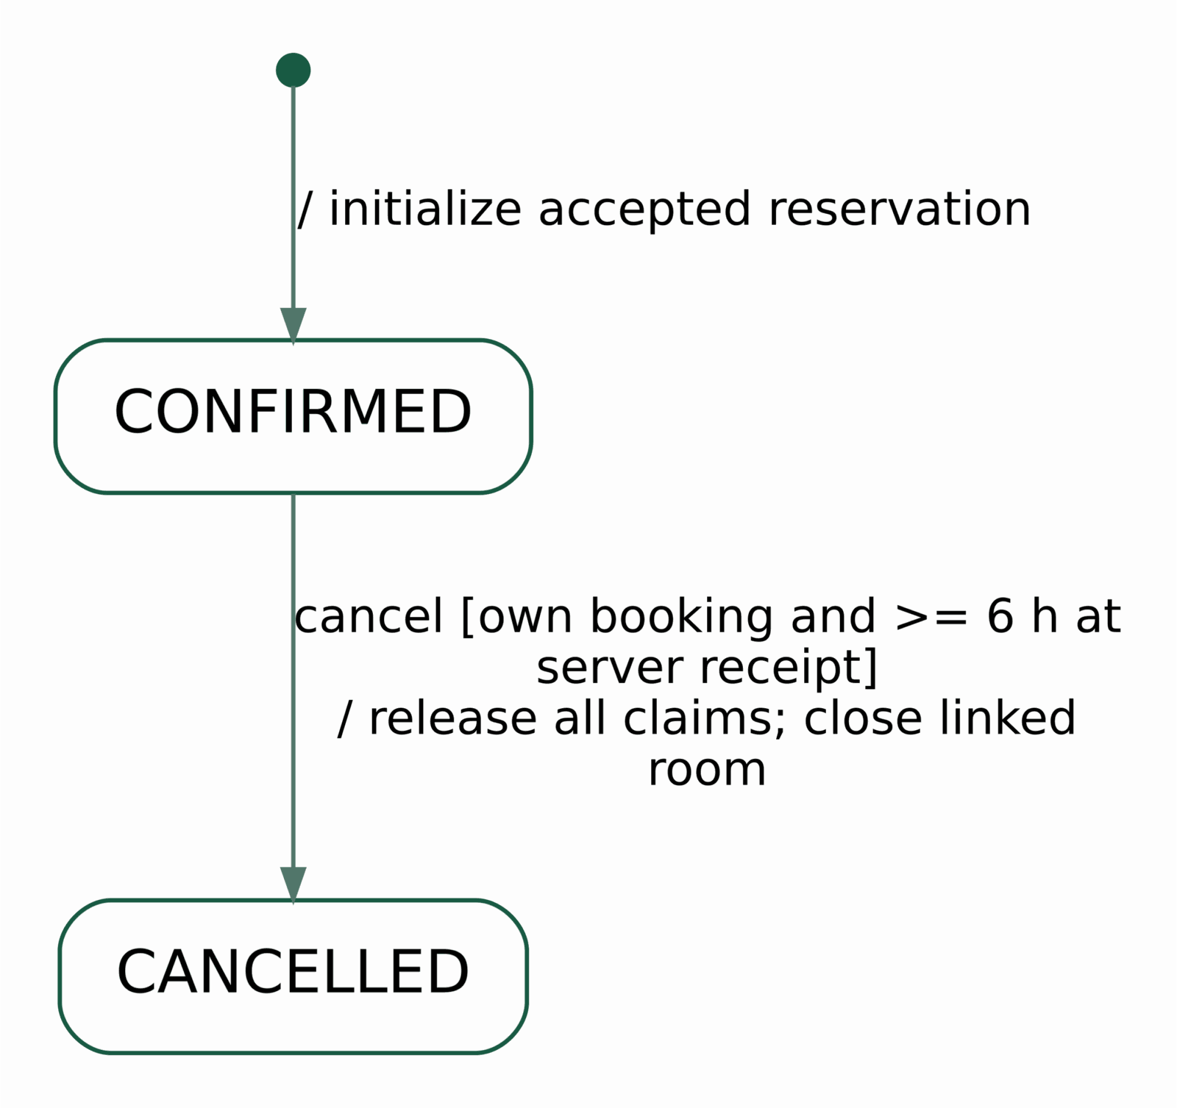
Figure 4.5a. Booking lifecycle; successful confirmation creates the aggregate.
This lifecycle begins only after successful confirmation validation; rejected confirmation creates no Booking object. The initial transition initializes the accepted reservation without a trigger or guard. Booking has two stored states. Whole-booking cancellation uses server receipt time; a failed cancellation preserves its prior state and accepted snapshots.
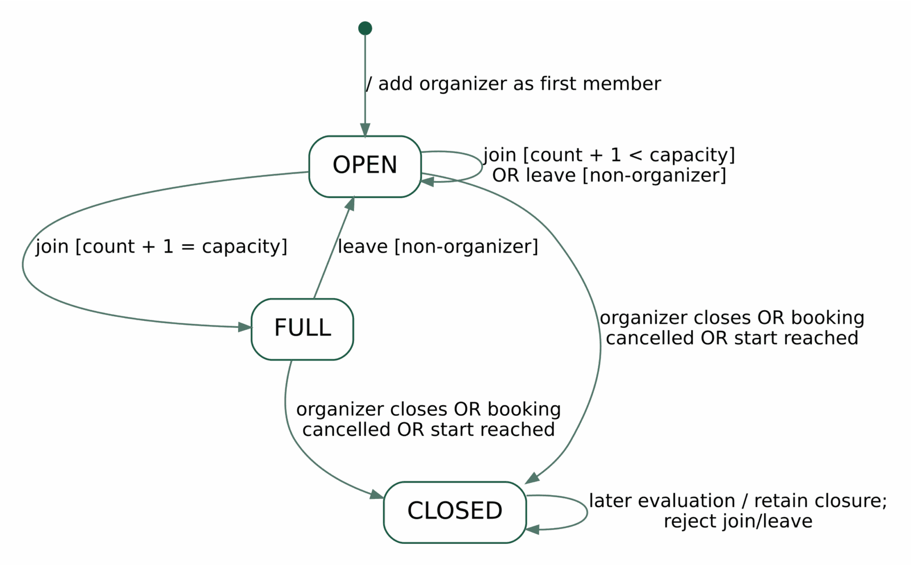
Figure 4.5b. Room lifecycle, derived fullness and irreversible closure.
Room creation validates the owned future CONFIRMED booking and capacity before entering this lifecycle. The initial transition adds the organizer, so the room starts OPEN. OPEN has member_count < capacity; FULL has member_count = capacity, with the source booking still eligible and play not started. CLOSED takes priority and cannot reopen. Closing retains the booking and current roster.
Slot offer lifecycle
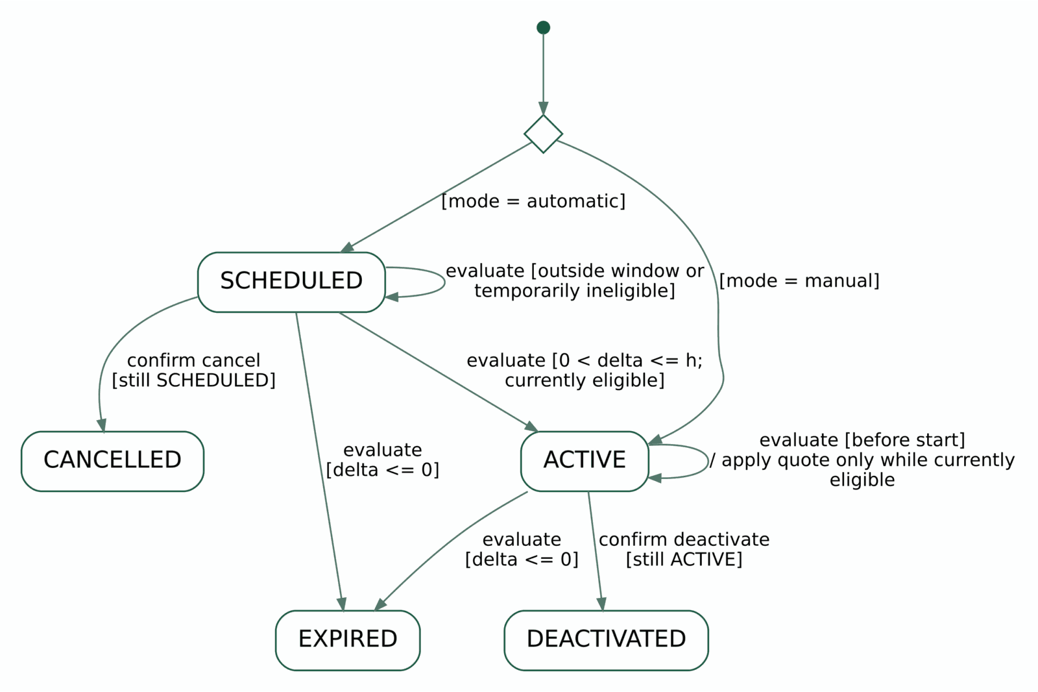
Figure 4.5c. Manual and automatic offer creation, activation and terminal states.
Creation first validates ownership, slot eligibility, discounted price and 0 < h <= 24. Here delta is slot start minus server time; manual creation also requires 0 < delta <= 24 hours. The initial transition reaches a choice: manual mode enters ACTIVE; automatic mode enters SCHEDULED. Automatic configuration may be saved earlier than 24 hours before play and first activates only when 0 < delta <= h <= 24 and current eligibility checks pass. An already eligible automatic configuration can move SCHEDULED to ACTIVE during that same request.
Stored ACTIVE means activation has occurred; it does not guarantee that the discount is currently applicable. Each displayed/confirmed quote rechecks eligibility, and can temporarily withhold an ACTIVE offer while a slot is booked/blocked or its current regular quote is no longer above the offer. Both SCHEDULED and ACTIVE expire at slot start. CANCELLED, DEACTIVATED and EXPIRED never revive; booking cancellation only restores an otherwise still eligible nonterminal offer. Evaluation is authoritative at reads/writes and confirmation; correctness does not depend solely on a timer job.
4.6 Design Principles and Patterns
Principle / technique | Applied in CourtMate | Reason and trade-off
Separation of concerns | React presentation; REST/auth boundary; domain-focused service interfaces; SQLAlchemy persistence. | Keeps UI changes separate from authoritative business rules; functions can realize service contracts without extra layers.
Transaction / Unit of Work | Request-scoped Session; booking, batch publication and room mutations. | One commit after successful validation; rollback on unhandled failure. No partial reservation/publication.
Pessimistic locking + uniqueness | Court-first row locks; Booking/Room where needed; SlotClaim PK and membership composite PK. | Prioritizes consistency for competing bookings and the final room place; accepts lock contention.
Immutable transaction snapshot | Booking total and interval; BookingSlot times, accepted price and slot version. | Preserves accepted history while future court/slot/offer data can change. Costs limited intentional duplication.
Derived state + explicit terminal lifecycle | Slot availability; Room fullness; current offer eligibility; sticky Room.closed and terminal offers. | Avoids redundant availability/fullness columns while retaining irreversible lifecycle decisions.
Authorization at the boundary | Verified Firebase token, backend User.role and resource-ownership checks. | Browser role/resource IDs cannot grant permission. Organizer remains a Player relationship.
Modular monolith | One FastAPI backend with courts/bookings/rooms/offers modules and one PostgreSQL database. | Matches the four-member course project and permits local transactions; no microservice/broker overhead.

No artificial inheritance hierarchy or unused Strategy/Factory pattern is introduced. The chosen structure favors clear responsibilities and direct traceability over additional abstractions. Architecture and deployment remain those of PA1 and Section 3.
5 Data Design
The design stores CourtMate business data in PostgreSQL 17 on Neon, using SQLAlchemy mappings and Alembic migrations. Eleven application tables cover identity, courts, schedule, reservations, rooms and optional slot offers. The Firebase identity provider retains credentials; CourtMate stores no password, identity token, payment, chat or review table.
5.1 Data Diagram
Chen notation: rectangles are entities, ellipses are attributes, diamonds are relationships, and underlining marks primary-key attributes. A pair (min,max) beside an entity gives its participation in that relationship; N means many. Figures 5.1a-c are views of one model. Selected attributes are shown; all 11 tables, complete columns, foreign keys and constraints remain in Section 5.2.
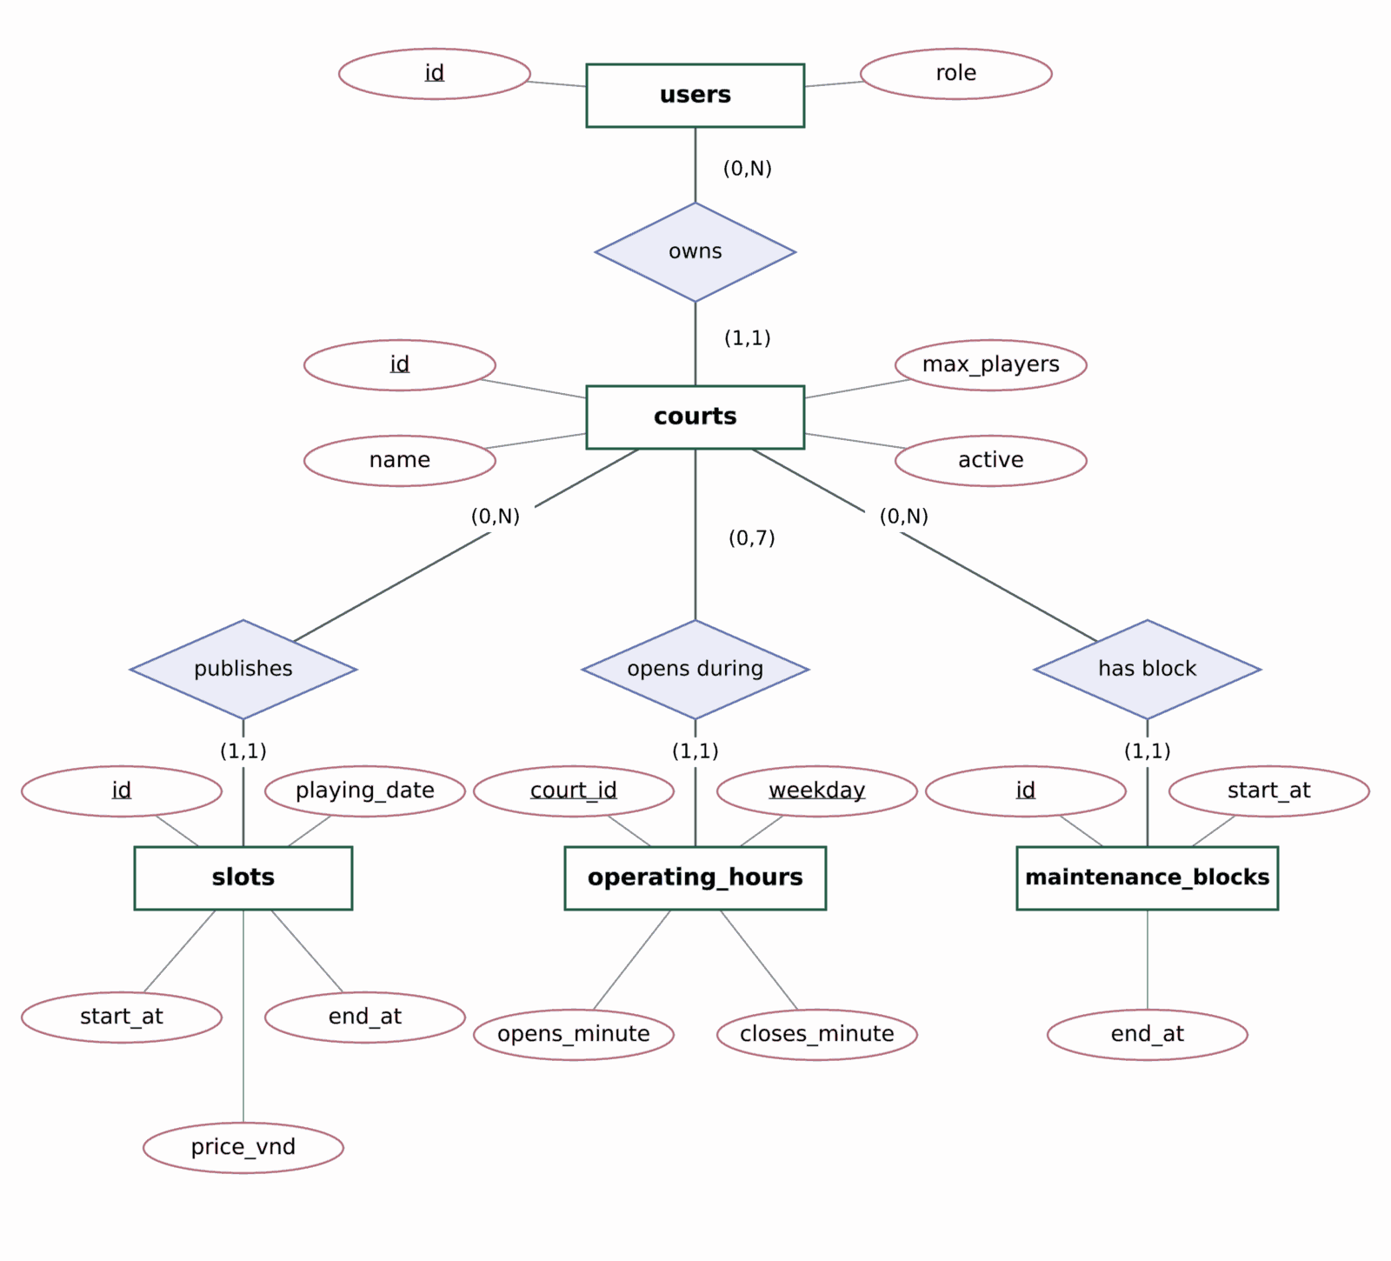
Figure 5.1a. Chen ERD for court ownership and scheduling.
Booking history and active claims
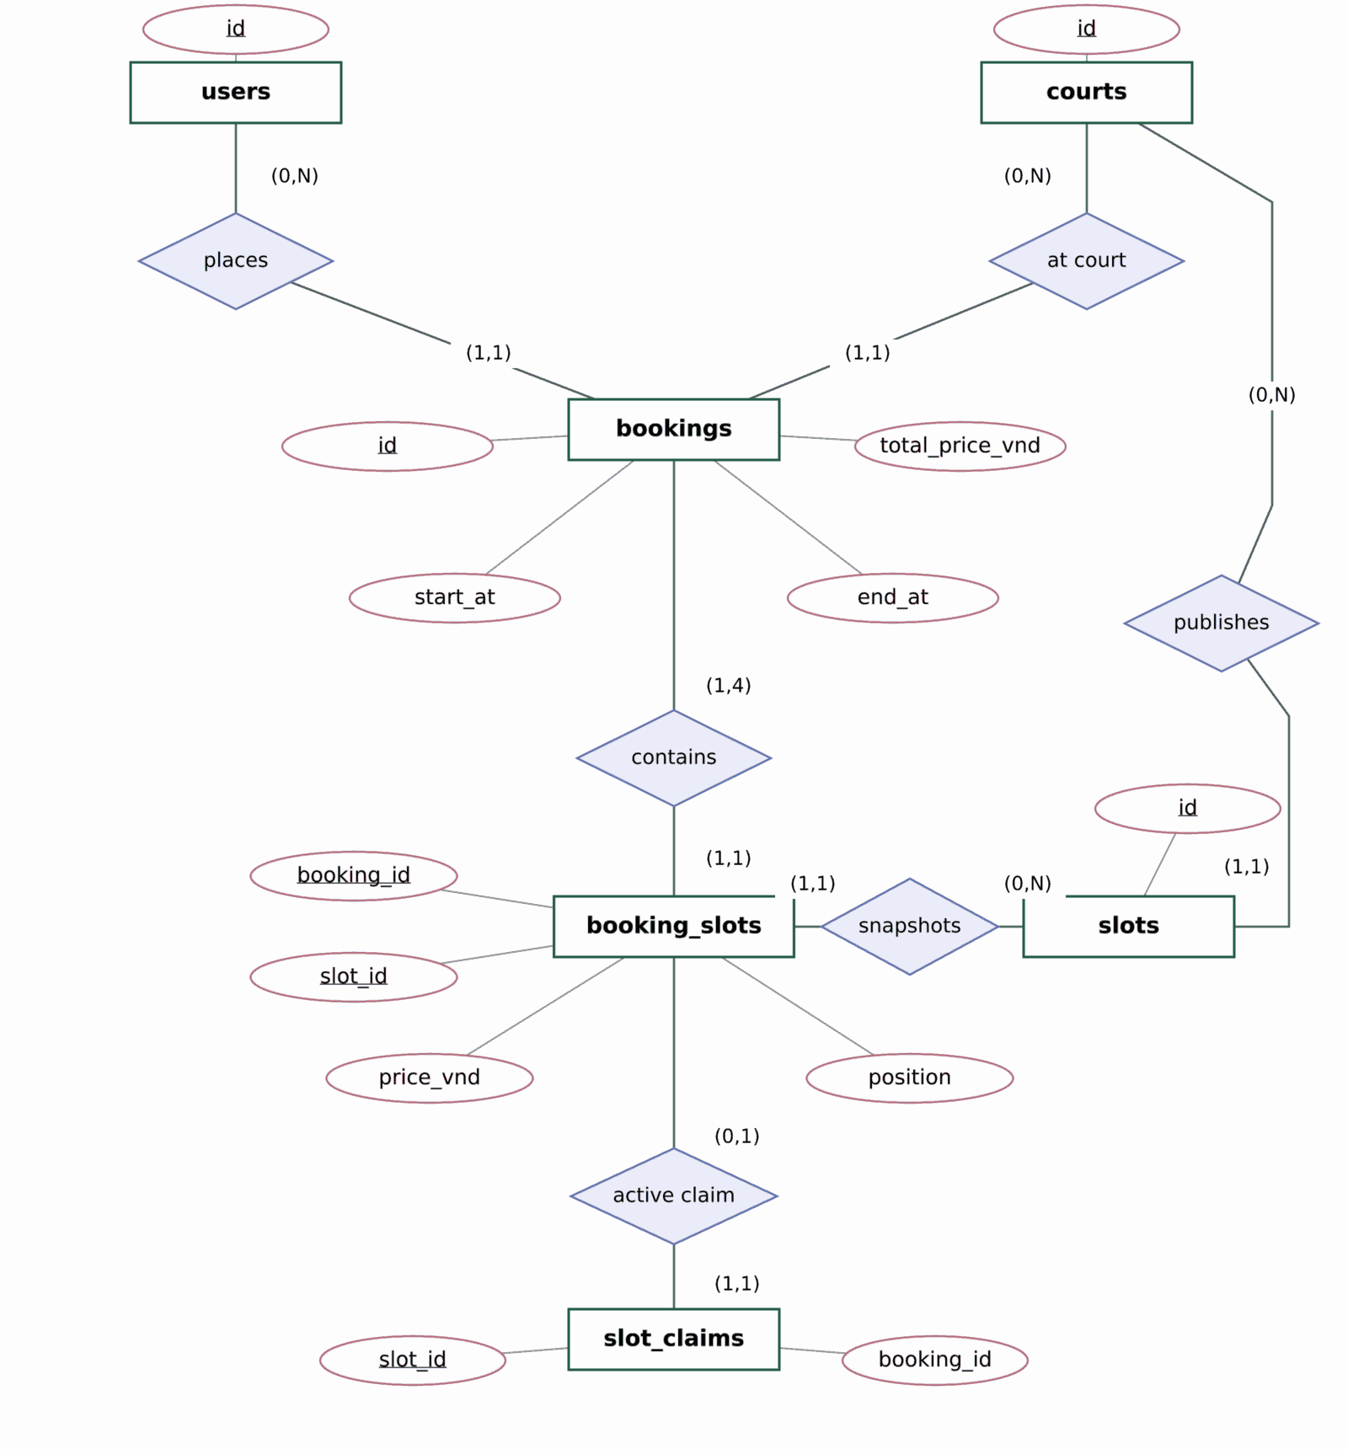
Figure 5.1b. Chen ERD for booking snapshots and active slot claims.
Room and offer persistence
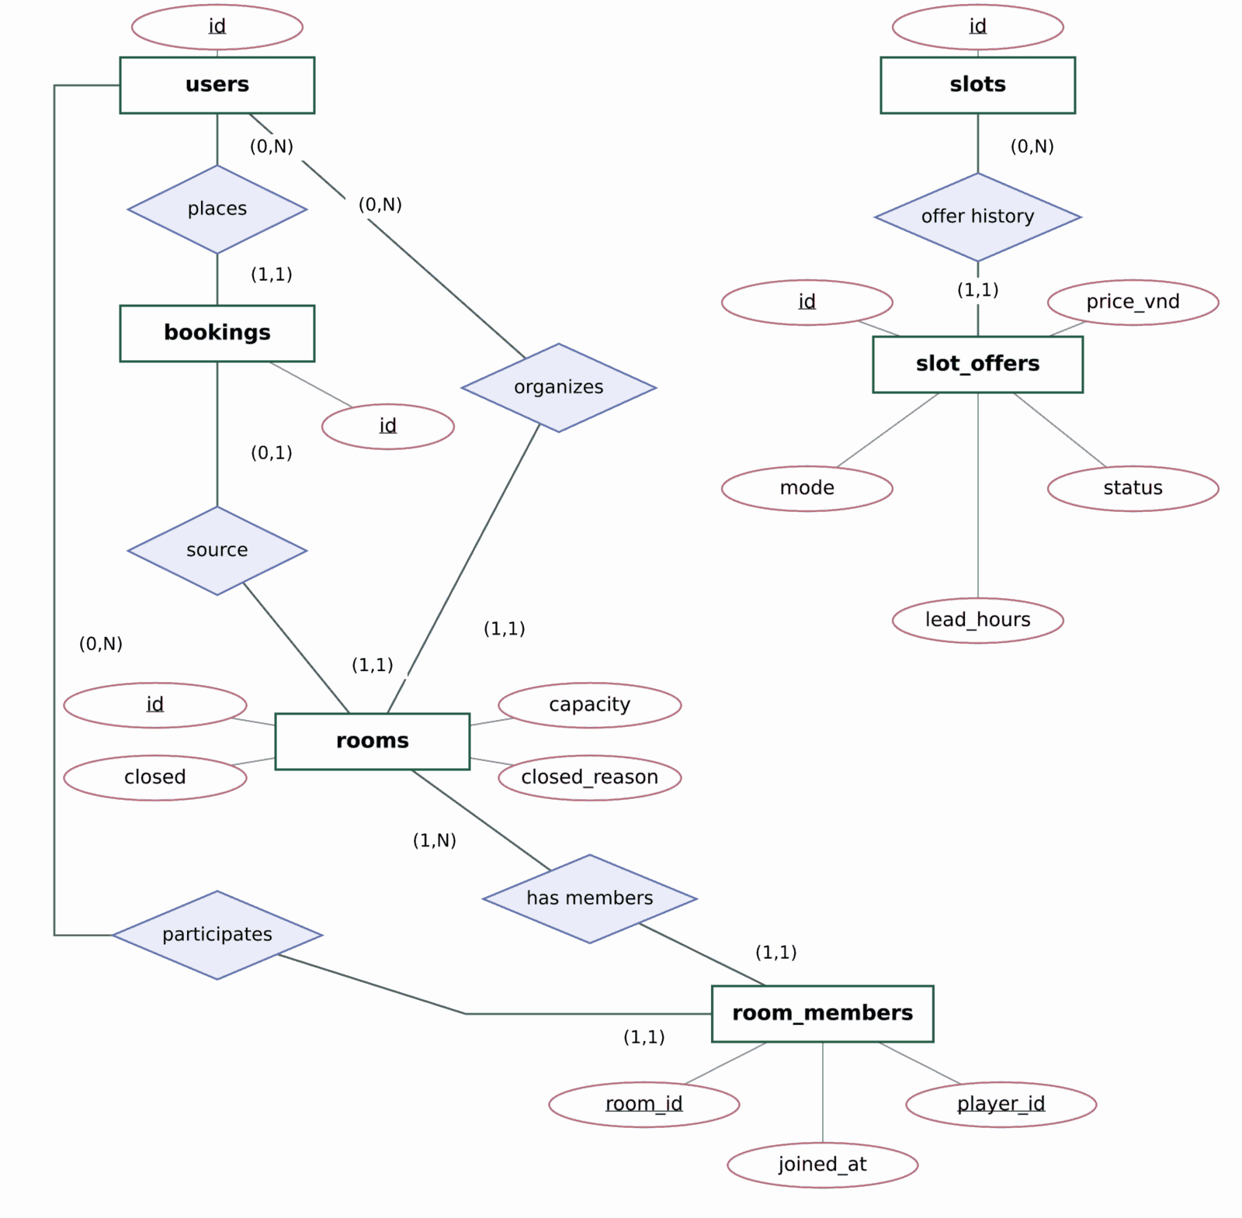
Figure 5.1c. Chen ERD for rooms, membership and slot offers.
The rooms.booking_id unique key enforces at most one room per booking for its lifetime. The room_members composite primary key prevents duplicate participation. The partial unique index on slot_offers permits multiple terminal historical records but only one SCHEDULED/ACTIVE configuration per slot. SlotClaim has a composite FK to the exact BookingSlot snapshot and a slot_id PK, so at most one historical snapshot can be the currently active claimant for a slot.
5.2 Data Specification
All attributes are listed below. NN = NOT NULL; PK implies NN; UQ = UNIQUE. UUID identifiers are generated by the application ORM unless specified otherwise. Money uses BIGINT in whole VND; decimal lead_hours uses NUMERIC rather than float. Instant values use TIMESTAMPTZ. playing_date and weekly time windows use Asia/Ho_Chi_Minh (UTC+07:00); intervals are half-open [start, end), so adjacent slots do not overlap.
Table users
Column | PostgreSQL type | Keys / constraints | Description
id | UUID | PK, NN; generated | Account ID
firebase_uid | VARCHAR(128) | UQ, NN | Verified Firebase UID
role | VARCHAR(16) | NN; CHECK player|owner; default player | Server-controlled account role
registration_email | VARCHAR(320) | nullable | Registration contact
display_name | VARCHAR(100) | NN; default empty | Profile display name
contact_preferences | VARCHAR(500) | NN; default empty | User communication preference
created_at | TIMESTAMPTZ | NN; default now() | Account creation

Table operating_hours
Column | PostgreSQL type | Keys / constraints | Description
court_id | UUID | PK(part), FK courts.id, NN | Court
weekday | INT | PK(part), CHECK 0..6 | Mon=0 .. Sun=6
opens_minute | INT | NN; 0≤open<close | Minutes after midnight
closes_minute | INT | NN; ≤1440 | May equal 24:00

Table courts
Column | PostgreSQL type | Keys / constraints | Description
id | UUID | PK, NN | Court ID
owner_id | UUID | FK users.id, NN; index | Owning Court Owner
name | VARCHAR(150) | NN | Name search/detail
sport | VARCHAR(80) | NN | Sport type
address | VARCHAR(300) | NN | Full address
area | VARCHAR(120) | NN | Area/location search
description | VARCHAR(4000) | NN; default empty | Public description
contact | VARCHAR(200) | NN; default empty | Contact
photo_urls | JSONB | NN; default [] | Optional external photo URLs
base_price_vnd | BIGINT | NN; CHECK >0 | Base hourly price
max_players | INT | NN; CHECK 2..30 | Simultaneous on-court capacity
active | BOOLEAN | NN; default true | Published listing eligibility
version | INT | NN; CHECK >0 | Court optimistic/version token

Table slots
Column | PostgreSQL type | Keys / constraints | Description
id | UUID | PK, NN | Slot ID
court_id | UUID | FK courts.id, NN; index with start_at | Court
playing_date | DATE | NN; derived Vietnam local day | Materialized Vietnam local start date; enforced by CHECK
start_at | TIMESTAMPTZ | NN; half-hour grid | Start instant
end_at | TIMESTAMPTZ | NN; 60–240 min and same local day | End instant
price_vnd | BIGINT | NN; CHECK >0 | Regular full-slot price
version | INT | NN; CHECK >0 | Quote invalidation
published | BOOLEAN | NN; default true | Publicly offered
blocked | BOOLEAN | NN; default false | Owner block

Table maintenance_blocks
Column | PostgreSQL type | Keys / constraints | Description
id | UUID | PK, NN | Maintenance ID
court_id | UUID | FK courts.id, NN; index with start_at | Affected court
start_at | TIMESTAMPTZ | NN | Maintenance begins
end_at | TIMESTAMPTZ | NN; CHECK end>start | Maintenance ends

Table bookings
Column | PostgreSQL type | Keys / constraints | Description
id | UUID | PK, NN | Booking ID
court_id | UUID | FK courts.id, NN; indexed with start_at | Booked court
player_id | UUID | FK users.id, NN; indexed with created_at | Booking Player
start_at | TIMESTAMPTZ | NN | Combined first slot start
end_at | TIMESTAMPTZ | NN; duration 60–240 min | Combined last slot end
status | VARCHAR(16) | NN; CHECK CONFIRMED|CANCELLED | Lifecycle
total_price_vnd | BIGINT | NN; CHECK >0 | Immutable accepted total
created_at | TIMESTAMPTZ | NN; DB clock timestamp | Created
cancelled_at | TIMESTAMPTZ | nullable; consistent with CANCELLED | Cancellation audit

Table booking_slots
Column | PostgreSQL type | Keys / constraints | Description
booking_id | UUID | composite PK, FK bookings.id | Source booking
slot_id | UUID | composite PK, FK slots.id | Selected slot
position | INT | NN; 0..3; UNIQUE(booking_id,position) | Consecutive order
start_at | TIMESTAMPTZ | NN; end>start | Snapshot start
end_at | TIMESTAMPTZ | NN | Snapshot end
price_vnd | BIGINT | NN; CHECK >0 | Accepted price for slot
slot_version | INT | NN | Confirmed slot version

Table slot_claims
Column | PostgreSQL type | Keys / constraints | Description
slot_id | UUID | PK, NN; composite FK with booking_id→booking_slots | Exactly one active claimant
booking_id | UUID | NN; index; composite FK with slot_id | Active owning booking

Table rooms
Column | PostgreSQL type | Keys / constraints | Description
id | UUID | PK, NN | Room ID
booking_id | UUID | UQ FK bookings.id, NN | One room per booking history
organizer_id | UUID | FK users.id, NN | Source booking Player
capacity | INT | NN; CHECK 2..60 | Room cap; service ≤2×court.max_players
closed | BOOLEAN | NN; default false | Sticky closure
closed_reason | VARCHAR(32) | nullable | Manual/cancel/start reason
created_at | TIMESTAMPTZ | NN; DB clock timestamp | Room created

Table room_members
Column | PostgreSQL type | Keys / constraints | Description
room_id | UUID | composite PK, FK rooms.id | Room
player_id | UUID | composite PK, FK users.id | Participating Player
joined_at | TIMESTAMPTZ | NN; DB clock timestamp | Membership record

Table slot_offers
Column | PostgreSQL type | Keys / constraints | Description
id | UUID | PK, NN | Offer ID
slot_id | UUID | FK slots.id, NN; partial unique nonterminal | Target slot
mode | VARCHAR(16) | NN; CHECK manual|automatic | How offer activates
price_vnd | BIGINT | NN; CHECK >0 | Offer price, validated < regular
lead_hours | NUMERIC | NN; CHECK 0<h≤24 | Automatic threshold; manual mode stores 24
status | VARCHAR(16) | NN; CHECK SCHEDULED / ACTIVE / CANCELLED / DEACTIVATED / EXPIRED | Lifecycle / eligibility
created_at | TIMESTAMPTZ | NN; DB clock timestamp | Audit history

Constraint enforcement and retained history
Invariant | Database enforcement | Service / transaction enforcement
One active booking claim per slot | slot_claims.slot_id PK; composite FK to booking_slots. | Lock Court and selected Slots, reject CONFIRMED interval overlap; insert all snapshots and claims together.
Valid published schedule | Slot duration/grid/local-date/price CHECKs; court/hour FKs. | Validate operating hours, maintenance, same-court overlap and protection of CONFIRMED bookings under Court lock.
Whole-booking selection and price | Booking status/duration/price/cancellation CHECKs; snapshot position range + UQ. | 1-4 distinct, consecutive same-court/date slots; quote revalidation; accepted sum and times recorded atomically.
Whole cancellation at >=6 hours | Consistent status/cancelled_at CHECK; retained snapshots. | Use backend receipt_at; authenticate owner; release every claim, close linked room and retain history in one transaction.
Room ownership and capacity | rooms.booking_id UQ; capacity CHECK 2..60; membership composite PK. | Organizer equals booking Player; add organizer initially; count <= capacity <= 2 x court.max_players; lock before count/write.
Slot-specific offer exclusivity | Offer mode/status/price/lead CHECKs; partial unique nonterminal index. | Owned eligible slot; price below current regular quote; current-time evaluation; fixed terminal states; immutable accepted totals.

Cancellation changes status and removes active SlotClaim rows, not historical BookingSlot rows. Closing a room preserves its current roster; leaving an open room deletes that participation record, so joined_at is not a full join/leave audit log. Court deletion is represented by deactivation in normal application flows; no cascading deletion of booking history is introduced. Foreign keys restrict removal of referenced records. Future schedule edits must preserve CONFIRMED bookings and may not rewrite accepted snapshots.
5.3 Normalisation and Indexes
The logical design is evaluated against 3NF using candidate keys and functional dependencies for all 11 relations below. Accepted snapshots and aggregates describe transactions; copying a value across relations does not by itself violate 3NF. The physical slots relation retains one derived attribute, playing_date: start_at determines its Vietnam local date although start_at is not a candidate key. This is a deliberate denormalization, so the physical schema is not claimed to be strictly 3NF. The corresponding 3NF logical relation omits playing_date and computes it in a query or view; the deployed schema and Section 5.2 retain the checked materialization.
Relation / key | Functional dependency and normalisation rationale
users: id; firebase_uid UQ | Either candidate key determines all identity/profile attributes. No non-key attribute determines another non-key attribute.
courts: id | id determines ownership, venue details, capacity, prices and version. Owner profile data remains in users.
operating_hours: (court_id, weekday) | The entire composite key determines opens_minute and closes_minute; neither key component alone determines a weekly window.
slots: id (logical relation) | id determines court, interval, quote, flags and version. The 3NF logical relation computes playing_date; the physical exception is described above.
maintenance_blocks: id | id determines court_id and the blocked interval; court descriptive data remains in courts.
bookings: id | id determines Player, court, accepted interval/total, state and timestamps. Aggregation from child snapshots does not establish a non-key dependency inside this relation.
booking_slots: (booking_id, slot_id); UQ(booking_id, position) | Both candidate keys determine the accepted interval, price and slot version. slot_id alone does not determine historical snapshot values across different bookings.
slot_claims: slot_id | slot_id determines booking_id. The composite FK selects the exact BookingSlot snapshot; the two-column relation has no partial or transitive non-key dependency.
rooms: id; booking_id UQ | Both candidate keys determine organizer, capacity, closure and timestamps. organizer_id is constrained to the source booking Player; booking_id is a key here.
room_members: (room_id, player_id) | The entire composite key determines joined_at. Neither a room nor a Player alone identifies one membership.
slot_offers: id | id determines slot, mode, price, lead time and lifecycle. slot_id is not a global candidate key because terminal history is retained; nonterminal uniqueness is conditional.

Stored value / design choice | Normalisation status and consistency rule
slots.playing_date | Physical denormalization: start_at -> Vietnam local date. The logical 3NF relation computes this value; a database CHECK maintains the retained physical column.
bookings.start_at/end_at/total_price_vnd | Accepted aggregate initialized from ordered booking_slots. These are transaction facts keyed by booking id; cross-relation aggregation is not itself a 3NF violation. Preserve first/last times and the accepted sum.
booking_slots snapshot fields | Historical facts keyed by one booking-slot pair. A later booking may accept different times, price or version, so slot_id alone does not determine these values. Retain snapshots after cancellation.
bookings.court_id; rooms.organizer_id | Cross-relation consistency constraints, not automatically 3NF violations. Selected slots must match booking.court_id; room.organizer_id must match booking.player_id. rooms.booking_id is itself a candidate key.
rooms.closed / closed_reason | Persisted closure is an irreversible business decision. OPEN/FULL and member_count remain derived rather than separate stored state/count fields.

Indexes for frequent queries
Index or constraint | Columns / predicate | Supported query or invariant
users.firebase_uid UNIQUE | firebase_uid | One backend account per Firebase identity.
ix_courts_owner_id | courts.owner_id | List/manage Owner courts; enforce ownership efficiently.
ix_slots_court_start | slots(court_id,start_at) | Per-court chronological slots/availability.
ix_maintenance_court_start | maintenance_blocks(court_id,start_at) | Intersect schedule with maintenance.
ix_bookings_court_start | bookings(court_id,start_at) | Owner calendar/booking lookup.
ix_bookings_player_created | bookings(player_id,created_at) | Newest-ten personal booking history.
uq_booking_slot_position | booking_slots(booking_id,position) | Stable 0..3 snapshot ordering.
slot_claims PK | slot_id | At most one active booking claim per slot.
rooms.booking_id UNIQUE | booking_id | One Room ever per Booking.
room_members composite PK | room_id,player_id | No duplicate room membership.
uq_offer_nonterminal_slot (partial) | slot_id WHERE status IN (SCHEDULED,ACTIVE) | No conflicting active/pending deal per slot.
ix_slot_claims_booking_id | slot_claims.booking_id | Release all active claims for a cancelled booking.

The compound court/start indexes support chronological schedule and interval prefilters; exact interval validity still uses predicates and transactional validation. No claim is made that these B-tree indexes accelerate arbitrary substring name/address searches. Additional search indexes require measured query evidence. Primary/unique keys also create supporting indexes in PostgreSQL.
Requirement-to-data coverage
PA2 requirement group | Stored design elements
FR-001-005; BR-09 | users and verified-provider identity mapping; backend-held role and ownership checks.
FR-006-013, FR-023-027, FR-046 | courts, operating_hours, slots and maintenance_blocks; public availability is derived.
FR-014-022, FR-028-030 | bookings, booking_slots and slot_claims; Player booking history and Owner-only booking views.
FR-031-038 | rooms and room_members; source booking/snapshots provide the accepted cost estimate.
FR-039-040 (Should) | users.display_name/contact_preferences; protected identity and role remain unchanged.
FR-041-045, FR-047-049 (F09 Should) | slot_offers plus accepted booking/snapshot prices. FR-045 specifically preserves the accepted total, not Room membership.

