3 Architectural Design

3.1 Architectural Style
CourtMate uses a client-server architecture with a responsive React/TypeScript/Vite web application, one modular FastAPI backend and one PostgreSQL application database on Neon. Firebase Authentication is the external identity provider. Within the backend, REST boundaries validate requests, service modules apply business rules, and a shared SQLAlchemy Session manages persistence. These are logical layers and modules within one deployable backend.
This structure fits a four-member course project: related schedule, booking, room and offer changes can share one local transaction, while the UI and API can evolve separately. It keeps responsibility boundaries clear without distributed transactions or additional runtime services. The trade-off is coupled backend deployment and contention when writes concern the same court. Short transactions and small connection pools address the initial workload; scaling decisions require measured demand.
Architectural driver | Design response and evaluation
Booking integrity  NFR-02; FR-015–018; BR-01/03/10 | Use atomic multi-slot confirmation, Court-first locking, slot claims and saved price snapshots. Race overlapping requests; assert no double booking or partial allocation.
Room integrity  NFR-03; FR-031–038; BR-04–06/08 | Lock the source Court, Booking and Room in order; enforce unique membership and capacity including the organizer. Race Join/Leave/Close and preserve booking history.
Access control  NFR-04; FR-001–005/030; BR-09 | Verify Firebase identity, resolve the application user and enforce backend role plus resource ownership. Test invalid tokens, role tampering and cross-user access.
Performance  NFR-01 | Target P95 <800 ms for search/view and <1500 ms for booking/write, with <1% application errors at 30 users over a 60-second steady-state workload after warm-up. Exclude expected validation/conflict responses; measure in a documented environment.
Usability  NFR-05 | Keep presentation in the responsive SPA; support 375/768/1280 px widths, keyboard and labelled controls. Verify layout, focus, contrast and Lighthouse accessibility ≥80 as specified in PA2.
F09 slot offers remain a Should feature (UC-16; FR-041–045/047–049; BR-07). Their evaluation is part of the same backend and transaction. Architecture decisions below describe the design; performance and security targets still require implementation evidence.

3.2 System Context Diagram C4 Level 1
This view identifies the people and external system interacting with CourtMate. It deliberately treats CourtMate as one software system; frontend, API and database are expanded at the next level.
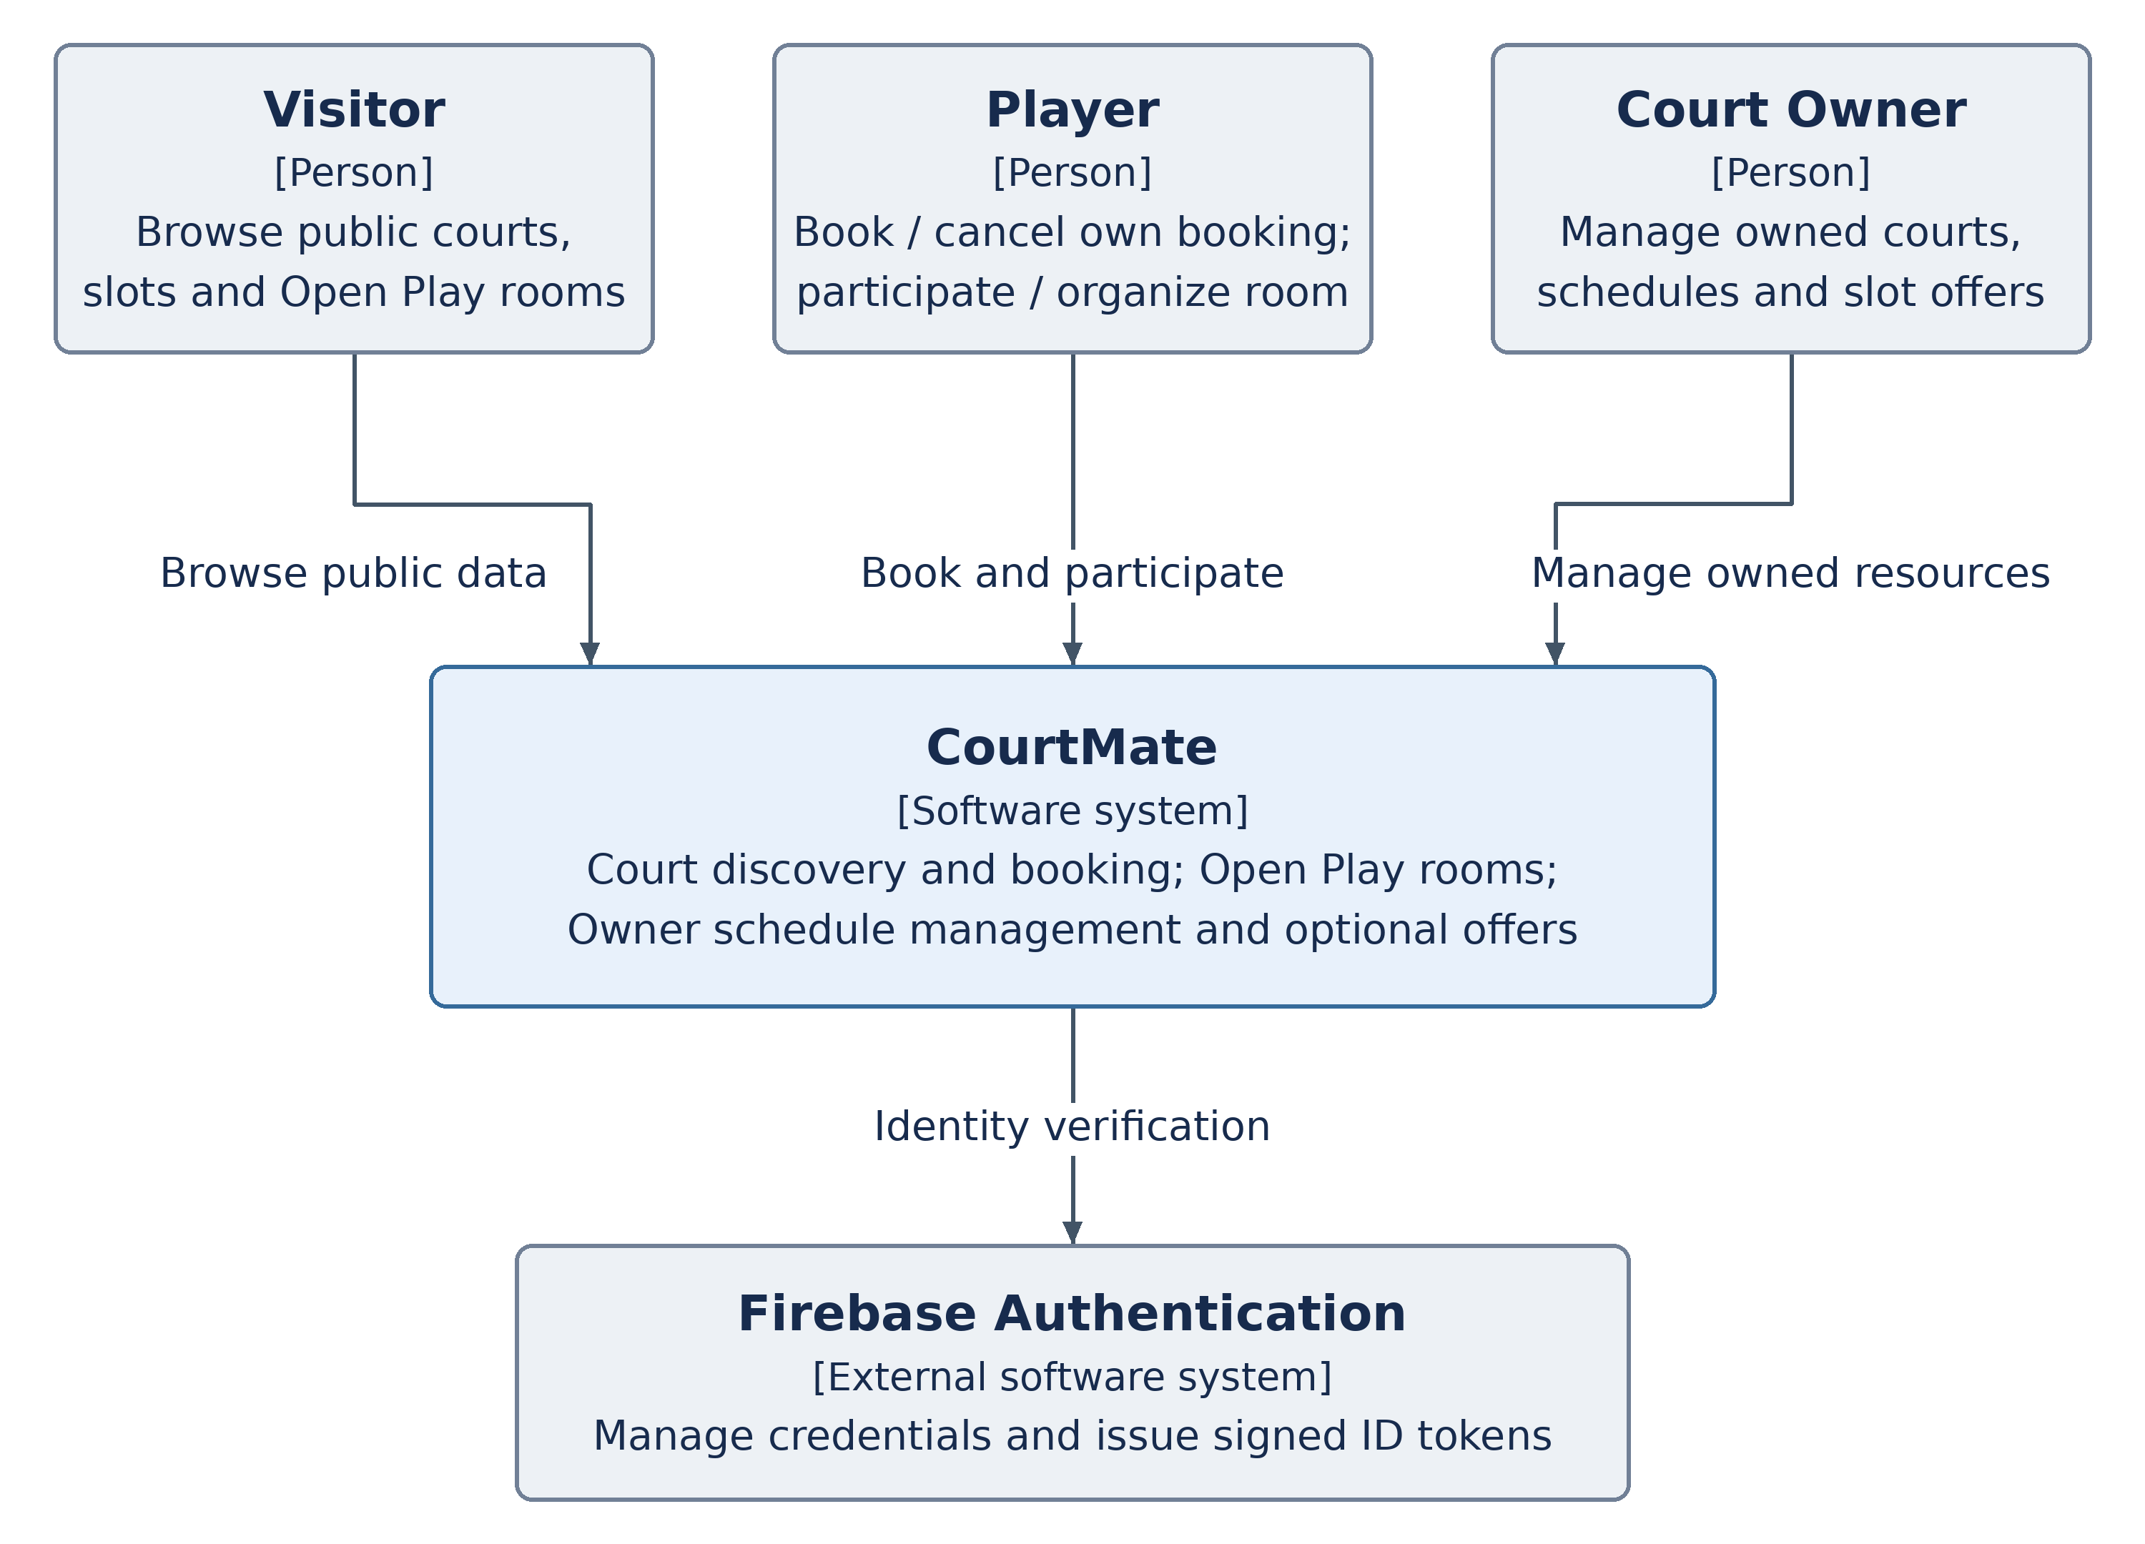
Figure 3.2. CourtMate system context and external identity provider.
Visitors browse public court details, published availability, previews and Open Play rooms (UC-03/04/11; FR-006–011/033/046). They do not receive private booking or contact data. Registration and sign-in establish an authenticated account through Firebase (UC-01/02).
Players review and confirm one booking, view/cancel their own bookings, manage their profile and create/join/leave rooms (UC-05–07/12–15). An organizer is the Player who owns the room’s source booking; only that relationship grants manual closure (UC-17), rather than a third account role.
Court Owners manage only their own courts, hours, slots, maintenance, booking views and optional offers (UC-08–10/16). Firebase manages credentials and issues signed ID tokens; CourtMate remains responsible for application roles, ownership and business rules. Optional map/directions (FR-013) may use an external navigation link; no integrated map backend is assumed. Online payment, chat and push notifications remain outside the PA1/PA2 scope.

3.3 Container Diagram C4 Level 2
The three CourtMate runtime/data containers are the browser SPA, backend API and application database. A C4 container means a runnable application or data store; it does not imply Docker. Firebase is outside the CourtMate system boundary.
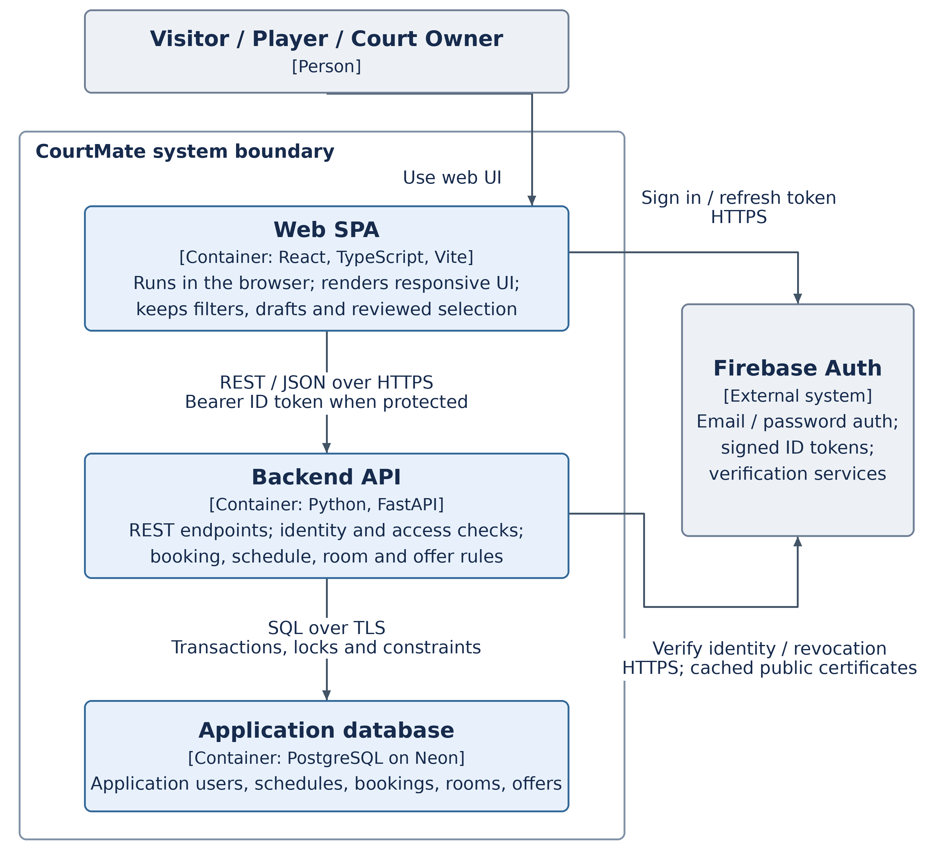
Figure 3.3. Container responsibilities, system boundary and communication protocols.
The SPA obtains an ID token from Firebase and includes it only where authentication is required. The API verifies identity with the Firebase Admin SDK, then uses users.role and the relevant ownership relation. Signature checks use cached provider certificates; revoked/disabled/deleted identity checks may need provider communication. Public endpoints expose only their public response contracts. Only the backend accesses PostgreSQL; neither the browser nor Firebase directly reads application tables.

3.4 Component Diagram C4 Level 3
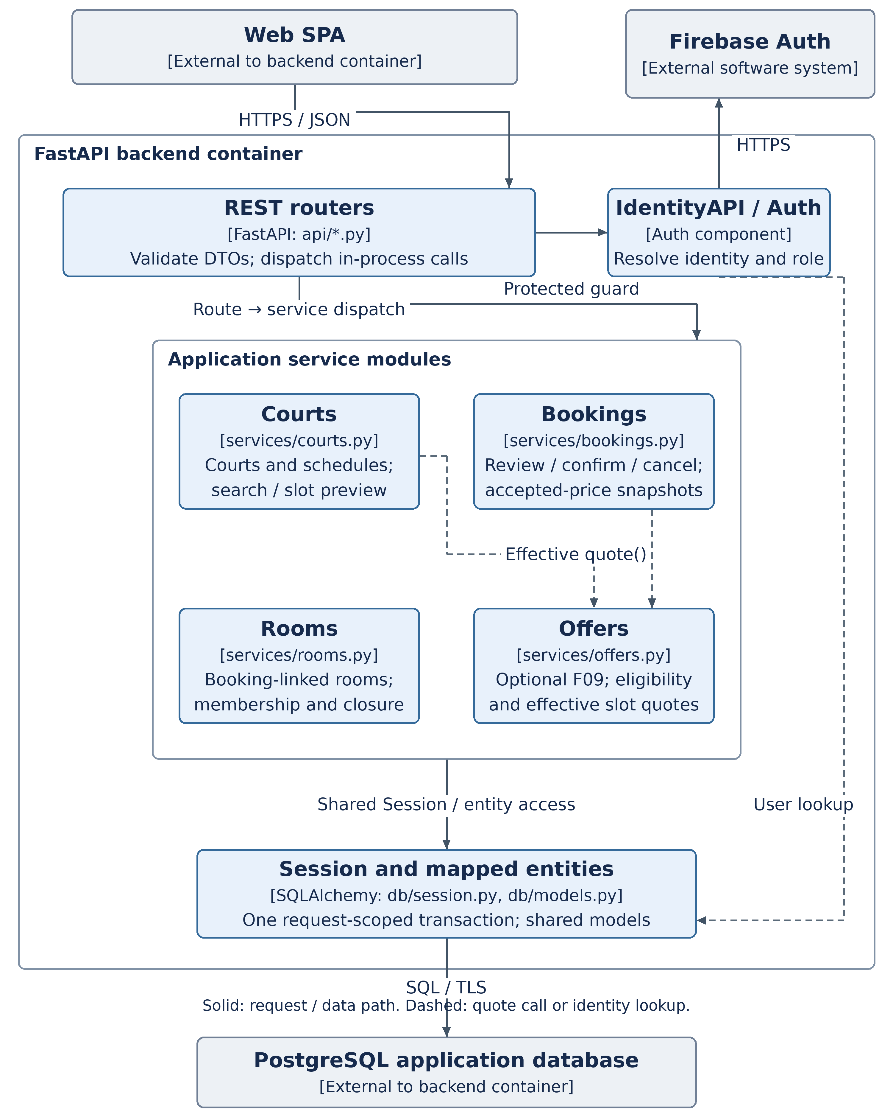
Figure 3.4. Backend components and in-process dependencies. The service-group arrows apply to every enclosed service.

3.4 Component Responsibilities and Control
The REST router box summarizes the existing API boundary, rather than adding another application service. Combining each route module with its service module gives the same design elements used in Section 4.2. The diagram shows shared paths at group level; the table makes their ownership and dependencies explicit.
Design element | Responsibility and dependencies
IdentityAPI / Auth | api/identity.py and core/auth.py: verify identity; map firebase_uid to User; initial registration and permitted profile changes. Reads users through Session. Protected routes use its guards; resource ownership is also rechecked in the relevant service. Trace: UC-01/02/15; FR-001–005/039–040; BR-09; NFR-04.
CourtsAPI / Courts | api/courts.py and services/courts.py: public discovery/preview and Owner court, hours, slot publication and maintenance operations. Uses Auth, shared entities/Session and Offers for effective quotes. Trace: UC-03/04/08/09; FR-006–013/023–027/046; BR-01/03/05.
BookingsAPI / Bookings | api/bookings.py and services/bookings.py: review, atomic confirmation, own-booking cancellation and authorized Player/Owner views. Uses Auth, Court/Slot/Booking/Room entities, Offers and Session. Cancellation closes a linked Room in the same transaction. Trace: UC-05–07/10; FR-014–022/028–030; BR-02/03/10; NFR-02.
RoomsAPI / Rooms | api/rooms.py and services/rooms.py: create one room per source booking, public search, membership, estimate and irreversible closure. Reads/locks Booking and Court entities through the shared Session; this does not require a network call to Bookings. Trace: UC-11–14/17; FR-031–038; BR-04–06/08; NFR-03.
OffersAPI / Offers | api/offers.py and services/offers.py: optional F09 configuration, effective quote, pending cancellation and active deactivation. Uses Auth, Court/Slot entities and Session; called by Courts and Bookings for current quotes. Trace: UC-16; FR-041–045/047–049; BR-07/10.
Session and mapped entities | db/session.py and db/models.py: one request-scoped SQLAlchemy Session, mapped application tables, SQL execution and transaction boundary. Shared by Auth and the domain modules; commits only when the operation completes successfully, before HTTP success, and rolls back failures. See Sections 4.2–4.4 and 5.1–5.3.
Control is synchronous: browser request → route/guard → service → shared Session → response. A confirmation revalidates court, selected slots and accepted quote under lock, then creates one Booking with all BookingSlot snapshots and SlotClaim rows. A conflict or changed quote rejects the whole request and requires fresh review. Merely reviewing slots creates no reservation.
Every court-affecting writer follows Court-first locking; selected Slot locks use a stable order. Room mutations follow Court → Booking → Room. Schedule/maintenance edits preserve confirmed bookings; room closure preserves its source booking. Effective room and offer states are evaluated against authoritative server time on the relevant read/write paths, so correctness does not depend on a timer job. UTC instants are stored; playing dates and the slot grid use Asia/Ho_Chi_Minh. BR-02 cancellation eligibility uses backend request receipt time.

3.5 Deployment Diagram
The deployment view maps the logical containers to the agreed hosting services. It shows the intended topology, rather than claiming availability or latency has already been validated.
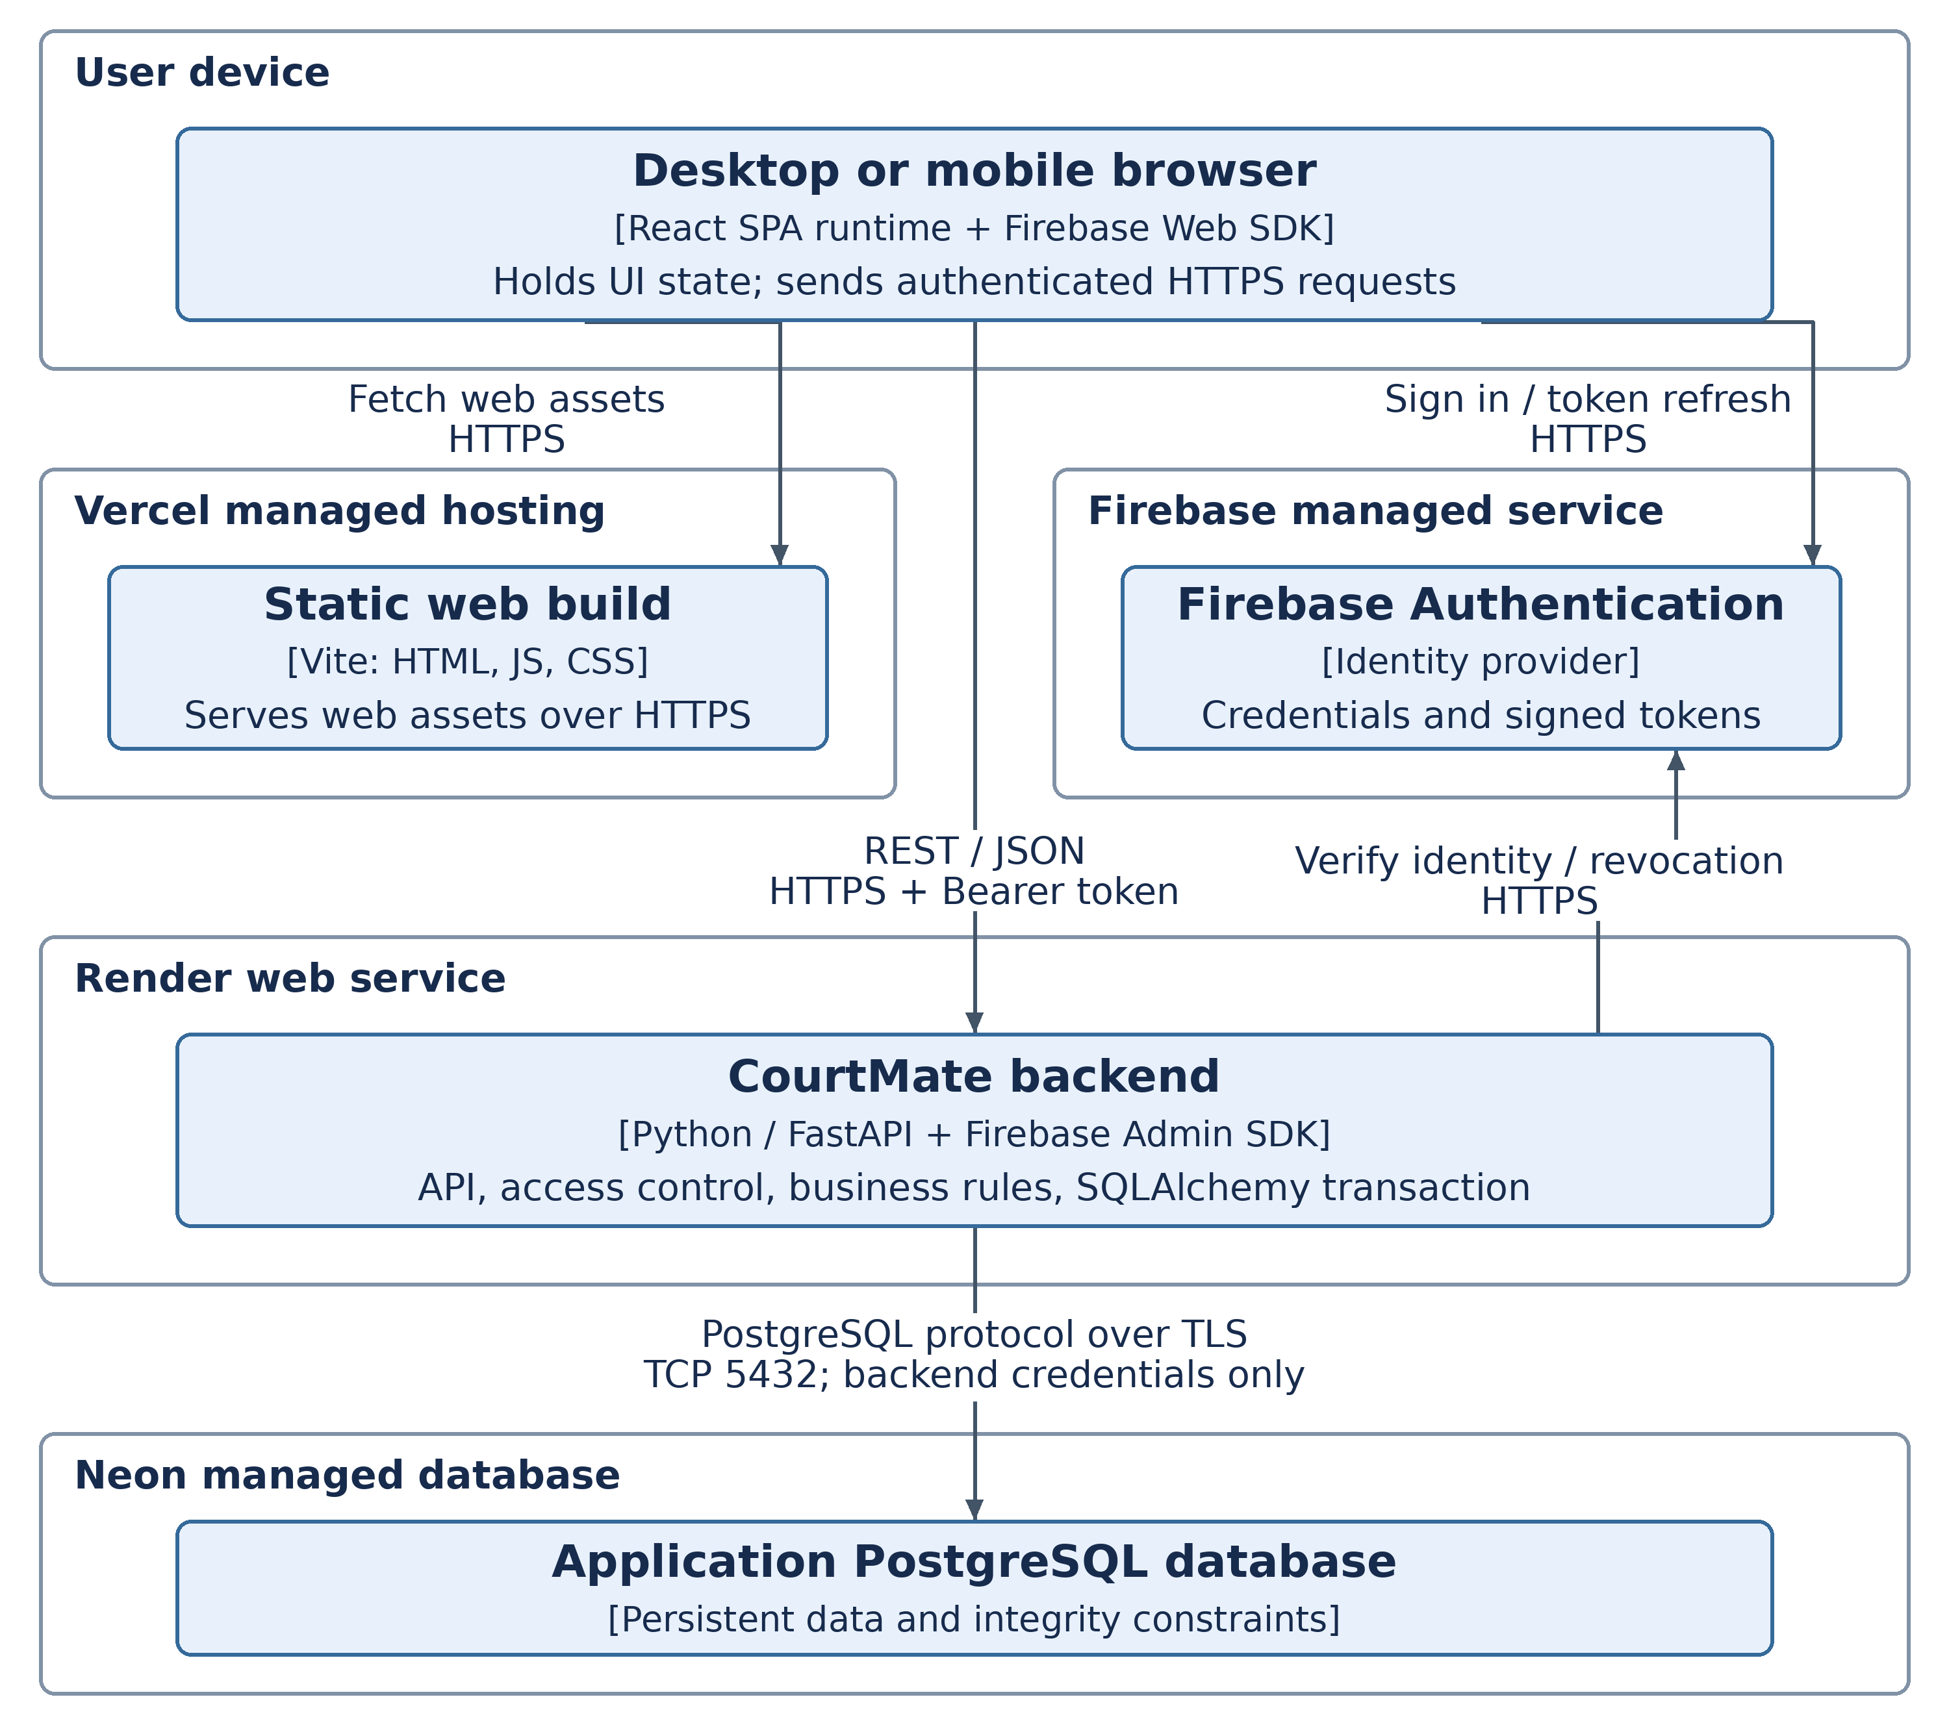
Figure 3.5. Browser runtime, Vercel asset hosting, Render API, Neon data and Firebase identity.
Vercel serves the Vite build; the downloaded SPA runs on the user device and calls Render directly. Render runs one backend deployment with all modules, terminates HTTPS through the platform, and connects to Neon using PostgreSQL over TLS. Firebase remains an external managed identity service. The hosting nodes do not add new domain services.
Keep database and Firebase Admin credentials server-side; configure the API URL and allowed CORS origins in deployment settings. Run schema migrations before serving and use API/database readiness checks. Verification outages fail closed for protected requests; failed writes roll back. Cold starts, provider outages and per-court lock waits may affect availability or latency. Validate NFR-01 after warm-up; hosting choice alone does not establish compliance.

3.6 Architecture Decision Records
Each record documents one significant decision, its assumptions, alternatives and consequences. Status is Proposed for team review; the selected technology baseline follows PA1/PA2. Detailed acceptance requires the team’s review and PA4 evidence.

ADR-001 Layered client-server with a modular backend
Field | Record
Status | Proposed
Context | CourtMate has a responsive Player/Owner UI and related scheduling, booking, room and offer rules. A four-member team needs a design it can implement and maintain within the course. Cross-domain consistency and NFR-01/NFR-05 matter more than independent service scaling at this stage.
Decision | Use React/TypeScript/Vite for presentation, one FastAPI deployment for the REST boundary and domain modules, and SQLAlchemy for persistence. Keep Identity, Courts, Bookings, Rooms and Offers responsibilities explicit. Use synchronous in-process service calls and a single application database. Vercel serves assets, Render runs the API and Neon hosts PostgreSQL (Figures 3.3–3.5).
Alternatives considered | A server-rendered application could satisfy the requirements with less client build tooling, but would change the chosen UI stack and interaction implementation. Microservices allow independent deployment/scaling but introduce network failures, distributed consistency and additional operations. The team retains its agreed SPA/API stack and modular monolith.
Consequences | Benefits: one local transaction across related rules, clear modules and straightforward deployment. Costs: coupled backend releases, separate SPA/API configuration and shared backend capacity. Keep transaction lifetimes short and avoid cyclic service orchestration. Revisit service extraction only when measurements or team ownership justify it.
Traceability | NFR-01/05; FR-006–018/025/031–038/046; UC-03–05/09/11–14/17; Sections 4.2 and 5.
Evaluation | Review route/service/entity responsibilities against Figures 3.3–3.4, then measure the PA2 workload and responsive/accessibility criteria. The design itself is not a performance test result.
Repository record: docs/design/adr/PA3-ADR-001-architecture.md

3.6 Architecture Decision Records continued

ADR-002 PostgreSQL transactions and shared integrity controls
Field | Record
Status | Proposed
Context | Concurrent requests must not double-book overlapping intervals, partially confirm a selection, overfill a room, alter accepted prices or invalidate a confirmed booking through an Owner edit. A request may update several related tables and optional offer states.
Decision | Use one PostgreSQL transaction per operation with a shared Session. Serialize court-affecting writes by locking Court first; lock selected Slots in stable order, and Room operations in Court → Booking → Room order. Revalidate interval overlap and current eligibility while locked. Persist one Booking, ordered BookingSlot snapshots and unique active SlotClaim rows atomically. Preserve snapshots on cancellation while releasing claims and closing the linked room.
Alternatives considered | Client-side or preflight availability checks alone race with other users. Optimistic version checks can work with conditional writes and retries, but add multi-row coordination here; reviewed-quote/version comparison remains useful alongside locks. An additional distributed lock service duplicates coordination already provided by the chosen database. Slot-claim uniqueness alone does not protect different slot IDs with overlapping intervals.
Consequences | Court-first locking plus interval checks prevents conflicting cooperating writers; database keys, foreign keys and checks provide additional integrity (Section 5.3). Unique room booking/membership keys and one nonterminal offer configuration per slot support their invariants. Room and offer eligibility still require locked service checks. Writes for the same court wait, so all writers must use the protocol and avoid external calls while holding locks where feasible. Unrelated courts can proceed independently.
Traceability | NFR-02/03; FR-015–018/020–027/031–038/043–045/047–049; BR-01–08/10; Figures 4.4 and 5.1; Section 5.3.
Evaluation | Run database-backed races for overlapping single/multi-slot confirmation, schedule edit versus confirmation, Join/Leave/Close and offer activation versus cancellation/deactivation. Assert atomic outcomes, unchanged accepted totals and no overcapacity.
Repository record: docs/design/adr/PA3-ADR-002-data-consistency.md

3.6 Architecture Decision Records continued

ADR-003 Firebase identity with backend role and ownership checks
Field | Record
Status | Proposed
Context | Visitors can read public information, while protected actions require a valid identity, exactly one application role and ownership of the relevant resource. Organizer permission is derived from a room’s source booking. Untrusted browser state must not grant access.
Decision | Delegate credentials and ID-token issuance to Firebase Authentication. The browser sends a Bearer token; the backend verifies it with the Firebase Admin SDK, including configured revocation/account-state checks, and resolves firebase_uid to the application User. Store the Player/Court Owner role in PostgreSQL, establish it only through valid initial registration, and reject later client attempts to change it. Enforce owner_id, player_id and organizer_id in protected operations and authorize response data.
Alternatives considered | Custom password authentication would add credential storage, password reset and session security work. Client-only route guards are bypassable. Firebase custom claims could carry authorization information, but introduce refresh/propagation concerns; they are not the authority for CourtMate resource ownership. The local user record keeps role and ownership checks aligned with application data.
Consequences | CourtMate does not store password hashes or persist bearer tokens in application tables; Firebase manages the credentials. Identity verification adds an external dependency and token refresh handling. Missing/invalid/expired/revoked identities are rejected; provider-verification failures fail closed. Use HTTPS, validate allowed origins, keep Admin credentials server-side and avoid token/secret logging. UI visibility is only a usability aid, not an access-control boundary.
Traceability | NFR-04; FR-001–005/030/037/039–040; BR-09; UC-01/02/05–10/12–17; IdentityAPI / Auth in Section 4.2.
Evaluation | Test absent/expired/forged tokens, both valid initial roles, post-registration role tampering, Player-to-Owner access, cross-Owner resources, another Player’s booking and non-organizer closure. Denied reads must expose no protected data; denied writes must change no protected state.
Repository record: docs/design/adr/PA3-ADR-003-auth-authorization.md

