Introduction to Software Engineering
Software Requirements
Specification
The student team is required to complete the Software Requirements Specification documentation for the assigned course project, following the attached template.

Software Engineering Department
Faculty of Information and Technology
University of Science

Table of Contents
Objectives 1
1 Member Contribution Assessment 2
2 Introduction 3
3 Problem Statement 6
4 Stakeholders 8
5 Requirements 9
6 Use Case Model 37
7 Use Case Specifications 42
8 Prototype / Mockups 76
9 Requirements Traceability Matrix 98
10 Requirements Review 103
11 AI Usage Log 104

Software Requirements Specification

Objectives
This document focus on the following topics:
- Completing the Software Requirements Specification (SRS) document with the following sections:
  - Problem Statement
  - Stakeholders
  - Functional, non-functional and domain requirements
  - Use case model and use case specifications
  - Prototype / mockups
  - Traceability and requirements review
- Including an AI usage log for this phase
- Understanding the Software Requirements Specification (SRS) document.

Member Contribution Assessment
Each member's contribution is agreed at 25%, totalling 100%. The table records completed PA2 responsibilities and evidence, including work completed by Hưng on behalf of Quang.
ID | Name | Role(s) | Contribution (%) | Evidence
24127174 | Nguyễn Đức Hưng | Lead; Sections 2–4, 6/8/9; F01/F02/F04/F06/F10 + AC; UC-05/17; integration/review. Completed UC-01–04/06/15 on behalf of Quang. | 25% | Issue #60; PR #68 approved and merged 24 Oct  Issue #74 — UC/model/UI/RTM  PR #79 — merged 7 November 2026
24127519 | Bùi Phạm Quang | Business analysis; Section 5.3; requirements review. UC-01–04/06/15 were assigned to Quang and completed by Hưng directly in the shared SRS. | 25% | Issue #63; CourtMate Business Rules BR-01–BR-07; reviewer of PR #68  Issue #75 — assigned to Quang; completed by Hưng in the shared SRS
24127040 | Dương Trung Hiếu | Section 5.2 NFR; integrated UC-08–10/16 Owner specifications; requirements review. | 25% | Issue #62; PR #64 merged 23 Oct  Issue #76 — Owner UCs
24127139 | Lê Thành Trung | F03/F05/F07/F08/F09 + AC; integrated UC-07/11–14 booking/room specifications; requirements review. | 25% | Issue #61; PR #70 — FR/AC contribution  Issue #77 — booking/room UCs
The team has agreed to equal 25% contributions. UC-01–04/06/15 were assigned to Quang and completed by Hưng directly in the shared SRS, without a separate commit.

Introduction

Purpose and Scope
CourtMate is a responsive web application for discovering, reserving and managing sports courts, and for organizing small public Open Play Rooms tied to confirmed court bookings. This SRS states observable system requirements, business rules, quality requirements and acceptance scenarios for later PA3 design and PA4 testing.
Intended readers: the T05 Nexora team (reviewers, developers and testers), instructor/teaching assistants. The document follows the PA1 proposal and records the team's agreed PA2 requirements baseline. Scope and business-rule decisions are resolved through the review and team confirmation recorded in Section 10.
Must-have scope:
- F01: Authentication & Authorization;
- F02: Browse and search by court name, sport, full address/area and optional time bounds, with a slot preview from each result;
- F03: Court details and Owner-published availability, excluding the optional map/directions capability FR-013;
- F04: Booking a single offered slot or several consecutive offered slots as ONE all-or-nothing reservation, with overlap prevention;
- F05: My Bookings & eligible whole-booking cancellation;
- F06: Owned court and schedule management, including daily calendars, individual/batch slot publication and maintenance;
- F07: Owner booking overview;
- F10: Booking-linked public Open Play Rooms, including address/area discovery, creation, joining, leaving and organizer-only manual closure.
Should-have scope:
- F08: editable non-critical profile information;
- F09: Owner-managed slot-specific Last-Minute Deals, created manually within 24 hours or configured to apply automatically at an Owner-selected threshold 0 < h ≤ 24 hours; prices are revalidated at application and booking confirmation.
- FR-013 within F03: optional court map and directions; manual address search and court viewing remain available without GPS permission.
Out of scope (PA1): The MVP excludes online payments, deposits, refunds, in-app messaging, push notifications, automated matchmaking, waitlists, general discount/loyalty campaigns, native mobile applications and algorithmic/demand-based repricing. Owner-configured slot-specific automatic offers under F09 are included as Should-have. Independent verification of the accuracy or reliability of Owner-supplied court information is also outside scope.
Operating and process boundary: CourtMate has two application roles, Player and Court Owner. During public email/password registration, a visitor chooses exactly one of these roles; the backend validates and stores that initial role. Existing users cannot change their own role through profile editing or forged requests. An organizer is a Player who owns a room-linked booking, not a third role. The proposed React/Vite, FastAPI, Firebase Authentication and PostgreSQL stack informs PA3 design; requirements remain traceable to FRs, BRs, ACs, UCs, screens and later tests.

Glossary
Term | Definition
FR / NFR | Functional Requirement / Non-Functional Requirement
BR / AC | Business Rule / Acceptance Criterion (testable pass-fail scenario)
MoSCoW | Must, Should, Could, Won’t (release prioritization)
UC / RTM | Use Case / Requirements Traceability Matrix
Player | Authenticated application role permitted to book and participate in Open Play Room.
Court Owner | Court Owner Account may manage only owned courts and their bookings.
Slot (or Interval) | A dated, nonoverlapping interval published by the Court Owner for one court, with start/end times on 30-minute boundaries, duration 60–240 minutes and its own positive whole-VND quote (BR-01).
Confirmed booking | A single saved CONFIRMED booking owned by one Player for one court, containing the booked IDs of one or more consecutive Owner-published slots, the combined start/end interval and the total explicitly accepted price. No online payment is implied.
Blocked interval | Time a court Owner marks unavailable, e.g., maintenance
Overlap | Two intervals [start, end) for the same court overlap when each starts before the other ends. Touching boundaries alone do not overlap; the earlier end may equal the next start.
Eligible cancellation | Whole-booking cancellation requested by the owning Player while the booking is CONFIRMED, when its earliest constituent slot starts at least six hours after the backend receives the request. Exactly six hours is eligible; the authoritative backend receipt time determines the cutoff (BR-02).
Room organizer | The Player who creates a room from their own confirmed booking and remains its first member. Only this Player may manually close that room; organizer is a relationship, not an application role.
Room capacity | Maximum room member count C, including the organizer, where C is an integer and 2 <= C <= 2 × court.max_players. Court max_players is an integer from 2 to 30; the room roster may include players who rotate on court (BR-05).
Booking price snapshot | Immutable total VND price explicitly accepted for all selected slots at confirmation; any applicable F09 offer affects only its eligible slot and the per-slot accepted prices can be retained for audit (BR-10).
Cost estimate | Informational per-person amount (in Open Play Room); not a payment or financial obligation.
Last-Minute Deal | A slot-specific Owner-created offer: either manually applied while 0 < remaining time ≤ 24 hours, or automatically applied under an Owner-configured threshold 0 < h ≤ 24 hours. A pending schedule is not yet a discounted quote; only a currently eligible ACTIVE offer may affect a new booking (BR-07).
Requirements baseline | Version of the SRS established and recorded after the project requirements review.
Automatic offer schedule | An Owner-configured price and lead-time threshold h for one published future slot. SCHEDULED waits for the applicable time and eligibility; ACTIVE is still revalidated for use. CANCELLED, DEACTIVATED and EXPIRED are terminal and never automatically revive.

Problem Statement
Business background: Recreational players need to discover available courts and book reliable intervals. Court owners need dependable schedules and visibility of reservations. Room Organizers who have already reserved a court may need to recruit participants. These are product hypotheses carried from PA1, not claims of completed market interviews.
Current problem: Availability published via calls, chats or spreadsheets may become stale; simultaneous requests can target the same interval; maintenance closures may invalidate offered time slots; organizers may track participant rosters across disconnected chats.
Stakeholder needs: Visitors and Players require search by court name, sport, full address/area and optional time bounds, accurate published availability and a slot preview from search results. Players require consecutive slots as one booking, a clear accepted total, history and eligible whole-booking cancellation. Court Owners require safe management of owned courts, daily schedules, batch publication and booking visibility. Organizers require public room discovery, participant rosters within the allowed room capacity and the ability to close their own OPEN/FULL room before play without cancelling the court booking; rooms also close on booking cancellation or arrival of the first slot start.
Proposed solution: CourtMate combines server-validated Court Owner published slots, atomic confirmation of one or several consecutive slots as a single booking, role/ownership checks, court scheduling and lightweight public room participation. Optional F09 supports manual offers and Owner-configured automatic offers for individual slots. An automatic offer becomes applicable only within its selected 0 < h ≤ 24-hour window and while the slot/price remain eligible; the booking total is revalidated before confirmation. No payment gateway or chat system is proposed.
Observable goals:
- One valid selection of consecutive published slots creates exactly ONE confirmed booking and one accepted total price.
- If any selected slot becomes invalid, none of the selected slots is reserved.
- Concurrent overlapping requests cannot both confirm.
- Cross-CourtOwner resource access is rejected.
- One booking links to at most one Open Play Room.
- Room membership never exceeds its capacity (C), which is at most twice the court’s simultaneous-player capacity.
- Cancellation releases the entire booked selection and closes its linked Open Play Room.
- Organizer-only manual room closure stops participation while preserving the confirmed booking, accepted total, reserved slots and member history.
Operating environment: Responsive desktop/mobile web clients connect to the proposed FastAPI server over HTTPS. Firebase Authentication supplies identity tokens; backend enforces authorization and transaction-safe updates in PostgreSQL. Proposed cloud hosts are Vercel, Render and Neon; actual production performance remains subject to NFR test evidence.
Design and implementation constraints: The four-member team works under Waterfall PA1–PA5 phase gates and a limited implementation window. Only Player and Court Owner are application roles. Must features cannot depend on payments or Should-have profile/offer functionality. F09 remains optional for both manual and Owner-configured automatic offers; unrestricted campaigns and algorithmic repricing are excluded.
Business Rules Constraints: Owner-published slot intervals, contiguous multi-slot selection, combined price, all-or-nothing booking, whole-booking cancellation, booking protection (no forced cancellation), doubled room membership capacity, and informational cost sharing follow BR-01–BR-10 in Section 5.3 and are cross-referenced in the FRs and acceptance criteria.

Stakeholders
Stakeholders and relevant viewpoints follow from the PA1 proposal; Firebase Authentication is an external service, not an additional human account role.
# | Stakeholder | Description | Interests / concerns
1 | Visitor (interactor) | Unauthenticated person who registers, signs in, searches courts, views published availability and browses/searches public rooms. | Useful discovery without compulsory sign-in or GPS; clear transition to authentication for protected actions.
2 | Player (interactor) | Searches, books and cancels own bookings; creates/joins/leaves public rooms and closes a room when acting as its organizer. | Accurate slots/prices, fair concurrency, usable mobile flows, privacy.
3 | Court Owner (interactor) | Manages own courts, hours, maintenance and booking visibility | Ownership security, booking integrity, schedule reliability; optional manual deals and configuration/management of slot-specific automatic offers.
4 | Firebase Authentication (interactor system) | External identity/token provider; not a CourtMate user role | Interoperable token validation, safe failure/expired-session behavior.
5 | Nexora T05 (indirect) | Implements/tests and manages scope across PA phases | Feasible Must set, traceability, maintainability and team evidence.
6 | Instructor / TA (indirect) | Sets phase expectations and evaluates deliverables | Correct template use, quality, reviews, honest AI disclosure.
Viewpoints: Interactor viewpoints cover Visitors, Players, Court Owners and the external authentication service. Indirect viewpoints cover the project team and instructor/TA. Domain viewpoints describe booking intervals, cancellation eligibility, availability, room capacity and lifecycle constraints; these domain rules are not additional human stakeholders or application roles.

Requirements

Functional Requirements
Functional requirements are identified by a unique FR ID, grouped by CourtMate feature and assigned a MoSCoW priority and a traceable source document or stakeholder domain.

F01 — Authentication & Authorization
ID | Requirement | Requirement Definition | Feature | Priority | Source
FR-001 | Register by email and select an initial role. | The system shall let a Visitor register using email/password through Firebase Authentication and select exactly one initial role, Player or Court Owner. The backend shall accept only these two role values and create one corresponding CourtMate account only after identity registration succeeds. Failed registration shall grant no protected access. | F01 | Must | PA1, Section 2.4 — F01
FR-002 | Sign in by email and sign out. | The system shall authenticate a registered account using its email and password and allow sign-out of the active application session. Failed sign-in shall create no authenticated session. After sign-out, protected requests from that application session shall require renewed valid authentication; no username-based sign-in is required. | F01 | Must | PA1, Section 2.4 — F01
FR-003 | Assign user roles. | Each account shall have exactly one backend-stored role, Player or Court Owner, selected through the permitted initial registration flow. After account creation, profile edits, request parameters and client-side state shall not change that role. Invalid/unassigned roles shall be denied protected access. A room organizer is a Player relationship, not another role (BR-09). | F01 | Must | PA1, Section 2.4 — F01
FR-004 | Require authentication for protected actions. | The system shall authenticate every request to view/create/cancel a protected booking, create/join/leave/manually close a room, edit a profile or change an Owner-managed court, schedule, maintenance interval or offer. Invalid authentication shall disclose no protected record and shall not modify protected data. Public court/room discovery remains available without authentication. | F01 | Must | PA1, Section 2.4 — F01
FR-005 | Check role and resource ownership. | The server shall check role and ownership for each protected action. Booking and room participation require an eligible Player; manual room closure additionally requires that room’s organizer. Court, schedule, maintenance, offer and owned-booking management require the owning Court Owner. Changing resource IDs or client role fields shall not bypass these checks. | F01 | Must | PA1, Section 2.4 — F01

F02 — Browse & Search
ID | Requirement | Requirement Definition | Feature | Priority | Source
FR-006 | Display active court listings. | - The system shall show publicly discoverable active courts with each court’s name, sport type and location (area/address) and allow navigation to its details (FR-010).  - A deactivated court shall not be available for a new booking. | F02 | Must | PA1, Section 2.4 — F02
FR-007 | Search courts by name. | The system shall accept direct keyboard entry of a complete or partial court name on the search page, trim surrounding whitespace and match the query as a case-insensitive substring. Results shall contain only matching active courts satisfying the other current filters. Clearing the name shall remove only the name restriction. | F02 | Must | PA1, Section 2.4 — F02
FR-008 | Filter courts by sport, address or area and optional time bounds. | The system shall combine the court-name query with optional sport, free-text full address/area, start datetime and end datetime criteria; every result shall satisfy all supplied criteria. Address matching shall be case-insensitive against the published address/area, without compulsory GPS or selection from suggestions. The sport control shall be a bounded scrollable dropdown with prefix search and single-option selection.  Either time bound may be supplied alone. When both are supplied, end must be later than start; invalid input shall show a field error. With any time bound, a returned court must have at least one future AVAILABLE published slot fully within the supplied bounds: slot.start >= start and slot.end <= end where those bounds exist. Editing/clearing one criterion shall preserve the others. Clear time removes only both time bounds; Clear all resets every criterion. | F02 | Must | PA1 F02; PA2 search/filter and time-bound requirements clarified through prototype review
FR-009 | Handle empty search results. | -The system shall display an explicit empty-results state when no active court satisfies the current search and filters, and allow the visitor to change or clear those criteria instead of showing unrelated courts. | F02 | Must | PA1, Section 2.4 — F02
FR-046 | Preview a result court’s matching or nearest slots. | Every active court card in search results shall provide a View slots action whether or not time bounds are set. It shall open that court’s slot-preview overlay without discarding the results or current criteria. With time bounds, list only future AVAILABLE published slots fully inside those bounds under FR-008. Without time bounds, list nearest upcoming eligible slots in chronological order. Each row shows playing date, start/end, full-slot quote and availability; no fixed two-slot limit is imposed. An empty preview shows no available matching slots. Closing restores the same search context. Choosing a slot proceeds to full slot selection/review; previewing reserves nothing (FR-011/014). | F02 | Must | PA2 search-result slot-preview requirement; UC-03/UC-04 and prototype D01/D04

F03 — Court Details & Owner-Published Availability
ID | Requirement | Requirement Definition | Feature | Priority | Source
FR-010 | Display court details. | The system shall display a court detail page showing its name, owner or contact, sport, address/area, descriptive information, available photos (when supplied), base price and a link to its available slot. | F03 | Must | PA1, Section 2.4 — F03
FR-011 | Display published slot lists and slot details | -The system shall display each Court Owner-published, dated slot within one court with its start/end time, total price for that individual slot, and current AVAILABLE, BOOKED or BLOCKED status.  -If F09 is implemented, show a valid slot-specific discounted deal price where applicable; availability must reflect any confirmed booking whose combined interval covers the slot (BR-01/BR-10). | F03 | Must | PA1, Section 2.4 — F03; PA2 BR-10
FR-012 | Select eligible consecutive court slots. | -The system shall allow selection only of currently AVAILABLE future Owner-published slots for the same court and playing date.  -It shall support selecting one slot or several strictly consecutive slots, and shall show why BOOKED, BLOCKED, nonconsecutive, mixed-court or otherwise incompatible selections cannot proceed (BR-10). | F03 | Must | PA1, Section 2.4 — F03; PA2 BR-10
FR-013 | Show optional court map and directions. | -If the optional map capability is delivered, the system shall show the court location on a map and provide a route-link or estimate using an explicit origin supplied or permitted by the visitor;  -Denying GPS permission shall not block court viewing. | F03 | Should | PA1, Section 2.4 — F03

F04 — Court Booking
ID | Requirement | Requirement Definition | Feature | Priority | Source
FR-014 | Review selected slots and total booking price. | -The system shall let an authenticated Player select one or more strictly consecutive, future AVAILABLE slots published by the Owner for the same active court and playing date, then review the ordered slot list, combined start/end times, total duration, each slot quote and summed booking price before one confirmation request. -Merely selecting slots shall not reserve them (BR-10). | F04 | Must | PA1, Section 2.4 — F04; PA2 BR-10
FR-015 | Validate booking eligibility and time rules. | -The system shall reject a requested booking if any selected slot is not a published eligible slot, starts in the past, overlaps maintenance or a confirmed booking, falls outside the court’s operating hours, or breaks the slot-grid, adjacency, same-court/date or combined 60–240-minute duration rules in BR-01/BR-10. No part of the selection shall be confirmed on rejection. | F04 | Must | PA1, Section 2.4 — F04; PA2 BR-10
FR-016 | Prevent overlapping bookings. | -The system shall atomically prevent overlapping CONFIRMED bookings for the same court, including bookings made from multiple consecutive published slots and concurrent requests sharing even one slot.  -If any part conflicts, at most one conflicting booking may be committed and no partial reservation of the losing selection may remain (NFR-02/BR-10). | F04 | Must | PA1, Section 2.4 — F04; PA2 BR-10
FR-017 | Create one confirmed booking for selected slots. | -The system shall create exactly ONE CONFIRMED booking per successful single-slot or contiguous multi-slot confirmation, with a unique booking ID, authenticated Player, court, ordered selected slot IDs, combined interval, status and explicitly accepted total price (with slot-price details retained or derivable for review).  -Confirmation shall show the same details (BR-10). | F04 | Must | PA1, Section 2.4 — F04; PA2 BR-10
FR-018 | Revalidate slots and prices at confirmation. | -At confirmation, the backend shall atomically revalidate the full ordered selected slot set, published schedule, adjacency, combined duration, all overlapping reservations, maintenance, each current slot quote and each applicable F09 offer.  -If any element or the summed price changed, reject the WHOLE request, explain the conflict or price change and require a fresh review; never silently reprice or partially book the selection (BR-10). | F04 | Must | PA1, Section 2.4 — F04; PA2 BR-10

F05 — My Bookings & Cancellation
ID | Requirement | Requirement Definition | Feature | Priority | Source
FR-019 | View recent booking history. | The system shall let a signed-in Player view their ten most recent booking records (or all if fewer), sorted by booking time descending. Each combined multi-slot booking shall appear as ONE item with its booking ID, court, overall interval, total price and status, not separate items for constituent slots. | F05 | Must | PA1, Section 2.4 — F05
FR-020 | Cancel an eligible whole booking. | -The system shall allow a Player to cancel only their own CONFIRMED booking, including one made from several slots, when at least 6 hours remain before the FIRST selected slot starts (BR-02).  -Recheck using backend time upon receipt; a successful cancellation shall set the single booking to CANCELLED, release its full set of slots when otherwise eligible and retain history.  - Partial per-slot cancellation is not supported. | F05 | Must | PA1, Section 2.4 — F05; PA2 BR-10
FR-021 | Display cancellation eligibility. | The system shall show whether each complete booking can currently be cancelled under BR-02 using the booking’s earliest start time. The Cancel action applies to the whole booking and shall be disabled with a clear reason when not eligible; the backend makes the authoritative decision. | F05 | Must | PA1, Section 2.4 — F05
FR-022 | Release slots after booking cancellation. | Following successful cancellation of a booking, the system shall release ALL its constituent future slots for new bookings, subject to the current Owner schedule and maintenance rules. It shall not leave a partially confirmed/cancelled multi-slot booking; any linked Open Play Room shall become CLOSED (BR-02/BR-06/BR-10). | F05 | Must | PA1, Section 2.4 — F05; PA2 BR-10

F06 — Court & Schedule Management
ID | Requirement | Requirement Definition | Feature | Priority | Source
FR-023 | Create and edit owned court listings. | -The system shall allow an authenticated Court Owner to create or edit only their own court listing, including name, sport, address/area, description, positive base price in VND and integer max_players from 2 to 30 (the simultaneous on-court player limit).  -The update shall be rejected if invalid, unauthorized, or if 2 × the proposed max_players would fall below the capacity of any existing future OPEN/FULL linked room (BR-05); existing court/room values remain unchanged. | F06 | Must | PA1, Section 2.4 — F06; PA2 BR-05
FR-024 | Deactivate an owned court. | -The system shall allow a Court Owner to deactivate only a court they own. -The deactivated court shall not be offered for new bookings, while existing booking records and their saved statuses shall remain unchanged. | F06 | Must | PA1, Section 2.4 — F06
FR-025 | Manage operating hours and published slots. | The system shall let an authenticated Court Owner select an owned court/date, set operating hours and view the full daily schedule. It shall support individual dated-slot entry and batch draft generation within a chosen interval using a chosen valid slot duration and positive whole-VND full-slot quote. The Owner may preview, edit/add/remove draft rows before explicit publication; leaving/cancelling a draft publishes nothing. There is no fixed two-slot publication limit.  Publication shall revalidate the entire submitted set against BR-01, the latest bookings and maintenance. An invalid/conflicting set shall leave the published schedule unchanged and identify errors. An AVAILABLE published slot may be edited; a slot in a CONFIRMED booking cannot have its interval or regular quote changed. No change may invalidate a confirmed single- or multi-slot booking (BR-03/BR-10). | F06 | Must | PA1 F06; PA2 daily-calendar and batch-publication workflow; BR-01/03/10
FR-026 | Mark court maintenance intervals. | -The system shall allow a Court Owner to mark maintenance intervals on their own court; such intervals shall be shown as unavailable and shall reject new booking requests.  -Any maintenance interval intersecting a confirmed booking shall follow FR-027/BR-03. | F06 | Must | PA1, Section 2.4 — F06
FR-027 | Protect confirmed bookings from schedule edits. | -The system shall reject Owner-initiated edits to a published slot’s time interval or regular quoted price while that slot is included in any CONFIRMED booking, even if the booking’s saved total would otherwise remain unchanged.  -It shall also reject opening-hour or maintenance changes that would invalidate or split any existing CONFIRMED booking covering one or multiple slots. Preserve the booking, its accepted total price and previously valid schedule (BR-03/BR-10). | F06 | Must | PA1, Section 2.4 — F06

F07 — Owner Booking Management
ID | Requirement | Requirement Definition | Feature | Priority | Source
FR-028 | View bookings for owned courts. | The system shall let a Court Owner view a list of bookings associated only with courts that the authenticated Owner owns, including their current status. | F07 | Must | PA1, Section 2.4 — F07
FR-029 | Display owned-court booking details. | For a booking on an owned court, the system shall show its unique booking ID, court, full combined playing interval, ordered constituent slots, accepted total VND price, status and creation timestamp. The only Player contact fields disclosed to that Owner are the registration email and display name when present; absence of an optional profile must not block the Owner’s booking view. Passwords, identity tokens, other bookings and private profile preferences shall not be disclosed. | F07 | Must | PA1, Section 2.4 — F07
FR-030 | Restrict access to other owners’ bookings. | The system shall reject Court Owner requests to view or modify booking data tied to courts owned by another account, including attempts made by changing resource identifiers in API requests. | F07 | Must | PA1, Section 2.4 — F07

F08 — Editable Profile
ID | Requirement | Requirement Definition | Feature | Priority | Source
FR-039 | Display editable basic profile. | The system shall show an authenticated user their basic editable profile information, such as display name and contact preferences, without allowing the user to self-edit application role or identity-provider-controlled fields. | F08 | Should | PA1, Section 2.4 — F08
FR-040 | Validate and save profile changes. | The system shall validate and save permitted changes to the current user’s basic profile, report validation errors without overwriting valid stored data and preserve protected role/identity attributes. | F08 | Should | PA1, Section 2.4 — F08

F09 — Last-Minute Deals
ID | Requirement | Requirement Definition | Feature | Priority | Source
FR-041 | Create manual slot-specific discounts. | If F09 is delivered, the system shall let an authorized Court Owner confirm a positive whole-VND offer below the regular quote for an owned, AVAILABLE, unblocked published slot of an active court, with authoritative remaining time 0 < Δ ≤ 24 hours. Reject creation if any SCHEDULED or ACTIVE manual/automatic configuration already exists for that slot. The offer applies only to that slot (BR-07/BR-10). | F09 | Should | PA1, Section 2.4 — F09; PA2 BR-07/BR-10
FR-042 | Deactivate an active discount offer. | The system shall let the authorized Court Owner confirm deactivation of their own ACTIVE manual or automatic offer. Keep/Cancel preserves its state. A deactivated offer cannot appear/apply in new confirmations or reactivate through a timer, availability change or booking cancellation. Deactivation does not require the slot to satisfy creation eligibility and preserves prior accepted booking totals. A new configuration requires current creation checks (BR-07). | F09 | Should | PA1, Section 2.4 — F09
FR-043 | Re-evaluate eligible offers after cancellation. | After an eligible whole-booking cancellation releases all constituent slots under BR-02/BR-10, the system shall re-evaluate any retained offer configuration independently for each slot. A manual ACTIVE offer requires 0 < Δ ≤ 24 hours. An automatic SCHEDULED/ACTIVE offer requires 0 < Δ ≤ h ≤ 24 hours. Court activity, availability, maintenance and the current price must also be valid. Never revive CANCELLED, DEACTIVATED or EXPIRED configurations; preserve the cancelled booking’s accepted-price history (BR-07). | F09 | Should | PA1, Section 2.4 — F09; PA2 BR-07/BR-10
FR-044 | Revalidate manual/automatic offers at confirmation. | When confirming a single-slot or combined booking involving F09, the system shall atomically recheck every selected slot, current prices and any offer’s ownership/state and mode-specific authoritative time window: manual 0 < Δ ≤ 24, automatic 0 < Δ ≤ h ≤ 24. A SCHEDULED automatic offer may first become ACTIVE only if all eligibility checks pass. Any changed or invalid quote rejects the entire confirmation and requires a fresh review/acceptance; no partial reservation is made (BR-07/BR-10). | F09 | Should | PA1, Section 2.4 — F09; PA2 BR-07/BR-10
FR-045 | Save the accepted discounted booking total. | The system shall save exactly one accepted total equal to the sum of validated regular or eligible manual/automatic offer quotes for the selected slots. Later activation, schedule cancellation, offer deactivation/expiry or Owner price/slot edits shall not change that accepted total. No discount spreads to adjacent slots and no online payment, deposit, coupon or unrestricted pricing campaign is created (BR-07/BR-10). | F09 | Should | PA1, Section 2.4 — F09; PA2 BR-07/BR-10
FR-047 | Configure a slot-specific automatic offer. | If F09 is delivered, the system shall let an authorized Court Owner configure and confirm one discounted whole-slot VND price and a numeric lead time h with 0 < h ≤ 24 hours, including fractional hours, for an owned AVAILABLE, unblocked published future slot of an active court. The offer price must be a positive integer below its regular quote. Configuration may be saved more than 24 hours before the slot starts. Show the computed application time and reject a second SCHEDULED/ACTIVE configuration for the same slot (BR-07). | F09 | Should | Owner product clarification, 6 Nov 2026; BR-07; FR-041/048/049
FR-048 | Apply automatic offers at the configured threshold. | For an enabled automatic configuration, the system shall use the current published slot start and authoritative server time. It shall first activate and apply the offer only when 0 < Δ ≤ h ≤ 24 hours and current court/slot/price eligibility passes. Before that window or while booked, blocked, inactive or invalidly priced, do not apply a discount; show the pending/ineligibility reason and re-evaluate if conditions recover before start. Repeated evaluations cannot duplicate offers. Slot/time/quote edits recompute eligibility, and each displayed/confirmed quote uses the current effective state without relying only on a scheduled job. At the slot start any remaining nonterminal configuration becomes EXPIRED and cannot newly activate; prior terminal states remain unchanged (BR-07). | F09 | Should | Owner product clarification, 6 Nov 2026; BR-07; NFR-02
FR-049 | Cancel a pending automatic offer schedule. | The system shall let an authorized Court Owner review and confirm cancellation of their owned SCHEDULED offer. Keep/Cancel leaves it unchanged. Recheck its current state before changing it: a successful cancellation records terminal CANCELLED and prevents later automatic activation. If it has become ACTIVE, require the separate active-offer deactivation confirmation instead of claiming a pending cancellation. Do not change slots, existing bookings or accepted totals (BR-07/FR-042). | F09 | Should | Owner product clarification, 6 Nov 2026; BR-07; FR-004/005

F10 — Open Play Rooms
ID | Requirement | Requirement Definition | Feature | Priority | Source
FR-031 | Create one room per eligible booking. | -The system shall allow a signed-in Player to create at most one public Open Play Room linked to their own future CONFIRMED booking, whether the booking contains one slot or multiple consecutive slots. Room court and full combined playing interval are inherited from that booking. - -Cancelled/started/already-linked bookings cannot create another room (BR-04). | F10 | Must | PA1, Section 2.4 — F10; PA2 BR-04/BR-10
FR-032 | Validate Open Play Room capacity. | -The system shall accept Open Play Room capacity (C) only when C is an integer between 2 and TWICE the linked court’s saved max_players (2 <= court.max_players <= 30, hence 2 <= C <= 60).  -The Room Organizer is included immediately as member one. Invalid capacities must not create a room (BR-05). | F10 | Must | PA1, Section 2.4 — F10; PA2 BR-05
FR-033 | Browse and search public rooms by court address or area. | The system shall let Visitors and Players browse/search public rooms by the linked court’s full address or area as optional free text, using case-insensitive matching against the court address/area without requiring GPS. Optional address suggestions shall not prevent manual input. Clearing location restores the public list; no match shows an explicit empty state. Each room displays its linked booking’s full interval, court/address, member count/capacity and effective OPEN/FULL/CLOSED status. Cancelled/started bookings and manually closed rooms shall be CLOSED and nonjoinable (BR-06). | F10 | Must | PA1 F10; PA2 Open Play address/area discovery requirement; BR-06
FR-034 | Join an eligible Open Play Room. | -The system shall let an authenticated Player join an OPEN Open Play Room only while the linked booking remains CONFIRMED and its start time is strictly in the future according to server time, the Player is not already a member, and active membership is below capacity. -Failed eligibility checks shall not create membership (BR-05/BR-06). | F10 | Must | PA1, Section 2.4 — F10
FR-035 | Prevent room overcapacity and duplicate joins. | -The system shall guarantee that simultaneous joins never push the stored active room member count above the selected capacity C (which itself cannot exceed 2 × court.max_players)  -Never create duplicate active membership for the same Player.  -The Room Organizer counts toward C (BR-05/NFR-03). | F10 | Must | PA1, Section 2.4 — F10
FR-036 | Leave an eligible Open Play Room. | Before the linked booking’s earliest start, an enrolled non-organizer Player may leave an OPEN/FULL room; the system shall update membership/estimate and reopen FULL to OPEN when a place becomes free, without changing the booking. The organizer cannot leave through this action. CLOSED rooms, including manually closed rooms, and rooms whose start time has arrived shall reject participation changes (BR-06). | F10 | Must | PA1, Section 2.4 — F10
FR-037 | Close rooms automatically or by organizer confirmation. | The system shall make a room irreversibly CLOSED when its source booking is cancelled, its earliest slot start is reached, or its authenticated organizer explicitly confirms manual closure. Manual closure is allowed for the organizer’s OPEN/FULL room while its source booking is future and CONFIRMED, including rooms with other enrolled members. Recheck role, organizer ownership, current room/booking status and server time before changing it.  Manual closure shall retain participant history/count, keep the booking CONFIRMED with its slots and accepted total unchanged, and permit no further Join/Leave, reopening or second room for that booking. Cancel/Keep open applies no change. Unauthorized requests are rejected; repeating closure of an already CLOSED room returns its current state without repeating effects. Effective cancellation/start closure is enforced from authoritative time/status on read/join/leave/close without requiring a scheduled job (BR-04/06). | F10 | Must | PA1 F10; PA2 organizer-only manual closure requirement and UC-17; BR-04/06
FR-038 | Display per-person cost estimate. | -The system shall display an informational per-person estimate equal to the one linked booking’s accepted TOTAL price (sum across all its selected slots) divided by current enrolled room members including the organizer, rounded to whole VND (BR-08).  - Update after joins/leaves  - It is not a deposit, payment or legally enforceable share. | F10 | Must | PA1, Section 2.4 — F10

Non-Functional Requirements
Each non-functional requirement defines an observable quality target, the conditions under which it applies and a repeatable verification method.
ID | Category | Requirement (measurable) | How it will be verified
NFR-01 | Performance | Under 30 concurrent virtual users during a 60-second steady-state workload after warm-up, search/view API P95 latency shall be < 800 ms, booking/write API P95 shall be < 1500 ms and the application error rate shall be < 1%, excluding expected validation/conflict responses. | Run JMeter or k6 against a documented test environment; record seeded data volume, request mix, warm-up, response-time P95 values and error rate.
NFR-02 | Booking concurrency | For any court, concurrent confirmation attempts that share at least one selected Owner-published slot or have partially/fully overlapping combined intervals shall never store conflicting CONFIRMED bookings or partially commit a multi-slot selection; each request succeeds as ONE entire booking or fails entirely. If F09 is implemented, concurrent manual/automatic configuration and activation/cancellation/deactivation shall retain at most one SCHEDULED/ACTIVE configuration per slot and shall never apply a terminal offer or modify a saved booking total. | Automated database-backed tests with at least 10 concurrent overlapping single-slot and multi-slot requests, including two requests sharing only one middle/end slot; verify zero overlapping CONFIRMED intervals, zero partial selected-slot allocations, and one booking ID per successful selection. For F09, also race duplicate manual/automatic creation, activation versus pending cancellation/deactivation and activation versus booking; assert unique configuration, authoritative final state and unchanged prior totals.
NFR-03 | Room concurrency | For any eligible room capacity C satisfying 2 <= C <= 2 × court.max_players (BR-05), even concurrent joins shall never store member_count > C or duplicate active membership for the same Player in a room; the organizer counts as member one. Concurrent Join/Leave/Close requests shall also preserve the effective lifecycle: after closure takes effect, no later Join/Leave may change membership, and manual closure shall not change the linked booking. | Exercise boundary cases for a court with max_players=8 and room capacities C=16 (valid) and C=17 (invalid); for a valid nearly-full room submit concurrent distinct joins plus duplicate retries, asserting active membership count never exceeds C. Exercise Join-versus-Close and Leave-versus-Close races; verify retained history, CLOSED participation rejection and an unchanged booking after manual closure.
NFR-04 | Security | Every protected API operation shall reject absent, invalid or expired identity tokens and enforce the backend-stored Player/Court Owner role plus resource ownership. Selecting either permitted role during valid initial registration is allowed. Once the account exists, client role changes or forged role/ownership claims shall grant no additional access or disclose another user’s protected data. Only the room organizer may manually close a room. | Automated API tests for missing/expired tokens, invalid registration roles, Player requests to Owner operations, Owner A accessing Owner B resources, post-registration role tampering and non-organizer room closure. Verify denied reads disclose no protected data and denied writes change no protected state. Include successful initial registration for both permitted roles as a control. If F09 is delivered, include cross-Owner automatic scheduling and schedule cancellation as denied-write cases.
NFR-05 | Usability / accessibility | At viewport widths 375, 768 and 1280 CSS pixels, Player search/slot selection/review, Open Play discovery and Owner slot management shall remain usable without clipped essential controls or page-level horizontal overflow. Every interactive control shall have a programmatically associated name/label and be keyboard operable with visible focus; dropdowns/dialogs shall support appropriate Escape and focus return. Selected, unavailable, invalid and disabled states shall have textual identification. Body text contrast shall be at least 4.5:1. The implemented core pages shall score at least 80/100 in Lighthouse accessibility under documented test settings. | Test the specified tasks at all three widths using keyboard-only navigation and a screen reader; record labels, focus order/return, errors and textual states. Measure rendered body-text contrast. Run Lighthouse on the tested implementation pages with recorded URL, build/browser/Lighthouse versions and settings; each score must be >=80/100. Automated scores supplement the manual checks and do not alone prove accessibility compliance.

Domain Requirements and Business Rules
BR-01–BR-07 originate from the team business-rule baseline (Issue #63) and PA1. This specification includes the agreed multi-slot aggregation, twice-court room membership and slot-specific manual/automatic offer rules. BR-08–BR-09 define cost estimates and account roles; BR-10 defines consecutive-slot booking. The team has confirmed BR-01–BR-10 as part of the PA2 requirements baseline recorded in Section 10.
Financial transactions, algorithmic/demand-based pricing, force-cancellation flows, push notifications and room waiting lists are excluded from the PA1-scoped requirements in this SRS.
ID | Short Description | Rule | Source (policy, law, standard)
BR-01 | Slot Scheduling Rules | The Court Owner alone publishes dated booking slots for their own court. Each published slot must start/end on a 30-minute local-time boundary, be 60–240 minutes long, fall within operating hours, avoid maintenance, and not overlap another published slot for the same court; each published slot must have a positive whole-VND quote. CourtMate initially displays times in Asia/Ho_Chi_Minh (UTC+07:00) and stores/compares unambiguous timezone-aware instants. The backend clock decides future eligibility. A Player chooses only from published slots; combining slots is governed by BR-10. Intervals are half-open [start, end): touching end/start boundaries do not overlap. | PA1 F04/F06; CourtMate PA2 booking-time interpretation (Issue #63); PA2 Owner-published slot interpretation
BR-02 | 6-Hour Booking Cancellation | Only the owning Player may cancel a CONFIRMED booking when the backend receives the request at least six hours before its earliest constituent slot starts; exactly six hours is eligible, less than six hours is not. Use authoritative backend receipt time, not a client timestamp. Cancellation applies to the entire booking: set CANCELLED, retain history and release all constituent slots subject to the current schedule/maintenance rules; partial cancellation is prohibited. Close any linked room and retain its history. A manually closed room does not cancel its booking or prevent an otherwise eligible booking cancellation. F09 bookings follow the same rule, with offer restoration governed by BR-07. | PA1 F05; CourtMate PA2 six-hour cancellation policy; PA2 Whole-booking cancellation
BR-03 | Protect Confirmed Bookings | An Owner may edit operating hours, maintenance intervals and AVAILABLE published slots only when doing so preserves every existing CONFIRMED booking. A published slot included in any CONFIRMED booking must not have its start/end interval or regular per-slot quoted price edited; reject such changes and preserve the prior slot/schedule. Changes to operating hours or maintenance that would invalidate or split a CONFIRMED single-slot or multi-slot booking must also be rejected. Edits to other AVAILABLE slots must still meet BR-01. A previously confirmed booking and its accepted total-price snapshot shall never be modified by later Owner changes. | CourtMate Business Rules BR-03 (Issue #63); PA1 F06; PA2 Combined booking schedule protection
BR-04 | One Room per Booking | A Player may create no more than one Open Play Room linked to their own future CONFIRMED booking (one slot or multiple consecutive slots). Room court and the entire combined playing interval, including its start time, are inherited from the booking and cannot be independently edited. Manual closure does not permit reopening or creation of another room for the same booking. | CourtMate Business Rules BR-04 (Issue #63); PA1 F10; PA2 One room per combined booking
BR-05 | Court and Room Capacity | Each court has an integer max_players from 2 to 30, representing its simultaneous on-court limit. A room capacity C must be an integer from 2 to twice the linked court’s max_players, so C is at most 60; the larger room roster permits rotation and does not increase the court’s on-court limit. Count the organizer as member one and prohibit duplicate active membership. Concurrent joins must never make member_count exceed C; FULL rejects further joins. Reject invalid creation/updates without modifying stored data. Reject a court-capacity decrease if twice the proposed max_players would be below any existing future OPEN/FULL room’s configured capacity; retain the previous court and room values. | PA1 F06/F10; CourtMate PA2 court capacity and room policy (Issue #63); PA2 Twice-court room roster
BR-06 | Open Play Room Lifecycle | Before the booking’s earliest start, a room is OPEN when active_members < C and FULL when active_members = C. FULL rejects Join but allows eligible non-organizer Leave to reopen a place. A room becomes irreversibly CLOSED when its booking is cancelled, the earliest slot starts or its organizer confirms manual closure. Manual closure is permitted for an owned OPEN/FULL room linked to a future CONFIRMED booking, including rooms with participants; it retains member history/count and does not cancel/reprice the booking or release its slots. CLOSED forbids Join/Leave, reopening and creation of a second room from that booking. The backend rechecks ownership, booking/time and current status and enforces effective closure without depending on a scheduled job; rejected/cancelled requests preserve the existing state. | PA1 F05/F10; CourtMate PA2 room lifecycle policy (Issue #63); PA2 Closure at combined booking start
BR-07 | Manual and Scheduled Last-Minute Deals | If F09 is delivered, an authorized Owner may create an offer for one owned AVAILABLE, unblocked published future slot of an active court. The offer price is a positive whole-VND amount below the current regular whole-slot quote. At most one nonterminal configuration (SCHEDULED or ACTIVE, manual or automatic) may exist per slot; discounts never stack or spread to adjacent slots.  Manual creation requires authoritative remaining time 0 < Δ ≤ 24 hours and creates ACTIVE. Automatic configuration accepts a numeric lead time 0 < h ≤ 24 hours, including fractions, and may be saved earlier than 24 hours before play. Compute the displayed application time from the current slot start minus h. Before the window it is SCHEDULED; if already within the window, apply immediately only after all checks pass.  An automatic offer is applicable only when 0 < Δ ≤ h ≤ 24 hours and the current court is active, slot is AVAILABLE/unblocked and offer price remains below the current regular quote. First valid evaluation makes it ACTIVE. If not yet eligible, withhold the discount, show the reason and re-evaluate when time/availability/price changes before start. Slot edits recompute the window; every quote read and booking confirmation checks effective eligibility using server time, independently of a background job. Repeated evaluation never creates a second offer.  Owner-confirmed cancellation of SCHEDULED records terminal CANCELLED. If it has become ACTIVE, use the separate confirmed deactivation action, producing DEACTIVATED. Keep/Cancel changes nothing. Deactivation does not require creation eligibility. At the current slot start any remaining nonterminal configuration becomes EXPIRED; prior terminal states remain unchanged. CANCELLED/DEACTIVATED/EXPIRED never automatically revive; a later eligible configuration must be newly created.  Existing accepted booking totals never change when an offer activates, is cancelled/deactivated/expires, or the Owner edits the slot/regular quote. Revalidate every selected quote and require fresh acceptance after any quote change. Whole-booking cancellation still uses BR-02; retained nonterminal offers are reconsidered under their own current time/slot/price conditions, without reviving terminal offers. No payment, unrestricted campaign or algorithmic demand-based pricing is introduced. | PA1 F09; CourtMate PA2 manual-offer policy (Issue #63); PA2 Slot-specific deals in combined bookings; Owner clarification on 6 Nov 2026: optional automatic slot offers with h ≤ 24 hours; included in the team-confirmed PA2 baseline (10 November 2026).
BR-08 | Per-Person Cost Estimate | The informational per-person Open Play Room estimate equals the linked booking’s confirmed total accepted price across all selected slots divided by the current number of enrolled room members including organizer; round display to nearest whole VND. Recalculate after joins/leaves. It creates no collection/payment obligation. | PA1 F10 — Open Play Room cost estimate; BR-05; PA2 Estimate from total accepted price
BR-09 | User Roles and Access | Every CourtMate account has exactly one backend-stored role, Player or Court Owner. Public email/password registration allows the visitor to select either role once; the backend validates that value and stores it only after successful identity registration. An existing account cannot change role through profile edits or forged client fields; invalid/unassigned roles are denied protected access. Ownership is checked independently of role. Room organizer is a relationship held by the Player who created that room from their own booking, not a third role. | PA1 F01; CourtMate PA2 two-role provisioning policy
BR-10 | Consecutive Multi-Slot Booking | A Player may select one Owner-published AVAILABLE slot or multiple slots for the SAME court and local playing date only when the ordered slots are strictly consecutive: each selected slot ends exactly when the next starts, with no unselected gap.  The combined booking length from first start to last end must be 60–240 minutes. The server displays each slot’s current full-slot VND price (regular or a valid slot-specific F09 offer), and the combined accepted total is their arithmetic sum.  The full selection is rechecked atomically at confirmation. ALL selected slots commit under exactly ONE booking ID and total-price snapshot, or NONE commits.  No independent partial booking/cancellation of constituent slots is permitted. Nonconsecutive, overlapping, already booked, blocked, cross-court/date or stale-priced selections are rejected. | CourtMate PA2 product decision — contiguous-slot aggregation and atomic price/booking policy; included in the team-confirmed PA2 baseline

Acceptance Criteria
The following Given–When–Then criteria specify observable success, rejection and boundary conditions for each functional requirement. Each AC links to the FR identifiers it verifies.
AC ID | Related FR | Given / When / Then acceptance criterion
AC-F01-01 | FR-001 | Given a Visitor supplies valid new email/password credentials and selects Player, when registration succeeds, then one identity account and one CourtMate account with the backend-stored Player role are created; no Owner permissions are assigned.
AC-F01-02 | FR-001 | Given registration data is rejected by the identity service (e.g., an email already registered), when registration is submitted, then the system displays a failure reason and does not grant access.
AC-F01-03 | FR-002 | Given a registered account with a valid assigned role and correct credentials, when the user signs in, then the system establishes an authenticated session and shows functions allowed to that role.
AC-F01-04 | FR-002, FR-004 | Given an existing account and incorrect credentials, when sign-in is attempted, then the system reports authentication failure, creates no authenticated session and grants no protected access.
AC-F01-05 | FR-003 | Given a Player account and a Court Owner account created through valid initial registration, when each signs in using email/password, then each receives exactly its stored role and corresponding permissions; an organizer relationship creates no third role.
AC-F01-06 | FR-004, FR-005 | Given a request without valid authentication, when it directly invokes protected booking, cancellation, room create/join/leave/close or Owner management through the API, then it is rejected without exposing or modifying protected records.
AC-F01-07 | FR-005 | Given Court Owner A and a court belonging to Court Owner B, when A uses B’s court ID in a direct edit, maintenance-block or deactivate API request, then access is denied and B’s court data/schedule remains unchanged.
AC-F01-08 | FR-005 | Given a signed-in Player, when a court-owner-only modification is requested, then the backend denies the request and leaves the court unchanged.
AC-F01-09 | FR-002 | Given an authenticated user with an active session, when the user signs out and next requests a protected action without signing in again, then the system denies that action and does not change protected data.
AC-F01-10 | FR-003, FR-004 | Given an authenticated identity has no assigned role or an invalid role, when it requests a role-restricted API operation, then the operation is denied and no protected record is changed.
AC-F01-11 | FR-001, FR-003 | Given an existing Player account, when a profile update or protected API request supplies a forged Court Owner role, then the backend preserves Player and rejects the Owner-only action. A valid initial choice of Court Owner during new registration is not treated as role escalation (BR-09).
AC-F01-12 | FR-001, FR-003 | Given a Visitor supplies valid new email/password credentials and selects Court Owner, when registration succeeds, then the backend creates exactly one Court Owner account; it can manage its own courts but cannot manage another Owner’s resources.
AC-F01-13 | FR-001, FR-003 | Given a new registrant submits an unsupported role or more than one role, when registration is validated, then no authorized CourtMate role/session is created and a validation error is shown.
AC-F02-01 | FR-006 | Given active and deactivated courts, when a visitor opens the court list, then each active result identifies its name, sport and area/address and links to its details; a deactivated court is not offered as bookable.
AC-F02-02 | FR-007 | Given at least two active courts with different names, when the visitor searches for one court name, then only name-matching active listings appear; clearing the search shows all active courts that still satisfy any other filters.
AC-F02-03 | FR-008 | Given courts with different sports and areas, when a visitor selects both sport and area filters, then every returned court satisfies both; the result updates correctly when either filter is cleared, without requesting device GPS permission.
AC-F02-04 | FR-009 | Given a search/filter combination has zero matching active courts, when results load, then an explicit no-results message appears and the user can change/clear the criteria.
AC-F02-05 | FR-007, FR-008 | Given court name, sport, address and time criteria are entered, when one criterion is edited or individually cleared, then every other criterion retains its value and the next search applies their conjunction. Clear time removes only both time bounds; Clear all removes all criteria.
AC-F02-06 | FR-008 | Given a court’s published full address is “12 Đường số 8, Thủ Đức”, when a Visitor searches either that full address or “Thủ Đức” with GPS denied, then that matching active court is returned subject to other filters; choosing an address suggestion is not compulsory.
AC-F02-07 | FR-008 | Given the sport menu contains “Cầu lông”, “Bóng đá” and “Bóng rổ”, when “Bóng” is typed in its search box, then the scrollable option list shows matching prefixes “Bóng đá” and “Bóng rổ”; selecting one sets that sport without changing name, address or time criteria.
AC-F02-08 | FR-008 | Given future AVAILABLE slots 16:00–17:00, 18:00–19:00, 19:00–20:00 and 20:00–21:00, when start=18:00 and end=20:00 are applied for that date, then only 18:00–19:00 and 19:00–20:00 qualify; a court with no qualifying slot is excluded. The displayed matching preview uses the same bounds.
AC-F02-09 | FR-008 | Given future slots on a playing date, when only start=18:00 is supplied, then eligible slot starts must be >=18:00; when only end=20:00 is supplied, eligible slot ends must be <=20:00. An omitted bound imposes no opposite bound, and all candidates must still start after server time.
AC-F02-10 | FR-008, FR-009 | Given both time bounds are entered, when end is equal to or earlier than start or a datetime is malformed, then the affected field shows an error and no misleading result set is applied; other input values remain available for correction. A valid range with zero matching slots produces an explicit empty result.
AC-F02-11 | FR-046, FR-008 | Given a result card is shown with or without time filters, when View slots is selected, then an overlay for that court opens. With bounds it shows only fully matching eligible slots; without bounds it shows nearest upcoming eligible slots in chronological order, each with date, interval and full-slot quote. No fixed two-slot cap hides additional available rows.
AC-F02-12 | FR-046, FR-014 | Given an open slot preview, when it is closed, then the same results and filter values remain; previewing creates no reservation. If no eligible slot remains, show an empty preview. Choosing an eligible slot leads to full selection/review, where eligibility is checked again.
AC-F03-01 | FR-010 | Given an active listed court with required fields, when a visitor opens its details, then its name, sport, address, contact/description, current base price and available supplied media are displayed.
AC-F03-02 | FR-011 | Given the Owner has published several nonoverlapping dated slots with regular or valid F09 quotes and different AVAILABLE/BOOKED/BLOCKED states, when the Player opens availability, then each slot shows its own start/end, full-slot quote and effective status; a slot covered by any existing multi-slot booking appears BOOKED (FR-011/BR-10).
AC-F03-03 | FR-012 | Given adjacent published AVAILABLE slots and other BOOKED/BLOCKED/nonconsecutive slots, when a Player selects slots, then only one or more consecutive available slots of the same court/date may advance to review; incompatible selections remain blocked with an explanation (FR-012/BR-10).
AC-F03-04 | FR-013 (Should) | Given map support is enabled and the visitor denies GPS permission, when the court detail page loads, then the map/address still appears and no route from current location is calculated without an origin.
AC-F03-05 | FR-011, FR-012 | Given one Owner-published court has 18:00–19:00 and 19:00–20:00 AVAILABLE, when a Player selects both, then both remain selected as one proposed 18:00–20:00 booking; a nonadjacent slot cannot be included (BR-10).
AC-F04-01 | FR-014 | Given an authenticated Player selects two adjacent AVAILABLE published slots for one court, when the Player opens Booking Review, then the page shows both individual slots/quotes, one combined start/end interval, combined duration, SUMMED quoted price and one Confirm action; the selection itself does not reserve either slot (BR-10).
AC-F04-02 | FR-015 | Given a Player attempts to confirm unpublished, nonconsecutive, cross-court/date, past, blocked or already-booked slots, a slot that violates a 30-minute boundary or 60–240-minute per-slot rule, or a combined interval >240 minutes, when confirmation is processed, then the entire request is rejected and no selected slot is reserved (BR-01/BR-10).
AC-F04-03 | FR-016 | Given two Players concurrently attempt bookings whose selections share at least one published slot (including one middle slot of a multi-slot selection), when both confirm, then at most one WHOLE booking succeeds, the other request conflicts, and neither overlapping nor partially confirmed booking records exist (NFR-02/BR-10).
AC-F04-04 | FR-017 | Given an authenticated Player confirms two still-available consecutive slots with valid quoted prices of VND 100,000 and VND 120,000, when confirmation succeeds, then exactly ONE CONFIRMED booking is saved with unique ID, Player, court, ordered constituent slot IDs, combined times and an accepted total snapshot of VND 220,000; it is shown as one reservation (BR-10).
AC-F04-05 | FR-018 | Given Player B reviewed two adjacent slots but Player A confirms an overlapping reservation affecting one of them first, when B requests confirmation, then the WHOLE combined request fails with a conflict, neither of B’s selected slots is booked and A’s booking is unchanged (BR-10).
AC-F04-06 | FR-014, FR-018 | Given a guest or a non-Player account attempts booking, when confirmation is requested, then the operation is rejected without a new confirmed booking.
AC-F04-07 | FR-017, FR-018 | Given the Player reviewed multiple slot quotes but a regular or eligible F09 quote for ANY selected slot changes before confirmation, when the old total is submitted, then the backend rejects the WHOLE booking, presents updated per-slot/total quotes for explicit new confirmation, and stores neither a silent new price nor a partial booking (BR-10).
AC-F04-08 | FR-014, FR-017, FR-018 | Given two consecutive published slots at VND 100,000 and VND 120,000, when one valid 18:00–20:00 booking is confirmed, then exactly one booking ID and accepted VND 220,000 total are returned; selected slot identities are recorded under that booking and no separate booking is created (BR-10).
AC-F04-09 | FR-015, FR-018 | Given 18:00–19:00 and 20:00–21:00 are AVAILABLE but 19:00–20:00 was not selected, or a proposed selection spans more than four hours, when the Player requests confirmation, then the backend rejects the entire request with no booking or partial slot allocation (BR-10).
AC-F04-10 | FR-016, FR-018 | Given two concurrent booking requests overlap only on the last selected slot of one multi-slot request, when both attempt confirmation, then at most one whole booking commits, the losing request allocates zero slots and the database contains no overlapping confirmed intervals (NFR-02).
AC-F05-01 | FR-019 | Given a Player has twelve bookings, including one composed of three consecutive slots, when My Bookings loads, then the page shows only the ten most recently created BOOKING records, with one row/ID and combined interval for the three-slot booking rather than three separate rows.
AC-F05-02 | FR-020 | Given a Player owns a CONFIRMED multi-slot booking whose earliest selected slot starts exactly six hours after the backend receives the cancellation request, when the backend confirms cancellation, then the ONE booking becomes CANCELLED, every constituent slot is released under BR-02/BR-10, and history is retained.
AC-F05-03 | FR-020 / FR-021 | Given a booking belongs to another Player, is no longer CONFIRMED, or starts in less than six hours according to authoritative server time, when cancellation is requested, then the backend rejects it with an eligibility reason and the booking remains unchanged (BR-02).
AC-F05-04 | FR-021 | Given a Player views their bookings, when the list loads, then Cancel is enabled only for their own CONFIRMED booking with at least six hours remaining according to the latest displayed server-backed state; disabled actions show a visible reason. Final eligibility is still rechecked by the backend (BR-02).
AC-F05-05 | FR-022 | Given a qualified multi-slot booking is cancelled successfully, when court availability refreshes, then ALL of its constituent slots become AVAILABLE unless currently blocked by an applicable schedule rule; the single cancelled booking remains in history and its linked room is CLOSED (BR-02/BR-06/BR-10).
AC-F05-06 | FR-020, FR-021 | Given the booking page previously showed Cancel enabled at six hours remaining, but the backend receives the cancellation request with five hours fifty-nine minutes remaining, when it rechecks server time, then cancellation is rejected and booking stays CONFIRMED (BR-02).
AC-F05-07 | FR-020, FR-022 | Given a CONFIRMED two-slot booking and a linked active room, when the authorized Player cancels with seven hours until the first selected slot, then the one booking is CANCELLED, both slots are released, and the room is CLOSED; no per-slot cancellation option is offered (BR-02/BR-06/BR-10).
AC-F06-01 | FR-023 | Given an authenticated Owner creates a court with valid required details, a positive VND base price and an integer max_players in [2, 30], when creation succeeds, then one court record is saved under that Owner and the configured max_players appears in their court details.
AC-F06-02 | FR-023, FR-024 | Given Owner A references a court owned by Owner B, when A submits an edit or deactivation request for that court, then the server rejects it and B’s court details, schedule and status remain unchanged.
AC-F06-03 | FR-024 | Given an owner deactivates their own active court and existing confirmed reservations have been recorded, when a visitor refreshes discovery, then that court cannot be newly booked and the existing reservation records retain their original statuses.
AC-F06-04 | FR-025 | Given an Owner publishes nonoverlapping 60–240-minute slots aligned to 30-minute boundaries without invalidating existing confirmed single- or multi-slot bookings, when the schedule is saved, then those slots and their own quotes appear in availability and any combined booking remains valid (BR-01/BR-03/BR-10).
AC-F06-05 | FR-026 | Given an owner marks a maintenance interval on their own court with no conflicting confirmed booking, when the schedule is viewed or a new booking is attempted for that interval, then it is marked unavailable and booking confirmation is rejected.
AC-F06-06 | FR-027 | Given an Owner-published slot belongs to an existing CONFIRMED booking, when the Owner attempts to change that slot’s time or regular price, then the edit is rejected and the slot and accepted booking total remain unchanged. Given a proposed opening-hour or maintenance change would invalidate a CONFIRMED booking, when the Owner submits it, then the system rejects the change and preserves the booking and prior schedule (BR-03).
AC-F06-07 | FR-023 | Given an Owner edits their own court with valid description, address, price or max_players that does not conflict with active rooms, when the update succeeds, then the stored values change while court ID and ownership are preserved.
AC-F06-08 | FR-023 | Given Owner creates or edits a court, when max_players is 1, 31 or fractional instead of an integer 2–30, then the backend rejects the change, explains the invalid capacity and preserves any existing court data (BR-05).
AC-F06-09 | FR-023, FR-032 | Given a court with max_players 8 and a future OPEN or FULL room of capacity 16 (valid under 2 × 8), when the Owner tries to lower max_players to 7 (new limit 14), then the edit is rejected and the court max_players and room capacity remain 8 and 16 respectively (BR-05).
AC-F06-10 | FR-025, FR-027 | Given an Owner tries to publish partly overlapping 18:00–19:00 and 18:30–19:30 slots for the same court/date, when submitting the schedule, then overlapping slots are rejected without replacing the previously valid schedule. An already confirmed multi-slot booking cannot be invalidated by a later schedule edit (BR-01/BR-03).
AC-F06-11 | FR-023, FR-025 | Given an Owner attempts to create a court with zero/negative base price or publish a slot with a zero/negative/fractional VND quote, when submitting, then the backend rejects the invalid price and leaves the prior valid court and schedule unchanged (BR-01).
AC-F06-12 | FR-025 | Given an Owner selects an owned court/date and a valid interval containing more than two complete slots, when batch generation runs, then every valid draft row appears with its interval and quote, without publishing slots or imposing a two-row product limit; the full list is accessible by scrolling.
AC-F06-13 | FR-025 | Given unpublished draft slots, when the Owner edits/adds/removes a draft row and opens preview, then the preview reflects those changes only for the selected court/date. Back or Cancel leaves the published schedule unchanged.
AC-F06-14 | FR-025, FR-027 | Given a valid reviewed batch, when the Owner explicitly confirms publication, then all submitted rows are revalidated and appear on that court’s selected-date schedule. If any row overlaps another slot, maintenance or a newly confirmed booking, violates hours/grid/duration, or has an invalid quote, reject the batch, explain the errors and leave the published schedule/bookings unchanged.
AC-F06-15 | FR-025, FR-027 | Given two owned courts with different schedules and confirmed bookings, when the Owner changes the selected court/date or scrolls its daily calendar, then only that context’s full-day AVAILABLE, BOOKED, BLOCKED and unpublished intervals are shown; actions do not edit a different court/date and protected bookings remain locked.
AC-F07-01 | FR-028 | Given Owners A and B own different courts, when A opens the booking list, then only bookings for A’s courts appear.
AC-F07-02 | FR-029 | Given an owned-court multi-slot booking and a Player with no optional profile, when its Owner opens details, then the booking ID, court, full interval, constituent slots, accepted total, status and creation timestamp appear with the Player registration email; display name appears only when present and no password, token or private profile field is disclosed.
AC-F07-03 | FR-030 | Given Owner A references a booking belonging to Owner B’s court, when A requests it directly by API or URL, then the request is denied and no protected record is disclosed or changed.
AC-F08-01 | FR-039 (Should) | Given a signed-in user opens their profile, when the page loads, then editable basic fields appear while role and identity-provider-controlled fields are read-only.
AC-F08-02 | FR-040 (Should) | Given valid permitted new basic profile data, when Save is selected, then the user’s profile is updated and reloaded values match the accepted input.
AC-F08-03 | FR-040 (Should) | Given a malformed permitted field or an attempted role change, when Save is submitted, then the system reports validation/authorization failure and protected values remain unchanged.
AC-F09-01 | FR-041 (Should) | Given Owner A selects their own AVAILABLE unblocked published slot starting in three hours and enters a positive discounted price below that slot’s regular current quote, when A creates a manual deal, then one ACTIVE offer exists ONLY for that slot, provided no SCHEDULED/ACTIVE configuration already exists (BR-07).
AC-F09-02 | FR-041 (Should) | Given an occupied/blocked slot, a manual-creation slot starting after 24 hours, a past slot, another Owner’s court, a slot with an existing SCHEDULED or ACTIVE manual/automatic configuration, or a proposed offer price that is nonpositive or not below the regular quote, when a deal is requested, then no new active offer is created (BR-07).
AC-F09-03 | FR-042 (Should) | Given Owner A has an owned ACTIVE offer, including when its slot no longer meets creation availability or time-window conditions, when A confirms deactivation, then that offer cannot appear/apply in new confirmations and prior accepted booking totals remain unchanged. If the slot is still AVAILABLE, unblocked, future and within 24 hours, a new valid offer may be created; the old offer never reactivates and at most one offer is ACTIVE (BR-07).
AC-F09-04 | FR-043 (Should) | Given a Player booked two adjacent slots with a valid F09 discount on only the first and cancels the one combined booking with 8 hours remaining, when availability refreshes, then both slots are released; the original discount on the first reappears only if still active, unexpired and eligible. No discount is automatically applied to the second slot (BR-02/BR-07/BR-10). An automatic offer additionally requires Δ ≤ its configured h; a terminal configuration never reappears (FR-043/BR-07).
AC-F09-05 | FR-044 (Should) | Given a Player reviewed two consecutive slots and the F09 offer for one slot becomes invalid before confirmation, when the Player submits the old combined total, then the ENTIRE confirmation is rejected; no constituent slot becomes booked (BR-07/BR-10).
AC-F09-06 | FR-045 (Should) | Given a Player accepts consecutive slots quoted at VND 80,000 with a valid F09 deal and VND 120,000 at the regular rate, when confirmation succeeds, then ONE booking contains the accepted total VND 200,000 and no payment/deposit transaction is created (BR-07/BR-10).
AC-F09-07 | FR-044, FR-045 | Given a two-slot selection with a valid deal for the first slot and a normal quote for the second, when both are verified at confirmation, then the accepted total is the sum of those two verified quotes and the discount is not duplicated on the regular slot (BR-07/BR-10).
AC-F09-08 | FR-047 | Given an owned future published slot starts in 48 hours, is AVAILABLE/unblocked and has no SCHEDULED/ACTIVE configuration, when the Owner confirms an automatic price of 90,000 VND below the 120,000 VND regular quote with h=3, then save one SCHEDULED configuration and show application at slot start minus three hours; do not discount it yet.
AC-F09-09 | FR-047, FR-048 | Given an otherwise eligible slot, when h=24 is submitted, then the threshold is accepted, including equality. When h is 0, negative, greater than 24 or nonnumeric, reject saving and retain stored data; explain the field error.
AC-F09-10 | FR-048 | Given a valid h=3 schedule for 21:00, when server time is 17:59:59, then no discount applies; at exactly 18:00 and while before 21:00, apply 90,000 VND only if current slot/court/price checks pass. Saving inside that window applies immediately after validation, without a second Owner action.
AC-F09-11 | FR-047, FR-048 | Given a valid schedule with h=0.5 for a 21:00 slot, when the Owner saves it before 20:30, then the application time is 20:30; exactly 20:30 is eligible and an earlier time is not. The threshold is not rounded up to a whole hour.
AC-F09-12 | FR-048 | Given a pending automatic schedule reaches its time window, when the slot is BOOKED/BLOCKED, court inactive or offer quote no longer below the current regular quote, then no discount applies and the reason is shown. If eligibility recovers before slot start, re-evaluate the same configuration once; never change an existing booking or create a duplicate offer.
AC-F09-13 | FR-049, FR-004, FR-005 | Given an owned SCHEDULED offer, when the Owner confirms cancellation, then record CANCELLED, keep the slot/bookings unchanged and do not activate it later. Keep/dismiss preserves the pending configuration. Reject another Owner’s request. If it became ACTIVE before submission, show current state and require deactivation confirmation instead.
AC-F09-14 | FR-042, FR-048 | Given an owned ACTIVE automatic offer, when its Owner confirms deactivation, then no new booking may use it; later timer evaluations, availability recovery or booking cancellation cannot revive it. Keep/dismiss changes nothing and earlier accepted booking totals remain unchanged.
AC-F09-15 | FR-041, FR-047, FR-048 | Given simultaneous manual and automatic creation requests or repeated activation evaluations for one slot, when they are processed, then at most one SCHEDULED/ACTIVE configuration exists; reject conflicting creation, never stack discounts and leave adjacent slots independently priced.
AC-F09-16 | FR-044, FR-045 | Given a Player reviewed 120,000 VND before automatic activation and the valid current quote is now 90,000 VND, when the Player confirms the stale total, then confirm nothing and require fresh review/acceptance. After accepting the current sum, save one booking at that total; later offer changes never reprice it, including combined regular/discounted slots.
AC-F09-17 | FR-048, FR-043 | Given a nonterminal automatic configuration, when the slot start arrives (Δ=0) or is already past, then mark EXPIRED and never activate/apply it. Before expiry, a permitted slot-start/regular-price edit recomputes current window/eligibility without changing accepted bookings. An EXPIRED/CANCELLED/DEACTIVATED configuration never revives after edits or cancellation.
AC-F10-01 | FR-031 | Given a Player owns a future CONFIRMED booking composed of two consecutive slots with no room yet, when they create a room with valid capacity, then exactly ONE room is linked to the entire combined booking, its Player owner is organizer and initial member count is one (BR-04).
AC-F10-02 | FR-031 | Given a booking belongs to another Player, has been cancelled, has started or has already been linked to a room, when room creation is requested, then no new room is created and a clear rejection reason is displayed.
AC-F10-03 | FR-032 | Given a court with max_players 8 and a Player with a valid future CONFIRMED booking, when room capacity is 2 or 16, then creation succeeds with organizer counted as member one; capacity 1, 17 or a non-integer is rejected (BR-05).
AC-F10-04 | FR-033 | Given OPEN, FULL, manually CLOSED and cancellation/start-CLOSED public rooms, when a Visitor or Player opens discovery/details, then each shows its effective status and only an eligible OPEN room offers Join; Visitors must authenticate as Players before joining.
AC-F10-05 | FR-034 | Given an authenticated non-member Player, a future CONFIRMED source booking and an OPEN room with a free place, when the Player joins before booking start according to server time, then exactly one membership is saved and the displayed and stored member counts increase by one (BR-05/BR-06).
AC-F10-06 | FR-034 | Given a Player is already a member or a room is FULL/CLOSED, including one closed because booking start has arrived, when that Player attempts to join, then no new membership row is added and capacity is not exceeded (BR-06).
AC-F10-07 | FR-035 | Given a room has one remaining capacity place under BR-05, when two different eligible Players join concurrently, then at most one new membership commits, the other attempt is rejected and the stored count does not exceed capacity.
AC-F10-08 | FR-036 | Given a FULL room with capacity 4 and a future CONFIRMED source booking, when a non-organizer confirms Leave before start, then member count becomes 3, effective status returns to OPEN and booking remains unchanged; an organizer leave request or a leave at/after start is rejected (BR-06).
AC-F10-09 | FR-037 | Given an active room is linked to a CONFIRMED booking and the booking owner cancels it with at least 6 hours remaining under BR-02, when cancellation succeeds, then the room becomes CLOSED and all subsequent join attempts are rejected (BR-06).
AC-F10-10 | FR-038 | Given one combined confirmed booking has accepted a total VND 240,000 across multiple slots and its Open Play Room has four enrolled members including organizer, when the room is viewed, then Estimated share shows VND 60,000 per person, with no payment/deposit action (BR-08).
AC-F10-11 | FR-031, FR-034, FR-037 | Given a room CLOSED by organizer confirmation, booking cancellation or arrival of booking start, when a user attempts Join/Leave or tries to create a second room for that booking, then the operation is rejected without modifying retained membership or booking records (BR-04/06).
AC-F10-12 | FR-038 | Given a room has no valid stored booking price snapshot, when the cost details are displayed, then the system shows “Estimate unavailable” and does not fabricate a price or initiate any payment (BR-08).
AC-F10-13 | FR-033, FR-034, FR-036, FR-037 | Given a room for a valid multi-slot CONFIRMED booking is OPEN or FULL immediately before the FIRST selected slot starts, when backend time reaches that earliest booking start, then the effective status becomes CLOSED and Join/Leave are rejected without a scheduled background job (BR-06).
AC-F10-14 | FR-031, FR-032 | Given a CONFIRMED combined two-slot booking on a court with max_players 8, when its owner creates a room with capacity 16, then the room is linked to the entire combined booking and permits up to 16 members including organizer; a second room for that booking is rejected (BR-04/BR-05).
AC-F10-15 | FR-033 | Given public rooms on courts in different areas, when a Visitor enters a complete matching court address or just its area and searches without GPS, then only rooms whose linked court matches appear; clearing location restores the list and no match shows an explicit empty state.
AC-F10-16 | FR-033 | Given a location-filtered room list, when a room is opened and the Visitor returns, then the location query remains; searching/viewing changes neither room membership nor the linked booking.
AC-F10-17 | FR-037 | Given an organizer owns an OPEN room with other members and a future CONFIRMED booking, when the organizer confirms Close room, then the room is CLOSED, membership/history is retained, Join/Leave are unavailable, and the same booking remains CONFIRMED with identical slots and accepted total (UC-17).
AC-F10-18 | FR-037 | Given an organizer’s FULL room with a future CONFIRMED booking, when that organizer confirms manual closure, then the same closure rules apply as for OPEN; existing participants do not prevent closure and the booking is unchanged.
AC-F10-19 | FR-004, FR-005, FR-037 | Given a non-organizer Player, Court Owner or unauthenticated requester, when they call a room’s manual-close API using its ID, then closure is denied and its room, membership and booking remain unchanged; public discovery does not grant organizer rights.
AC-F10-20 | FR-031, FR-037 | Given an organizer opens closure confirmation, when Keep open/Cancel is selected, then no room/booking changes occur. After successful closure, a repeated close returns the current CLOSED state without duplicate effects; reopening and creation of a second room for that booking are rejected.
AC-F10-21 | FR-034, FR-036, FR-037 | Given a valid room and concurrent Join/Leave/Close requests, when the backend serializes their changes, then closure retains the membership history at its effective transition and no Join/Leave committed after that transition changes the CLOSED room. Its court booking and accepted total remain unchanged.

Use Case Model

Use Case Diagram
Figures 6-1 to 6-4 are complementary views of the same CourtMate system. They use the UC identifiers in Section 6.3. Solid associations identify actor participation; they do not show screen order or the sequence of steps. Authentication and role/ownership checks are preconditions and system responsibilities of protected use cases.
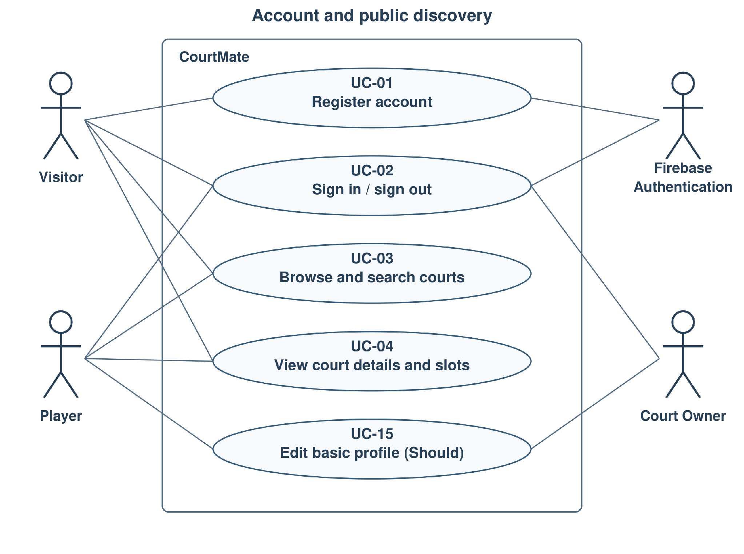
Figure 6-1. Account and public discovery use cases.
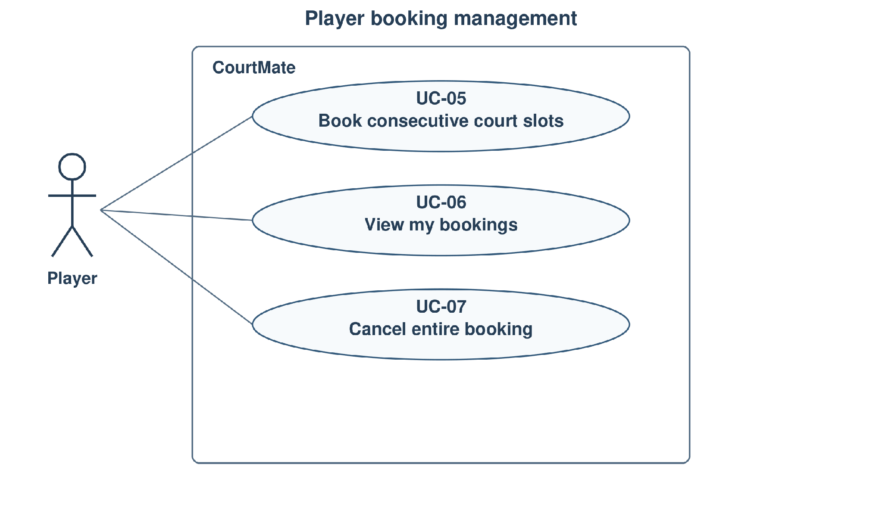
Figure 6-2. Player booking use cases.
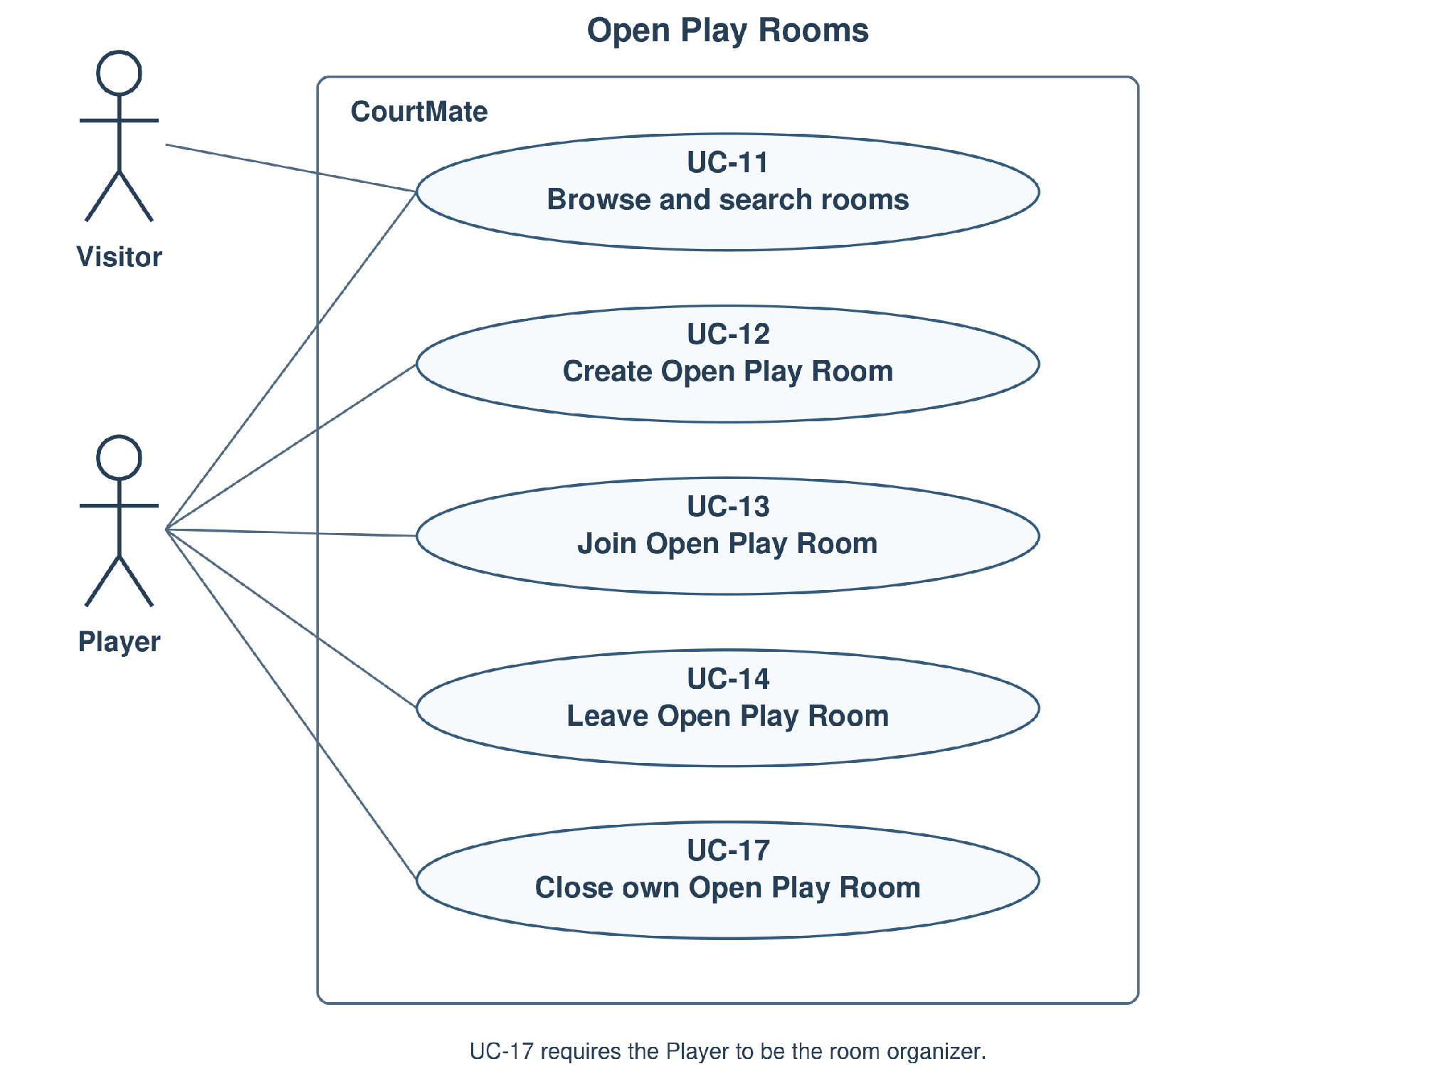
Figure 6-3. Public room discovery and Player room participation use cases.
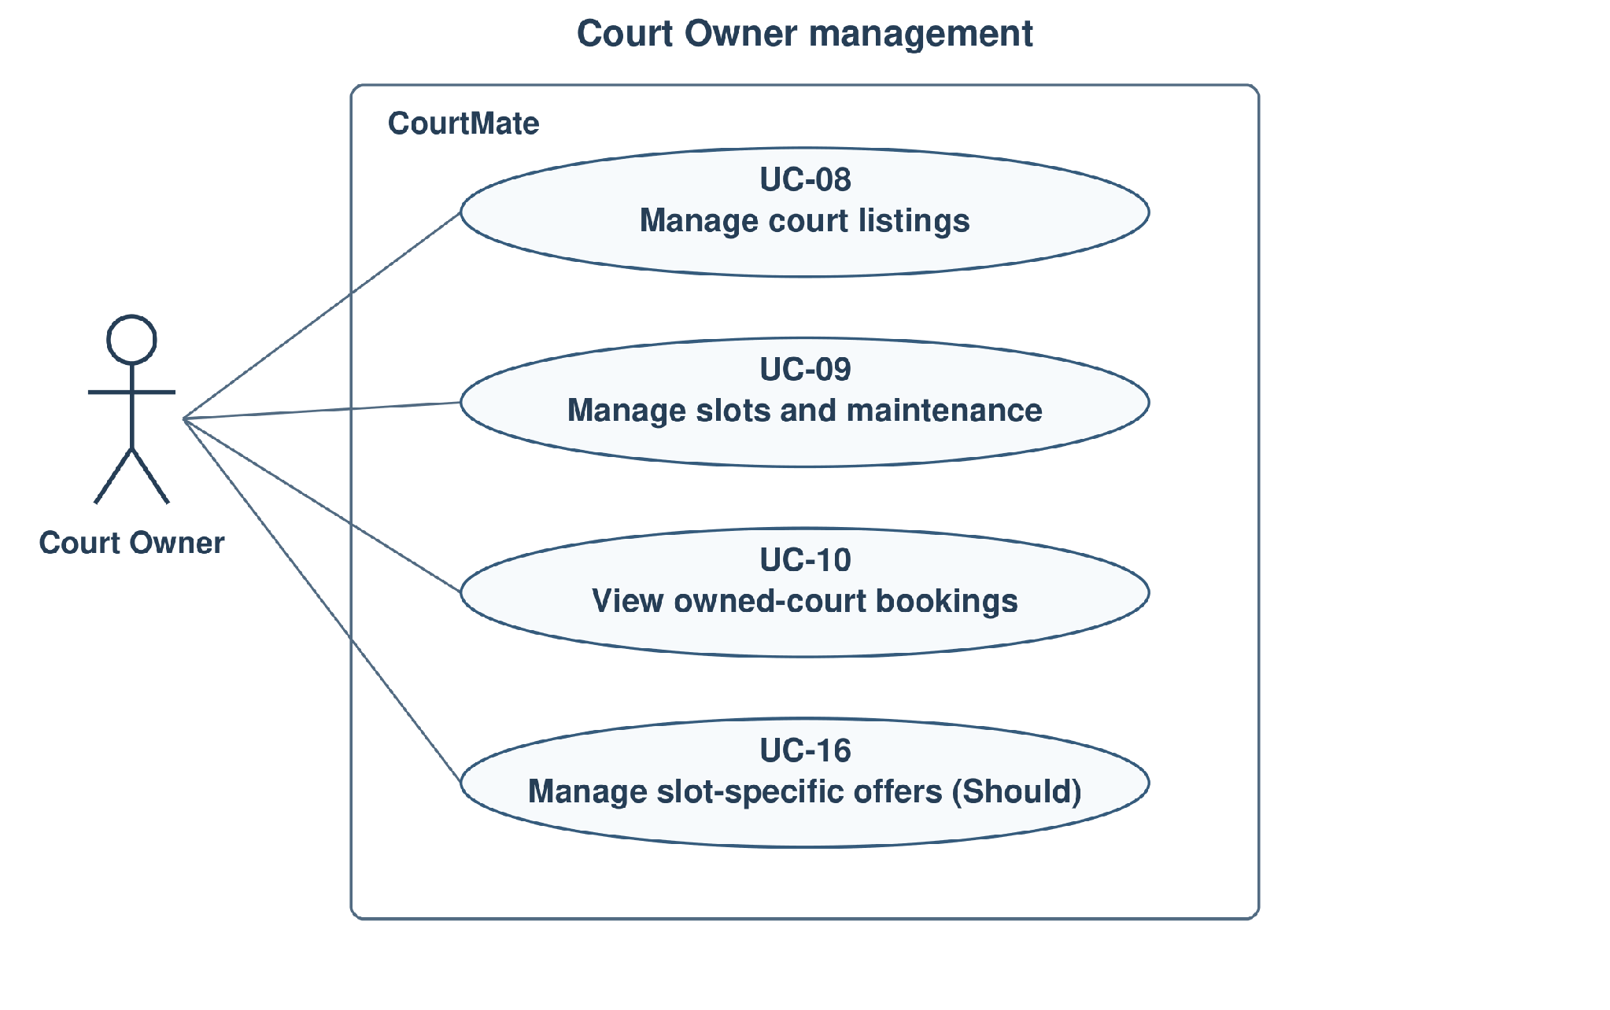
Figure 6-4. Court Owner management use cases.

Actors
Actor | Description
Visitor | An unauthenticated person. May register a Player or Court Owner account, sign in, browse/search active courts, view court details and published slots, and browse/search public Open Play Rooms. Protected booking, room participation and court-management actions require the appropriate authenticated role.
Player | An authenticated account with the Player role. May book eligible published slots, view/cancel its own bookings, and create/join/leave eligible Open Play Rooms. A Player may close a room only when it is that room's organizer. A Player may also use public discovery features and edit its own basic profile.
Court Owner | A registered account assigned the Court Owner role through the registration policy in FR-001/FR-003 and BR-09. May manage only its own court listings, operating hours, dated slots, maintenance and owned-court booking information; may manage slot-specific offers if F09 is delivered, and may edit its own basic profile.
Firebase Authentication | The external identity service supporting registration and sign-in/authentication. It is a supporting system actor, not a CourtMate application user role.
Room Organizer is a contextual relationship between a Player and a room, not a third application role. No Admin dashboard or additional account role is introduced by these use cases.

Use Case List
The model contains 17 use cases: 15 Must-have and 2 Should-have. A use case represents an externally observable user goal. Entering a filter, opening a slot preview, reviewing a selection, and creating a batch of slots are steps within the relevant use case rather than separate use cases. Optional F09 behavior remains Should-have when referenced by a Must-have booking or cancellation use case.
ID | Use case | Primary actor | Priority | Related FR
UC-01 | Register Account | Visitor | Must | FR-001, FR-003
UC-02 | Sign In / Sign Out | Visitor (sign in); Player / Court Owner (sign out) | Must | FR-002, FR-004–005
UC-03 | Browse and Search Courts | Visitor / Player | Must | FR-006–009, FR-046
UC-04 | View Court Details and Availability | Visitor / Player | Must | FR-010–012, FR-046; FR-013 (Should)
UC-05 | Book Consecutive Court Slots | Player | Must | FR-012, FR-014–018; FR-004–005; FR-044–045 if F09 is delivered
UC-06 | View My Bookings | Player | Must | FR-019, FR-021
UC-07 | Cancel Entire Booking | Player | Must | FR-020–022; FR-004–005; FR-043 if F09 is delivered
UC-08 | Manage Court Listings | Court Owner | Must | FR-023–024
UC-09 | Manage Slots and Maintenance | Court Owner | Must | FR-025–027
UC-10 | View Owned-Court Bookings | Court Owner | Must | FR-028–030
UC-11 | Browse and Search Open Play Rooms | Visitor / Player | Must | FR-033, FR-037–038
UC-12 | Create Open Play Room | Player | Must | FR-031–032, FR-037–038; FR-004–005. Room discovery is UC-11 (FR-033).
UC-13 | Join Open Play Room | Player | Must | FR-034–035, FR-038,FR-004–005
UC-14 | Leave Open Play Room | Player (non-organizer member) | Must | FR-036–038; FR-004–005
UC-15 | Edit Basic Profile | Player / Court Owner | Should | FR-039–040
UC-16 | Manage Slot-Specific Offers | Court Owner | Should | FR-041–042, FR-047–049; FR-004–005. FR-043 is in UC-07; FR-044–045 in UC-05 when F09 is delivered.
UC-17 | Close Own Open Play Room | Player (Room Organizer) | Must | FR-037; FR-004–005 (protected access)
UC-03 includes the court-name, sport, location and optional time filters, together with the slot preview available from search results. UC-09 includes operating hours, individual/batch slot publication, preview/edit of draft slots, and maintenance. UC-11 includes optional address/area search for the linked court. If F09 is delivered, FR-043 is traced through UC-07 and FR-044–045 through UC-05; UC-16 covers manual creation, automatic scheduling/application, cancellation of pending schedules and deactivation of active offers. FR-046 specifies the search-result slot-preview entry and is traced through UC-03/UC-04; the full availability list remains FR-011.

Use Case Specifications
Section 7 specifies all 17 use cases in Section 6: 15 Must-have use cases and the two Should-have use cases UC-15 and UC-16. Each uses the same 15-field format with numbered main steps and step-referenced alternative/exception flows, aligned with the current FRs, NFRs, business rules and acceptance criteria in Section 5. These specifications form part of the agreed PA2 requirements baseline. Implementation verification is performed in the later phases.

Use Case UC-01 — Register Account
Use case ID | UC-01
Use case name | Register Account
Brief description | A Visitor creates an email/password account through Firebase Authentication and selects exactly one initial CourtMate role, Player or Court Owner. The application records that validated role only after identity registration succeeds.
Primary actor | Visitor
Secondary actors | Firebase Authentication: registers the email/password identity and reports the registration outcome.
Priority | Must
Related requirements | FR-001, FR-003. AC-F01-01–02 and AC-F01-11–13. Screens: S03, S151, S05, S152; protected access remains subject to FR-004–005.
Trigger | The Visitor chooses Register from the public application or sign-in page.
Pre-conditions | 1. The requester is a Visitor without an authenticated CourtMate session for this registration.  2. The registration form is accessible. Email uniqueness, identity-provider credential validation and the role choice are checked on submission; they are not assumed to have passed beforehand.
Post-conditions | Success: exactly one corresponding CourtMate account has a successfully registered identity and one backend-stored Player or Court Owner role. Only the permitted initial role is assigned; no access to another user’s resources is granted.  Failure/cancel: no authorized CourtMate account/session is granted from a rejected or incomplete registration. An uncertain identity-service result is reconciled before retry; it is not presented as completed registration.
Main flow | 1. The Visitor opens the registration form (S03 / S151).  2. The system displays email/password inputs and the two permitted initial roles, with the current single choice visible.  3. The Visitor enters the registration credentials and selects Player.  4. The Visitor submits registration.  5. The application validates the submitted role as exactly one permitted value and submits the credentials to Firebase Authentication for identity-provider validation and registration.  6. After identity registration succeeds, the application creates exactly one corresponding CourtMate account linked to that identity and stores the validated Player role on the backend.  7. The system shows registration success and the selected role (S05), with the appropriate sign-in or entry action. Protected access still requires valid authentication and the stored role; displaying success alone grants no extra permission.
Alternative flows | A1 (step 3): The Visitor selects Court Owner instead. Follow the same validation and identity-registration steps, store exactly the Court Owner role and show the Owner registration-success state S152. Ownership checks still restrict subsequent management to that Owner’s resources.  A2 (steps 2–4): The Visitor changes the role choice before submission. Replace the initial choice; do not assign both roles or change any existing account.  A3 (steps 2–4): The Visitor chooses Back/Cancel or proceeds to Sign In instead of submitting. End registration without creating an identity or CourtMate account through this request; sign-in continues through UC-02.
Exception flows | E1 (step 5): Firebase rejects the credentials or the email is already registered. Explain the failure, offer correction or sign-in, and grant no protected access (AC-F01-02).  E2 (step 5): The submitted role is absent, unsupported or contains more than one role. Reject registration and show a validation error; assign no authorized role/session (AC-F01-13).  E3 (step 6): CourtMate account creation fails after an identity-service response, or the outcome is uncertain. Do not claim a completed usable account or grant protected access. Establish the current registration outcome before retry so one identity does not receive duplicate CourtMate accounts or conflicting roles.  E4 (steps 1, 5–7): The form, identity service or application cannot be reached. Show recoverable feedback without exposing passwords or tokens; do not interpret a timeout as successful registration.  E5 (steps 5–6): A request targets an existing account or supplies role changes through a forged profile/client request. Do not use registration to overwrite that account’s role; preserve the backend-stored role and deny unauthorized access (AC-F01-11).
Business rules | BR-09: exactly one permitted initial role, backend validation and no later self-service role change. Room Organizer is a Player relationship, not an additional registration role.
Non-functional constraints | NFR-01: applicable response-time targets in Section 5.2. NFR-04: validate the initial role and prevent later role escalation; never disclose credentials/tokens in feedback. NFR-05: labelled inputs, clear selected-role and error states, keyboard access and recovery.

Use Case UC-02 — Sign In / Sign Out
Use case ID | UC-02
Use case name | Sign In / Sign Out
Brief description | A registered user signs in with email/password, receives access according to the backend-stored role and can end the current application session. Public discovery remains available without a session.
Primary actor | Visitor (sign in); Player / Court Owner (sign out)
Secondary actors | Firebase Authentication: authenticates email/password credentials and supports identity/session validation.
Priority | Must
Related requirements | FR-002, FR-004–005; role interpretation follows FR-003. AC-F01-03–06 and AC-F01-08–11. Screens: S02 / S04; S17–19 and S49 provide failure/session recovery states.
Trigger | The Visitor selects Sign In, an unauthenticated requester chooses a protected action, or an authenticated user selects Sign Out.
Pre-conditions | 1. For sign-in, an email/password registration exists; credentials and role validity are checked during the flow.  2. For sign-out, the user has a current application session. A session that is expired/invalid cannot authorize a protected operation.
Post-conditions | Sign-in success: the application establishes an authenticated session for the verified identity and its valid stored role; protected actions remain subject to their own role and ownership checks.  Sign-out success: the current application session no longer authorizes protected requests; renewed valid authentication is required. Existing bookings, courts, rooms and profile data are unchanged.  Failure/cancel: no authenticated session or additional permission is granted by the failed attempt.
Main flow | 1. The Visitor opens a sign-in form (S02 / S04).  2. The system displays email and password inputs. The page/route does not determine or override an existing account’s stored role.  3. The Visitor enters the registered email/password and submits Sign In.  4. Firebase Authentication verifies the credentials and returns the authentication outcome.  5. On identity success, the application validates the authenticated identity and resolves its corresponding backend-stored CourtMate role.  6. If the role is valid, the application establishes the session and shows functions allowed to that Player or Court Owner. It does not trust a role supplied in a URL, form or client state.  7. The system shows the appropriate authenticated entry. Each later protected request independently rechecks authentication, role and resource ownership before exposing or changing protected data.
Alternative flows | A1 (authenticated entry, instead of step 1): The Player or Court Owner chooses Sign Out. End that application session, remove its protected access and return to a public/sign-in state. A subsequent protected request from that session requires renewed valid authentication (AC-F01-09); saved domain records are unchanged.  A2 (steps 1–3): The Visitor chooses Back/Cancel or Register without submitting credentials. No session is created; return to public discovery or UC-01.  A3 (after step 7): Sign-in was requested from a protected booking/room/Owner action. Return to an appropriate current screen, then recheck that action’s role, ownership and eligibility in its own UC. Authentication must not automatically repeat a mutation or confirm a stale selection.
Exception flows | E1 (step 4): Credentials are incorrect or identity authentication fails. Show sign-in failure, grant no protected access and allow correction/retry (AC-F01-04).  E2 (step 5): The corresponding account has an absent/invalid role or cannot be established. Deny protected access and show the recovery state; do not infer Owner permissions from the selected form (AC-F01-10).  E3 (step 7 or A3): Authentication expires or a role/resource check fails. Deny the request without disclosure or modification of protected records; request renewed sign-in or show access denied as appropriate.  E4 (steps 4–7 or A1): Identity/session validation or the sign-out outcome cannot be established. Do not claim a verified success or show protected data as authorized; offer session refresh/recovery and establish the current authentication outcome before retry.  E5 (step 5 or later protected request): Client-supplied role/ownership values conflict with stored authorization. Preserve the stored role and reject unauthorized access, including Player-to-Owner escalation and access to another Owner’s records.
Business rules | BR-09: backend-stored role and independent resource ownership; permitted initial registration is distinct from later forged role claims. Sign-out does not cancel bookings or close rooms.
Non-functional constraints | NFR-01: applicable response targets. NFR-04: invalid/expired authentication, forged roles and cross-user access are rejected without protected-data disclosure. NFR-05: named credential inputs, understandable errors, visible focus, keyboard operation and recovery.

Use Case UC-03 — Browse and Search Courts
Use case ID | UC-03
Use case name | Browse and Search Courts
Brief description | A Visitor or Player discovers active courts using optional court-name, sport, full-address/area and independent datetime criteria. Every result offers a slot preview that follows the same applied time criteria and preserves the search context.
Primary actor | Visitor / Player
Secondary actors | None required. Manual name/address/area search does not depend on GPS or an external suggestion service.
Priority | Must
Related requirements | FR-006–009, FR-046. AC-F02-01–12. Screens: S01, S191–194, S149 / S150 and D01 / D04; D08–D10 cover preview empty/loading/failure states.
Trigger | The user opens public court discovery or submits/changes a court-search criterion.
Pre-conditions | 1. Public court discovery is accessible; sign-in is not required to browse/search or preview slots.  2. Active court listings and Owner-published schedules are read from the current data. The existence of a matching court/slot is not a pre-condition.
Post-conditions | Success: the user sees only active courts satisfying all supplied criteria and may inspect a selected result’s eligible slot preview. Closing the preview restores the same results and applied filter values.  Empty/invalid/error outcome: the system explains no matches, a field error or a load failure with recovery actions. Searching/previewing creates no booking and reserves no slot.
Main flow | 1. The user opens the court-search page (S01).  2. The system displays active court summaries and the current court-name, sport, address/area and optional start/end datetime controls.  3. The user enters any desired criteria: a full/partial court name directly on the page; one sport from an anchored, bounded scrollable dropdown with prefix search; a specific full address or an area as free text; and either, both or neither datetime bounds in displayed Vietnam time. Optional suggestions do not prevent manual address entry.  4. The user submits Search. The system retains all entered values, trims surrounding court-name whitespace and validates the supplied datetimes; when both bounds exist, end must be later than start.  5. The system returns only active courts matching the case-insensitive name substring, selected sport and case-insensitive address/area criteria together. If either time bound is supplied, a court also needs at least one future AVAILABLE published slot fully inside every supplied bound: slot.start >= start and slot.end <= end where those bounds exist.  6. The system displays matching result cards (S191 and responsive/guest variants), each with court name, sport, address/area, court-details navigation and View slots regardless of whether time filters were applied.  7. The user chooses View slots. The preview opens for that court without discarding the results/criteria. With time bounds, list only future AVAILABLE published slots fully satisfying those same bounds; without them, list nearest upcoming eligible slots in chronological order. Show each playing date, interval and full-slot quote without a fixed two-slot cap.  8. The user closes the preview and returns to the unchanged search context.
Alternative flows | A1 (steps 2–4): The user leaves every criterion blank. Browse active courts without an added filter restriction; an active court may have an empty nearest-slot preview.  A2 (steps 3–6): The user edits or clears one criterion. Preserve every other value and apply their conjunction on the next search. All sports clears only sport; Clear time removes both time bounds only; Clear all resets all criteria.  A3 (step 3): The user enters only start or only end. Apply only that bound; do not invent the omitted bound. All candidate slots must still start after authoritative server time.  A4 (step 6): The user opens court details. Continue through UC-04 for that court while retaining the search context for return.  A5 (step 7): The user chooses an eligible preview slot. Continue to that court’s full availability/selection through UC-04 / UC-05. Authentication and booking eligibility are rechecked before confirmation; previewing itself reserves nothing.
Exception flows | E1 (step 4): A datetime is malformed or end <= start. Show the affected field error (S149), keep other input for correction and do not apply a misleading result set.  E2 (steps 5–6): No active court satisfies all current criteria. Show an explicit empty result with change/clear actions; do not substitute unrelated courts.  E3 (step 7): No eligible preview slot remains, including after concurrent booking/schedule changes. Show an empty preview (D08); preserve the underlying court-search context. A stale slot must be rechecked before any booking.  E4 (steps 2, 5–7): Court/slot data cannot be loaded. Show error/retry/back feedback (D10 for preview failure); retain the criteria and do not fabricate availability.  E5 (step 3): GPS permission or optional address suggestions are unavailable. Keep manual address/area input and search usable; they are not prerequisites.
Business rules | BR-01: dated Owner-published slots, timezone and authoritative future eligibility. BR-10 applies only when a selection advances to booking. If F09 is delivered, displayed slot quotes follow current BR-07 eligibility; listing/previewing does not fix an accepted booking price.
Non-functional constraints | NFR-01: search/view response targets under the Section 5.2 workload. NFR-05: direct labelled inputs, scrollable keyboard-operable sport menu, visible errors, responsive results and overlay focus/close/return behavior. Public discovery requires no compulsory authentication or GPS.

Use Case UC-04 — View Court Details and Availability
Use case ID | UC-04
Use case name | View Court Details and Availability
Brief description | A Visitor or Player views one court’s published details and dated availability, understands full-slot prices and textual availability states, and may proceed to eligible consecutive-slot selection. Optional map/directions do not block the Must-have viewing flow.
Primary actor | Visitor / Player
Secondary actors | None for Must-have viewing. An external map/directions service is involved only if optional FR-013 is delivered and requested.
Priority | Must. Map/directions under FR-013 and F09 quote handling remain conditional Should-have capabilities.
Related requirements | FR-010–012, FR-046; FR-013 (Should). AC-F03-01–05 and AC-F02-11–12. Screens: S06, S127, D01 / D04; S69 / S95 are optional map/GPS fixtures.
Trigger | The user opens a court from discovery/results, follows its public detail link or requests full availability from its slot preview.
Pre-conditions | 1. Public court details/availability can be accessed without sign-in.  2. The requested court identifier is supplied. Court existence/activity and current slots are checked while loading; selection and confirmation do not rely on a previously viewed snapshot.
Post-conditions | Success: current court information and its published dated slots are displayed with individual full-slot quotes and AVAILABLE / BOOKED / BLOCKED states. Any proposed selection remains unreserved until UC-05 confirms it.  Failure/back: the user receives unavailable/error feedback or returns to the prior search context; no court, slot or booking record is changed.
Main flow | 1. The user requests the selected court’s details (S06).  2. The system resolves the court and displays its name, sport, owner/contact, full address/area, description, available supplied photos and base price. It provides navigation to dated availability.  3. The user opens availability and chooses a playing date, or retains the date of the slot chosen from a preview.  4. The system displays that court’s Owner-published slots for the selected date (S127), each with its start/end, full-slot quote and current textual AVAILABLE, BOOKED or BLOCKED status. A confirmed combined booking makes every covered constituent slot BOOKED.  5. The system identifies future AVAILABLE slots as candidates for selection and explains unavailable/past states. If F09 is delivered, show a discounted quote only while the manual/automatic offer is currently eligible under BR-07; the base court price is not substituted for each full-slot quote.  6. The user inspects the date/slots and may change the date or return to details/search. Viewing availability does not reserve slots or freeze prices.
Alternative flows | A1 (steps 4–5): The Player selects one eligible future slot or several strictly consecutive eligible slots for the same court/date. Continue through UC-05, which validates the 60–240-minute combined selection, review and one complete booking. Merely selecting slots creates no reservation.  A2 (step 5): A Visitor chooses a protected booking action. Continue through UC-02; after authentication refresh the court/slots and check the Player role before UC-05. Signing in must not automatically confirm an old selection.  A3 (step 2, if FR-013 is delivered): The user opens map/directions. Use an explicitly supplied or permitted origin; do not calculate a route from current location without one. Court viewing and manual address search remain usable without GPS.  A4 (entry from UC-03): The user first opens View slots on a result card. The preview follows the applied time bounds or nearest-upcoming rule in FR-046. Opening full availability leads to steps 3–5; closing the preview restores the same results/criteria. The full daily list may show BOOKED/BLOCKED states even though the selectable search preview lists eligible slots only.  A5 (step 6): The user returns to court discovery. Restore the prior search criteria/results context where entered from UC-03.
Exception flows | E1 (steps 1–2): The court is missing, unavailable or no longer active for new bookings. Show the current unavailable/inactive state (S239 where applicable) and offer return to discovery; do not offer a new booking for an inactive court.  E2 (step 4): No slots are published for the date, or no future AVAILABLE slot remains. Show the appropriate empty/unavailable state and allow another date or return; do not fabricate slots.  E3 (step 5 or A1): A slot is BOOKED, BLOCKED, past, nonconsecutive or otherwise incompatible. Do not allow that selection to proceed; explain the reason and allow correction. UC-05 rechecks every selected slot at confirmation.  E4 (steps 2–4): Court, media or schedule data cannot be obtained. Show recoverable error/back actions; do not misrepresent a failed load as current availability. Missing optional photos do not prevent displaying available court details.  E5 (A3): GPS is denied or map/directions fails. Explain the optional-service limitation and retain court/address/availability access; do not treat GPS permission as required.
Business rules | BR-01: published slot grid/duration, full-slot quotes, local-time display and authoritative future checks. BR-10: same-court/date consecutive selection and one combined booking. BR-07 applies only when F09 quotes are delivered; an accepted total is established later in UC-05.
Non-functional constraints | NFR-01: view/read response targets. NFR-05: responsive court/slot views, named controls, textual status/selection reasons, keyboard date/slot navigation and recovery. NFR-04 governs any transition to protected booking; public viewing discloses no protected booking details.

Use Case UC-05 — Book Consecutive Court Slots
Use case ID | UC-05
Use case name | Book Consecutive Court Slots
Brief description | An authenticated Player selects one or more strictly consecutive, future AVAILABLE Owner-published slots of one active court on one playing date, reviews their prices, and confirms exactly one booking for the complete selection.
Primary actor | Player
Secondary actors | None directly. The application verifies the authenticated identity and assigned Player role for protected actions.
Priority | Must. Slot-specific deal handling is conditional on delivery of F09 (Should).
Related requirements | FR-012, FR-014–018; FR-004–005. FR-044–045 apply if F09 is delivered. Related AC: the AC-F04 entries in Section 5.4.
Trigger | The Player chooses to book a court and begins selecting its published dated slots.
Pre-conditions | 1. The Player has a valid authenticated account with the Player role.  2. The court is active and its Owner has published dated slots with positive whole-VND quotes.  3. Availability can be viewed; selecting a slot has not reserved it. Final eligibility is rechecked at confirmation.
Post-conditions | Success: exactly one CONFIRMED booking has a unique ID, the ordered selected slot IDs, combined interval, accepted total price and owning Player. All selected slots are protected from conflicting bookings.  Failure: no partial booking or partial slot allocation is committed. The system explains the rejection and provides a recovery action.
Main flow | 1. The system displays the court’s published slots for the selected date, including start/end time, full-slot quote and AVAILABLE/BOOKED/BLOCKED status.  2. The Player selects one AVAILABLE future slot and may add strictly adjacent AVAILABLE slots for the same court and playing date.  3. The system validates adjacency, slot-grid rules and the combined 60–240-minute duration, and displays the current selection. Selection alone reserves nothing.  4. The Player requests a review. The system shows the ordered slots, combined interval, duration, each quote and summed total.  5. The Player explicitly accepts that total and submits one confirmation request.  6. The system rechecks authentication, role, active court, every slot’s eligibility, schedule, adjacency, duration, maintenance and booking conflicts. Compare each current slot quote with its reviewed quote and recheck the sum. Any changed slot quote requires fresh review and explicit acceptance, even if the sum is unchanged. If F09 is delivered, recheck manual/automatic eligibility at authoritative server time, including the configured threshold and terminal states.  7. If all checks pass, the system confirms the entire selection as exactly one booking and saves the explicitly accepted total price.  8. The system displays the booking ID, CONFIRMED status, court, full combined interval, constituent slots and accepted total.
Alternative flows | A1 (step 2): The Player selects exactly one eligible slot. Continue at step 3; the result is still one booking.  A2 (steps 2–4): The Player adds/removes slots or changes the date/court. The system validates and recalculates the new selection before another review.  A3 (step 4, if F09 is delivered): A selected slot has an eligible manual or automatically activated offer within its configured window. Apply that quote only to that slot; sum the independent quotes of all selected slots.  A4 (steps 2–5): The Player cancels or returns to the court/search screen. No booking is created and no slot is reserved.
Exception flows | E1 (steps 2–3): A selection is nonconsecutive, cross-court/date, on an invalid grid, or outside the 60–240-minute combined duration. Explain the invalid selection and allow correction; do not proceed to confirmation.  E2 (step 6): A selected slot is no longer AVAILABLE, the court is inactive, the start has passed, or schedule/maintenance eligibility fails. Reject the whole selection, refresh availability and allow reselection; do not confirm a subset.  E3 (step 6): Any current regular or eligible offer quote differs from that slot’s reviewed quote, the summed total changes, or an offer becomes invalid. Reject the whole request, even if offsetting quote changes leave the sum unchanged. Display current per-slot quotes and their sum; require fresh review/acceptance and reserve no slot.  E4 (step 6): Authentication, role or authorization is invalid. Deny confirmation without changing booking data and offer the appropriate sign-in/recovery action.  E5 (steps 1, 4 or 6–8): Required data or the confirmation response cannot be obtained. Explain the failure. Do not claim success without an established booking outcome; allow refresh/retry and checking My Bookings.
Business rules | BR-01 (published slot grid/duration/prices); BR-03 (confirmed-booking protection); BR-09 (roles/access); BR-10 (same court/date, strict adjacency, 60–240-minute combined duration, one complete booking and total-price snapshot). BR-07 applies if F09 is delivered.
Non-functional constraints | NFR-01 (response-time targets); NFR-02 (no conflicting or partial multi-slot confirmations); NFR-04 (authentication, role and ownership enforcement); NFR-05 (clear, accessible slot selection, review, errors and recovery).

Use Case UC-06 — View My Bookings
Use case ID | UC-06
Use case name | View My Bookings
Brief description | An authenticated Player views their ten most recently created booking records, each combined booking as one record, and sees whole-booking cancellation eligibility based on the earliest constituent-slot start.
Primary actor | Player
Secondary actors | None directly. The application validates identity, Player role and ownership for every protected read.
Priority | Must
Related requirements | FR-019, FR-021; protected access under FR-004–005. AC-F05-01, AC-F05-03–04 and AC-F05-06. Screens: S12, S100 / S116; S131 / S132 illustrate the cancellation boundary.
Trigger | The Player opens My Bookings or follows a link to their saved booking details.
Pre-conditions | 1. The requester has valid authentication with the Player role.  2. No booking is required to exist; an empty history is a valid outcome. Any requested booking must belong to that Player, checked before its details are disclosed.
Post-conditions | Success: only the requester’s booking records are displayed, at most ten in the history list (or all if fewer), sorted by creation time descending. Each combined booking retains one ID, full interval, accepted total and saved status; cancellation eligibility is explained.  Empty/error/unauthorized outcome: show an empty, recoverable error or denied state as appropriate, without exposing another Player’s bookings or changing any record.
Main flow | 1. The Player selects My Bookings (S12).  2. The system validates authentication and the Player role, and scopes the request to that Player’s own bookings.  3. The system retrieves the ten most recently created booking records, or all records if fewer, sorted by booking-creation time descending.  4. The system displays each record once with booking ID, court, full combined playing interval, accepted total price and current saved status. A booking containing several consecutive slots is one item, not one row per slot.  5. For each complete booking, the system evaluates displayed cancellation eligibility using the current server-backed state: it belongs to the Player, is CONFIRMED and has at least six hours before its earliest constituent-slot start. Exactly six hours is eligible.  6. The system enables Cancel only where currently eligible and shows a visible reason for disabled/ineligible actions. The displayed eligibility does not replace the final backend receipt-time check in UC-07.  7. The Player reviews the history or opens an owned record to inspect its ordered slots, full interval, status and unchanged accepted total.
Alternative flows | A1 (step 3): The Player has no booking records. Show an explicit empty history and a route to court discovery; no booking is fabricated.  A2 (steps 6–7): The Player requests Cancel for a currently eligible booking. Continue to UC-07, which confirms and revalidates cancellation of the entire booking. Opening the list/details does not cancel or release any slot.  A3 (step 7): The Player follows an existing linked-room history/detail link, or requests room creation for an eligible booking. Continue to UC-11 / UC-12 as appropriate; those UCs check their own eligibility. A manually closed room does not cancel its source booking.  A4 (step 7): The Player returns from details to the list or refreshes after an independently completed booking/cancellation. Reload the latest owned records and eligibility; do not create a second record for constituent slots. Existing saved bookings remain readable even if the court is no longer offered for new bookings.
Exception flows | E1 (step 2 or 7): Authentication is invalid/expired, the role is not Player, or a changed identifier targets another Player’s booking. Deny the protected read without revealing the record; offer sign-in/access recovery as appropriate.  E2 (step 5 or 6): A previously eligible booking is no longer CONFIRMED or has crossed below the six-hour boundary. Refresh its displayed reason/disabled action. If cancellation is subsequently requested, UC-07 makes the authoritative decision; viewing does not alter the booking.  E3 (steps 3 or 7): The requested owned record cannot be found or data cannot be loaded. Show unavailable/retry/back feedback; do not replace it with another user’s record or invent booking details.  E4 (step 4): The original accepted price/history must be displayed. Do not recalculate a saved total from a new regular/offer quote; if required details cannot be obtained, show a load error and allow recovery rather than a fabricated amount.
Business rules | BR-02: cancellation of the entire owned CONFIRMED booking uses earliest start and the backend receipt-time six-hour cutoff. BR-10: one combined booking ID, ordered constituent slots and an immutable accepted-total snapshot. BR-09: protected role/ownership. BR-03 / BR-07 preserve accepted totals despite later Owner/offer changes.
Non-functional constraints | NFR-01: owned-list/detail response targets. NFR-04: authentication and ownership on list/detail reads. NFR-05: readable combined booking summaries, visible eligibility reasons, keyboard navigation and empty/error recovery. Actual cancellation atomicity belongs to UC-07 / NFR-02.

Use Case UC-07 — Cancel Entire Booking
Use case ID | UC-07
Use case name | Cancel Entire Booking
Brief description | An authenticated Player cancels one complete owned booking, whether it contains one slot or several consecutive slots, when at least six hours remain before the booking’s earliest start.
Primary actor | Player
Secondary actors | None directly. The application verifies the authenticated identity and authorization for the selected booking.
Priority | Must. Restoration of eligible slot-specific offers is conditional on delivery of F09 (Should).
Related requirements | FR-020–022; FR-004–005. FR-043 applies only if F09 is delivered. Related AC: AC-F05-02–06; AC-F09-04 if F09 is delivered; protected-access criteria in Section 5.4.
Trigger | The Player selects Cancel Booking for one booking in My Bookings or its booking details.
Pre-conditions | 1. The requester is authenticated with the Player role.  2. The selected booking belongs to that Player and is CONFIRMED.  3. Eligibility is evaluated against the earliest constituent-slot start and authoritative backend receipt time; it is rechecked for the cancellation request.
Post-conditions | Success: the entire booking is CANCELLED and all constituent-slot reservations are released together. Booking history and its accepted total remain available; any linked room becomes CLOSED. If F09 is delivered, retained nonterminal offers are re-evaluated under current manual/automatic windows and court/slot/price conditions; CANCELLED schedules and DEACTIVATED/EXPIRED offers never revive.  Failure: no partial cancellation or slot release occurs; this request leaves booking/linked data unchanged. No payment or refund is processed.
Main flow | 1. The Player opens My Bookings and selects an owned confirmed booking.  2. The Player chooses Cancel Booking.  3. The system displays the court, complete combined interval, constituent slots and accepted total, explains the six-hour rule, and states that the whole booking will be cancelled. Any linked-room closure is also explained.  4. The Player confirms cancellation.  5. The system rechecks authentication, role, ownership, CONFIRMED status and that the earliest start minus the authoritative backend receipt time of this cancellation request is at least six hours (exactly six hours is eligible).  6. If eligible, the system cancels the entire booking and releases all constituent reservations together, closes any linked room, and applies the conditional F09 restoration rules under the mode-specific window, without reviving CANCELLED schedules or DEACTIVATED/EXPIRED offers.  7. The system displays cancellation success and the CANCELLED booking in My Bookings. It does not present a partial-slot cancellation or refund operation.
Alternative flows | A1 (steps 3–4): The Player chooses Keep Booking or closes the confirmation. Return to the booking/list with all records unchanged.  A2 (step 5): The booking was already cancelled by a successful earlier request. Show its current CANCELLED status without repeating cancellation effects.
Exception flows | E1 (step 5): Less than six hours remain before the earliest start, the booking has started, or its current status is otherwise ineligible. Explain why cancellation is unavailable and preserve the complete booking.  E2 (step 5): The session is invalid, the role is ineligible or the booking belongs to another Player. Deny cancellation without revealing another user’s protected data or modifying it.  E3 (steps 1–3): Booking data cannot be loaded. Show an error and allow retry or return to My Bookings.  E4 (steps 6–7): Cancellation fails or its outcome cannot be established. Do not display an unverified success or perform a partial release; allow refresh/retry against the current booking status.
Business rules | BR-02 (at least six hours before earliest start); BR-06 (linked-room closure); BR-09 (role/ownership); BR-10 (whole-booking cancellation with no independent cancellation of constituent slots). BR-07 applies if F09 is delivered.
Non-functional constraints | NFR-01 (response-time targets); NFR-02 (consistent complete booking/slot state); NFR-04 (authentication and ownership enforcement); NFR-05 (clear confirmation, error messages and recovery). NFR-03 applies to consistent linked-room closure against concurrent participation requests.

Use Case UC-08 — Manage Court Listings
Use case ID | UC-08
Use case name | Manage Court Listings
Brief description | An authenticated Court Owner creates, edits, or deactivates their own court listings, managing details such as name, sport, address, base price, and player capacity, without affecting existing confirmed bookings.
Primary actor | Court Owner
Secondary actors | None directly. The application verifies the authenticated identity and assigned Court Owner role.
Priority | Must
Related requirements | FR-023, FR-024; FR-004, FR-005. Related constraints: FR-032. Related AC: AC-F06-01, AC-F06-02, AC-F06-03, AC-F06-07, AC-F06-08, AC-F06-09, AC-F06-11 (base-price validation).
Trigger | The Court Owner chooses to create a new court or manage their existing court listings.
Pre-conditions | 1. The user is authenticated with the Court Owner role.  2. For editing or deactivating: The court must exist and belong to the authenticated Court Owner.
Post-conditions | - Success: The court record is created, updated, or marked as deactivated in the database. Existing CONFIRMED bookings and their saved statuses remain unchanged.  - Failure: No unauthorized edits or invalid capacity changes are applied; existing court data remains intact.
Main flow | 1. The Court Owner views their list of owned courts.  2. The Owner selects to create a new court or edit an existing active court.  3. The system displays a form to input or edit the court's name, sport, address/area, description, base price, and max_players.  4. The Owner inputs valid data, ensuring the price is a positive VND amount and max_players is an integer from 2 to 30.  5. The Owner submits the creation or update request.  6. The system rechecks authentication, Court Owner role, ownership of the court (if editing), and validates the input data against capacity rules.  7. If validation passes, the system saves the new or updated court record.  8. The system displays a success message and updates the court list.
Alternative flows | A1 (step 2): The Owner selects Deactivate for an owned active court. The system explains that new bookings will stop and existing bookings retain their saved statuses. On confirmation, the system rechecks authentication, Court Owner role and court ownership, then deactivates the listing. Continue at step 8. If the Owner cancels, return to the list with no change.  A2 (steps 3–5): The Owner cancels creation/editing. Discard the unsubmitted input and return to the court list; no court data changes.
Exception flows | - E1 (step 6): The input max_players is invalid (e.g., fractional, outside 2-30) or a decrease would violate the capacity of an existing future OPEN/FULL room. The system rejects the change, explains the capacity rule, and preserves existing data. Return to step 3.  - E2 (step 6): The base price is non-positive. The system rejects the input. Return to step 3.  - E3 (step 6 or A1 authorization check): Authentication is invalid, or the Owner attempts to modify a court they do not own. The system denies the request without changing data or exposing another owner's details.
Business rules | BR-05 (Court and Room Capacity); BR-09 (User Roles and Access).
Non-functional constraints | NFR-01 (Section 5.2 response-time targets); NFR-04 (backend role and ownership checks); NFR-05 (labelled fields, keyboard operation and clear errors).

Use Case UC-09 — Manage Slots and Maintenance
Use case ID | UC-09
Use case name | Manage Slots and Maintenance
Brief description | An authenticated Court Owner manages an owned court’s daily calendar, operating hours, individual or batch-published dated slots and maintenance. Draft changes require explicit publication and must preserve all confirmed single- and multi-slot bookings.
Primary actor | Court Owner
Secondary actors | None directly. The application verifies the authenticated identity and assigned Court Owner role.
Priority | Must
Related requirements | FR-025–027; FR-004–005. Related AC: AC-F06-04–06 and AC-F06-10–15. Cross-use-case constraints: BR-01, BR-03 and BR-10; UC-04/UC-05 use only the resulting published availability.
Trigger | The Court Owner selects a specific owned court and date to manage its schedule or maintenance.
Pre-conditions | 1. The requester is authenticated with the Court Owner role.  2. The selected court exists and belongs to that Owner.  3. The calendar and every draft are scoped to one selected court and local playing date. Current hours, published slots, maintenance and confirmed bookings are read for that context.
Post-conditions | Success: the entire valid submitted batch, single-slot change, operating-hour change or maintenance change is saved for the selected court/date. Confirmed bookings, their constituent intervals/regular quotes and accepted totals remain unchanged.  Failure/cancel: no invalid or partial batch is published and the previous valid schedule remains unchanged. Merely generating, editing, adding, removing or leaving draft rows publishes nothing.
Main flow | 1. The Owner selects an owned court and playing date.  2. The system shows its full daily calendar, operating hours, AVAILABLE, BOOKED, BLOCKED and unpublished intervals. Confirmed booking intervals and regular quotes are protected.  3. The Owner chooses batch slot generation.  4. The Owner enters an interval within operating hours, a 60–240-minute duration aligned to 30-minute boundaries and a positive whole-VND full-slot quote.  5. The system generates draft rows for that context and shows every generated interval and quote in a scrollable preview, without a fixed two-row limit or publishing any row.  6. The Owner reviews the complete draft and explicitly confirms publication.  7. Before saving, the system rechecks authentication, Court Owner role, ownership and the entire submitted set against current operating hours, 30-minute boundaries, 60–240-minute duration, positive whole-VND quotes, mutual non-overlap, existing published slots, maintenance and the latest confirmed bookings. Touching half-open boundaries do not overlap.  8. Only if every submitted row passes, the system publishes the complete batch together and refreshes the selected court/date calendar. It does not modify any confirmed booking or its accepted total.
Alternative flows | A1 (step 3): The Owner adds one dated slot or edits an AVAILABLE published slot. Show its interval/quote for review. On explicit save, apply the same authorization and current schedule checks as step 7, excluding the edited slot’s old version from its own overlap check. A valid change is saved; continue at step 8. A booked slot cannot be edited.  A2 (step 3): The Owner changes operating hours. Preview the change and affected schedule. On confirmation, recheck authorization, ownership and BR-01/BR-03 against current published slots and confirmed bookings. Save only a valid change, without invalidating/splitting a confirmed booking; continue at step 8.  A3 (step 3): The Owner marks a maintenance interval. Preview its court/date and affected time. On confirmation, recheck authorization, ownership and current confirmed bookings; an intersecting confirmed interval is rejected. Save a valid block, show it as unavailable and prevent new bookings in it; continue at step 8.  A4 (step 5): The Owner edits, adds or removes draft rows. Refresh the preview for that court/date and return to step 6; the published schedule is unchanged.  A5 (steps 4–6 or A1–A3 before save): The Owner chooses Back/Cancel or leaves the draft. Apply no publication/change and return to the same court/date calendar.  A6 (steps 1–2): The Owner switches court/date or scrolls the calendar. Show only the selected context’s full-day schedule; do not publish or apply another context’s pending changes.  A7 (after a valid available-slot/hour/maintenance change): If F09 is delivered, recompute any linked automatic offer’s current application time and eligibility. Withhold an ineligible discount; never revive a terminal configuration or change an already accepted booking total (BR-07).
Exception flows | E1 (step 7 or A1–A3 final validation): Any change conflicts with a newly confirmed booking, changes a confirmed constituent slot’s interval/regular quote, or invalidates/splits a confirmed single- or multi-slot booking. Reject the submitted change or entire batch, explain affected intervals and preserve the previous schedule, booking and accepted total. Return to step 2.  E2 (step 7 or A1–A3 validation): Any row violates hours, date, grid, duration, quote, mutual overlap, existing published slots or maintenance. Reject the entire submitted batch; publish none of its rows. Identify the errors and return to step 4/5 for correction. Invalid individual/hour changes likewise preserve the current schedule.  E3 (step 7 or A1–A3 final validation): Authentication, role or court ownership fails. Deny the operation, disclose no other Owner’s protected information and change no schedule.  E4 (steps 2, 5 or 8): Loading/saving fails or its outcome is uncertain. Do not claim unverified publication or repeat it blindly. Refresh authoritative calendar state, then offer retry; never present a partially published batch as success.
Business rules | BR-01 (Owner-published dated slots, hours, timezone, grid, duration, quote and half-open non-overlap); BR-03 (protect confirmed slot intervals, regular quotes and accepted totals); BR-09 (role and ownership); BR-10 (preserve confirmed consecutive multi-slot bookings).
Non-functional constraints | NFR-01 (Section 5.2 response-time targets); NFR-02 (schedule publication remains consistent with concurrent booking confirmation); NFR-04 (backend role and court ownership); NFR-05 (usable daily calendar and scrollable draft list at 375/768/1280 px, labelled keyboard-operable controls and textual states).

Use Case UC-10 — View Owned-Court Bookings
Use case ID | UC-10
Use case name | View Owned-Court Bookings
Brief description | An authenticated Court Owner views a list and detailed information of bookings specifically associated with the courts they own, with access strictly isolated from other owners' data.
Primary actor | Court Owner
Secondary actors | None directly. The application verifies the authenticated identity and assigned Court Owner role.
Priority | Must
Related requirements | FR-028–030; FR-004, FR-005. Related AC: AC-F07-01, AC-F07-02, AC-F07-03
Trigger | The Court Owner navigates to the booking overview section.
Pre-conditions | 1. The user is authenticated with the Court Owner role.
Post-conditions | - Success: The Owner sees a list of bookings and details restricted to their owned courts.  - Failure: The system denies access if authentication fails or if the Owner attempts to access data for a court they do not own.
Main flow | 1. The Court Owner requests to view their bookings list.  2. The system verifies authentication and the Court Owner role.  3. The system retrieves and displays a list of bookings filtered exclusively for courts owned by this authenticated user.  4. The Owner selects a specific booking to view its details.  5. The system verifies that the selected booking belongs to a court owned by the requester.  6. The system displays the booking details: unique booking ID, court, full combined playing interval, ordered constituent slots, accepted total VND price, status, creation timestamp, and permitted Player contact info (registration email and display name if present). An absent optional profile does not block access. Do not disclose passwords, tokens, other bookings or private profile preferences.
Alternative flows | A1 (step 3): The Owner applies a status/date filter. Recheck access to the selected owned-court context and show the matching list, including an explicit empty state if no booking matches. Continue at step 4 when a booking is selected.  A2 (step 6): The Owner returns to the list. Retain its current filters; no booking is changed.
Exception flows | - E1 (steps 2 or 5): The request lacks valid authentication or the correct role. The system denies access and shows an error.  - E2 (step 5): The Owner attempts to view details of a booking that belongs to a court owned by a different user (e.g., by modifying an API ID). The system rejects the request, disclosing no protected information.  E3 (steps 3 or 6): Data cannot be loaded. Show retry/back actions without fabricating a booking or exposing another Owner's data; no booking changes.
Business rules | BR-09 (User Roles and Access: ownership is checked independently of role).
Non-functional constraints | NFR-01 (performance); NFR-04 (security: strictly enforce cross-user resource isolation).

Use Case UC-11 — Browse and Search Open Play Rooms
Use case ID | UC-11
Use case name | Browse and Search Open Play Rooms
Brief description | A Visitor or Player browses public Open Play Rooms, optionally narrows the list by the linked court’s address or area, and views a room’s court, organizer, playing interval, capacity, membership, status and informational per-person cost estimate.
Primary actor | Visitor / Player
Secondary actors | None. Public browsing and room details do not require authentication.
Priority | Must
Related requirements | FR-033, FR-037–038. Related AC: AC-F10-04, AC-F10-09–13 and AC-F10-15–16; manual-closure display follows AC-F10-17–18.
Trigger | The user opens Open Play from navigation or follows a public room link.
Pre-conditions | The public room-discovery page is accessible. The user may be unauthenticated (Visitor) or authenticated as a Player. A public room does not have to exist for browsing to begin.
Post-conditions | Success: the user sees the matching list or requested public room details with its effective current status and informational cost estimate. Viewing/searching does not create membership or change the linked booking.  Empty/error outcome: the system explains that no rooms match, the room is unavailable, or data cannot be loaded and offers an appropriate recovery action.
Main flow | 1. The user opens Open Play.  2. The system displays public room summaries with the linked court/location, complete playing interval, member count/capacity, effective OPEN/FULL/CLOSED status and per-person estimate.  3. The user may enter a specific court address or an area and submit the search. The system retains that input and displays rooms whose linked court matches the optional free-text criterion case-insensitively against its full address or area; GPS is not required and optional suggestions do not prevent manual input.  4. The user selects View Room for a listed room.  5. The system displays its public details, including organizer, court/address, the linked booking’s complete interval, member count, capacity, effective status and cost estimate. Available participation actions reflect authentication and room eligibility.
Alternative flows | A1 (step 3): The user leaves the location criterion empty or clears it. Restore the public list without an unrelated location restriction.  A2 (step 5): The user returns to the list. Keep the current location criterion so the user can continue browsing.  A3 (step 5): An authenticated Player chooses Join Room. Continue through UC-13; merely viewing the room has not joined it.  A4 (step 5): A Visitor chooses a protected participation action. Offer sign-in; do not create membership while unauthenticated.
Exception flows | E1 (steps 1–3): There are no public rooms or no rooms match the address/area. Show an explicit empty state and allow changing/clearing the criterion.  E2 (steps 2 or 5): Room data cannot be loaded. Show a concise error with retry/back actions; do not display fabricated room availability.  E3 (steps 4–5): The requested room no longer exists or is not publicly accessible. Explain that it is unavailable and offer return to the public list.  E4 (steps 2 or 5): The linked booking was cancelled, its earliest start was reached, or the organizer closed the room. Display effective CLOSED status and disable joining/leaving; retain public history where available.
Business rules | BR-04 (court and full interval inherited from the linked booking); BR-05 (capacity and organizer membership); BR-06 (effective room lifecycle, including manual closure); BR-08 (accepted booking total divided by enrolled members, including organizer; rounded to the nearest whole VND; informational estimate only).
Non-functional constraints | NFR-01 (read/search response-time targets); NFR-04 (only public information exposed without authentication); NFR-05 (responsive discovery, clear status labels, accessible search and recovery).

Use Case UC-12 — Create Open Play Room
Use case ID | UC-12
Use case name | Create Open Play Room
Brief description | An authenticated Player creates one public Open Play Room from their own future confirmed booking. The room inherits the court and complete playing interval; the organizer is immediately its first member.
Primary actor | Player
Secondary actors | None directly. The application checks the authenticated Player and ownership of the source booking.
Priority | Must
Related requirements | FR-031–032, FR-038; FR-004–005. FR-037 governs effective closure and the prohibition on another room after closure. Related AC: AC-F10-01–03, AC-F10-10–14; protected-access criteria in Section 5.4.
Trigger | The Player chooses Create Open Play Room for an owned booking, from My Bookings or Open Play.
Pre-conditions | 1. The requester is authenticated with the Player role.  2. The selected source booking belongs to that Player, is CONFIRMED and its earliest constituent-slot start is strictly in the future.  3. No room has ever been linked to that booking, including a room now CLOSED. The current court capacity is available for validation. These conditions are rechecked when creation is submitted.
Post-conditions | Success: exactly one OPEN room is linked to the entire booking, with the same court and full combined interval; the requester is organizer and the only initial enrolled member (member_count = 1). The saved integer capacity satisfies 2 ≤ C ≤ 2 × court.max_players. Display the informational estimate under BR-08.  Failure/cancel: no new room or partial organizer membership is created. The booking, constituent slots, accepted total and any previously linked room remain unchanged.
Main flow | 1. The Player chooses Create Open Play Room.  2. The system shows that Player’s future CONFIRMED bookings that have never been linked to a room. An already linked CLOSED room does not make a booking eligible again.  3. The Player selects one eligible booking.  4. The system displays its court, address, complete combined playing interval, constituent slots, accepted total and current court.max_players; court/time are inherited and read-only.  5. The Player enters an integer room capacity C between 2 and twice the linked court’s saved max_players. The system explains that the organizer counts as member one.  6. The Player submits room creation.  7. Immediately before creation, the system rechecks authentication, Player role, booking ownership, CONFIRMED status, authoritative earliest start, absence of any previously linked room and capacity against the current saved court limit.  8. If eligible, the system creates exactly one room and its organizer membership together, with OPEN status and member_count = 1. Concurrent/repeated requests cannot create two rooms for the same booking.  9. The system displays the created room and its inherited full interval, 1/C members and estimate: accepted booking total divided by enrolled members, rounded to nearest whole VND. The booking and its accepted total remain unchanged.
Alternative flows | A1 (steps 3–6): The Player chooses Back/Cancel. Return to the booking or Open Play list with no room or membership created.  A2 (step 2): No owned booking is eligible. Explain the eligible-booking conditions and allow return to My Bookings; the use case ends without creating a room.
Exception flows | E1 (steps 5 or 7): Capacity is fractional, below 2 or above twice the current court.max_players. Explain the allowed range; save nothing and return to step 5.  E2 (step 7): The session/role is invalid or the booking belongs to another Player. Deny creation without disclosing protected booking data or changing records.  E3 (step 7): The booking was cancelled, has started or already has a room, including CLOSED. Reject creation, explain the current eligibility and return to the booking list; never reopen/replace the old room.  E4 (step 8): Another creation request already linked a room or creation fails. Do not create a second room or partial organizer membership. Refresh the authoritative linked-room state before allowing retry.  E5 (steps 2, 4 or 9): Data cannot be loaded or the result is uncertain. Offer retry/back without fabricated room details or duplicate creation. If the accepted price snapshot cannot be read, show Estimate unavailable; do not invent a price.
Business rules | BR-04 (one room per owned future confirmed booking; immutable inherited court/full interval; no second room after closure); BR-05 (integer capacity 2..2 × court.max_players; organizer member one); BR-06 (effective lifecycle); BR-08 (accepted-total/member-count estimate, nearest whole VND and no payment); BR-09 (Player and ownership); BR-10 (one room inherits the entire combined booking).
Non-functional constraints | NFR-01 (Section 5.2 read/write targets); NFR-03 (valid capacity, unique membership and consistent room state); NFR-04 (backend Player role and source-booking ownership); NFR-05 (labelled capacity input, accessible validation, confirmation and recovery).

Use Case UC-13 — Join Open Play Room
Use case ID | UC-13
Use case name | Join Open Play Room
Brief description | An authenticated non-member Player joins an eligible OPEN room before its source booking starts. The system enforces capacity and unique membership even when requests run concurrently.
Primary actor | Player
Secondary actors | None directly; the authenticated session is verified by the backend against the configured identity provider.
Priority | Must
Related requirements | FR-034–035, FR-037–038; FR-004–005. Related AC: AC-F10-05–07, AC-F10-10–13 and AC-F10-21; protected-access criteria in Section 5.4.
Trigger | The Player selects Join Room in the public details of a room, including details opened through a public room link.
Pre-conditions | 1. The requester is authenticated with the Player role and is not already an active member.  2. The room is effectively OPEN with active_members < capacity.  3. The source booking is CONFIRMED and its earliest constituent-slot start is strictly in the future according to authoritative server time. Manual closure, cancellation and start-time closure are enforced even if no scheduled job has run. All eligibility conditions are rechecked on submission.
Post-conditions | Success: exactly one active membership is added for the requester and member_count increases by one without exceeding capacity. The room becomes FULL only if the count reaches capacity; otherwise it remains OPEN. Recalculate the informational per-person estimate. The source booking, slots and accepted total are unchanged.  Failure/cancel: this request adds no membership and changes no count/booking. An independently completed closure or other valid request remains effective; never reopen a CLOSED room.
Main flow | 1. The Player opens a room’s public details through UC-11 or its public link.  2. The system displays the inherited full interval, court/address, effective room status, enrolled count/capacity and estimate, offering Join only when the current state permits it.  3. The Player selects Join Room.  4. Before changing membership, the system rechecks authentication, Player role, absence of an existing active membership, effective OPEN state, CONFIRMED source booking, authoritative time before its earliest start and a free capacity place.  5. The system commits the eligibility check and one membership insertion together with the count/status update. Concurrent distinct joins, duplicate retries and Close requests must not produce duplicate membership, overcapacity or a Join committed after closure. The organizer remains included in capacity.  6. The system shows successful membership, the updated count, OPEN/FULL status and the estimate based on the unchanged accepted booking total divided by enrolled members, rounded to nearest whole VND.
Alternative flows | A1 (step 2): The Player chooses Back/View Another Room. Return to UC-11 with its search criterion retained; no membership is added.  A2 (step 2): An unauthenticated Visitor requests participation. Continue to sign-in, without joining; after sign-in, refresh details and perform all checks at step 4 before any membership change.
Exception flows | E1 (step 4): Authentication or the Player role is invalid. Reject Join without changing membership or exposing protected data.  E2 (steps 4–5): The Player is already a member or a repeated/concurrent request has joined successfully. Do not add another membership or increment the count again; show the current membership.  E3 (steps 4–5): The last place was taken, the room is FULL/CLOSED, the organizer closed it, the booking was cancelled or its earliest start has arrived. Reject this Join and show the current state; no membership is inserted and CLOSED is never reopened.  E4 (steps 1–2 or 6): Room data cannot be loaded, the room is unavailable or the result is uncertain. Offer refresh/back; resolve authoritative membership before retrying rather than assuming success.  E5 (steps 2 or 6): A valid accepted booking-price snapshot is unavailable. Show Estimate unavailable; do not fabricate a price or initiate payment.
Business rules | BR-05 (organizer counts, no duplicate membership and no overcapacity); BR-06 (effective OPEN/FULL/CLOSED state, earliest start and irreversible manual closure); BR-08 (informational estimate from accepted total, rounded to whole VND); BR-09 (authenticated Player).
Non-functional constraints | NFR-01 (Section 5.2 read/write targets); NFR-03 (atomic capacity/unique membership and Join-versus-Close consistency); NFR-04 (backend authentication and Player role); NFR-05 (accessible actions, textual eligibility and clear conflict/retry feedback).

Use Case UC-14 — Leave Open Play Room
Use case ID | UC-14
Use case name | Leave Open Play Room
Brief description | An enrolled Player who is not the room organizer leaves an OPEN/FULL room before the source booking’s earliest start. The system updates membership and estimate without changing the court booking.
Primary actor | Player
Secondary actors | None directly; the authenticated session is verified by the backend against the configured identity provider.
Priority | Must
Related requirements | FR-036–038; FR-004–005. Related AC: AC-F10-08, AC-F10-10–13 and AC-F10-21; protected-access criteria in Section 5.4.
Trigger | The enrolled non-organizer Player selects Leave Room in the details of a room they joined.
Pre-conditions | 1. The requester is authenticated with the Player role, currently enrolled in the selected room and is not its organizer.  2. The room is effectively OPEN or FULL; its source booking remains CONFIRMED and authoritative server time is before the booking’s earliest constituent-slot start.  3. CLOSED rooms, including rooms manually closed before play, permit no voluntary Leave. These conditions are rechecked on submission.
Post-conditions | Success: exactly the requester’s active membership is removed/deactivated, the active count decreases by one and the per-person estimate is recalculated. A formerly FULL room becomes OPEN only while it remains otherwise eligible. The organizer stays enrolled; booking, slots and accepted total are unchanged.  Failure/cancel: no membership is removed and this request changes no member count, room state or booking. An independently effective closure is retained; a CLOSED room is never reopened.
Main flow | 1. The Player opens the details of a room they joined.  2. The system displays effective status, the full booking interval, member count/capacity and estimate, offering Leave only to an eligible enrolled non-organizer before the earliest start.  3. The Player selects Leave Room.  4. The system displays a leave confirmation (S23), explains the membership change and offers Confirm Leave or Stay in Room. Opening this confirmation changes no membership or booking data.  5. The Player confirms Leave.  6. Immediately before changing membership, the system rechecks authentication, Player role, active membership, non-organizer identity, effective OPEN/FULL status, CONFIRMED source booking and authoritative time before its earliest constituent-slot start.  7. If eligible, the system removes/deactivates exactly that membership together with the count and effective status update. If a place becomes free, FULL returns to OPEN only if no closure/start/cancellation has taken effect. Concurrent Leave/Join/Close requests cannot remove membership after closure, decrement twice or reopen CLOSED.  8. The system shows that the Player has left (S24), the updated count/status and the estimate from the unchanged accepted booking total divided by remaining enrolled members including the organizer, rounded to nearest whole VND. The source booking is unchanged.
Alternative flows | A1 (step 2): The Player chooses Back/View Another Room without selecting Leave. Return to UC-11 with its location query retained; membership and booking are unchanged.  A2 (step 4): The Player chooses Stay in Room or dismisses/cancels the confirmation before step 5. Return to the room details with membership, member count, room status and booking unchanged by this request.  A3 (steps 6–7): A retry follows a previously successful Leave and the Player is no longer enrolled. Show the current non-member state; do not decrement again or change other members.
Exception flows | E1 (step 6): Authentication/role is invalid or the requester is not a current member. Deny the requested removal without changing membership/count or exposing protected data.  E2 (step 6): The requester is the organizer. Reject Leave and explain that organizer participation cannot be removed through this action; retain all records. UC-17 is the separate organizer closure action.  E3 (steps 6–7): The room is CLOSED, the booking is cancelled or its earliest start has arrived. Reject Leave, retain membership/history and show the effective closure reason. This applies to manual closure and does not depend on a scheduled job.  E4 (steps 1–4 or 7–8): Data cannot be loaded or the write result is uncertain. Refresh authoritative membership/status before retry; do not claim unverified success or decrement the count twice.  E5 (steps 2 or 8): The accepted booking-price snapshot cannot be read. Show Estimate unavailable rather than a fabricated price; no payment operation is created.
Business rules | BR-05 (organizer retained as member one and valid membership count); BR-06 (only non-organizer Leave before earliest start; FULL→OPEN only when eligible; CLOSED blocks participation); BR-08 (estimate from accepted total, nearest whole VND and no payment); BR-09 (authenticated Player).
Non-functional constraints | NFR-01 (Section 5.2 response-time targets); NFR-03 (Leave-versus-Join/Close consistency, no participation change after closure or repeated decrement); NFR-04 (backend Player and membership/organizer checks); NFR-05 (accessible Leave action, textual eligibility and recovery).

Use Case UC-15 — Edit Basic Profile
Use case ID | UC-15
Use case name | Edit Basic Profile
Brief description | If F08 is delivered, an authenticated Player or Court Owner views and changes permitted non-critical basic profile fields, while application role and identity-provider-controlled fields remain protected.
Primary actor | Player / Court Owner
Secondary actors | None directly. Identity-provider-controlled account attributes are outside this profile-editing use case.
Priority | Should
Related requirements | FR-039–040; protected access under FR-004–005. AC-F08-01–03 and AC-F01-11. Screens: S46 / S76, S47 (saved) and S48 (validation failure).
Trigger | The authenticated user opens their own Profile and chooses Edit.
Pre-conditions | 1. F08 is delivered as a Should-have capability; Must-have booking/Owner tasks do not depend on it.  2. The requester is authenticated as Player or Court Owner and the profile belongs to that same identity.
Post-conditions | Success: valid permitted basic profile changes are saved for the current user and reloaded values match the accepted input. Stored role and identity-provider-controlled attributes remain unchanged.  Failure/cancel: no invalid/unauthorized update overwrites the stored profile; cancelling unsubmitted edits changes no record. An uncertain save is not reported as verified success.
Main flow | 1. The user opens their own profile (S46 / S76).  2. The system validates authentication and scopes the read to that user’s profile.  3. The system displays the current permitted basic fields, such as display name and contact preferences. Role and identity-provider-controlled attributes are read-only and cannot be submitted as editable profile fields.  4. The user edits the permitted fields and selects Save.  5. The system rechecks authentication and ownership, validates the permitted input and rejects attempts to change protected attributes through forged fields or identifiers.  6. If validation succeeds, the system saves only the valid permitted changes for the current user, preserving the backend-stored role and protected identity attributes.  7. The system shows save success (S47) and reloads the accepted values so the user can verify the result.
Alternative flows | A1 (steps 3–4): The user chooses Back/Cancel before Save. Discard the unsubmitted draft and return to the profile/previous page; stored profile, role and domain records remain unchanged.  A2 (step 3): Optional basic profile values have not yet been supplied. Show the permitted empty fields for editing; their absence does not prevent Must-have court, booking or room tasks.  A3 (step 7): The user continues to another allowed task. That task uses current authentication and stored authorization; updating basic profile data grants no new Player/Owner permission.
Exception flows | E1 (step 5): A permitted field is malformed under its displayed validation. Show a field error (S48), retain the draft for correction and do not overwrite valid stored data.  E2 (step 2 or 5): Authentication has expired, the profile belongs to another user, or a request attempts a protected role/identity-field change. Reject without disclosing or modifying protected data; retain the original role/profile and offer appropriate recovery.  E3 (steps 2–3): Current profile data cannot be loaded. Show retry/back feedback; do not fabricate stored values or claim an update.  E4 (steps 6–7): Saving fails or the response is uncertain. Do not claim success or blindly repeat an unverified write. Refresh the current profile to establish its authoritative values before retry; protected fields remain unchanged.
Business rules | BR-09: each account retains one backend-stored role selected during initial registration; profile editing never changes that role. Basic profile editing changes neither court/booking/room ownership nor an accepted booking total.
Non-functional constraints | NFR-01: applicable profile read/write response targets. NFR-04: authenticated self-profile access, protected-field validation and no role escalation. NFR-05: labelled editable/read-only fields, visible validation/save feedback, keyboard access and recoverable errors.

Use Case UC-16 — Manage Slot-Specific Offers
Use case ID | UC-16
Use case name | Manage Slot-Specific Offers
Brief description | If F09 is delivered, an authenticated Court Owner creates a manual offer or configures a slot-specific automatic offer with 0 < h ≤ 24 hours, cancels a pending schedule or deactivates an active offer. System-time eligibility determines automatic application; prior accepted booking totals are preserved.
Primary actor | Court Owner
Secondary actors | None directly. The application verifies the authenticated identity and assigned Court Owner role.
Priority | Should
Related requirements | FR-041–042, FR-047–049; FR-004–005. AC-F09-01–03 and AC-F09-08–17. Conditional booking restoration is FR-043/UC-07; confirmation and accepted totals are FR-044–045/UC-05.
Trigger | The Owner opens offer management for an owned slot and chooses Manual or Automatic, or requests cancellation/deactivation of an existing configuration. An automatic configuration is subsequently evaluated when its time window/current eligibility is reached.
Pre-conditions | 1. F09 is delivered (Should). The requester is authenticated with the Court Owner role and owns the court/configuration.  2. Creation uses a published future AVAILABLE/unblocked slot of an active court, with no SCHEDULED/ACTIVE configuration. The positive whole-VND offer quote is below the current regular quote.  3. Manual creation additionally requires 0 < Δ ≤ 24 hours. Automatic configuration requires numeric 0 < h ≤ 24 (fractions allowed) and may be saved earlier than 24 hours before play.  4. Pending cancellation targets an owned SCHEDULED offer; deactivation targets an owned ACTIVE offer. Recheck the applicable conditions on submission.
Post-conditions | Success: one valid SCHEDULED automatic configuration is saved, or a currently eligible offer becomes ACTIVE, or the selected pending/active configuration becomes terminal CANCELLED/DEACTIVATED. Only the selected slot is affected; no duplicate/stacked or adjacent-slot discount is created.  Failure/Keep/Cancel: this request makes no invalid or unconfirmed change. Every prior accepted booking total and reservation is preserved. At slot start the offer expires; CANCELLED/DEACTIVATED/EXPIRED configurations never automatically revive.
Main flow | 1. The Owner opens the schedule or offer management for an owned court and selects one future published slot.  2. The system shows slot/date, regular quote, current availability and any existing offer configuration.  3. The Owner chooses Automatic and enters a whole-slot offer quote plus numeric lead time h (0 < h ≤ 24 hours).  4. The system validates the draft and shows the computed application time (current slot start minus h), scope and conditions, without saving a change.  5. The Owner confirms Save Schedule.  6. The system rechecks authorization/ownership, current published future slot/court eligibility, positive whole-VND quote below regular, h and absence of any SCHEDULED/ACTIVE configuration for that slot.  7. The system saves exactly one configuration. If currently outside its window, it is SCHEDULED. If 0 < Δ ≤ h and every eligibility condition passes, it immediately becomes ACTIVE; no second Owner action is required.  8. The system shows the saved state, application time/quote and applicable Cancel Schedule or Deactivate action. Merely saving a future schedule changes neither bookings nor the effective regular quote before eligibility.
Alternative flows | A1 (step 3): The Owner chooses Manual. Require 0 < Δ ≤ 24 hours and a valid lower whole-slot quote, preview it and request creation confirmation. On submission perform the same authorization, uniqueness and current slot/price checks; create one ACTIVE manual offer, then continue at step 8.  A2 (step 8): The Owner chooses Cancel Schedule for SCHEDULED. Show S245/S255 and offer Confirm Cancellation or Keep Schedule. Keep/dismiss preserves it. On confirmation recheck ownership and state, then record CANCELLED. If it became ACTIVE, show the current state and require the separate deactivation confirmation; do not misreport cancellation.  A3 (step 8): The Owner chooses Deactivate for ACTIVE (manual or automatic). Show S220/S252 with Confirm/Keep. Keep/dismiss makes no change. Confirm rechecks authorization, ownership and ACTIVE state, then records DEACTIVATED; creation time/availability is not a prerequisite. Prior totals stay unchanged and the old configuration never reactivates.  A4 (steps 3–5): The Owner cancels before submitting creation. Return to offer management; no configuration or booking changes.  A5 (after step 7): At a subsequent time/quote/slot-state evaluation, use authoritative server time and the current slot start. Activate a pending automatic offer exactly once only when 0 < Δ ≤ h and current court/slot/price checks pass. Before the window or while ineligible, withhold the discount and show why; re-evaluate the same nonterminal configuration if eligibility recovers before start. Slot edits recompute the time window. Each displayed/confirmed quote checks effective eligibility without depending only on a background job. At Δ ≤ 0, record EXPIRED.  A6 (after cancellation/deactivation/expiry): The Owner may create a new configuration only after all current creation checks pass. The old terminal record stays terminal; retries cannot duplicate it or change a saved booking.
Exception flows | E1 (step 6 or A2/A3 submission): Authentication, Court Owner role or ownership fails. Reject without changing data or disclosing another Owner’s configuration.  E2 (steps 4–6): h is nonnumeric, ≤0 or >24; or the quote is nonpositive, fractional or not below current regular. Keep the input for correction and save nothing. Exactly h=24 and valid fractional values are accepted.  E3 (step 6/A1): The slot/court is missing, inactive, unpublished, booked, blocked or past, or manual creation is more than 24 hours early. Reject creation. A future automatic configuration is not rejected solely because the slot is more than 24 hours away.  E4 (step 6/A1/A5): A competing SCHEDULED/ACTIVE configuration or duplicate activation request is detected. Retain one configuration; reject conflicting creation, do not stack discounts and show authoritative current state.  E5 (A5 or booking confirmation): Current availability/court/price/window is invalid. Do not apply the discount or alter an existing booking. If a reviewed price changed, UC-05 requires a new review and explicit acceptance. A terminal configuration cannot activate.  E6 (steps 6–8/A2/A3): Saving fails or the result is uncertain. Refresh authoritative configuration before retry; do not claim unverified success, create duplicates or undo a confirmed cancellation/deactivation.
Business rules | BR-07: manual versus automatic windows, 0 < h ≤ 24, unique SCHEDULED/ACTIVE slot configuration, current eligibility, confirmed cancellation/deactivation, terminal-state and accepted-price protection. BR-09: backend role/ownership. BR-10: independent per-slot quotes in combined bookings. BR-02/FR-043 restoration remains within UC-07.
Non-functional constraints | NFR-01: Section 5.2 response targets. NFR-02 if F09 is delivered: unique concurrent offer writes, cancellation/activation/booking consistency and accepted-total protection. NFR-04: role and ownership for every configuration change. NFR-05: labelled time/price inputs, textual pending/active/terminal states, keyboard operation and recoverable errors.

Use Case UC-17 — Close Own Open Play Room
Use case ID | UC-17
Use case name | Close Own Open Play Room
Brief description | The Player who organizes an OPEN or FULL room manually closes it before the linked booking begins. Closure is irreversible, prevents further joins/leaves and preserves the underlying booking and room history, including when other participants have already joined.
Primary actor | Player acting as that room’s Room Organizer
Secondary actors | None directly. The application verifies the authenticated Player and room-organizer relationship.
Priority | Must
Related requirements | FR-037 (manual closure and effective CLOSED state); FR-004–005 (authenticated role and ownership). FR-033/FR-036 define the related status display and participation restrictions. Related AC: AC-F10-17–21.
Trigger | The Room Organizer selects Close Room in the details of a room they organize.
Pre-conditions | 1. The organizer is authenticated with the Player role.  2. The room belongs to a booking owned by that organizer and the organizer relationship is valid.  3. The room is currently OPEN or FULL; its linked booking is CONFIRMED and has not reached its earliest start. The room may already have other participants.
Post-conditions | Success: the room is irreversibly CLOSED. No new join or voluntary leave is permitted. The source booking remains CONFIRMED with the same slots, playing interval and accepted total; existing member/history records are retained.  Failure/cancel: no unauthorized or partial change is committed. Any independently occurring booking cancellation or start-time closure remains effective.
Main flow | 1. The organizer opens the public details of a room they organize.  2. The system shows the room’s current status, linked court/interval and member count, and offers Close Room when manual closure is eligible.  3. The organizer chooses Close Room.  4. The system requests confirmation, explaining that closing stops joins/leaves, cannot be undone, retains current participant records and does not cancel the booked court.  5. The organizer confirms closure.  6. The system rechecks authentication, Player role, room-organizer ownership, source-booking status, authoritative start time and current room status, and records manual closure if still eligible.  7. The system displays CLOSED status, the closure reason and the unchanged booking information. Public discovery/details and later participation requests use this effective CLOSED state.
Alternative flows | A1 (steps 4–5): The organizer chooses Keep Room Open or dismisses confirmation. Return to room details without applying manual closure.  A2 (step 6): The room is already CLOSED because of an earlier request, source-booking cancellation or arrival of the earliest start. Show the current CLOSED status and reason; never reopen it or repeat closure effects.  A3 (steps 2–6): The room is FULL or has other participants. Manual closure remains allowed for its organizer; confirmation still explains the impact on those participants.
Exception flows | E1 (step 6): Authentication is missing/expired, the account is not an eligible Player or the requester is not the room organizer. Deny the action without modifying the room/booking or exposing protected ownership details.  E2 (steps 1–2): The room cannot be found or loaded. Show an appropriate unavailable/error state with back/retry actions.  E3 (steps 6–7): The close request fails or its result cannot be established. Do not claim unverified success. Refresh the authoritative room state before offering a retry; preserve the source booking and avoid partial changes.
Business rules | BR-04 (one source booking and inherited court/interval); BR-06 (irreversible manual/time/booking-driven closure, CLOSED blocks joins/leaves); BR-09 (Player role and authorization). The organizer is a Player relationship rather than an additional application role.
Non-functional constraints | NFR-01 (write response-time targets); NFR-03 (consistent room-participation state under concurrent requests); NFR-04 (authentication and organizer/ownership enforcement); NFR-05 (clear impact confirmation, state labels and error recovery).

Prototype / Mockups

Screen Register and Use Case Mapping
This section covers the 17 use cases in Section 6 through primary screens, supporting states, navigation diagrams and screen specifications. UC-15 and UC-16 remain Should-have. Each linked screen ID opens an existing editable frame in the team Figma file; representative illustrations below are current exports of those frames.
Review fixtures use fixed dates rather than live availability. Ordinary court/room examples use 27–28 October 2026 playing dates and are reviewed before the first slot starts; a reference time of 26 October 2026 10:00 UTC+7 is used for those scenarios. F09 examples use 24 October 2026 10:00 with slots later that day. Cancellation-boundary fixtures use the explicit time shown on their own screen. These are separate scenarios, not a single current server clock. Automatic-offer examples use the distinct An Phú slot on 24 October 2026, 21:00–22:00, regular quote 120,000 VND and offer quote 90,000 VND. At 17:00, h=3 is SCHEDULED and h=24 is immediately eligible; h=3 reaches its threshold at 18:00 and expires at 21:00. R04 opens these independent clock fixtures; it is not a live scheduler.
Screen | Purpose | Use case(s) | Editable frame
S03 | Account registration: Player selection | UC-01 | S03
S151 | Account registration: Court Owner selection | UC-01 | S151
S02 | Player sign-in | UC-02 | S02
S04 | Court Owner sign-in | UC-02 | S04
S01 | Court search and independent filters | UC-03 | S01
S191 | Search results retaining criteria | UC-03 | S191
D01 | Slot preview from a result card | UC-03 / UC-04 | D01
S06 | Court details | UC-04 | S06
S127 | Published daily slots and selection | UC-04 / UC-05 | S127
S217 | Review selected slots and total | UC-05 | S217
S218 | One booking confirmed | UC-05 | S218
S12 | My booking history | UC-06 | S12
S13 | Confirm whole-booking cancellation | UC-07 | S13
S14 | Cancellation result | UC-07 | S14
S30 | Owned courts and quick actions | UC-08 | S30
S31 | Create owned court | UC-08 | S31
S32 | Edit owned court | UC-08 | S32
S33 | Confirm deactivation | UC-08 | S33
S34 | Daily court calendar | UC-09 | S34
S201 | Configure multiple dated slots | UC-09 | S201
S202 | Preview and edit draft slot rows | UC-09 | S202
S203 | Published slot calendar | UC-09 | S203
S206 | Edit one AVAILABLE/draft slot | UC-09 | S206
S35 | Configure maintenance interval | UC-09 | S35
S208 | Preview maintenance impact | UC-09 | S208
S38 | Bookings for owned courts | UC-10 | S38
S39 | Owned-court booking detail | UC-10 | S39
S20 | Search public rooms by court location | UC-11 | S20
S21 | Public room details | UC-11 / UC-13 | S21
S25 | Create room from eligible owned booking | UC-12 | S25
S26 | Created organizer room | UC-12 / UC-17 | S26
S22 | Joined room / FULL sample | UC-13 | S22
S23 | Confirm leaving a room | UC-14 | S23
S155 | Organizer room with current members | UC-17 | S155
S153 | Confirm manual room closure | UC-17 | S153
S154 | Manually CLOSED room | UC-17 | S154
S46 | Basic profile | UC-15 | S46
S42 | Owned slot-specific offers | UC-16 | S42
S43 | Create an eligible offer | UC-16 | S43
S220 | Confirm offer deactivation | UC-16 | S220
S241 | Hẹn ưu đãi tự động | UC-16 (Should) | S241
S242 | Ưu đãi đã được hẹn | UC-16 (Should) | S242
S243 | Ưu đãi đang tự áp dụng | UC-16 (Should) | S243
S244 | Kiểm tra thời điểm áp dụng | UC-16 (Should) | S244
S245 | Hủy lịch ưu đãi này? | UC-16 (Should) | S245
S246 | Đã hủy lịch ưu đãi | UC-16 (Should) | S246
S247 | Đã đến giờ · đang chờ slot trống | UC-16 (Should) | S247
S248 | Ưu đãi đã hết hiệu lực | UC-16 (Should) | S248
S249 | Hẹn ưu đãi tự động | UC-16 (Should) | S249
S250 | Ưu đãi đang tự áp dụng | UC-16 (Should) | S250
S251 | Hẹn ưu đãi | UC-16 (Should) | S251
S252 | Tắt ưu đãi tự động này? | UC-16 (Should) | S252
S253 | Đã tắt ưu đãi tự động | UC-16 (Should) | S253
S254 | Đã hẹn ưu đãi | UC-16 (Should) | S254
S255 | Hủy lịch ưu đãi? | UC-16 (Should) | S255
S256 | Đã hủy lịch | UC-16 (Should) | S256
S257 | Slot đã có lịch hoặc ưu đãi | UC-16 (Should) | S257
S258 | Mobile offer management; S251 returns here without saving | UC-16 (Should) | S258
Supporting states and responsive variants
Family | Verified frame links
Account success and access failures | S05, S152, S17, S18, S19, S49, S77
Search/preview variants and empty/error states | S192, S193, S194, S149, S150, S50, S51, S52, D04, D05, D06, D07, D08, D09, D10
Booking conflict, repricing and boundary fixtures | S10, S11, S16, S70, S75, S137, S138, S239
Cancellation and linked-room outcomes | S15, S100, S131, S132, S134, S135, S136
Court input, capacity and deactivation states | S41, S129, S140, S219, S221, S222, S233, S234, S235
Slot add/edit, hours and protected booking states | S200, S204, S205, S207, S210, S211, S157, S158
Maintenance and owner-only booking access | S36, S209, S240, S40, S232
Room search, guest, capacity and lifecycle states | S94, S212, S230, S231, S27, S29, S63, S78, S79, S145, S146
Manual close with FULL/other member samples | S175, S176, S177, S186, S187, S169, S170, S171, S172, S173, S174
Profile validation and optional F09 cases | S47, S48, S76, S44, S159, S160, S120, S121, S133, S138
Phone/tablet task variants | S56, S60, S161, S164, S165, S166, S167, S213, S214, S215, S236, S237, S238
Automatic-offer lifecycle, threshold and mobile fixtures | S241, S242, S243, S244, S245, S246, S247, S248, S249, S250, S251, S252, S253, S254, S255, S256, S257, R04
Interactive entry: CourtMate prototype guide | Requirements review navigator

Screen Navigation Diagrams
The diagrams show selected linked prototype journeys. Nodes are screen/overlay IDs, and arrows are user actions or conditional navigation. A screen diagram describes navigation; it is not a use case diagram. Back/Cancel and required validation outcomes are detailed in the screen specifications. Conflict, repricing, loading and security fixtures can also be opened separately through the review navigator; their presence does not imply a live backend.
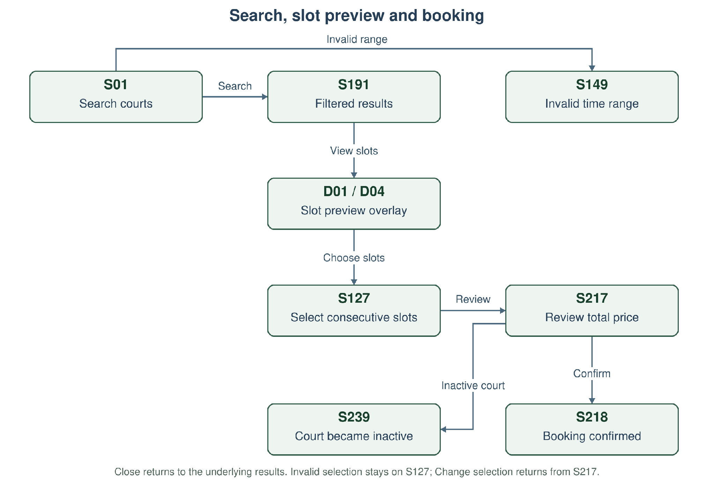
Figure 8-1. Court search, slot preview and consecutive-slot booking navigation.
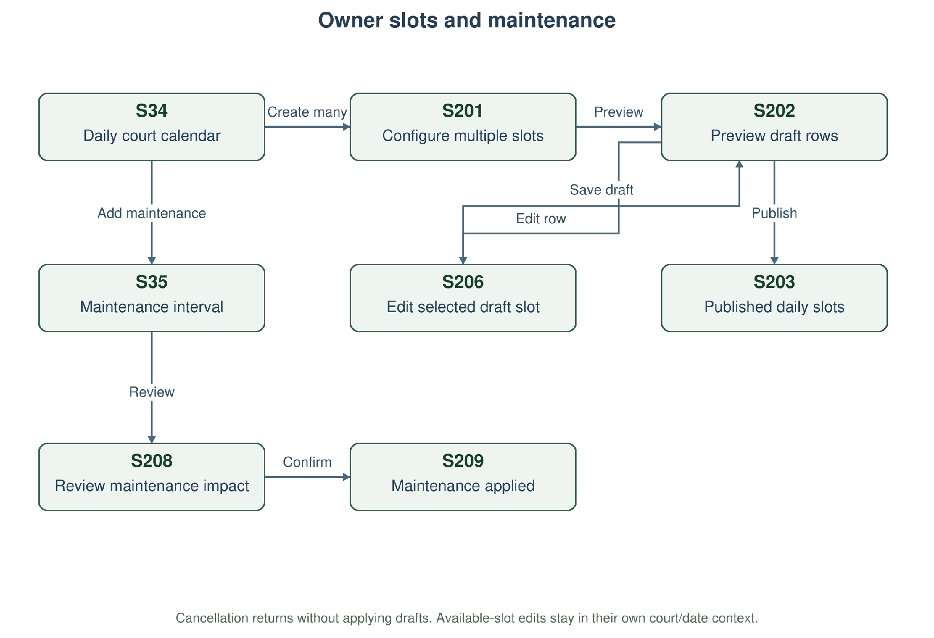
Figure 8-2. Owner daily calendar, slot publication and maintenance navigation.
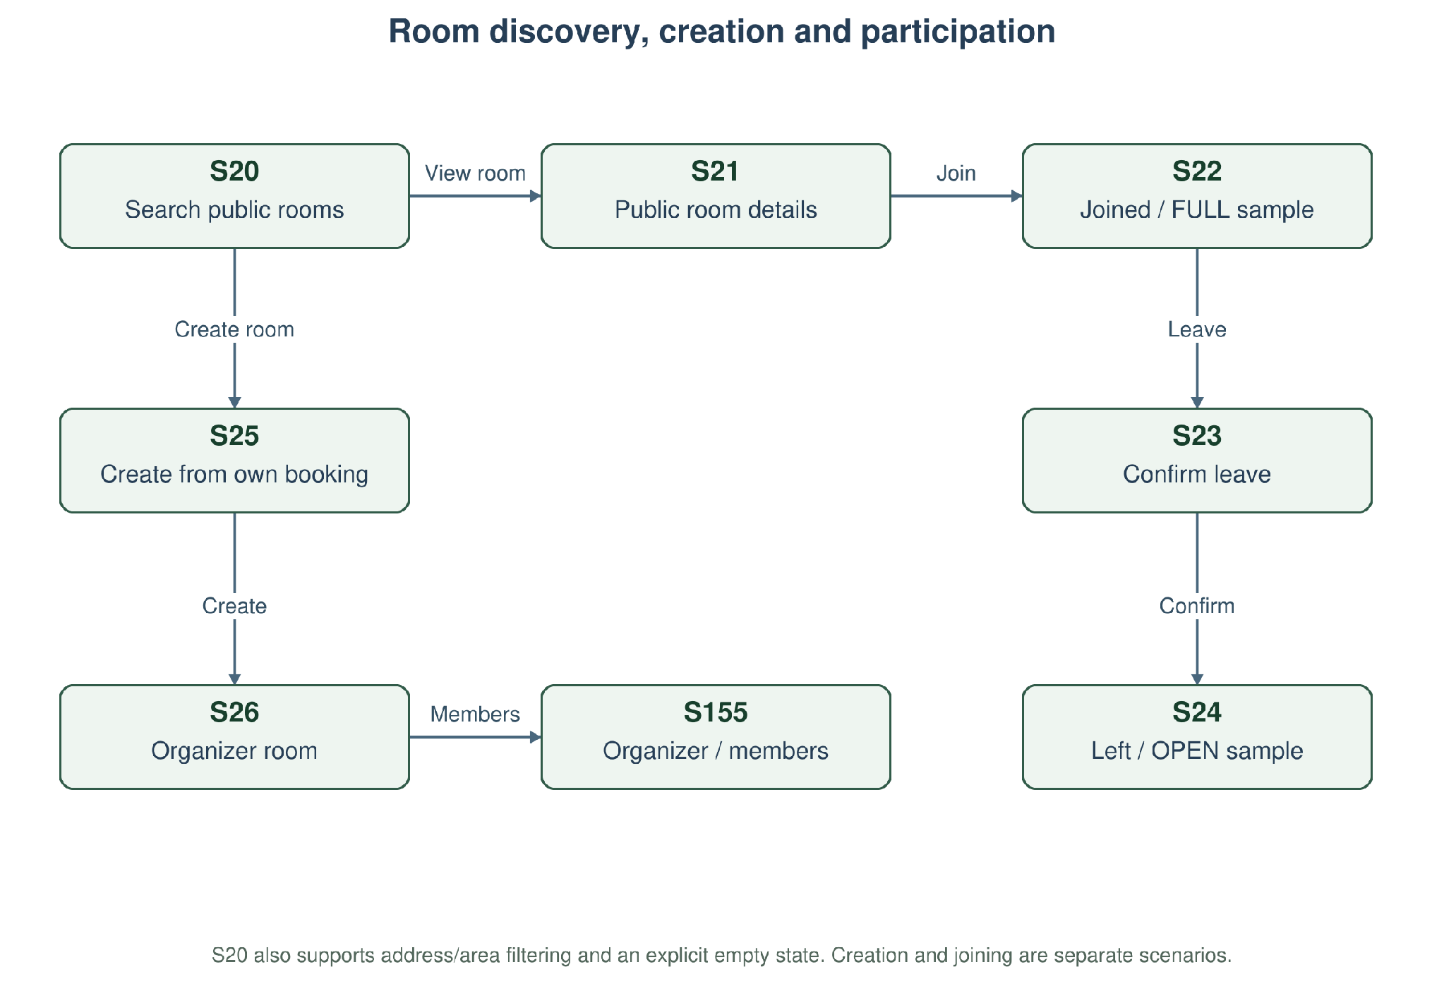
Figure 8-3. Open Play Room discovery, creation, joining and leave confirmation.
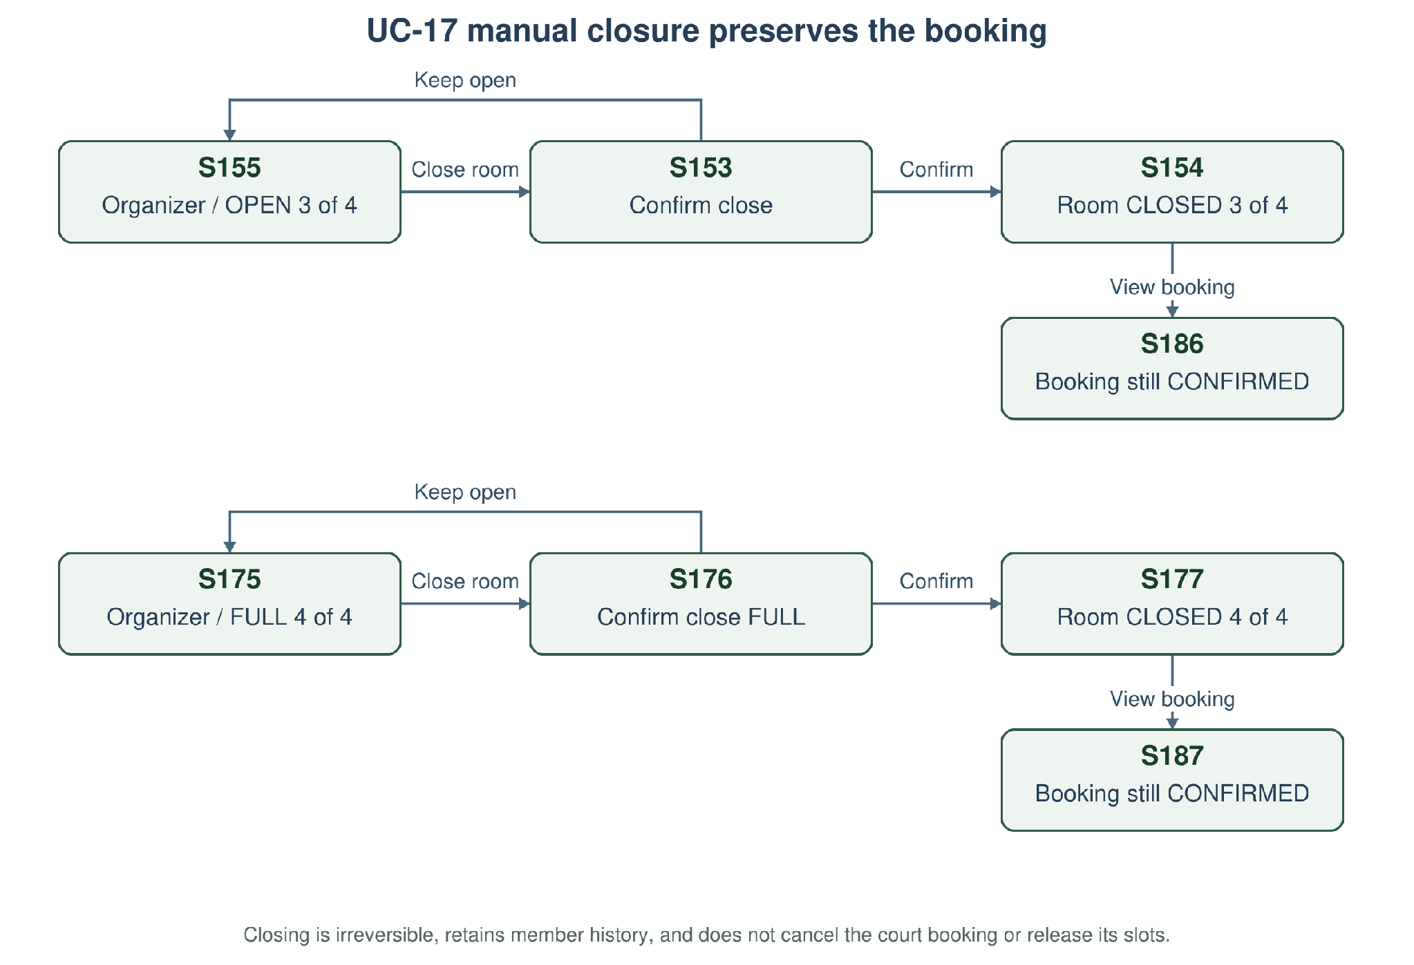
Figure 8-4. Organizer closure of OPEN/FULL rooms with the court booking preserved.

Representative Current Mockups
These figures replace the earlier search form without time limits and the former fixed Slot A/Slot B publication form. Long calendars and result lists use scrolling; a viewport illustration may show only the first part. All controls remain explained in Section 8.4 and full editable frames remain linked.
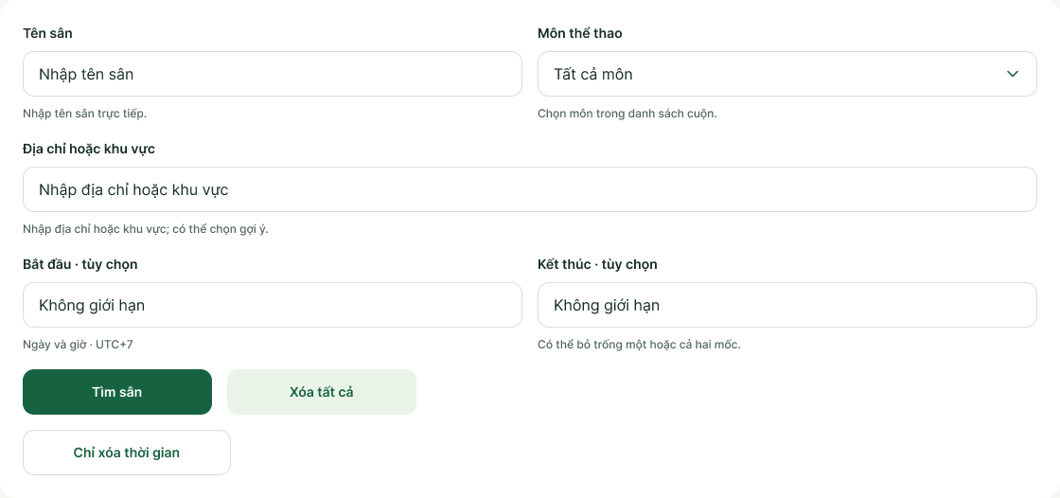
Figure 8-5. Current search controls: court name, scrollable sport dropdown, address/area and independent optional time bounds. The exported detail is the search-form region of S01. Open S01
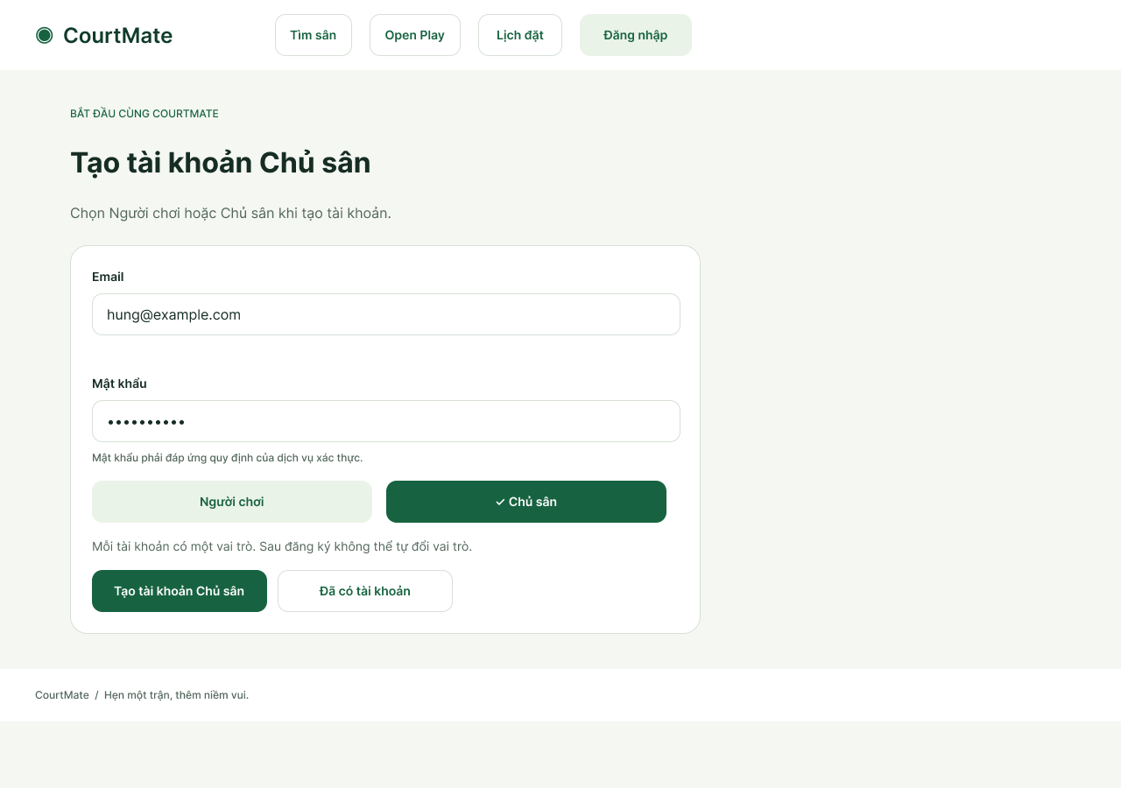
Figure 8-6. Court Owner registration is an initial role-selection branch of Register Account. Open S151
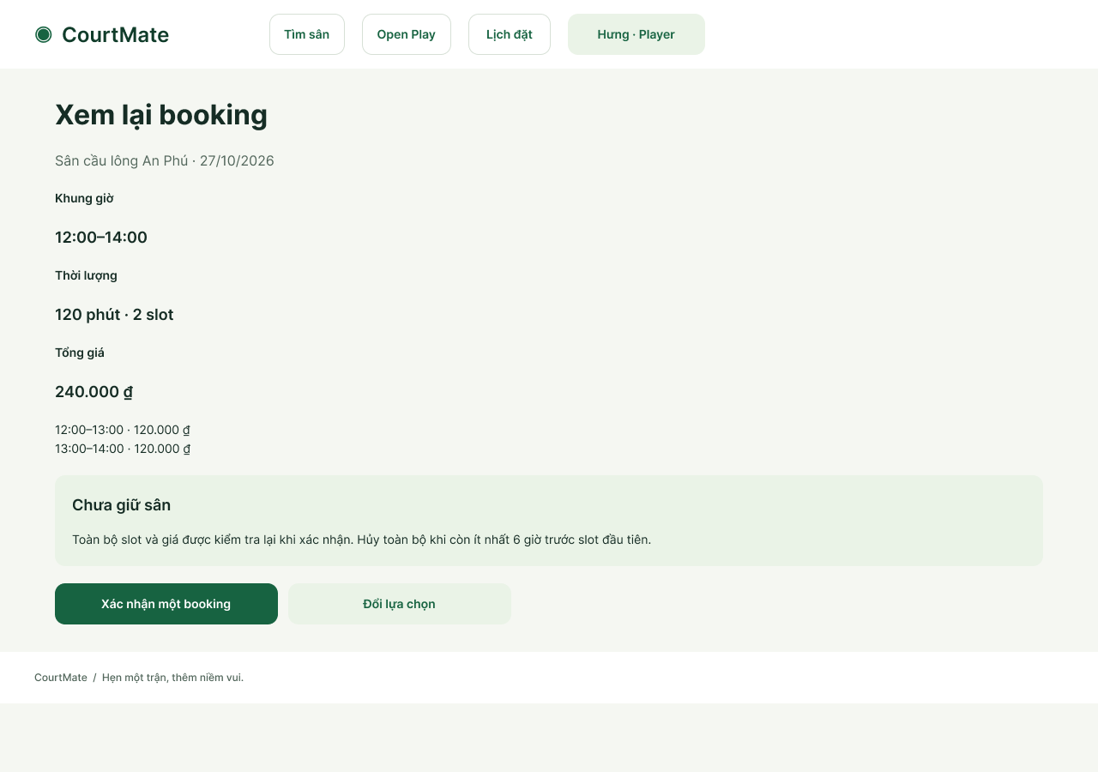
Figure 8-7. A representative review state for two adjacent 12:00–14:00 slots, 120 minutes and a 240,000 VND total. Open S217
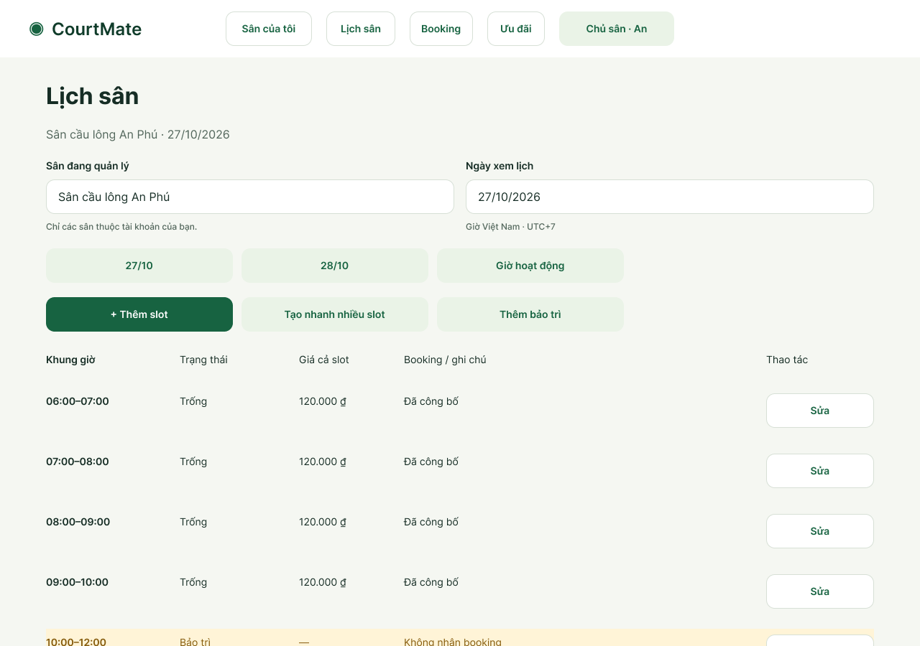
Figure 8-8. The daily Owner calendar replaces the fixed two-slot form; scroll for later AVAILABLE, BOOKED, BLOCKED and unpublished intervals. Open S34
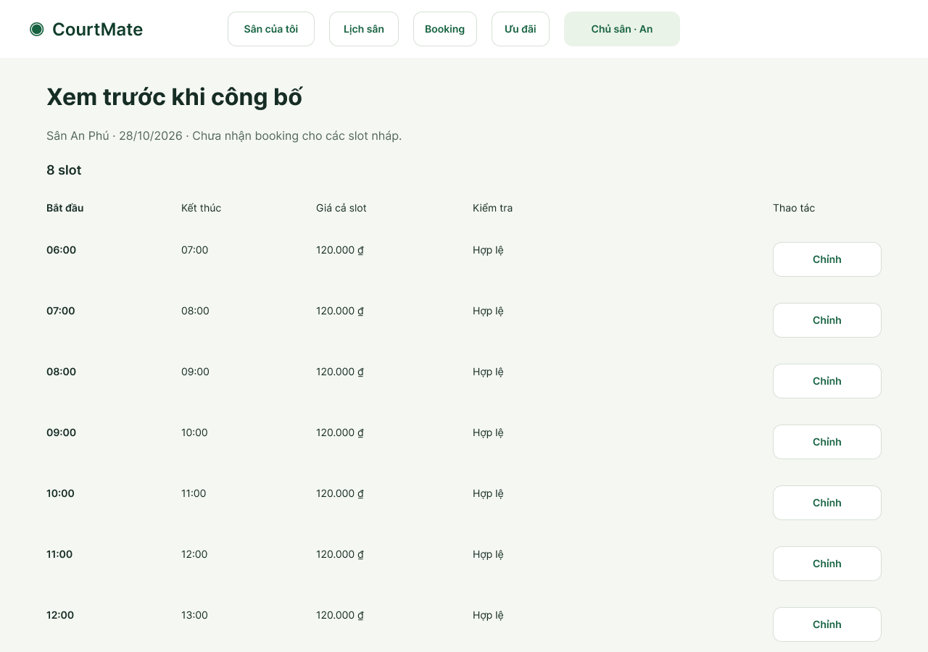
Figure 8-9. Draft-row preview for batch publication. The sample has eight rows with a ninth-row interaction; scroll to the publication action. Open S202
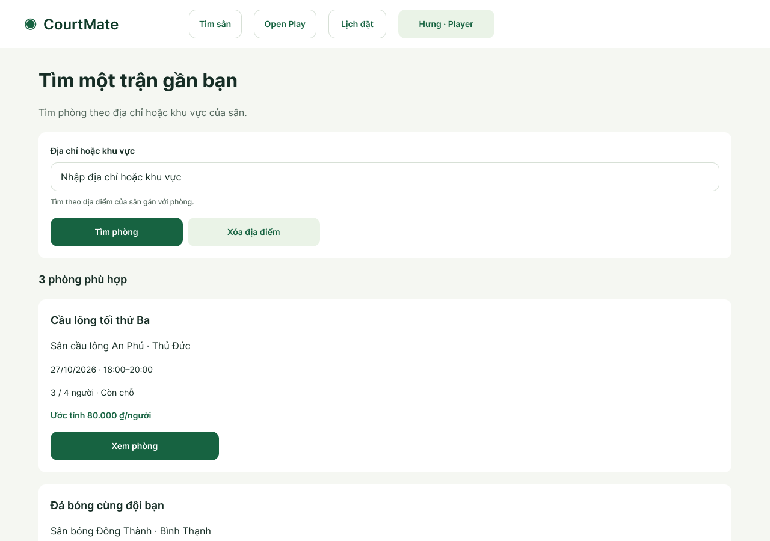
Figure 8-10. Open Play discovery now includes court address/area search and independent location clearing. Open S20
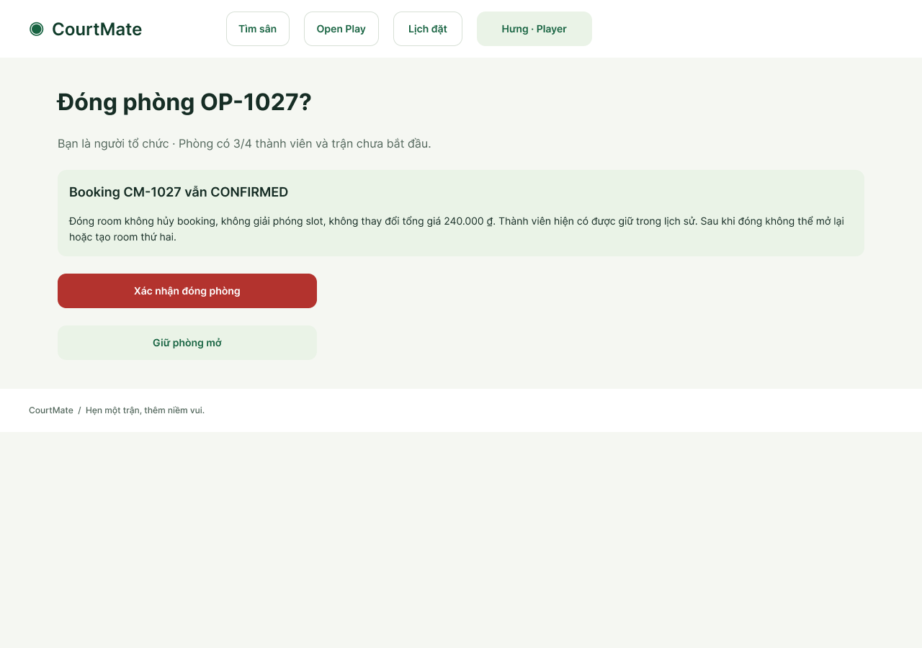
Figure 8-11. UC-17 closure confirmation explains participant history and the unchanged CONFIRMED court booking. Open S153
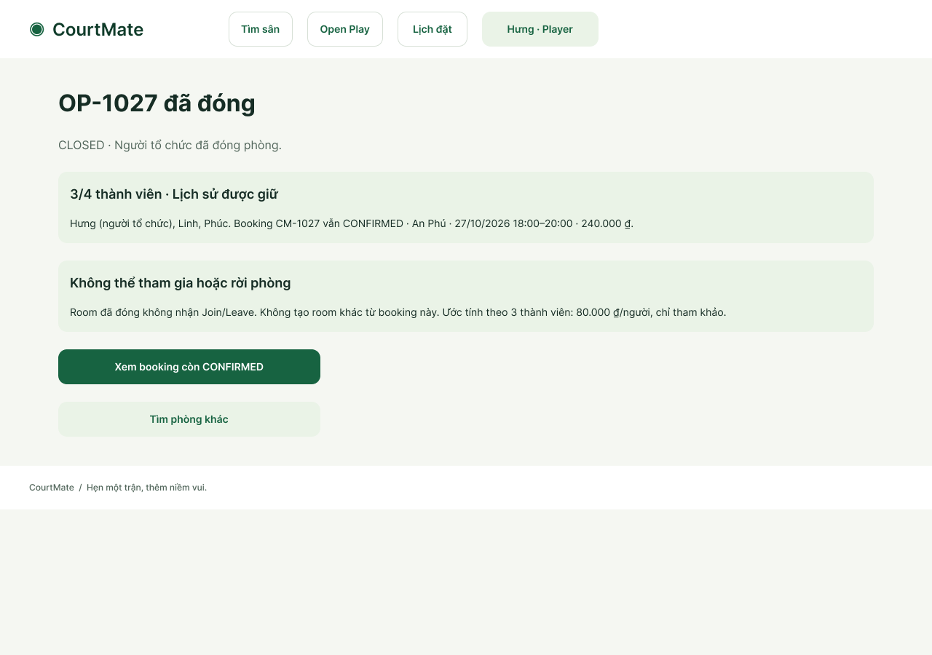
Figure 8-12. Manual CLOSED room result: membership history retained; further joins/leaves unavailable; the booking remains accessible. Open S154
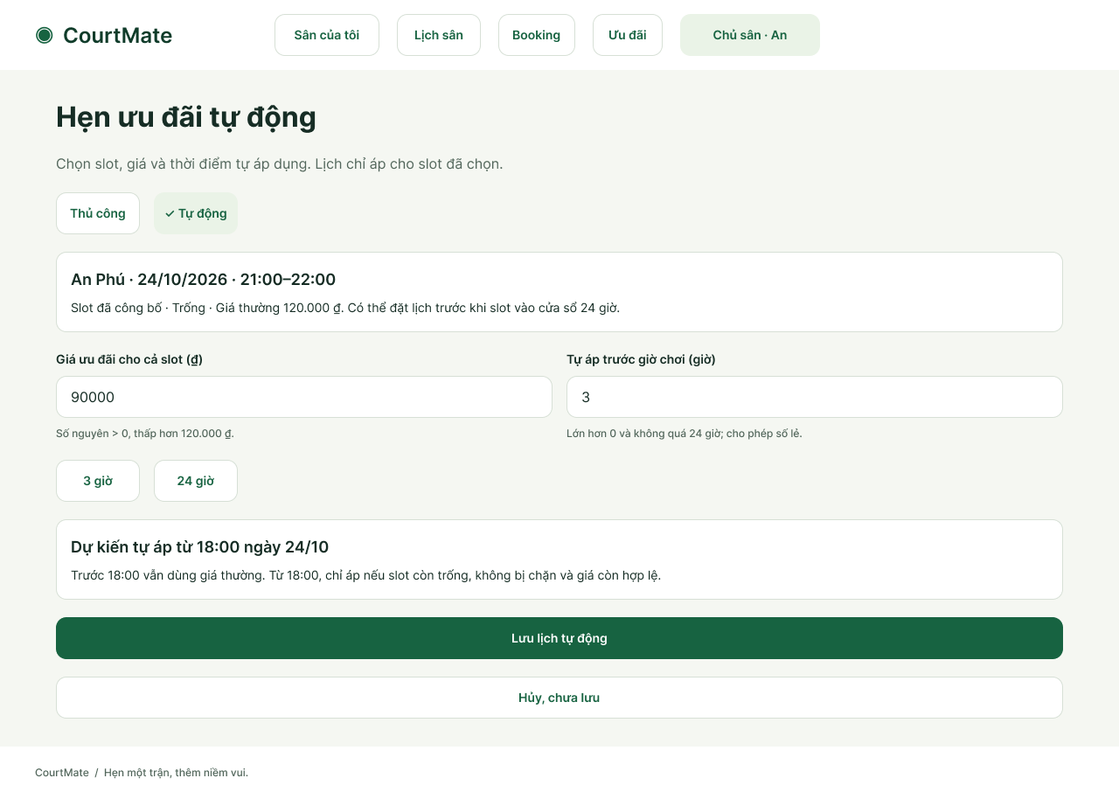
Figure 8-13. Owner automatic-offer configuration for one slot, including lead time and the computed application time.
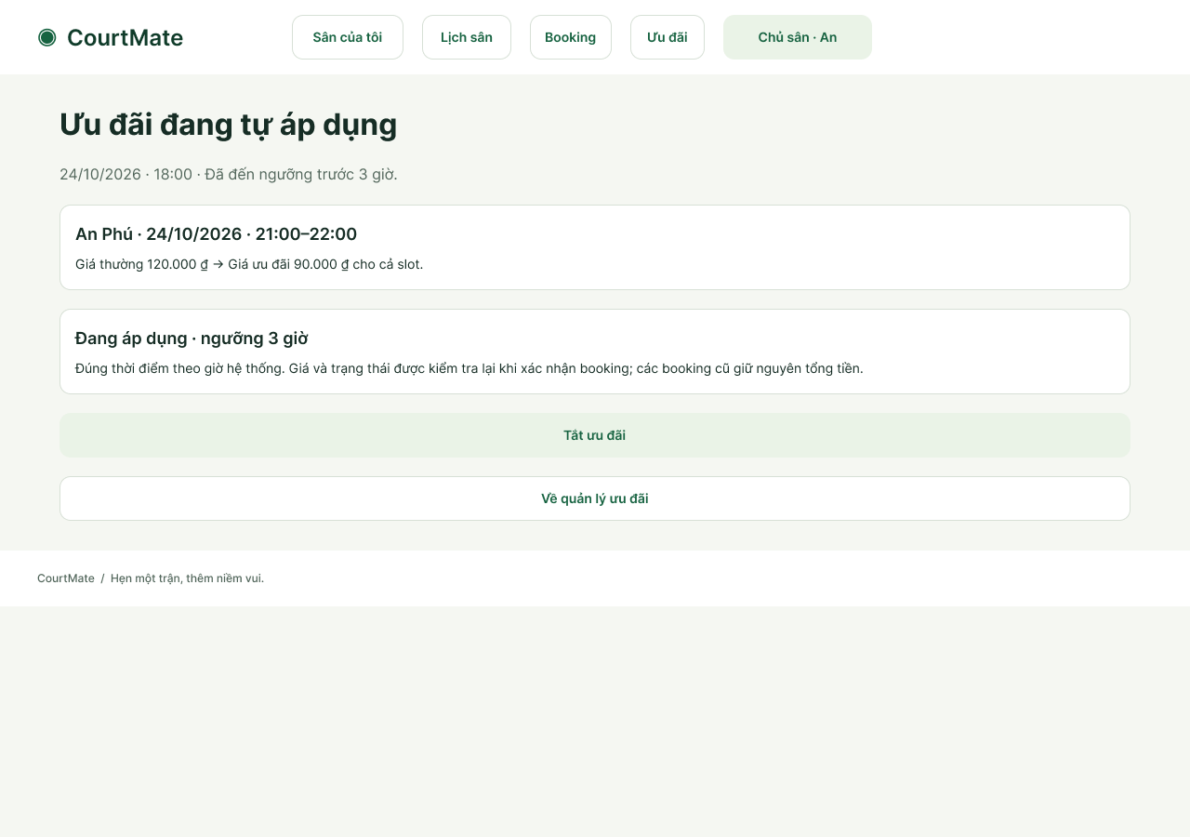
Figure 8-14. Automatically applicable offer after its configured threshold; prior booking totals remain protected.

Screen Specifications
The following specifications define required application behavior and feedback. The native Figma prototype uses predefined data, variable states and clickable navigation. It does not accept arbitrary keyboard input, call Firebase, persist bookings, execute server transactions, or prove keyboard/screen-reader compliance. Prefix matching and free-form text entry describe the intended application interaction; bounded sample states demonstrate the design.
S03 / S151 / S02 / S04 — Account forms
Control / action | Required behavior and validation | Feedback / next state
Email, password and role | Accept email/password according to the identity provider’s validation. Initial registration allows Player or Court Owner; show the selected role and prohibit later self-editing of that role. Registration failure creates no protected session. | Success uses S05 or S152. Field errors remain on the form; no real credentials or identity-provider transaction are executed in the prototype.
Sign in, sign out, session recovery | Successful sign-in routes to the role-appropriate entry. Signing out removes protected access. Missing/expired identity or an invalid role cannot authorize a protected action. | Use S17, S18, S19 or S49 as appropriate; retain only non-sensitive input during recovery.
S01 / S191 / D01 / D04 — Search and slot preview
Control / action | Required behavior and validation | Feedback / next state
Court name and address/area | Allow direct court-name text and either a full address or a broader area. Address suggestions are optional shortcuts; manual filtering must work without GPS. Editing one criterion preserves all other selected criteria. | Search combines selected name, sport, location and time criteria. No matching court produces an explicit empty state rather than unrelated results.
Sport dropdown | Open a menu anchored below the sport field. Keep the search box above a bounded vertically scrollable option list; typing a name prefix narrows the options. Choosing an option updates the displayed sport; All sports removes only that restriction. | The design is a scrollable dropdown, not a separate centered input dialog or a permanently expanded checklist. Current native Figma uses sample states rather than arbitrary keyboard input.
Optional start/end datetime | Accept either bound independently or both, using displayed Vietnam time. With both supplied, the end must be later than the start. A displayed matching slot must lie within the applied bounds; clearing time preserves name, sport and location. | Invalid ranges show S149. No eligible court/slot shows an empty state. The implementation must validate datetime syntax and eligibility against server time.
Search, clear and result cards | Search applies the current criteria together and keeps them visible on the result screen. Clear all resets all criteria; Clear time resets only the two temporal bounds. Each active court card links to its court details and slot preview. | S191 is the desktop result state; S192/S193/S194 are guest/phone/tablet variants. Availability is not reserved by searching.
View slots overlay | Provide the slot-preview link even when no time filter is applied. With time limits, list eligible matching slots only; without time limits, show nearest upcoming eligible published slots in time order. Show playing date, interval, full-slot price and availability. | Close returns to the same underlying results. Loading, empty and failure are D09, D08 and D10; full-day selection is available through S127. No unpublished, booked or blocked slot is presented as selectable.
S06 / S127 / S217 / S218 — Court details and booking
Control / action | Required behavior and validation | Feedback / next state
Court details and available slots | Show court name, sport, address/area, description, supplied photos, owner/contact fields approved for display, base price and a link to published availability. Explain that the quoted price of each slot is used for booking. | GPS denial must not block details or manual location/directions. Slot status must include text rather than color alone.
Slot selection and review | Select only future AVAILABLE published slots for one active court/date. Allow one or multiple strictly adjacent slots totalling 60–240 minutes. Display ordered slots, complete interval, each quote and their sum before confirmation. | Invalid or discontiguous selection stays on S127 with a reason. Clear selection is available. Review occurs at S217; changing the choice returns to S127.
Confirm one booking | Recheck the whole selection, permissions, schedule, conflicts, current quotes and applicable F09 offers. Commit exactly one complete booking or none. Mere selection/review reserves nothing. | S218 is the success fixture. S10/S11/S137/S138 document conflict/repricing outcomes; S239 covers an inactive court. The native prototype does not perform transactional server validation.
S12 / S13 / S14 — My bookings and cancellation
Control / action | Required behavior and validation | Feedback / next state
History and booking details | Show the ten most recent owned records (or all if fewer), newest booking timestamp first. A multi-slot booking is one record with its unique ID, court, overall interval, accepted total and status. | Only the owning Player may view/cancel protected records. A room-linked booking retains links to its room/history.
Cancel / Keep Booking | Confirm cancellation of the entire booking and explain any linked-room closure. Recheck ownership/status and at least six hours before the earliest slot start; Keep Booking returns without changes. | S14 shows the CANCELLED result. S15/S132 reject ineligible cancellation, S131 shows the exact six-hour boundary. Release the whole reservation together; no partial-slot cancellation or payment/refund operation is offered.
S30 / S31 / S32 / S33 — Owned court listings
Control / action | Required behavior and validation | Feedback / next state
Create/edit court | Capture name, sport, full address/area, description, positive base price and integer max_players from 2 to 30. Preserve input on validation failure; editing is restricted to an owned court. | Reject a decrease that would invalidate a future OPEN/FULL linked room’s capacity. S41/S129 represent invalid input/capacity. Creating a court leads to its own setup at S221, not another court’s schedule.
Deactivate court | Request confirmation that new bookings stop while existing booking records, intervals, accepted totals and statuses remain intact. Keep active returns without change. | S219 is the inactive listing fixture. Existing bookings remain available through owner booking views.
S34 / S201 / S202 / S203 / S206 — Calendar and slots
Control / action | Required behavior and validation | Feedback / next state
Court/date and daily calendar | Retain the selected owned court and playing date. Distinguish AVAILABLE, BOOKED, BLOCKED and not-yet-published time with text labels and contextual actions. Scroll through the entire operating day. | No fixed two-slot publication limit is imposed. BOOKED rows open their booking; unpublished time is not a selectable Player slot.
Create many / preview / publish | Enter dated start/end, each slot’s 60–240-minute duration and positive whole-VND full-slot price. Generate draft rows on the 30-minute grid, within opening hours, with no overlap or maintenance conflict. Review and correct individual rows before publication. | S201 → S202 → S203. The sample generates eight rows and can show a ninth; this is sample data, not a product cap. Back/Cancel must not publish drafts.
Add/edit one slot and operating hours | Add a dated slot or edit the chosen AVAILABLE slot in its own court/date context. Preserve other slots’ prices. An already CONFIRMED booking locks its constituent slots’ time intervals and regular quotes. | S204/S205 add one slot; S206/S207 edit; S210/S211 set hours. Reject any change invalidating an existing confirmed booking; S157/S158 demonstrate the lock.
S35 / S208 / S209 — Maintenance
Control / action | Required behavior and validation | Feedback / next state
Interval and impact confirmation | Enter the owned court/date and maintenance interval, then preview the affected AVAILABLE time before confirming. Reject overlap with any confirmed booking, including a combined booking. | S35 → S208 → S209 is the valid sample. S36 is the rejection fixture. Cancel preserves the valid schedule and all existing bookings.
S38 / S39 — Owner booking views
Control / action | Required behavior and validation | Feedback / next state
Filters, list and details | Limit data to owned courts; support booking/status/date lookup. Details identify the booking, court, full interval, status, creation timestamp and Player registration email and display name when present. | Show empty/error states appropriately. S40 demonstrates rejected access to another Owner’s data; no force-cancellation control is introduced.
S20 / S21 — Public room discovery
Control / action | Required behavior and validation | Feedback / next state
Address/area search and room list | Accept a full court address or an area, with optional suggestions. Apply the criterion to the linked court and show matching rooms with full playing interval, current count/capacity, effective status and per-person estimate. | Clear location restores the public list. S212 is the empty-location result; S94 is public guest discovery. Retain the criterion when returning from details.
View room | Display public organizer/court/interval, capacity, membership, status and informational estimate. Searching or viewing changes no membership or booking. | An unauthenticated Visitor may browse but must sign in for protected participation. Effective CLOSED rooms prohibit join/leave.
S25 / S26 — Create room
Control / action | Required behavior and validation | Feedback / next state
Owned booking and capacity | Choose only an owned future CONFIRMED booking not already linked to a room. Inherit its court and complete interval. Accept integer capacity C between 2 and twice court.max_players; count the organizer as member one. | Revalidate before creation. S27/S29 handle invalid capacity or an existing room; S145/S146 demonstrate max_players=8 with capacity 16.
Create / Cancel | Create at most one public room per eligible booking, then show the room and its informational cost estimate. Cancel returns without room creation. | The estimate is the saved accepted booking total divided by current enrolled members, including organizer, rounded to whole VND; it is not a payment request.
S21 / S22 / S23 / S24 — Join and leave
Control / action | Required behavior and validation | Feedback / next state
Join room | Require an authenticated eligible Player, OPEN status, a future CONFIRMED linked booking, a free place and no existing active membership. Recheck eligibility on submission. | S22 is a joined/FULL fixture; S63/S78 reject a lost final place or a full room. Concurrent duplicate/overcapacity prevention requires backend testing.
Leave / Stay | Before the earliest start, offer an enrolled non-organizer in an OPEN/FULL room an explicit leave confirmation (S23). Confirm Leave submits the request and rechecks eligibility before updating membership/count/estimate; FULL reopens only when still eligible. Stay or cancelling the confirmation changes no membership or booking data. | S23 → S24 is the leave sample. The organizer cannot abandon the source-booking relationship through Leave. Started/CLOSED rooms reject participation changes.
S155 / S153 / S154 — UC-17 close own room
Control / action | Required behavior and validation | Feedback / next state
Close Room / Keep Open | Offer manual closure only to the room’s authenticated organizer. Confirm irreversibility, blocked future joins/leaves, retained member history and the fact that the court booking is not cancelled. Permit closure even when others have joined or the room is FULL. | Keep Open returns to S155 (or S175 for FULL). Recheck organizer ownership, booking/time and current status before changing the room.
Closed result and booking link | Show CLOSED with the manual-closure reason, retained member count/history and disabled participation. Keep the booking CONFIRMED with unchanged slots and accepted total. Do not reopen or create a second room for the same source booking. | S154 → S186 verifies the unchanged booking fixture; S175/S176/S177/S187 cover FULL. An already CLOSED room displays current state; unauthorized/failed requests cannot claim closure.
S46 / S47 / S48 — Basic profile (Should)
Control / action | Required behavior and validation | Feedback / next state
Editable profile fields | Allow permitted basic profile/contact-preference changes only. Do not expose role or identity-provider-controlled fields as editable profile settings. | Validate before save, retain input on failure and preserve protected fields. S47/S48 demonstrate success/error; S76 is the Owner variant.
S42 / S43 / S220 / S241–S257 — Slot-specific manual and automatic offers (Should)
Control / action | Required behavior and validation | Feedback / next state
Create manual offer | Confirm creation for an owned AVAILABLE/unblocked future slot with 0 < Δ ≤ 24 hours and a valid lower whole-slot quote. Reject any existing SCHEDULED/ACTIVE configuration. Offer applies only to that slot. | S43; S44 is a manual-window rejection and offers a switch to Automatic. S159 rejects a scheduled or active duplicate.
Deactivate ACTIVE offer | Show S220 (manual) or S252 (automatic), identify the configuration and explain preserved booking totals. Confirm rechecks ownership/ACTIVE state and records DEACTIVATED; Keep/dismiss makes no change. A terminal record never revives. | S252 → S253; S220 → S42. FR-042 covers both modes.
Configure automatic offer | Input the selected slot, positive whole-VND lower quote and numeric 0 < h ≤ 24 hours; allow fractions and saving earlier than 24 hours. Show the computed start-minus-h time before Save. Reject invalid inputs or an existing SCHEDULED/ACTIVE configuration. | S241 → S242; S249 (h=24) → S250 if already eligible. S244 retains invalid input; S257 rejects duplicate automatic-slot configuration. S251 → S254 is the 375 px path.
Effective automatic application | Before its window retain the regular quote. At 0 < Δ ≤ h, apply only while court/availability/maintenance/current price remain valid; otherwise withhold and show why. Re-evaluate after permitted changes, without duplicate offers; expire at slot start. Prior accepted totals never change. | S242 → S243 is the separate 18:00 fixture. S247 is temporarily blocked; S248 is expired. R04 opens independent time fixtures, not a live scheduler.
Cancel pending schedule | Show S245/S255 with Confirm Cancellation and Keep Schedule. Recheck ownership/state before CANCELLED. Keep preserves it. If it became ACTIVE, require deactivation confirmation. Terminal schedules never reactivate. | S245 → S246; Keep → S242. Mobile S255 → S256; Keep → S254. FR-049.

Prototype Scenarios and Verification
On 30 October 2026, existing frame IDs, stored reactions and selected conditional actions were inspected. The checks below evaluated stored prototype actions in memory and inspected design-state content; they did not run an implemented website, identity service or database. No missing destination was found in the 16 checked screen roots. Source code/test-case identifiers will be added in the later phases when they exist.
Journey | Screen sequence | Expected outcome | Observed evidence / limitation
Registration and role access | S03 → S05; S151 → S152; S02/S04 | Initial role selection succeeds into the correct account context; later role escalation is denied. | Screen text/routes inspected; IdP and authorization execution pending.
Court search and preview | S01 → S191 → D01/D04; S149 for invalid range | Retain unrelated filters, show only matching eligible slots, and keep preview access with or without time bounds. | Stored-action cases checked for sport preservation and 12:00–14:00 matching.
One or several consecutive slots | S127 → S217 → S218; return S217 → S127 | Exactly one complete booking at the accepted sum; invalid/discontiguous or over-240-minute selections cannot proceed. | All 512 combinations of the nine sample AVAILABLE slots checked: 21 valid; no mismatch. No database confirmation was executed.
Whole-booking cancellation | S12 → S13 → S14; S131/S132 boundaries | Keep leaves all records intact; an eligible cancellation releases the complete reservation and closes any linked room. | Confirmation/rejection fixtures inspected. Server-time and atomic-write tests pending.
Owner publication and changes | S34 → S201 → S202 → S203; S202 → S206 → S202 | Review many draft rows, update the selected date/slot only, and publish after explicit confirmation. | Ninth-row state and all 26 sample date/slot edit targets checked; no mismatch.
Maintenance and protected bookings | S34 → S35 → S208 → S209; S36/S157/S158 | Preview effects and reject changes that would invalidate confirmed bookings. | Linked design states inspected; server enforcement pending.
Room discovery / participation | S20 → S21 → S22 → S23 → S24; S20 → S25 → S26 | Address/area filtering, truthful empty results, correct member count/status and informational cost after joins/leaves. | Full-address match and empty-result actions checked; join/leave links inspected. Concurrent membership tests pending.
Manual closure — UC-17 | S155 → S153 → S154 → S186; S175 → S176 → S177 → S187 | Keep Open returns unchanged; closure freezes participation while preserving the booking and member history, including FULL rooms. | Close/Keep/booking links checked. Static postconditions are shown; concurrent closure/join backend checks pending.
Owner manual and automatic offers (Should) | S42 → S43 / S241 → S242; S249 → S250; S245 → S246; S252 → S253; R04 clock/boundary fixtures | Only currently eligible quotes apply; h=24 accepted, invalid thresholds rejected; pending/active cancellations are confirmed; terminal offers never revive and accepted totals remain unchanged. | New editable frames, action destinations and state branches inspected on 6 November 2026. Boundary rules checked against requirements scenarios; no backend scheduler or database execution is claimed.

Accessibility and Usability Review
The review follows the instructor’s familiarity, consistency, minimal-surprise, recoverability, guidance and user-diversity principles. States use explicit labels and explanations, not color alone. The fixed two-slot publication form and centered filter-input dialogs have been replaced by the calendar/batch workflow and direct/anchored filter controls.
Criterion | Current design evidence | Required verification / status
Labels, state and recovery | Named fields; textual AVAILABLE/BOOKED/BLOCKED/CLOSED states; Keep/Cancel, clear filters, retry and empty-state actions. | Design review recorded. User task evaluation and implementation error-recovery checks remain pending.
Contrast tokens | Measured token pairs: ink on white 14.62:1; muted on white 6.16:1; white on green 7.25:1; green on soft 6.38:1; amber on amberSoft 5.48:1. | These sampled pairs exceed 4.5:1. This is token-level evidence only; all rendered text/control combinations still require checking.
Phone and tablet tasks | Linked 375/768/1280 design variants cover search, Player slots, Owner slots and room discovery; long lists/calendar views have bounded scrolling. | Verify the complete same task on actual phone/tablet/desktop browser viewports; independent frame existence is not a complete responsive test.
Keyboard and dialogs | The design specifies visible labels and bounded dropdown/overlay interactions. | Pending: Tab order, visible focus, Enter/Space, Escape, modal focus containment/return and scroll operation in the implemented browser UI.
Assistive technology | Court/slot/room states and errors are expressed in text. | Pending: semantic labels, accessible names, live error/status announcements, alt text and screen-reader operation.
Learnability and speed | Main tasks have explicit review/confirmation and contextual actions; Owner batch publication reduces repeated slot entry. | Pending: representative Player/Owner task sessions measuring completion, errors, recovery and feedback. Do not claim a successful user study.
Automated accessibility / NFR-05 | NFR-05 in Section 5.2 defines viewport, keyboard/label/state, text-contrast and Lighthouse targets. No Lighthouse or axe implementation result is claimed. | Run documented browser, keyboard, screen-reader, rendered-contrast and user/manual checks against the implementation. A Lighthouse score alone does not establish accessibility conformance.

Requirements Traceability Matrix

Functional Requirement Traceability
Section 5.1 defines 49 FR IDs, including FR-046 for the search-result slot preview. The tables link the functional requirements, non-functional requirements and business rules to their use cases and prototype evidence. A screen link establishes design traceability, not implementation compliance; PA3 design and PA4 test-case identifiers remain planned until those artifacts exist.
Req. ID | Use case(s) | Prototype / design-state evidence | Design element (PA3) | Test cases (PA4)
FR-001 | UC-01 | S03, S151, S05, S152 | Planned in PA3 | Planned in PA4
FR-002 | UC-02 | S02, S04, S17, S49 | Planned in PA3 | Planned in PA4
FR-003 | UC-01 / UC-02 | S03, S151, S77, S19 | Planned in PA3 | Planned in PA4
FR-004 | UC-02, UC-05–10, UC-12–17 (UC-15/16 conditional) | S17, S18, S19, S49; protected journeys in Section 8.4 | Planned in PA3 | Planned in PA4
FR-005 | UC-05–10, UC-12–17 (UC-15/16 conditional) | S18, S40, S129, S153; protected ownership checks in Section 8.4 | Planned in PA3 | Planned in PA4
FR-006 | UC-03 | S01, S191, S50, S219 | Planned in PA3 | Planned in PA4
FR-007 | UC-03 | S01, S191, S197 | Planned in PA3 | Planned in PA4
FR-008 | UC-03 | S01, S191, S149, S150, S162, S163, D01, D04 | Planned in PA3 | Planned in PA4
FR-009 | UC-03 | S50, S150 | Planned in PA3 | Planned in PA4
FR-010 | UC-04 | S06, S84, S85, S92 | Planned in PA3 | Planned in PA4
FR-011 | UC-03 / UC-04 | D01, D04, S127, S93 | Planned in PA3 | Planned in PA4
FR-012 | UC-04 / UC-05 | S127, S217, S161 | Planned in PA3 | Planned in PA4
FR-013 | UC-04; optional FR-013 | S69, S95 | Planned in PA3 | Planned in PA4
FR-014 | UC-05 | S127, S217, S133 | Planned in PA3 | Planned in PA4
FR-015 | UC-05 | S127, S16, S10, S239 | Planned in PA3 | Planned in PA4
FR-016 | UC-05 | S10, S75 | Planned in PA3 | Planned in PA4
FR-017 | UC-05 | S218, S09 | Planned in PA3 | Planned in PA4
FR-018 | UC-05 | S11, S70, S137, S217 | Planned in PA3 | Planned in PA4
FR-019 | UC-06 | S12, S100, S116 | Planned in PA3 | Planned in PA4
FR-020 | UC-07 | S13, S14, S131, S132 | Planned in PA3 | Planned in PA4
FR-021 | UC-06 / UC-07 | S12, S15, S132 | Planned in PA3 | Planned in PA4
FR-022 | UC-07 | S14, S28, S79, S135, S136 | Planned in PA3 | Planned in PA4
FR-023 | UC-08 | S31, S32, S41, S129, S140, S221 | Planned in PA3 | Planned in PA4
FR-024 | UC-08 | S33, S219, S239 | Planned in PA3 | Planned in PA4
FR-025 | UC-09 | S34, S201, S202, S203, S204, S206, S210, S157, S158 | Planned in PA3 | Planned in PA4
FR-026 | UC-09 | S35, S208, S209, S240 | Planned in PA3 | Planned in PA4
FR-027 | UC-09 | S36, S157, S158 | Planned in PA3 | Planned in PA4
FR-028 | UC-10 | S38, S235 | Planned in PA3 | Planned in PA4
FR-029 | UC-10 | S39, S125, S126, S232 | Planned in PA3 | Planned in PA4
FR-030 | UC-10 | S40 | Planned in PA3 | Planned in PA4
FR-031 | UC-12 | S25, S26, S29 | Planned in PA3 | Planned in PA4
FR-032 | UC-12 | S25, S27, S145, S146 | Planned in PA3 | Planned in PA4
FR-033 | UC-11 / UC-12 / UC-17 | S20, S21, S26, S94, S154; AC-F10-15/16 | Planned in PA3 | Planned in PA4
FR-034 | UC-13 | S21, S22, S78, S79 | Planned in PA3 | Planned in PA4
FR-035 | UC-13 | S63, S78, S79 | Planned in PA3 | Planned in PA4
FR-036 | UC-14 | S23, S24, S79 | Planned in PA3 | Planned in PA4
FR-037 | UC-11 / UC-14 / UC-17 | S21, S79, S155, S153, S154, S175, S176, S177, S186, S187; AC-F10-17–21 | Planned in PA3 | Planned in PA4
FR-038 | UC-11–14 / UC-17 | S20, S21, S22, S24, S26, S154, S177 | Planned in PA3 | Planned in PA4
FR-039 | UC-15 (Should) | S46, S76 | Planned in PA3 | Planned in PA4
FR-040 | UC-15 (Should) | S47, S48 | Planned in PA3 | Planned in PA4
FR-041 | UC-16 (Should) | S42, S43, S44, S159; S241/S242 demonstrate the conflicting scheduled configuration. | Planned in PA3 | Planned in PA4
FR-042 | UC-16 (Should) | S42, S220, S160, S252, S253 | Planned in PA3 | Planned in PA4
FR-043 | UC-07; conditional F09 (Should) | S134, S135, S121, S136; S247/S248; AC-F09-12/14/17 (current automatic window/terminal state). | Planned in PA3 | Planned in PA4
FR-044 | UC-05; conditional F09 (Should) | S133, S53, S137, S138, S139; AC-F09-16; S243/S250 demonstrate automatic quote eligibility. | Planned in PA3 | Planned in PA4
FR-045 | UC-05; conditional F09 (Should) | S66, S67, S133, S217; AC-F09-14/16 (saved total unchanged). | Planned in PA3 | Planned in PA4
FR-046 | UC-03 / UC-04 | D01, D04, S01, S191; AC-F02-11/12 | Planned in PA3 | Planned in PA4
FR-047 | UC-16 (Should) | S241, S244, S249, S251, S257 | Planned in PA3 | Planned in PA4
FR-048 | UC-16 (Should) | S242, S243, S247, S248, S250 | Planned in PA3 | Planned in PA4
FR-049 | UC-16 (Should) | S245, S246, S255, S256 | Planned in PA3 | Planned in PA4

Non-Functional Requirement Traceability
Req. ID | Related use cases | Design evidence | Verification and status
NFR-01 | All read/write journeys | Prototype links and feedback states are in Section 8; no latency measurements were made. | Run the specified 30-user workload; record P95 latency and application-error rate. Runtime pending.
NFR-02 | UC-05 / UC-07 / UC-09; UC-16 if F09 is delivered (Should) | S10, S127, S217, S218, S36: selection and conflict/protection states. The 512-case check validates sample selection logic only. | Database-backed overlapping confirmation/cancellation tests; prove no conflicts or partial allocations. Runtime pending. If F09 is implemented, test concurrent schedule/manual creation, activation/cancellation/deactivation and booking; verify unique nonterminal configuration and unchanged accepted totals.
NFR-03 | UC-12–14 / UC-17 | S27, S63, S145, S153, S154, S176, S177: capacity, duplicate/final-place and closure states. | Concurrent distinct/duplicate joins, leave/close races and authoritative room-state checks. Runtime pending.
NFR-04 | All protected use cases | S17, S18, S19, S40; initial role selection in S03/S151 and protected ownership in UC-17. | API tests for invalid tokens, post-registration role escalation and cross-user/Owner access. Legitimate initial role registration must remain distinct from forged role claims. Runtime pending.
NFR-05 | Player/Owner main tasks | Responsive variants, state/error text and sampled token contrast are recorded in Section 8.6. | Section 5.2 now specifies measurable targets and verification conditions. Execute responsive-browser, keyboard, screen-reader, contrast and Lighthouse checks on the implementation; runtime verification pending.

Business Rule Traceability
Rule | Related use cases | Prototype evidence | Coverage / source status
BR-01 | UC-04 / UC-05 / UC-09 | S127, S34, S201, S202, S204, S206 | Published slot grid/duration, positive whole-slot quotes, hours and non-overlap are specified; server validation pending.
BR-02 | UC-07 | S13, S14, S15, S131, S132 | Six-hour eligibility uses backend receipt time and the earliest slot start; cancellation is whole-booking, releases all slots and closes the linked room. Source definition complete; runtime boundary/atomicity tests pending.
BR-03 | UC-09 | S36, S157, S158, S208 | Confirmed booking interval/regular quote and accepted total must survive Owner edits; runtime enforcement pending.
BR-04 | UC-12 / UC-17 | S25, S26, S29, S153, S154, S186 | One room per owned eligible booking; court/full interval inherited; manual closure does not enable a second room.
BR-05 | UC-08 / UC-12 / UC-13 | S129, S140, S27, S145, S146, S63 | Court max_players 2–30; integer room capacity 2 to twice max_players; organizer included; duplicate/overcapacity protection and capacity-decrease rejection. Source definition complete; runtime/concurrency tests pending.
BR-06 | UC-07 / UC-11–14 / UC-17 | S79, S28, S153, S154, S175, S176, S177 | OPEN/FULL/CLOSED lifecycle, cancellation/start/manual closure and blocked participation after CLOSED are traced. Runtime/concurrency pending.
BR-07 | UC-16; UC-05 / UC-07 if F09 delivered | S42, S43, S220, S159, S121, S133, S138, S241, S242, S243, S245, S247, S248, S249, S252 | Manual and scheduled offers, threshold 0 < h ≤ 24, current eligibility, one SCHEDULED/ACTIVE configuration, confirmed cancellation/deactivation, terminal expiry and accepted-price protection. AC-F09-08–17; backend/runtime verification pending.
BR-08 | UC-11–14 / UC-17 | S20, S21, S22, S24, S26, S154, S177 | Informational accepted-total/member-count estimate, including organizer, rounded to whole VND; no collection/payment obligation.
BR-09 | UC-01 / UC-02 and protected actions | S03, S151, S77, S18, S19, S40, S153 | Exactly one application role; permitted initial role registration is distinct from later unauthorized role changes. Organizer remains a Player relationship.
BR-10 | UC-05 / UC-07 / UC-09 / UC-12 | S127, S217, S218, S13, S14, S36, S25 | Same-court/date strictly consecutive 60–240-minute selection, one accepted total and all-or-none booking/cancellation. Runtime atomicity pending.

Coverage and Verification Status
All 17 UC IDs in Section 6 have linked prototype screen families in Section 8.1. All 49 defined FRs, five NFRs and ten BRs appear in the traceability tables. FR-046, Open Play location search, organizer-only closure, BR-02/05 and NFR-05 have source definitions and relevant AC/verification links. Section 7 now contains 17 detailed specifications (UC-01–17), covering all 15 Must-have use cases and both Should-have use cases. This is a requirements/specification/mapping check; implementation, accessibility and user-task test results remain pending. Requirements review and final team confirmation are recorded in Section 10. Runtime tests are performed against the implementation in the later phases.
Item | Coverage and remaining verification
FR-046 | Defined in Section 5.1 as the search-result preview entry and filtering behavior; FR-011 retains the full published availability list. Traced to UC-03/04, D01/D04 and AC-F02-11/12. Verify in the implementation.
Open Play address/area search | Defined in FR-033 with manual full-address/area input, optional suggestions, retained query and explicit empty results; covered by UC-11 and AC-F10-15/16. Runtime verification pending.
Manual closure authorization | FR-004/005/037 and BR-04/06 specify organizer-only closure of OPEN/FULL rooms, retained membership, unchanged booking and rejection of later participation. UC-17 and AC-F10-17–21 cover these outcomes; backend/concurrency verification pending.
BR-02 / BR-05 / NFR-05 | Source definitions are complete in Sections 5.2–5.3. Verify cancellation boundaries, room/court capacity and accessibility targets against the implemented application; do not treat prototype states as completed tests.
F09 placement | UC-16 covers Owner manual creation and automatic scheduling/application/cancellation under FR-041/042/047–049. FR-043 remains in UC-07; FR-044/045 remains in UC-05. Threshold equality h=24 and terminal-state/quote protection are defined in BR-07 and AC-F09-08–17. F09 stays Should-have.
Review and runtime evidence | The requirements review was held on 1 November 2026. The team confirmed the integrated requirements, UC/prototype alignment and equal 25% contribution allocation on 10 November 2026, establishing this PA2 baseline (Section 10). API/database/identity, concurrency, time-boundary, accessibility and user-task tests follow in the implementation/testing phases; prototype-action checks are recorded separately.

Requirements Review
Review date: 1 November 2026 (01/11/2026). Reviewers for the selected items: Dương Trung Hiếu, Lê Thành Trung and Nguyễn Đức Hưng. The table summarizes the review of Sections 2–5. The review items have been resolved. On 10 November 2026, the team confirmed the integrated requirements, use cases, prototype alignment and final contribution allocation of 25% per member, totalling 100%. This revision is the agreed PA2 requirements baseline.
Post-review clarification — 6 November 2026: the Owner requested optional per-slot automatic offers with a configurable lead time 0 < h ≤ 24 hours. FR-047–049, BR-07, AC-F09-08–17, UC-16, prototype states and traceability are updated in this revision. This clarification was added after the 1 November review and is included in the PA2 baseline confirmed by the team on 10 November 2026.
# | Issue found | Requirement(s) | Resolution
1 | Scope and stakeholder responsibilities needed clearer boundaries. | Sections 2–4; FR-004–005; BR-09. | Clarified Must/Should scope, exclusions, stakeholder needs and the Player/Court Owner roles. Room Organizer is a Player relationship, not a separate account role. Reviewer: Dương Trung Hiếu.
2 | Booking and cancellation rules needed to be consistent across related requirements. | Section 5.1 / 5.3; FR-014–022; BR-01–03 / BR-10. | Aligned Owner-published slots, consecutive slots as one booking, protection of confirmed bookings and whole-booking cancellation at least six hours before the earliest start. Reviewer: Lê Thành Trung.
3 | Quality targets and Open Play constraints needed clearer acceptance and verification criteria. | Sections 5.2–5.4; NFR-01–05; BR-04–06 / BR-08. | Specified measurable quality targets and verification methods; clarified room capacity, lifecycle and informational cost estimates, with corresponding acceptance criteria. Reviewer: Nguyễn Đức Hưng.

AI Usage Log
# | Member | Tool | Task / purpose | How the output was verified and changed
1 | Nguyễn Đức Hưng | ChatGPT | Refine UC-05, search/slot-preview descriptions and the RTM. | Checked against agreed FRs/BRs; corrected slot handling, interactions and ID mappings.

