PRACTICAL EXAM

**Course**: PRN292

**Time**: 85 minutes

**\* Students are ONLY allowed to use:**

His / her study materials like sample codes, program examples stored on his / her computer only.

**\*Instructions**

· Prepare to submit answer:

o Create a folder named with **RollNumber** (SExxxxxx) then create two sub-folders are: **Source** and **Run**

o Copy *.exe (.dll) and *.exe.config files in the Bin/Debug of the project into **Run** folder,

o Copy entire the project into the **Source** folder then zip the **RollNumber** folder and submit on the PEA software

**\* Software Requirements**

o MS SQL Server 2012 or later

o Visual Studio.NET 2012 or later

o .NET Framework 3.5 or later

o WinRAR / WinZip with Windows Explorer (File Explorer) on Windows 7 and above.

**\* Notes**

* The use of software(tools) other than those allowed in the above section whether intentionally or unintentionally, is considered a violation of the exam rules, and the score is **0**

**-----------------------------------------------------------------------------------------------------------**

* In MS SQL Server, create a **ProductDB** database. This database has table **Products**. (**note**: the database name, table name, and column names must be correct) or student can run ProductDB.sql in the Given folder to create database.

|  |  |
| --- | --- |
| Field Name | Type |
| ProductId | Varchar(10) (Primary Key) |
| ProductName | VarChar(50) |
| Category | VarChar(10) |
| Description | Varchar(200) |
| Date | DateTime |

* Create a winform application named **ProductApp** which has a user interface as the following figures and process functions of the buttons ( Student can use the ProductApp project in the Given folder)

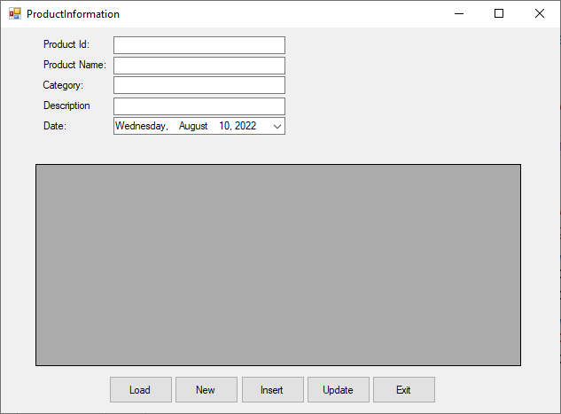

* When the user clicks the ***“Load”*** button: Load all information of the Products in Products table into the DataGridView and TextBoxes. **(2 marks)**
* When the user clicks to select a row on the DataGridView, compatible information will be shown on TextBoxes. **(1 mark)**
* When the user clicks the ***“Insert”*** button, the information of the new row on TextBoxes will be inserted into the Products table. **(2 marks)**
* When the user clicks the ***“Update”*** button then compatible information on the TextBoxes will be updated in table Products. **(2 marks)**
* When the user clicks the ***“New”*** button, all fields will be clear. **(1 mark)**
* When the user clicks the ***“Exit”*** button, close the application. **(1 mark)**
* Check validation for all fields are not empty when the user clicks the ***“Insert”*** or ***“Update”*** button (**1 mark** )

**Note**: Students must use **App.config (app.config)** file to store the database connection string in this project. If don’t use **App.config** (**app.config**) file, the score is 0