4. UCs for HR Manager
- 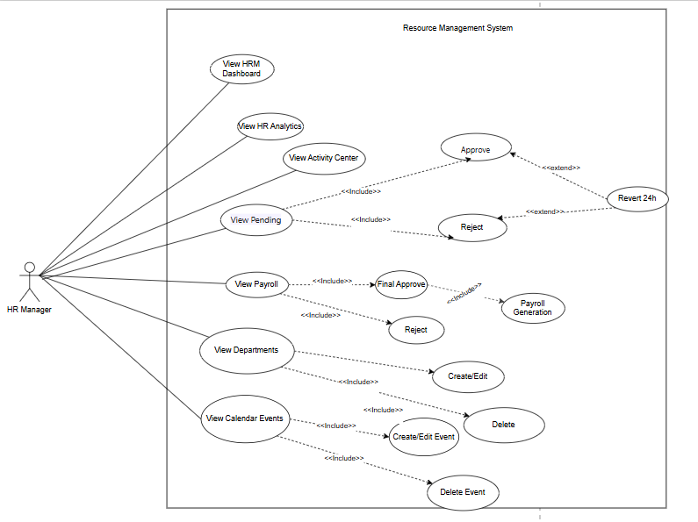

4.1: USE CASE: DASHBOARD & ANALYTICS

Field | Content
ID and Name | UC-12: View Dashboard
Primary Actor | HR Manager (HRM)
Description | Allows the HR Manager to view KPI overviews, visual charts, and recent activities (Dashboard); perform in-depth HR analysis (Analytics); and monitor system activity logs (Activity Center). This is a view-only function; editing of data is not permitted.
Trigger | The HR Manager selects the "Dashboard" menu on the HRM portal.
Preconditions | The HR Manager has successfully logged into the system with an active account possessing the HR_MANAGER role.  The system is functioning normally with a stable database connection.
Postconditions | * The displayed statistics, charts, and logs are accurate and complete.  * Data integrity is maintained; no changes are made to the system's business data.
Normal Flow | 1. The HR Manager navigates to the Dashboard page on the HRM portal.  2. The system retrieves overview data and displays key KPI indicators, including: total number of employees, order queue, and payroll summary status.  3. The system retrieves and displays the department distribution chart (number of employees by department) and a list of upcoming events.  4. The HR Manager can switch between tabs: Dashboard (Overview), Analytics (In-depth Analysis), and Activity Center (System Logs).  5. The system displays the corresponding information for the selected tab without allowing any data modification.
Alternative Flows | AF1 — No Pending Payroll  At Step 2, if there are no payroll batches in pending approval or processing status:  * AF1.1: The system displays the pending payroll KPI as 0.  * AF1.2: The system continues to load and display the remaining Dashboard components normally  AF2 — Department Chart Loading Error  At Step 3, if the system fails to load or render the department distribution chart due to rendering issues or missing local data:  * AF2.1: The system displays a local error message or placeholder icon in the chart area.  * AF2.2: The system keeps and displays all other information, KPIs, and upcoming events normally.  AF3 — No Recent Activity  When the HR Manager views recent activities (or accesses the Activity Center), if no activities have been recorded in the system:  AF3.1: The system displays an empty state message (e.g., "No activities recorded").
Exceptions | Lỗi database; timeout analytics
Business Rules | BR1: Only users with the HR_MANAGER role are authorized to access and view management-level dashboards, analytics, and the Activity Center.  BR2: All screens within this Use Case are strictly read-only; no create, update, or delete operations on business data shall be integrated into this interface.

- 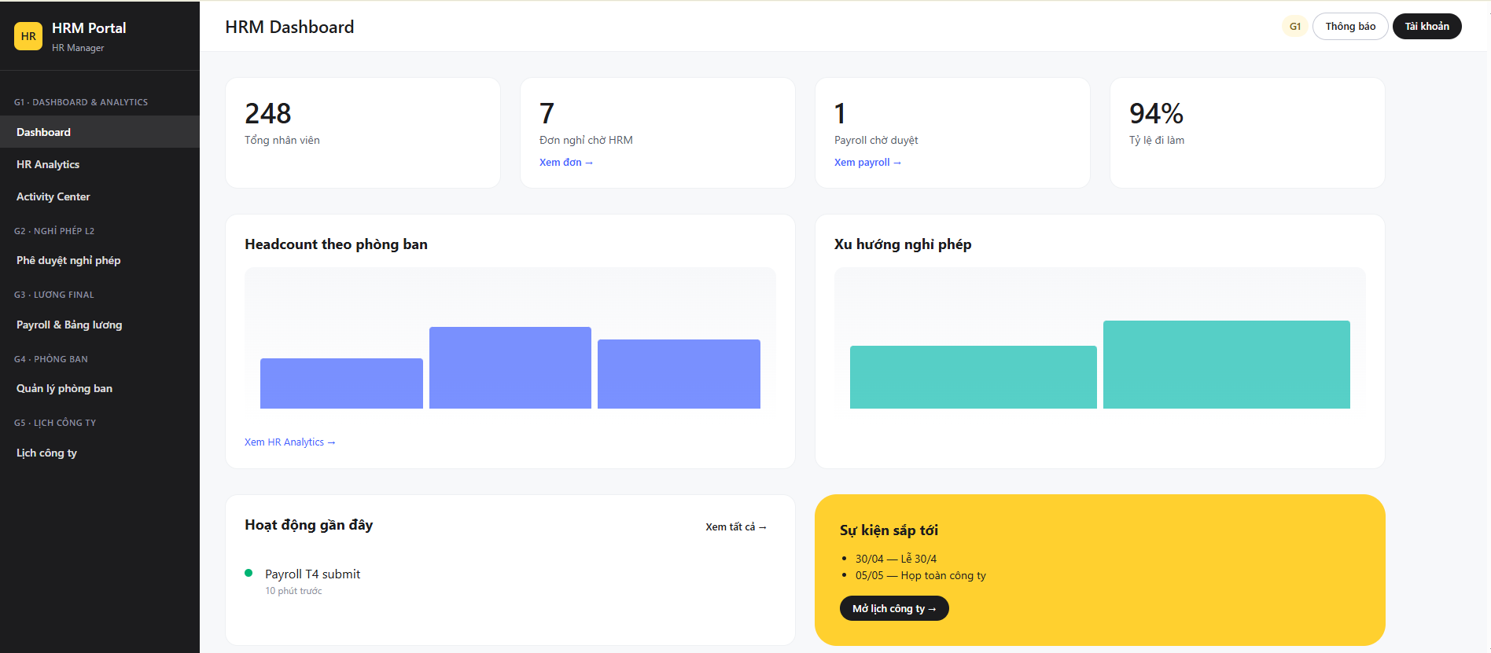

Field | Content
ID and Name | UC-12.1: View HR Analytics
Primary Actor | HR Manager (HRM)
Description | Allows the HR Manager to view and analyze HR metrics through dynamic charts filtered by specific periods and departments (e.g., department distribution, salary trends, diversity metrics, and training progress). This is a view-only function; editing of data is not permitted, but exporting data as a report is supported.
Trigger | The HR Manager selects the "HR Analytics" menu on the HRM portal.
Preconditions | The HR Manager has successfully logged into the system with an active account possessing the HR_MANAGER role.  The system is functioning normally with active records available in the Department and Employee databases.
Postconditions | The HR Manager has successfully logged into the system with an active account possessing the HR_MANAGER role.  The system is functioning normally with active records available in the Department and Employee databases.
Normal Flow | 1. The HR Manager navigates to the HR Analytics page on the HRM portal.  2. The system displays the default analytics dashboard (the current period and all departments) along with filter selection controls.  3. The HR Manager selects a specific time period and/or department from the filters, then submits the selection.  4. The system validates the filter inputs.  5. The system queries the Department, Employee, and related historical records based on the active filters.  6. The system aggregates the data and renders the analysis charts, including: Department breakdown, Salary allocation/trends, Diversity demographics, and Training progress.
Alternative Flows | AF1 — Individual Chart Module Fault  At Step 6, if a specific analytical module (e.g., Diversity demographics) encounters a data processing or rendering error:  * AF1.1: The system isolates the faulty module and displays a localized error message or placeholder inside that specific chart's container.  * AF1.2: The system continues to process, load, and display all other functional charts (Department, Salary, Training) normally.
Exceptions | Lỗi database; timeout analytics
Business Rules | BR1: Only users with the HR_MANAGER role are authorized to access and view management-level HR analytics and metrics.  BR2: This interface is strictly read-only; no data modifications (insert, update, or delete operations) can be executed from this view.

- 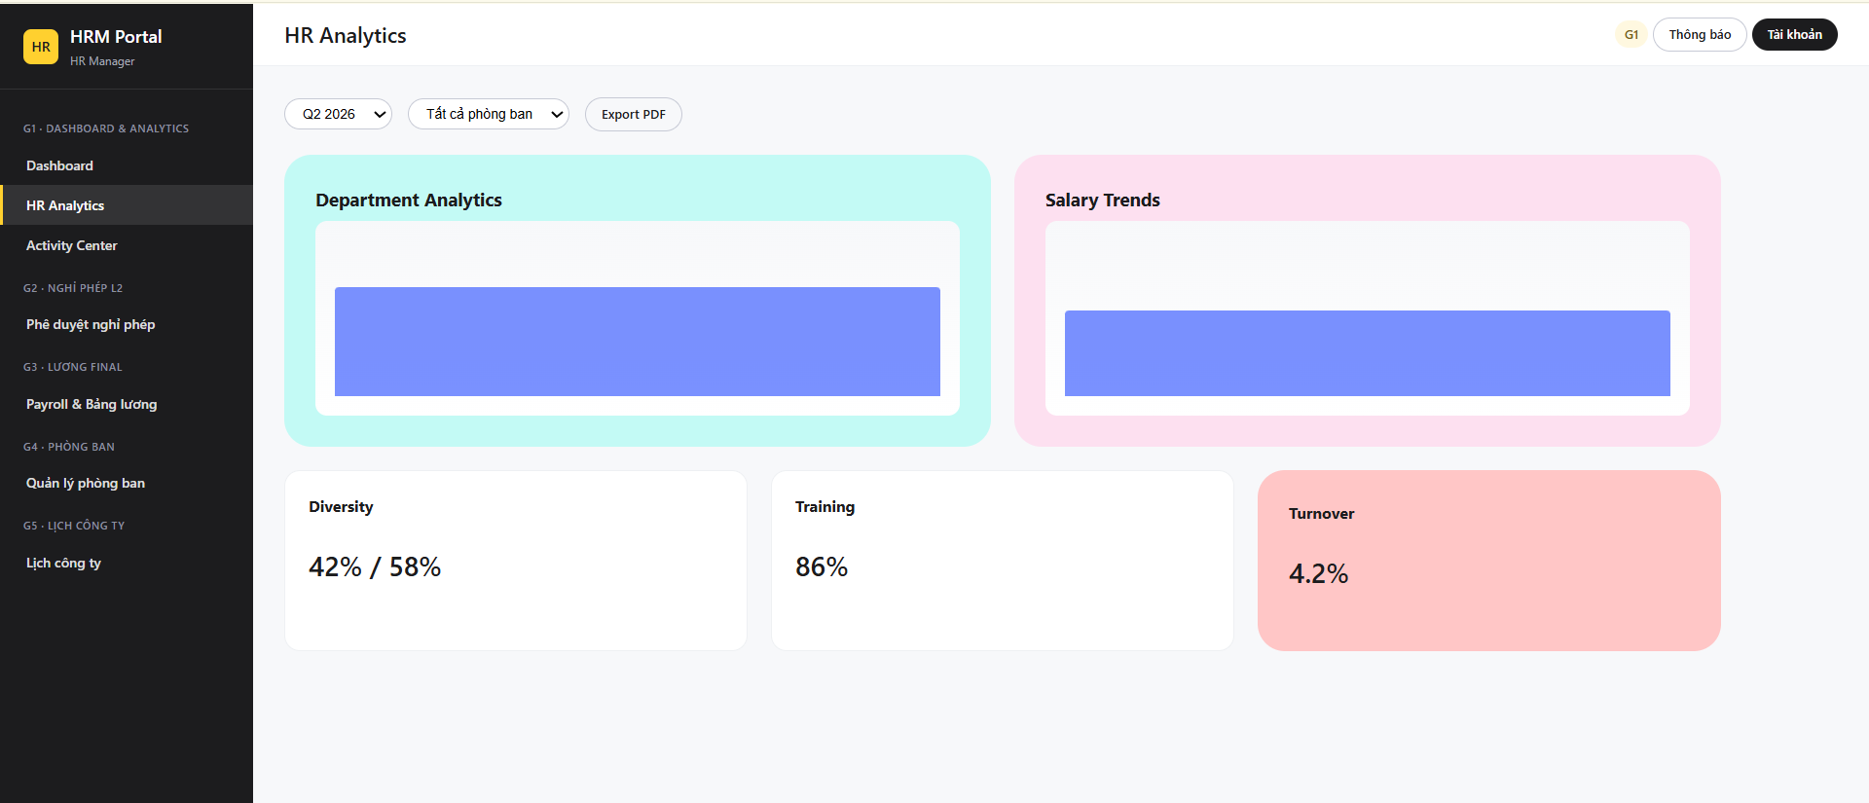

Field | Content
ID and Name | UC-12.2: View Activity Center
Primary Actor | HR Manager (HRM)
Description | Allows the HR Manager to view, search, and filter system activity logs. This is a strictly view-only function; editing, deleting, or modifying log records is not permitted.
Trigger | HRM selects the Activity Center menu.
Preconditions | The HR Manager selects the "Activity Center" menu on the HRM portal.
Postconditions | The HR Manager has successfully logged into the system with an active account possessing the HR_MANAGER role.  * The system is functioning normally.
Normal Flow | 1. The HR Manager navigates to the Activity Center page on the HRM portal  2. The system retrieves and displays the default list of activity logs, sorted by the most recent records first.  3. The HR Manager inputs search keywords (e.g., specific actions, user IDs) or selects activity type filters.  4. The system validates the search and filter inputs.  5. The system queries the ActivityLog table based on the active search/filter criteria.  6. The system displays the matching records in a paginated list format (e.g., 20 items per page) with navigation controls.
Alternative Flows | AF1 — No Results Found  At Step 5, if no activity logs match the search keywords or filters applied by the HR Manager:  * AF1.1: The system displays an empty state message (e.g., "No activity logs found matching your criteria").  * AF1.2: The system keeps the current filter and search inputs active so the user can modify and search again.  * AF1.3: The pagination controls are disabled or hidden.
Exceptions | Lỗi database; timeout analytics
Business Rules | BR1: Only users with the HR_MANAGER role are authorized to access and view management-level dashboards, analytics, and system activity logs.  BR2: This interface is strictly read-only; no data modifications (insert, update, or delete operations) of activity logs can be executed from this view.  BR3: Activity log displays must implement mandatory pagination (e.g., limited to a maximum of 50 records per page) to prevent system performance degradation when querying high volumes of data.

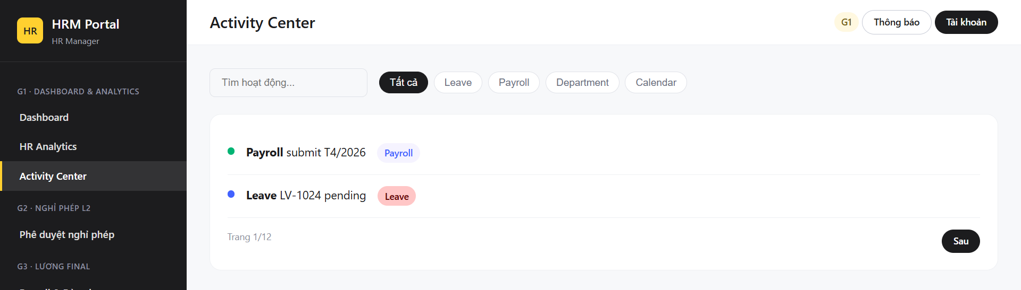

4.2 USE CASE: LEAVE MANAGEMENT

Field | Content
ID and Name | UC-13:Approve leave
Primary Actor | HR Manager (HRM)
Secondary Actors | Employee
Description | HRM reviews leave requests requiring approval (maternity, long-term, etc.), approves or rejects them (individually or in bulk), and reverses the decision within 24 hours. If successful, a notification is sent to the employee.
Trigger | HRM selects Pending Leave (HRM)
Preconditions | HRM is logged in; there are pending HRM applications (or applications that have been decided upon revert).
Postconditions | The application has been approved/rejected; or restored after revert; the audit has been recorded and notification sent (if successful).
Normal Flow | 1. The HR Manager navigates to the "Pending Leave (HRM)" page.  2. The system retrieves and displays the table of pending leave requests, including filters for leave types.  3. The HR Manager selects one or more leave requests and clicks the Approve button.  4. The system validates the requests against system rules (such as leave policies, remaining quota, and department coverage constraints).  5. The system locks the records and updates the status of the selected leave request(s) to APPROVED.  6. The system records the approval details in the audit log.  7. The system sends a status update notification to the respective Employee(s).  8. The system refreshes the request table grid, removing the processed requests, and displays a success message to the HR Manager..
Alternative Flows | AF1 — Reject Leave Request  At Step 3, if the HR Manager decides to reject the request(s) instead of approving:  * AF1.1: The HR Manager clicks the Reject button.  * AF1.2: The system displays a rejection form requiring a mandatory rejection reason.  * AF1.3: The HR Manager enters the rejection reason and confirms.  * AF1.4: The system validates that the rejection reason is not empty.  * AF1.5: The system updates the status of the selected request(s) to REJECTED and stores the rejection reason.  * AF1.6: The system records the action in the audit log, sends a rejection notification to the Employee, and displays a success message to the HR Manager.  AF2 — Missing Rejection Reason  At Step AF1.4, if the rejection reason is empty or contains only whitespace:  * AF2.1: The system detects the invalid input and blocks the rejection process.  * AF2.2: The system displays a validation error message (e.g., "Rejection reason is required").  * AF2.3: The leave request status remains unchanged (PENDING_HRM) and the form remains open for input.  AF3 — Revert Decision (Within 24 Hours)  From the processed requests view, if the HR Manager needs to reverse a prior approval or rejection:  * AF3.1: The HR Manager selects a processed request and clicks the Revert button.  * AF3.2: The system checks if the time elapsed since the decision is less than or equal to 24 hours.  * AF3.3: The system restores the leave request back to its previous status (e.g., PENDING_HRM) and recalculates the employee's leave balance accordingly.  * AF3.4: The system updates the audit log and displays a success message to the HR Manager.  AF4 — Revert Window Expired  At Step AF3.2, if more than 24 hours have passed since the original decision:  * AF4.1: The system determines the action is invalid.  * AF4.2: The system blocks the reversion and displays an error message (e.g., "Decisions cannot be reverted after 24 hours").  * AF4.3: The request status remains unchanged.  **Undo (24h):** Click Revert → check if 24 hours are still valid → restore previous state → log  Empty list: Shows no pending orders Test error: Reports an error to HRM, does not change the state, does not provide a notification.
Exceptions | Lỗi database; error sending notification
Business Rules | BR1: Only users with the HR_MANAGER role are authorized to approve, reject, or revert leave requests requiring management-level decision.  BR4: A non-empty text justification (rejection reason) is strictly mandatory for any leave rejection.  BR5: Reversion of an approval or rejection decision is strictly restricted to a maximum of 24 hours(<= 24 from the exact timestamp the original decision was recorded.  BR6: Employee notifications are only triggered upon the successful completion of a status transition transaction in the database.
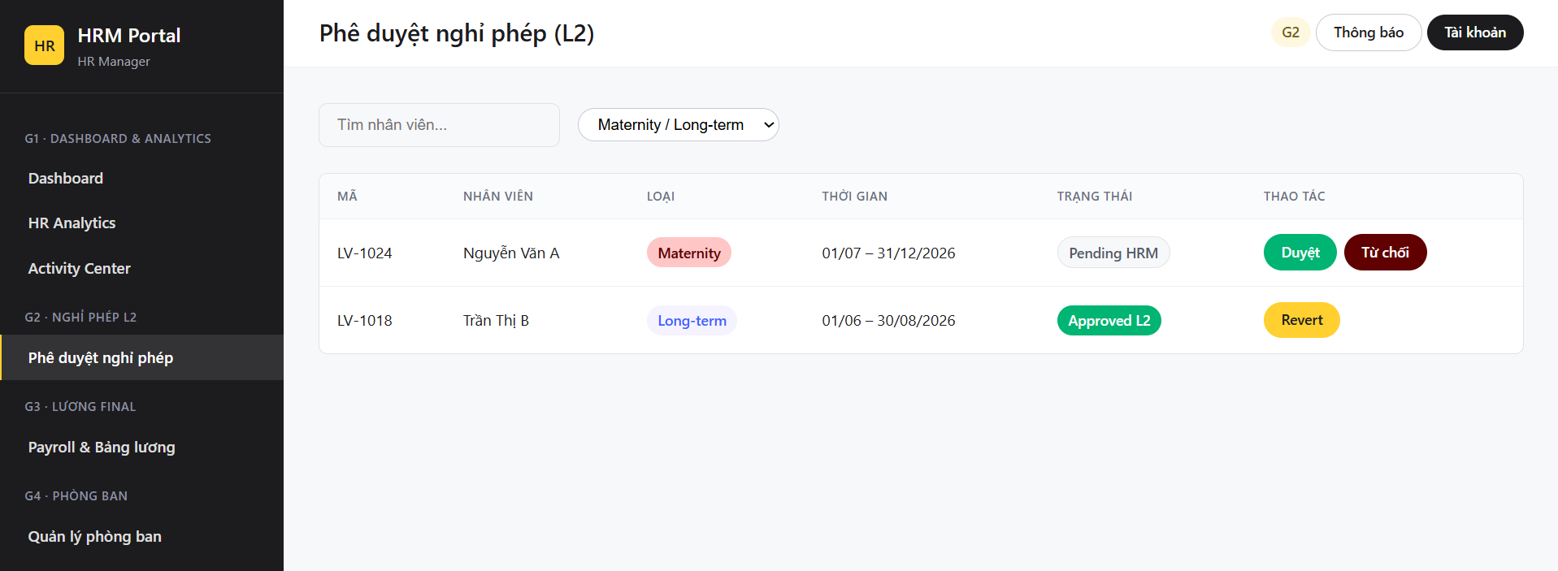

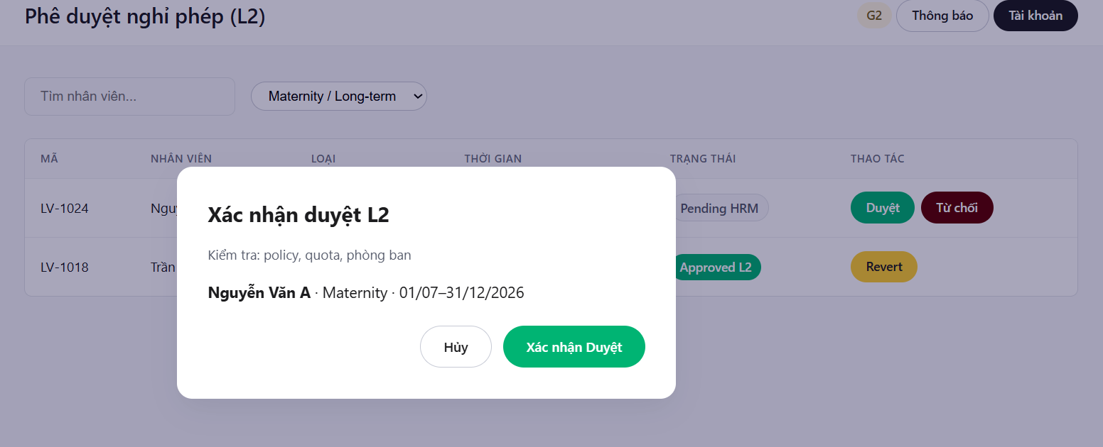
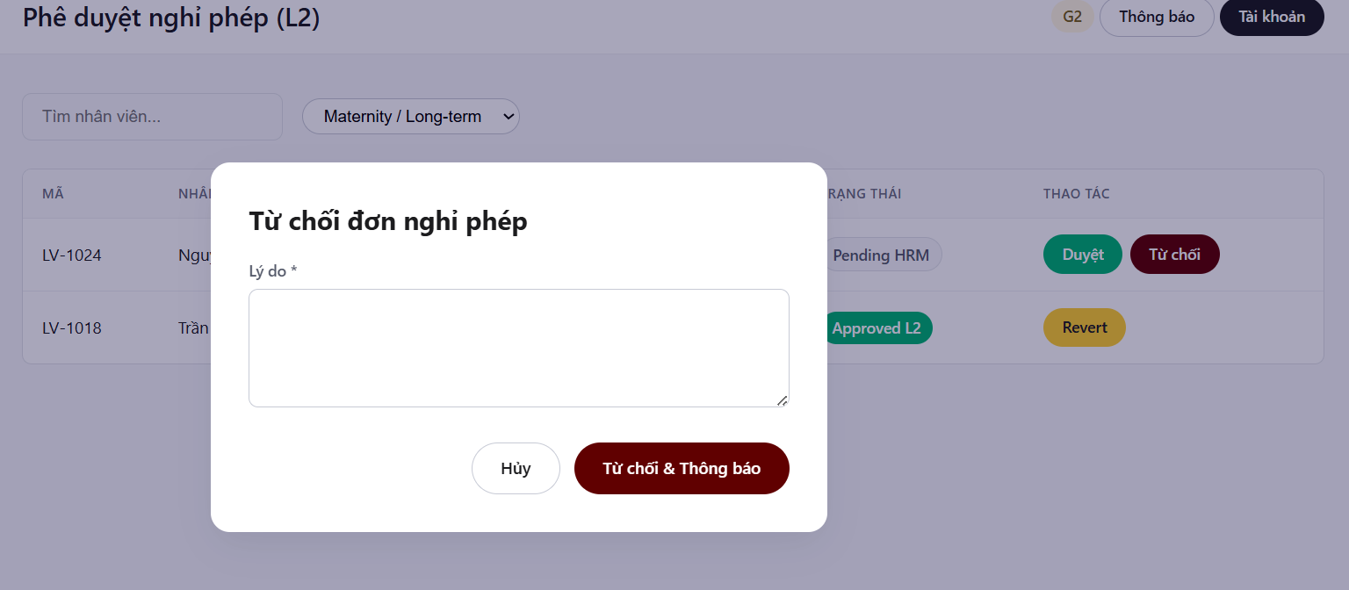

4.3: USE CASE: FINAL SALARY APPROVAL & PAYROLL GENERATION

Field | Content
ID and Name | UC14 - Manage Payroll for Approval
Primary Actor | HR Manager (HRM)
Secondary Actor | Employee
Description | Allows an HR Manager to review submitted payroll batches, perform final approval or rejection, publish employee payslips, send notifications, and export payroll CSV files for bank transfer processing.
Trigger | The HR Manager selects the Payroll for Approval menu on the HRM portal.
Preconditions | The HR Manager has successfully logged into the system with an active HR_MANAGER account; at least one PayrollBatch exists in SUBMITTED status; all Payslip records for that batch have been generated; the payroll period has not been locked.
Postconditions | The PayrollBatch is updated to APPROVED_FINAL or REJECTED. If approved, all Payslips are published and Employees receive notifications. If export is performed, a payroll CSV file is generated and made available for download.
Normal Flow | 1. The HR Manager navigates to the Payroll for Approval page.  2. The system retrieves PayrollBatch records in SUBMITTED status. .  3. The system retrieves related Payslip records  4.The system displays payroll summary information and payslip details.  5.The HR Manager reviews payroll information.  6. The HR Manager clicks Final Approve  7. The system displays a final approval confirmation dialog and the HR Manager confirms.  8. The system locks the PayrollBatch.  9. The system updates the PayrollBatch status to APPROVED_FINAL.  10. The system publishes all Payslip records belonging to the PayrollBatch.  11. The system sends payslip notifications to Employees  12. The system displays a successful approval message.  13. The HR Manager clicks Export Bank File.  14. The system verifies that the PayrollBatch status is APPROVED_FINAL.  15. The system retrieves payroll data from Payslip and employee data from Employee.  16. The system generates a payroll CSV file and makes it available for download.
Alternative Flows | AF1 — Reject Payroll At Step 6, instead of selecting Final Approve:  AF1.1 : The HR Manager clicks Reject.  AF1.2 :The system displays a rejection form requiring a rejection reason  AF1.3: The HR Manager enters a rejection reason and confirms.  AF1.4: The system validates the rejection reason.  AF1.5:The system updates the PayrollBatch status to REJECTED and stores the rejection reason.  AF 1.6: The system does not publish Payslips.  AF1.7: The system displays a successful rejection message.  AF2 — Missing Rejection Reason At Step AF1.4, if the rejection reason is empty  AF2.1:The system detects that the rejection reason is empty.  AF2.2: The system displays a validation error message.  AF2.3: The system keeps the entered information for correction.  AF2.3: The PayrollBatch status remains unchanged  AF3 — Export Before Final Approval At Step 14, if the PayrollBatch status is not APPROVED_FINAL:  AF3.1: The system determines that the PayrollBatch has not been finally approved.  AF3.2: The system rejects the export request.  AF3.3:The system displays an error message.  AF3.4: No CSV file is generated
Exceptions | EX1 — Payslip Publishing Failure  EX2 — Notification Service Failure
Business Rules | BR1:Only users with role HR_MANAGER may approve or reject PayrollBatch records  BR7: Only PayrollBatch records with status SUBMITTED may be finally approved  BR8:CSV export is allowed only when PayrollBatch status is APPROVED_FINAL.  BR9: A PayrollBatch must be locked immediately after final approval.

- 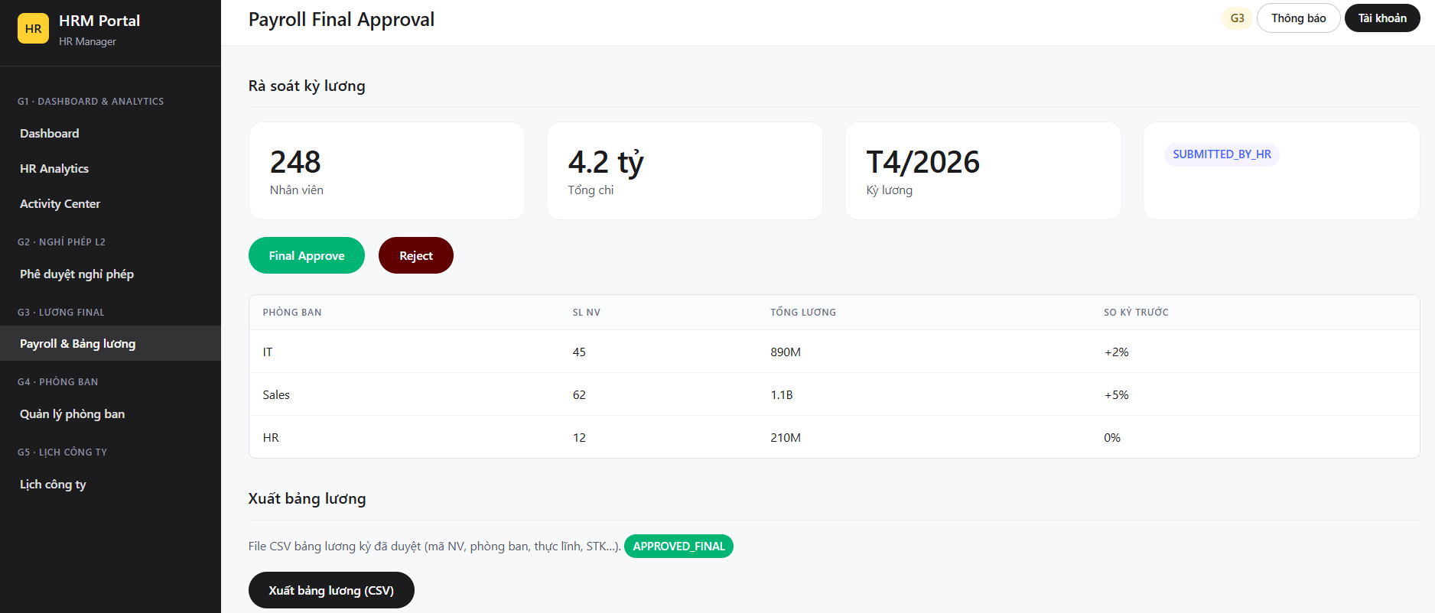
- 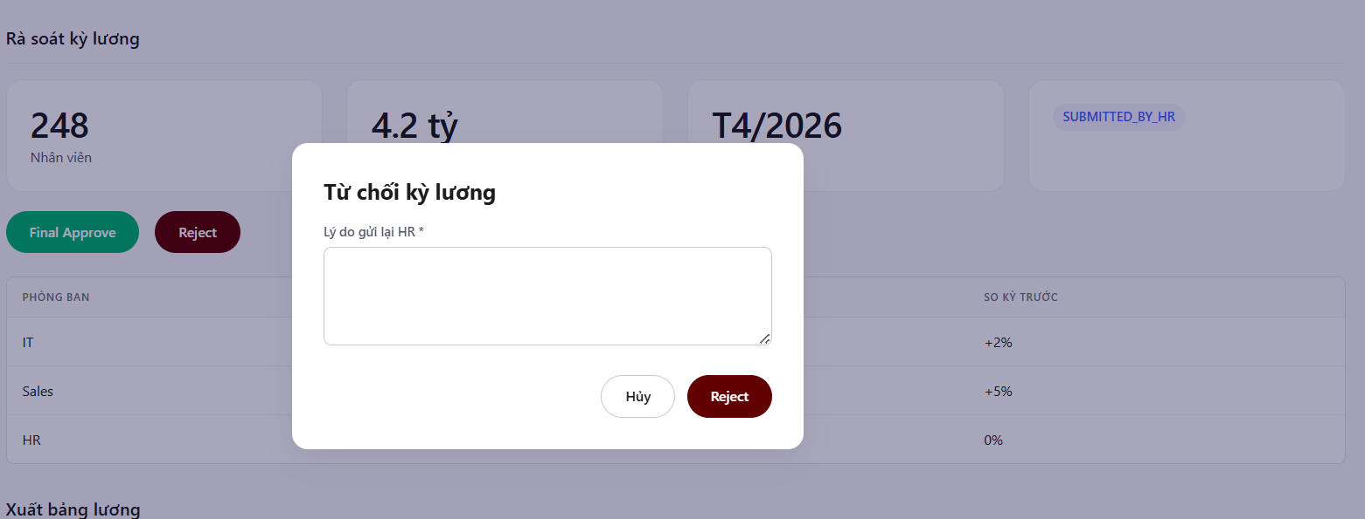
- 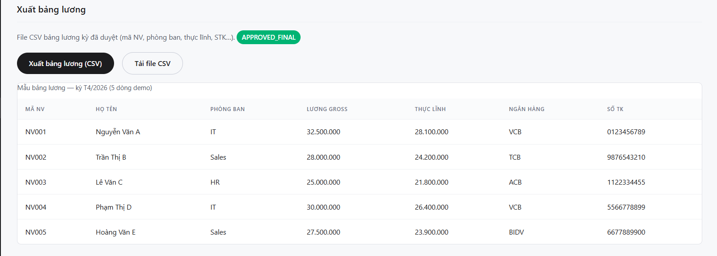

4.3A: COMMUNICATION DIAGRAM

- 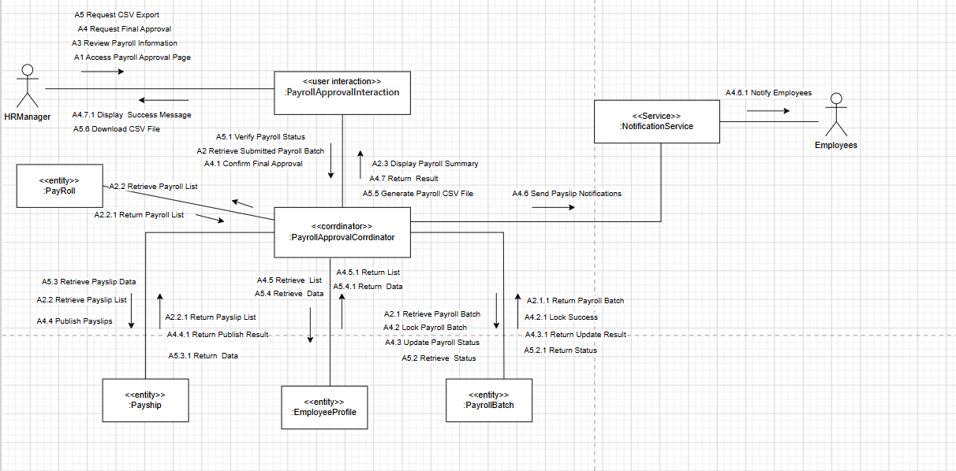
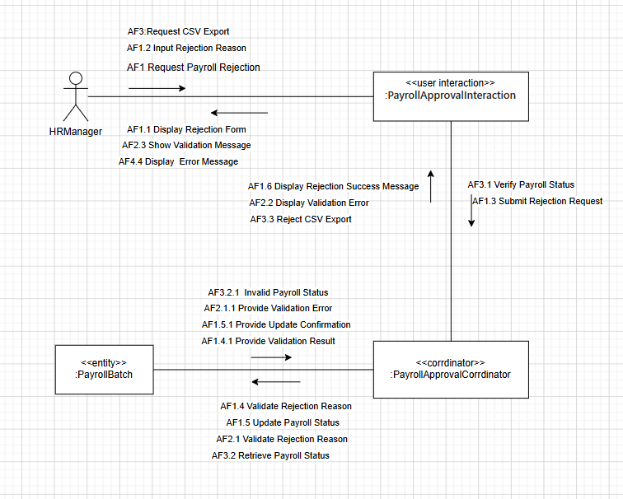

4.4. USE CASE:DEPARTMENT MANAGEMENT

Field | Content
ID and Name | UC15 - Department management
Primary Actor | HR Manager (HRM)
Description | HRM can view the department list, create new, edit, and delete (when the employee is no longer listed). Only HRM can use CRUD.
Trigger | HRM selects the Departments menu.
Preconditions | HRM is logged in
Postconditions | Departments are created/updated/deleted; the list is updated.
Normal Flow | 1. HRM opens the department list.  2. The system displays the table (code, name, number of employees).  3. HRM selects **Create Department** or **Edit**  4. The system displays the form (code, name).  5. HRM enters the information and selects **Save**.  6. The system checks for duplicate names/codes  7. The system saves the department.  8. The system updates the table and reports success to HRM.
Alternative Flows | AF1 — Delete Department (Success - Soft Delete)  At Step 3, if the HR Manager decides to delete a department:  * AF1.1: The HR Manager clicks the Delete button next to a department.  * AF1.2: The system displays a confirmation dialog.  * AF1.3: The HR Manager confirms the deletion.  * AF1.4: The system verifies that the current number of assigned employees in this department is 0  * AF1.5: The system performs a soft delete on the department record (setting its status to inactive) to preserve historical logs.  * AF1.6: The system updates the department table and displays a success message.  AF2 — Delete Department Failed (Active Staff Present)  At Step AF1.4, if the system detects that there is at least one active employee still assigned to the department:  * AF2.1: The system blocks the deletion request.  * AF2.2: The system displays an error message (e.g., "Cannot delete department because active employees are still assigned to it").  * AF2.3: The department status remains unchanged.
Exceptions | Lỗi database
Business Rules | BR1: Only users with the HR_MANAGER role are authorized to access and perform CRUD operations on department data.  BR10: Department Code and Department Name must be unique across the entire system (case-insensitive).  BR11: Deletion of a department is strictly prohibited if there are active employees currently mapped to that department.  BR12: Deleted departments must be soft-deleted in the database to maintain referential integrity with historical payroll and activity logs.
- 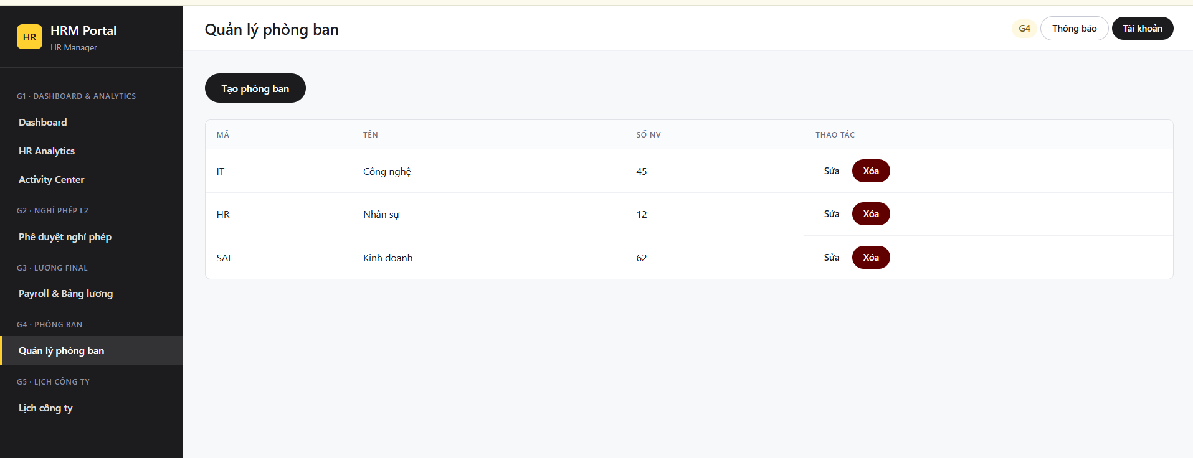
- 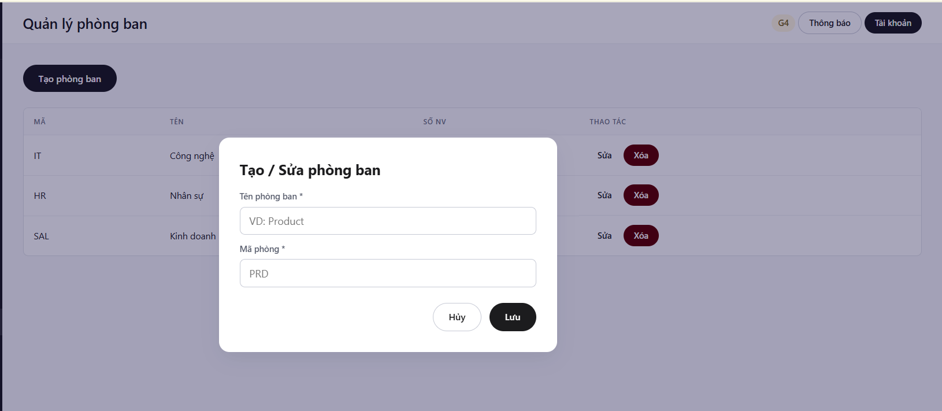
- 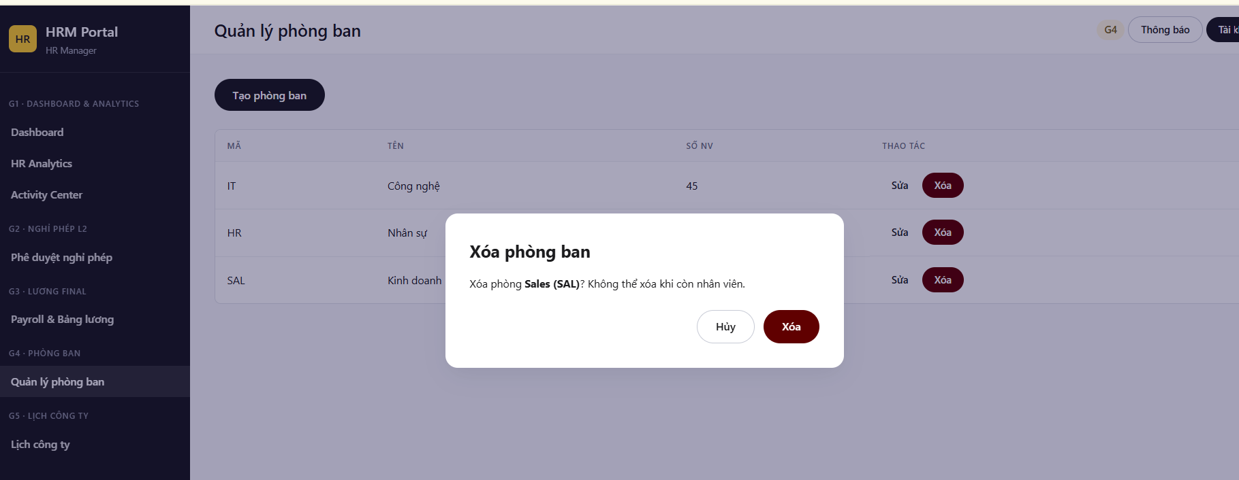

4.5. USE CASE: MANAGE COMPANY CALENDAR

Field | Content
ID and Name | UC16- Company schedule management
Primary Actor | HR Manager (HRM)
Secondary Actors | Employee
Description | This allows HRM to view the company calendar and add/edit/delete events (holidays, meetings, deadlines). After successful saving or deletion, the system sends a notification to the relevant employee.
Trigger | HRM selects the Company Calendar menu.
Preconditions | HRM has logged in; the system is functioning normally.
Postconditions | The event is updated on the calendar; the screen displays the new data; a notification has been sent (if successful).
Normal Flow | 1. HRM opens the company calendar page.  2. The system displays the monthly grid and event list.  3. HRM selects Create or Edit.  4. The system displays the form (title, type, date).  5. HRM enters the information and selects Save.  6. The system checks the data (valid date, no holiday conflicts).  7. The system saves the event and logs it.  8. The system sends a notification to the employee  9. The system updates the calendar and reports success to HRM.
Alternative Flows | AF1 — Delete Event: HRM selects delete and confirms; the system deletes the event, logs it, notifies the employee, and updates the calendar.  AF2 — Data Error: Invalid data; the system reports an error on the form; HRM corrects or cancels  AF3 — Cannot Delete: Event does not meet the deletion criteria; the system reports an error; no notification.
Exceptions | Database error; notification sending error (saved but not sent).
Business Rules | BR1: Only users with the HR_MANAGER role are authorized to create, update, or delete company calendar events.  BR13: For any calendar event, the End Date/Time must be greater than or equal to (>=) the Start Date/Time.  BR14: Company notifications are strictly triggered only after a schedule modification is successfully committed to the database..

